[Grab your reader’s attention with a great quote from the document or use this space to emphasize a key point. To place this text box anywhere on the page, just drag it.]
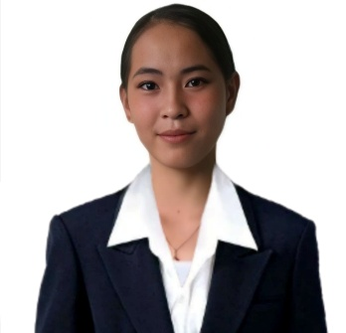



About Me
I am hardworking and trustworthy eager to start my career. I value honesty, teamwork, and excellent customer service, and I aim to ensure every transaction is accurate and every customer feels satisfied.
Experience
WORK IMMERSION
Human Resource at LGU (June 2023)
Language
Tagalog
Bisaya
English

References
NAME: CARDINES, ARJIE
CONTACT: 09632603218
NAME: BOKINGO, KAYLE
CONTACT: 09658660149
CONTACT
Rowenabitoy5@gmail.com

09752212641
5, Sanisidro Lunocan , Manolo Fortich , Bukidnon
,
Education
TERTIARY
NORTHERN BUKIDNON STATE COLLEGE
BACHELOR OF SCIENCE IN BUSINESS ADMINISTRATION
FINANCIAL MANAGEMENT
2023 – Present
MAJOR: FINANCIAL MANAGEMENT

SECONDARY
MANOLO NATIONAL HIGH SCHOOL
ABM
2021 – 2023
STRAND: ACCOUNTANCY BUSINESS AND MANAGEMENT

PRIMARY
LUNOCAN ELEMENTARY SCHOOL
2016-2017

ROWENA L. BITOY

Expertise
- Honest and Responsible
- Hardworking and willing to learn
- Polite and respectful

