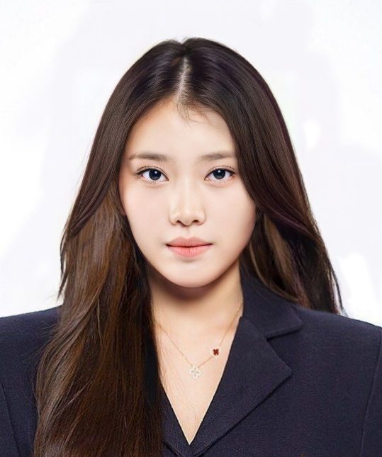
GRYCKA YVONNE P. GONHAY
CONTACT


096565882375

Grycka Yvonne P. Gonhay

Gryckayvonnegonhay@gmail.com

EDUCATION

Tertiary: Northern Bukidnon State College
Secondary: Manolo Fortich National School
w
Lingion Elementary School
SKILLS

