**Abstract**

It is almost impossible to not digitalize any or all aspects of your work. The internet and technology are push the boundaries of production as well pushing out the mistakes we used to make. The power pack of technology and the internet enables the once thought to be impossible.

Keeping track of anything isn’t a simple and an easy thing to do even with the best humanly possible management. We tend to lose it when the size of the information becomes unbearable. This is where the computers come in, with the power pack, we are able to keep records of almost anything in the best maintainable manner. Easy input, easy access, and easy management.

**CHAPTER 1**

**1.1 Introduction**

Over the years, the GRA has been processing the payments of their service providers and keeping track of the payments on papers. Commissioner-SSD is a web-based system designed solely to convert the traditional record keeping method into electronic record keeping.

**1.2 Background of the study**

The secured sections of every nation’s government have always been guarded by the best possible way there is. The GRA is the main source of income for the government of Ghana, hence it cannot rely on hard copy files for safe record keeping.

**1.3 Statement of the problem**

The world is evolving, and as a developing country, we cannot be keeping essential records in books and papers.

**1.4 Objectives of the project**

This project aims to develop a web-based system to keep an accurate, secured, and reliable records of payment activities of the service providers of GRA.

**CHAPTER 2**

**2.1 Introduction**

This chapter focuses on the concepts of the Commissioner-SSD.

**2.2 Concepts of Commissioner-SSD**

So, over the years, corporate institutions with heavy loads of responsibilities have been keeping records of almost everything that goes on within themselves and with others as well, example, payments, this was mostly done via hardcopy. It becomes out of hand when the records or books are piled up.

The introduction of the Commissioner-SSD will enable the GRA to keep, maintain, manger, and assess records of payment with ease.

**2.3 Limitations of the existing system**

* Prone to alteration
* Prone to misplacement
* Almost impossible to keep track of

**2.4 The proposed system in relation to the existing system**

The proposed system will be performing every activity the old system was performing alongside with new activities in a more secured, accurate, suitable and 21st century-like manner.

**CHAPTER THREE**

SYSTEM DESIGN

This chapter is to provide a detailed description of the functionalities of the Commissioner-SSD system and to specify the target users, hardware and software requirements. This chapter also describes the design specifications of the system as well as the used architecture.

**3.1 Project Scope**

The system is a browser-based system. It is designed to accept payment details and keep them.

**3.2 Overall Description**

The system will have a form to receive the details of payments, review and approved before payment is done.

**3.3 User and Characteristics**

Since the system is built to enable GRA to record and track visitations of clients on daily basis. The primary users will be; 1. AC’s office, 2. DC’s office and 3. Commissioners office.

**3.4 Operating Environment**

The system is made of HTML, CSS, Bootstrap, JS, JQuery for the frontend, PHP and MySql for the backend and database respectively. This system is able to run on most web browsers.

**3.5 System Requirements**

Since it is a web-based system, it depends on a **server** to be alive and a browser to be accessed through.

**3.6 Functional Requirements**

* The system will enable officers to add payment details
* The system will enable the internal authorities to assess the stored records

**3.1** **Design Methodology**

The software engineering model that has been used to design the system is prototyping model. The prototyping model as a development method was chosen because it allows a prototype to be built, tested and then reworked as necessary until an acceptable prototype is finally achieved from which the complete system or product can now be developed. This kind of model is chosen because the system requirements are well understood and allows easy incorporation of changes.

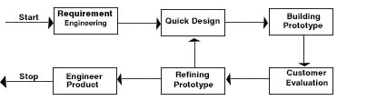

Figure 3.1 Prototyping Model

ADMIN

COMMISSIONER

DC

AC

STAFF

**3.2 Use Case**

ACTIVATE/DEACTIVATE USER

VIEW PAYMENT

DELETE PAYMENT

DECLINE/APPROVE PAYMENT

EDIT PAYMENT

ADD DEPARTMENT

ADD PAYMENT

ADD USER

ADD OFFICE

Yes

No

End

No

Yes

No

C

C

Yes

No

Status=Revise

Status=Declined

Status=Approved

C

Status=Recommended

DC approval

Status=Stand By

AC approval

Status=Submitted

Add payment

start

Yes

**3.3 Flow chart**

A

A

B

B

If AC

AC approve

DC approve

Commissioner approval

Com approve

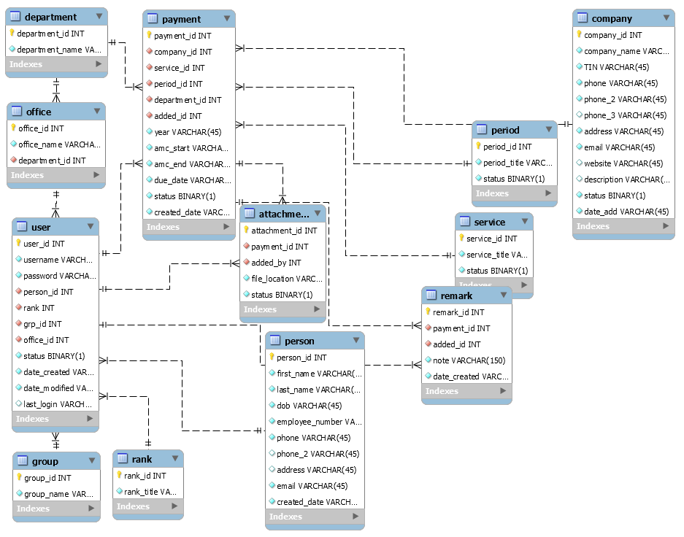

-Null

-Not Null

-Foreign key

**3.4 ER Diagram**

**Admin**

**Not so Ordinary**

**Ordinary**

**Like-Admin**

4

* Add payment
* Edit payment
* Fly payment
* Add user users
* Deactivate/Activate user
* Deactivate/Activate company
* Deactivate/Activate service
* Deactivate/Activate period
* Add department
* Add office
* Add other Admins
* Delete anything
* Deactivate/Activate user

3

* Add payment

2

* Add payment
* Edit payment
* Fly payment
* Add user users
* Deactivate/Activate user
* Deactivate/Activate company
* Deactivate/Activate service
* Deactivate/Activate period

1

**3.5 Groups**