Reconstruction & Analysis of Shredded & Ripped-up Documents using Deep Learning for Forensic Investigation
In this work we are employing CNN deep learning algorithm to reconstruct shredded and ripped-up documents. CNN will take normal and shredded documents as input and then trained a model and this model can be applied on shredded or ripped pieces to reconstruct document. CNN will utilize pairwise similarity between trained features and shredded pieces to find closest piece and then start reconstruction.
We are employing trained model on test data shredded pieces to analyse reconstructed content and then compare with ground truth document to calculate reconstructed accuracy.
Currently no dataset exists to reconstruct documents from irregular shapes so we got below shredded document dataset from internet which is showing below
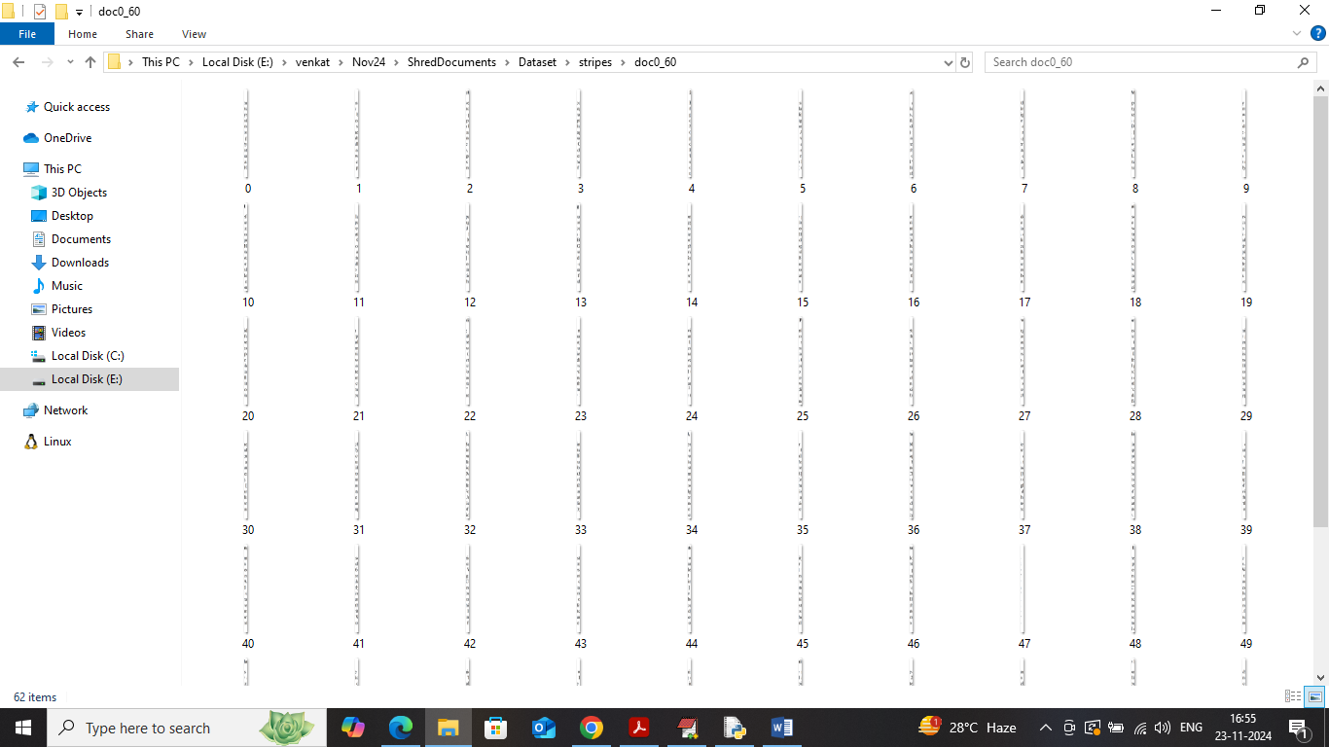
In above screen can see text document which is divided into shredded pieces which has ripped text also. CNN will get trained on above dataset.
To implement this project we have designed following modules
- Upload Shredded Documents Dataset: using this module will upload shredded documents pieces dataset to application and then application will read and resize each document into equal size
- Pre-process Dataset: using this module application will shuffle and normalize all documents images
- Split Train & Test Dataset: split processed documents into train and test where application using 80% dataset features for training and 20% for testing
- Run Deep Learning Algorithm: 80% processed document will be input to CNN deep learning algorithm to train a model and this model will be applied on 20% test data to reconstruct document and then perform content analysis between trained and reconstructed document to calculate reconstruction accuracy
- Document Reconstruction: using this module will upload test shredded documents pieces folder and then CNN will analyse each shredded piece using pairwise similarity to gather closest matching document and then start reconstruction and then display both shredded and reconstructed document as output
SCREEN SHOTS
To run project double click on run.bat file to get below page
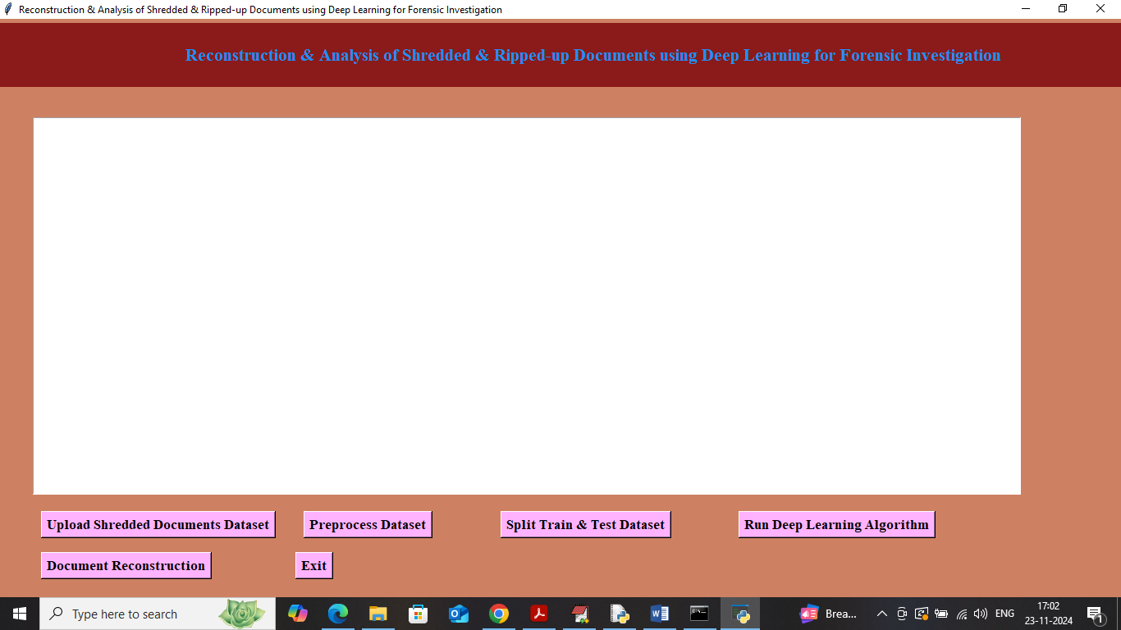
In above screen click on ‘Upload Shredded Documents Dataset’ button to get below page
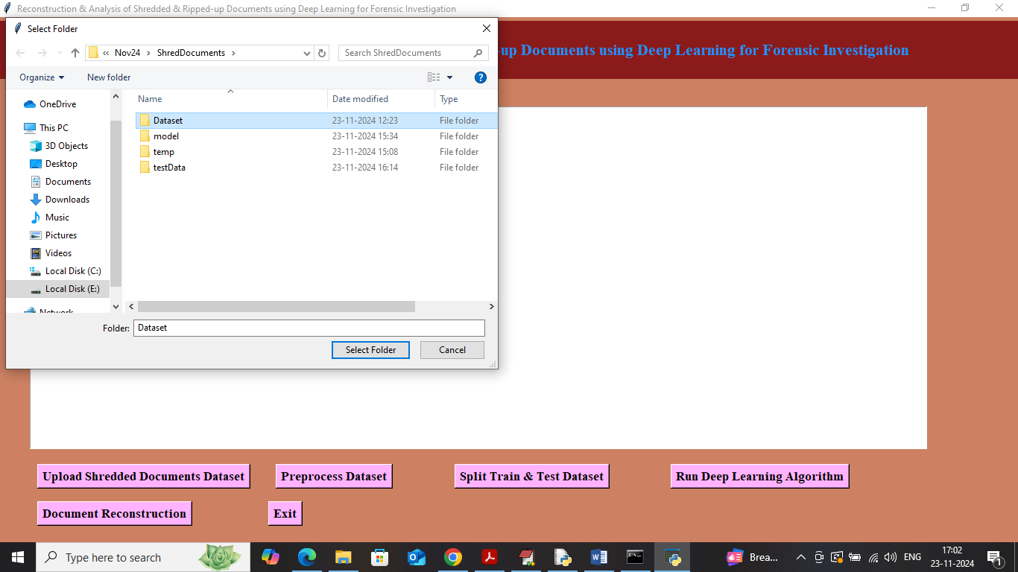
In above screen selecting and uploading entire dataset folder and then click on ‘Select Folder’ button to load dataset and get below page
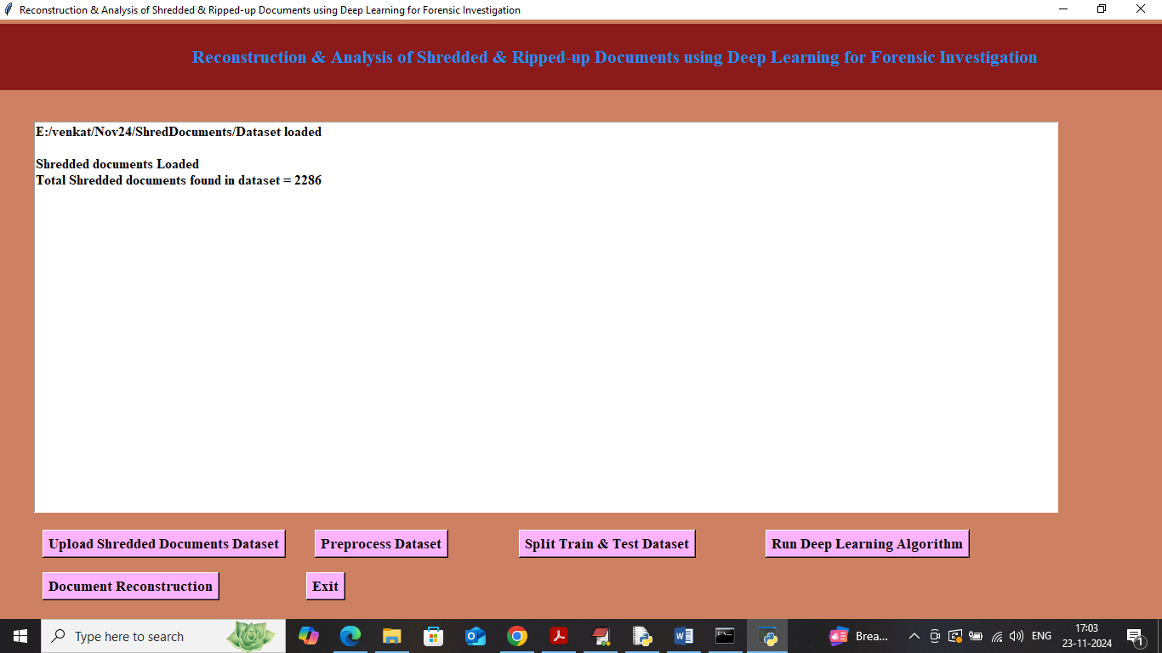
In above screen can see dataset loaded and can see number of shredded pieces loaded from dataset and now click on ‘Pre-process Dataset’ button to process dataset and get below page
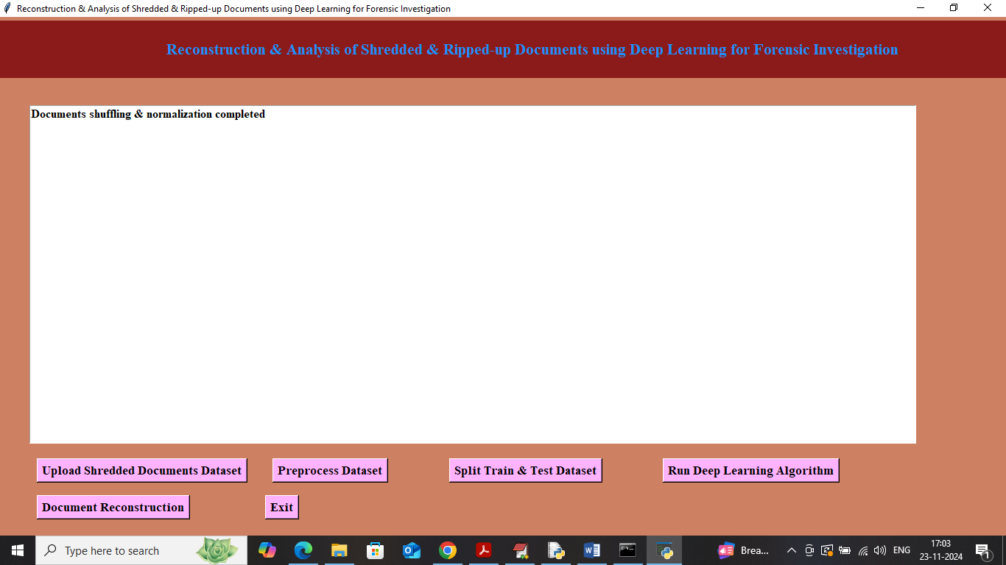
In above screen dataset processing completed and now click on Split Train & Test Dataset’ button to split dataset into train and test and then will get below output
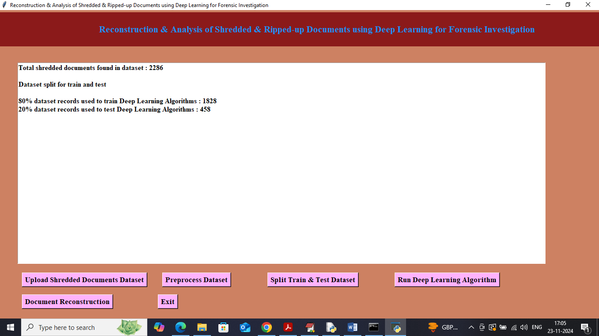
In above screen can see train and test size and now click on ‘Run Deep Learning Algorithm’ button to get below output
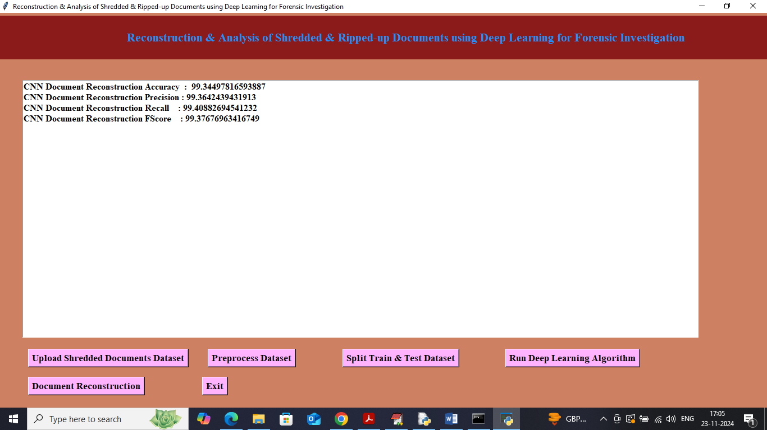
In above screen deep learning CNN model got 99% accuracy on document reconstruction on test data and can see other metrics like precision, recall and FSCORE. Now click on ‘Document Reconstruction’ button to upload shredded pieces of documents and get below page
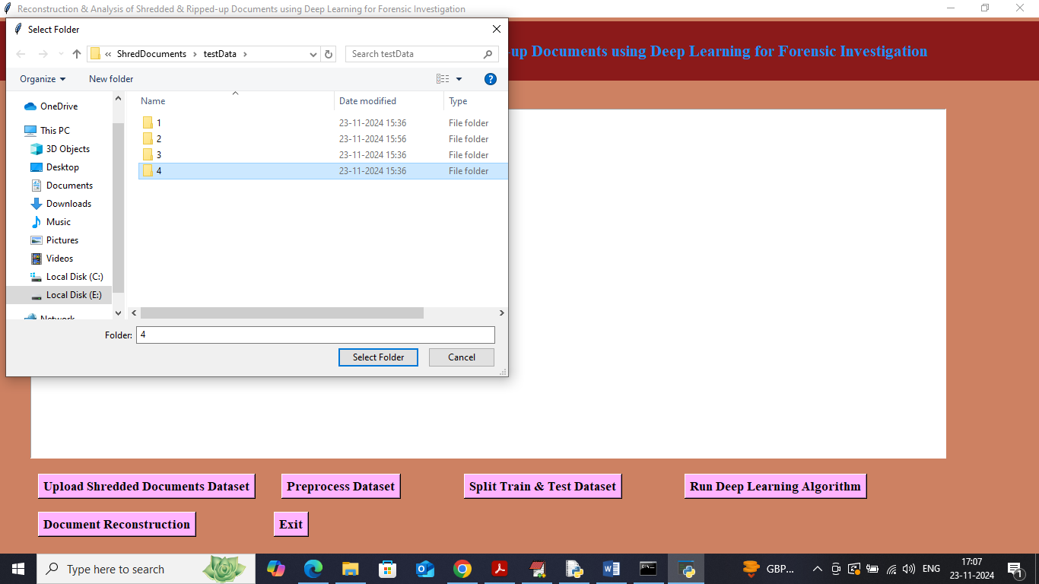
In above screen selecting and uploading ‘4’ folder and then click on ‘Select Folder’ button to get below output
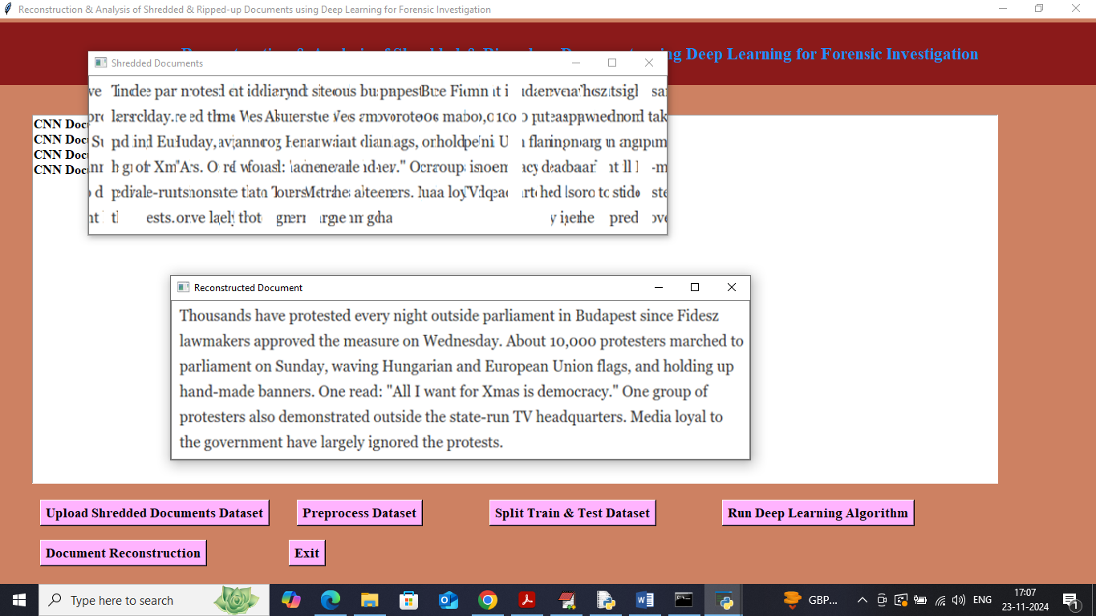
In above screen first image showing shredded and ripped text data and in second image can see reconstructed data. Similarly you can upload and test other document. In below screen showing another test sample
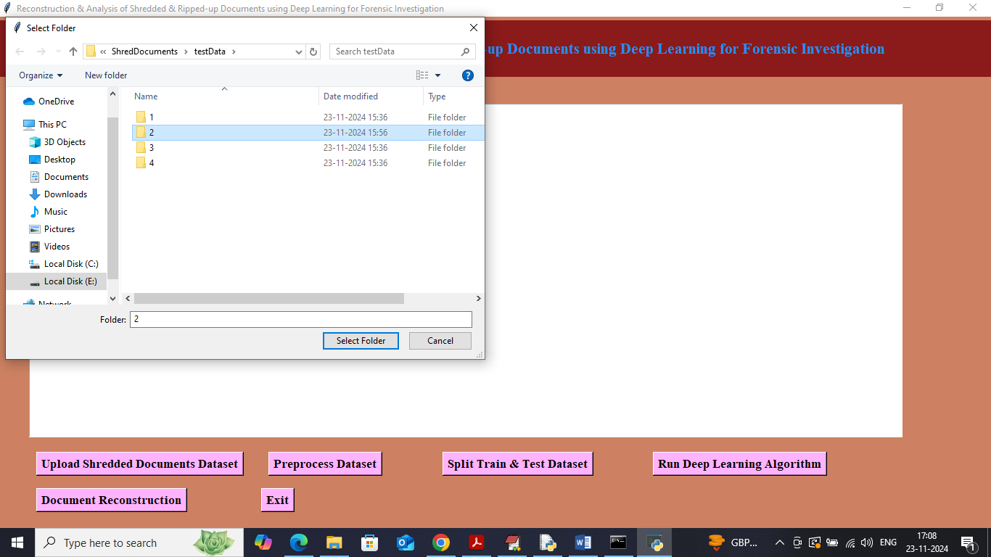
In above screen uploading another shredded folder and below is the output
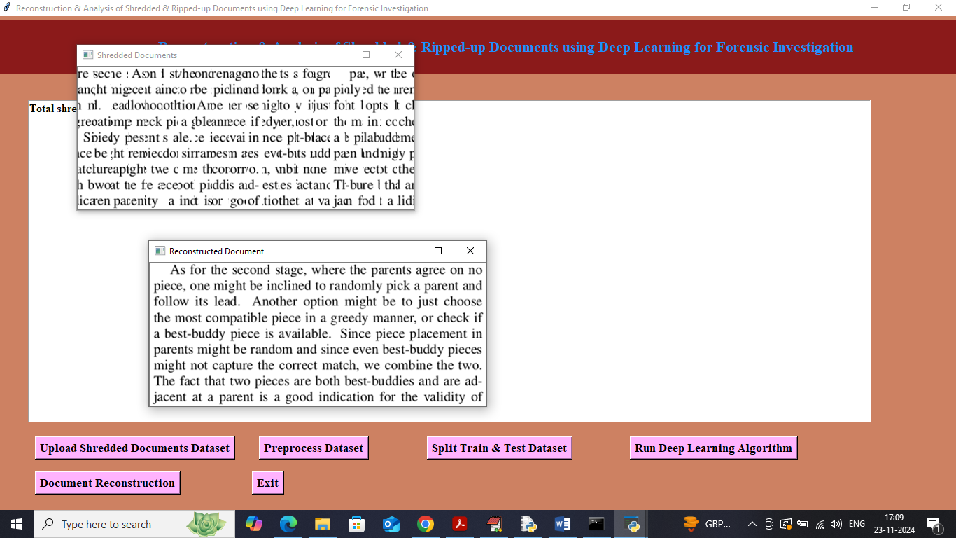
In above screen first image is the integrated pieces of shredded documents and second one is the reconstructed document.

