**Problem Statement:** Analyzing the data for fantasy game Heroes of Pymoli.

Like many others in its genre, the game is free-to-play, but players are encouraged to purchase optional items that enhance their playing experience. The task is to generate a report that breaks down the game's purchasing data into meaningful insights.

**Player Count**

* Total Number of Players

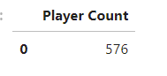

**Purchasing Analysis (Total)**

* Number of Unique Items
* Average Purchase Price
* Total Number of Purchases
* Total Revenue



**Gender Demographics**

* Percentage and Count of Male Players
* Percentage and Count of Female Players
* Percentage and Count of Other / Non-Disclosed

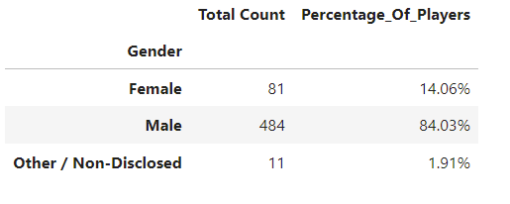

**Purchasing Analysis (Gender)**

* The below each broken by gender
  + Purchase Count
  + Average Purchase Price
  + Total Purchase Value
  + Average Purchase Total per Person by Gender

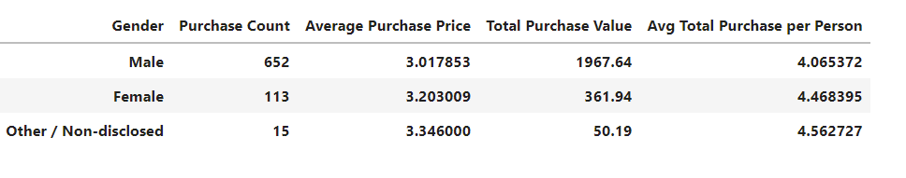

**Age Demographics**

* The below each broken into bins of 4 years (i.e. <10, 10-14, 15-19, etc.)
  + Purchase Count
  + Average Purchase Price
  + Total Purchase Value
  + Average Purchase Total per Person by Age Group

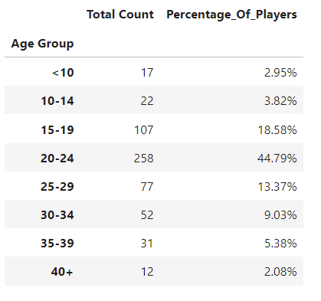

**Purchasing Analysis (age)**

* The below each broken into bins of 4 years (i.e. <10, 10-14, 15-19, etc.)
  + Purchase Count
  + Average Purchase Price
  + Total Purchase Value
  + Average Purchase Total per Person by Age

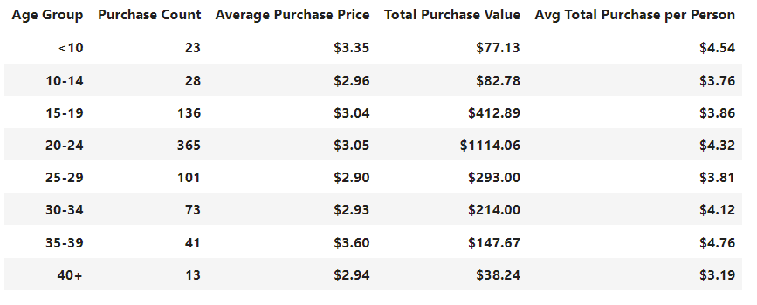

**Top Spenders**

* Identify the the top 5 spenders in the game by total purchase value, then list (in a table):
  + SN
  + Purchase Count
  + Average Purchase Price
  + Total Purchase Value

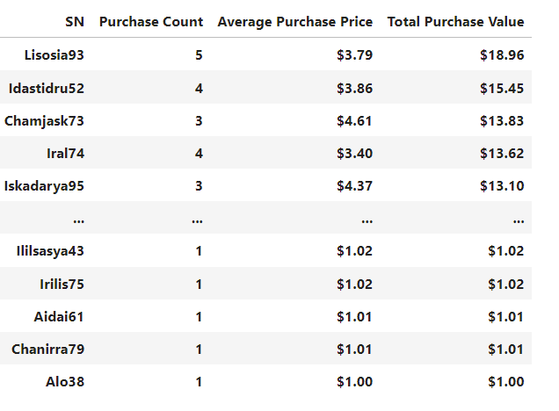

**Most Popular Items**

* Identify the 5 most popular items by purchase count, then list (in a table):
  + Item ID
  + Item Name
  + Purchase Count
  + Item Price
  + Total Purchase Value

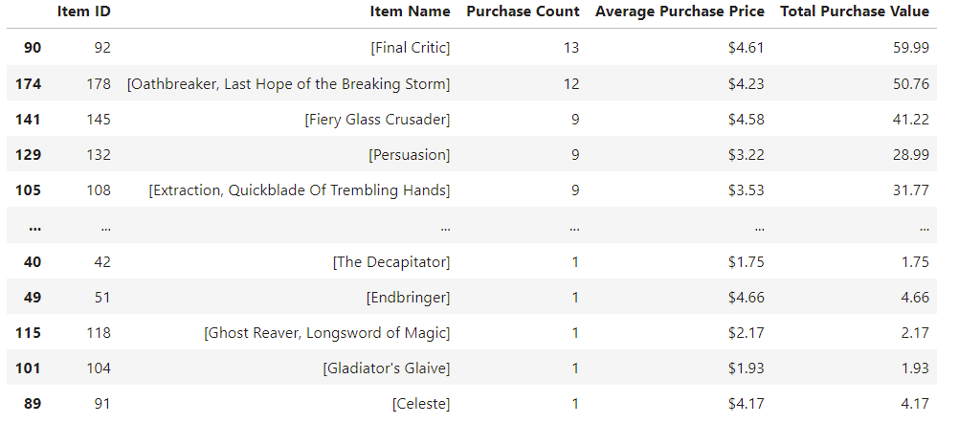

**Most Profitable Items**

* Identify the 5 most profitable items by total purchase value, then list (in a table):
  + Item ID
  + Item Name
  + Purchase Count
  + Item Price
  + Total Purchase Value

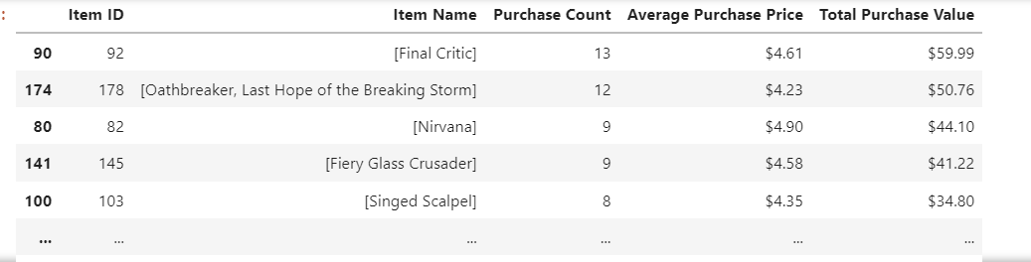

**Observable trend based on data:**

1. This type of Fantasy games is more popular among mail players [652 out of 780] compare to female [113 out of 780] players.
2. This type of games is popular between age 15 to 29 [more than 76%].
3. Although most of the popular games are profitable [Example: Final Critic] but all profitable games are not popular. [Example: Nirvana]