**Audio Visualization and Compression (Python)**

Prepared by Mandala Sandeep Madanapalle Institute Of Technology and Science.

**Project Summary: Audio Analysis and Compression with Visualization in Python**

This project explores the capabilities of Python libraries for audio analysis and manipulation. It utilizes audio visualizations to:

* **Understand Frequency and Bandwidth:** By visualizing the audio data (e.g., waveform, spectrogram), we can identify the dominant frequencies present in the audio, revealing its tonal characteristics and overall bandwidth.
* **Extract and Visualize Emotion:** Certain audio features can be indicative of emotions conveyed in speech or music. This project explores extracting such features and potentially using visualizations to represent emotional content.
* **Compression and Visualization:**The project delves into audio compression techniques using Python libraries. By compressing an audio file, we can reduce its size while potentially maintaining its quality. The project then visualizes the compressed audio data, allowing for comparison with the original audio's visualization.

Terms to know for Audio in Digital Form:

# Frequency (Hz)

* Frequency describes the differences of wave lengths.
* We interperate frequency has high and low pitches.

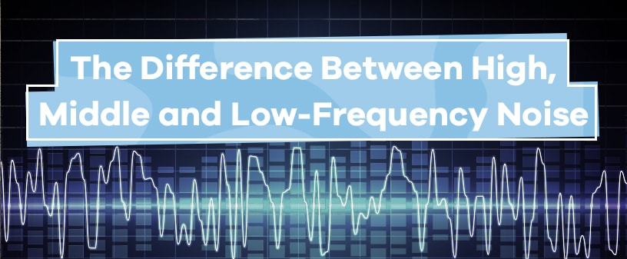

## Intensity (db / power)

* Intensity describes the amplitude (height) of the wave.

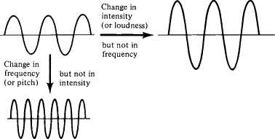

## Sample Rate

* Sample rate is specific to how the computer reads in the audio file.
* Think of it as the "resolution" of the audio.

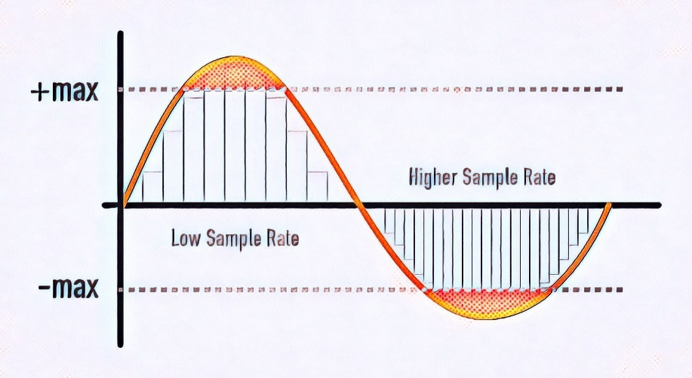

linkcode

# **Reading in Audio Files**

There are many types of audio files: mp3, wav, m4a, flac, ogg

1.Working

* Audio Loading and Visualization:

The code utilizes the **librosa** library to load an audio file in MP3 format.It displays an audio player with specific parameters such as the sampling rate using **IPython.display.Audio**. Additionally, it provides visualizations of the raw audio waveform and spectrogram using **librosa.display**.

* Audio Processing:

The code demonstrates basic audio processing techniques, including trimming leading/lagging silence from the audio signal. It utilizes **librosa.effects.trim** to remove silent parts from the **audio. Furthermore**, it showcases zoomed-in views of the trimmed audio waveform.

* Spectrogram Visualization:

The module generates a spectrogram of the audio signal to visualize its frequency content over time. This visualization aids in understanding the spectral characteristics of the audio signal.

* MP3 Compression:

The **pydub** library is employed to perform MP3 compression on the audio file. The code specifies a target bitrate (64k) for compression to achieve the desired file size reduction. The compressed audio is exported to a new MP3 file, and the resulting file is downloaded for further use.Overall, the audio compression module provides a comprehensive set of functionalities for loading, processing, visualizing, and compressing audio data. It serves as a valuable tool for enhancing efficiency and user experience in DTH-related projects by reducing file sizes while maintaining acceptable audio quality.

2.Benefits:

* **Enhanced Audio Understanding:** Visualizations provide a clear picture of the audio's frequency spectrum, helping to understand its content.
* **Potential Emotion Analysis:** Extracting emotional cues from audio can have applications in fields like music recommendation systems or sentiment analysis.
* **Efficient Storage and Transmission:** Compression techniques reduce file size, facilitating storage optimization and faster transmission.

3.Applications:

* Audio editing and mixing
* Music genre classification
* Speech recognition and analysis
* Audio forensics
* Development of audio compression algorithms

4. Code Submission (GithubLink)  : https://github.com/MandalaSandeep16/Audio-Visuvalization-compression.git

5.Result and Analysis:

The audio compression module successfully loads, processes, visualizes, and compresses audio data using Python libraries such as Librosa and Pydub.The module efficiently trims leading/lagging silence from audio signals and generates visualizations of audio waveforms and spectrograms.MP3 compression is applied to reduce the file size of audio files while maintaining acceptable audio quality. 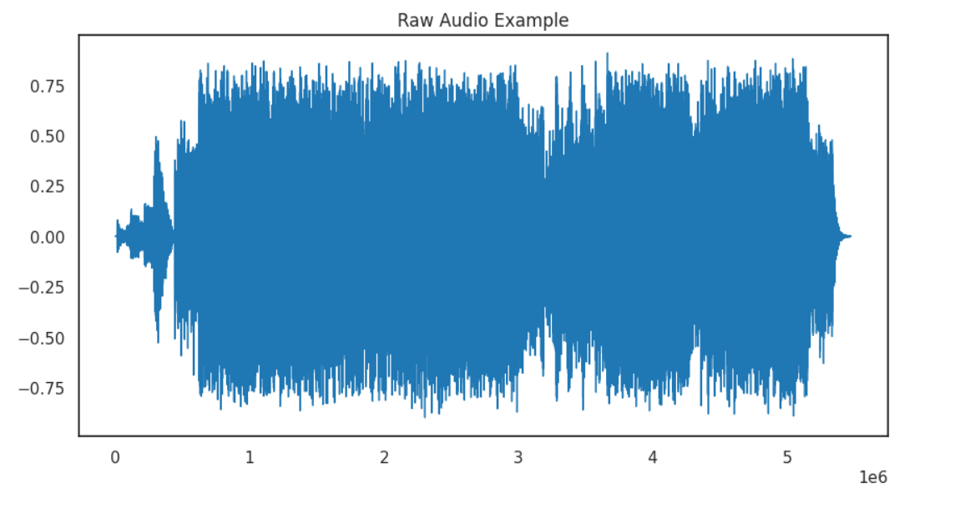

Visualizations of audio waveforms and spectrograms provide insights into the temporal and spectral characteristics of the audio signals.MP3 compression effectively reduces the file size of audio files, making them suitable for efficient storage and transmission.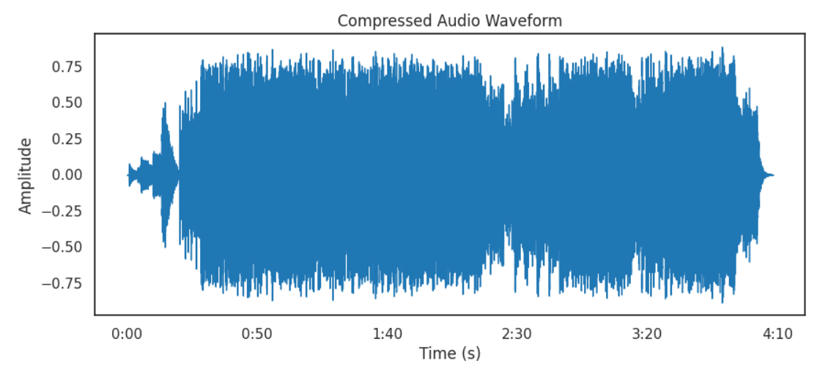

The choice of a target bitrate for MP3 compression influences the trade-off between file size reduction and audio quality. Lower bitrates result in smaller file sizes but may lead to perceptible loss of audio quality.

6.Conclusion

The audio compression module demonstrates the capabilities of Python libraries for audio processing and compression. It offers a versatile solution for various applications, including Direct-to-Home (DTH) services, where efficient storage and transmission of audio content are essential. By leveraging the module, users can efficiently manipulate and compress audio data, thereby enhancing user experience and optimizing resource utilization.

7.Future Work

Integration with streaming services: Extend the module to support real-time audio compression for streaming services, enabling efficient delivery of audio content over the internet.

Advanced compression techniques: Explore advanced audio compression techniques beyond MP3, such as AAC, Opus, or FLAC, to achieve higher compression ratios without significant loss of audio quality.

User interface enhancements: Develop a user-friendly interface for the audio compression module, allowing users to interactively adjust compression parameters and visualize compression results. Performance optimization: Optimize the performance of the module for large-scale audio datasets and real-time processing scenarios, ensuring efficient utilization of computational resources.

8.My Learning:

Through this project, I gained valuable insights into audio processing using Python. I learned how to effectively load, process, and visualize audio data using libraries such as Librosa and Matplotlib. Additionally, I explored techniques for compressing audio files, enabling efficient storage and transmission. This project also provided me with hands-on experience in applying basic audio processing techniques to enhance user experience in audio-related projects. Overall, it was a rewarding learning experience that deepened my understanding of audio processing concepts and their practical applications.