Classes and objects

* A class is a user-defined blueprint or prototype from which objects are created.
* **Class Definition Syntax:**

class ClassName:

# Statement-1

.

.

# Statement-N

* An Object is an instance of a Class.
* **self**

Class methods must have an extra first parameter in the method definition.

* __init__ method is used to initializing the object’s state.
* Constructors are used to initializing the object’s state.
* Types of constructors :

1. default constructor
2. parameterized constructor

* Destructors are called when an object gets destroyed.
* Polymorphism
* Encapsulation
* Abstraction

Inheritance in python

* Inheritance is, a class that inherits all the methods and properties from another class.

**Child class**

**Parent class**

* Properties:

1. It represents real-world relationships well.
2. It provides reusability of code.
3. It is transitive in nature.

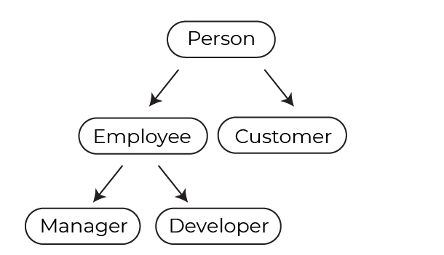

* Types of Inheritance:

1. Single Inheritance
2. Multiple Inheritance
3. Multilevel Inheritance
4. Hierarchical Inheritance
5. Hybrid Inheritance

* Single Inheritance:

When a child class inherits from only one parent class, it is called single inheritance.

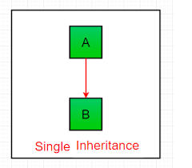

* Multiple Inheritance:

When a child class inherits from multiple parent classes, it is called multiple inheritance.

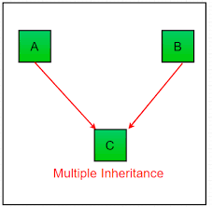

* Multilevel Inheritance:

When we have a child and grandchild relationship.

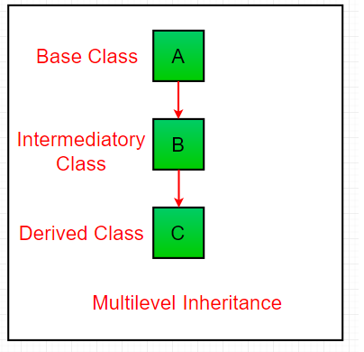

* Hierarchical Inheritance:

More than one derived classes are created from a single base.

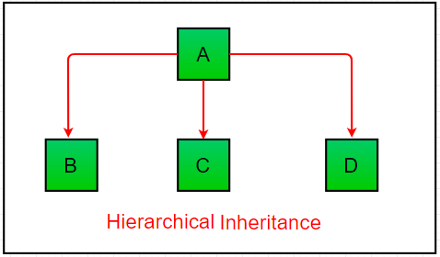

* Hybrid Inheritance:

This form combines more than one form of inheritance.

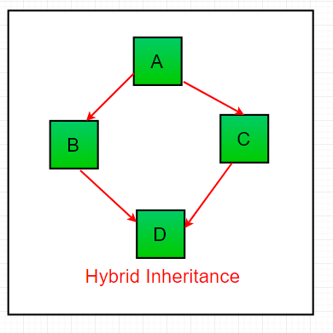

**School**

Student 2

Student 1

Student 3

**Super() Function:**

Super function allows us to call a method from the parent class.

Example-

Let’s take an example of animals. Dogs, cats and cows are part of animals. They also share common characteristics like –

* They are mammals.
* They have a tail and four legs.
* They are domestic animals.

**Method Overriding**

You can override a method in python

The functionality of the parent class method is changes by overriding the same method in the child class.