Test Protocol Execution Report

Run Summary
Goal | Search for 'Frontend Master' youtube channel
Start URL | https://youtube.com
Total Steps | 3
Status | FINISH
Started | 2026-09-22 05:28:36 UTC
Duration | 63.7s

Execution Steps
Step # | Action | Expected Result | Actual Result | Screenshot
1 | input combobox 'Search' → 'Frontend Master'  [URL: https://www.youtube.com/] | Type 'Frontend Master' in the search bar and search | Completed successfully | 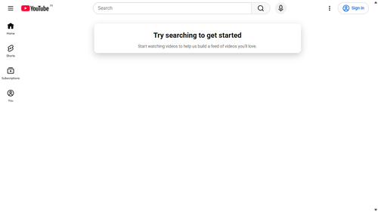
2 | press_enter combobox 'Search'  [URL: https://www.youtube.com/results?search_query=Frontend+Master] | Type 'Frontend Master' in the search bar and search | Completed successfully | 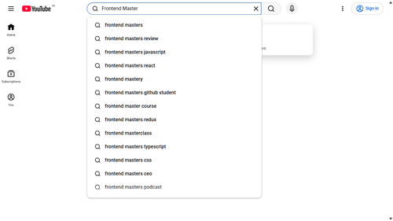
3 | goto → 'https://www.youtube.com/results?search_query=Frontend+Master&sp=EgIQAg%3D%3D'  [URL: https://www.youtube.com/results?search_query=Frontend+Master&sp=EgIQAg%253D%253D] | Search for 'Frontend Master' on YouTube | Completed successfully | 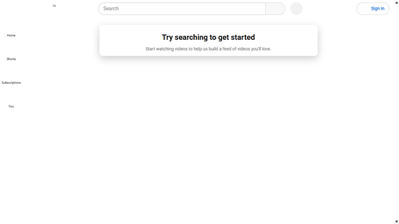

Generated: 2026-09-22 05:29:40 UTC

