____________________________________________

SIC One Pass Assembler

Group No : 15

Group Members :

-> Mandar Manohar Patade (19CSE1018)

-> Atharva Vijay Khade (19CSE1007)

__________________________________________________



________________________________________________________

Guide On How To Use The Code :

________________________________________________________

1] Open appropriate directory:

Open terminal of Windows/ Linux

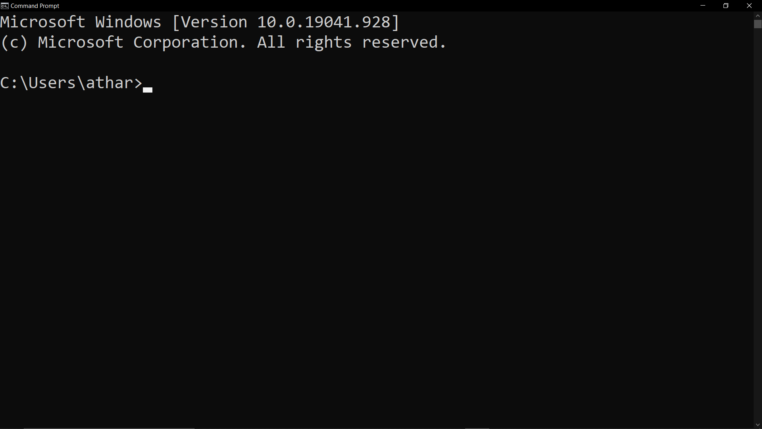

Move on to the correct path where program is stored

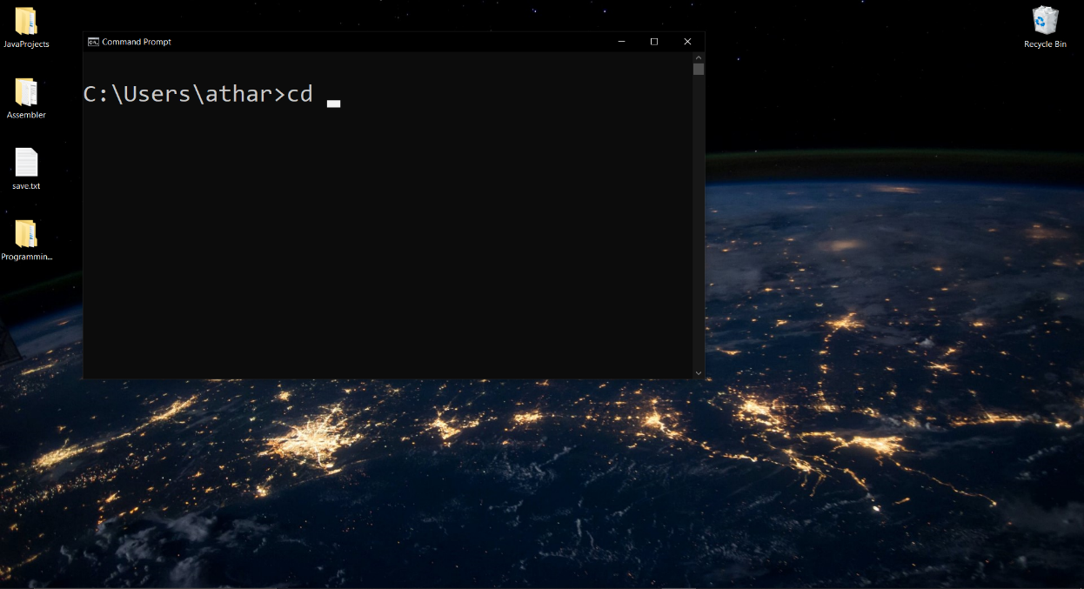

Select the file path given in the folder where the program is stored and use cd command to enter into that location as shown in to below pictures

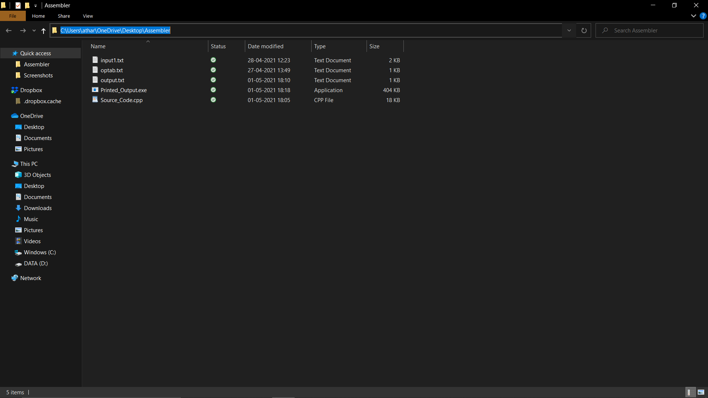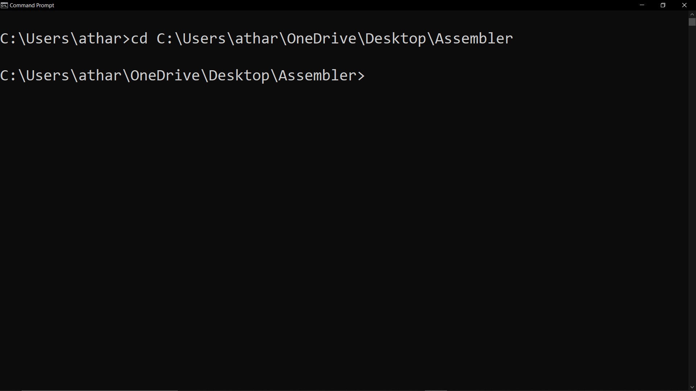

Now the file location is setup.

________________________________________________________

2] Compile the Program

________________________________________________________

Compile the program using the below shown line

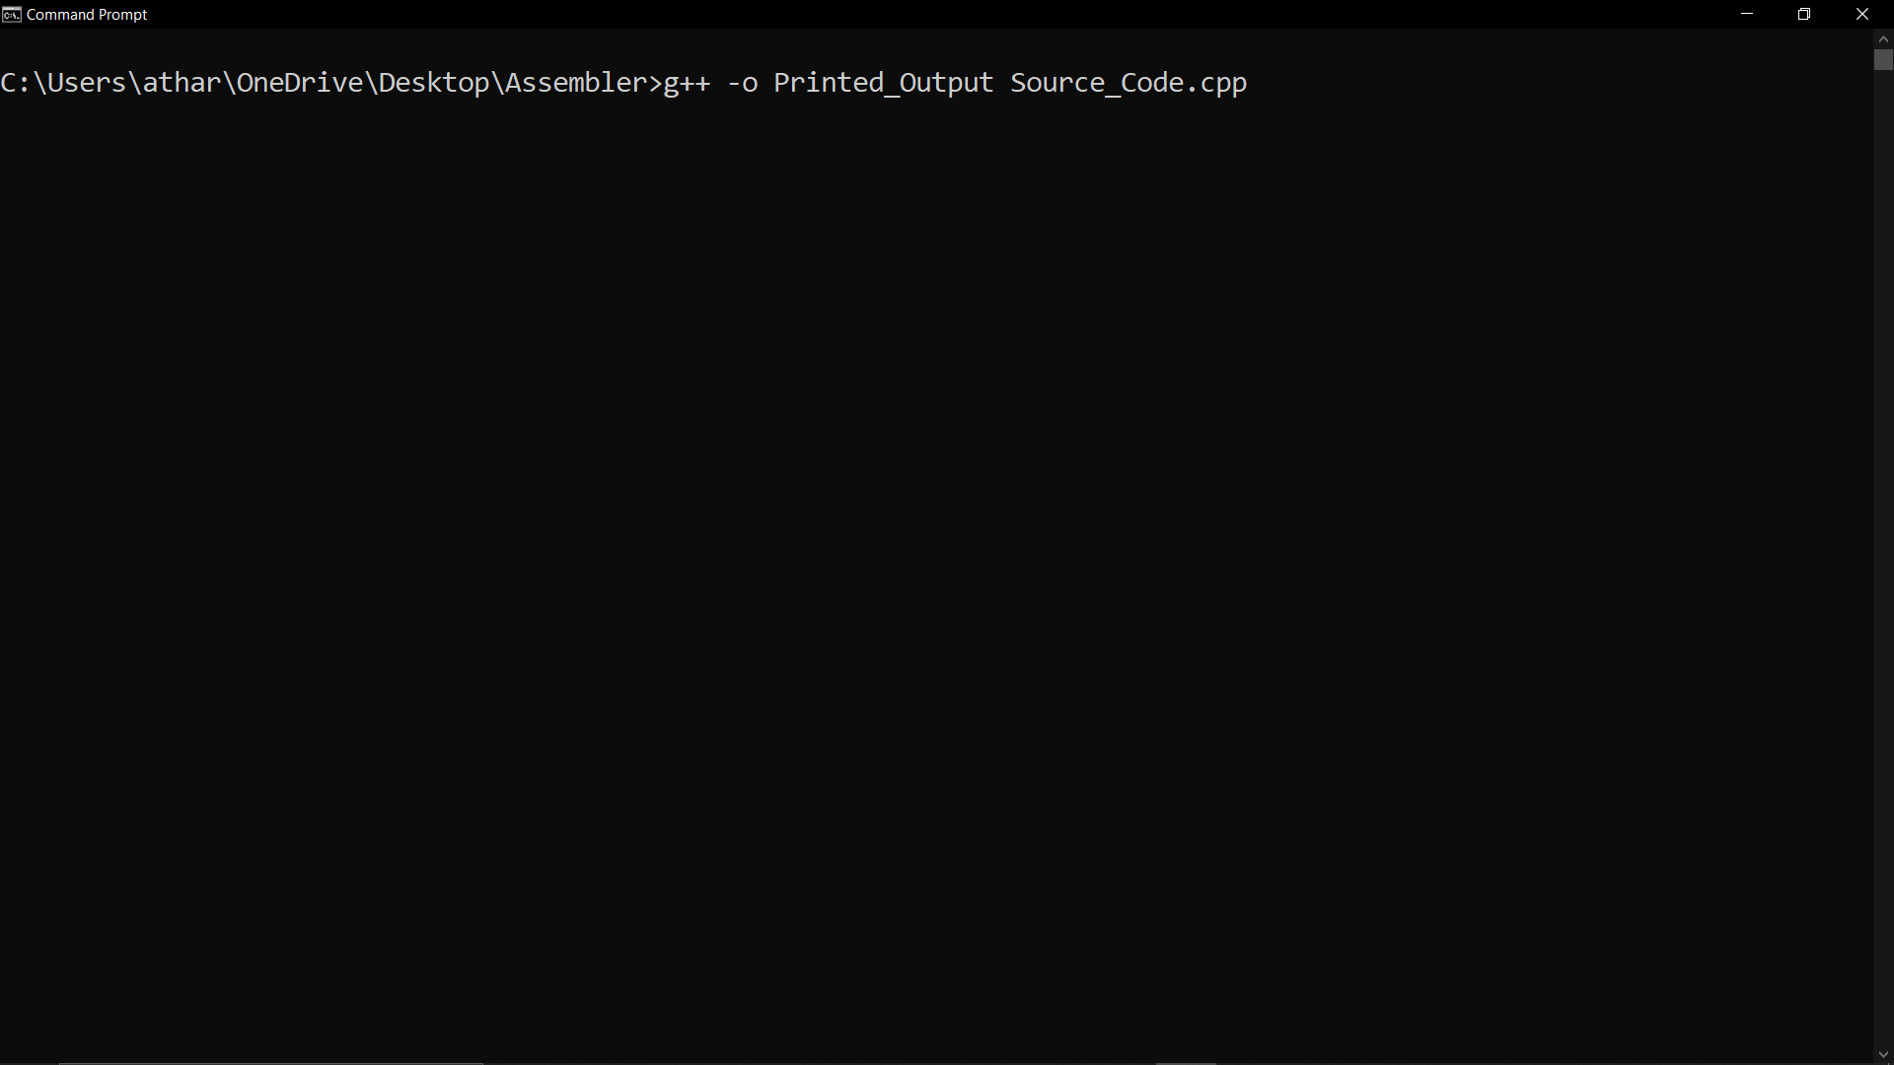

If compilation is successful :

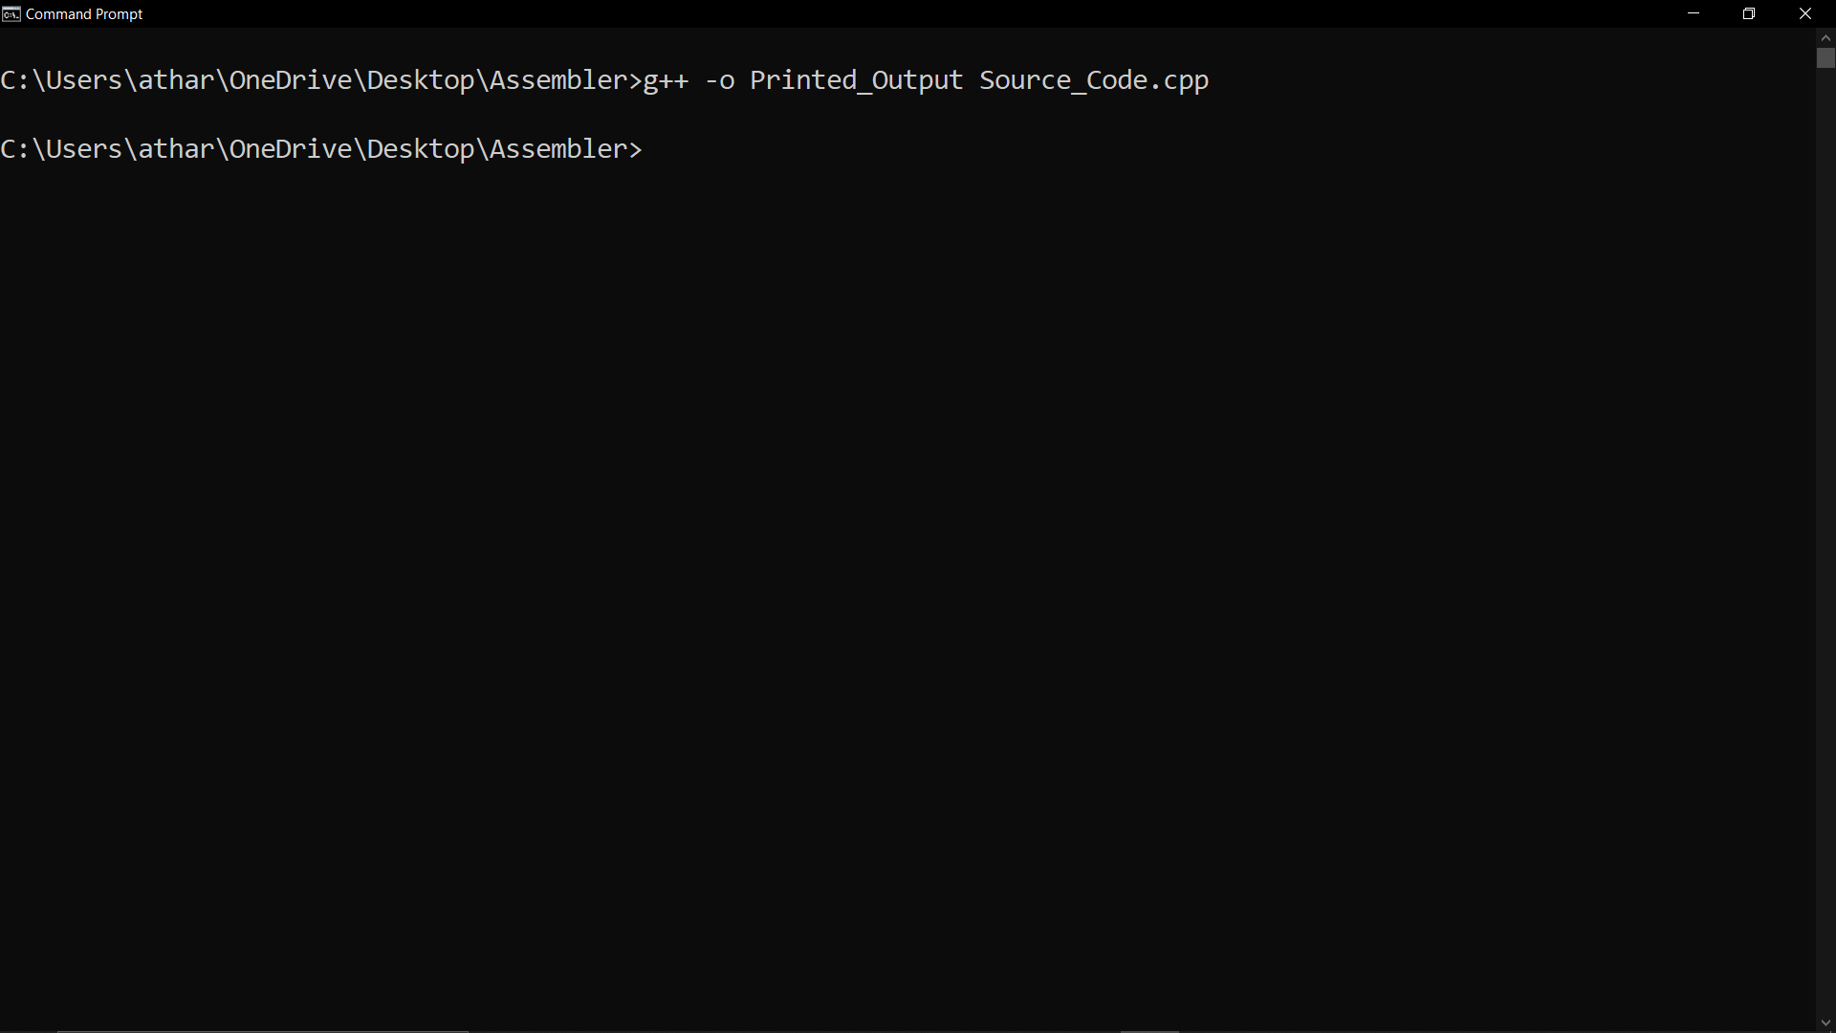

________________________________________________________

3] Running the Programming

________________________________________________________

Enter the commands shown below to run the program

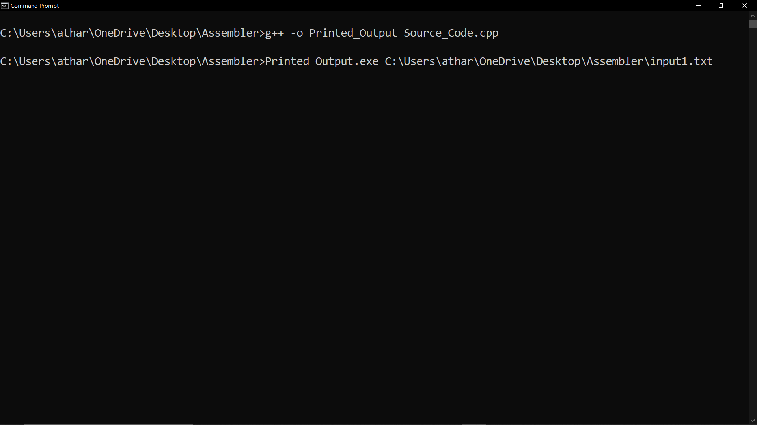

Syntax -> Printed_Output.exe <space> file_Path\input1.txt

If file path is appropriate we will get the output as follows :

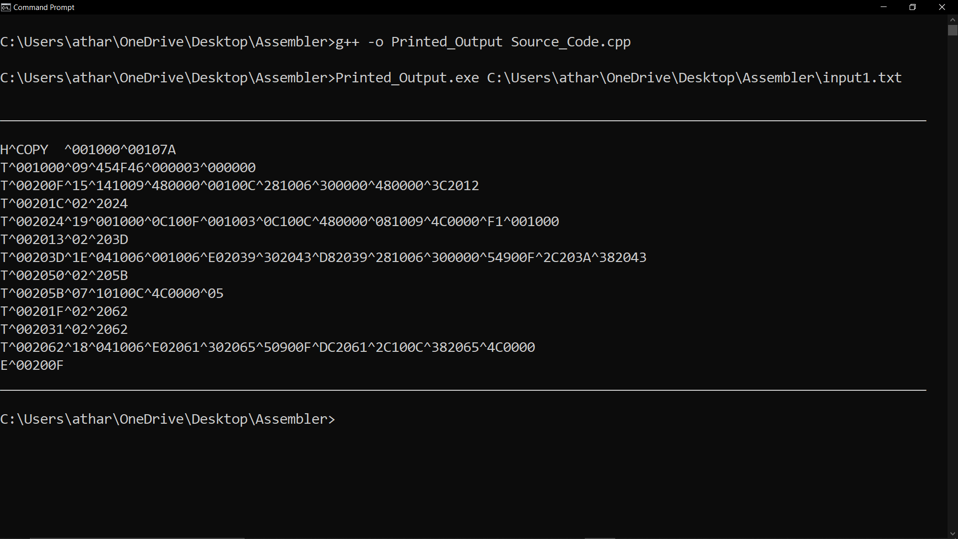

For the input file given as :

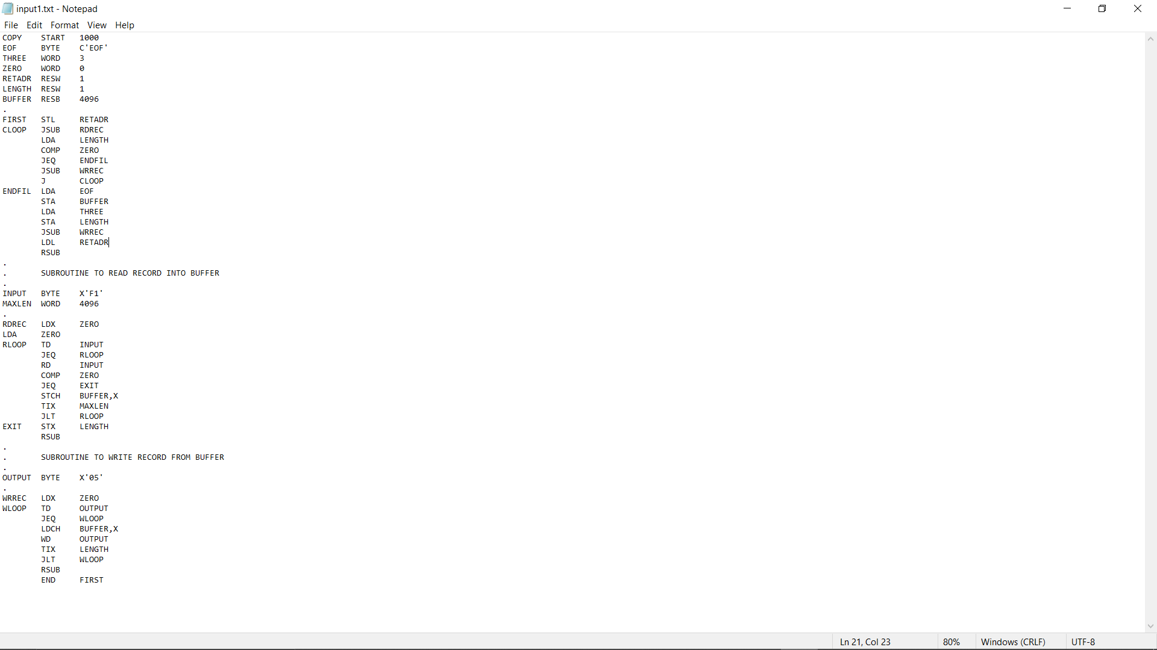

The output file is also updated with the object program corresponding the input1.txt file given as input

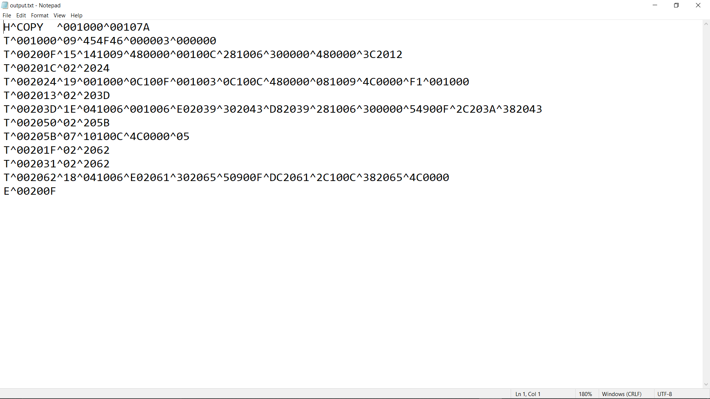

________________________________________________________

Thank You