iTAF Installation Manual
(Selenium 4.25.0\ Java 11 +\ Maven 3.9.6)
Document Version : v6.0
Date : 11/11/2025
Author: Mandar Rane
Email: Mandar.Rane@majesco.com




Confidentiality Statement
This document contains proprietary and confidential information and data of Majesco and Affiliates. This document is provided, on the express condition that such information and data will not be used, disclosed, or reproduced in any form, in whole or in part, for any purpose (other than solely for evaluation purposes by authorized representatives with a need to know), without the express written approval of Majesco. The right to use, disclose, and reproduce such information and data shall be governed by the service agreement between the client and Majesco.

Warnings and Disclaimer
The information provided is on an as is basis. Every effort has been made to make this book as complete and as accurate as possible, but no warranty or fitness is implied. The authors and the publisher shall have neither liability nor responsibility to any person or entity with respect to any loss or damages arising from the information contained in this book. Screenshots and data used within are for illustration purpose and may vary from the actual application.

Version Control
Version No. | Date | Author/Editor | Details of Change
0.1 | 28-07-2022 | Subhasis Pratihari | Template Format Change
0.2 | 02-08-2022 | Mandar Rane | Template updated
2.0 | 24-11-2022 | Mandar Rane | Eclipse version updated
3.0 | 02-01-2023 | Mandar Rane | Steps for SSL connectors updated
4.0 | 01-06-2023 | Mandar Rane | Updated confluence link, SVN plugins, SVN Connectors setup, project mapping
5.0 | 29-03-2024 | Mandar Rane | Document updated with Selenium 4 changes.
6.0 | 05-02-2025 | Mandar Rane | Document updated for access rights email id’s.
7.0 | 11-11-2-25 | Mandar Rane | Java version and email id’s updated

1. Introduction 6
1.1 Purpose 6
1.2 Scope 6
2. Knowing Your Automation Requirement 7
3. Java Version 8
4. iTAF Lite (Bat Version) 11
4.1. Prerequisites: 11
4.2 Installation Steps 11
5. iTAF Eclipse-Maven Version 15
5.1 Prerequisites: 15
5.2 Maven Setup 17
5.3 Eclipse Setup 18
5.4 Installing SVN Plugins 21
5.5 Installing SVN Connectors 25
5.6 Connecting to iTAF SVN Live Branch 30
5.7 Convert to Maven Project 33
5.8 Setting up JDK 35
5.9 Setting up Maven 38
5.10 Verify SVN connection 44
6. Monthly iTAF Release – SVN Update Process 46
7. Performing Maven Build 48
8. How to run a test pack using iTAF developer version 52
8.1 Setting up the WebDriver 52
8.2 Initiate the automation run in Debug Mode 58
8.3 Initiate the automation run in Run Mode 59

Introduction

This document is a step-by-step guide to install iTAF (Insurance Test Automation Framework) with Selenium 4 on to the user’s machine. The previous version of iTAF supported Selenium 3.15.

1.1 Purpose

This user manual is intended for business and end users to understand the process of installing the new iTAF framework, which supports Selenium 4, using Eclipse, Maven, SVN, and the batch file version on their machines. It will guide you step by step without requiring any technical dependencies.

1.2 Scope

- This document is targeted towards the end users to install iTAF on their respective machines without any technical assistance.
- Any minute technical specification of the framework scripting is out of scope.

View the document in Navigation pane to understand the section references.

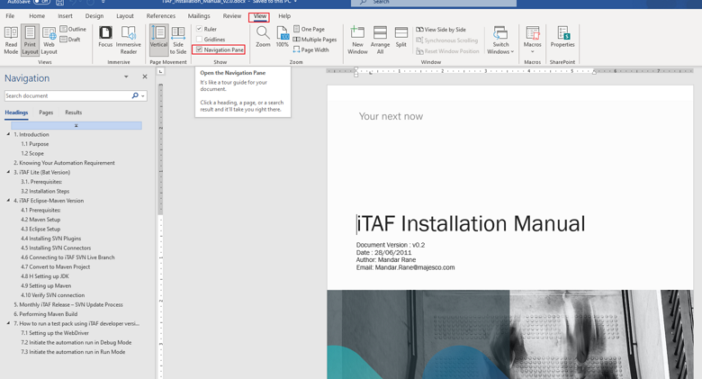

Knowing Your Automation Requirement

Which iTAF version do I require?...

Let’s simplify this, iTAF Framework has two versions.
- iTAF Lite (Batch File Version).
- iTAF Developer Version (Eclipse-Maven).

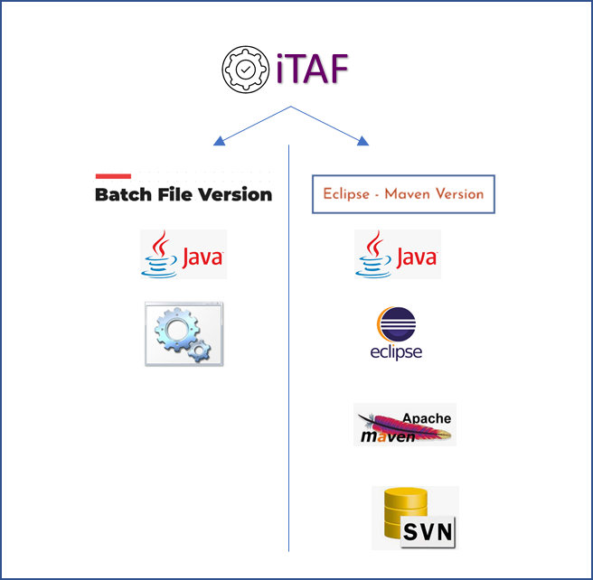

iTAF Lite is a ready-to-use package where the user only needs to download the zip version of iTAF and start test execution immediately. We’ll look at this in detail in the next section.

On the other hand, the developer version requires configuration of Eclipse and Maven. This version is primarily used by automation testers to debug issues and modify or enhance the code if necessary. We advise you to review your requirements and then follow this document to set up either one or both versions.

Java Version
For iTAF - Selenium 4 version to work on your machine you are required to install Java version 11 and above. We are currently restricting the version till Java 17.

If you have admin rights on your machine you can delete the existing Java version (1.8) from control panel. If you don’t have admin rights, raise a request with the IT helpdesk team and ask them to install java 11.

- Navigate to panel on your local machine\VM.

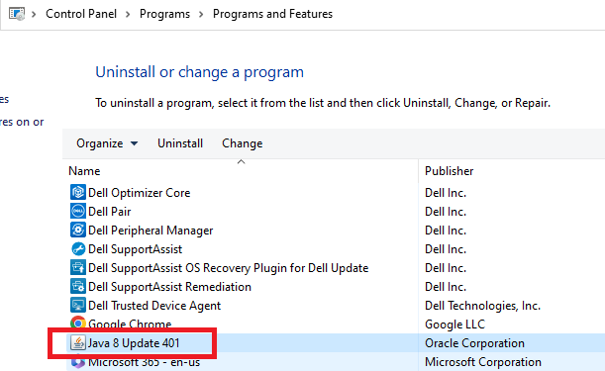

- Select all the Java 8 files (there can be multiple) and uninstall them one by one.
- Restart your machine once all the Java 8 files are uninstalled.
- Install Java 11 or above.
- Installation Link:

https://www.oracle.com/in/java/technologies/javase/jdk11-archive-downloads.html
Current latest version of Java 11 is Java SE Development Kit 11.0.21 (29/03/2024)

- Install the downloaded ‘jdk-11.0.21_windows-x64_bin.exe’ file.
- Run it as admin if you have admin rights.
- Keep all the parameters default and complete the installation.

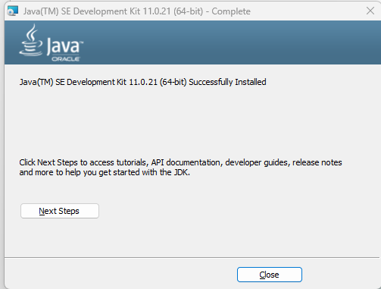

- Java 11 will show up in your control panel.

- Verify the Program Files path.
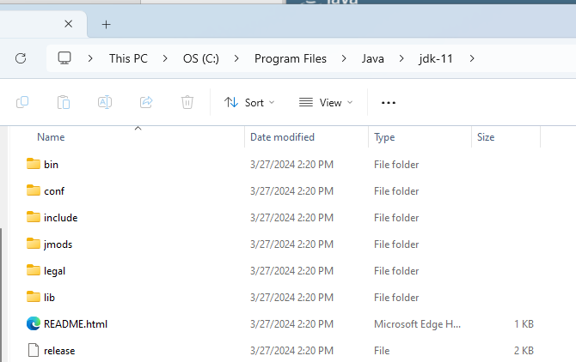

- Set the environment variables.
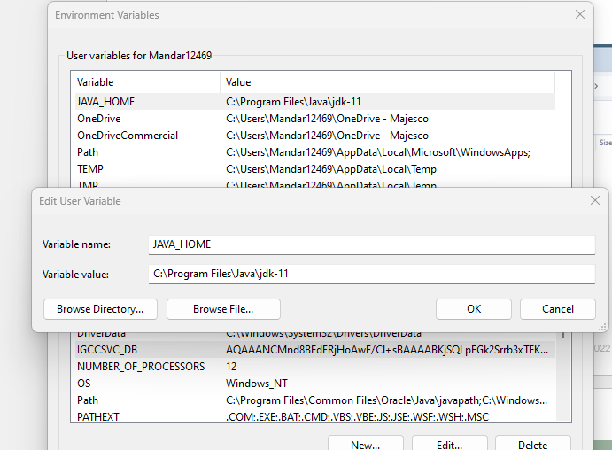

- Restart the machine.
- To check Java version in cmd use command: java -version.
- To check set java path in cmd use command: echo %JAVA_HOME%.
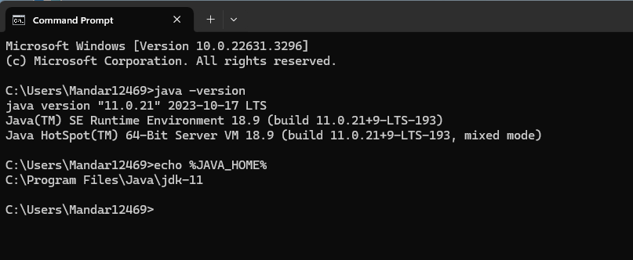

iTAF Lite (Bat Version)
This is the zip version of iTAF, where you only need to run the 'startiTAF.bat' batch file. This batch file invokes the framework and triggers the test execution. We call it iTAF Lite because it doesn't require downloading the source code onto the local machine or setting up Eclipse and Maven. This approach avoids the need to share the source code and connect to iTAF – Majesco SVN. This version is mostly recommended for SI partners and other Majesco clients.

You should consider this version mainly:
- If your requirement is to only execute or run test packs.
- To schedule nightly runs using windows scheduler.
- To schedule nightly runs using Jenkins.
- Running iTAF on Clients and SI partner machines.

4.1. Prerequisites:
- Java Version 11 or 17 (covered under section 3: Java Version).
- Set JAVA_HOME path under environment variables for User Profile (covered under section 3: Java Version).
- iTAF Automation ready test pack obtained from the product teams (Billing, PAS, Claims, DM etc).

4.2 Installation Steps

- Download the iTAF Lite version from the below given confluence link.
- iTAF-Fall'25 Update 1 - Toolkit Knowledge Base - MJ Confluence
- Start of every month you will see a new iTAF version. We suggest you always pick the latest one.
- Click on the ‘HERE’ link as shown below.
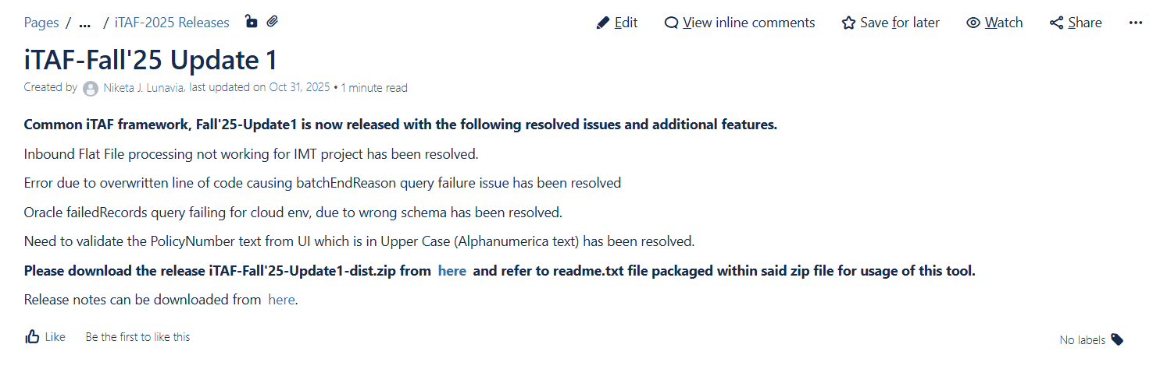

- When you click on the Zip folder it will start to auto download.

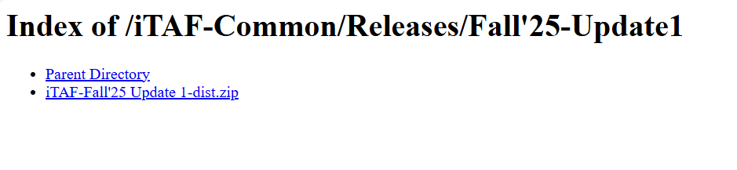

- Extract the Zip Folder
- You can copy this folder on to any of your drives.

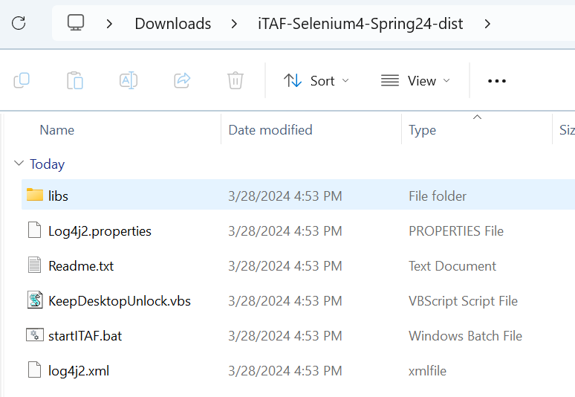

- Now add/paste the Test pack folder shared by your relevant product/project team.
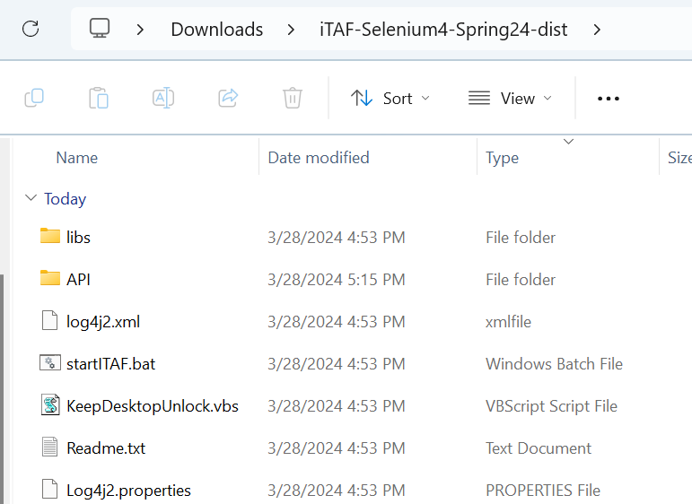

- The Folder structure within the project folder will appear as shown below (Can differ in case of PAS, Claims). Below given is the folder structure for Billing.
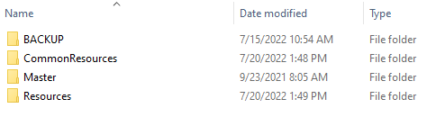

- Now right click on the ‘startITAF.bat’ file and select edit in notepad.

- Here you will have to pass the path of the test pack that you must execute. In the below example its ‘API\CommonResources\Config.xls’. Also, make sure to pass the parameter in the end as per your product SILO (Pas, Billing, Claims, DM, LNA, DS, GB, CS). Post making the changes close the file.

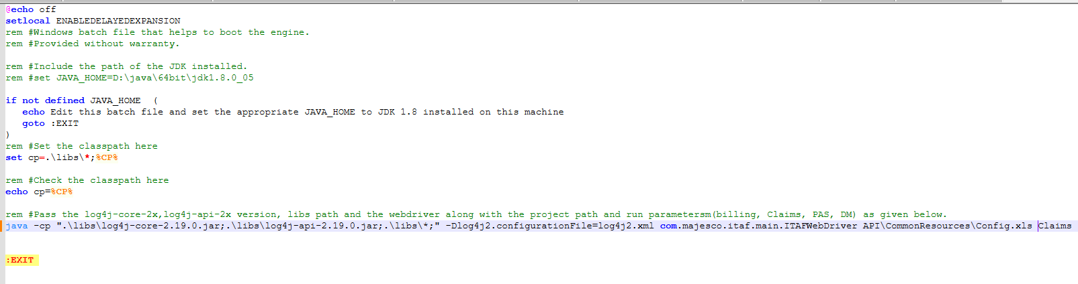

Make sure to pass the parameter at the end (example – Claims) and double check the config version (xls\xlsx).

E.g. API\CommonResources\Config.xls Claims

- Lastly set the start pointer in the Mainctroller.xlsx file and make sure the config path is set correctly in the Config.xls\xlsm.

- Now double click on the ‘startITAF.bat’ file and the test execution will commence. A cmd window will appear that will keep displaying the execution logs.

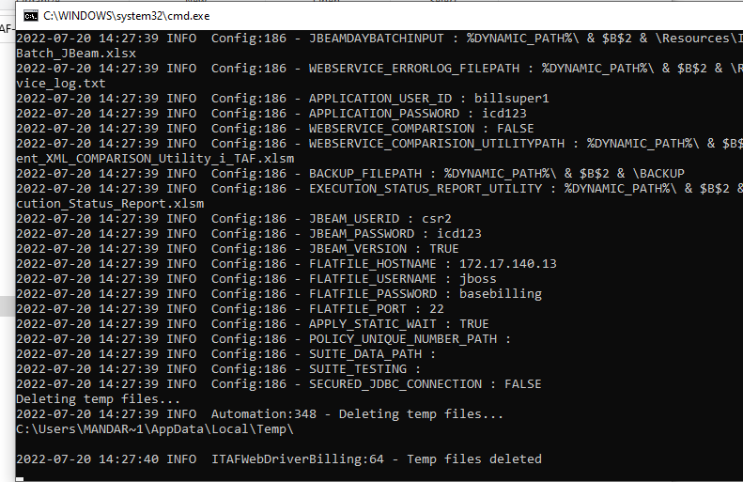

- You can also refer to the Readme.txt for detailed steps.

iTAF Eclipse-Maven Version
This version of iTAF is also known as the 'Developer Version' because it enables users to access the source code, modify, and enhance UI screens according to project requirements. It is widely used for scripting new UI screens or modifying existing ones. Automation testers run this version of iTAF through Eclipse in debug mode, allowing them to test new screen navigation. Basic XPath changes or failures in test runs can be debugged using this version. It gives testers the freedom to explore the framework and understand its workings in detail.

You should consider this version mainly:
- To run test packs, script new screens, modify the code and add new features.
- To understand iTAF working and code flow.
- To analyse failures, debug the issues and fix them.

Prerequisites:
- Java Version 11 or 17.
- Set JAVA_HOME path under environment variables for User variable.
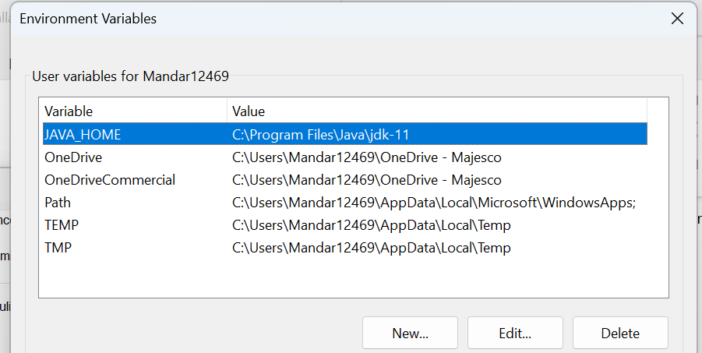

- iTAF Automation ready test pack obtained from the product team (Billing, PAS, Claims, DM).
- Drop an email to mandar.rane@majesco.com,
- CC -Niketa.Lunaviai@majesco.com for access rights to iTAF SVN Live Branch.

Live Branch Link:
https://ind-mhp1v65lnx06.majesco.com/svn/ToolsRepository/ICD/Tools/iTAF/Branches/iTAF_Live_Branch_Selenium4

Email Example:

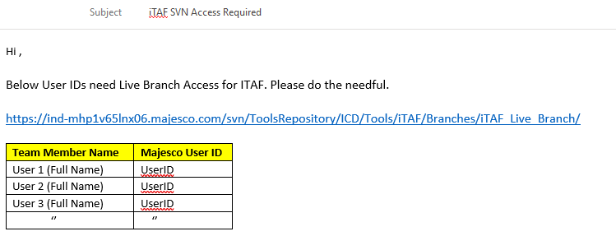

- Enter the below given SVN IP Address in your host file.

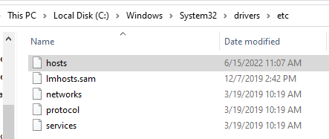

#SVN Toolkit Hostname
172.16.246.178 ind-mhp1v65lnx06.majesco.com

- Active VPN connection for Majesco Employee and VDI for SI partners.

5.2 Maven Setup

Follow the below given steps to install Maven on your machine.

- Copy the ‘apache-maven-3.9.6.zip’ from the below given location.
https://ind-mhp1v65lnx06.majesco.com/svn/ToolsRepository/ICD/Tools/iTAF/MavenDownload

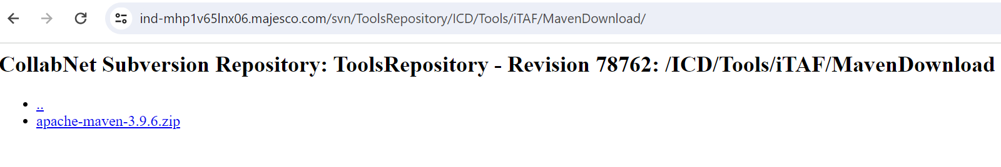
- Extract the Zip folder and save in you desired drive.

5.3 Eclipse Setup

Follow the below given steps to install Eclipse on your machine.

- Download any latest stable version of Eclipse.
Link: https://www.eclipse.org/downloads/packages/

Tested Version: 2023-12 (4.30) as of 29/03/2024.

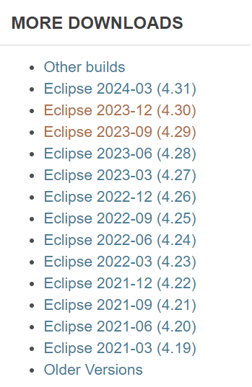
- Select the Eclipse IDE for Java Developers - Windows Option.

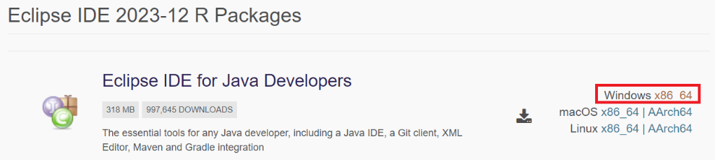

- Allow the download to complete.

- Extract the eclipse zip version to your local drive.

- Create a new workspace folder.

*For new laptops, if you are running iTAF on your local we suggest you create a new folder named ‘iTAF’ in your ‘C:\Users\XXXXX\iTAF’ and create the Workspace folder under it. For VM’s you can choose any of the drives apart from C.

e.g. C:\Users\Mandar12469\iTAF

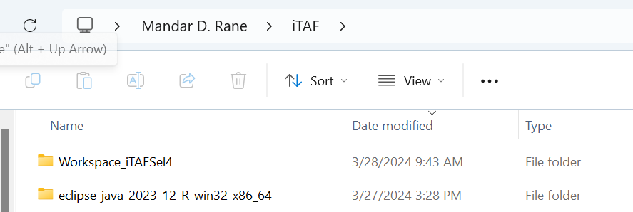

- Under your workspace folder create another folder where you will store all the test packs.
e.g., ‘Automation_Packs’

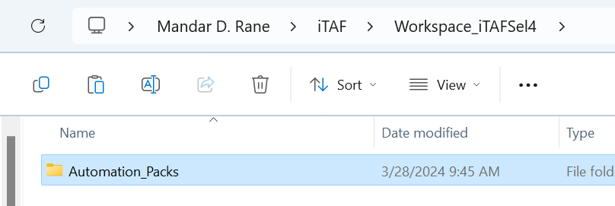

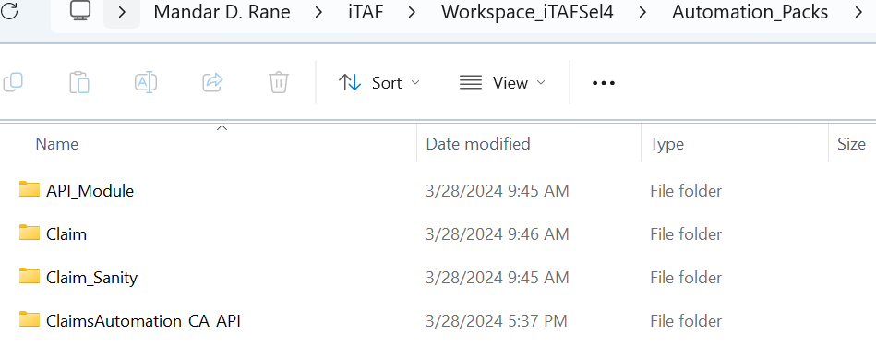

- Navigate back to the extracted eclipse folder and double click on the eclipse.exe.

- Now pass the newly created Workspace address in Eclipse and click on launch.
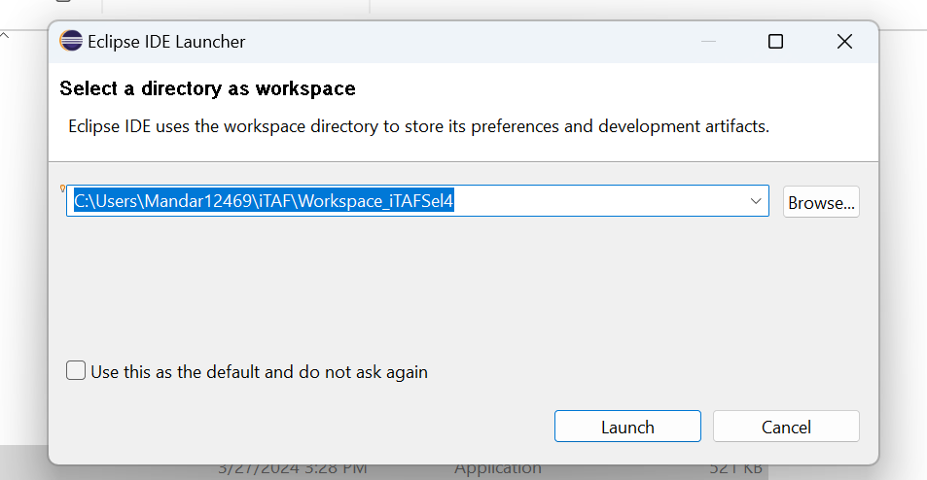

- Eclipse will now open on your machine, and you can verify the creation of a ‘. metadata' folder in your workspace.

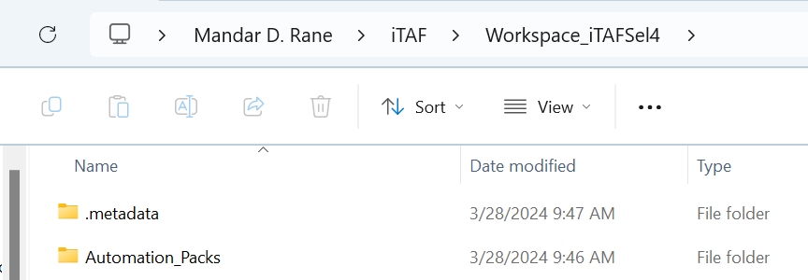

- Now close the welcome window.



5.4 Installing SVN Plugins

- Navigate to the Eclipse Marketplace as shown below.

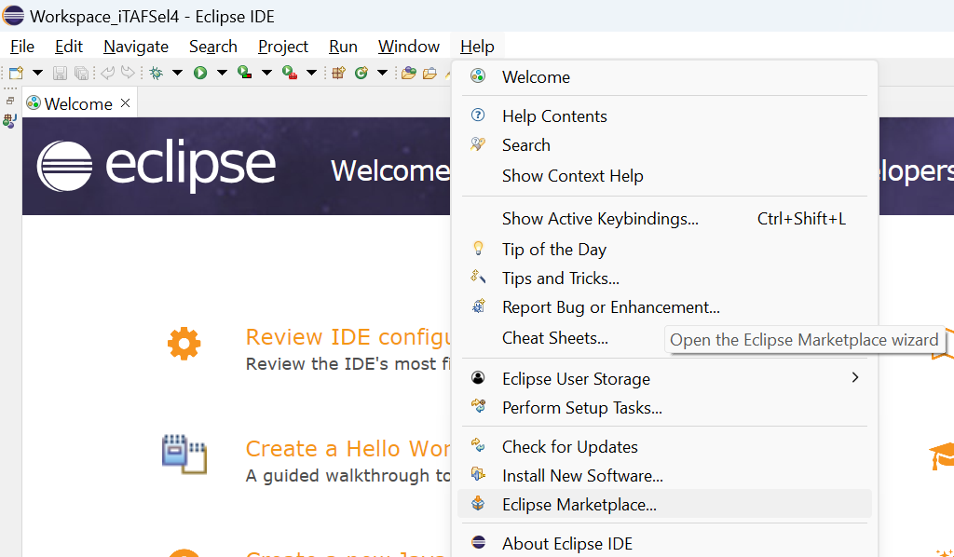

- Type SVN and click on go.

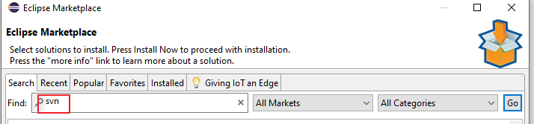

Note*: Post step 2 - If you are unable to connect to the marketplace and there are no results showing after clicking on the ‘Go’ button, you may want to check your network setting in eclipse.
Follow the below steps or directly move to Subversive-SVN plugin step if you can see the plugins.

Navigate to Windows – Preferences – Network Connections. By default, it is ‘Native’.

Try Selecting ‘Direct’ or ‘Manual’, any one of them should work.

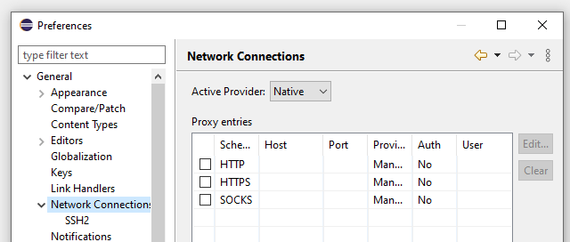

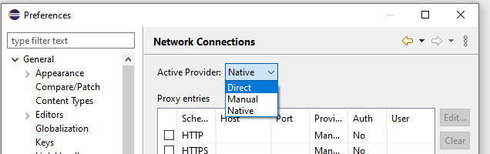

- Once you are connected to the marketplace, install the plugin shown below.

- Subversive - SVN Team Provider 4.8 (as of 29/03/2024). Version keeps on updating.
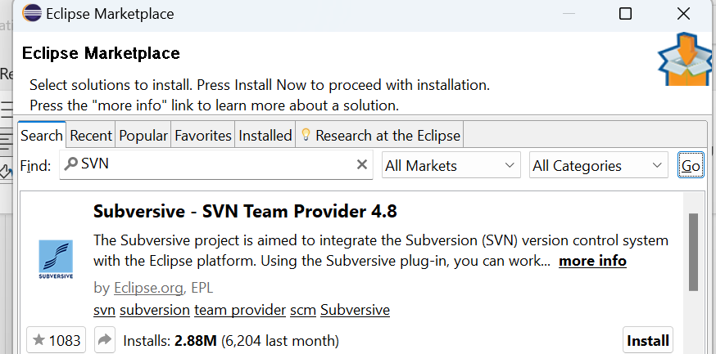

- Click on Subversive, select the first checkbox and click on confirm.

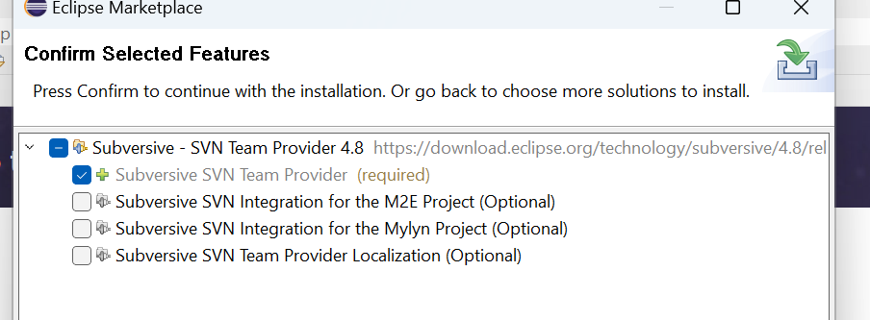

Installation will start, let it complete...

- Accept the License and Click on the Finish button.

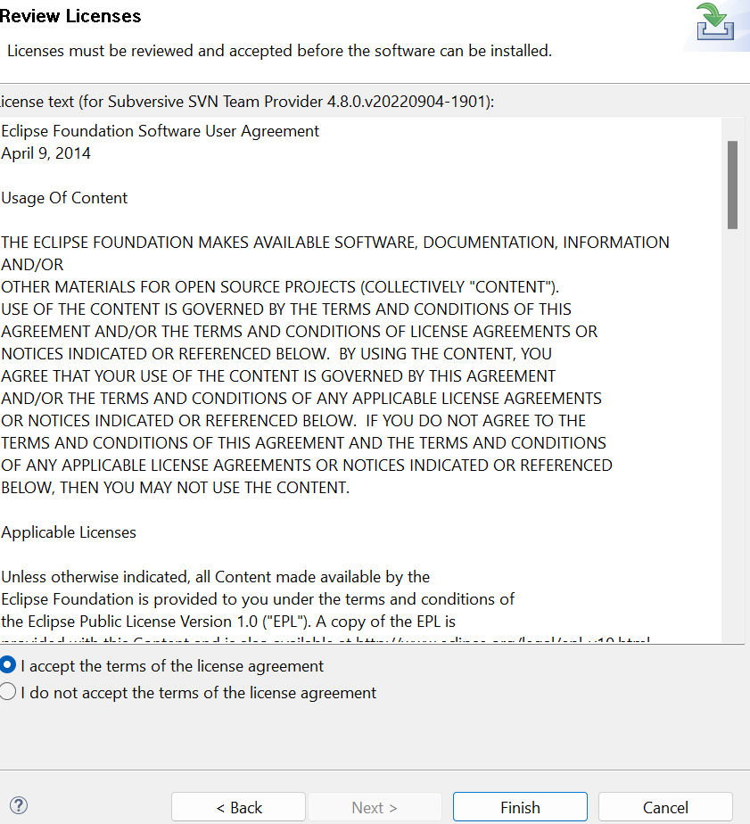

- Allow the installation to complete.

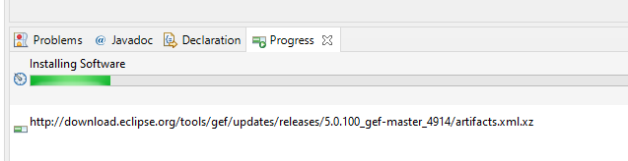

- If you get any other popups, click on Install anyway.
- Restart Eclipse.
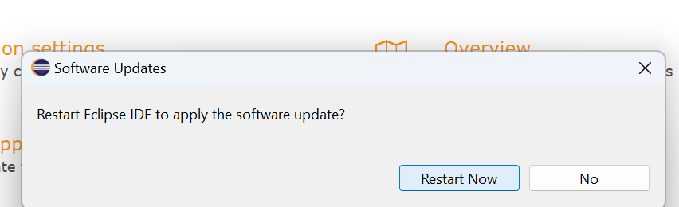

5.5 Installing SVN Connectors

- Navigate to help – Install New Software.
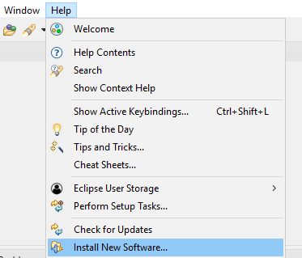

- Paste the below given link in the ‘Work With section and click on the Add button.
(https://osspit.org/eclipse/subversive-connectors/).

Enter any name and click on the Add button.
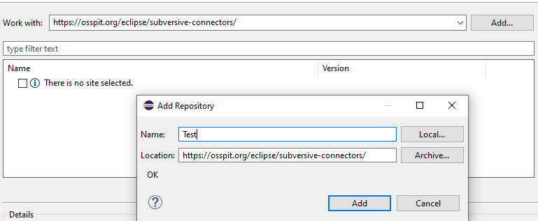

- Select all the checkboxes and click on the Next button.
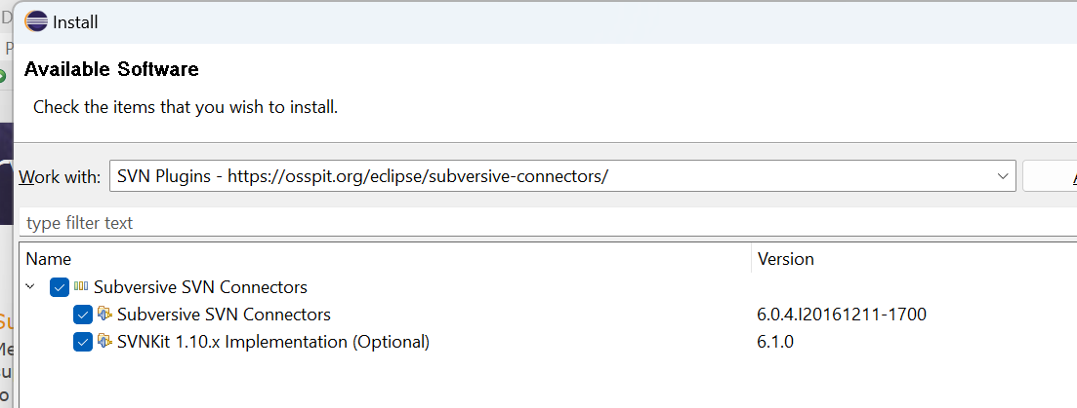
- Follow the process and click on the Finish button.

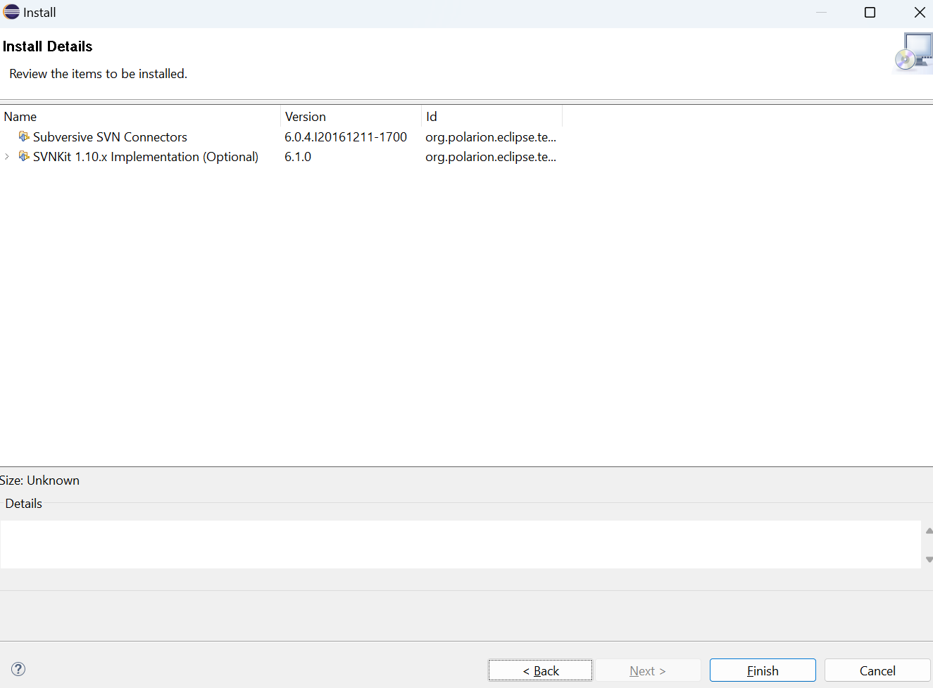

- You may get an additional window, follow the steps as shown below.

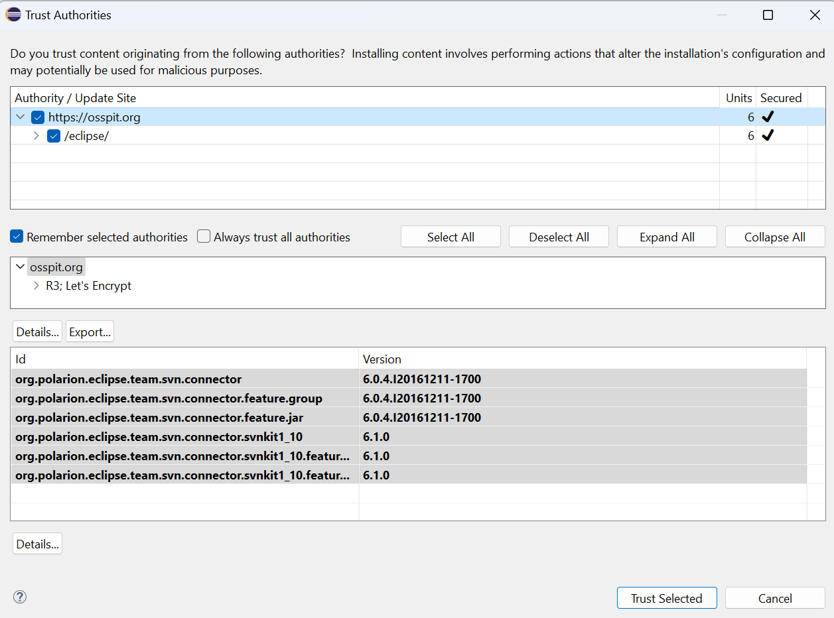

- Click on Yes, I Accept the Risk.

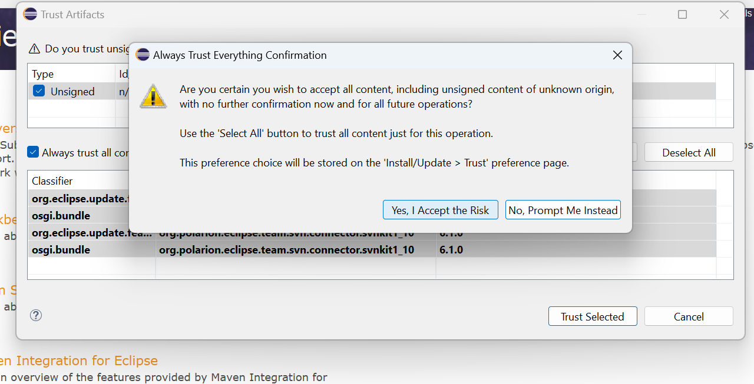

- Click on Trust Selected.

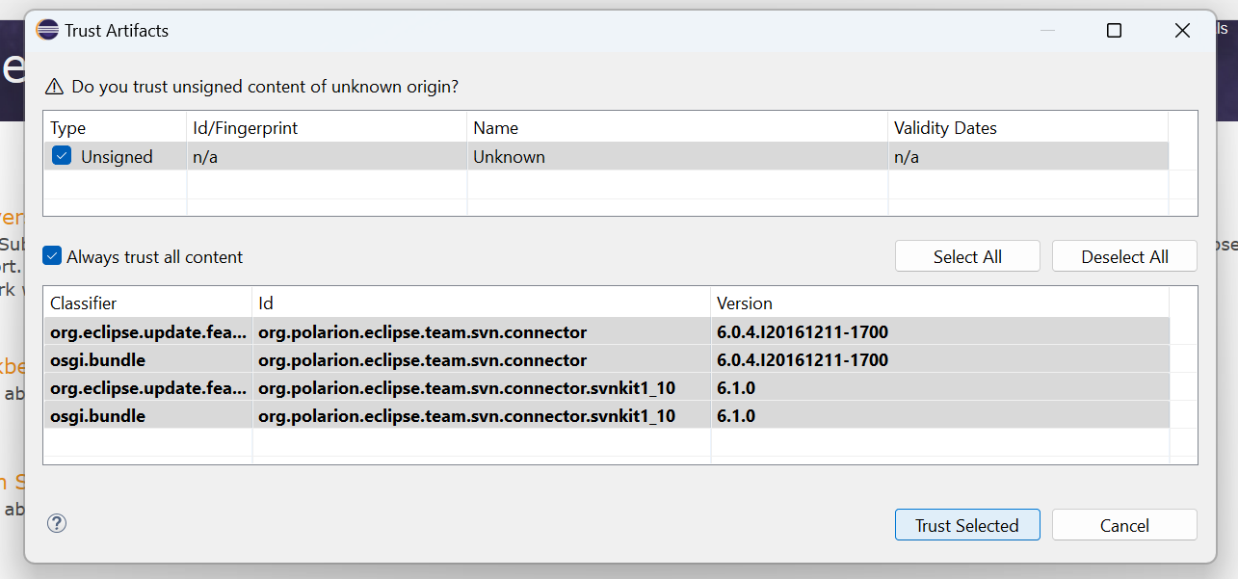

- Follow the flow and it will ask you to restart eclipse at the end.

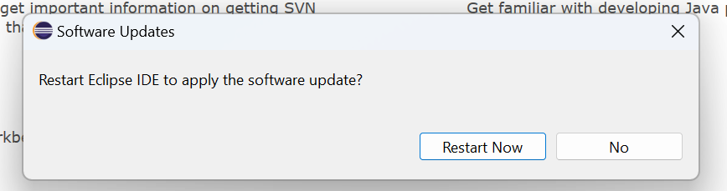

- Navigate to Windows – Preferences – Type SVN in the search box.

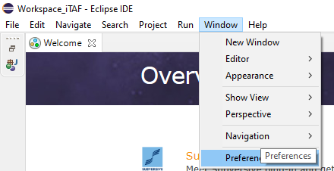

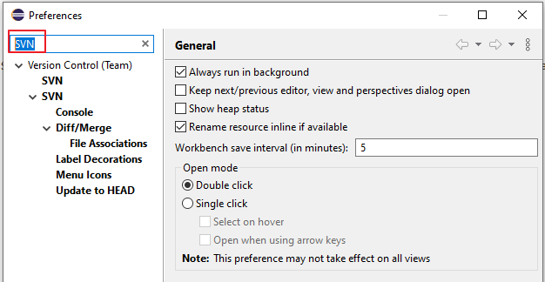

- Click on the first SVN option – SVN Connector tab – Click on Get Connectors.
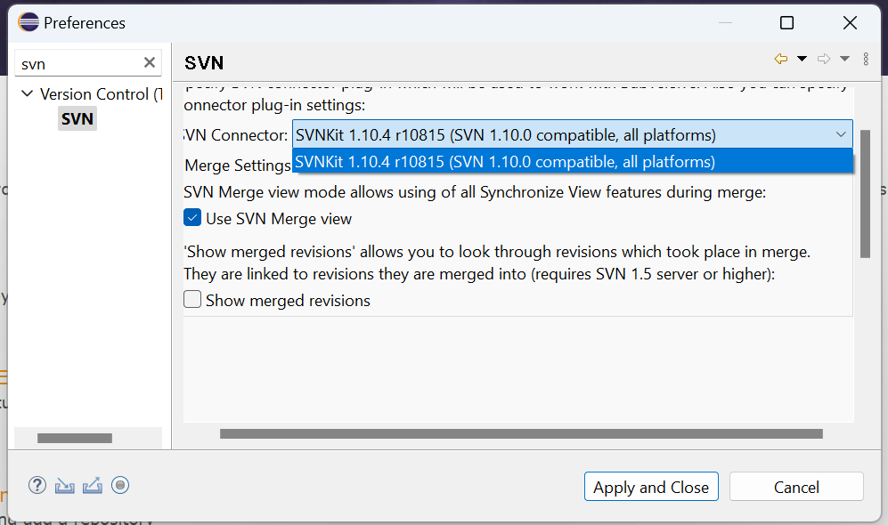
- Select SVN Kit and click on the Apply button.

- Follow the flow, select all the checkboxes, and click on Next.

- At the end it will ask you to restart Eclipse.

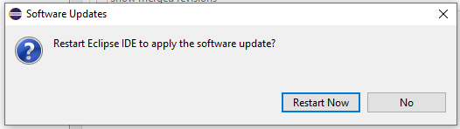

5.6 Connecting to iTAF SVN Live Branch

1. Once Eclipse restarts, click on the restore button.
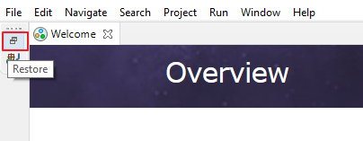

- Click on Import Project.
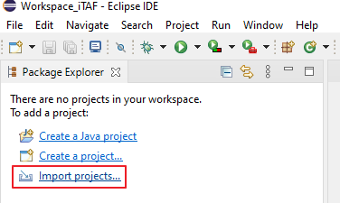

- Select Checkout Project from SVN option and click on Next.
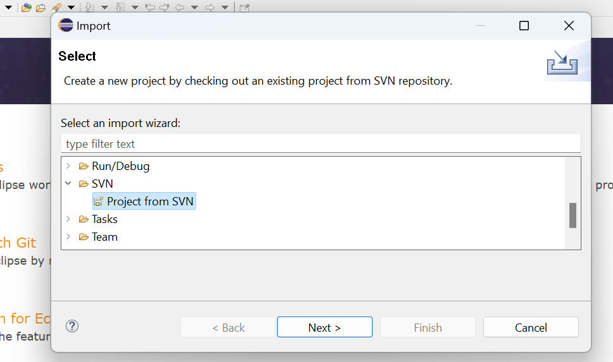
- Enter the Live Branch URL, use a custom Label, your credentials, save authentication and click on Next.

Live Branch Link:
https://ind-mhp1v65lnx06.majesco.com/svn/ToolsRepository/ICD/Tools/iTAF/Branches/iTAF_Live_Branch_Selenium4

You can connect to the iTAF SVN only if you have been given the access rights as mentioned in the prerequisites (5.1).

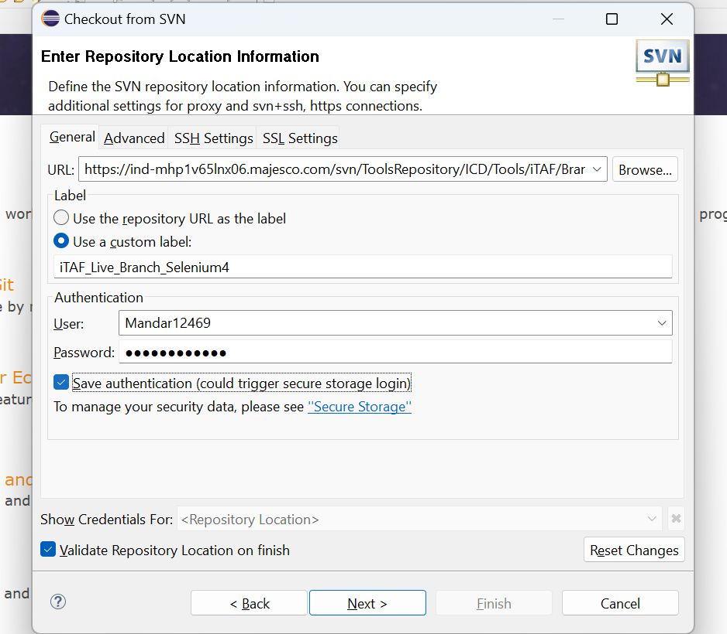

- Click on Next.
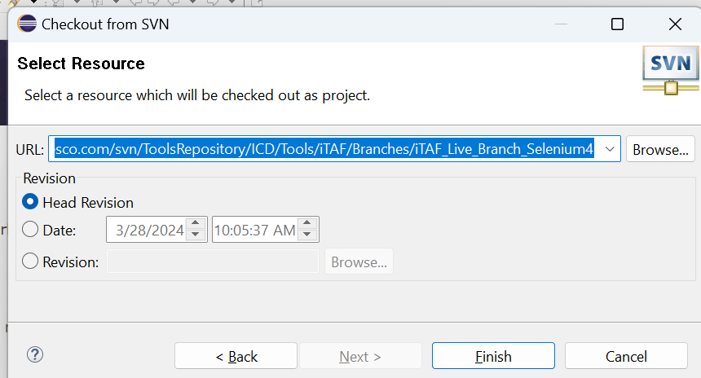

- Select the Option as given below and click on the Finish button.

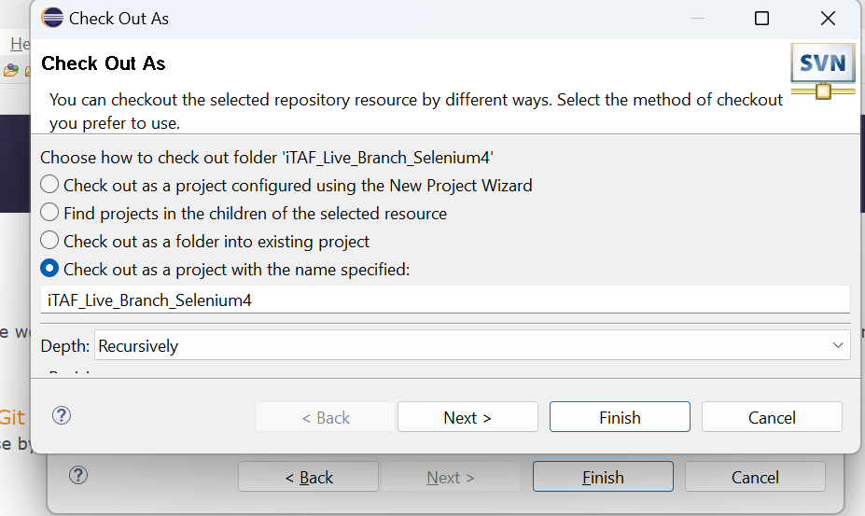

- Checkout process will begin.

- You will get the project under package explorer.

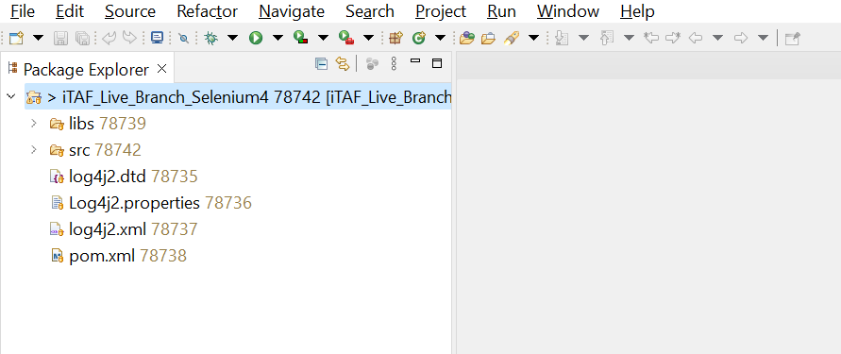

- You will now get to folders under your workspace folder.

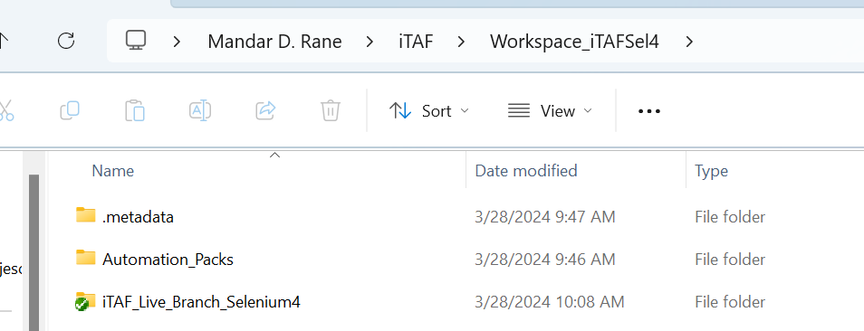

5.7 Convert to Maven Project

- 1. Right Click on the Project – Configure – Convert to Maven Project.

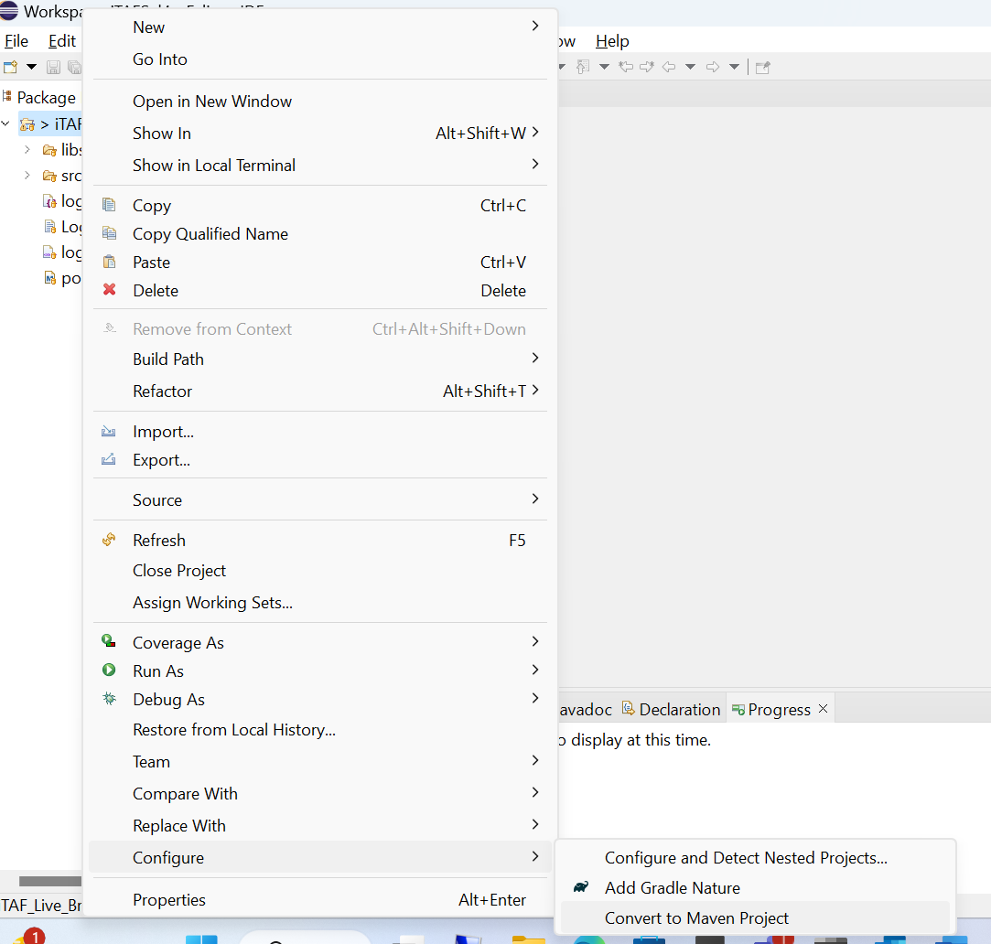

- This make take few minutes.

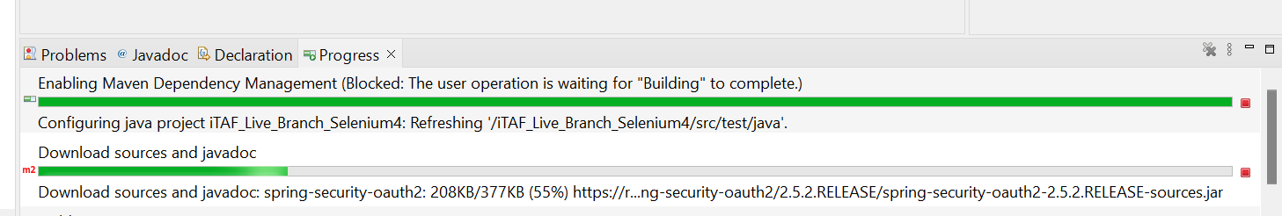

- Maven conversion is completed.

Note*: Post completion you may see few errors, ignore them at this stage.

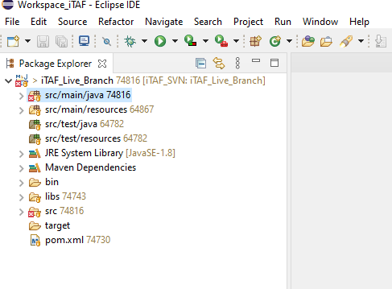

5.8 Setting up JDK

- Navigate to Windows – Preferences -Java – Compiler. Set the Complier to 1.8.
We are still testing compiler 11 and 17, until then use 1.8.

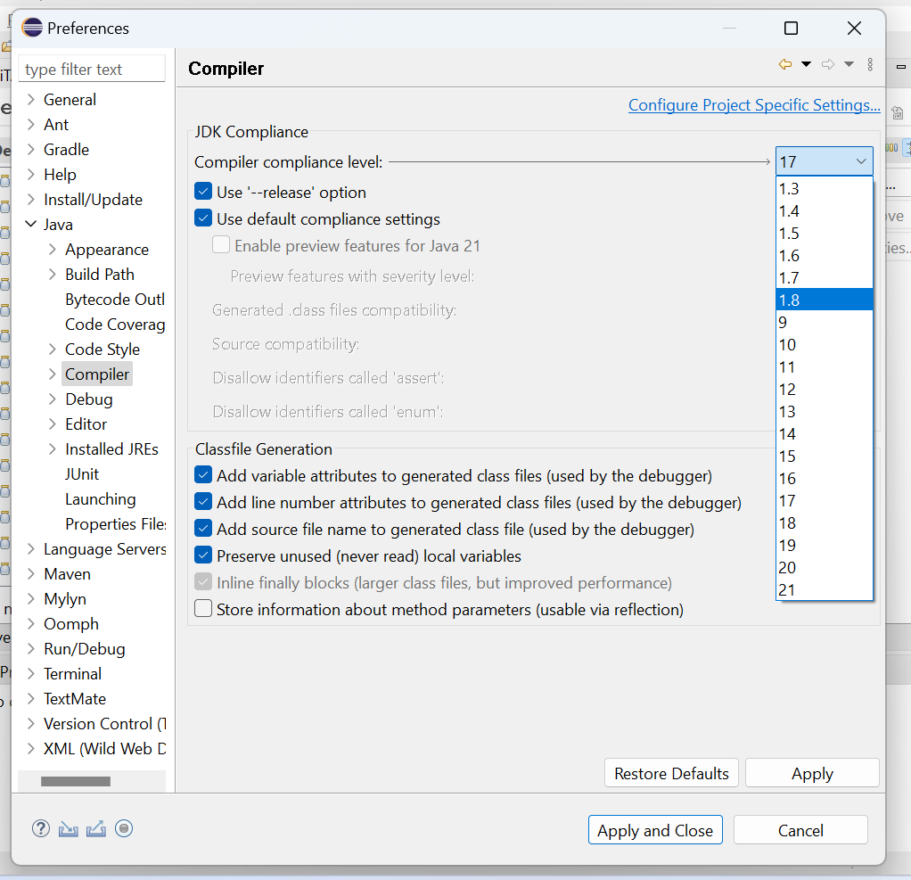

- Click on the Yes button.

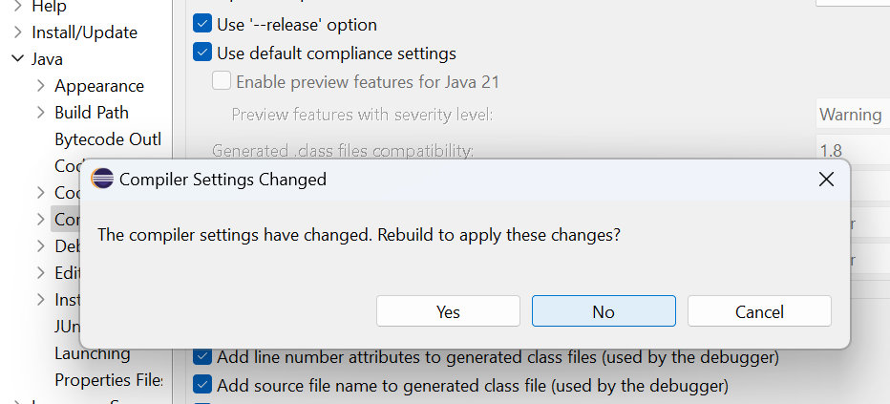

- Select ‘jre’ and click on the Remove button.

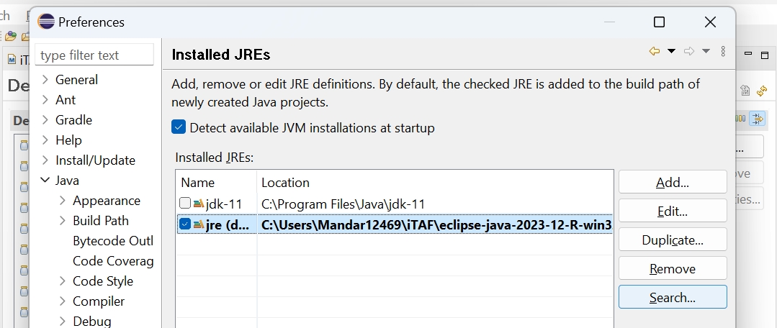

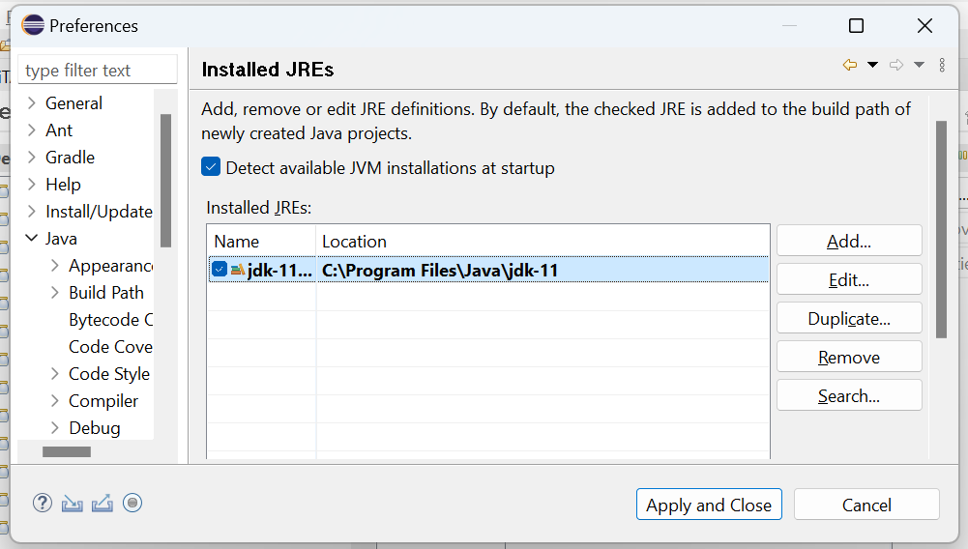

- Select the JDK entry and click on the Edit button. Add the below given line.,
-Dlog4j2.configurationFile=src/main/resources/log4j2.xml
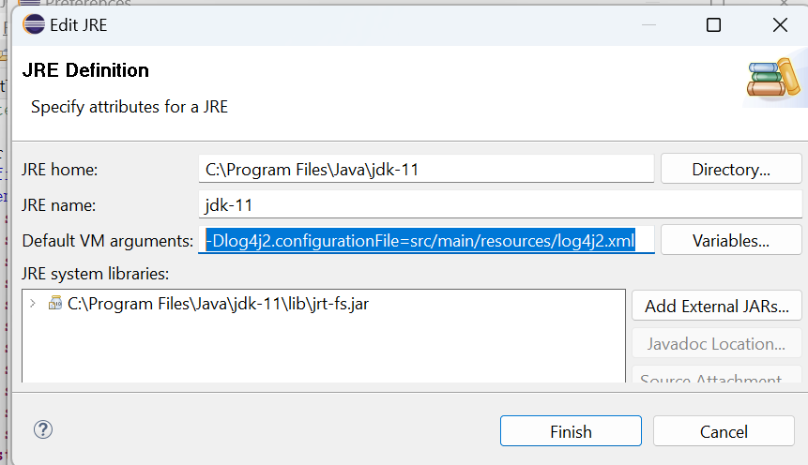
- You will get a message like this, click on the yes button.
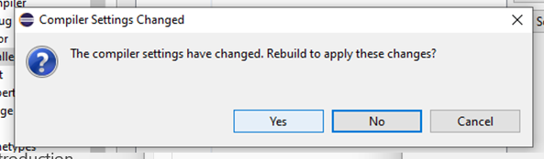

- The project will rebuild.

5.9 Setting up Maven
- Navigate to Maven – Installations and click on Add.
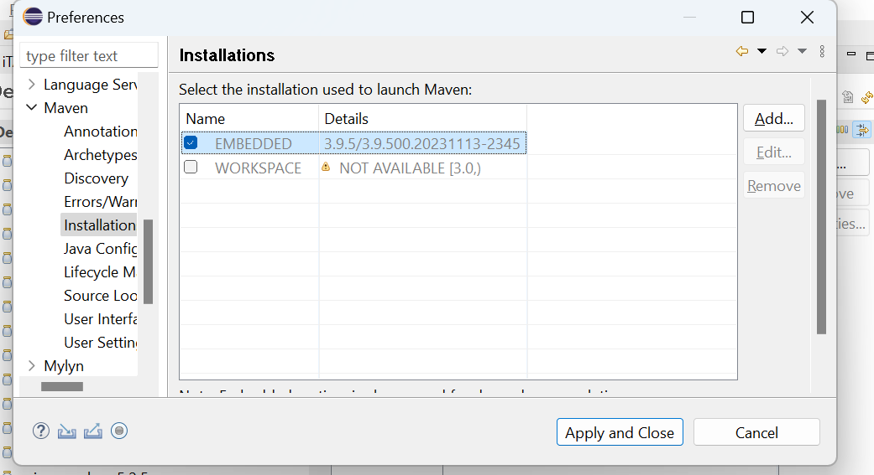

- Select your Maven directory that you had saved in step 5.2

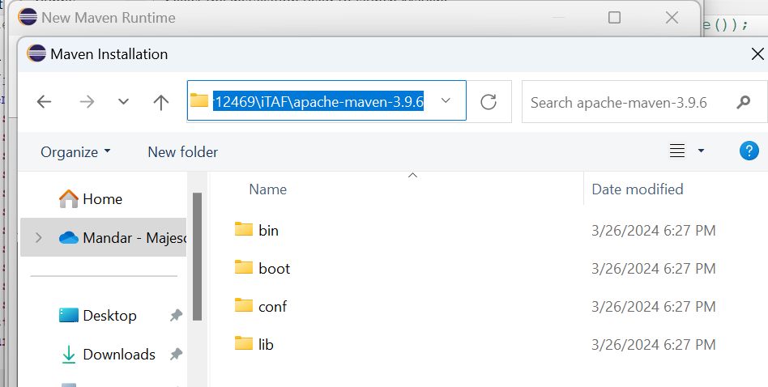

- Click on the Finish button.

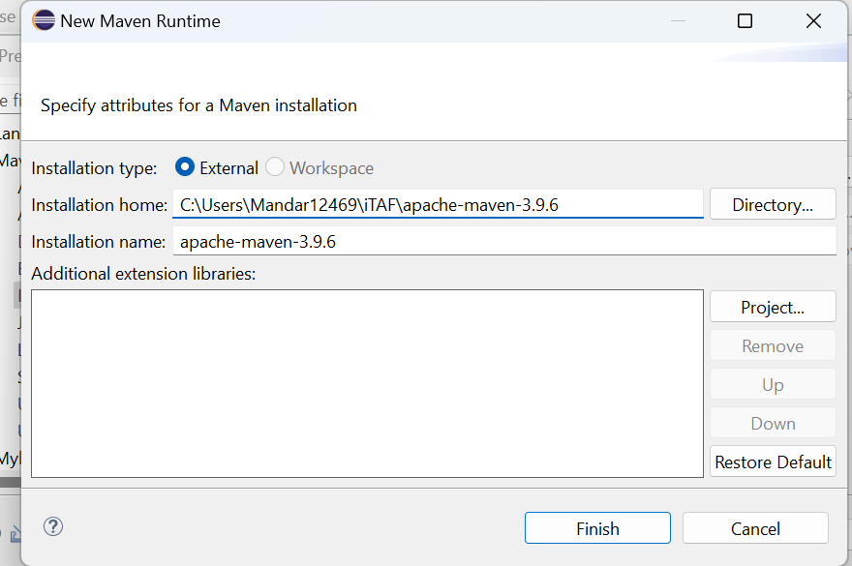

- Navigate to User Settings – Click on Browse under Global Settings.
Click on Browse, Pass the ‘settings.xml’ path as shown below.

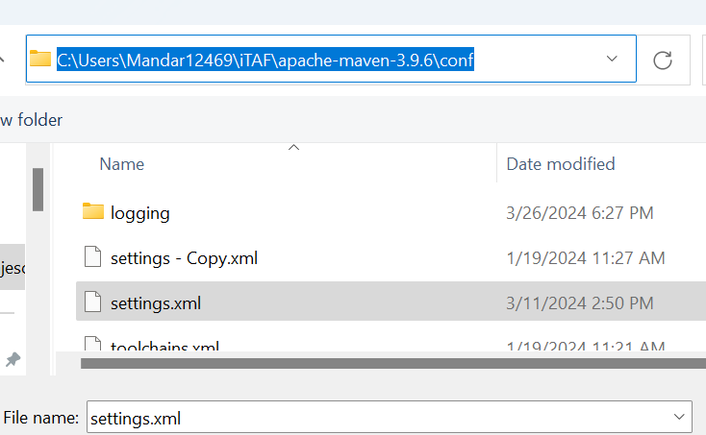

- Repeat the same step for User Settings as well and then click on Apply and Close.

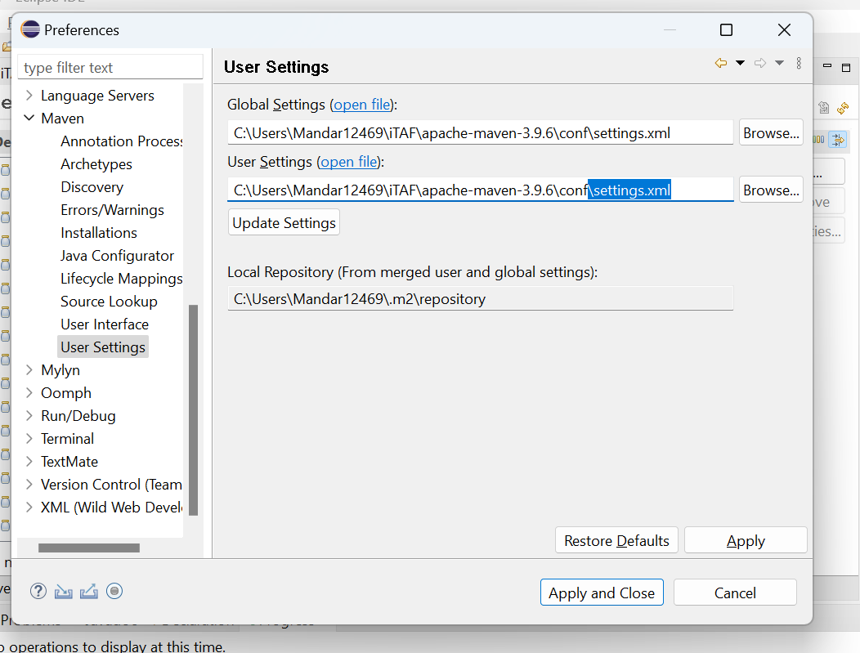

- Click on the Yes button.

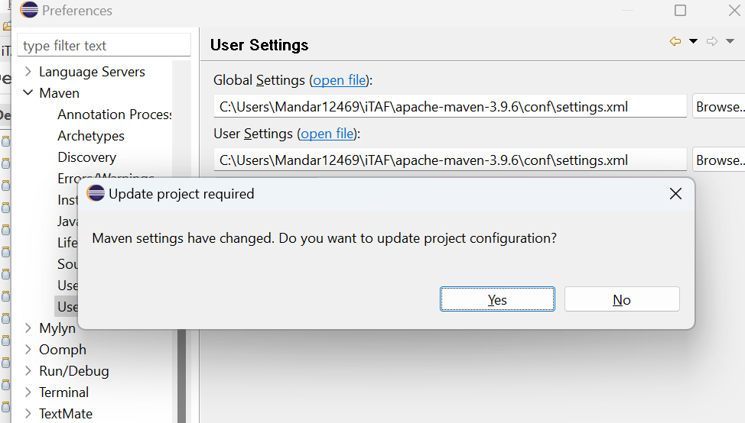

- It will start downloading dependencies.
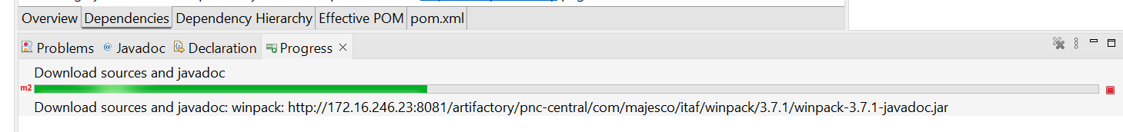

- Once the dependencies are downloaded exit from Eclipse.

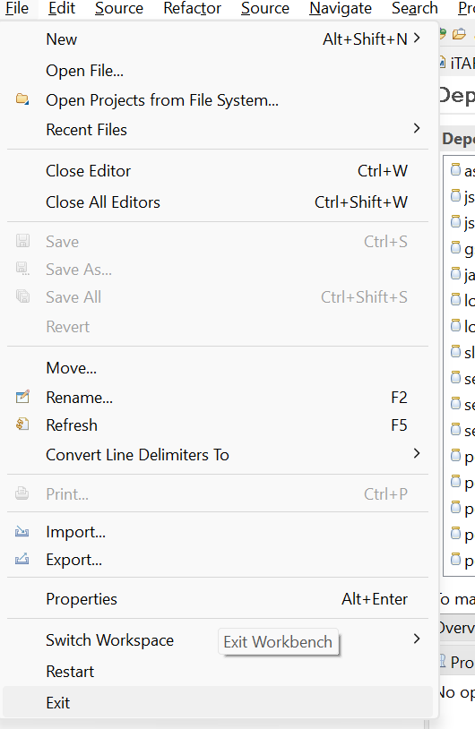

- Navigate to your ‘.m2’ folder and delete it.

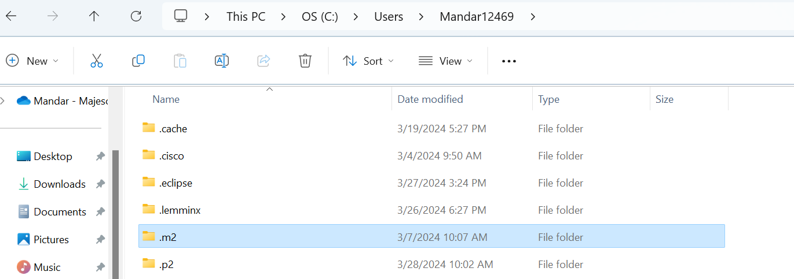

- Launch Eclipse again.

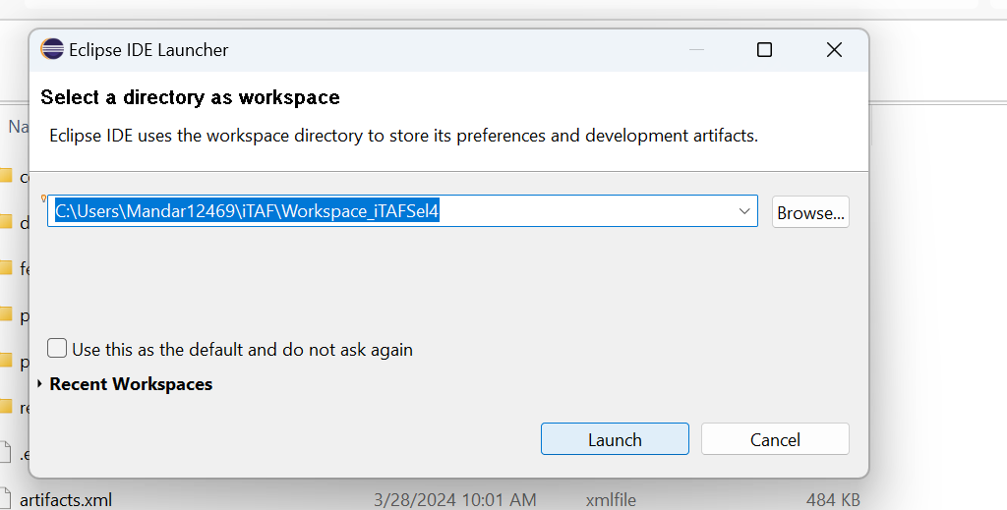

- You may see this red symbol.

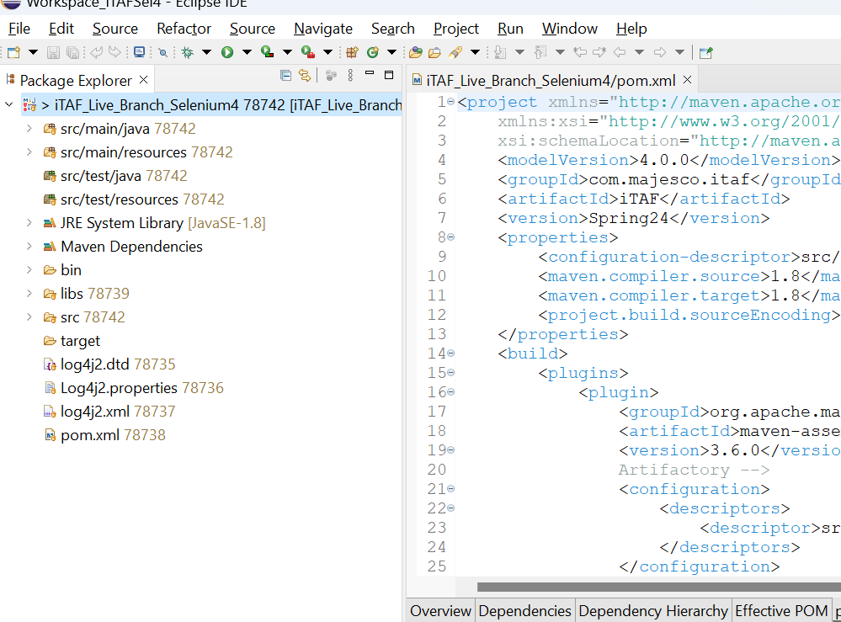

- Navigate to Project and Click on the Clean option.

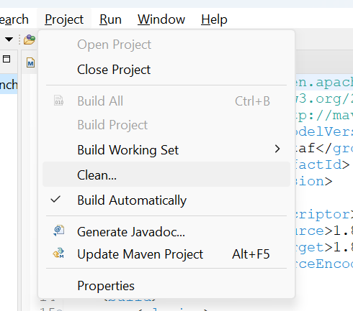

- At this stage all the errors must be resolved.

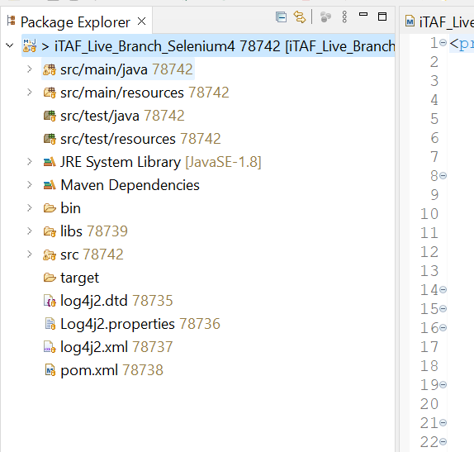

5.10 Verify SVN connection

- Right click on the project (src/mani/java…) navigate to Team – Synchronize with Repository.
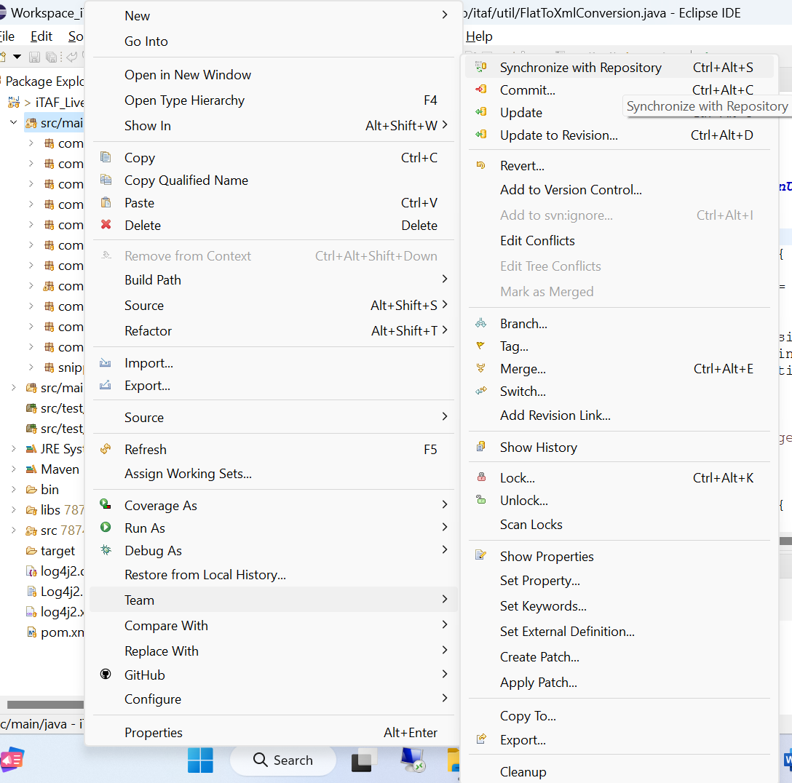

- Below given pop-up may appear, select the check box, and click on Yes.

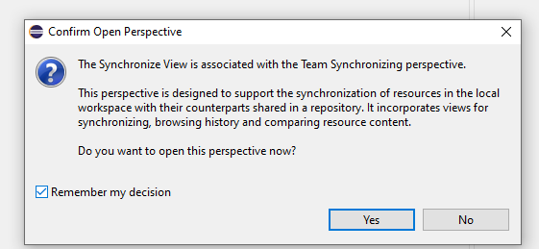

- This will show as ‘No changes in ‘SVN….’ as you will be connected to the latest version of iTAF. However, start of every month you will have to take SVN update to be on the latest version.

We’ll see how to take the update in detail in the next section.

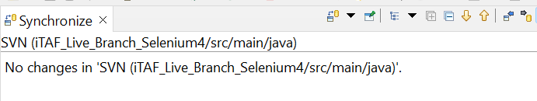

Monthly iTAF Release – SVN Update Process
The release of iTAF is scheduled for the last Friday of every month. Following the release, you can obtain the latest version of iTAF Lite (batch file) from Majesco Confluence or perform an SVN update for the iTAF Eclipse – Maven version. Once you receive the Yammer updates from the iTAF team on Friday evening, you can proceed with the SVN update.

For iTAF Lite you need to follow the steps given in section (4.2).

For iTAF Eclipse – Maven version follow the below given steps to take an SVN update.

- Right Click on the project source (src/main/java) folder – Team – Update.

This will update iTAF Source on your machine to the latest version of SVN.
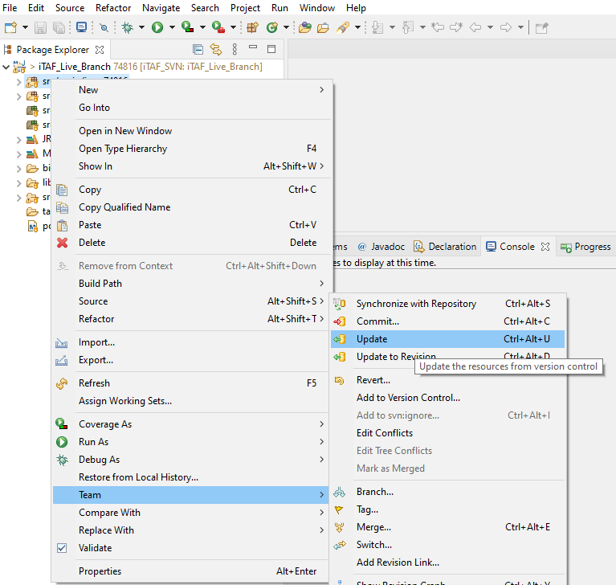

- Similarly, follow the steps to update the POM file.

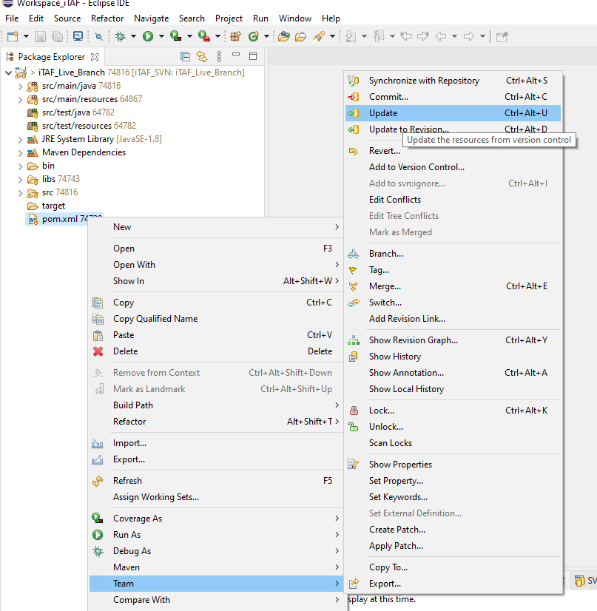

Performing Maven Build
- After every SVN update you must perform a maven build to update the repository.
This must also be done post any code changes done to the SRC files.

- Right click on Project SRC – Run As – Run Configurations

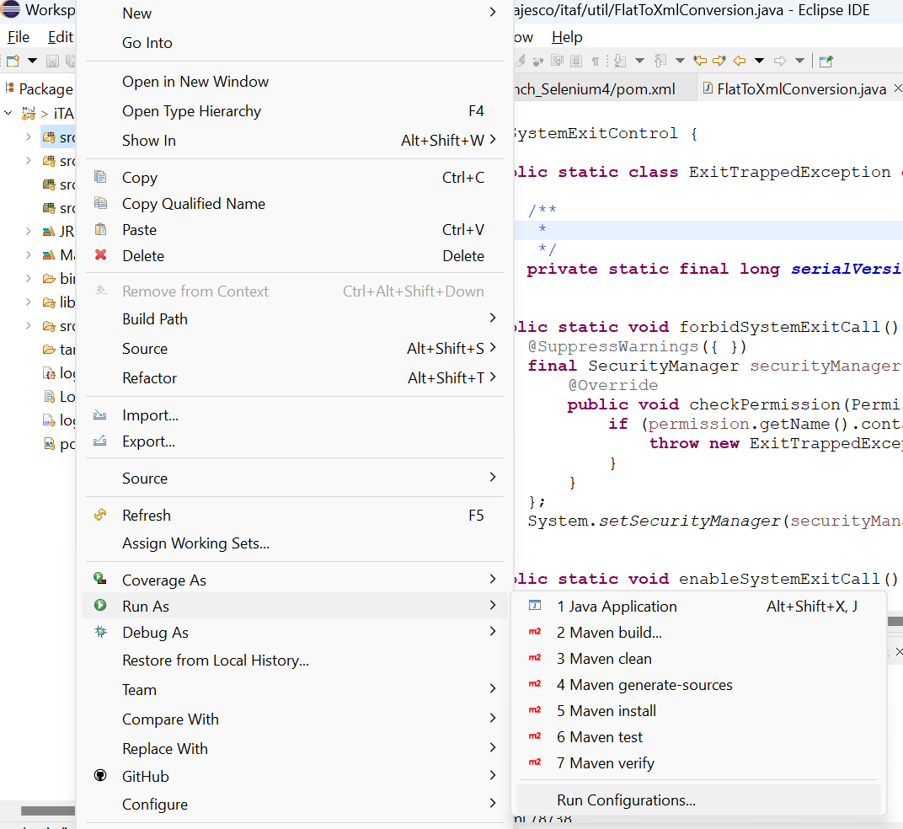

- Click on New Configuration

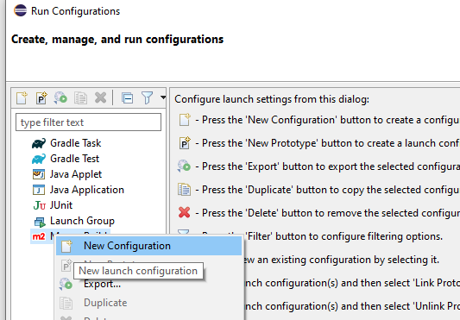

- Click on Workspace under base director – Select the folder as shown below.

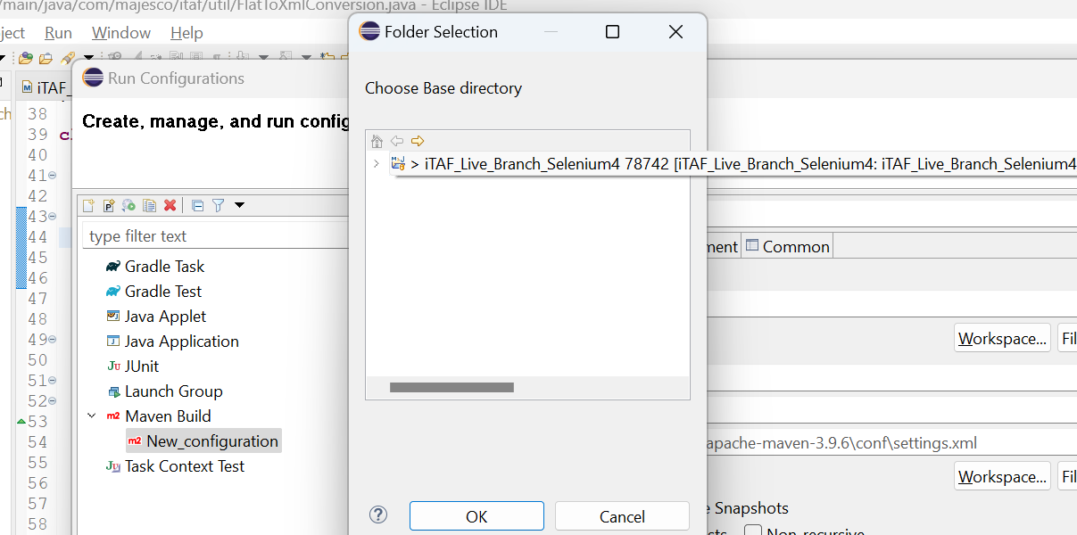

- Fill in the Name and Goals section as given below.

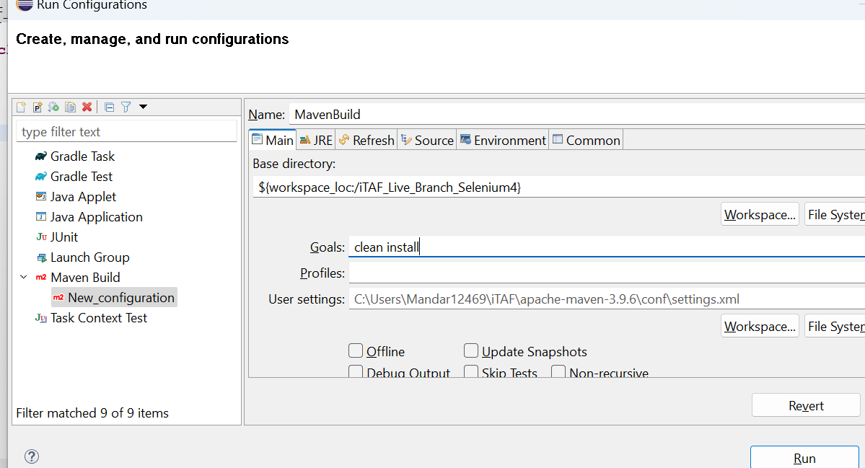

- Click on the Common Tab and check the Debug and Run options.

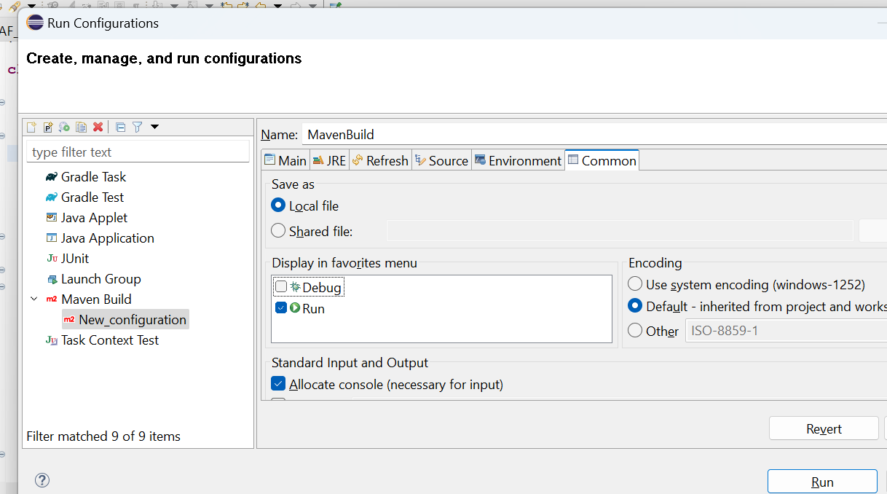

- Click on Run.

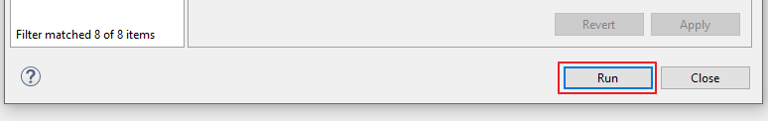

- Maven Build will start.

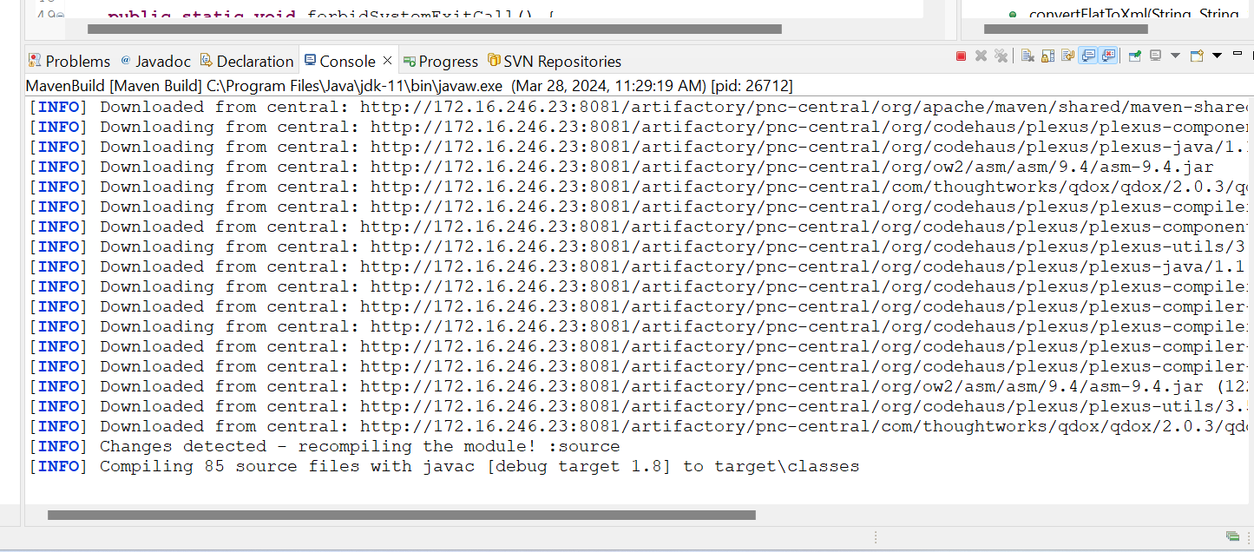

- Once the build is completed the Stop button will be disabled and ‘BUILD SUCCESS’ message will be displayed.

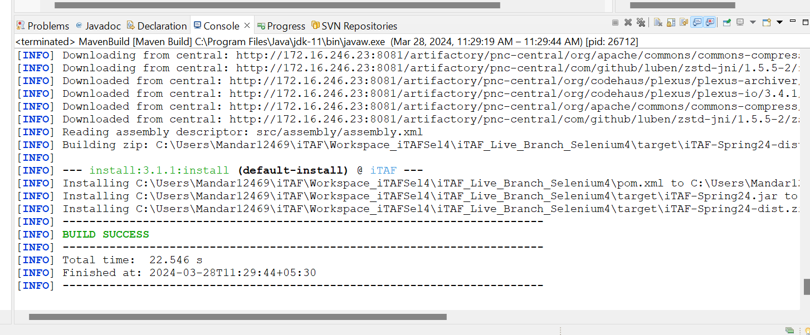

How to run a test pack using iTAF developer version
Once you have reached this stage then you are all set to run your test pack using this setup.
Follow the below given steps to trigger the run.

8.1 Setting up the WebDriver

- Navigate to Run Configurations and Select the Java Application option.
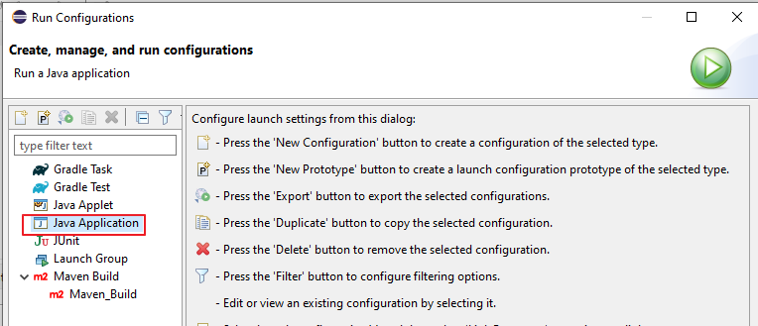

- Click on New Configuration.
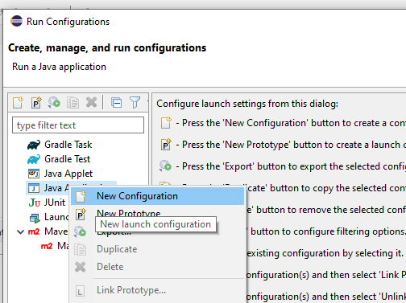

- Enter Name of the Test Pack (any name will do) and click on Search.
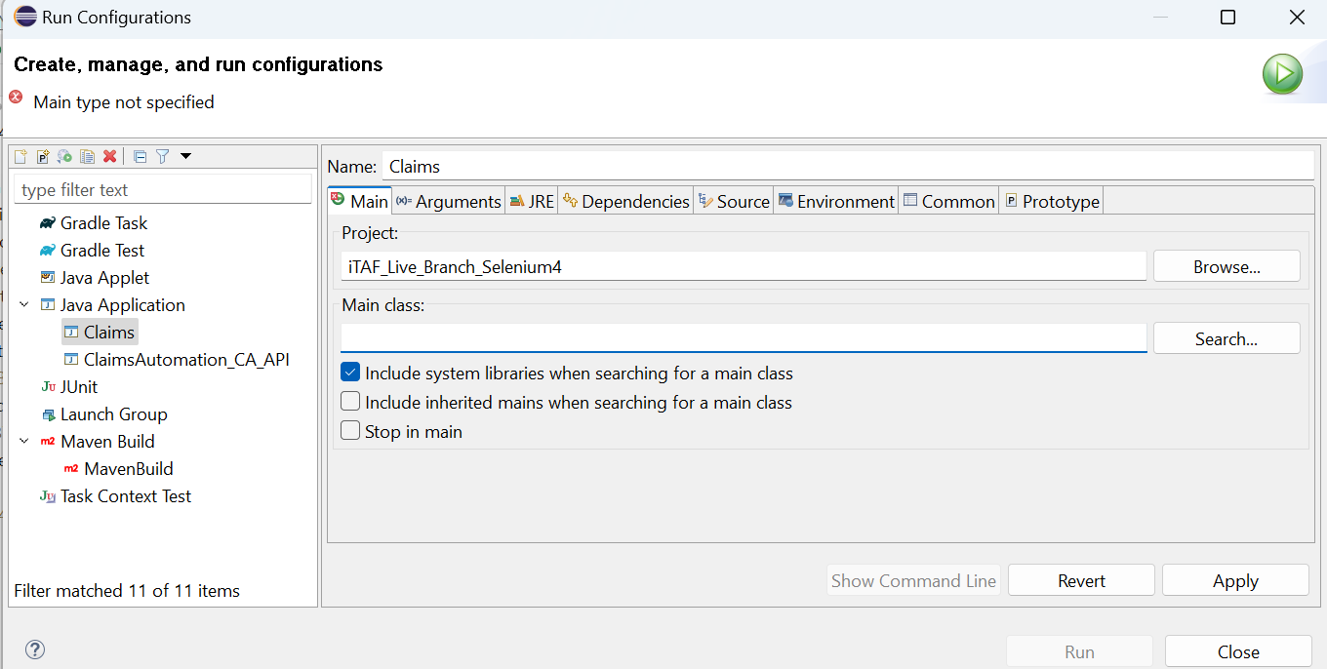

- Enter iTAF.
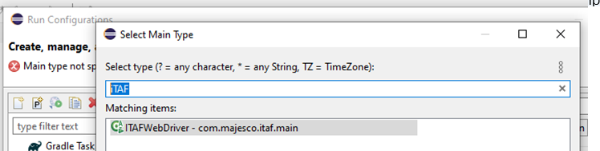

- Select the ‘iTAFWebDriver’ and click on OK.
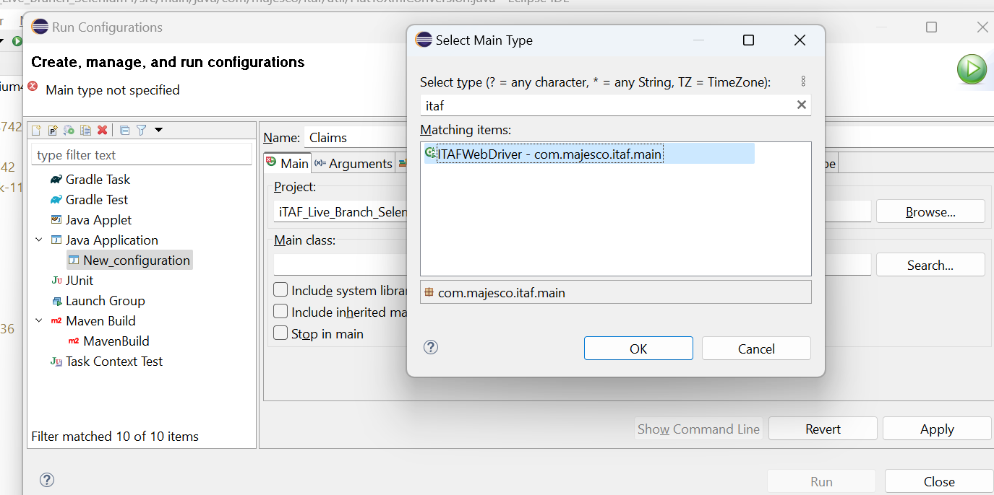

- Select the ‘Include system libraries’ checkbox.
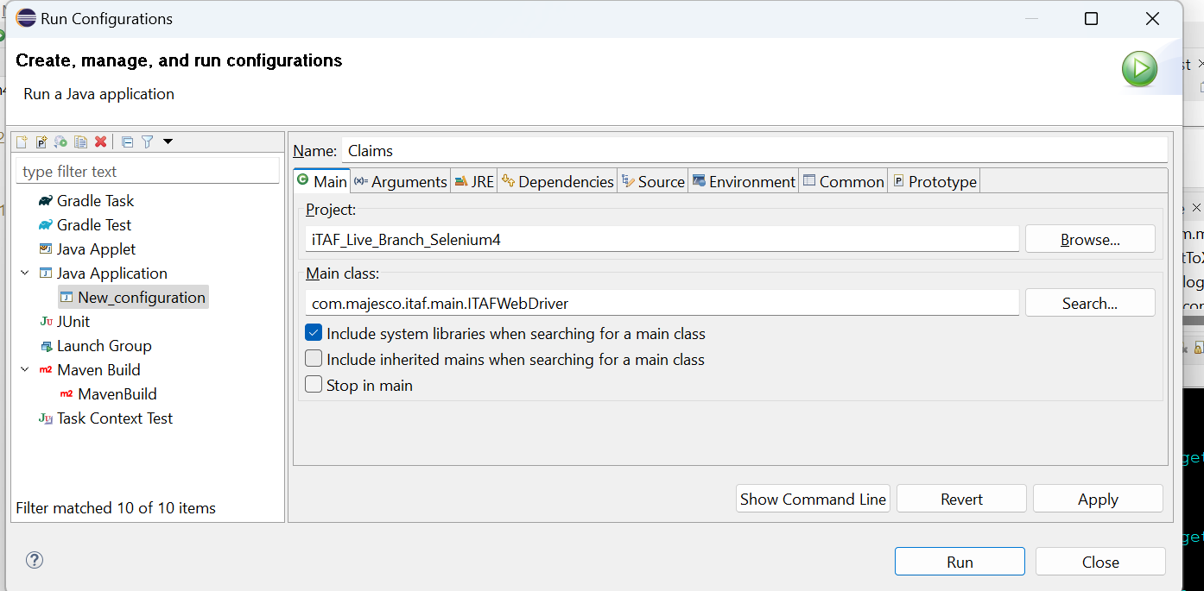

- Click on the Arguments Tab and enter the ‘Config.xlsm or xls’ path as per your project.
Note*: You must also pass the parameter in the end as per your project SILO (PAS, BILLING,
CLAIMS, DM).
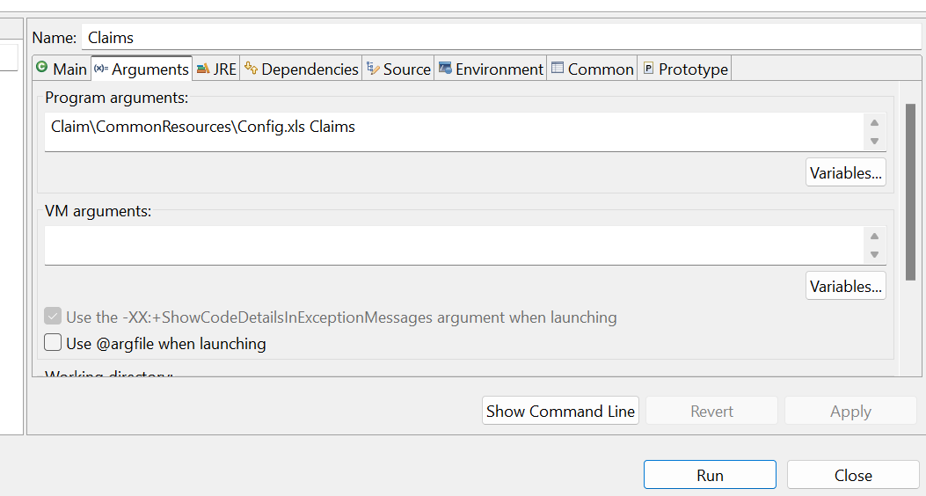

- For e.g. we have Regression Testing as the Test pack.

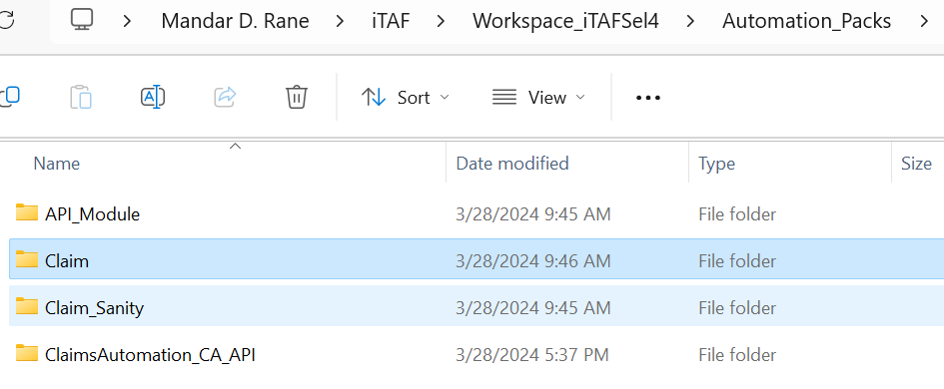

- Pass the Automation Pack Folder path here.

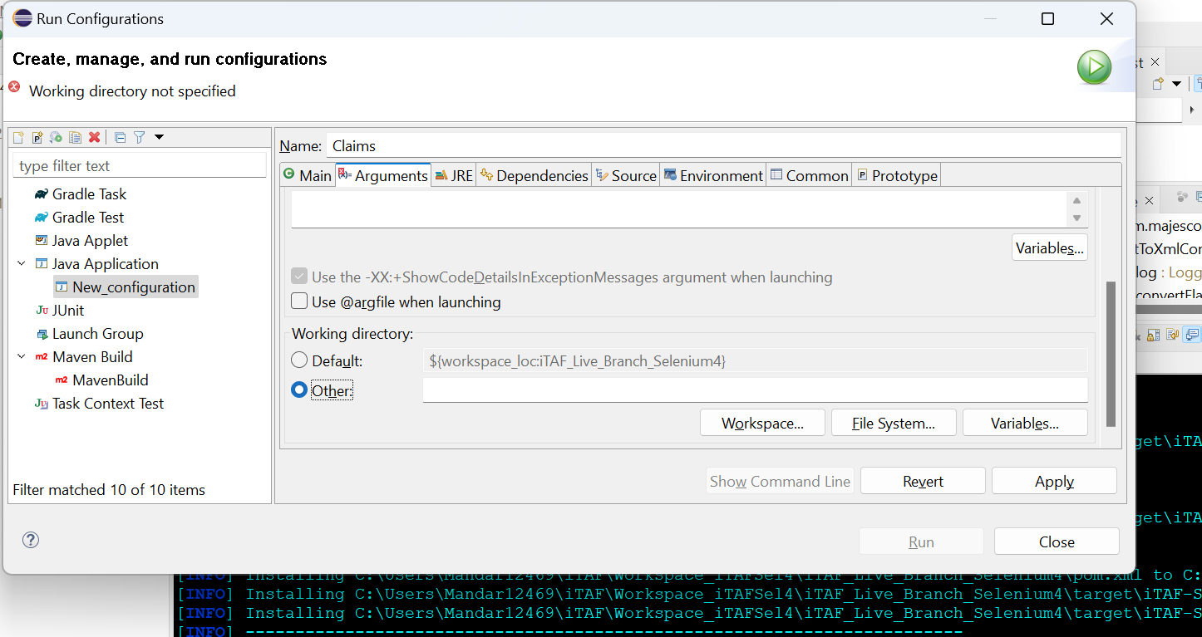

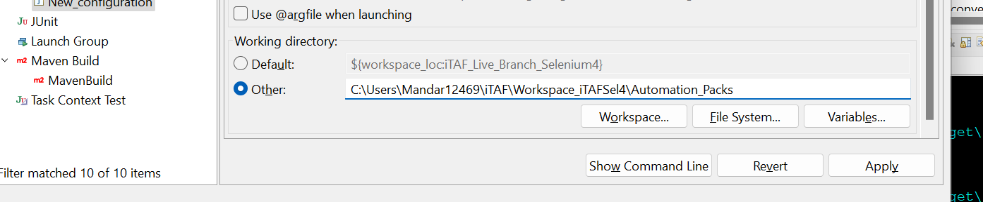

- Navigate to dependencies – Advanced – Check the add Folders option.

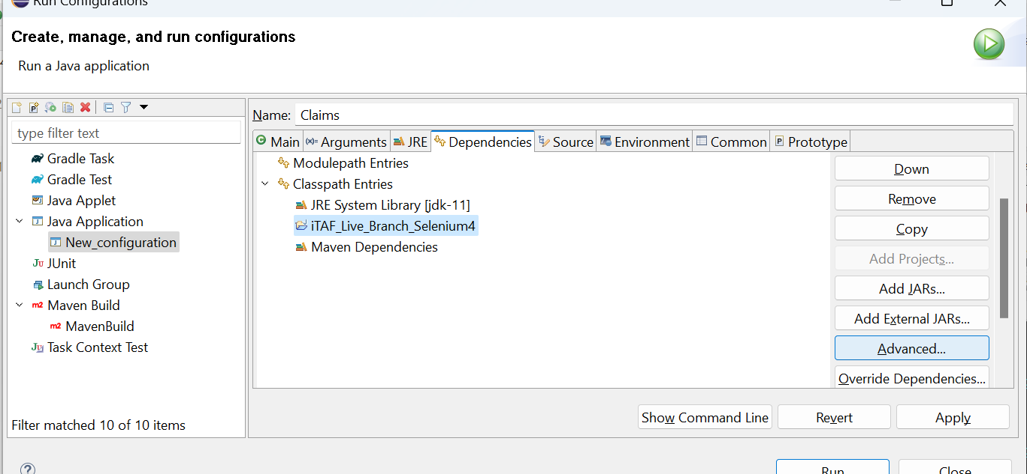

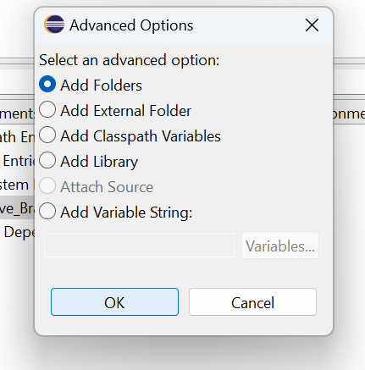

- Select the Live Branch – Click Ok.

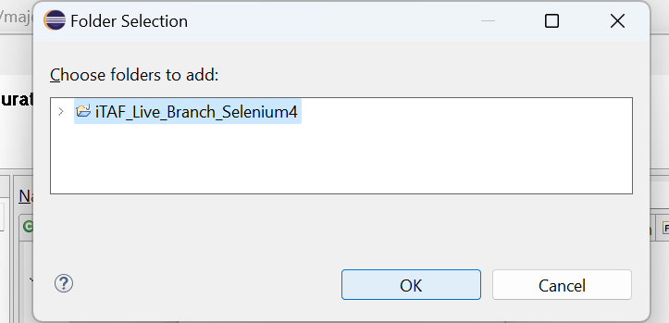
- Navigate to Common – Select Debug and Coverage. Click on the Close button.
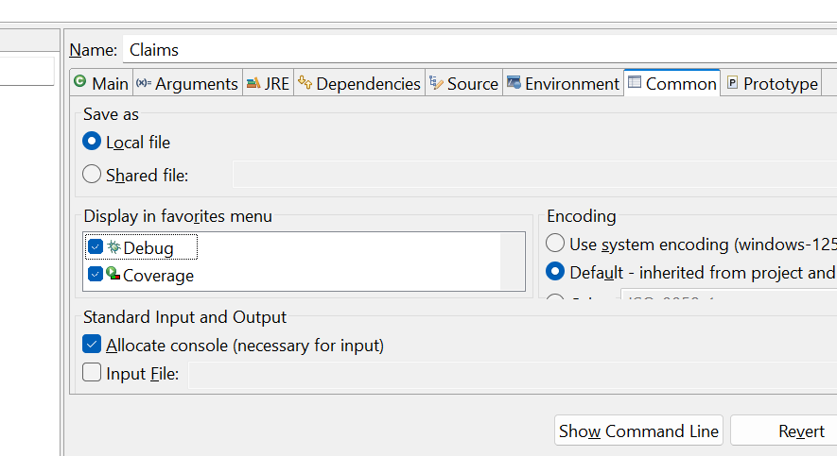

- Click on the downwards arrow symbol and select Organize Favorites.

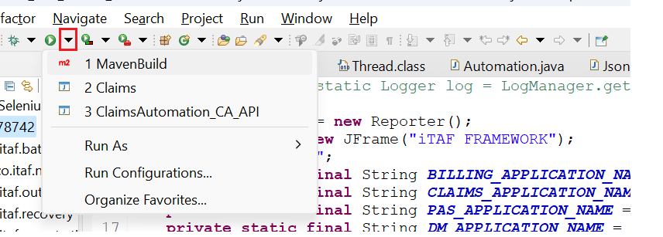

- Click on the Add button.

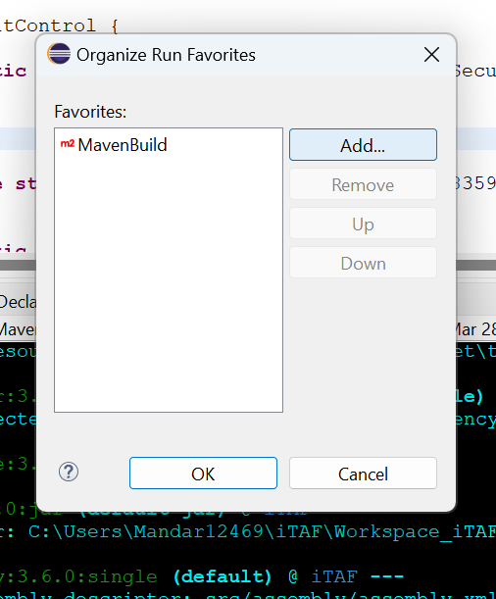
- Select the Claims option – Click OK.

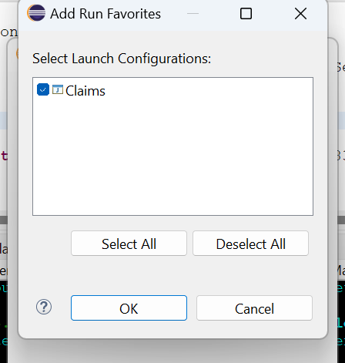

8.2 Initiate the automation run in Debug Mode

Using debug mode gives the user the liberty to place ‘stop pointers’ in failed conditions in the code so as the script stops in case of a failure and doesn’t proceed ahead.

- Click on the downwards error as shown below and select Claims option.
- Using break points you can traverse through the code and understand it better.

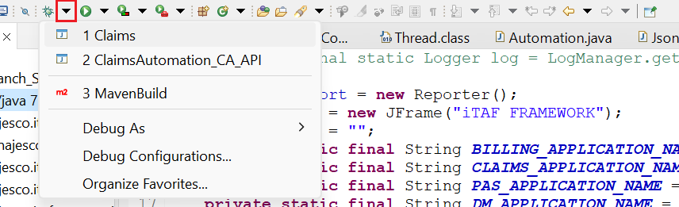

- Once the execution starts you may be getting the below given popup window as this will be a new run with the Java 11 version. Click on Allow.
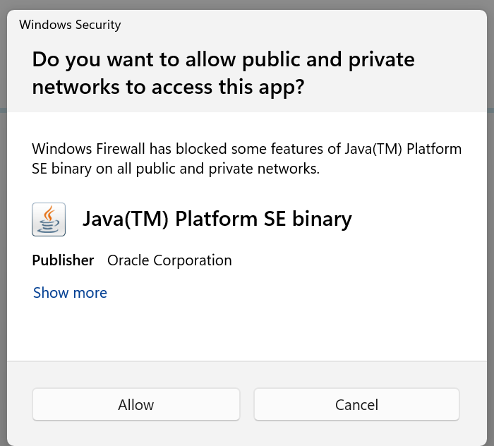

8.3 Initiate the automation run in Run Mode

The run mode will directly run and execute the test pack till its completion. In case of failures, it will
move on to the next case marking the failed one as ‘FAIL’ in the summarysheet.csv file.

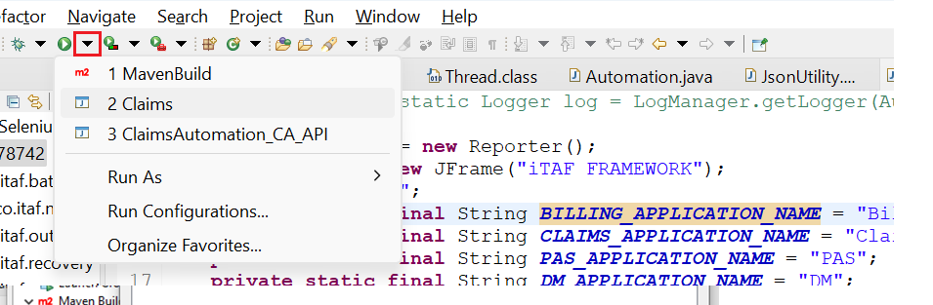

For any iTAF related issue please get in touch with your product test team. The product team can connect with the iTAF – Devops Team if required.

THANK YOU

