Data Modeling and Visualization: Unit 4 Exam Answers
Unit 4 (Q7/Q8): Data Analysis of Visualization and Modeling | Syllabus Unit VI

Unit Snapshot
No. | Question | Max Marks | Years Asked | Importance
4.1 | Data reconstruction and its types / techniques | 9 | 2023, 2024, 2025, 2026 | ★★★
4.2 | PET images: formation process and applications | 9 | 2023, 2024, 2025, 2026 | ★★★
4.3 | ER/Studio and its applications | 9 | 2023, 2024, 2026 | ★★★
4.4 | Ultrasound images and applications | 6 | 2023, 2024, 2025 | ★★★
4.5 | Magnetic resonance images (MRI) | 4.5 | 2023, 2024, 2025 | ★★★
4.6 | ER/Studio, Erwin and DbSchema Pro for medical imaging data | 9 | 2025 | ★
4.7 | Lucidchart; advantages over traditional ER tools | 9 | 2026 | ★
4.8 | Case study: medical image visualization + database modeling | 6 | 2025 | ★
4.9 | DbSchema Pro modeler | 4 | 2023 | ★
4.10 | SQL Database Modeler | 4 | 2023 | ★
4.11 | Analysis of medical images | 4 | 2026 | ★
Must-do first (★★★): 4.1 Data reconstruction · 4.2 PET images · 4.3 ER/Studio · 4.4 Ultrasound · 4.5 MRI. (4.1 and 4.2 appeared in every paper.)
All answers are written for (highest marks + 2). Source = Textbooks/DMV Textbook.pdf (scanned; PDF page numbers).

Full Answers

4.1 Discuss data reconstruction and its types / techniques in data modeling and visualization
★★★ (all 4 papers) | Asked for max 9 marks → written for 11 | Asked in: 2023 (7), 2024 (9), 2025 (6), 2026 (8) | Source: DMV Textbook.pdf, PDF p. 83-84 (6.1 Reconstruction and its Types in Data Modelling and Visualization)
Variants: “Discuss Data Reconstruction and its types in data modeling and visualization” (2023, 2025) · “Explain the various data reconstruction techniques used to assist data modeling and visualization” (2024, 2026).
Definition: Data reconstruction is the process of transforming and reshaping raw data (aggregating, filtering, transforming, cleaning, combining) to enhance its usability for analysis and visualization, and to present information in a more structured, understandable form. It also means creating a model/representation (e.g. a 3-D model from 2-D images) from raw data.
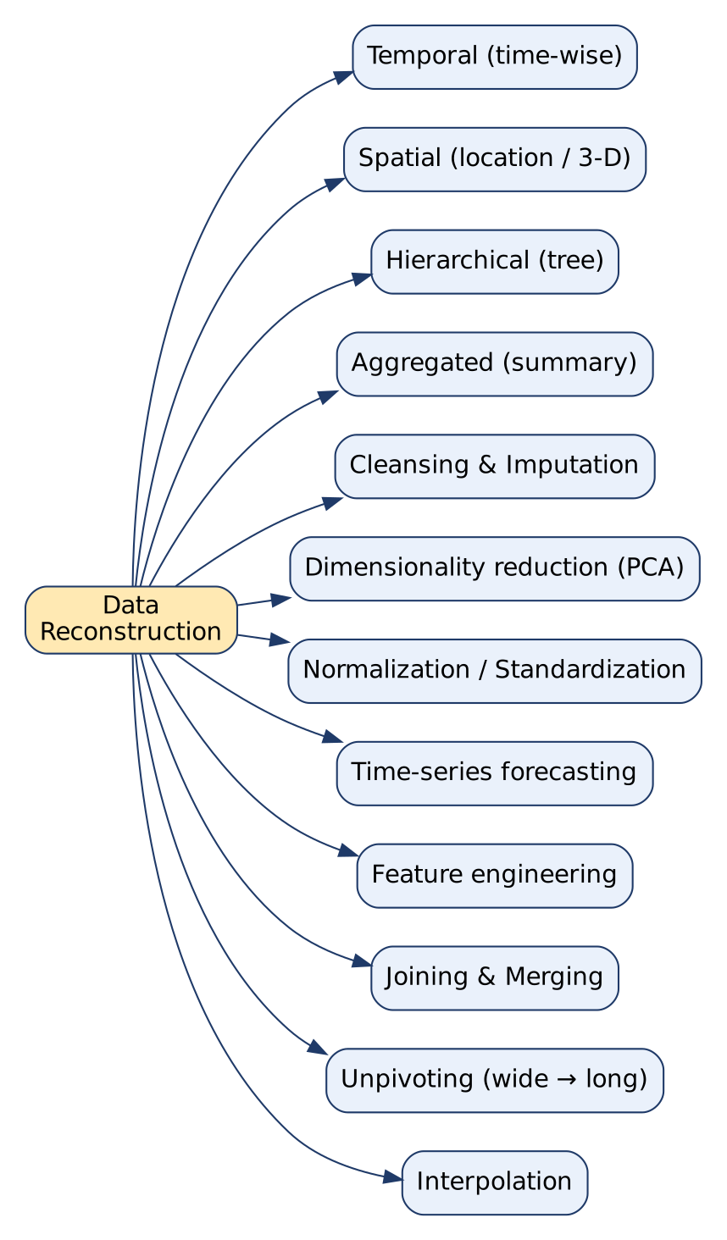
Types of data reconstruction

1. Types / techniques of data reconstruction (with examples)
No. | Type | What it does | Example
1 | Temporal reconstruction | Organises data over time (daily → weekly/monthly summaries) | Daily sales → monthly trend, peak seasons
2 | Spatial reconstruction | Organises data by location; maps, 3-D shapes | GPS data → heat map of user hotspots
3 | Hierarchical reconstruction | Arranges data into a tree structure | Employees → organisation chart
4 | Aggregated reconstruction | Summarises many records (sum, mean) | Sales by region and product
5 | Data cleansing & imputation | Fixes missing / erroneous values | Fill missing age with mean
6 | Dimensionality reduction | High-dim → low-dim (PCA, t-SNE) keeping key patterns | 50 customer features → 2-D plot
7 | Normalization / standardization | Scale to a common range: x’ = (x − min)/(max − min); z = (x − μ)/σ | Compare income and age on one chart
8 | Time-series forecasting | Reconstructs future values from past patterns | Stock or demand forecast
9 | Feature engineering | Creates new variables | Sentiment score from social-media text
10 | Joining & merging | Combines multiple datasets | Health records + lab reports → patient profile
11 | Unpivoting | Wide → long format | Survey: one column per question → one row per answer
12 | Interpolation | Estimates missing points between known points | Missing hourly temperature readings
Symbols: x = value, min/max = minimum/maximum, μ = mean, σ = standard deviation.

2. Reconstruction as “creating representations” (applications)
- 3-D reconstruction from imaging data: series of 2-D MRI/CT slices → 3-D anatomical model (diagnosis, surgery planning, VR).
- Financial data visualization: raw transactions → interactive dashboards.
- Biological systems modeling: pathways, protein interaction networks.
- Historical data reconstruction: fragments → timeline of past events.
- Meteorological visualization: temperature, wind → weather maps, animations.
- Social network analysis: interaction data → network graphs of communities and influence.
- CAD model rendering: engineering models → realistic renderings.
- Astronomy simulations: reconstruct galaxy formation, black-hole dynamics.

3. Importance
- Converts raw, messy data into usable, informative formats.
- Reveals insights not visible in the original dataset.
- Makes visualizations accurate and comprehensible → better decisions.
Conclusion: Data reconstruction reshapes and rebuilds data (in time, space, hierarchy, dimensions or completeness) so that it can be modelled and visualised meaningfully.
Memory trick: “TSHA-CD-NF-FJUI” → “The Smart Hospital Always Cleans Data, Never Fakes Files, Just Uses Insight” (Temporal, Spatial, Hierarchical, Aggregated, Cleansing, Dimensionality, Normalization, Forecasting, Feature eng., Joining, Unpivoting, Interpolation).

4.2 What are PET images? Explain the process of PET image formation and its applications in data modeling and visualization
★★★ (all 4 papers) | Asked for max 9 marks → written for 11 | Asked in: 2023 (short note 3.5), 2024 (9), 2025 (short note 4), 2026 (9) | Source: DMV Textbook.pdf, PDF p. 86-87 (PET Images: applications, data modeling, visualization, SUV). Image-formation physics: ⚠ Not found in your materials. Standard textbook answer.
Variants: “Short note: PET Images” (2023, 2025) · “Explain PET Images and its applications in data modeling and visualization” (2024) · “What are PET images? Explain the process of PET image formation” (2026).
Definition: Positron Emission Tomography (PET) is a functional (molecular) imaging technique that uses a radioactive tracer to visualise metabolic processes in tissues, such as glucose metabolism, blood flow or neurotransmitter receptor binding. PET shows how tissue is working, not just its structure.

1. Process of PET image formation
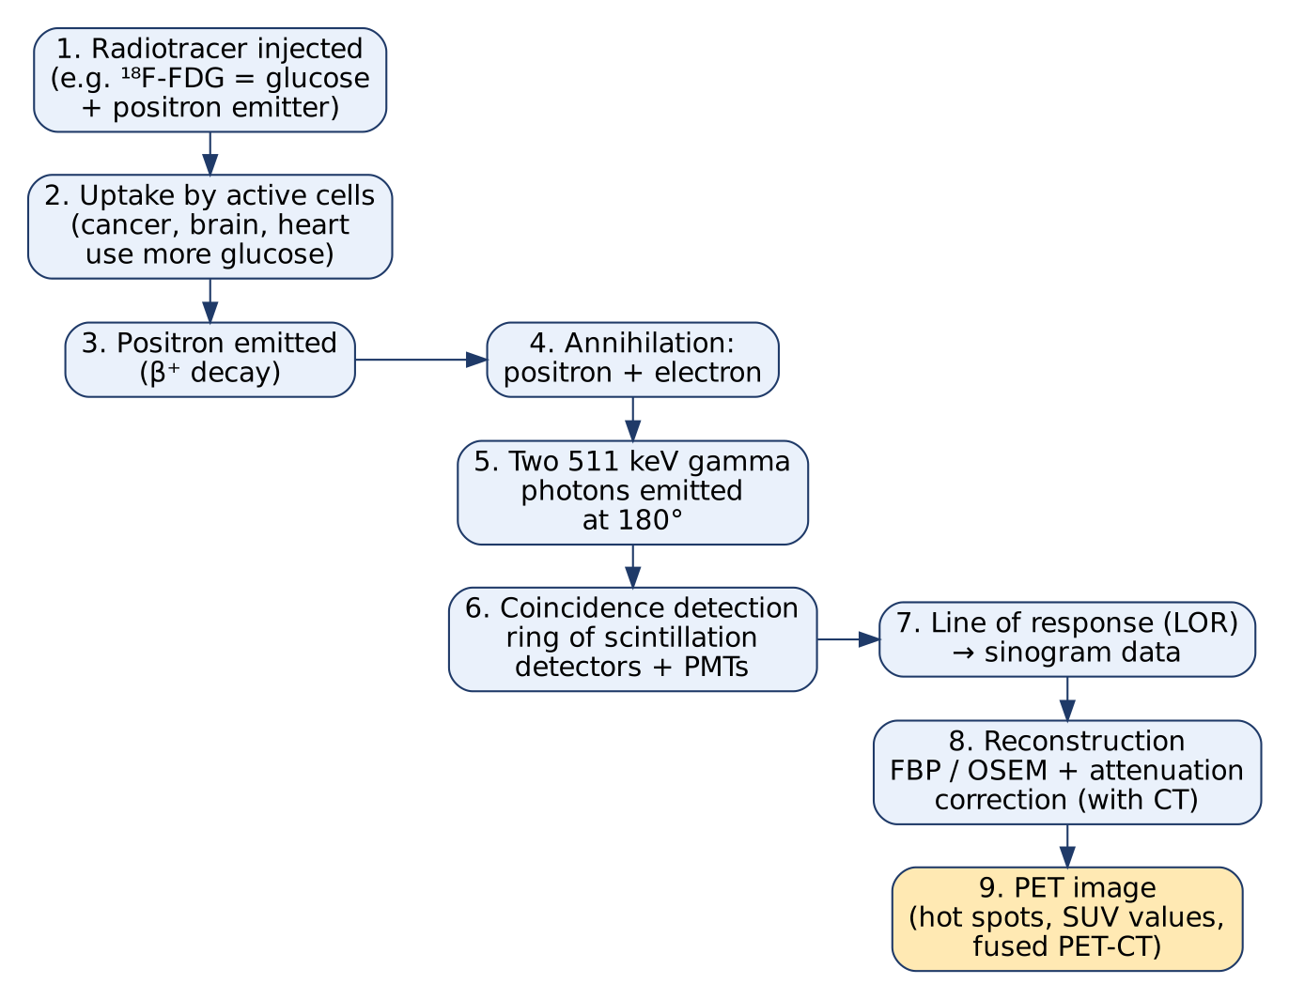
PET image formation
- Radiotracer injection: a biologically active molecule labelled with a positron-emitting isotope, most commonly ¹⁸F-FDG (fluorodeoxyglucose), is injected.
- Uptake: tissues with high metabolism (cancer cells, active brain regions, heart muscle) absorb more tracer (~60 min wait).
- Positron emission: the isotope decays (β⁺ decay) and emits a positron.
- Annihilation: the positron travels ~1 mm, meets an electron and both are annihilated.
- Gamma photons: annihilation produces two 511 keV gamma photons travelling in opposite directions (180°).
- Coincidence detection: a ring of scintillation detectors (crystals + photomultiplier tubes) records the two photons arriving at the same time (within a few nanoseconds).
- Line of response (LOR): each coincidence defines a line on which the annihilation occurred; millions of LORs are stored as a sinogram.
- Image reconstruction: algorithms such as filtered back-projection (FBP) or iterative OSEM convert sinograms into 3-D images, with attenuation correction (usually from a CT scan in PET-CT). (Textbook: advanced reconstruction algorithms give high resolution and better signal-to-noise ratio.)
- Quantification & display: intensity shows tracer concentration; hot spots = high uptake; SUV values computed.
Standardized Uptake Value: SUV = C_{tissue} / (Injected dose / Body weight), where C_{tissue} = tracer concentration in the region (kBq/mL). SUV > ~2.5 often suggests malignancy (with FDG).

2. Applications in data modeling and visualization (textbook)
- Cancer diagnosis & treatment planning: high glucose uptake marks tumours; PET fused with CT/MRI localises tumours, shows spread (staging) and response to therapy.
- Neuroscience: brain function, receptor distribution; binding potentials and brain activation maps for Alzheimer’s, schizophrenia, epilepsy.
- Cardiology: tracers like Rubidium-82 and ¹³N-ammonia measure myocardial blood flow and viability → coronary artery disease.
- Infection & inflammation: ¹⁸F-FDG highlights inflamed or infected areas.
- Pharmacology & drug development: kinetic modeling of tracer pharmacokinetics in animal models to select drug candidates.
- Personalised medicine: biomarker expression on PET to predict treatment response.

3. Data modeling and visualization techniques used
- Reconstruction algorithms (FBP, OSEM) and kinetic (compartment) modeling.
- Voxel-based analysis and region-of-interest (ROI) analysis.
- Co-registration / fusion with MRI or CT → combined anatomy + function images.
- Quantitative visualization: SUV maps, colour scales (hot-metal colour map), 3-D rendering.

4. Advantages / Limitations
- + Shows function/metabolism early (before structural change), whole-body scan, quantitative.
- − Radiation exposure, expensive, short-lived isotopes (cyclotron needed), lower spatial resolution (4-6 mm) than CT/MRI.
Conclusion: PET images map metabolic activity by detecting paired gamma photons from positron annihilation; with data modeling (reconstruction, kinetic models, SUV) and visualization (fusion, ROI maps) they are central to cancer, brain and heart diagnosis.
Memory trick: “I-U-P-A-G-C-L-R-I” → “Inject, Uptake, Positron, Annihilate, Gamma pair, Coincidence, LOR, Reconstruct, Image”. Key number: 511 keV at 180°.

4.3 Explain ER/Studio with its applications
★★★ | Asked for max 9 marks → written for 11 | Asked in: 2023 (6), 2024 (9), 2026 (short note 4) | Source: DMV Textbook.pdf, PDF p. 90 (6.4.1 ER/Studio)
Definition: ER/Studio is a comprehensive data modeling tool developed by Embarcadero (later part of Quest/IDERA, as the textbook notes). It helps data professionals design, manage and document data assets by creating conceptual, logical and physical data models of an organisation’s data.
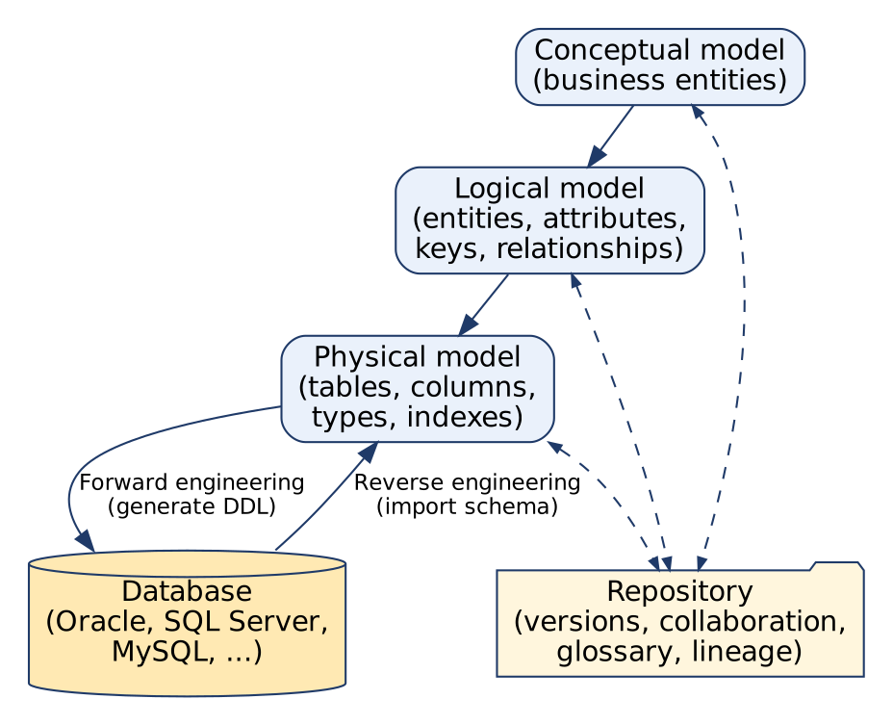
ER/Studio modeling workflow
Diagram explanation:
- Conceptual model: high-level business entities (Customer, Order).
- Logical model: entities with attributes, keys and relationships, independent of any DBMS.
- Physical model: actual tables, columns, data types, indexes for a chosen DBMS.
- Forward engineering: generate SQL / DDL scripts from the physical model to create the database.
- Reverse engineering: import an existing database into a visual model.
- Repository: central store for versions, collaboration, business glossary, lineage.

1. Features
- Conceptual, logical and physical modeling with conversion between levels.
- Forward engineering (DDL generation) and reverse engineering (legacy DBs → model).
- Collaboration: multiple users work on the same model; version control / change history.
- Impact analysis: shows the effect of a change (e.g. renaming a column) on the whole architecture.
- Data lineage: tracks where data comes from and how it is transformed.
- Data governance: central repository, naming standards, support for GDPR/CCPA compliance.
- Documentation: automatic reports (HTML/RTF) and data dictionaries.
- Visualization: clear, attractive ER diagrams and metadata views.
- Multi-DBMS support: Oracle, SQL Server, DB2, MySQL, PostgreSQL, etc.; compare/synchronise model with live DB.

2. Applications
- Database design for new applications.
- Data warehouse design: star/snowflake schemas, fact and dimension tables; ETL design.
- Legacy system documentation and migration (via reverse engineering).
- Enterprise data architecture & governance: one standard model across teams.
- Regulatory compliance: identify where personal data (PII) is stored.
- Communication: business users and technical teams agree on one visual model.
- Healthcare: modeling patient, study, image and report entities (see 4.6).

3. Example
A hospital designs a database: conceptual model (Patient, Doctor, Appointment) → logical model (keys, 1:N relationships) → physical model for SQL Server → forward-engineer DDL → database created; later, a change to Patient.phone is checked with impact analysis.

Advantages / Limitations
- + Enterprise-grade, strong collaboration & governance, multi-DBMS, good documentation.
- − Commercial (costly licence), steep learning curve, Windows desktop application.
Conclusion: ER/Studio is an enterprise data modeling and visualization tool that takes a design from business concept to physical database, with collaboration, governance and documentation built in.
Memory trick: “CLP-FR-CIDD”: Conceptual, Logical, Physical; Forward & Reverse engineering; Collaboration, Impact analysis, Data lineage, Documentation.

4.4 Explain ultrasound images and their applications in data modeling and visualization
★★★ | Asked for max 6 marks → written for 8 | Asked in: 2023 (6), 2024 (short note 4.5), 2025 (5) | Source: DMV Textbook.pdf, PDF p. 87-88 (Ultrasound Images). Pulse-echo principle: ⚠ Not found in your materials. Standard textbook answer.
Definition: Ultrasound imaging (sonography) uses high-frequency sound waves (typically 2-18 MHz) to produce real-time images of internal body structures. It is non-invasive, has no ionising radiation, and is cheap and portable.

1. Principle (pulse-echo)
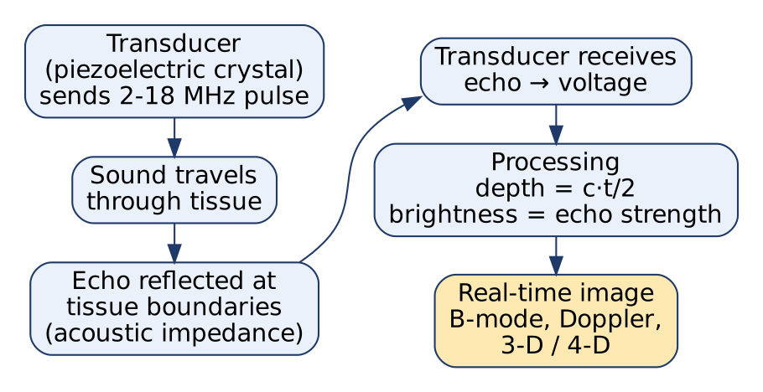
Ultrasound image formation
- Transducer (piezoelectric crystal) converts electrical pulses into sound pulses.
- Sound travels through tissue; at boundaries of different acoustic impedance, part of it is reflected (echo).
- The same transducer receives echoes and converts them back to voltage.
- Depth of each boundary: d = c · t / 2, where c ≈ 1540 m/s (speed of sound in soft tissue), t = round-trip time.
- Brightness of each pixel ∝ echo strength → B-mode image; Doppler mode shows blood-flow velocity; 3-D/4-D modes show volumes in real time.

2. Applications (textbook)
- Obstetrics: fetal development, gestational age, growth, abnormalities.
- Abdominal / radiology: liver, kidneys, gallbladder → tumours, cysts.
- Cardiology (echocardiography): heart structure and function, ejection fraction, cardiac output.
- Urology: kidneys, bladder, prostate; kidney stones; guiding biopsies.
- Musculoskeletal: tendons, ligaments, joints (tendonitis, bursitis).
- Emergency medicine: internal bleeding, trauma assessment.
- Interventional radiology: real-time guidance for needles and catheters.
- Breast, thyroid, gastrointestinal: benign vs malignant masses, nodules.

3. Role of data modeling and visualization
- Data modeling: algorithms for image enhancement, noise (speckle) reduction, feature extraction, automatic measurements (fetal size, ejection fraction), benign/malignant classification.
- Visualization: real-time display of motion, 3-D and 4-D ultrasound for fetal and cardiac imaging, colour Doppler maps.
- Research: new imaging techniques, evaluating therapies.
Advantages: safe (no radiation), real-time, portable, low cost. Limitations: operator-dependent, speckle noise, cannot image through bone or air (lungs, bowel gas).
Conclusion: Ultrasound forms images from reflected sound echoes; with data modeling and real-time visualization it supports safe, fast diagnosis across many specialties.
Memory trick: “Sound out, Echo back, Depth = c·t/2.” Applications: “O-A-C-U-M-E” (Obstetrics, Abdomen, Cardiac, Urology, Musculoskeletal, Emergency).

4.5 Write a short note on magnetic resonance images (MRI)
★★★ | Asked for max 4.5 marks → written for 6.5 | Asked in: 2023 (3.5), 2024 (4.5), 2025 (4) | Source: DMV Textbook.pdf, PDF p. 88-89 (Magnetic Resonance Images). Image-formation physics: ⚠ Not found in your materials. Standard textbook answer.
Definition: Magnetic Resonance Imaging (MRI) is a non-invasive imaging technique that uses a strong magnetic field and radio waves (no ionising radiation) to create detailed images of internal body structures, with excellent soft-tissue contrast.
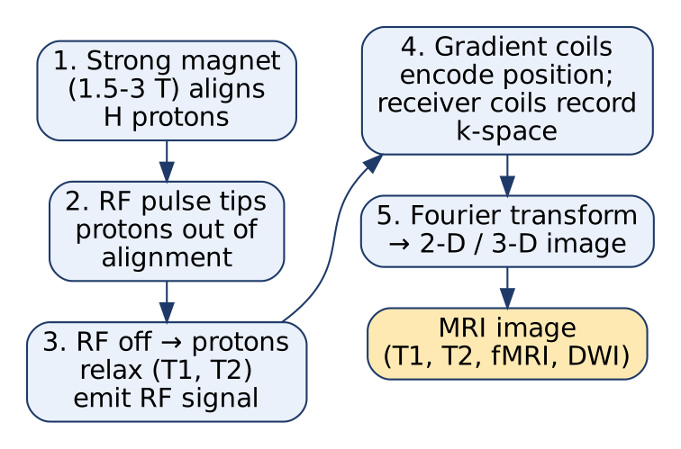
MRI image formation

Working (brief)
- A strong magnet (1.5-3 Tesla) aligns hydrogen protons in body water.
- An RF pulse tips the protons out of alignment.
- When the pulse stops, protons relax (T1, T2 relaxation) and emit RF signals.
- Gradient coils encode position; receiver coils record data in k-space.
- A Fourier transform converts k-space into the image. Different tissues relax at different rates → contrast (T1-weighted, T2-weighted).

Applications (textbook)
- Neuroimaging: brain structures, Alzheimer’s, multiple sclerosis, stroke; fMRI (brain activity during tasks) and DWI/DTI (white-matter tractography).
- Oncology: brain, breast, prostate tumours; segmentation, staging, treatment response.
- Musculoskeletal: ligament tears, cartilage, herniated discs.
- Cardiac: heart motion, blood flow, myocardial viability.
- Abdominal: liver, kidneys, pancreas; fetal MRI.

Data modeling & visualization
Automated segmentation, volume quantification, motion correction, AI/ML detection; 3-D rendering and multi-planar views.
Advantages: no radiation, best soft-tissue contrast, multi-planar 3-D. Limitations: expensive, long scan time, noisy, not for patients with metal implants/pacemakers.
Conclusion: MRI gives high-contrast, radiation-free anatomical and functional images that are essential for brain, cancer and joint diagnosis.
Memory trick: “Magnet aligns, Radio tips, Relax emits, Fourier forms” (MRRF).

4.6 How can tools like ER/Studio, Erwin Data Modeler and DbSchema Pro aid in structuring and analysing medical imaging data?
★ | Asked for max 9 marks → written for 11 | Asked in: 2025 (9) | Source: DMV Textbook.pdf, PDF p. 90 (ER/Studio), p. 91 (Erwin Data Modeler), p. 92-93 (DbSchema Pro), p. 85-86 (medical image analysis). The medical-imaging schema (DICOM hierarchy) is ⚠ not found in your materials: standard textbook answer.
Introduction: Medical imaging produces huge volumes of images (DICOM files) plus metadata (patient, study, modality, findings). Data modeling tools such as ER/Studio, Erwin Data Modeler and DbSchema Pro help design the database structure that stores, links and analyses this data, while images themselves are kept in a PACS (Picture Archiving and Communication System).

1. Typical medical imaging data model (designed in these tools)
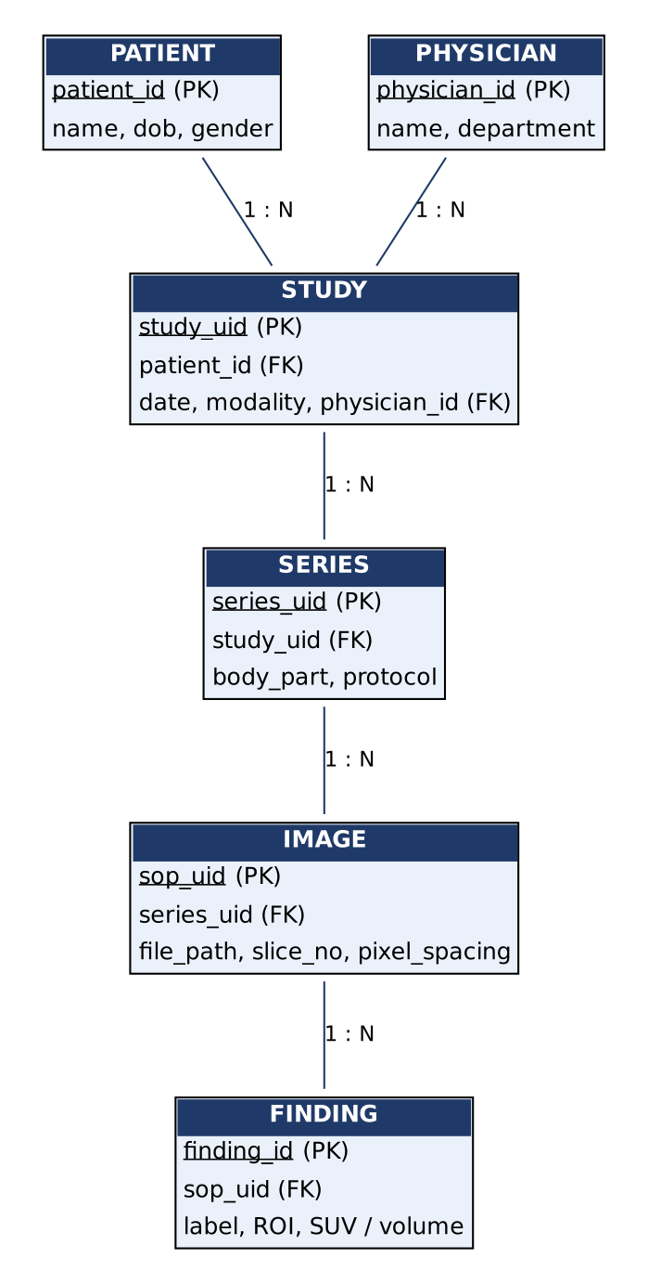
ER model for medical imaging data
Diagram explanation: follows the DICOM hierarchy: one PATIENT has many STUDIES (scan visits); each study has many SERIES (e.g. T1, T2 sequences); each series has many IMAGES (slices); each image can have many FINDINGS (tumour ROI, SUV, volume). A PHYSICIAN orders/reads many studies. All links are 1 : N with foreign keys.

2. How each tool helps
Tool | Key strengths (textbook) | Use for medical imaging data
ER/Studio (Embarcadero / IDERA) | Conceptual → logical → physical models, forward/reverse engineering, repository, data lineage, impact analysis, governance (GDPR) | Enterprise hospital data model linking PACS, EHR and lab systems; track lineage of image-derived measurements; control access to sensitive data
Erwin Data Modeler (Erwin Inc., now Quest) | Drag-and-drop conceptual/logical/physical modeling, reverse engineering, version control, impact analysis, DBMS integration, data warehouse & ETL design, documentation | Design a research imaging data warehouse (fact = finding, dimensions = patient, modality, date) for analytics; document legacy radiology databases
DbSchema Pro | Visual interactive diagrams, multi-DBMS (MySQL, PostgreSQL, Oracle, SQL Server), reverse engineering, schema synchronisation, built-in SQL editor & query-result charts, virtual foreign keys, data import/export, collaboration | Explore an existing imaging DB, run queries (e.g. average tumour volume by age group) and chart results, keep dev/production schemas in sync

3. Common benefits for medical imaging
- Structure: clear entities, keys and relationships → data integrity (no orphan images).
- Integration: link imaging metadata with EHR, lab results, genomics (textbook: data integration in medical image analysis).
- Reverse engineering of legacy PACS/RIS databases for migration.
- Governance & privacy: identify PHI fields, apply naming standards, support HIPAA/GDPR compliance.
- Analysis-ready design: warehouse/star schemas let analysts query findings across thousands of studies (e.g. SUV trends during chemotherapy).
- Documentation & communication: radiologists, IT and researchers share one visual model.
- Collaboration & version control as the hospital system evolves.
Conclusion: These tools do not process pixels; they design and govern the database that organises imaging metadata and results, making medical imaging data consistent, secure and easy to analyse.
Memory trick: “ER/Studio = Enterprise governance, Erwin = Warehouse & ETL, DbSchema = Diagrams + queries + charts.” Hierarchy: “P-S-S-I” (Patient → Study → Series → Image).

4.7 Explain Lucidchart and its use in data visualization and database modeling. Mention advantages of Lucidchart over traditional ER diagram tools
★ | Asked for max 9 marks → written for 11 | Asked in: 2026 (9) | Source: DMV Textbook.pdf, PDF p. 94-95 (LucidChart)
Definition: Lucidchart is a web-based (cloud) diagramming and visualization tool (by Lucid Software) used to create flowcharts, ER diagrams, UML, BPMN, data-flow diagrams, network and org charts. Its user-friendly drag-and-drop interface and real-time collaboration make it popular for data modeling.
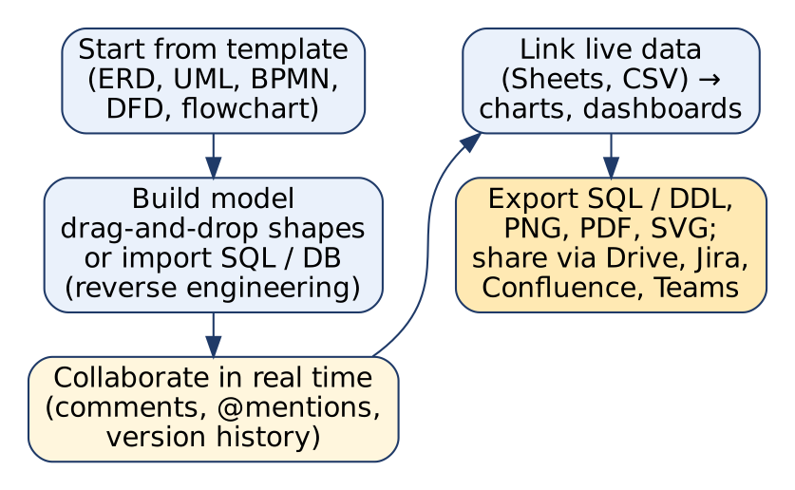
Lucidchart workflow
Diagram explanation: start from a template → build the model by drag-and-drop or by importing an existing database → collaborate in real time → link live data for charts → export SQL/DDL or images and share through integrated apps.

1. Use in database modeling
- ER diagrams (conceptual, logical, physical) with entity shapes, keys and crow’s-foot relationships.
- Reverse engineering: import schema from MySQL, PostgreSQL, SQL Server, Oracle → auto-generated ERD.
- SQL / DDL generation (forward engineering) from the diagram.
- Import/export in various formats for compatibility with other tools.
- Version control / revision history: compare and restore earlier versions.
- Data-driven automation: rules that update diagram elements when data changes.

2. Use in data visualization
- Charts, graphs and dashboards linked to live data sources (Google Sheets, CSV).
- Flowcharts, DFDs, BPMN to visualise processes and data flow.
- Presentation mode to show diagrams professionally in meetings.
- Org charts, mind maps, network diagrams.

3. Collaboration & integration
- Real-time multi-user editing, comments, @mentions; non-technical stakeholders can give feedback.
- Integrations: Google Drive/Workspace, Microsoft OneDrive/Office/Teams, Dropbox, Atlassian Jira & Confluence, Slack.
- Security: role-based access, SSO, encryption.

4. Advantages of Lucidchart over traditional ER diagram tools
No. | Point | Lucidchart | Traditional ER tools (e.g. ER/Studio, Erwin, desktop Visio)
1 | Platform | Browser-based, no installation, any OS | Desktop install, often Windows only
2 | Collaboration | Real-time co-editing, comments | Check-in/check-out, one editor at a time
3 | Ease of use | Drag-and-drop, templates, low learning curve | Feature-heavy, steep learning curve
4 | Cost | Free tier + low subscription | Expensive enterprise licences
5 | Diagram range | ERD + UML + BPMN + flowcharts + dashboards in one tool | Mainly data models
6 | Integrations | Google, Microsoft, Jira, Confluence, Slack | Limited office/cloud integration
7 | Sharing | Share by link, cloud storage, presentation mode | Export files, email
8 | Live data | Charts linked to live data sources | Usually static
9 | Access | Any device, anywhere | Licensed machine
Limitation (be balanced): Lucidchart is weaker for enterprise data governance: deep impact analysis, data lineage, large model repositories and complex DDL compare/sync remain stronger in ER/Studio or Erwin.

Example
A college team designs a Library Management database in Lucidchart: imports the existing MySQL schema, adds a new Reservation entity together in real time, comments are resolved, then exports DDL and embeds the ERD in a Confluence page.
Conclusion: Lucidchart makes database modeling and visualization collaborative, cloud-based and easy, which is its main advantage over traditional, desktop-based ER tools.
Memory trick: “WE-CAN-SHARE”: Web-based, Easy, Collaborative, Affordable, No install; SHARE via integrations.

4.8 Discuss a case study where medical image visualization and database modeling played a crucial role in diagnosis or treatment
★ | Asked for max 6 marks → written for 8 | Asked in: 2025 (6) | Source: General concepts: DMV Textbook.pdf, PDF p. 85-87 (visualization & analysis of medical images; PET-CT fusion in cancer). The specific case study: ⚠ Not found in your materials. Standard textbook answer (illustrative composite case, not a real patient record).
Introduction: In modern hospitals, imaging data (CT, MRI, PET) and clinical data are linked through a well-designed database, and clinicians use visualization tools (3-D rendering, PET-CT fusion) to diagnose and plan treatment.

Case: lung cancer diagnosis and treatment monitoring with PET-CT (illustrative)
1. Problem: A 58-year-old smoker has a persistent cough; a chest X-ray shows a suspicious nodule.
2. Imaging & visualization:
- CT scan: 3-D volume rendering shows a 2.4 cm nodule in the right lung (anatomy).
- ¹⁸F-FDG PET-CT: fused image shows high uptake (SUV_{max} = 8.5) in the nodule and one mediastinal lymph node → suspicious for cancer with lymph-node spread.
- Segmentation & quantification: tumour volume and SUV measured automatically (CAD software).
3. Database modeling (designed with ER/Studio/Erwin):
- Entities: Patient → Study → Series → Image → Finding, plus Biopsy, Treatment, Physician (see the ER model in 4.6).
- Each finding stores SUV, volume, location, date, linked to biopsy result (adenocarcinoma) and treatment plan.
- Integration with EHR and lab systems via keys (patient_id, study_uid).
4. Diagnosis & treatment: Biopsy-guided by CT confirms cancer, stage determined from PET (node involvement) → chemo-radiotherapy planned; PET-CT contours define the radiation target.
5. Monitoring: After 3 cycles, follow-up PET-CT; a database query compares findings over time: SUV 8.5 → 2.1, volume −60% → good response. A line chart of SUV vs date (from the database) is shown at the tumour board.

Role played by each component
Component | Contribution
Visualization (3-D rendering, PET-CT fusion, colour SUV maps) | Located tumour, showed spread, defined radiation target
Data modeling (normalised imaging + clinical schema) | Linked images, findings, biopsy and treatment for each patient; enabled longitudinal queries
Analytics (SUV trends, volume change) | Objective measure of treatment response

Outcome / benefits
Faster, more accurate staging, personalised treatment, objective monitoring, data available for research (cohort analysis of response).
Conclusion: Visualization shows where and how active the disease is; database modeling connects every image and result over time; together they improve diagnosis, treatment planning and follow-up.
Exam tip: Structure any case study as Problem → Imaging & visualization → Database design → Diagnosis/treatment → Monitoring → Outcome, and draw the Patient-Study-Series-Image-Finding ER diagram.

4.9 Explain DbSchema Pro modeler in data modeling and visualization
★ | Asked for max 4 marks → written for 6 | Asked in: 2023 (4) | Source: DMV Textbook.pdf, PDF p. 92-93 (6.4.3 DbSchemaPro)
Definition: DbSchema Pro is a feature-rich, cross-platform visual database design and management tool that helps database professionals design, manage, document and visualise complex databases through interactive diagrams.

Features
- Visual data models: conceptual, logical, physical diagrams; drag-and-drop; drill down into entities and relationships.
- Multi-DBMS support: MySQL, PostgreSQL, Oracle, SQL Server, and more (via JDBC); also some NoSQL.
- Reverse engineering: import an existing database into a diagram.
- Schema synchronisation & migration: compare model with database and deploy differences.
- Built-in SQL editor / query builder; results visualised as charts, graphs, pivot tables.
- Virtual foreign keys, data import/export, random data generator.
- HTML/PDF documentation generation.
- Collaboration: concurrent editing, version control (Git); security for sensitive data.

Uses
Designing new databases, understanding legacy schemas, keeping dev/test/prod schemas in sync, quick data exploration and charting.
Conclusion: DbSchema Pro combines schema design, synchronisation, querying and charting in one visual tool for many databases.
Memory trick: “VRS-QD”: Visual diagrams, Reverse engineering, Sync; Query + charts, Documentation.

4.10 Explain SQL Database Modeler in data modeling and visualization
★ | Asked for max 4 marks → written for 6 | Asked in: 2023 (4) | Source: DMV Textbook.pdf, PDF p. 94 (6.4.5 SQL Database Modeller)
Definition: SQL Database Modeler is a specialised (web-based) tool for data modeling and visualization of SQL databases. It lets database professionals, architects and developers design, manage and visualise database structures.

Features
- Visual data models: conceptual, logical and physical models of tables, columns and relationships.
- Multi-DBMS: MySQL, PostgreSQL, SQL Server, Oracle, and others.
- Reverse engineering: import existing databases → automatic diagrams (document legacy DBs).
- Interactive, navigable diagrams of schema, tables, columns, keys.
- SQL scripting & query execution inside the tool; forward engineering (DDL generation).
- Database synchronisation and migration support.
- Documentation, charting of query results, export as PNG, SVG, PDF.
- Version control and team collaboration (concurrent editing); customisation to company standards.

Uses
Designing relational schemas, documenting legacy databases, migrating between DBMSs, team-based schema design.
Conclusion: SQL Database Modeler gives a visual, collaborative way to design and maintain SQL databases, from diagram to DDL.
Memory trick: “D-R-I-S-S”: Design models, Reverse engineer, Interactive diagrams, SQL scripting, Sync/migrate.

4.11 Write a short note on analysis of medical images
★ | Asked for max 4 marks → written for 6 | Asked in: 2026 (short note 4) | Source: DMV Textbook.pdf, PDF p. 85-86 (6.2 Visualization and Analysis of Medical Images), p. 89 (image pre-processing, feature extraction, classification, segmentation)
Definition: Medical image analysis is the use of data modeling, algorithms and visualization to extract meaningful, quantitative information from medical images (X-ray, CT, MRI, ultrasound, PET, SPECT) for diagnosis, treatment planning and monitoring.
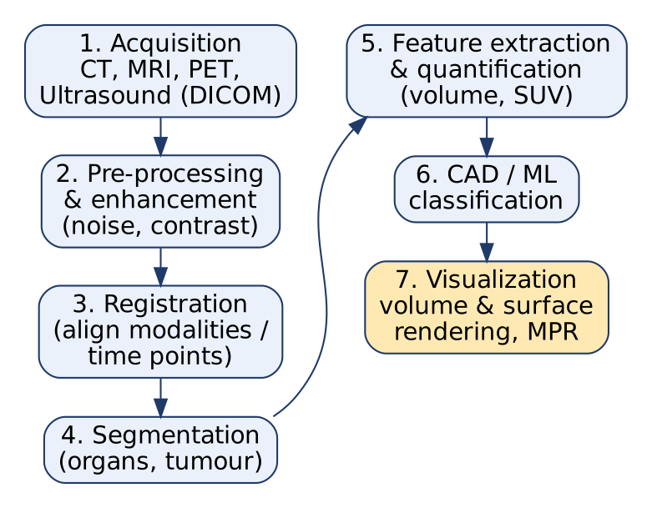
Medical image analysis pipeline

Steps / components
- Image acquisition from modalities (stored as DICOM).
- Pre-processing & enhancement: noise reduction, contrast enhancement, resizing.
- Image registration: align images from different modalities or time points (e.g. PET on MRI).
- Segmentation: divide image into regions (organs, tumour), e.g. U-Net, thresholding.
- Feature extraction & quantitative measurement: tumour volume, heart chamber volume, SUV, texture.
- Computer-aided diagnosis (CAD): ML/CNN classifiers act as a second opinion.
- Image-based modeling: patient-specific 3-D models for surgery and implant design.
- Visualization: volume rendering, surface rendering, multi-planar reformatting (MPR).
- Data integration with demographics, lab and genomic data.
Conclusion: Medical image analysis turns images into measurements and decisions, improving diagnostic accuracy and reducing human error.
Memory trick: “A-P-R-S-F-C-V” → “All Patients Receive Safe, Fast Care Visually”.

Last-Minute Revision Sheet: Unit 4
Topic | Key points to write
Data reconstruction | Transform/reshape raw data for analysis & visualization. 12 types: temporal, spatial, hierarchical, aggregated, cleansing/imputation, dimensionality reduction (PCA), normalization, forecasting, feature engineering, join/merge, unpivot, interpolation. Also 3-D reconstruction from MRI/CT slices.
PET | Functional imaging. ¹⁸F-FDG → uptake → positron → annihilation → 2 × 511 keV photons at 180° → coincidence detection → LOR/sinogram → FBP/OSEM reconstruction → image. SUV = C_{tissue} / (dose/weight). Uses: cancer, brain, heart, infection, drugs, personalised medicine. PET-CT fusion.
ER/Studio | Embarcadero/IDERA data modeling tool. Conceptual → logical → physical; forward (DDL) & reverse engineering; repository, collaboration, impact analysis, lineage, governance, documentation. Uses: DB design, data warehouse, ETL, migration.
Ultrasound | High-frequency sound, pulse-echo; depth d = c·t/2, c ≈ 1540 m/s. B-mode, Doppler, 3-D/4-D. Uses: obstetrics, abdomen, echocardiography, urology, MSK, emergency, guided biopsy. Safe, real-time.
MRI | Magnet aligns H protons → RF pulse → relaxation T1/T2 → signal → k-space → Fourier transform. No radiation, best soft-tissue contrast. fMRI, DWI/DTI. Uses: brain, cancer, joints, heart.
Tools for medical imaging | ER model: Patient → Study → Series → Image → Finding (1:N). ER/Studio = governance & lineage; Erwin = warehouse/ETL; DbSchema = diagrams + SQL + charts.
Lucidchart | Web-based diagramming: ERD, UML, BPMN, DFD; import DB, generate SQL; real-time collaboration; live-data charts; integrations. Advantages: browser, collaboration, ease, cost, integrations (“WE-CAN-SHARE”).
Case study | Problem → imaging & visualization (PET-CT fusion, 3-D) → DB design → diagnosis/treatment → monitoring (SUV trend) → outcome.
DbSchema Pro | Visual diagrams, multi-DBMS, reverse engineering, sync, SQL editor + charts, docs, Git collaboration.
SQL Database Modeler | Web tool for SQL DBs: models, reverse engineering, interactive diagrams, SQL scripting, sync/migration, export PNG/SVG/PDF.
Medical image analysis | Acquire → pre-process → register → segment → extract features/quantify → CAD → visualize (volume/surface rendering, MPR).

Assumptions & Gaps
- Exam Unit 4 = question pair Q7/Q8 = syllabus Unit VI “Data Analysis of Visualization and Modeling” (textbook Chapter 6, PDF p. 83-96).
- All citations are to Textbooks/DMV Textbook.pdf (scanned, OCR’d; PDF page numbers). There are no separate lecture notes in the repo.
- ⚠ Not found in your materials (standard textbook answers):
  - 4.2 PET image formation physics (positron annihilation, 511 keV coincidence detection, LOR/sinogram, FBP/OSEM, SUV formula). The textbook covers PET applications, reconstruction algorithms in general, ROI/voxel analysis and SUVs, but not the formation process asked in 2026.
  - 4.4 ultrasound pulse-echo principle and depth formula; 4.5 MRI physics (proton alignment, RF, T1/T2, k-space). The textbook covers only applications and data modeling/visualization uses.
  - 4.6 medical imaging ER schema / DICOM hierarchy and the tool-to-use mapping; tool features themselves are from the textbook.
  - 4.8 case study: the textbook has no medical case study (its “Case Study” heading covers the modeling tools). The lung-cancer PET-CT case is an illustrative composite built from standard clinical practice, not a real patient record.
- Facts added from standard knowledge: ER/Studio’s original developer Embarcadero (the textbook says Quest Software/IDERA); Lucidchart integrations such as Slack and Teams, its free tier, and the comparison table with traditional tools; DbSchema’s JDBC/NoSQL support and Git integration; normalization formulas in 4.1.
- Archi and PgModeler (textbook PDF p. 93-95) were never asked in the PYQs, so they are not answered here.

