Quantum Artificial Intelligence — Unit 4: Quantum Search, Quantum Walks and Quantum AI / Data Science
Exam answers for 70-mark end-sem (2.5 hrs). Each answer is written for (max marks asked + 2). Sources are PDF page numbers of the files in your repo; ⚠ marks content NOT found in your materials.

1. Unit snapshot
No. | Question | Max Marks | Years Asked | Importance
4.1 | Quantum Walk (incl. Random Insect / short note) | 9 | 2023, 2024, 2025 | ★★★
4.4 | Challenges and limitations of quantum computing in Data Science | 9 | 2023, 2024, 2025 | ★★★
4.3 | Quantum Tree Search | 8 | 2023, 2024 | ★★
4.6 | Heuristic Search with example | 8 | 2023, 2024 | ★★
4.2 | Quantum Neural Computation (and its significance) | 6 | 2023, 2025 | ★★
4.5 | Quantum Production System (Tarrataca's) | 6 | 2023, 2025 | ★★
4.7 | PennyLane - cross-platform Python library | 6 | 2025 | ★
4.8 | Quantum Search | 5 | 2025 | ★

2. Must-do first (★★★)
1. Q4.1 Quantum Walk (incl. Random Insect / short note) — max 9 marks, asked 2023, 2024, 2025
2. Q4.4 Challenges and limitations of quantum computing in Data Science — max 9 marks, asked 2023, 2024, 2025

3. Full answers (★★★ → ★★ → ★)

Q4.1. Quantum Walk (incl. Random Insect / short note)
Importance | Max marks asked | Answer written for | Asked in | Source
★★★ | 9 | 11 marks | 2023 Q7a; 2024 Q8a; 2025 Q8c | Not in your materials (quantum walk appears only inside a question list, QAI-ii.pdf p.37)

Question wording(s) asked: 2023 Q7a [6]: “Write short note on Quantum Walk.” | 2024 Q8a [9]: “Describe the Quantum Walk-Random Insect.” | 2025 Q8c [5]: “Write a note on Quantum walk.”
Source status: ⚠ Not found in your materials. Standard textbook answer. Interpretation: ‘Random Insect’ (2024 Q8a) is read as the classical random walk of an insect/drunkard on a line, compared with its quantum version.

Definition: A quantum walk is the quantum analogue of a classical random walk: instead of a particle moving left/right by a coin toss, the walker has a quantum coin and is in a superposition of positions, so different paths interfere. This makes it spread quadratically faster and is a tool for building quantum algorithms.

1. Classical random walk (the ‘insect’)
- An insect on a line tosses a coin each step: heads → right, tails → left.
- After t steps position spread σ ≈ √t (diffusive); distribution is a bell curve centred at the start.

2. Discrete-time quantum walk (coined walk)
1. State space: position |x⟩ ⊗ coin |c⟩ with c ∈ {0 (left), 1 (right)}.
2. Coin operation C: apply a Hadamard to the coin qubit → coin in superposition of ‘left’ and ‘right’.
3. Shift operation S: move right if coin = 1, left if coin = 0 (conditional on coin): S|x,c⟩ = |x ± 1, c⟩.
4. One step: U = S·(C ⊗ I). Repeat t times (no measurement in between, so paths interfere).
5. Measure position at the end → probability distribution.
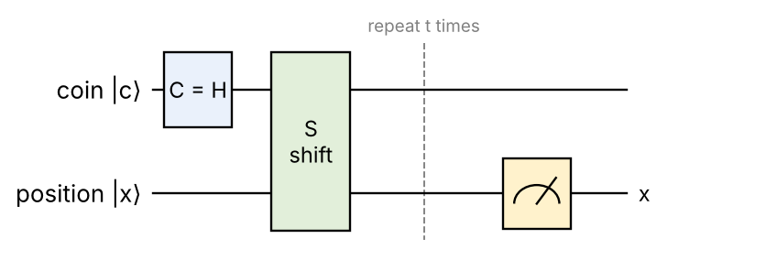
Fig: One step of a discrete quantum walk: coin flip (Hadamard) then conditional shift; repeated t times
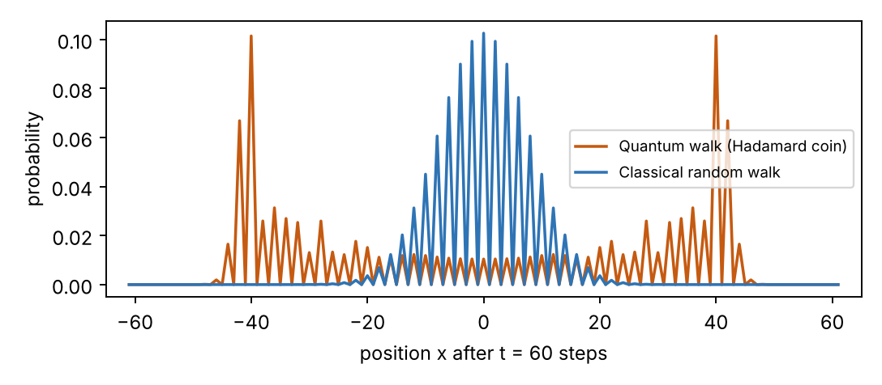
Fig: Probability after 60 steps: classical walk (blue, narrow bell) vs quantum Hadamard walk (orange, spread out with peaks near the ends)

3. Continuous-time quantum walk
- No coin; evolution U(t) = e^(−iHt) where H = adjacency matrix (or Laplacian) of the graph; state spreads over graph nodes by Schrödinger evolution.

4. Comparison
Point | Classical random walk | Quantum walk
Randomness | Coin toss, one path at a time | Superposition of all paths + interference
Spread σ after t steps | ≈ √t | ≈ t (ballistic, ≈ 0.54 t for Hadamard coin)
Distribution | Bell curve (binomial) centred at start | Two peaks near ±t/√2, flat middle
Evolution | Stochastic (probabilities) | Unitary (amplitudes), reversible
Hitting time on graph | Polynomial | Can be exponentially faster on some graphs

5. Applications
- Quantum search on graphs/grids (spatial search – matches Grover's √N), element distinctness, triangle finding, evaluating game trees (quantum tree search), graph isomorphism heuristics.
- Universal model of quantum computation; basis for quantum Monte-Carlo / PageRank and for quantum transport in photosynthesis.

6. Worked example – the ‘insect’ walk for 3 steps
Convention: coin |0⟩ → step left, coin |1⟩ → step right; start at x = 0 with coin |0⟩; coin operator = H.
1. Step 1: (|−1,0⟩ + |+1,1⟩)/√2 → P(−1) = P(+1) = ½ (same as a classical insect).
2. Step 2: ½[|−2,0⟩ + |0,1⟩ + |0,0⟩ − |2,1⟩] → P(−2) = ¼, P(0) = ½, P(2) = ¼ (still classical-looking).
3. Step 3: (1/2√2)[|−3,0⟩ + 2|−1,0⟩ + |−1,1⟩ − |1,0⟩ + |3,1⟩] – the two |0,1⟩ terms (+ and −) cancelled (destructive interference).
Position after 3 steps | −3 | −1 | +1 | +3
Classical random walk | 1/8 | 3/8 | 3/8 | 1/8
Quantum (Hadamard) walk | 1/8 | 5/8 | 1/8 | 1/8

Interference already makes the quantum distribution different (asymmetric for this start state); after many steps it spreads ballistically (σ ≈ 0.54 t, the plot above shows t = 60: σ ≈ 32 vs √60 ≈ 7.7).
Conclusion: A quantum walk replaces the random coin by a quantum coin, so superposition and interference make the walker spread quadratically faster – the basis of many quantum search algorithms.

💡 Memory trick / Exam tip: “Coin – Shift – Repeat – Measure; spread t (quantum) vs √t (classical).”

Q4.4. Challenges and limitations of quantum computing in Data Science
Importance | Max marks asked | Answer written for | Asked in | Source
★★★ | 9 | 11 marks | 2023 Q8a; 2024 Q7a; 2025 Q8b | QAI-ii.pdf p.22 (4.2.3 Challenges of quantum-enhanced machine learning: hardware limitations, error correction, hybrid integration, scalability), p.2–4 (QC overview, noise and decoherence)

Question wording(s) asked: 2023 Q8a [6]: “State the challenges and limitations are associated with quantum computing in data sciences.” | 2024 Q7a [9]: “State the challenges and limitations are associated with quantum computing in data sciences.” | 2025 Q8b [6]: “Enlist and discuss challenges and limitations associated with quantum computing utilised in Data Science.”
Source status: Partly ⚠ not found: your book lists general challenges of quantum-enhanced ML (p.22); the data-science-specific points (data loading, dequantization, readout, benchmarks) are from standard knowledge.

Definition: Data science needs to load, store and analyse very large classical data. Quantum computing promises speed-ups for linear algebra, optimisation and ML, but it faces many technical and practical challenges and limitations before it can be used in data science.

Challenge / limitation | Explanation | Possible remedy
Quantum hardware limits | Few qubits, short coherence, noisy gates (NISQ) – QAI-ii.pdf p.22 | Better hardware, error mitigation
Noise & error correction | Qubits are fragile; QEC needs 100s–1000s of physical qubits per logical qubit (p.22) | Fault-tolerant codes, VQAs
Data loading (QRAM) | Classical big data must be encoded into qubits (amplitude encoding); loading can cost O(N) and kill the speed-up | QRAM, efficient state preparation
Readout bottleneck | Measurement gives only samples, not the full result vector (e.g. HHL gives |x⟩, not x) | Ask for aggregate properties
Assumption-dependent speed-ups | HHL needs sparse, well-conditioned matrices; ‘dequantized’ classical algorithms often match QML | Honest benchmarking
Hybrid integration | Combining classical and quantum workflows efficiently is non-trivial (p.22) | Frameworks: Qiskit, PennyLane
Scalability | Algorithms must scale to real datasets; qubit count and circuit depth limited (p.22) | Modular / networked QC
Training difficulties | Barren plateaus, many measurement shots, noisy gradients | Better ansatz, initialisation
Skills, tools, cost | Shortage of quantum-ML experts; expensive access; immature software, no standards | Education, cloud access
Interpretability & benchmarking | Hard to compare with strong classical baselines; results are probabilistic | Standard benchmarks
Security | Quantum computers threaten current encryption of data (Shor) | Post-quantum cryptography

Overall: quantum computing is promising for data science but today works best for small, structured problems; realistic gains need fault-tolerant hardware and efficient data loading.

Explanation of the three biggest barriers
1. Data loading (input problem): a dataset of N numbers must be encoded into log₂N qubits; without fast QRAM, preparing the state takes O(N) time, so the claimed exponential speed-up disappears.
2. Read-out (output problem): a measurement returns one sample; recovering an N-dimensional answer needs about N repetitions. Useful only when a single number (expectation, class label) is needed.
3. NISQ hardware: today's 50–1000 noisy qubits with ~10⁻³ gate errors allow only shallow circuits; deep algorithms (HHL, Shor-scale) need error-corrected logical qubits.

Where quantum computing can still help data science
Area | Quantum approach
Optimisation (scheduling, portfolio) | QAOA, quantum annealing
Kernel methods / classification | Quantum kernels, QSVM, VQC
Sampling & Monte-Carlo | Amplitude estimation (quadratic speed-up)
Linear algebra on huge sparse data | HHL-type algorithms (future, fault-tolerant)

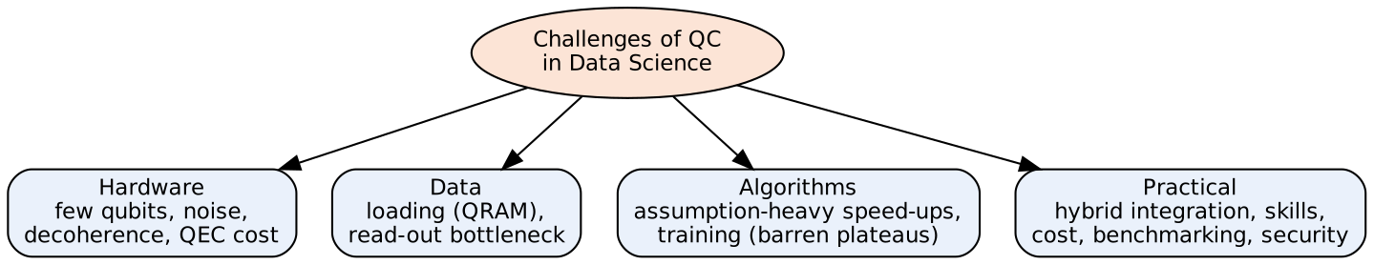
Fig: Mind-map: four groups of challenges (easy to redraw in the exam)
Groups: Hardware limits what can run; Data limits how fast information gets in and out; Algorithms limits where speed-ups are real; Practical issues limit adoption.
Conclusion: Limited, noisy hardware, expensive data loading/readout and assumption-heavy speed-ups are the main barriers to using quantum computing in data science.

💡 Memory trick / Exam tip: “Hardware, Noise, Loading, Readout, Hybrid, Scale.” Give at least 6 points with one-line explanations.

Q4.3. Quantum Tree Search
Importance | Max marks asked | Answer written for | Asked in | Source
★★ | 8 | 10 marks | 2023 Q7c; 2024 Q8b | Not in your materials (only Grover's algorithm, QAI-ii.pdf p.13–15, is the related tool)

Question wording(s) asked: 2023 Q7c [5]: “Write a short note on Quantum Tree Search.” | 2024 Q8b [8]: “Write a short note on Quantum Tree Search.”
Source status: ⚠ Not found in your materials. Standard textbook answer.

Definition: Quantum tree search applies quantum algorithms (Grover search and quantum walks) to search a tree (state-space of a puzzle, game or constraint problem) for a goal node/leaf, giving a quadratic speed-up: about √T steps for a tree with T nodes instead of T.

1. Classical tree search
- Depth-first / breadth-first / backtracking explore nodes one by one: tree with branching factor b and depth d has about bᵈ nodes → time O(bᵈ).

2. Quantum approach
1. Represent paths from the root as basis states: each path (sequence of rule/branch choices) is a binary string |p⟩.
2. Superposition: Hadamards create all paths of depth d simultaneously.
3. Oracle: checks (reversibly) whether the path ends in a goal state and marks it with a −1 phase.
4. Amplitude amplification (Grover): ≈ (π/4)√(bᵈ) = O(b^(d/2)) iterations.
5. Measure → the path to a goal; verify classically.
6. (Alternative: quantum backtracking – a quantum walk on the tree finds a marked node in ≈ √T·poly(d) steps.)
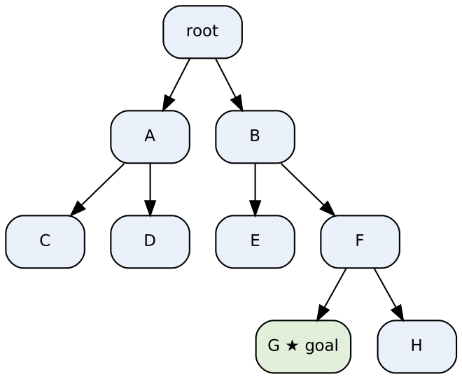
Fig: Tree with one goal leaf (G): Grover searches all root-to-leaf paths in superposition
Example: binary tree of depth 3 → 8 leaf paths (3 qubits). Classical search needs up to 8 (≈ 4 on average) goal tests; Grover needs ≈ (π/4)√8 ≈ 2 iterations.
Point | Classical | Quantum
Nodes examined | ≈ T (or bᵈ) | ≈ √T (b^(d/2))
Idea | Sequential visiting | Superposition of paths + amplitude amplification / quantum walk
Result | Deterministic | Probabilistic, verified

3. Uses
- Constraint satisfaction, SAT, puzzles, game-tree evaluation, planning in AI (links to quantum production systems).

4. Encoding a search tree in qubits
- A tree with branching factor b and depth d has bᵈ root-to-leaf paths.
- Each path = sequence of d choices → needs d·⌈log₂ b⌉ qubits (e.g. b = 2, d = 3 → 3 qubits, 8 paths).
- The oracle follows the choices with reversible circuits and tests the leaf state against the goal.

5. Example – maze / 8-puzzle
For an 8-puzzle limited to depth d = 10 with average branching b ≈ 3, classical exhaustive search checks up to 3¹⁰ ≈ 59 000 paths; Grover-based tree search needs about (π/4)√59 000 ≈ 190 oracle calls (plus verification) – quadratic saving.

6. Limitations
- Only quadratic speed-up; the number of qubits grows with depth; all rule applications must be reversible; real trees are irregular (need quantum backtracking to handle them efficiently).

7. Game-tree evaluation
For AND–OR (NAND) game trees with N leaves, a continuous-time quantum-walk algorithm (Farhi, Goldstone, Gutmann, 2007) decides the winner in about N^0.5 time, versus about N^0.753 for the best classical randomized algorithm – another quantum tree-search speed-up.
Conclusion: Quantum tree search speeds up exhaustive tree exploration quadratically by searching all paths in superposition with Grover/quantum-walk techniques.

💡 Memory trick / Exam tip: “bᵈ → b^(d/2).”

Q4.6. Heuristic Search with example
Importance | Max marks asked | Answer written for | Asked in | Source
★★ | 8 | 10 marks | 2023 Q8c; 2024 Q7b | Passing mention only: QAI-ii.pdf p.15 (heuristics as rules of thumb guiding search, job-shop scheduling case study)

Question wording(s) asked: 2023 Q8c [5]: “Describe the Heuristic Search with example.” | 2024 Q7b [8]: “Describe Heuristic Search with example.”
Source status: ⚠ Not found in your materials. Standard textbook answer.

Definition: Heuristic search is a search that uses problem-specific knowledge – a heuristic function h(n) estimating the cost from node n to the goal – to explore the most promising nodes first, instead of searching blindly. Heuristics are ‘rules of thumb’ (QAI-ii.pdf p.15).

1. A* algorithm (best-first search)
f(n) = g(n) + h(n)
g(n) = actual cost from start to n ; h(n) = estimated cost from n to goal ; f(n) = estimated total cost through n
1. Put the start node in OPEN with f = h(start).
2. Remove the node with the lowest f from OPEN.
3. If it is the goal → stop (optimal if h never overestimates, i.e. is admissible).
4. Otherwise expand it, compute f for its successors, add them to OPEN (update if a cheaper path is found).
5. Repeat.

2. Example
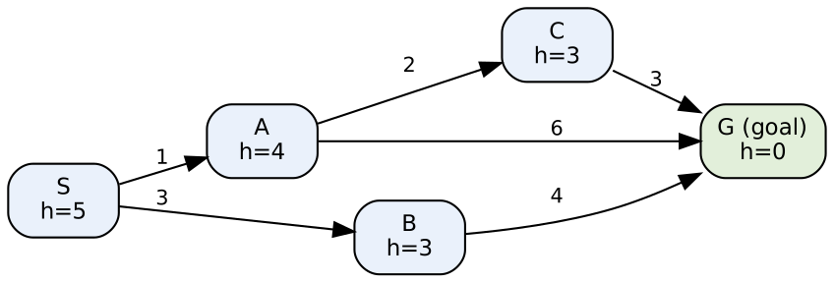
Fig: Search graph: edge labels = step cost, h = heuristic estimate to G
Step | Expanded node | OPEN list with f = g + h
1 | S | A (1+4=5), B (3+3=6)
2 | A (f=5) | B 6, C (3+3=6), G (7+0=7)
3 | B (f=6) | C 6, G 7 (via B: 7, no better)
4 | C (f=6) | G (6+0=6) – improves G
5 | G (f=6) | Goal reached

Solution: S → A → C → G with total cost 1 + 2 + 3 = 6 (optimal); blind search would have explored all nodes.

3. Quantum connection
- A good heuristic prunes the tree (reduces branching factor b); quantum search (Grover / quantum production system) is then applied to the pruned tree → time ≈ √(b_eff^d), combining both speed-ups.
- Variational/heuristic methods like QAOA also act as heuristics for optimisation (book p.15–16).
Blind search | Heuristic search
No problem knowledge | Uses h(n)
Explores many nodes | Explores few promising nodes
Always complete, slow | Fast; optimal if h admissible

4. Types of heuristic search
Method | Evaluation used | Property
Hill climbing | h(n) only, best neighbour | Fast, may get stuck in local maxima
Greedy best-first | f(n) = h(n) | Fast, not optimal
A* | f(n) = g(n) + h(n) | Optimal with admissible h
Beam search | Keeps best k nodes | Memory-bounded, not complete

5. Good heuristics
- Admissible: never overestimates the true cost (h(n) ≤ h*(n)) → A* is optimal.
- Consistent: h(n) ≤ cost(n, n′) + h(n′).
- 8-puzzle examples: h₁ = number of misplaced tiles; h₂ = sum of Manhattan distances (h₂ dominates h₁ and expands fewer nodes).

6. Applications
- Route finding (Google Maps-style A*), game AI and robot path planning, puzzle solving (8-puzzle, Rubik's cube), job-shop scheduling (book p.15: heuristics as ‘rules of thumb’), and as a pruning stage before quantum tree search.
Conclusion: Heuristic search guides exploration with an estimate h(n), reaching the goal with far fewer nodes; quantum search can speed up the remaining search further.

💡 Memory trick / Exam tip: “f = g + h; pick the lowest f; admissible h ⇒ optimal.”

Q4.2. Quantum Neural Computation (and its significance)
Importance | Max marks asked | Answer written for | Asked in | Source
★★ | 6 | 8 marks | 2023 Q7b; 2025 Q8a | QAI-ii.pdf p.20–23 (QNN in quantum-enhanced ML), p.34–35 (QNN: encoding, quantum neurons, operations, measurement and learning; XOR example)

Question wording(s) asked: 2023 Q7b [6]: “Explain Quantum Neural Computation.” | 2025 Q8a [6]: “Discuss quantum neural computations with its significance.”
Source status: Partly ⚠ not found: your book explains Quantum Neural Networks, but not ‘quantum neural computation’ as a topic; the answer builds on the QNN pages and adds standard background (quantum perceptron, associative memory).

Definition: Quantum neural computation is information processing with neural-network models implemented on quantum systems: inputs are encoded in qubits, quantum gates act as neurons/weights, and learning adjusts gate parameters (QAI-ii.pdf p.34). It merges the parallelism of quantum computing with the learning ability of neural networks.

1. Elements (book p.34)
Element | Classical neural net | Quantum neural computation
Input | Vector x | Quantum state |ψ_x⟩ (quantum encoding)
Neuron | y = f(Σ wᵢxᵢ) | Quantum gates / circuits (quantum perceptron U(θ))
Weights | Real numbers | Gate parameters θ (rotation angles)
Output | Activation value | Measurement result (probabilistic)
Learning | Back-propagation | Classical optimiser adjusts θ (hybrid)

Fig: Quantum neural computation (hybrid training loop)

2. Significance (why it matters)
- Exponentially large state space: n qubits represent 2ⁿ amplitudes → compact models.
- Superposition & entanglement give parallelism and rich correlations.
- Quantum associative memory: stores ~2ⁿ patterns in n qubits (classical Hopfield stores ≈ 0.14·n).
- Potentially faster training / fewer parameters; applications in pattern recognition, classification, optimisation, quantum-data analysis (QAI-ii.pdf p.20–23).

3. Example (book p.35)
XOR problem solved by a QNN with ZZ-feature-map encoding and RealAmplitudes layers, trained with SPSA: predicted labels [0 1 1 0] = true labels (100 % accuracy).

4. Limitations
- Noise, few qubits, barren plateaus, data-loading cost; measurement is probabilistic.

5. Quantum perceptron (model of a quantum neuron)
Classical neuron: y = f( Σᵢ wᵢ xᵢ + b )
Quantum neuron: |ψ_x⟩ → U(w)|ψ_x⟩ , output P(1) = |⟨1|U(w)|ψ_x⟩|² (measurement acts as activation)
- Inputs xᵢ are encoded as rotation angles or amplitudes; weights wᵢ are gate parameters; the non-linear ‘activation’ comes from measurement probabilities.
- Quantum associative memory / Hopfield-type models store patterns as superpositions and retrieve the closest pattern with Grover-like amplification.

6. Applications
- Image and speech pattern recognition, classification of quantum data (phase detection in physics), associative memory and pattern completion, optimisation and financial forecasting using hybrid QNN models.
Conclusion: Quantum neural computation implements neurons as parameterised quantum circuits and trains them hybrid-style, offering large representational capacity and possible speed-ups.

💡 Memory trick / Exam tip: “Neuron = quantum gate, weight = angle, activation = measurement.”

Q4.5. Quantum Production System (Tarrataca's)
Importance | Max marks asked | Answer written for | Asked in | Source
★★ | 6 | 8 marks | 2023 Q8b; 2025 Q7c | Not in your materials

Question wording(s) asked: 2023 Q8b [6]: “Explain Quantum Production System in detail.” | 2025 Q7c [6]: “Elaborate tarrataca's quantum production system.”
Source status: ⚠ Not found in your materials. Standard textbook answer. Details of Tarrataca's model below are recalled from general knowledge of the literature (L. Tarrataca & A. Wichert, tree search with Grover's algorithm) – verify the exact formulation against your class notes.

Definition: A production system (classical AI) solves problems by repeatedly applying production rules (IF condition THEN action) to a current state until a goal is reached; the possible states form a search tree. A quantum production system (as proposed by Tarrataca) represents states and rules with qubits and uses quantum superposition and Grover's algorithm to search this tree faster.

1. Classical production system – three parts
- Rule base (productions: condition → action).
- Working memory / database: the current state.
- Control strategy (inference engine): chooses which applicable rule to fire (DFS, BFS, heuristic).

2. Quantum production system
1. State register: qubits storing the current state (initial state in |s₀⟩).
2. Rule/choice register: in a uniform superposition of all rule choices at each depth level.
3. Reversible rule application: each production is implemented as a unitary operator so that all rule sequences are applied in superposition: Σ |r₁…r_d⟩|s₀⟩ → Σ |r₁…r_d⟩|s_(r₁…r_d)⟩.
4. Goal test oracle: marks (phase −1) all sequences whose final state satisfies the goal.
5. Grover amplitude amplification on the rule-sequence register (≈ √(bᵈ) iterations).
6. Measure the rule register → sequence of rules (solution path).
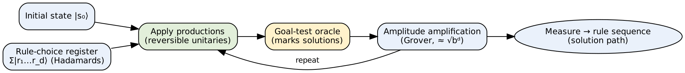
Fig: Block diagram of a quantum production system
Components: the rule-choice register encodes every possible sequence of rules; the productions act as reversible gates; the oracle tells goal from non-goal; Grover boosts the goal paths.
Point | Classical production system | Quantum production system
States | One current state | Superposition of all reachable states
Search | Sequential, O(bᵈ) | Amplitude amplification, O(b^(d/2))
Rules | Arbitrary functions | Must be reversible (unitary)
Result | Deterministic path | Probabilistic, verified path

3. Limitations
- Needs reversible rules and enough qubits (grows with depth); only quadratic speed-up; noise on current hardware.

4. Example of production rules (8-puzzle / water-jug style)
Rule | Condition (IF) | Action (THEN)
R1 | blank not in top row | move blank up
R2 | blank not in bottom row | move blank down
R3 | blank not in left column | move blank left
R4 | blank not in right column | move blank right

Classically, the control strategy fires one rule at a time and back-tracks. In the quantum production system the rule-choice register holds all sequences R₁R₂…R_d at once (2 qubits per step for 4 rules), so a depth-d search over 4ᵈ sequences needs only about 2ᵈ Grover iterations.
Conclusion: A quantum production system encodes the production-rule search tree in qubits and uses Grover's algorithm to find a goal path in about √(bᵈ) steps.

💡 Memory trick / Exam tip: “Rules as unitaries + Superposed paths + Goal oracle + Grover.”

Q4.7. PennyLane - cross-platform Python library
Importance | Max marks asked | Answer written for | Asked in | Source
★ | 6 | 8 marks | 2025 Q7a | Not in your materials

Question wording(s) asked: 2025 Q7a [6]: “Discuss penny lane a cross platform python library.”
Source status: ⚠ Not found in your materials. Standard textbook answer.

Definition: PennyLane is an open-source, cross-platform Python library (from Xanadu) for quantum machine learning, quantum computing and quantum chemistry. Its key feature is automatic differentiation of quantum circuits, so hybrid quantum–classical models can be trained like neural networks.

1. Why cross-platform
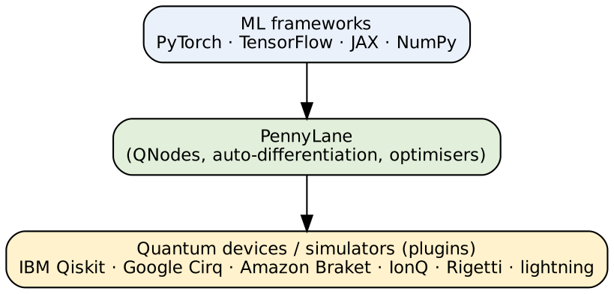
Fig: PennyLane sits between ML libraries and quantum hardware/simulators

2. Features
- QNode: a quantum function bound to a device, callable like a normal Python function.
- Hardware-agnostic: same code runs on many simulators/hardware (change the device name).
- Automatic differentiation: gradients via parameter-shift rule, back-propagation (simulators).
- Built-in optimisers (GradientDescent, Adam), templates (AngleEmbedding, StronglyEntanglingLayers) and chemistry tools.
- Integrates with PyTorch/TensorFlow/JAX for hybrid models.

3. Example
import pennylane as qml
from pennylane import numpy as np
dev = qml.device('default.qubit', wires=2)

@qml.qnode(dev)
def circuit(params):
qml.RX(params[0], wires=0)
qml.CNOT(wires=[0, 1])
qml.RY(params[1], wires=1)
return qml.expval(qml.PauliZ(1)) # cost

params = np.array([0.5, 0.2], requires_grad=True)
opt = qml.GradientDescentOptimizer(0.1)
for _ in range(50):
params = opt.step(circuit, params) # minimise <Z>

The circuit is evaluated on the device; PennyLane differentiates it and the classical optimiser updates `params` – a variational quantum algorithm in a few lines.

4. Applications / comparison
- Variational classifiers, QNNs, VQE for molecules, QAOA, quantum kernels.
- Unlike Qiskit (IBM-centric circuits), PennyLane's focus is differentiable programming across platforms.

5. Key concepts
Concept | Meaning
Device | Backend that runs the circuit: qml.device('default.qubit', wires=2) or a hardware plugin
QNode | Quantum function + device, decorated with @qml.qnode; returns expectation values/probabilities
Templates | Ready layers: AngleEmbedding, StronglyEntanglingLayers, QAOA layers
Interfaces | Gradients flow into PyTorch / TensorFlow / JAX models
Optimisers | GradientDescentOptimizer, AdamOptimizer, QNGOptimizer

6. PennyLane vs other libraries
Point | PennyLane | Qiskit | Cirq
Developer | Xanadu | IBM | Google
Focus | Differentiable QML, hybrid models | Circuits, IBM hardware, algorithms | Circuits, Google hardware, NISQ research
Hardware | Many (via plugins) | Mainly IBM | Mainly Google
Auto-diff | Built-in | Via add-ons | Via TensorFlow Quantum

7. Getting started
Install with pip install pennylane; add plugins such as pennylane-qiskit to run the same QNode on IBM devices. The same code also runs on a laptop simulator, which makes PennyLane suitable for teaching and research.
Conclusion: PennyLane is a hardware-agnostic Python library that makes quantum circuits differentiable and trainable, enabling hybrid quantum machine learning.

💡 Memory trick / Exam tip: “PennyLane = Python + Autodiff + Any device.”

Q4.8. Quantum Search
Importance | Max marks asked | Answer written for | Asked in | Source
★ | 5 | 7 marks | 2025 Q7b | QAI-ii.pdf p.13–15 (Grover's algorithm, steps, 8-element example), p.20–22 (quantum search algorithms in quantum-enhanced ML), p.29 (Grover for nearest-neighbour search)

Question wording(s) asked: 2025 Q7b [5]: “Write a note on Quantum search.”
Definition: Quantum search is the use of quantum algorithms – mainly Grover's algorithm – to find a marked item in an unsorted collection of N items in about √N steps, a quadratic speed-up over classical O(N) search (QAI-ii.pdf p.13).

Point | Classical search | Quantum search (Grover)
Queries (N items) | O(N) | O(√N)
Method | Check items one by one | Superposition + oracle + amplitude amplification
Success | Certain after N checks | ≈ 1 after (π/4)√N iterations
Optimality | – | Proven optimal: no quantum algorithm beats Ω(√N)

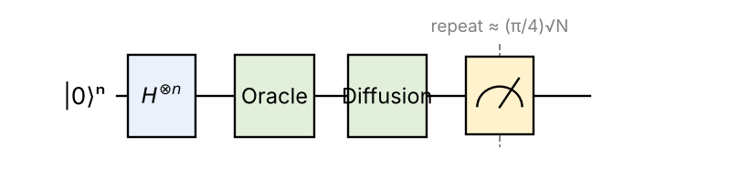
Fig: Quantum search circuit (Grover)

Steps (short)
1. Prepare equal superposition of all N items (Hadamards).
2. Oracle marks the target with a −1 phase.
3. Diffusion (inversion about the mean) increases the target's amplitude.
4. Repeat about (π/4)√N times; measure.

Variants and uses
- Amplitude amplification (generalised), quantum counting (number of solutions), search with unknown number of solutions.
- Quantum walk search on graphs, tree search, nearest-neighbour search (QAI-ii.pdf p.29), SAT/optimisation, key search.
Example: N = 8 → ≈ 2 iterations give success probability ≈ 94.5 % (see Q1.2).

Why √N (intuition)
- Each Grover iteration rotates the state by an angle 2θ (sin θ = 1/√N) towards the target in the plane of |w⟩ and the uniform state.
- About (π/2)/(2θ) ≈ (π/4)√N rotations bring it to the target.
- Lower bound (BBBV, 1997): any quantum algorithm needs Ω(√N) queries for unstructured search, so Grover is optimal – quantum computers cannot search unsorted data exponentially faster.

Example – N = 4
Two qubits, one marked item |10⟩. Initial amplitudes ½ each; oracle makes |10⟩ → −½; mean = ¼; inversion about the mean gives 2(¼) − ½ = 0 for the others and 2(¼) + ½ = 1 for |10⟩. After one iteration the target is found with certainty (classically up to 3–4 checks).
Conclusion: Quantum search finds a marked item among N in O(√N) queries and is provably optimal, forming the basis of many quantum AI algorithms.

💡 Memory trick / Exam tip: “Quantum search = Grover = √N (not exponential).”

4. Last-minute revision sheet

Key definitions
- Quantum walk: coin + shift, superposition of paths; spread ∝ t vs √t classical.
- Challenges in data science: hardware limits, noise/QEC, data loading (QRAM), readout, hybrid integration, scalability, training, skills.
- Quantum neural computation: neurons = parameterised quantum gates; measure; hybrid optimiser.
- Quantum tree search: Grover/quantum walk over tree paths: bᵈ → b^(d/2).
- Quantum production system (Tarrataca): rules as unitaries + superposed rule sequences + goal oracle + Grover.
- Heuristic search: A*: f = g + h; admissible h ⇒ optimal.
- PennyLane: cross-platform Python library, autodiff of quantum circuits, QNodes.
- Quantum search: Grover, O(√N), optimal.

Formulas
U = S·(C ⊗ I) (coined quantum walk) ; σ_quantum ≈ 0.54 t, σ_classical = √t
Grover iterations ≈ (π/4)√N ; tree: O(bᵈ) → O(b^(d/2))
A*: f(n) = g(n) + h(n)

Memory tricks
- Walk = C-S-R-M (Coin, Shift, Repeat, Measure).
- Production system = Rules + Memory + Control; quantum adds superposition + Grover.
- Challenges = HNLRHS: Hardware, Noise, Loading, Readout, Hybrid, Scale.
- PennyLane = Python + Autodiff + Any device.

5. Assumptions & gaps
- Unit 4 = Q7/Q8 of 2023–2025 (quantum search, quantum walks, quantum production systems, heuristic search, quantum AI/data science).
- Your materials cover only: Grover/quantum search (QAI-ii.pdf p.13–15, 20–22, 29), QNN (p.20–23, 34–35) and a general challenges list for quantum-enhanced ML (p.22). Quantum walk, tree search, production system, heuristic search and PennyLane are not in your materials and are marked ⚠ (written from standard knowledge; no citations to your files are claimed).
- The Unit 4 topics (production systems, quantum tree search, Tarrataca's quantum production system, heuristic search, random/quantum walk, quantum neural computation) appear to follow A. Wichert, Principles of Quantum Artificial Intelligence (World Scientific) – this book is NOT in your repo; adding it (or its lecture notes) would let these answers be cited.
- 2024 Q8a ‘Quantum Walk – Random Insect’ is interpreted as the classical random walk of an insect/drunkard compared with the quantum walk. Please check with your class notes if ‘Random Insect’ refers to something specific.
- Tarrataca's quantum production system (Q4.5): the description is a general account recalled from the literature (rules as reversible operators + Grover over the search tree); I cannot verify the exact formulation from your files – please check against your lecture notes before relying on it.
- Q4.4 and Q4.2 are only partly covered by your book (flagged ⚠ partial).
- The quantum-walk plot is a computer simulation (Hadamard coin, symmetric initial coin state, 60 steps), not from your book.
- Answer lengths follow (max marks + 2): Quantum walk, Challenges = 11; Tree search, Heuristic search = 10; Neural computation, Production system, PennyLane = 8; Quantum search = 7.
Questions flagged ⚠ (not found in your materials): Q4.1 Quantum Walk (incl. Random Insect / short note); Q4.4 Challenges and limitations of quantum computing in Data Science (partly); Q4.3 Quantum Tree Search; Q4.6 Heuristic Search with example; Q4.2 Quantum Neural Computation (and its significance) (partly); Q4.5 Quantum Production System (Tarrataca's); Q4.7 PennyLane - cross-platform Python library

