Machine Learning — Unit 1 Exam Answers
Unit 1: Supervised Learning: Classification & Regression (Syllabus Unit III)
SPPU B.E. (AI & DS) 2019 Pattern, Course 417521 · Exam: 70 marks, 2.5 hours · Paper unit = question pair (Q1/Q2 → Unit 1, Q3/Q4 → Unit 2, Q5/Q6 → Unit 3, Q7/Q8 → Unit 4).
Each answer is written for (X + 2) marks, where X = highest marks ever asked. Sources cite your PDFs by file name and PDF page number.

1. Unit Snapshot
No. | Question | Max Marks | Years Asked | Importance
U1-1 | Explain the K-Nearest Neighbour (KNN) classification algorithm with a suitable example (including numerical). | 12 | Nov-Dec 2023, Nov-Dec 2024, Nov-Dec 2025 | ★★★
U1-2 | Evaluation measures of binary classification: accuracy, precision, recall, F1-score (formula + numerical on confusion matrix). | 12 | Nov-Dec 2023, Nov-Dec 2024 | ★★★
U1-3 | What are kernel functions in SVM? Describe Linear, Polynomial, Radial Basis (Gaussian) and Sigmoid kernels. | 6 | Nov-Dec 2024, Nov-Dec 2025 | ★★
U1-4 | Differentiate between Balanced and Imbalanced classification. | 6 | Nov-Dec 2024, Nov-Dec 2025 | ★★
U1-5 | Explain the Support Vector Machine (SVM) classification algorithm with a suitable example. | 6 | Nov-Dec 2023 | ★
U1-6 | Explain the concept of soft margin SVM. How does it differ from hard margin SVM? | 6 | Nov-Dec 2025 | ★
U1-7 | Explain construction of a multi-class classifier: (i) One-vs-All (ii) One-vs-One. | 6 | Nov-Dec 2023 | ★
U1-8 | Differentiate between Binary and Multiclass classification. | 6 | Nov-Dec 2023 | ★
U1-9 | Explain any 4 evaluation measures of Multiclass classification. | 4 | Nov-Dec 2024 | ★
U1-10 | Explain evaluation measures (SSE, MSE) for a regression model, with numerical. | 6 | Nov-Dec 2025 | ★
U1-11 | Explain Bayesian Linear Regression. | 6 | Nov-Dec 2025 | ★

2. Must-Do First (★★★)
- U1-1 — Explain the K-Nearest Neighbour (KNN) classification algorithm with a suitable example (including numerical). (12 M)
- U1-2 — Evaluation measures of binary classification: accuracy, precision, recall, F1-score (formula + numerical on confusion matrix). (12 M)

3. Full Answers

U1-1. Explain the K-Nearest Neighbour (KNN) classification algorithm with a suitable example (including numerical).
Importance: ★★★ | Max asked: 12 M → write for 14 M | Asked in: Nov-Dec 2023, Nov-Dec 2024, Nov-Dec 2025
Source: ML Unit 3-6.pdf, pp. 25–28 (Sec. 3.6 K Nearest Neighbor, book pp. 3-25 to 3-28). Worked numerical: solved here from the 2023 paper data.
Asked as: Apply K-Nearest Neighbor Algorithm (KNN) on following data. Predict the student result for values physics = 6 marks, Chemistry = 8 marks. Consider number of neighbours K = 3 and Euclidean Distance as distance measure. (Nov-Dec 2023 Q1(a), 12 M) | Write a detailed note on K Nearest Neighbour algorithm with suitable example. (Nov-Dec 2024 Q2(c), 8 M) | Explain K nearest neighbor classification algorithm with suitable example. (Nov-Dec 2025 Q1(b), 6 M)

Definition
K-Nearest Neighbour (KNN) is a supervised, non-parametric, instance-based (lazy) learning algorithm. It classifies a new point by the majority class of its K closest training points, measured by a distance metric (usually Euclidean).

1. Key Ideas
- Lazy learner: no model is built during training; all training data is stored and work is done at prediction time.
- Non-parametric: makes no assumption about data distribution.
- Similarity = closeness: similar points lie near each other in feature space.
- Used for classification (majority vote) and regression (average of K neighbours).

2. KNN Algorithm (steps)
1. Load the training data and choose the value of K (number of neighbours).
2. For the new (query) point, compute the distance to every training point.
3. Sort the distances in ascending order.
4. Select the K nearest points.
5. Classification: assign the majority class among the K neighbours. Regression: take their mean value.
6. Return the predicted class/value.

3. Distance Measures
Euclidean: d(p, q) = √[ (x₁ − x₂)² + (y₁ − y₂)² ]
Manhattan: d(p, q) = |x₁ − x₂| + |y₁ − y₂|
- (x₁, y₁) = query point, (x₂, y₂) = training point.

4. Choosing K
- Small K (e.g., 1) → sensitive to noise, overfitting.
- Large K → smooth boundary but may underfit; slow.
- Choose an odd K for 2 classes (avoids ties); common rule K ≈ √n; tune with cross-validation.

5. Solved Numerical (Nov-Dec 2023, 12 M)
Given: Query → Physics = 6, Chemistry = 8; K = 3; Euclidean distance.
Physics (x) | Chemistry (y) | Result | Distance from (6, 8) | Rank
4 | 3 | Fail | √[(6−4)² + (8−3)²] = √29 = 5.385 | 5
6 | 7 | Pass | √[(0)² + (1)²] = √1 = 1.000 | 1
7 | 8 | Pass | √[(1)² + (0)²] = √1 = 1.000 | 1
5 | 5 | Fail | √[(1)² + (3)²] = √10 = 3.162 | 4
8 | 8 | Pass | √[(2)² + (0)²] = √4 = 2.000 | 3

- 3 nearest neighbours: (6,7) Pass – 1.0, (7,8) Pass – 1.0, (8,8) Pass – 2.0
- Votes: Pass = 3, Fail = 0
- Final answer: the student with Physics = 6, Chemistry = 8 is predicted PASS.
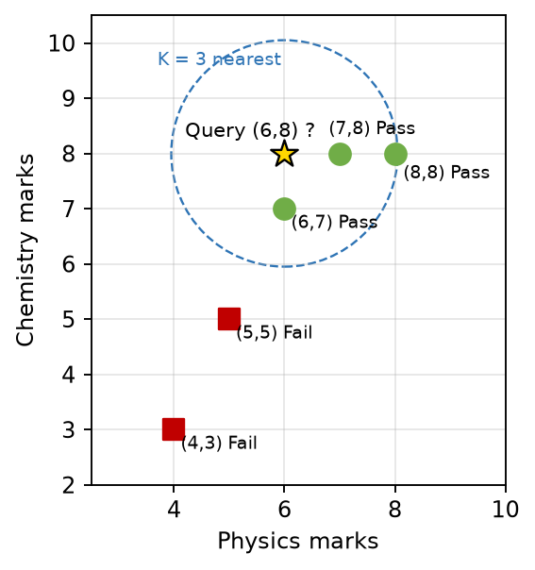
Fig. KNN with K = 3: query (6,8) and its 3 nearest neighbours (all Pass)
- Axes: Physics and Chemistry marks (features).
- Green circles / red squares: training points labelled Pass / Fail.
- Star: query point; dashed circle: region holding the K = 3 nearest points.

6. Advantages
- Very simple, easy to implement; no training phase.
- Works for multi-class problems and naturally adapts to new data.

7. Disadvantages
- Slow prediction for large data (distance to all points).
- Needs feature scaling (normalisation); sensitive to irrelevant features and noise.
- Suffers from the curse of dimensionality; choice of K is critical.

8. Applications
- Recommendation systems, handwriting/digit recognition, medical diagnosis, credit scoring.

Conclusion
KNN predicts by "asking the neighbours": compute distances, pick the K closest, take a majority vote. It is simple and effective for small, well-scaled datasets.
Memory trick – "D-S-K-V": Distance → Sort → pick K → Vote. Exam tip: always show the full distance table and the final vote count; state units/labels in the final answer.

U1-2. Evaluation measures of binary classification: accuracy, precision, recall, F1-score (formula + numerical on confusion matrix).
Importance: ★★★ | Max asked: 12 M → write for 14 M | Asked in: Nov-Dec 2023, Nov-Dec 2024
Source: ML Unit 3-6.pdf, pp. 8–16 (Sec. 3.3 Performance Evaluation: confusion matrix, accuracy, precision, recall, F-measure; book pp. 3-8 to 3-16).
Asked as: Explain any 4 evaluation measures of Binary classification with example? (Nov-Dec 2023 Q2(a), 6 M) | Write formula for accuracy, precision, recall and f1-score. Calculate accuracy, precision, recall and f1-score for given example. (Confusion matrix: Predicted Cancer -> 45 actual Cancer, 18 actual No Cancer; Predicted No Cancer -> 12 actual Cancer, 25 actual No Cancer) (Nov-Dec 2024 Q1(b), 12 M)

Definition
For a binary classifier, performance is measured from the confusion matrix, a 2 × 2 table that compares predicted classes with actual classes. Accuracy, precision, recall and F1-score are computed from its four cells.

1. Confusion Matrix
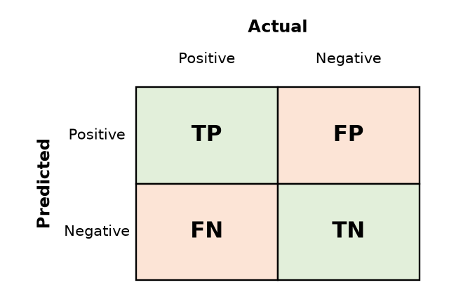
Fig. Confusion matrix for binary classification
- TP (True Positive): actual positive, predicted positive.
- TN (True Negative): actual negative, predicted negative.
- FP (False Positive, Type I error): actual negative, wrongly predicted positive.
- FN (False Negative, Type II error): actual positive, wrongly predicted negative.

2. Evaluation Measures (formulas)
Accuracy = (TP + TN) / (TP + TN + FP + FN)
- Fraction of all predictions that are correct. Misleading for imbalanced data.
Precision = TP / (TP + FP)
- "Of all predicted positives, how many are truly positive?" Important when FP is costly (spam filter).
Recall (Sensitivity, TPR) = TP / (TP + FN)
- "Of all actual positives, how many did we catch?" Important when FN is costly (cancer detection).
F1-score = 2 × Precision × Recall / (Precision + Recall)
- Harmonic mean of precision and recall; useful for imbalanced data.
Specificity (TNR) = TN / (TN + FP)
- Fraction of actual negatives correctly identified.
Error rate = (FP + FN) / Total = 1 − Accuracy ; FPR = FP / (FP + TN)
- ROC curve plots TPR (recall) vs FPR at different thresholds; AUC (area under it) near 1 = good classifier.

3. Solved Numerical (Nov-Dec 2024, 12 M)
Given confusion matrix (rows = predicted, columns = actual, as printed in the paper):
Predicted \ Actual | Cancer (Actual +) | No Cancer (Actual −)
Cancer (Pred +) | TP = 45 | FP = 18
No Cancer (Pred −) | FN = 12 | TN = 25

Total = 45 + 18 + 12 + 25 = 100
1. Accuracy = (45 + 25) / 100 = 70/100 = 0.70 (70 %)
2. Precision = 45 / (45 + 18) = 45/63 = 0.714 (71.4 %)
3. Recall = 45 / (45 + 12) = 45/57 = 0.789 (78.9 %)
4. F1-score = 2 × 0.714 × 0.789 / (0.714 + 0.789) = 1.127 / 1.503 = 0.75 (75 %)
(check: F1 = 2TP / (2TP + FP + FN) = 90/120 = 0.75 ✓)
5. (Extra) Specificity = 25 / (25 + 18) = 0.581; Error rate = 30/100 = 0.30
Interpretation: the model finds 79 % of cancer patients (recall) but 12 patients with cancer are missed (FN) — in medical diagnosis recall should be improved.

4. Example (concept)
- Spam filter: precision matters (don't send good mail to spam).
- Disease test: recall matters (don't miss a sick patient).

Conclusion
Accuracy gives the overall picture, while precision, recall and F1 show which kind of mistakes a classifier makes; for imbalanced problems always report precision, recall and F1.
Memory trick: Precision → Predicted column/row (TP+FP); Recall → Real (actual) positives (TP+FN). Common mistake: swapping FP and FN — first check whether the table's rows are actual or predicted.

U1-3. What are kernel functions in SVM? Describe Linear, Polynomial, Radial Basis (Gaussian) and Sigmoid kernels.
Importance: ★★ | Max asked: 6 M → write for 8 M | Asked in: Nov-Dec 2024, Nov-Dec 2025
Source: ML Unit 3-6.pdf, pp. 36–38 (Sec. 3.8 Kernel Functions, 3.8.2 RBF, Gaussian, Polynomial; book pp. 3-36 to 3-38). Note: your textbook writes the polynomial kernel as (x·xᵢ + 1)^d, i.e. γ = 1, c = 1.
Asked as: What are kernel functions in SVM? Describe the Radial Basis Kernel, and Sigmoid kernel. (Nov-Dec 2024 Q1(a), 6 M) | What are kernel functions in SVM? Describe the Radial Basis Kernel, Gaussian, Polynomial, and Sigmoid kernel (Nov-Dec 2025 Q1(c), 6 M)

Definition
A kernel function K(xᵢ, xⱼ) computes the dot product of two points in a higher-dimensional feature space φ(x) without explicitly transforming them. This "kernel trick" lets a linear SVM separate non-linearly separable data.
K(xᵢ, xⱼ) = φ(xᵢ) · φ(xⱼ)

1. Why kernels are needed
- Many datasets cannot be separated by a straight line (e.g., circular classes).
- Mapping to a higher dimension makes them linearly separable, but explicit mapping is costly.
- The kernel computes the similarity directly → low cost, same result.
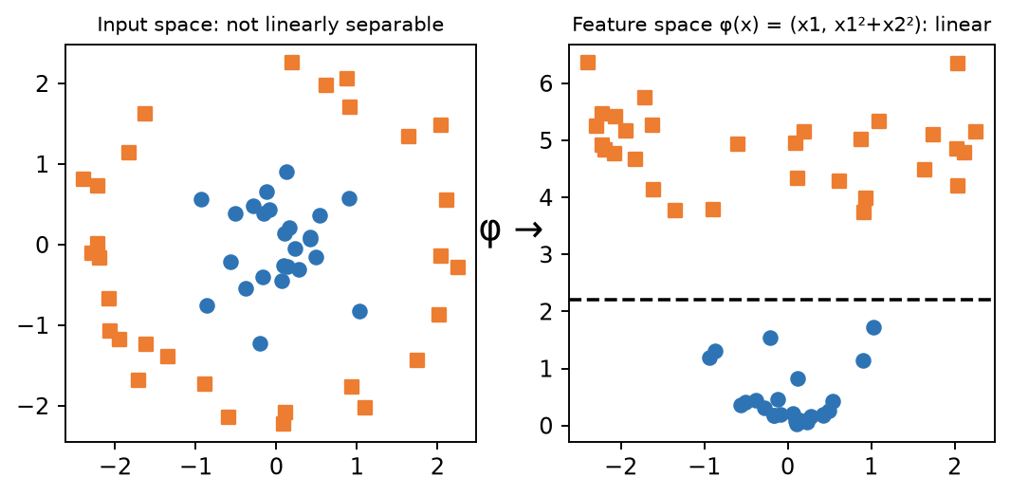
Fig. Kernel trick: circular data becomes linearly separable after mapping φ
- Left: input space – inner (blue) and outer (orange) classes; no straight line separates them.
- Right: after mapping with φ, a straight line (dashed) separates the classes.

2. Types of Kernel Functions
1. Linear kernel: K(x, y) = x · y — for linearly separable data, text classification.
2. Polynomial kernel: K(x, y) = (γ x · y + c)^d — d = degree, c = constant; captures feature interactions (image processing).
3. Radial Basis Function (RBF) / Gaussian kernel:
K(x, y) = exp( − ‖x − y‖² / (2σ²) ) = exp( − γ ‖x − y‖² )
- ‖x − y‖ = Euclidean distance, σ = width (spread), γ = 1/(2σ²).
- Value is 1 for identical points and falls to 0 for far points → similarity measure.
- Most popular default kernel; maps to an infinite-dimensional space.
- Large γ → tight, complex boundary (overfit); small γ → smooth boundary.
4. Sigmoid kernel:
K(x, y) = tanh( α x · y + c )
- α = slope, c = intercept; behaves like a two-layer perceptron (neural network) activation.
- Not always positive semi-definite; used less often.

3. Note on "RBF vs Gaussian"
- The Gaussian kernel is the most common RBF kernel; any kernel depending only on distance ‖x − y‖ is an RBF. (Laplace RBF: exp(−‖x − y‖/σ).)
Kernel | Formula | Use
Linear | x · y | Linearly separable, text
Polynomial | (γ x·y + c)^d | Interaction features, images
RBF / Gaussian | exp(−γ‖x − y‖²) | General non-linear (default)
Sigmoid | tanh(α x·y + c) | Neural-network-like

Conclusion
Kernels let SVM draw non-linear boundaries cheaply; choose linear for simple data, RBF as a default for non-linear data, and tune γ / degree with cross-validation.
Memory trick – "LPRS": Linear, Polynomial, RBF (Gaussian), Sigmoid (tanh). RBF = "Radius-Based Fading similarity".

U1-4. Differentiate between Balanced and Imbalanced classification.
Importance: ★★ | Max asked: 6 M → write for 8 M | Asked in: Nov-Dec 2024, Nov-Dec 2025
Source: ML Unit 3-6.pdf, pp. 3–4 (Sec. 3.1.2 Balanced and Imbalanced Classification Problems; book pp. 3-3, 3-4).
Asked as: Differentiate Balanced and Imbalanced Classification. (Nov-Dec 2024 Q2(b), 6 M) | Differentiate between balanced and imbalanced classification. (Nov-Dec 2025 Q2(b), 6 M)

Definition
A dataset is balanced when all classes have (nearly) equal numbers of samples; it is imbalanced when one class (majority) heavily dominates the other (minority). Imbalance is expressed as majority : minority ratio (e.g., 8 : 1 : 1).
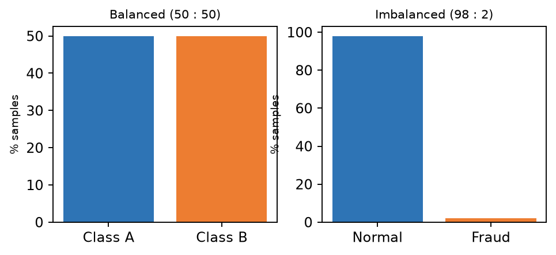
Fig. Balanced vs imbalanced class distribution
Basis | Balanced classification | Imbalanced classification
Class distribution | Classes nearly equal (e.g., 50 : 50) | One class dominates (e.g., 98 : 2)
Model bias | Model learns all classes fairly | Model is biased toward majority class
Accuracy as metric | Accuracy is reliable | Accuracy is misleading (98 % by always predicting majority)
Preferred metrics | Accuracy, error rate | Precision, recall, F1, ROC-AUC, PR curve
Extra handling | Not required | Resampling (oversampling, SMOTE, undersampling), class weights
Training difficulty | Easier | Harder; minority patterns may be ignored
Decision threshold | Default 0.5 works | Threshold often tuned
Examples | Cat vs dog images (equal), digit recognition | Fraud detection, rare disease, spam, fault detection

Example from notes: 100 fruits – 80 oranges, 10 apples, 10 pears → imbalanced, ratio 8 : 1 : 1.

Conclusion
Balanced data can be modelled directly; imbalanced data needs resampling or class weighting and must be judged by precision/recall/F1, not accuracy.
Exam tip: Always give one numerical example of imbalance (98 : 2 fraud) and mention SMOTE — examiners look for it.

U1-5. Explain the Support Vector Machine (SVM) classification algorithm with a suitable example.
Importance: ★ | Max asked: 6 M → write for 8 M | Asked in: Nov-Dec 2023
Source: ML Unit 3-6.pdf, pp. 29–33 (Sec. 3.7 Linear Support Vector Machines, 3.7.2 Applications, 3.7.3 Limitations; book pp. 3-29 to 3-33).
Asked as: Explain support Vector Machine classification algorithm with suitable example. (Nov-Dec 2023 Q1(b), 6 M)

Definition
Support Vector Machine (SVM) is a supervised learning algorithm that finds the optimal hyperplane which separates classes with the maximum margin. The data points closest to the hyperplane are called support vectors.

1. Key Terms
- Hyperplane: decision boundary w · x + b = 0 (a line in 2-D, a plane in 3-D).
- Margin: distance between the hyperplane and the nearest points of each class = 2 / ‖w‖.
- Support vectors: points lying on the margin boundaries; they alone decide the hyperplane.
- Maximum margin classifier: larger margin → better generalisation.
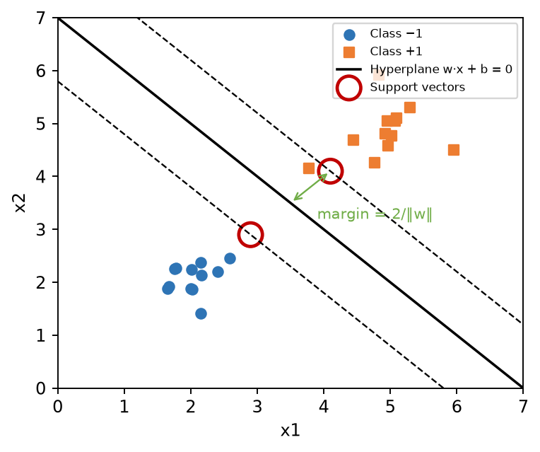
Fig. Linear SVM: hyperplane, margins and support vectors
- Solid line: optimal hyperplane w·x + b = 0.
- Dashed lines: margin boundaries w·x + b = ±1.
- Circled points: support vectors; green arrow: margin 2/‖w‖.

2. Working / Algorithm
1. Take labelled data (xᵢ, yᵢ) with yᵢ ∈ {+1, −1}.
2. Find w and b so that every point satisfies yᵢ (w · xᵢ + b) ≥ 1.
3. Maximise margin 2/‖w‖ ⇔ minimise ½‖w‖² subject to the constraint above.
4. Solve with Lagrange multipliers; points with non-zero multipliers are support vectors.
5. Classify new x by sign(w · x + b).
6. If data is not linearly separable → use soft margin (slack) or kernel trick.

3. Example
- Email spam: features = frequency of words "free", "offer". SVM finds the widest line separating spam (+1) and not-spam (−1); a new mail is labelled by which side it falls.

4. Advantages / Disadvantages
- + Effective in high-dimensional spaces; memory-efficient (uses only support vectors); kernels handle non-linear data.
- − Slow on very large datasets; choosing kernel and C is tricky; no direct probability output.

Conclusion
SVM is a maximum-margin classifier decided only by the support vectors; with kernels it handles complex, non-linear boundaries.
Memory trick: "Widest street" — SVM builds the widest street between two classes; the houses on the kerb are the support vectors.

U1-6. Explain the concept of soft margin SVM. How does it differ from hard margin SVM?
Importance: ★ | Max asked: 6 M → write for 8 M | Asked in: Nov-Dec 2025
Source: ML Unit 3-6.pdf, pp. 33–35 (Sec. 3.7 Soft Margin SVM; book pp. 3-33 to 3-35). The term 'hard margin' is not used by name in your textbook; the comparison table is standard.
Asked as: Explain the concept of a soft margin SVM. How does it differ from a hard margin SVM? (Nov-Dec 2025 Q2(c), 6 M)

Definition
A hard-margin SVM requires every training point to be correctly classified and outside the margin. A soft-margin SVM allows some points to be inside the margin or misclassified by introducing slack variables ξᵢ, controlled by a penalty C.

1. Soft-Margin Formulation
Minimise ½‖w‖² + C Σ ξᵢ subject to yᵢ(w · xᵢ + b) ≥ 1 − ξᵢ, ξᵢ ≥ 0
- ξᵢ (slack): 0 → correct & outside margin; 0 < ξ ≤ 1 → inside margin; ξ > 1 → misclassified.
- C (regularisation): large C → few violations (narrow margin, risk of overfit); small C → wider margin, more violations.
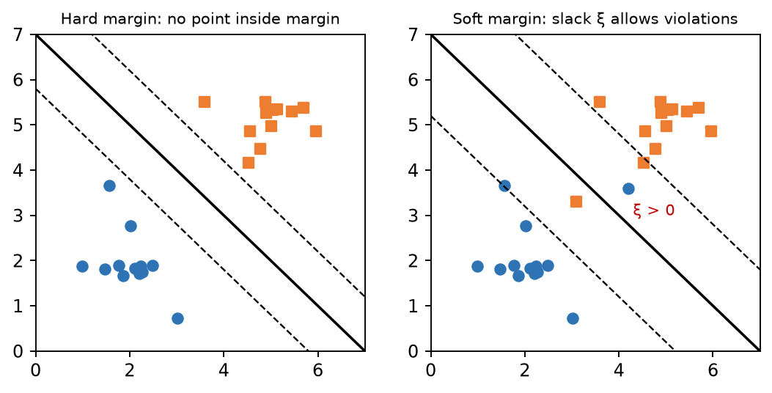
Fig. Hard margin (left) vs soft margin with slack ξ (right)

2. Hard vs Soft Margin
Basis | Hard margin SVM | Soft margin SVM
Data assumption | Perfectly linearly separable | Overlapping / noisy data allowed
Misclassification | Not allowed | Allowed via slack ξᵢ
Objective | min ½‖w‖² | min ½‖w‖² + C Σξᵢ
Constraint | yᵢ(w·xᵢ + b) ≥ 1 | yᵢ(w·xᵢ + b) ≥ 1 − ξᵢ
Outliers | Very sensitive; may fail | Robust to outliers
Margin width | Narrow | Wider (tunable by C)
Generalisation | Can overfit | Better on real data

Conclusion
Real data is rarely perfectly separable, so soft margin (with a tuned C) is used in practice; hard margin is the special case C → ∞.
Memory trick: "Soft = Slack, C = Strictness." Big C = strict teacher (few mistakes allowed).

U1-7. Explain construction of a multi-class classifier: (i) One-vs-All (ii) One-vs-One.
Importance: ★ | Max asked: 6 M → write for 8 M | Asked in: Nov-Dec 2023
Source: ML Unit 3-6.pdf, pp. 19–23 (Sec. 3.4 Multiclass Classification, 3.4.2 One-vs-One / One-vs-All; book pp. 3-19 to 3-23).
Asked as: Explain construction of multi-classifier. i) One Vs. All approach ii) One Vs One approach (Nov-Dec 2023 Q2(b), 6 M)

Definition
Many algorithms (e.g., SVM, logistic regression) are binary. A multi-class classifier for N classes is built by decomposing the problem into several binary problems using One-vs-All (OvA / One-vs-Rest) or One-vs-One (OvO).
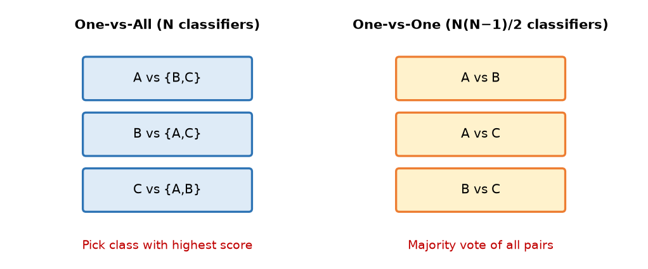
Fig. One-vs-All and One-vs-One for classes A, B, C

1. One-vs-All (One-vs-Rest)
1. For each class i, train one binary classifier: class i = positive, all other classes = negative.
2. Total classifiers = N.
3. For a new sample, run all N classifiers; choose the class whose classifier gives the highest confidence score.
- Example: classes {Red, Green, Blue} → Red vs (Green, Blue), Green vs (Red, Blue), Blue vs (Red, Green).
- + Few classifiers (N). − Each classifier sees imbalanced data; scores must be comparable.

2. One-vs-One
1. Train a binary classifier for every pair of classes.
2. Total classifiers = N(N − 1)/2.
3. For a new sample, each classifier votes for one class; the class with most votes wins.
- Example: 3 classes → 3 classifiers (R vs G, R vs B, G vs B); 4 classes → 6 classifiers.
- + Each classifier trains on small, balanced data. − Number of classifiers grows quadratically.
OvA | OvO
N classifiers | N(N−1)/2 classifiers
Uses whole dataset per classifier | Uses only 2 classes per classifier
Decision: highest score | Decision: majority vote

Conclusion
OvA is cheaper; OvO is more accurate for algorithms like SVM that scale poorly with data size (sklearn's SVC uses OvO).
Memory trick: OvA = "one against the crowd" (N); OvO = "every pair shakes hands" (N(N−1)/2).

U1-8. Differentiate between Binary and Multiclass classification.
Importance: ★ | Max asked: 6 M → write for 8 M | Asked in: Nov-Dec 2023
Source: ML Unit 3-6.pdf, p. 3 (Sec. 3.1.1 Binary-vs-Multiclass Classification table; book p. 3-3).
Asked as: Differentiate between Binary - vs - Multiclass Classification. (Nov-Dec 2023 Q2(c), 6 M)

Definition
Binary classification assigns each item to one of two classes; multiclass classification assigns each item to one of three or more mutually exclusive classes.
Basis | Binary classification | Multiclass classification
Number of classes | Exactly 2 (0/1, yes/no) | More than 2 (k classes)
Probability model | Predicts a Bernoulli distribution | Predicts a Multinoulli (categorical) distribution
Output function | Sigmoid, single output | Softmax, one output per class
Typical algorithms | Logistic regression, SVM, KNN, decision tree, Naive Bayes | KNN, decision tree, Naive Bayes, random forest, gradient boosting
Binary algorithms used via | — | OvA / OvO decomposition
Evaluation | 2×2 confusion matrix, precision, recall, F1 | k×k confusion matrix, per-class / macro / micro averages
Decision boundary | One boundary | Multiple boundaries
Example | Email spam or not spam | Email as advertisement, newsletter, phishing or personal; digit 0–9

Conclusion
Binary is the basic two-class case; multiclass generalises it using softmax or binary decomposition, with averaged metrics for evaluation.
Memory trick: Bi = two (bicycle); Multi = many — Bernoulli for bi, Multinoulli for multi.

U1-9. Explain any 4 evaluation measures of Multiclass classification.
Importance: ★ | Max asked: 4 M → write for 6 M | Asked in: Nov-Dec 2024
Source: ML Unit 3-6.pdf, pp. 17–18 and 23–24 (Sec. 3.4 multiclass confusion matrix, per-class precision/recall; Sec. 3.5 Micro-average method; book pp. 3-17, 3-18, 3-23, 3-24).

Definition
For a multiclass problem with k classes, a k × k confusion matrix is built and metrics are computed per class (treating that class as positive and the rest as negative), then averaged.

Four Evaluation Measures
1. Overall accuracy = Σ diagonal (correct) / total samples.
2. Per-class precision Pᵢ = TPᵢ / (TPᵢ + FPᵢ) and per-class recall Rᵢ = TPᵢ / (TPᵢ + FNᵢ).
3. Macro-average = simple mean of per-class precision/recall/F1 → treats every class equally.
Macro-P = (P₁ + P₂ + … + Pₖ) / k
4. Micro-average = pool TP, FP, FN of all classes first, then compute → weights by class frequency.
Micro-P = ΣTPᵢ / (ΣTPᵢ + ΣFPᵢ)
- (Also: weighted-average F1, Cohen's kappa.)
Example: 3 classes with precisions 0.9, 0.6, 0.3 → macro-precision = 0.6.

Conclusion
Use macro averages when every class is equally important and micro/weighted when overall performance on frequent classes matters.
Tip: Macro = "Mean of Metrics"; Micro = "Merge counts first".

U1-10. Explain evaluation measures (SSE, MSE) for a regression model, with numerical.
Importance: ★ | Max asked: 6 M → write for 8 M | Asked in: Nov-Dec 2025
Source: ML Textbook.pdf, pp. 57–58 (Sec. 2.2 Cost Functions (Evaluation Metrics): Mean Error, MSE, MAE, RMSE, R-squared; book pp. 2-22 to 2-25). SSE is the total of the squared-error column in the textbook tables.
Asked as: Explain evaluation measures (SSE, MSE) for regression model. For a given data having 100 examples, if squared errors SE1, SE2, and SE3 are 13.33, 3.33 and 4.00 respectively, calculate Mean Squared Error (MSE). State the formula for MSE. (Nov-Dec 2025 Q1(a), 6 M)

Definition
Regression models predict continuous values; their error is measured from the residual eᵢ = yᵢ − ŷᵢ (actual − predicted). SSE and MSE are the basic squared-error measures.
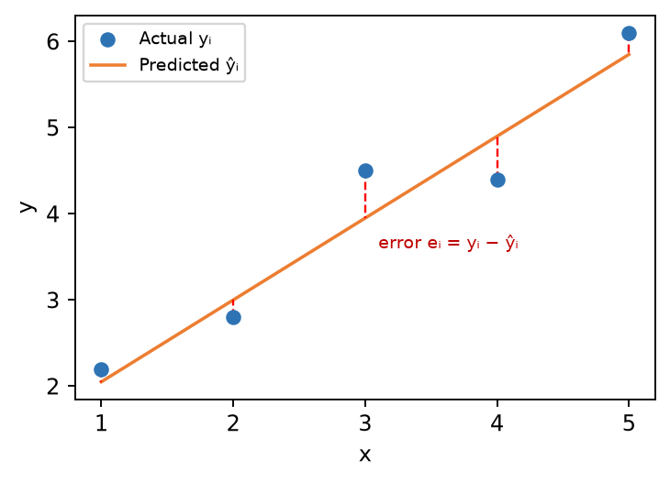
Fig. Residuals (red dashed) between actual points and the regression line

1. Formulas
SSE = Σ (yᵢ − ŷᵢ)² (i = 1 … n)
MSE = SSE / n = (1/n) Σ (yᵢ − ŷᵢ)²
RMSE = √MSE , MAE = (1/n) Σ |yᵢ − ŷᵢ|
- yᵢ = actual value, ŷᵢ = predicted value, n = number of examples.
- Squaring removes sign and penalises large errors more. Lower = better.
- Your textbook calls these cost functions (evaluation metrics) and also lists Mean Error (ME), which is weak because positive and negative errors cancel.
- Textbook example: actual (10, 8, 5, 7, 4) vs predicted (9.2, 8.3, 4.7, 7.9, 3.1): squared errors 0.64, 0.09, 0.09, 0.81, 0.81 → SSE = 2.44, MSE = 2.44/5 = 0.488, RMSE = 0.698.

2. Numerical (Nov-Dec 2025)
Given: n = 100 examples; squared-error terms SE₁ = 13.33, SE₂ = 3.33, SE₃ = 4.00.
1. SSE = 13.33 + 3.33 + 4.00 = 20.66
2. MSE = SSE / n = 20.66 / 100 = 0.2066
3. (If the three values are SSEs of three separate models, MSE₁ = 0.1333, MSE₂ = 0.0333, MSE₃ = 0.04 → model 2 is best.)

Conclusion
SSE measures total squared error, MSE the average squared error per example; both should be minimised and are used to compare regression models.
Tip: Always write the formula first, then substitute — formula carries marks even if arithmetic slips.

U1-11. Explain Bayesian Linear Regression.
Importance: ★ | Max asked: 6 M → write for 8 M | Asked in: Nov-Dec 2025
Source: ML Textbook.pdf, pp. 56–57 (Sec. 2.1.13 Bayesian Linear Regression; book pp. 2-21, 2-22).
Asked as: Explain Baysian Linear Regression. (Nov-Dec 2025 Q2(a), 6 M)

Definition
Bayesian Linear Regression (BLR) treats the regression weights w as random variables with a probability distribution rather than fixed numbers. Using Bayes' theorem, a prior belief about w is updated with data to obtain a posterior distribution, giving predictions with uncertainty.

1. Model
y = wᵀx + ε , ε ~ N(0, σ²)
Posterior P(w | D) = P(D | w) · P(w) / P(D) ∝ Likelihood × Prior
- P(w) = prior (e.g., Gaussian N(0, α⁻¹I)); P(D | w) = likelihood of data; P(w | D) = posterior.

2. Steps
1. Choose a prior distribution over weights (usually Gaussian).
2. Define the likelihood of the observed data given weights (Gaussian noise).
3. Compute the posterior = likelihood × prior (Gaussian prior + Gaussian likelihood → Gaussian posterior).
4. Predict by averaging over all weights → predictive mean and variance.
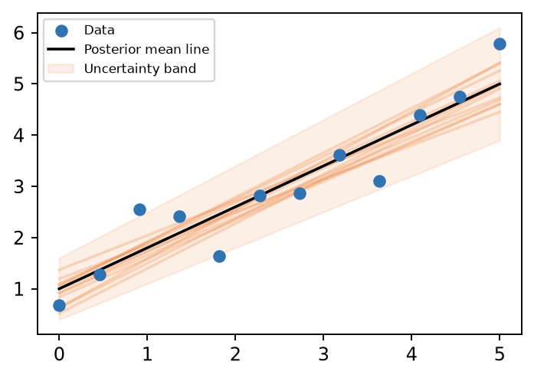
Fig. BLR gives a family of plausible lines and an uncertainty band

3. Advantages / Disadvantages
- + Gives uncertainty (confidence) of predictions; works with small data; prior acts as regularisation (MAP with Gaussian prior = Ridge regression).
- − Computationally heavier; result depends on choice of prior.

Example
Predicting house price from area with only 10 houses: BLR predicts ₹50 L ± ₹4 L, while ordinary regression gives only ₹50 L.

Conclusion
BLR = linear regression + Bayes' theorem; it outputs a distribution of predictions instead of a single value.
Memory trick: "Prior + Data = Posterior" (PDP).

4. Last-Minute Revision Sheet

Key Definitions
- KNN: lazy, non-parametric; majority vote of K nearest (Euclidean) neighbours.
- SVM: maximum-margin hyperplane; support vectors decide it; margin = 2/‖w‖.
- Soft margin: slack ξᵢ + penalty C; hard margin = no violations.
- Kernel trick: K(x, y) = φ(x)·φ(y) without computing φ.
- Imbalanced data: majority dominates → use precision/recall/F1, SMOTE, class weights.
- OvA: N classifiers; OvO: N(N−1)/2 classifiers + voting.
- BLR: weights have prior → posterior via Bayes.

Formulas
Measure | Formula
Euclidean distance | √Σ(xᵢ − yᵢ)²
Accuracy | (TP + TN) / Total
Precision | TP / (TP + FP)
Recall | TP / (TP + FN)
F1 | 2PR / (P + R) = 2TP / (2TP + FP + FN)
Specificity | TN / (TN + FP)
RBF kernel | exp(−γ‖x − y‖²), γ = 1/2σ²
Polynomial kernel | (γ x·y + c)^d
Sigmoid kernel | tanh(α x·y + c)
Soft-margin SVM | min ½‖w‖² + CΣξᵢ
SSE / MSE | Σ(y − ŷ)² ; SSE/n

Memory Tricks
- KNN = D-S-K-V (Distance, Sort, K, Vote).
- Kernels = LPRS. SVM = "widest street".
- Precision → Predicted positives; Recall → Real positives.
- Soft margin = Slack, C = Strictness.
- Numericals: draw the table, write formula, substitute, box the answer.

5. Assumptions & Gaps
- Unit mapping: papers do not label units; Q1/Q2 are taken as Unit 1 (= syllabus Unit III, Classification) because every paper places classification/regression evaluation here.
- 2024 Q1(b) confusion matrix: the printed table has Actual values as columns and Predicted values as rows; it was read as TP = 45, FP = 18, FN = 12, TN = 25. If your teacher reads rows as actual, FP and FN swap: precision = 45/57 = 0.789, recall = 45/63 = 0.714, F1 = 0.75 and accuracy = 0.70 (unchanged).
- 2025 Q1(a) MSE: the wording "100 examples, squared errors SE1, SE2, SE3" is ambiguous; main answer sums them (SSE = 20.66, MSE = 0.2066) and the alternative reading is shown.
- All Unit 1 topics were found in your textbooks (Classification in ML Unit 3-6.pdf; regression metrics and Bayesian Linear Regression in ML Textbook.pdf, Unit II). No ⚠ flags. Only the name 'hard margin' does not appear in the OCR text of the textbook.

