Machine Learning — Unit 2 Exam Answers
Unit 2: Unsupervised Learning: Clustering (Syllabus Unit IV)
SPPU B.E. (AI & DS) 2019 Pattern, Course 417521 · Exam: 70 marks, 2.5 hours · Paper unit = question pair (Q1/Q2 → Unit 1, Q3/Q4 → Unit 2, Q5/Q6 → Unit 3, Q7/Q8 → Unit 4).
Each answer is written for (X + 2) marks, where X = highest marks ever asked. Sources cite your PDFs by file name and PDF page number.

1. Unit Snapshot
No. | Question | Max Marks | Years Asked | Importance
U2-1 | Explain the K-Means (centroid-based) clustering algorithm with example. State its advantages and disadvantages. | 9 | Nov-Dec 2023, Nov-Dec 2024, Nov-Dec 2025 | ★★★
U2-2 | Explain the DBSCAN algorithm. How does it work? State its advantages and disadvantages. | 9 | Nov-Dec 2024, Nov-Dec 2025 | ★★★
U2-3 | Describe the Gaussian Mixture Model (GMM) for distribution-based clustering with example. How is it different from other clustering algorithms? | 9 | Nov-Dec 2023, Nov-Dec 2025 | ★★★
U2-4 | What is clustering? Elaborate the types of clustering. | 9 | Nov-Dec 2024 | ★
U2-5 | Elaborate the need of clustering and explain how the elbow method is used to decide the value of k. | 9 | Nov-Dec 2023 | ★
U2-6 | Differentiate Agglomerative Hierarchical Clustering and Divisive Hierarchical Clustering. | 8 | Nov-Dec 2024 | ★
U2-7 | Explain the Divisive Hierarchical Clustering (DHC) algorithm with example. | 8 | Nov-Dec 2023 | ★
U2-8 | Discuss applications of clustering in market segmentation, social network analysis, image segmentation and anomaly detection, with examples. | 8 | Nov-Dec 2025 | ★

2. Must-Do First (★★★)
- U2-1 — Explain the K-Means (centroid-based) clustering algorithm with example. State its advantages and disadvantages. (9 M)
- U2-2 — Explain the DBSCAN algorithm. How does it work? State its advantages and disadvantages. (9 M)
- U2-3 — Describe the Gaussian Mixture Model (GMM) for distribution-based clustering with example. How is it different from other clustering algorithms? (9 M)

3. Full Answers

U2-1. Explain the K-Means (centroid-based) clustering algorithm with example. State its advantages and disadvantages.
Importance: ★★★ | Max asked: 9 M → write for 11 M | Asked in: Nov-Dec 2023, Nov-Dec 2024, Nov-Dec 2025
Source: ML Unit 3-6.pdf, pp. 45 and 52–58 (partitioning/centroid methods; K-Means and K-Medoids; book pp. 4-6, 4-13 to 4-19).
Asked as: Explain K - Means clustering algorithm and states the advantages and disadvantages of k-means clustering algorithm. (Nov-Dec 2023 Q3(a), 9 M) | Describe centroid based clustering algorithm and explain any one type with example. (Nov-Dec 2024 Q4(b), 9 M) | Explain the K-Means clustering algorithm. What are its advantages and disadvantages. (Nov-Dec 2025 Q4(b), 8 M)

Definition
K-Means is an unsupervised, centroid-based (partitioning) clustering algorithm that divides n data points into K clusters, where each point belongs to the cluster with the nearest centroid (mean). It minimises the Within-Cluster Sum of Squares (WCSS).

1. Centroid-Based Clustering
- Each cluster is represented by a central vector (centroid); points are assigned to the closest centroid.
- K must be given in advance; it is an iterative, flat (non-hierarchical) method.
- Types: K-Means (centroid = mean), K-Medoids/PAM (centroid = actual data point), K-Means++ (smart initialisation), Fuzzy C-Means.

2. K-Means Algorithm
1. Choose the number of clusters K.
2. Initialise K centroids randomly (or with K-Means++).
3. Assign each point to the nearest centroid (Euclidean distance).
4. Update each centroid = mean of points assigned to it.
5. Repeat steps 3–4 until centroids do not change (convergence) or max iterations reached.
Objective: J = Σₖ Σ_{x ∈ Cₖ} ‖x − μₖ‖²
- Cₖ = k-th cluster, μₖ = its centroid, ‖x − μₖ‖ = Euclidean distance.
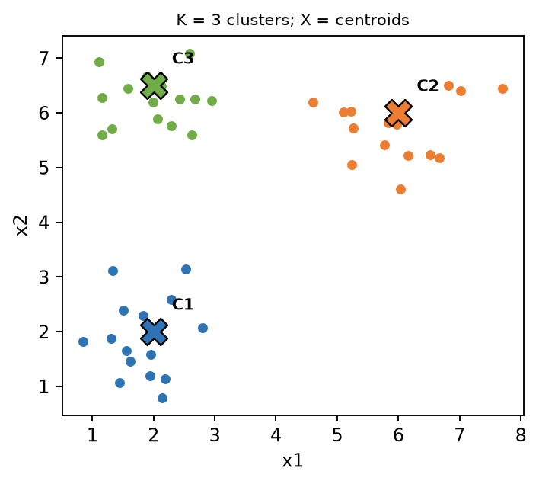
Fig. K-Means with K = 3: points grouped around centroids C1, C2, C3
- Coloured points: members of each cluster. X marks: centroids (means). Boundaries lie midway between centroids.

3. Worked Example (1-D, K = 2)
Data: {2, 4, 10, 12, 3, 20, 30, 11, 25}; initial centroids m₁ = 2, m₂ = 4.
Iteration | Cluster 1 | Cluster 2 | New m₁ | New m₂
1 | {2, 3} | {4, 10, 12, 20, 30, 11, 25} | 2.5 | 16
2 | {2, 3, 4} | {10, 12, 20, 30, 11, 25} | 3 | 18
3 | {2, 3, 4, 10} | {12, 20, 30, 11, 25} | 4.75 | 19.6
4 | {2, 3, 4, 10, 12, 11} | {20, 30, 25} | 7 | 25
5 | {2, 3, 4, 10, 12, 11} | {20, 30, 25} | 7 | 25 (no change → stop)

Final clusters: {2, 3, 4, 10, 11, 12} and {20, 25, 30}. (In iteration 1, point 3 is equidistant from 2 and 4; the tie is given to cluster 1.)

4. Advantages
- Simple, easy to implement and interpret.
- Fast & scalable – O(n·K·t); works on large datasets.
- Guaranteed to converge; tight, spherical clusters.

5. Disadvantages
- K must be specified in advance (use elbow/silhouette).
- Sensitive to initial centroids (different runs → different results) and to outliers.
- Assumes spherical, equal-size clusters; fails on non-convex shapes.
- Works only with numerical data (mean must exist).

6. Applications
- Customer segmentation, image compression (colour quantisation), document clustering.

Conclusion
K-Means repeatedly assigns points to the nearest mean and updates the means until stable; it is fast and popular but needs K and good initialisation.
Memory trick – "CAUR": Choose K → Assign → Update → Repeat. Common mistake: forgetting the stopping condition.

U2-2. Explain the DBSCAN algorithm. How does it work? State its advantages and disadvantages.
Importance: ★★★ | Max asked: 9 M → write for 11 M | Asked in: Nov-Dec 2024, Nov-Dec 2025
Source: ML Unit 3-6.pdf, pp. 61–62 (density-based clustering, DBSCAN; book pp. 4-22, 4-23).
Asked as: Explain DBSCAN algorithm with advantages and disadvantages. (Nov-Dec 2024 Q4(a), 8 M) | Explain the DBSCAN algorithm. How does it work? What are its advantages and disadvantages. (Nov-Dec 2025 Q3(a), 9 M)

Definition
DBSCAN (Density-Based Spatial Clustering of Applications with Noise) groups points that lie in dense regions and marks points in low-density regions as noise (outliers). It needs two parameters: ε (eps) – neighbourhood radius and MinPts – minimum points to form a dense region.

1. Key Terms
- ε-neighbourhood: all points within distance ε of a point.
- Core point: has ≥ MinPts points (including itself) in its ε-neighbourhood.
- Border point: fewer than MinPts neighbours but lies in the ε-neighbourhood of a core point.
- Noise point: neither core nor border.
- Directly density-reachable: q is in ε-neighbourhood of core point p.
- Density-reachable: reachable through a chain of core points. Density-connected: both reachable from a common core point.
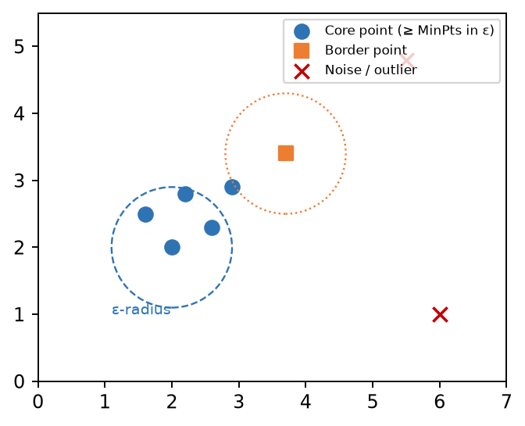
Fig. DBSCAN: core, border and noise points with ε-radius
- Blue (dashed circle): core point and its ε-radius containing ≥ MinPts points.
- Orange square: border point (inside a core's ε but not dense itself).
- Red ×: noise / outliers – not assigned to any cluster.

2. Algorithm / Working
1. Set ε and MinPts; mark all points unvisited.
2. Pick an unvisited point p; mark it visited and find its ε-neighbours.
3. If neighbours < MinPts → mark p as noise (may later become border).
4. If neighbours ≥ MinPts → p is a core point; start a new cluster and add all neighbours.
5. Expand: for each neighbour that is also a core point, add its neighbours to the cluster (density-reachable points).
6. Repeat until all points are visited. Clusters = density-connected sets.

3. Example
Customer GPS locations: dense shopping areas form clusters of any shape (along roads); isolated locations are flagged as noise. With ε = 1 km, MinPts = 5.

4. Advantages
- No need to specify the number of clusters.
- Finds clusters of arbitrary shape (non-spherical).
- Robust to outliers – identifies noise explicitly.
- Only two parameters; order of data has little effect.

5. Disadvantages
- Choosing ε and MinPts is difficult (k-distance graph helps).
- Fails when clusters have varying densities.
- Poor in high dimensions (distance becomes less meaningful); O(n²) without index.
- Border points may be assigned to different clusters depending on order.

Conclusion
DBSCAN clusters by density, finding arbitrary-shaped clusters and outliers automatically, but is sensitive to ε and MinPts.
Memory trick – "C-B-N": Core (dense), Border (edge), Noise (alone). "Two knobs: ε = how far, MinPts = how many."

U2-3. Describe the Gaussian Mixture Model (GMM) for distribution-based clustering with example. How is it different from other clustering algorithms?
Importance: ★★★ | Max asked: 9 M → write for 11 M | Asked in: Nov-Dec 2023, Nov-Dec 2025
Source: ML Unit 3-6.pdf, pp. 64–65 (Sec. 4.6 distribution-based clustering, 4.6.1 Gaussian Mixture Model, EM; book pp. 4-25, 4-26).
Asked as: Explain Gaussian mixture model with example. (Nov-Dec 2023 Q3(b), 8 M) | Describe the Gaussian Mixture Model (GMM) for distribution-based clustering. How is it different from other clustering algorithms? (Nov-Dec 2025 Q4(a), 9 M)

Definition
A Gaussian Mixture Model (GMM) is a probabilistic, distribution-based clustering model which assumes data is generated from a mixture of K Gaussian (normal) distributions, each with its own mean μₖ, covariance Σₖ and mixing weight πₖ. It performs soft clustering – each point gets a probability of belonging to each cluster.

1. Model
p(x) = Σₖ πₖ · N(x | μₖ, Σₖ) , Σₖ πₖ = 1
- πₖ = mixing coefficient (prior weight of cluster k), μₖ = mean (centre), Σₖ = covariance (shape/orientation), N = Gaussian density.
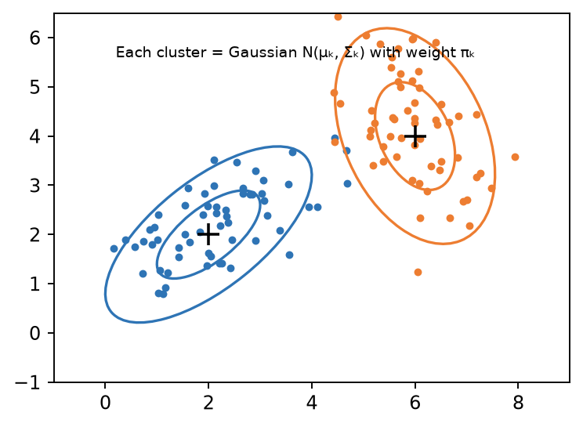
Fig. GMM: two Gaussian components with elliptical contours
- Ellipses: 1σ and 2σ contours of each Gaussian – clusters can be elliptical and of different sizes.
- + marks: means μₖ. Points in the overlap get split membership probabilities.

2. EM Algorithm for GMM
1. Initialise μₖ, Σₖ, πₖ (randomly or from K-Means).
2. E-step (Expectation): compute responsibility γ(zₙₖ) = probability that point xₙ belongs to cluster k:
γₙₖ = πₖ N(xₙ | μₖ, Σₖ) / Σⱼ πⱼ N(xₙ | μⱼ, Σⱼ)
3. M-step (Maximisation): update parameters using responsibilities:
- μₖ = Σₙ γₙₖ xₙ / Nₖ ; Σₖ = Σₙ γₙₖ (xₙ − μₖ)(xₙ − μₖ)ᵀ / Nₖ ; πₖ = Nₖ / N, where Nₖ = Σₙ γₙₖ.
4. Compute log-likelihood; repeat E and M steps until it converges.
5. Assign each point to the cluster with the highest probability (if hard labels needed).

3. Example
Heights of a mixed group of adults: two overlapping bell curves – women (μ ≈ 160 cm) and men (μ ≈ 175 cm). GMM learns both Gaussians; a person of 168 cm may get 0.45 women / 0.55 men.

4. How GMM differs from other clustering algorithms
Basis | GMM | K-Means / DBSCAN / Hierarchical
Assignment | Soft (probabilities) | Hard (one cluster)
Cluster shape | Elliptical, different sizes (covariance) | K-Means: spherical; DBSCAN: arbitrary
Basis | Statistical distribution (likelihood) | Distance (K-Means, HC) or density (DBSCAN)
Algorithm | EM (E-step, M-step) | Assign–update / region growing / merge-split
Output | μ, Σ, π + membership probabilities | Labels (and centroids)
Generative | Yes – can generate new samples | No
K required | Yes (choose by BIC/AIC) | K-Means yes; DBSCAN no

5. Advantages / Disadvantages
- + Flexible cluster shapes; soft membership; probabilistic interpretation; density estimation.
- − Needs K; sensitive to initialisation; can converge to local optimum; slower than K-Means; assumes Gaussian data.

Conclusion
GMM models data as a weighted sum of Gaussians learnt by EM, giving soft, elliptical clusters – a probabilistic generalisation of K-Means.
Memory trick: "E = Estimate who belongs, M = Move the Gaussians." GMM = "soft K-Means with shapes".

U2-4. What is clustering? Elaborate the types of clustering.
Importance: ★ | Max asked: 9 M → write for 11 M | Asked in: Nov-Dec 2024
Source: ML Unit 3-6.pdf, pp. 41–48, 61, 64 (Sec. 4.1 What is clustering; types: partitioning, hierarchical, density, distribution; book pp. 4-2 to 4-9, 4-22, 4-25). Grid-based and fuzzy types are standard additions.
Asked as: What is clustering? Elaborate Types of Clustering. (Nov-Dec 2024 Q3(b), 9 M)

Definition
Clustering is an unsupervised learning technique that groups unlabelled data objects so that objects in the same cluster are similar (high intra-cluster similarity) and objects in different clusters are dissimilar (low inter-cluster similarity).

1. Characteristics of good clustering
- High intra-cluster similarity, low inter-cluster similarity.
- Scalable, handles different attribute types, noise and arbitrary shapes; interpretable.
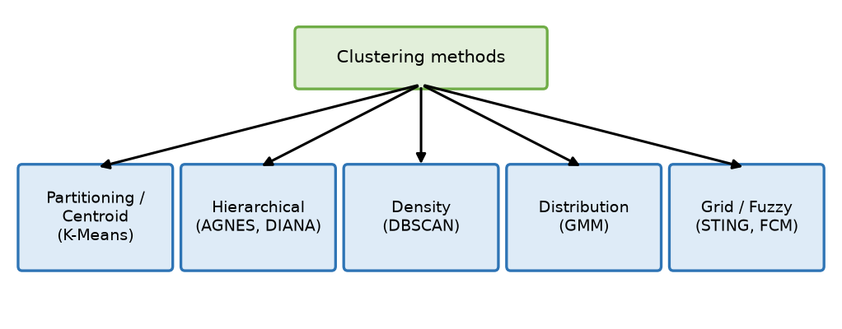
Fig. Types of clustering methods

2. Types of Clustering
1. Partitioning / Centroid-based clustering
- Divides data into K non-overlapping groups; each represented by a centroid.
- Examples: K-Means, K-Medoids (PAM), CLARA.
- Fast; needs K; spherical clusters.
2. Hierarchical (connectivity-based) clustering
- Builds a tree of clusters (dendrogram).
- Agglomerative (AGNES) – bottom-up merging; Divisive (DIANA) – top-down splitting.
- No need for K in advance; costly O(n²).
3. Density-based clustering
- Clusters = dense regions separated by sparse regions; finds arbitrary shapes and noise.
- Examples: DBSCAN, OPTICS, Mean-shift.
4. Distribution (model)-based clustering
- Assumes data comes from probability distributions; soft membership.
- Example: Gaussian Mixture Model (EM).
5. Grid-based clustering
- Quantises space into a grid of cells and clusters the cells; very fast.
- Examples: STING, CLIQUE.
6. Fuzzy (soft) clustering
- A point can belong to several clusters with membership degrees (0–1).
- Example: Fuzzy C-Means.
- Also: Hard vs soft clustering; flat vs hierarchical.

3. Example
Online store groups customers by spending and visits: K-Means → 3 segments (budget, regular, premium); DBSCAN flags bulk-buying outliers.
Type | Idea | Example
Partitioning | Nearest centroid | K-Means
Hierarchical | Merge / split tree | AGNES, DIANA
Density | Dense regions | DBSCAN
Distribution | Mixture of Gaussians | GMM
Grid | Cells of space | STING
Fuzzy | Membership degrees | FCM

Conclusion
Clustering finds natural groups in unlabelled data; the type is chosen according to cluster shape, size, noise and data volume.
Memory trick – "PHD-DG-F": Partitioning, Hierarchical, Density, Distribution, Grid, Fuzzy.

U2-5. Elaborate the need of clustering and explain how the elbow method is used to decide the value of k.
Importance: ★ | Max asked: 9 M → write for 11 M | Asked in: Nov-Dec 2023
Source: ML Unit 3-6.pdf, pp. 41–42 (uses / need of cluster analysis) and pp. 59–60 (elbow method; book pp. 4-2, 4-3, 4-20, 4-21).
Asked as: Elaborate need of clustering and explain how the elbow method is used to decide the value of cluster k. (Nov-Dec 2023 Q4(a), 9 M)

Definition
Clustering groups unlabelled data into meaningful groups. The Elbow method is a graphical technique to choose the optimal number of clusters K for K-Means by plotting WCSS against K and picking the "elbow" point.

1. Need of Clustering
1. Labelled data is costly – clustering finds structure without labels.
2. Pattern discovery: reveals hidden groups (customer types, gene families).
3. Data summarisation / reduction: represent many points by few centroids (compression).
4. Pre-processing for other algorithms (features, sampling, semi-supervised labelling).
5. Outlier/anomaly detection: points far from all clusters.
6. Decision making: targeted marketing, resource allocation, recommendation.

2. Elbow Method – Steps
1. Run K-Means for K = 1, 2, …, 10.
2. For each K compute WCSS (inertia):
WCSS = Σₖ Σ_{x ∈ Cₖ} ‖x − μₖ‖²
- μₖ = centroid of cluster Cₖ; ‖·‖ = Euclidean distance.
3. Plot WCSS (y-axis) vs K (x-axis).
4. WCSS always decreases as K increases (K = n → WCSS = 0).
5. Choose K at the "elbow" – where the decrease sharply slows down; adding more clusters gives little gain.
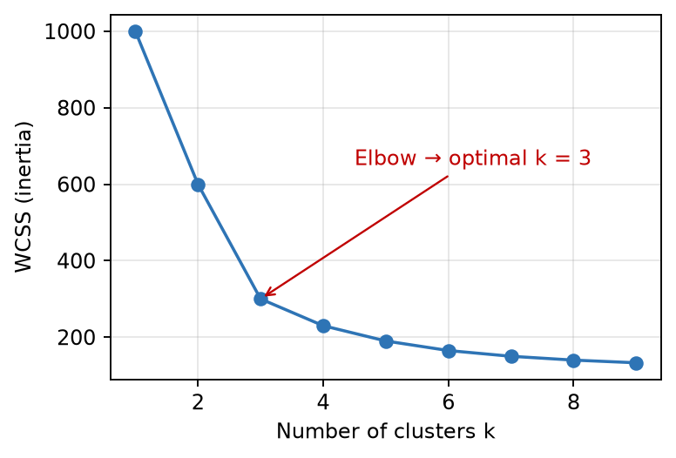
Fig. Elbow curve: WCSS drops sharply till K = 3, then flattens
- x-axis: number of clusters K; y-axis: WCSS.
- Elbow (K = 3): best trade-off between compactness and number of clusters.

3. Example
WCSS = 1000, 600, 300, 230, 190 for K = 1…5 → drop 400, 300, then only 70 → K = 3.

4. Limitations
- Elbow may be unclear/smooth; then use silhouette score or gap statistic.

Conclusion
Clustering is needed to discover structure in unlabelled data, and the elbow method gives a simple visual way to choose K for K-Means.
Memory trick: "Bend your arm – the elbow is where the curve bends." Plot WCSS vs K, not accuracy.

U2-6. Differentiate Agglomerative Hierarchical Clustering and Divisive Hierarchical Clustering.
Importance: ★ | Max asked: 8 M → write for 10 M | Asked in: Nov-Dec 2024
Source: ML Unit 3-6.pdf, pp. 48–52 (hierarchical clustering: agglomerative and divisive, dendrogram; book pp. 4-9 to 4-13). The worked example is a standard illustration.

Definition
Hierarchical clustering builds a hierarchy (tree) of clusters shown as a dendrogram. Agglomerative (AHC/AGNES) works bottom-up by merging; Divisive (DHC/DIANA) works top-down by splitting.
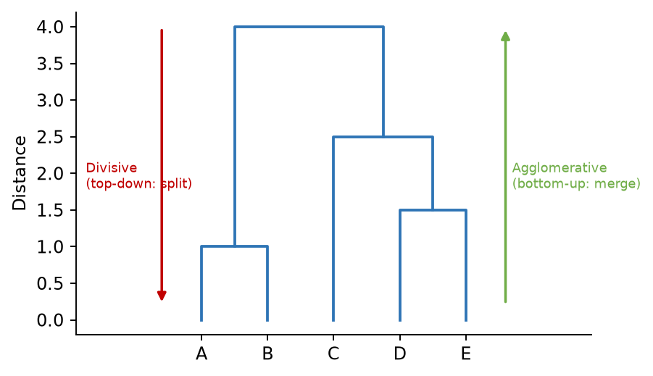
Fig. Dendrogram: agglomerative merges upward, divisive splits downward
Basis | Agglomerative (AHC) | Divisive (DHC)
Approach | Bottom-up | Top-down
Start | Each point is its own cluster (n clusters) | All points in one cluster
Operation | Merge the two closest clusters | Split a cluster into two
End | One cluster (or K clusters) | Each point alone (or K clusters)
Decision based on | Linkage: single, complete, average, Ward | Largest diameter / dissimilarity (DIANA), or K-Means split (bisecting)
Complexity | O(n² log n) to O(n³) | O(2ⁿ) exhaustive; heuristics needed
Accuracy | Local decisions; early merges cannot be undone | Uses global view first → can be more accurate at top levels
Popularity | More common, easy to implement | Less common, complex
Algorithm name | AGNES | DIANA
Good for | Finding small clusters | Finding large clusters

Example
Points A–E: AHC merges (A,B), (D,E), then C with (D,E), then all. DHC first splits {A..E} into {A,B} and {C,D,E}, then continues splitting.

Conclusion
Both produce a dendrogram; AHC merges small clusters upward, DHC splits the whole set downward. Cut the dendrogram at a height to get K clusters.
Memory trick: Agglomerative = Add together (bottom-up); Divisive = Divide (top-down).

U2-7. Explain the Divisive Hierarchical Clustering (DHC) algorithm with example.
Importance: ★ | Max asked: 8 M → write for 10 M | Asked in: Nov-Dec 2023
Source: ML Unit 3-6.pdf, pp. 48–52 (hierarchical clustering: agglomerative and divisive, dendrogram; book pp. 4-9 to 4-13). The worked example is a standard illustration.
Asked as: Explain Divisive Hierarchical clustering (DHC) algorithm with example. (Nov-Dec 2023 Q4(b), 8 M)

Definition
Divisive Hierarchical Clustering (DHC / DIANA – DIvisive ANAlysis) is a top-down clustering method: it starts with all points in one cluster and recursively splits clusters until each point is a separate cluster or a stopping criterion (K clusters) is met.

1. Algorithm (DIANA)
1. Start with one cluster containing all n points; compute the distance matrix.
2. Choose the cluster with the largest diameter (max distance between any two of its points).
3. In that cluster, find the point with the highest average dissimilarity to the others → it starts a new "splinter group".
4. Move points that are closer (on average) to the splinter group than to the remaining group into the splinter group.
5. Repeat step 4 until no point moves → the cluster is split into two.
6. Repeat steps 2–5 until every cluster has one point (or K clusters reached).
7. Draw the dendrogram (top-down).
- Alternative: Bisecting K-Means – split the largest cluster with K-Means (K = 2) repeatedly.
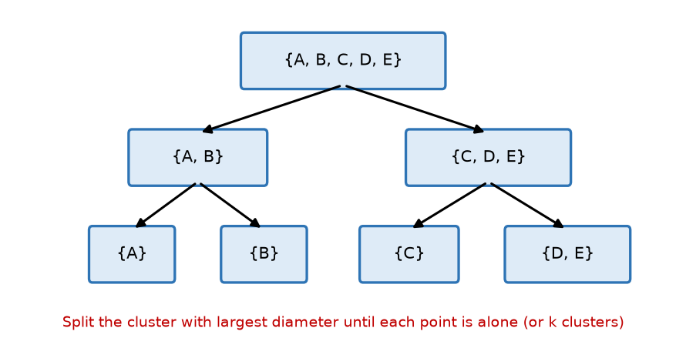
Fig. Divisive clustering: splitting {A..E} step by step

2. Example
1-D points: A = 1, B = 2, C = 6, D = 9, E = 10.
- Step 1: {A,B,C,D,E}. Average distance of A to others = (1+5+8+9)/4 = 5.75 (highest) → A starts splinter group.
- B: avg to splinter {A} = 1, to rest {C,D,E} = (4+7+8)/3 = 6.33 → B moves. C: to {A,B} = 4.5, to {D,E} = 3.5 → stays.
- Split 1: {A, B} and {C, D, E}.
- Step 2: largest diameter is {C,D,E} (10 − 6 = 4) → C is farthest (avg 3.5) → {C} and {D, E}.
- Step 3: split {A,B} → {A},{B}; split {D,E} → {D},{E}. Done.

3. Advantages / Disadvantages
- + Takes a global view first; good at finding large clusters; no K needed (cut dendrogram).
- − Computationally expensive; splits cannot be undone; sensitive to outliers.

Conclusion
DHC (DIANA) starts from one cluster and keeps splitting the widest cluster using the splinter-group idea until all points are separated, producing a top-down dendrogram.
Memory trick: "DIANA divides – find the odd one out (splinter), pull its friends, split."

U2-8. Discuss applications of clustering in market segmentation, social network analysis, image segmentation and anomaly detection, with examples.
Importance: ★ | Max asked: 8 M → write for 10 M | Asked in: Nov-Dec 2025
Source: ML Unit 3-6.pdf, pp. 66–67 (Sec. 4.7 Application of Clustering Technique: market segmentation, social network analysis, image segmentation, anomaly detection; book pp. 4-27, 4-28).
Asked as: Discuss the applications of clustering techniques in market segmentaion, social network analysis, image segmentation, and anomaly detection. Provide examples for each application. (Nov-Dec 2025 Q3(b), 8 M)

Definition
Clustering groups similar unlabelled objects; because it needs no labels, it is widely used to discover segments, communities, regions and outliers in real data.
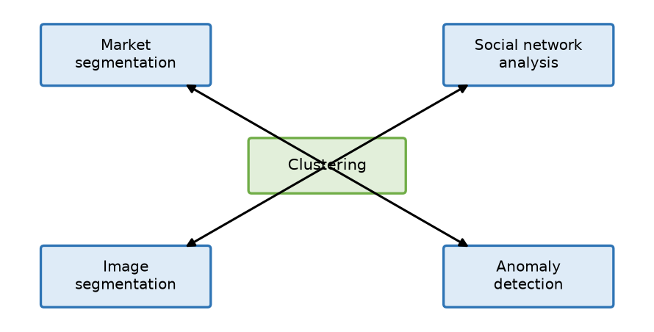
Fig. Major applications of clustering

1. Market Segmentation
- Group customers by demographics, purchase history, spending, frequency (RFM).
- Algorithm: K-Means / GMM.
- Example: a supermarket finds 3 segments – budget shoppers, regular families, premium buyers – and sends targeted offers to each.

2. Social Network Analysis
- Detect communities – groups of users who interact more with each other than with others.
- Algorithm: hierarchical / graph (spectral) clustering.
- Example: Facebook/LinkedIn suggest friends or groups by clustering users with common connections and interests; detecting fake-account rings.

3. Image Segmentation
- Group pixels with similar colour, intensity or texture into regions.
- Algorithm: K-Means on pixel colours, mean-shift, DBSCAN.
- Example: in an MRI scan, separating tumour tissue from healthy tissue; separating road, sky and vehicles in self-driving car images; colour quantisation.

4. Anomaly (Outlier) Detection
- Points that do not belong to any cluster or lie far from centroids are anomalies.
- Algorithm: DBSCAN (noise points), distance from K-Means centroid.
- Example: credit-card fraud – a transaction far from a customer's usual cluster (amount, location, time) is flagged; network intrusion detection.

5. Other Applications (brief)
- Document/news grouping, recommendation systems, biology (gene expression), city planning, insurance.
Application | What is clustered | Typical algorithm | Example
Market segmentation | Customers | K-Means, GMM | Budget vs premium buyers
Social network analysis | Users / nodes | Hierarchical, spectral | Friend communities
Image segmentation | Pixels | K-Means, mean-shift | Tumour region in MRI
Anomaly detection | Transactions / events | DBSCAN | Card fraud

Conclusion
Clustering turns raw unlabelled data into actionable groups – segments for marketing, communities in networks, regions in images and outliers for security.
Memory trick – "MSIA": Market, Social, Image, Anomaly. Always give one concrete example per application.

4. Last-Minute Revision Sheet

Key Definitions
- Clustering: unsupervised grouping; high intra-, low inter-cluster similarity.
- K-Means: centroid-based; minimise WCSS; Choose K → Assign → Update → Repeat.
- Elbow method: plot WCSS vs K; choose bend point.
- DBSCAN: density-based; ε & MinPts; core / border / noise; arbitrary shapes; no K.
- GMM: mixture of Gaussians; soft clustering; EM algorithm (E: responsibilities, M: update μ, Σ, π).
- Hierarchical: dendrogram; AHC (AGNES, bottom-up merge), DHC (DIANA, top-down split).

Formulas
Item | Formula
Euclidean distance | √Σ(xᵢ − yᵢ)²
K-Means objective / WCSS | ΣₖΣ‖x − μₖ‖²
Centroid update | μₖ = mean of points in Cₖ
GMM density | p(x) = Σ πₖ N(x | μₖ, Σₖ), Σπₖ = 1
GMM responsibility | γₙₖ = πₖN(xₙ|μₖ,Σₖ) / Σⱼ πⱼN(xₙ|μⱼ,Σⱼ)
DBSCAN core point | |N_ε(p)| ≥ MinPts

Memory Tricks
- K-Means = CAUR; Clustering types = PHD-DG-F; DBSCAN = C-B-N.
- GMM = "soft K-Means with shapes"; EM = Estimate, Move.
- Agglomerative = Add; Divisive = Divide. Applications = MSIA.
- In K-Means numericals, show each iteration as a table and stop when centroids repeat.

5. Assumptions & Gaps
- Unit mapping: Q3/Q4 of each paper are taken as Unit 2 (= syllabus Unit IV, Clustering).
- 2024 Q4(b) "centroid based clustering, explain any one type" is merged with K-Means (U2-1) because K-Means is the type normally explained.
- The K-Means and DIANA worked examples are standard illustrations created for practice (not copied from a paper).
- All Unit 2 topics were found in ML Unit 3-6.pdf (Unit IV); no ⚠ flags.

