Machine Learning — Unit 4 Exam Answers
Unit 4: Reinforcement Learning (Syllabus Unit VI)
SPPU B.E. (AI & DS) 2019 Pattern, Course 417521 · Exam: 70 marks, 2.5 hours · Paper unit = question pair (Q1/Q2 → Unit 1, Q3/Q4 → Unit 2, Q5/Q6 → Unit 3, Q7/Q8 → Unit 4).
Each answer is written for (X + 2) marks, where X = highest marks ever asked. Sources cite your PDFs by file name and PDF page number.

1. Unit Snapshot
No. | Question | Max Marks | Years Asked | Importance
U4-1 | What is Reinforcement Learning? Explain its need/importance, types and real-time applications. | 9 | Nov-Dec 2023, Nov-Dec 2024, Nov-Dec 2025 | ★★★
U4-2 | Compare supervised, unsupervised and reinforcement learning with examples. | 9 | Nov-Dec 2023, Nov-Dec 2024, Nov-Dec 2025 | ★★★
U4-3 | Explain the Q-Learning algorithm: important terms, working, and an example. | 9 | Nov-Dec 2023, Nov-Dec 2025 | ★★★
U4-4 | Explain the Markov property and Markov Decision Process (MDP). How does the Markov property relate to RL and why is it important? | 9 | Nov-Dec 2024, Nov-Dec 2025 | ★★★
U4-5 | Explain the terms: Markov Property, Markov Chain, Markov Reward Process, Bellman Equation, Q-table, Q-function. | 8 | Nov-Dec 2023, Nov-Dec 2024 | ★★★

2. Must-Do First (★★★)
- U4-1 — What is Reinforcement Learning? Explain its need/importance, types and real-time applications. (9 M)
- U4-2 — Compare supervised, unsupervised and reinforcement learning with examples. (9 M)
- U4-3 — Explain the Q-Learning algorithm: important terms, working, and an example. (9 M)
- U4-4 — Explain the Markov property and Markov Decision Process (MDP). How does the Markov property relate to RL and why is it important? (9 M)
- U4-5 — Explain the terms: Markov Property, Markov Chain, Markov Reward Process, Bellman Equation, Q-table, Q-function. (8 M)

3. Full Answers

U4-1. What is Reinforcement Learning? Explain its need/importance, types and real-time applications.
Importance: ★★★ | Max asked: 9 M → write for 11 M | Asked in: Nov-Dec 2023, Nov-Dec 2024, Nov-Dec 2025
Source: ML Unit 3-6.pdf, pp. 87–94 (Sec. 6.1 What is RL, need, elements, real-time applications; Sec. 6.2–6.3 types, positive vs negative reinforcement; book pp. 6-2 to 6-9).
Asked as: What is Reinforcement Learning? Explain the real time applications of reinforcement learning. (Nov-Dec 2023 Q8(a), 8 M) | Explain Reinforcement Learning need and its types in detail? (Nov-Dec 2024 Q7(b), 9 M) | Define reinforcement learning. Why is reinforcement learning important in the field of machine learning? (Nov-Dec 2025 Q7(a), 9 M)

Definition
Reinforcement Learning (RL) is a type of machine learning in which an agent learns to take actions in an environment by trial and error, receiving rewards or penalties, so as to maximise the cumulative (long-term) reward. No labelled data is given – only a reward signal.
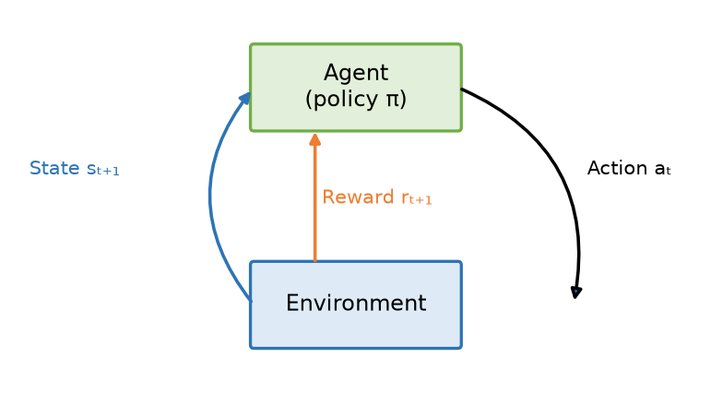
Fig. Agent–environment interaction loop in RL
- Agent: learner/decision maker (follows policy π).
- Environment: world the agent acts in.
- Action aₜ: move chosen by the agent. State sₜ₊₁: new situation returned by environment.
- Reward rₜ₊₁: numerical feedback (+ve = good, −ve = bad).

1. Elements of RL
- Agent, Environment, State (s), Action (a), Reward (r).
- Policy π(a|s): strategy mapping states to actions.
- Value function V(s): expected long-term return from a state.
- Q-value Q(s,a): expected return of taking action a in state s.
- Model (optional): agent's prediction of environment's next state/reward.
- Discount factor γ (0–1): importance of future rewards.
Return Gₜ = rₜ₊₁ + γ rₜ₊₂ + γ² rₜ₊₃ + …

2. Need / Importance of RL
1. Learns without labelled data – only feedback from interaction.
2. Solves sequential decision-making problems where actions affect future states.
3. Handles delayed rewards (e.g., winning a game only at the end).
4. Adapts to dynamic, uncertain environments; continuous learning.
5. Balances exploration vs exploitation – discovers new strategies.
6. Achieves super-human performance (AlphaGo, Atari games) and real-world control.

3. Types of Reinforcement Learning
1. Positive reinforcement: a reward is given for good behaviour → increases frequency of that behaviour (maximises performance; too much may overload states).
2. Negative reinforcement: behaviour is strengthened by removing/avoiding a negative condition (e.g., penalty) → ensures minimum standard of performance.
- By approach:
- Model-based vs model-free (Q-learning, SARSA are model-free).
- Value-based (Q-learning, DQN), policy-based (REINFORCE), actor–critic.
- On-policy (SARSA) vs off-policy (Q-learning).

4. Real-Time Applications
Area | Application
Games | AlphaGo, chess, Atari – learn winning strategies
Robotics | Robot walking, grasping objects, industrial automation
Self-driving cars | Lane keeping, parking, trajectory planning
Finance | Stock trading, portfolio management
Healthcare | Dynamic treatment plans, drug dosage
Recommendation | News/video recommendations (YouTube, Netflix)
Resource management | Data-centre cooling (Google), traffic-light control
NLP / Chatbots | Dialogue systems, RLHF for large language models

Example
A dog learns tricks: it sits (action) after the command (state); gets a biscuit (reward); it learns to repeat the action. Similarly a robot learns to walk by getting +1 for each step forward and −10 for falling.

Conclusion
RL lets an agent learn optimal behaviour from rewards through interaction; it is essential for sequential decision problems such as games, robotics and autonomous driving.
Memory trick – "A-E-S-A-R": Agent in Environment sees State, takes Action, gets Reward. Types: +ve adds a reward, −ve removes a penalty.

U4-2. Compare supervised, unsupervised and reinforcement learning with examples.
Importance: ★★★ | Max asked: 9 M → write for 11 M | Asked in: Nov-Dec 2023, Nov-Dec 2024, Nov-Dec 2025
Source: ML Unit 3-6.pdf, p. 92 (Sec. 6.1.6 Difference between Supervised, Unsupervised and Reinforced Learning; book p. 6-7).
Asked as: Explain following terms: i) Supervised Learning. ii) Unsupervised Learning. iii) Reinforcement Learning. (Nov-Dec 2023 Q8(b), 9 M) | Differentiate supervised and unsupervised learning with example. (Nov-Dec 2024 Q7(a), 8 M) | Compare and contrast supervised, unsupervised, and reinforcement learning. Provide examples of each type. (Nov-Dec 2025 Q8(b), 8 M)

Definition
- Supervised learning: learns a mapping from labelled data (input → known output) to predict outputs for new inputs.
- Unsupervised learning: finds hidden patterns/structure in unlabelled data.
- Reinforcement learning: an agent learns by interaction, using rewards to find the best actions.
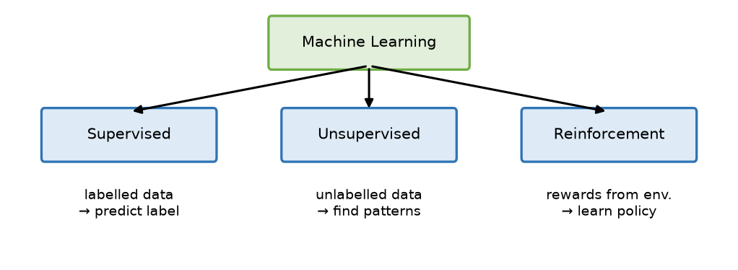
Fig. Three learning paradigms of machine learning

1. Supervised Learning
- Data: pairs (x, y) – a "teacher" provides correct answers.
- Tasks: classification (discrete y) and regression (continuous y).
- Algorithms: linear/logistic regression, KNN, SVM, decision trees, neural networks.
- Example: email spam detection; house-price prediction.

2. Unsupervised Learning
- Data: only x (no labels).
- Tasks: clustering, association rules, dimensionality reduction.
- Algorithms: K-Means, DBSCAN, hierarchical, PCA, Apriori.
- Example: customer segmentation; market-basket analysis.

3. Reinforcement Learning
- Data: generated by agent–environment interaction; feedback = reward.
- Tasks: sequential decision making / control.
- Algorithms: Q-learning, SARSA, DQN, policy gradient.
- Example: game playing (AlphaGo), self-driving car, robot navigation.

4. Comparison
Basis | Supervised | Unsupervised | Reinforcement
Input data | Labelled (x, y) | Unlabelled (x) | No fixed dataset; states from environment
Feedback | Direct – correct answer | None | Reward / penalty (delayed)
Goal | Predict output / label | Discover patterns, groups | Maximise cumulative reward
Learning style | Learn from teacher (examples) | Self-organisation | Trial and error
Tasks | Classification, regression | Clustering, association, dim. reduction | Control, decision making
Algorithms | LR, SVM, KNN, DT | K-Means, DBSCAN, PCA, Apriori | Q-learning, SARSA, DQN
Decision type | Independent, one-shot | – | Sequential, each action affects future
Evaluation | Accuracy, MSE | Silhouette, WCSS | Total reward
Example | Spam filter, price prediction | Customer segmentation | Chess/AlphaGo, robot walking

Conclusion
Supervised learning learns from answers, unsupervised learning finds structure, and reinforcement learning learns from rewards by acting in an environment.
Memory trick: Supervised = Student with teacher; Unsupervised = Unguided explorer; Reinforcement = Reward-driven pet.

U4-3. Explain the Q-Learning algorithm: important terms, working, and an example.
Importance: ★★★ | Max asked: 9 M → write for 11 M | Asked in: Nov-Dec 2023, Nov-Dec 2025
Source: ML Unit 3-6.pdf, pp. 99–101 (Sec. 6.5 Q Learning; book pp. 6-14 to 6-16). The numerical update example is a standard illustration.
Asked as: Explain Q-Learning algorithm with an example. (Nov-Dec 2023 Q7(b), 9 M) | Introduce Q-learning. What are the important terms used in Q-learning? How does Q-learning work? (Nov-Dec 2025 Q8(a), 9 M)

Definition
Q-Learning is a model-free, off-policy, value-based reinforcement learning algorithm that learns the optimal action-value function Q*(s, a) – the expected cumulative reward of taking action a in state s and acting optimally afterwards – using the Bellman equation and a Q-table.

1. Important Terms
- State (s), Action (a), Reward (r), Next state (s′).
- Q-value Q(s,a): "quality" of action a in state s.
- Q-table: table with rows = states, columns = actions, entries = Q-values (initialised to 0).
- Learning rate α (0–1): how much new information overrides old.
- Discount factor γ (0–1): importance of future rewards.
- Episode: one run from start state to terminal state.
- ε-greedy policy: with probability ε explore (random action), else exploit (best Q action).
- Temporal Difference (TD) error: r + γ max Q(s′,a′) − Q(s,a).

2. Q-Learning Update Rule (Bellman)
Q(s, a) ← Q(s, a) + α [ r + γ · maxₐ′ Q(s′, a′) − Q(s, a) ]
- r + γ max Q(s′,a′) = target (TD target); difference from old Q = TD error.

3. Algorithm / How it works
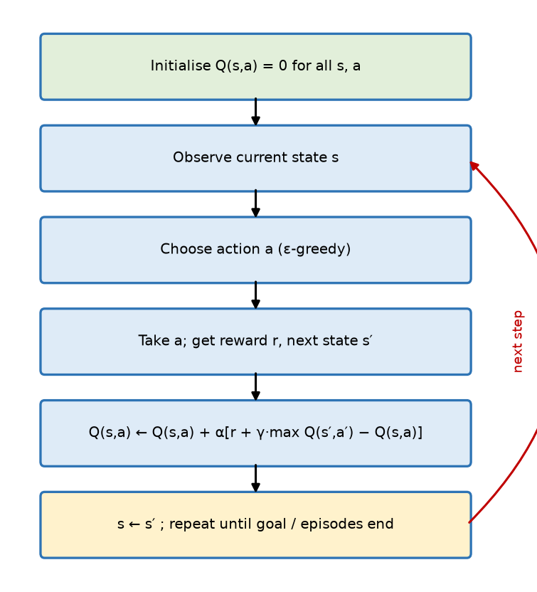
Fig. Q-Learning algorithm flowchart
1. Initialise Q(s, a) = 0 for all states and actions; set α, γ, ε.
2. For each episode: start at initial state s.
3. Choose action a using ε-greedy policy.
4. Perform a, observe reward r and next state s′.
5. Update Q(s, a) using the update rule.
6. Set s ← s′; repeat steps 3–6 until terminal state.
7. Repeat many episodes until Q-values converge; optimal policy π*(s) = argmaxₐ Q(s, a).

4. Example (one update)
Robot in a grid: state S1, action Right → reaches S2, reward r = +10. Given α = 0.5, γ = 0.9, Q(S1,Right) = 0, max Q(S2,·) = 5:
Q(S1,Right) = 0 + 0.5 [10 + 0.9 × 5 − 0] = 0.5 × 14.5 = 7.25
State | Left | Right | Up | Down
S1 | 0 | 7.25 | 0 | 0
S2 | 0 | 5 | 0 | 0

Next time in S1, the agent prefers Right (highest Q).

5. Advantages / Disadvantages
- + Model-free (no environment model needed); off-policy (learns optimal policy while exploring); simple; guaranteed convergence with enough exploration.
- − Q-table becomes huge for large/continuous state spaces (→ Deep Q-Network); slow convergence; needs tuning of α, γ, ε.

6. Applications
- Game playing, robot navigation, traffic signal control, recommendation, trading bots.

Conclusion
Q-learning fills a Q-table by repeatedly applying the Bellman update while exploring, and finally acts greedily on the learned Q-values.
Memory trick: "New Q = Old Q + α (Target − Old)", Target = r + γ·max next Q. Off-policy = learns the max, even while acting ε-greedy.

U4-4. Explain the Markov property and Markov Decision Process (MDP). How does the Markov property relate to RL and why is it important?
Importance: ★★★ | Max asked: 9 M → write for 11 M | Asked in: Nov-Dec 2024, Nov-Dec 2025
Source: ML Unit 3-6.pdf, pp. 94–99 (Sec. 6.4 Markov Decision Process, Markov property, Bellman equation; book pp. 6-9 to 6-14).
Asked as: How does the Markov property relate to Reinforcement Learning? Why is it important? (Nov-Dec 2024 Q8(b), 9 M) | Explain Markov's Decision Process (MDP). What is the Markov property in the context of MDP? (Nov-Dec 2025 Q7(b), 8 M)

Definition
The Markov property states that the future state depends only on the present state (and action), not on the past history. A Markov Decision Process (MDP) is the mathematical framework of RL in which an agent makes decisions in states that satisfy the Markov property.
P(sₜ₊₁ | sₜ, aₜ) = P(sₜ₊₁ | s₁, a₁, …, sₜ, aₜ)
- "The future is independent of the past given the present."

1. MDP Components – tuple (S, A, P, R, γ)
- S: finite set of states.
- A: set of actions.
- P(s′ | s, a): transition probability of reaching s′ from s by action a.
- R(s, a): reward received after taking action a in state s.
- γ: discount factor (0 ≤ γ ≤ 1).
- Policy π(a | s): what the agent does in each state; goal = find optimal policy π maximising expected return
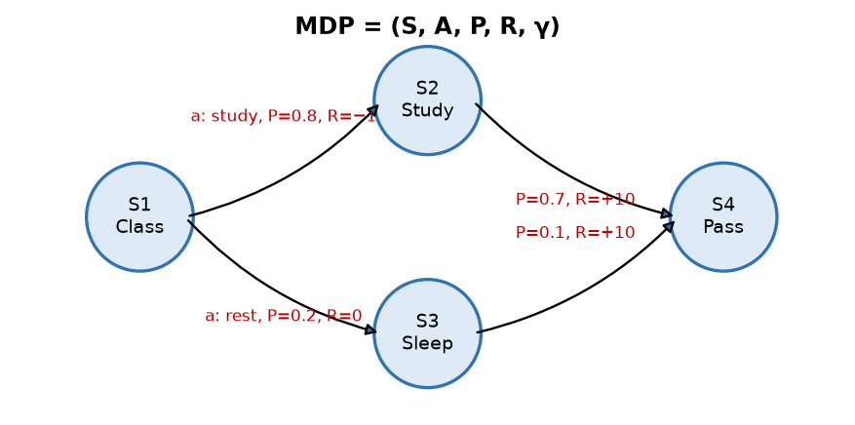
Fig. Simple MDP: states, actions, transition probabilities and rewards
- Circles: states (Class, Study, Sleep, Pass). Arrows: actions/transitions with probability P and reward R.
- Next state depends only on the current state and chosen action → Markov property.

2. Working of an MDP
1. Agent observes state sₜ.
2. Chooses action aₜ by policy π.
3. Environment moves to sₜ₊₁ with probability P(sₜ₊₁ | sₜ, aₜ) and gives reward rₜ₊₁.
4. Repeat; maximise expected return Gₜ = Σ γᵏ rₜ₊ₖ₊₁.
5. Solve using Bellman equations (value iteration, policy iteration, Q-learning).
V*(s) = maxₐ [ R(s, a) + γ Σₛ′ P(s′ | s, a) V*(s′) ]

3. Relation of Markov Property to RL & Why it is Important
1. Foundation of RL: RL problems are modelled as MDPs; the Markov property makes the state a sufficient statistic of history.
2. Simplifies decision making: the agent needs only the current state to choose the best action – no need to store full history.
3. Enables Bellman equations / recursion: value of a state can be written in terms of values of next states → basis of dynamic programming, Q-learning, TD learning.
4. Reduces computation & memory – policies and value functions are functions of state only.
5. Guarantees convergence of algorithms like value iteration and Q-learning (under conditions).
6. If the property does not hold (partial observation), we use POMDPs or add history (e.g., stacking frames) to make the state Markov.

Example
Chess: the current board position contains all information needed for the next move – how the pieces arrived there does not matter → Markov. Weather with only today's state deciding tomorrow's is a Markov chain.

Conclusion
MDP = (S, A, P, R, γ) is the framework of RL, and the Markov property (future depends only on present) makes it solvable with Bellman equations.
Memory trick: MDP = "SAP-R-γ" (States, Actions, Probabilities, Rewards, γ). Markov = "Present is enough".

U4-5. Explain the terms: Markov Property, Markov Chain, Markov Reward Process, Bellman Equation, Q-table, Q-function.
Importance: ★★★ | Max asked: 8 M → write for 10 M | Asked in: Nov-Dec 2023, Nov-Dec 2024
Source: ML Unit 3-6.pdf, pp. 95–101 (Markov property p. 95, Markov chain pp. 96–97, Markov reward process p. 98, Bellman equation pp. 98–99, Q-table / Q-function pp. 100–101; book pp. 6-10 to 6-16).
Asked as: Explain following terms: i) Markov Property ii) Bellman Equation iii) Markov Reward Process iv) Markov Chain (Nov-Dec 2023 Q7(a), 8 M) | Explain following terms: i) Belman Equation ii) Markov Chain iii) Q table iv) Q function (Nov-Dec 2024 Q8(a), 8 M)

Definition
These terms form the mathematical base of reinforcement learning: a Markov chain adds probabilities to states, a Markov Reward Process adds rewards, an MDP adds actions, and Bellman equations / Q-functions compute the value of states and actions.

1. Markov Property
- The next state depends only on the current state, not on past states.
P(sₜ₊₁ | sₜ) = P(sₜ₊₁ | s₁, s₂, …, sₜ)
- Example: in Ludo/snake-ladder, next position depends only on present position and dice.

2. Markov Chain (Markov Process)
- A sequence of random states with the Markov property, defined by a tuple (S, P) – states and transition probability matrix.
- Each row of P sums to 1.
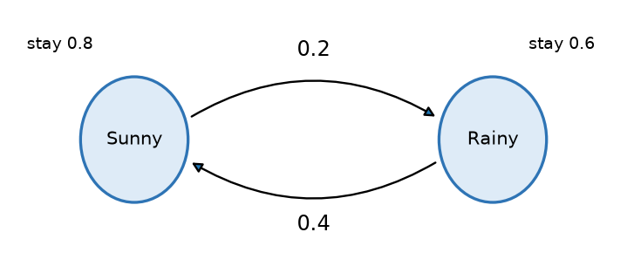
Fig. Two-state weather Markov chain
- Example: Sunny → Sunny 0.8, Sunny → Rainy 0.2; Rainy → Sunny 0.4, Rainy → Rainy 0.6.

3. Markov Reward Process (MRP)
- A Markov chain with rewards: tuple (S, P, R, γ).
- R(s) = expected immediate reward in state s; γ = discount factor.
- Return: Gₜ = rₜ₊₁ + γrₜ₊₂ + γ²rₜ₊₃ + …; state value V(s) = E[Gₜ | sₜ = s].
- Example: in the weather chain, reward +1 for Sunny, −1 for Rainy.

4. Bellman Equation
- Expresses the value of a state as immediate reward + discounted value of next states (recursive).
V(s) = R(s) + γ Σₛ′ P(s′ | s) V(s′) (MRP)
Q(s, a) = R(s, a) + γ Σₛ′ P(s′ | s, a) maxₐ′ Q(s′, a′) (Bellman optimality)
- Used by dynamic programming and Q-learning to compute optimal values.

5. Q-Table
- A lookup table with rows = states, columns = actions; each cell stores Q(s, a).
- Initialised to 0 and updated during Q-learning; the agent picks the action with the highest value in its row.
State | Up | Down | Left | Right
S1 | 0.2 | 0.0 | 0.1 | 0.8
S2 | 0.6 | 0.3 | 0.0 | 0.1

6. Q-Function (Action-Value Function)
- Q^π(s, a) = expected cumulative discounted reward of taking action a in state s and then following policy π:
Q^π(s, a) = E_π [ Gₜ | sₜ = s, aₜ = a ]
- Optimal Q-function Q(s,a) gives the optimal policy: π(s) = argmaxₐ Q(s, a)*.
- Relation: V(s) = maxₐ Q(s, a) (for optimal values).

Conclusion
Markov chain (S, P) → MRP (S, P, R, γ) → MDP (S, A, P, R, γ); the Bellman equation computes values recursively and the Q-function/Q-table stores the value of each action in each state.
Memory trick: "Chain → +Reward → +Action" = MC → MRP → MDP. Q-table = "cheat-sheet of best moves".

4. Last-Minute Revision Sheet

Key Definitions
- RL: agent learns by trial & error to maximise cumulative reward.
- Elements: agent, environment, state, action, reward, policy, value, model.
- Types: positive & negative reinforcement; model-based/model-free; value/policy-based.
- Markov property: future depends only on present.
- Markov chain: (S, P); MRP: (S, P, R, γ); MDP: (S, A, P, R, γ).
- Q-learning: model-free, off-policy, Q-table + Bellman update, ε-greedy.

Formulas
Item | Formula
Return | Gₜ = Σₖ γᵏ rₜ₊ₖ₊₁
Markov property | P(sₜ₊₁|sₜ) = P(sₜ₊₁|s₁…sₜ)
Bellman (MRP) | V(s) = R(s) + γΣP(s′|s)V(s′)
Bellman optimality | V(s) = maxₐ[R(s,a) + γΣP(s′|s,a)V(s′)]
Q-function | Q^π(s,a) = E[Gₜ | s, a]
Q-learning update | Q(s,a) ← Q(s,a) + α[r + γ maxQ(s′,a′) − Q(s,a)]
Optimal policy | π(s) = argmaxₐ Q(s,a)

Memory Tricks
- RL loop = A-E-S-A-R; MDP = SAP-R-γ; MC → MRP → MDP = "+Reward, +Action".
- Learning types: Student-teacher, Unguided explorer, Reward-driven pet.
- Q update: "New = Old + α(Target − Old)".
- α = learning rate (how fast), γ = discount (how far-sighted), ε = exploration (how curious).

5. Assumptions & Gaps
- Unit mapping: Q7/Q8 of each paper are taken as Unit 4 (= syllabus Unit VI, Reinforcement Learning). The supervised/unsupervised comparison (U4-2) appears in this slot in all three papers, so it is kept in Unit 4.
- 2023 Q8(b) ("Explain: supervised, unsupervised, reinforcement learning") and 2024 Q7(a) (supervised vs unsupervised only) are merged into the three-way comparison U4-2.
- 2023 Q7(a) and 2024 Q8(a) (term lists) are merged into U4-5, which covers all six terms asked.
- All Unit 4 topics were found in ML Unit 3-6.pdf (Unit VI); no ⚠ flags.

