Data Modeling and Visualization: Unit 1 Exam Answers
Unit 1 (Q1/Q2): Basics of Data Visualization | Syllabus Unit III

Unit Snapshot
No. | Question | Max Marks | Years Asked | Importance
1.1 | Data handling for data visualization (effect on accuracy & performance) | 10 | 2023, 2024, 2026 | ★★★
1.2 | Types of data visualization with examples / applications | 9 | 2023, 2024, 2025 | ★★★
1.3 | (Scientific) design choices in data visualization | 8 | 2024, 2025, 2026 | ★★★
1.4 | Need / role of graphics and computing in data visualization | 10 | 2023, 2025 | ★★
1.5 | Statistical historiography | 8 | 2023, 2025 | ★★
1.6 | Computational statistics and its role in data visualization | 8 | 2024, 2025 | ★★
1.7 | Presentation graphics vs exploratory graphics | 6 | 2025, 2026 | ★★
1.8 | Static graphics; features of a complete plot | 6 | 2026 | ★
1.9 | Output formats and speed issues | 6 | 2026 | ★
1.10 | 3-D plots in data modeling and visualization | 5 | 2026 | ★
Must-do first (★★★): 1.1 Data handling · 1.2 Types of data visualization · 1.3 Design choices.
All answers are written for (highest marks + 2). Source = Textbooks/DMV Textbook.pdf (scanned; PDF page numbers).

Full Answers

1.1 Explain data handling for data visualization. How does it affect accuracy and performance?
★★★ | Asked for max 10 marks → written for 12 | Asked in: 2023 (10), 2024 (9), 2026 (6) | Source: DMV Textbook.pdf, PDF p. 57-58 (Data Handling); p. 46-47 (speed strategies)
Variants: “Explain data handling in data modeling and visualization” (2023) · “Explain data handling for data visualization” (2024) · “Discuss how data handling techniques affect visualization accuracy and performance” (2026).
Definition: Data handling is the process of acquiring, cleaning, transforming, integrating and preparing data before it is visualized. It decides the quality, accuracy and structure of the data, so that the final chart is truthful and fast to render.

1. Steps in data handling
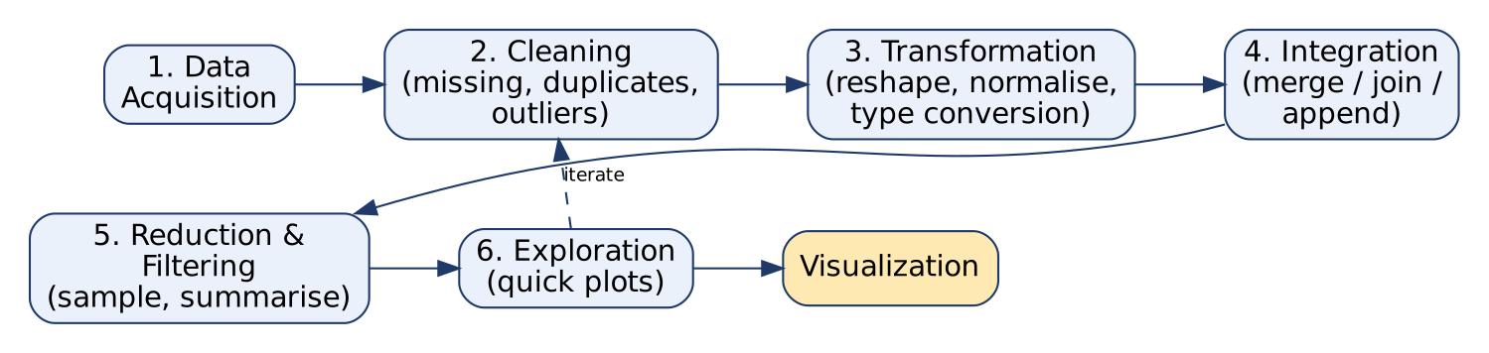
Data handling pipeline
- Data acquisition: collect data from databases, files (CSV/Excel), APIs, web scraping. Check its format and structure.
- Data cleaning: handle missing values (impute/remove), duplicates, outliers and inconsistent entries (e.g. “Pune” vs “pune”).
- Data transformation: reshape data to suit the chart, convert data types, normalise/scale values, aggregate (e.g. daily → monthly).
- Data integration: combine several sources by merging, joining or appending on a common key.
- Handling categorical data: convert categories to numbers using one-hot encoding or label encoding.
- Handling time-series data: parse timestamps, fill missing time points, align data for time comparisons.
- Data reduction: sampling or summarisation for very large datasets.
- Data filtering: keep only the subset relevant to the question (time period, region, criteria).
- Data exploration: quick plots to spot issues; go back and re-clean if needed (iterative).
Diagram explanation: Steps 1 → 4 make the data correct and complete; steps 5 → 6 make it small and focused; the dashed “iterate” arrow shows that exploration often sends us back to cleaning.

2. Effect on accuracy
- Missing values / outliers not handled → bars and averages are biased, trends look false.
- Duplicates → counts are inflated.
- Wrong data type (date stored as text) → points plotted in wrong order.
- Unscaled variables → one variable dominates a multi-variable chart.
- Correct joins in integration → no records lost or double-counted.

3. Effect on performance (speed)
- Aggregation / binning reduces the number of points to draw (1 million rows → 365 daily totals).
- Sampling and filtering cut memory use and rendering time.
- Correct, compact data types (category, int32) speed up computation.
- Clean, pre-processed data allows interactive zoom/filter without lag.

Example
A sales dataset of 10 lakh transactions: remove duplicate bills → fill missing city with “Unknown” → convert date text to datetime → group by month → plot a 12-point line chart. The chart is accurate (no double counts) and fast (12 points instead of 10 lakh).
Conclusion: Data handling is the foundation of visualization. Good handling gives accurate charts and fast, responsive visuals; poor handling gives misleading charts.
Memory trick: “A-C-T-I-R-F-E” → Acquire, Clean, Transform, Integrate, Reduce, Filter, Explore. (“ACT I Really Find Errors”)

1.2 Explain the different types of data visualization with suitable examples / applications
★★★ | Asked for max 9 marks → written for 11 | Asked in: 2023 (8), 2024 (9), 2025 (6) | Source: DMV Textbook.pdf, PDF p. 43 (3.1.1 Types of Data Visualization)
Variants: “Explain the types of Data Visualization with suitable example” (2023) · “Explain the different types of Data visualization” (2024) · “…and their applications” (2025).
Introduction: Data visualization is the graphical representation of data. Different types suit different data and different insights (comparison, trend, proportion, relationship, distribution, location, network).
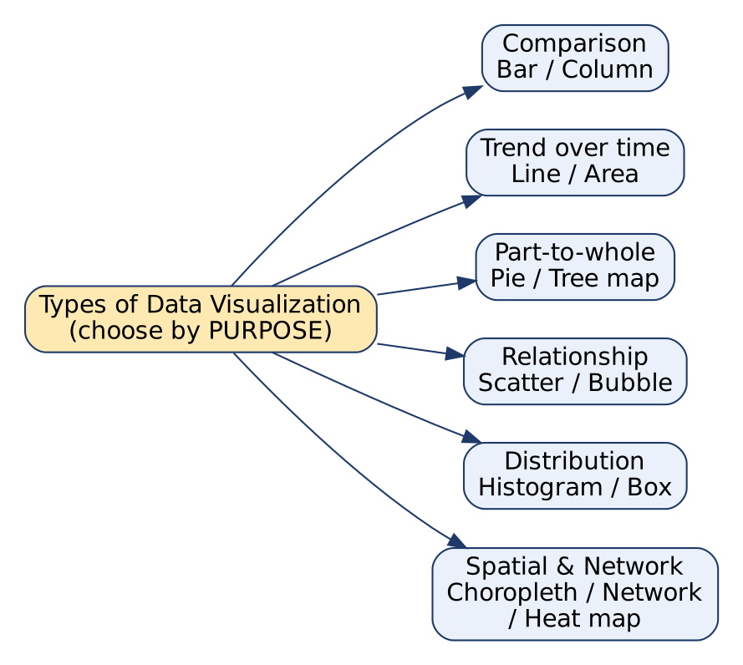
Types of data visualization by purpose
Diagram explanation: the chart type is chosen by the purpose of the question: compare → bar; trend → line; part-of-whole → pie; relationship → scatter; spread → histogram/box; location/links → map/network.
No. | Type | How it shows data | Best for | Example / Application
1 | Bar / column chart | Rectangular bars, length ∝ value | Comparing discrete categories | Sales of 5 products
2 | Line chart | Points joined by lines | Trends over time | Monthly temperature, stock price
3 | Pie chart | Slices of a circle | Part-to-whole (%) | Market share of brands
4 | Scatter plot | One dot per record (x, y) | Relationship / correlation, clusters | Height vs weight
5 | Area chart | Line chart with area filled | Cumulative totals over time | Total website traffic by source
6 | Heat map | Colour intensity in a 2-D matrix | Patterns / correlations in a matrix | Correlation matrix, hourly footfall
7 | Bubble chart | Scatter + bubble size = 3rd variable | Three variables | GDP vs life expectancy, size = population
8 | Histogram | Bars over value ranges (bins) | Distribution / frequency | Exam-mark distribution
9 | Box plot | Median, quartiles, whiskers, outliers | Spread & outliers | Salary spread per department
10 | Choropleth map | Regions coloured by value | Geographic variation | COVID cases per state
11 | Tree map | Nested rectangles, area ∝ value | Hierarchical part-to-whole | Disk usage by folder
12 | Network graph | Nodes + edges | Relationships / connections | Social network friends
13 | Word cloud | Word size ∝ frequency | Text frequency | Customer review keywords

Applications (where each family is used)
- Business intelligence dashboards: bar, line, pie, KPI charts.
- Science & research: scatter, histogram, box plot, heat map.
- Geography / public health: choropleth maps.
- Social media / IT: network graphs, word clouds.
Conclusion: No single chart fits all data; select the type by the question you want to answer and the type of data (categorical, numerical, temporal, spatial).
Memory trick: “CT-PR-DS”: Compare (bar), Trend (line), Part-whole (pie), Relationship (scatter), Distribution (histogram/box), Spatial (map). Common mistake: using a pie chart for more than 5-6 categories or for trends over time.

1.3 Explain (scientific) design choices in data visualization. Why are they important?
★★★ | Asked for max 8 marks → written for 10 | Asked in: 2024 (8), 2025 (6), 2026 (6) | Source: DMV Textbook.pdf, PDF p. 49-51 (3.5 Scientific Design Choices in Data Visualization)
Variants: “Explain in detail design choices in data visualization” (2024) · “What are some key Scientific Design Choices … why are they important?” (2025) · “Explain the concept of scientific design choices in visualization” (2026).
Definition: Scientific design choices are the deliberate, well-informed decisions a practitioner makes so that a visualization is accurate, clear and effective. They follow evidence about human perception, not personal taste.
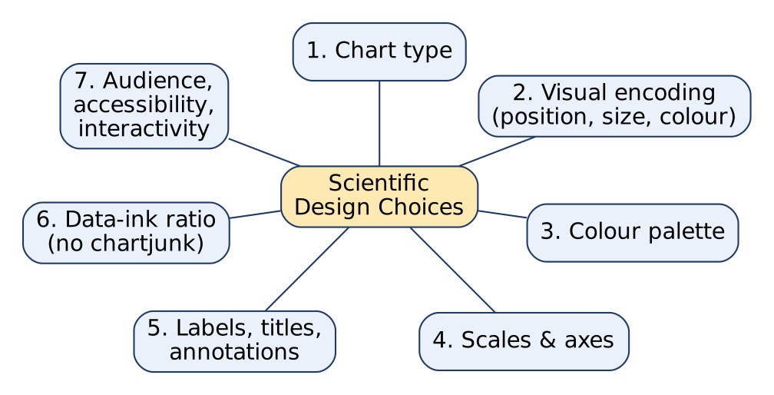
Scientific design choices
Diagram explanation: each branch below is one decision the designer must take before the chart is final.

Key design choices
- Visualization (chart) type: match the chart to the data: bar for categories, line for time trends, scatter for relationships.
- Visual encodings: map data to position, length, size, colour, shape. Position and length are read most accurately; use them for the most important variable.
- Colour palette: colours must be distinguishable and meaningful; use perceptually uniform scales (e.g. viridis) for numbers and colour-blind-safe palettes.
- Scales and axes: start bar axes at zero, use log scale for wide ranges, label units and ticks clearly. A truncated axis distorts differences.
- Labels, titles and annotations: informative title, axis labels with units, legend, notes on important points.
- Data-ink ratio: maximise ink used for data; remove chartjunk (3-D effects, heavy grids, shadows). (Edward Tufte’s idea.)
- Data density: avoid over-plotting; use transparency, sampling or aggregation.
- Interactivity: tooltips, zoom, filter, but only when they help.
- Accessibility & responsiveness: readable fonts, alt-text, works on mobile screens.
- User-centric design & storytelling: design for the target audience and guide them through a clear narrative.

Why they are important
- Prevent misleading interpretations (e.g. truncated y-axis exaggerates a 2% rise).
- Make comparisons reliable and quick.
- Improve clarity, trust and decision-making.
- Make charts inclusive (colour-blind viewers).
Example: Showing monthly revenue for 3 regions: choose a line chart, encode region by colour (3 distinct colour-blind-safe hues), y-axis from 0 with ₹ units, a clear title “Monthly Revenue by Region, 2025”, no 3-D effects.
Conclusion: Scientific design choices turn raw charts into honest, readable and persuasive visuals; they are the difference between information and decoration.
Memory trick: “TEC-SL-DI-A”: Type, Encoding, Colour, Scale, Labels, Data-ink, Interactivity, Audience.

1.4 Explain the need / role of graphics and computing in data visualization (and how exploratory graphics help)
★★ | Asked for max 10 marks → written for 12 | Asked in: 2023 (10), 2025 (6) | Source: DMV Textbook.pdf, PDF p. 45 (3.3.1 Graphics), p. 46-48 (3.3.2-3.3.5 Computing, Computational Power and Rendering, Graphic Speed and Power); p. 44-45 (Exploratory Graphics)
Variants: “Explain need of Graphics and computing in data visualization. How exploratory graphics is useful in visualization.” (2023) · “Discuss the role of Computing in Graphics and its impact on Data Visualization.” (2025)
Introduction: Graphics are the visual bridge between raw data and human understanding. Computing is the engine that processes data, calculates statistics and renders graphics quickly and interactively.

1. Need of graphics in data visualization
- Visual perception: the human eye sees patterns in a picture much faster than in tables of numbers.
- Communication: complex data becomes understandable to non-technical audiences.
- Exploration and discovery: reveals hidden patterns, outliers, correlations.
- Context and comparison: easy comparison between categories / time periods.
- Storytelling: graphics build a data-driven narrative for decisions.

2. Role of computing in data visualization
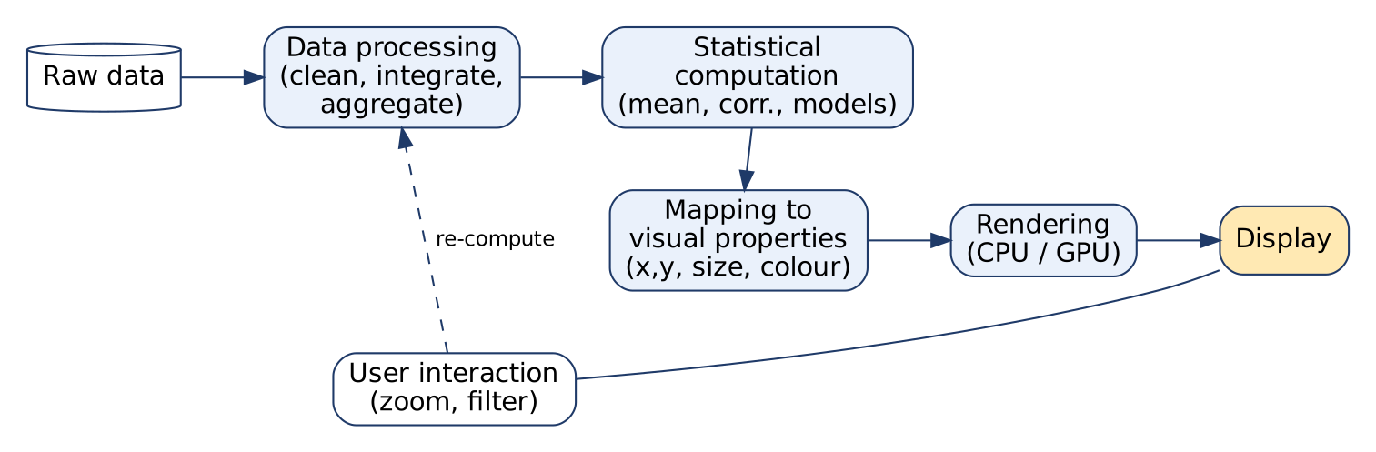
Role of computing
Diagram explanation (each block):
- Raw data: messy, large, many formats.
- Data processing: computer cleans, integrates and aggregates data.
- Statistical computation: calculates mean, median, SD, correlation, runs models (clustering, regression).
- Mapping: converts values into visual properties: position (x, y), size, colour, shape; computes scales and coordinates.
- Rendering (CPU/GPU): draws thousands of elements; GPU and parallel processing make it fast.
- User interaction: zoom, pan, filter; computing re-calculates and re-draws in real time (dashed loop).

3. Impact of computing on visualization (graphic speed and power)
- Speed: fast rendering enables real-time, interactive charts; slow rendering frustrates exploration.
- Power: ability to handle big data and 3-D / complex visuals without losing quality.
- Strategies used: data aggregation, simplification / level-of-detail, progressive loading, GPU acceleration, parallel processing, caching.
- Advanced analysis: machine-learning results (clusters, predictions) can be visualized directly.

4. How exploratory graphics help (2023 part)
- Quick first look at data without a fixed hypothesis.
- Detect outliers, clusters and relationships → generate hypotheses.
- Interactive and flexible: zoom, filter, drill-down.
- Typical tools: scatter plots, histograms, box plots, heat maps.

Applications
Business-intelligence dashboards, scientific research, EDA, geospatial maps, data journalism, data-driven art.
Conclusion: Graphics make data understandable; computing makes graphics possible, fast and interactive. Together they turn large datasets into insight.
Exam tip: Draw the 6-block pipeline (Data → Process → Compute → Map → Render → Display, with interaction loop). It earns diagram marks quickly. Memory trick (need of graphics): “PCECS”: Perception, Communication, Exploration, Comparison, Storytelling.

1.5 Write a short note on statistical historiography in data visualization
★★ | Asked for max 8 marks → written for 10 | Asked in: 2023 (8), 2025 (6) | Source: DMV Textbook.pdf, PDF p. 48-50 (3.4 Statistical Historiography, 3.4.1 Features, 3.4.2 Applications)
Definition: Statistical historiography is the study of the history and evolution of statistical graphics and visual representations of data: their origins, how they changed over time, and the pioneers who shaped the field.

1. Timeline of key milestones
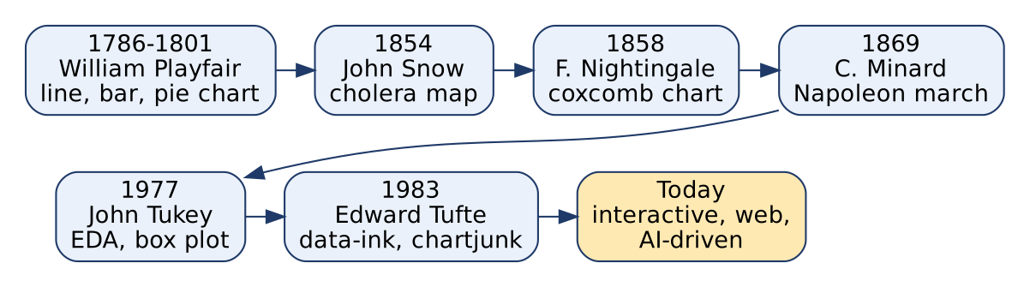
Milestones in statistical graphics
Diagram explanation:
- William Playfair (late 18th century): invented the line graph, bar chart and pie chart.
- John Snow (1854): cholera map of London; clustering of deaths around a water pump proved cholera was water-borne.
- Florence Nightingale (1858): coxcomb (polar area) chart of Crimean-War deaths; changed hospital sanitation policy.
- Charles Minard (1869): flow map of Napoleon’s march to Moscow (six variables in one chart).
- John Tukey (1970s): exploratory data analysis (EDA), box plot.
- Edward Tufte (1980s): data-ink ratio, avoiding chartjunk and misleading graphics.
- Mid-20th century → today: computers, then the internet, interactive web charts, data journalism and AI-assisted visualization.

2. Features
- Historical context: explains where today’s charts came from.
- Contributions of pioneers: Playfair, Nightingale, Snow, Minard.
- Evolution of techniques: from hand-drawn static charts to interactive, computer-generated graphics.
- Influence on decision-making: Snow’s map and Nightingale’s charts changed public policy.
- Impact on communication: stresses honest, effective presentation (Tukey, Tufte).

3. Applications
- Informing best practices: learn from past successes and mistakes.
- Inspiring innovation: old creative ideas inspire new chart types.
- Research and education: teaching the evolution of visualization.
- Data journalism: historical examples improve data-driven storytelling.
- Interdisciplinary collaboration: brings together statisticians, computer scientists, designers, domain experts.
Conclusion: Statistical historiography shows that good visualization has always changed decisions; studying it helps us build better, more honest visuals today.
Memory trick: “Please Save Nurses’ Maps, Tukey Teaches” = Playfair → Snow → Nightingale → Minard → Tukey → Tufte (chronological order).

1.6 What is computational statistics? Explain its role in data visualization
★★ | Asked for max 8 marks → written for 10 | Asked in: 2024 (8), 2025 (6) | Source: DMV Textbook.pdf, PDF p. 43-44 (3.1.2 Computational Statistics, 3.1.3 Applications)
Variants: “Write a short note on Role of Computational Statistics in data visualization” (2024) · “What is Computational Statistics, and how does it relate to Data Visualization?” (2025).
Definition: Computational statistics is an interdisciplinary field that combines statistics, mathematics and computer science to solve complex data-analysis problems using algorithms, simulation and high-performance computing. It arose because data grew too large for hand calculation.
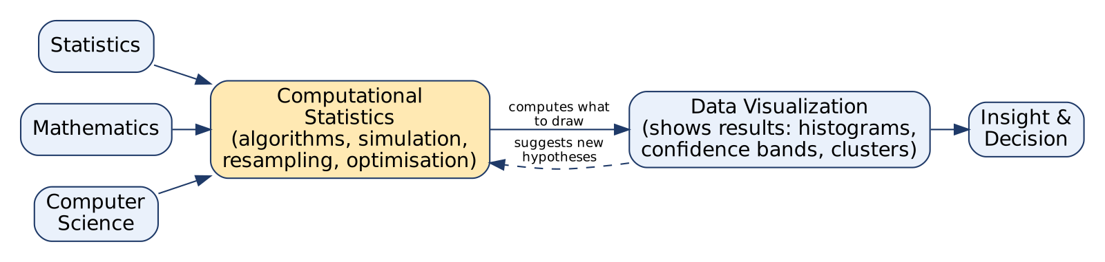
Computational statistics and visualization
Diagram explanation: three disciplines feed computational statistics; it computes the summaries, models and uncertainties that the visualization draws; the visualization in turn suggests new hypotheses (dashed arrow) to test computationally.

1. Key aspects of computational statistics
- Algorithm development: numerical algorithms for statistics on large data.
- Simulation techniques: Monte Carlo simulation to model uncertain systems.
- Bayesian inference: computational methods (e.g. MCMC) for complex Bayesian models.
- High-performance computing: parallel and distributed processing of big data.
- Machine-learning integration: predictive models, pattern discovery.
- Resampling methods: bootstrapping, cross-validation to estimate uncertainty.
- Optimisation: numerical methods for maximum likelihood estimation.

2. Role / relation to data visualization
- Computes what is drawn: histograms need bin counts, box plots need quartiles, regression lines need fitted coefficients.
- Uncertainty display: bootstrap confidence intervals shown as error bars / bands.
- Dimensionality reduction: PCA, MDS, t-SNE compress many variables into 2-D plots.
- Density estimation & smoothing: KDE curves, moving averages.
- Clustering / classification results coloured on scatter plots.
- Big-data visualization: aggregation and sampling algorithms make plotting millions of points possible.
- Visual diagnostics: residual plots, Q-Q plots check model assumptions.

3. Applications
Data science, bioinformatics (genetic data), finance (risk modelling, option pricing), environmental science (climate models), social sciences.
Example: Estimating average delivery time with a 95% bootstrap confidence interval (1,000 resamples) and plotting it as a bar with an error bar.
Conclusion: Computational statistics is the calculating brain behind visualization, and visualization is the window through which its results are understood.
Memory trick: “A-S-B-H-M-R-O” → “A Smart Boy Has Many Rich Options” (Algorithms, Simulation, Bayesian, HPC, ML, Resampling, Optimisation).

1.7 Differentiate between presentation graphics and exploratory graphics with examples
★★ | Asked for max 6 marks → written for 8 | Asked in: 2025 (6), 2026 (5) | Source: DMV Textbook.pdf, PDF p. 44-45 (3.2 Presentation and Exploratory Graphics)
Introduction: Presentation graphics are polished visuals made to communicate known insights to an audience. Exploratory graphics are quick visuals made by an analyst to discover patterns in data without a preconceived hypothesis.
No. | Point | Presentation graphics | Exploratory graphics
1 | Purpose | Communicate a known message | Discover unknown patterns, generate hypotheses
2 | Audience | Others: managers, clients, public | The analyst / researcher themselves
3 | Stage of analysis | End (reporting) | Beginning (EDA)
4 | Design effort | High: polished colours, fonts, layout | Low: quick and rough
5 | Number made | Few, carefully chosen | Many, made and discarded quickly
6 | Annotations | Titles, labels, captions, story | Minimal labels
7 | Interactivity | Mostly static (reports, slides) | Often interactive: zoom, filter, drill-down
8 | Focus | Clarity, simplicity, storytelling | Flexibility, speed, completeness
9 | Typical charts | Bar, line, pie, infographics | Scatter, histogram, box plot, density plot, heat map
10 | Example | Annual-report bar chart of yearly profit | Scatter-matrix of all variables to spot correlations and outliers
Examples:
- Presentation: a clean line chart “Revenue grew 18% in 2025” shown in a board meeting.
- Exploratory: an analyst draws 20 histograms and box plots of a new customer dataset and notices age has outliers (age = 999).
Conclusion: Exploratory graphics help find the story; presentation graphics help tell the story.
Memory trick: Exploratory = Examine (for me); Presentation = Public (for them).

1.8 Define static graphics. Discuss the features of a complete plot
★ | Asked for max 6 marks → written for 8 | Asked in: 2026 (6) | Source: DMV Textbook.pdf, PDF p. 53-55 (3.7 Static Graphics, 3.7.2 Complete Plots and their implementation in Matplotlib)
Definition (static graphics): Static graphics are visualizations that are fixed and non-interactive: an image (chart, map, infographic) that the viewer cannot zoom, filter or change. Examples: charts in printed reports, books, academic papers, slides.

1. Characteristics of static graphics
- Simple and easy to understand; convey a clear, concise message.
- Reproducible: same image can be reused in many documents.
- Computationally efficient: generated and rendered quickly.
- Need careful design (colour, size, layout) because the user cannot interact.
- Limitation: cannot show complex, multi-layer data or allow exploration.
Definition (complete plot): A complete plot is a self-contained visualization that includes all the elements needed to understand the data at a glance, without extra explanation.
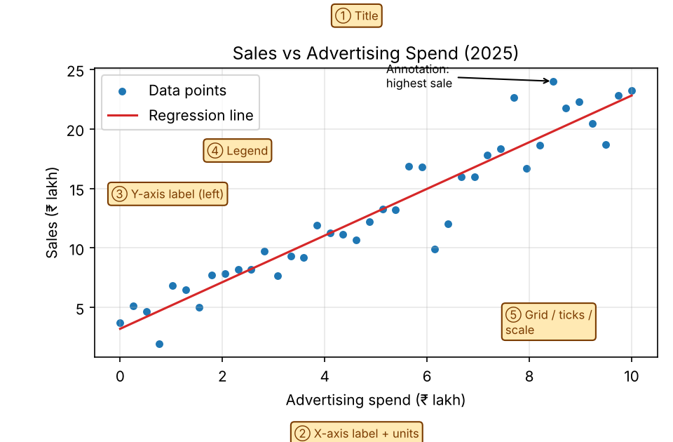
Anatomy of a complete plot

2. Features of a complete plot (labelled in the figure)
- Title ①: tells what the plot shows.
- Axis labels with units ②③: the scale and meaning of each axis.
- Legend ④: identifies each series/colour (data points vs regression line).
- Scales, ticks and grid ⑤: allow accurate reading of values.
- Annotations: arrows or text explaining important points (e.g. highest sale).
- Appropriate colours and markers: distinguish groups and highlight key data.
- Summary elements: e.g. regression line on a scatter plot, median/quartiles/outliers in a box plot.
- Balance: enough detail to be complete, but no clutter.

3. Implementation (Matplotlib)
plt.scatter(x, y, label="Data Points")
plt.plot(x, m*x + c, color="r", label="Regression Line")
plt.title("Scatter Plot with Regression Line")
plt.xlabel("X"); plt.ylabel("Y"); plt.legend(); plt.show()
Conclusion: Static graphics are best for print and reports; making each one a complete plot ensures it is understood without the presenter.
Memory trick: “TALL-SAC”: Title, Axis labels, Legend, Lines/grid (scale), Summary line, Annotations, Colours.

1.9 Write short notes on output formats and speed issues
★ | Asked for max 6 marks → written for 8 | Asked in: 2026 (6) | Source: DMV Textbook.pdf, PDF p. 57 (3.8.2 Output Formats); p. 46-47 (Graphic Speed and Power, Computational Power and Rendering)

(a) Output formats
Definition: Output formats are the different ways visualizations or model results are presented, shared or saved. The choice depends on data complexity, audience, need for interactivity, and intended use.
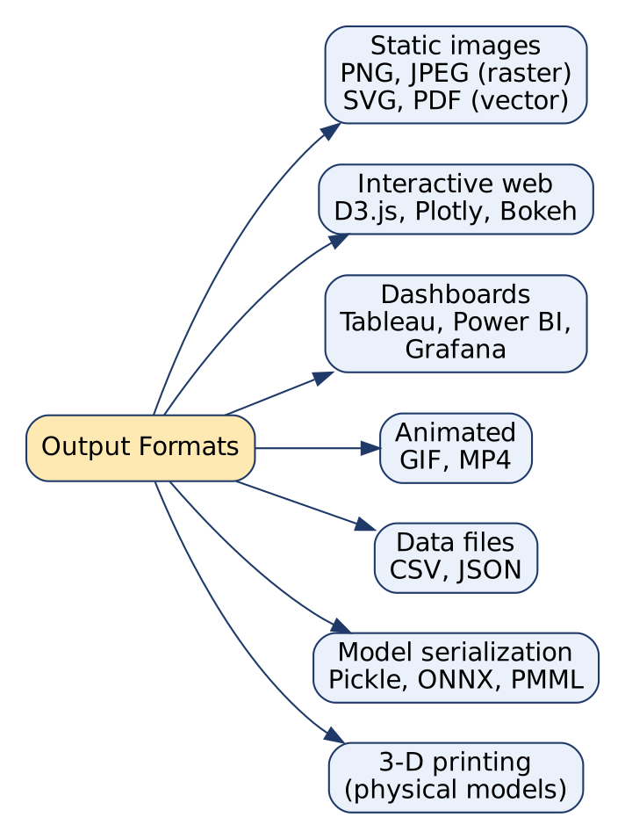
Output formats
- Static images: PNG, JPEG (raster, pixel-based), SVG, PDF (vector, scale without blur). Used in reports, papers, slides.
- Interactive web-based visualizations: D3.js, Plotly, Bokeh; embedded in websites; user can zoom, filter.
- Dashboards: Tableau, Power BI, Grafana; collection of linked charts for real-time monitoring and business intelligence.
- Animated visualizations: GIF, MP4; show change over time, simulations.
- Data files: CSV, JSON for model outputs (predictions, feature importances) to reuse in other tools.
- Model serialization: Pickle, ONNX, PMML; save trained models.
- 3-D printing: physical models in engineering and medical visualization.

(b) Speed issues
Meaning: Speed = how quickly a visualization is rendered and updated when data or user input changes. Slow rendering frustrates users and blocks interactive exploration, especially with big data or 3-D charts.
Causes of slowness: very large number of points, complex 3-D/animated graphics, heavy computations on every interaction, limited hardware.
Strategies to improve speed:
- Data aggregation / binning: draw summaries, not every row.
- Sampling and simplification: fewer points / level-of-detail (LOD) rendering.
- Progressive loading: show a rough view first, add detail later.
- GPU acceleration for 3-D and real-time graphics.
- Parallel processing and caching of computed results.
- Choose a lighter format (PNG instead of SVG with 1 lakh elements; WebGL for big web charts).
Conclusion: Pick the output format to fit the audience and medium, and manage speed by reducing what must be drawn and using hardware acceleration.
Memory trick (formats): “SIDAD-M3”: Static, Interactive, Dashboard, Animated, Data files, Model serialization, 3-D print.

1.10 Explain 3-D plots in data modeling and visualization
★ | Asked for max 5 marks → written for 7 | Asked in: 2026 (5) | Source: DMV Textbook.pdf, PDF p. 56-57 (3.8.1 What are 3D Plots?)
Definition: 3-D plots are visual representations of data in three dimensions (x, y, z). They are used when data has three variables or has spatial, temporal or volumetric nature, giving a fuller view of structure and patterns.

Types of 3-D plots
Type | What it shows | Example
3-D scatter plot | Points defined by 3 attributes | Height, weight, age of patients
3-D surface plot | Continuous surface z = f(x, y) | Terrain elevation, loss surface
3-D line plot | Line through 3-D points | Flight path / trajectory over time
3-D bar plot | Bars across two category axes | Sales by region × year

Uses in data modeling
- 3-D feature space: see how three features relate to the target.
- 3-D decision boundaries: how a classifier separates classes.
- Model evaluation / hyperparameter tuning: accuracy as a surface over two hyperparameters.
- Medical & engineering: CT/MRI volume rendering, CAD models.

Implementation (Matplotlib)
from mpl_toolkits.mplot3d import Axes3D
ax = plt.figure().add_subplot(projection="3d")
ax.scatter(x, y, z)

Limitations
- Occlusion (points hide each other) and perspective distortion make values hard to read.
- Harder to interpret on paper; needs rotation/interaction.
- Not suitable for very high-dimensional data (use PCA/MDS instead).
Conclusion: 3-D plots are powerful for spatial and three-variable data but must be used judiciously; a 2-D chart is often clearer.
Exam tip: Always mention one limitation (occlusion/distortion); examiners look for balanced answers.

Last-Minute Revision Sheet: Unit 1
Topic | Key points to write
Data handling | Acquire → Clean → Transform → Integrate → Reduce → Filter → Explore. Accuracy (no bias/duplicates) + Performance (aggregate, sample). “ACT I R F E”
Types of DV | Bar (compare), Line (trend), Pie (part-whole), Scatter (relationship), Histogram/Box (distribution), Heat map, Bubble, Choropleth, Tree map, Network, Word cloud. “CT-PR-DS”
Design choices | Chart type, encoding, colour, scale/axes (start at 0), labels, data-ink ratio (no chartjunk, Tufte), interactivity, audience/accessibility. “TEC-SL-DI-A”
Graphics & computing | Graphics = visual bridge (perception, communication, exploration, comparison, storytelling). Computing = process → compute → map → render (GPU) → interact. Speed & power.
Statistical historiography | History of statistical graphics. Playfair (line/bar/pie), Snow (cholera map 1854), Nightingale (coxcomb 1858), Minard (1869), Tukey (EDA, box plot), Tufte (data-ink).
Computational statistics | Stats + maths + CS. Algorithms, Monte Carlo, Bayesian, HPC, ML, bootstrap/cross-validation, optimisation (MLE). Computes what charts draw.
Presentation vs exploratory | Presentation: communicate, audience, polished, static. Exploratory: discover, analyst, quick, interactive. E = Examine, P = Public
Static graphics / complete plot | Static = fixed, non-interactive. Complete plot = title, axis labels+units, legend, scale/grid, annotations, summary line. “TALL-SAC”
Output formats | PNG/JPEG/SVG/PDF, interactive web (D3, Plotly, Bokeh), dashboards (Tableau, Power BI), GIF/MP4, CSV/JSON, Pickle/ONNX/PMML, 3-D print.
Speed | Aggregation, sampling/LOD, progressive loading, GPU, parallel processing, caching.
3-D plots | Scatter, surface, line, bar in 3-D. Uses: feature space, decision boundary, model tuning. Limits: occlusion, distortion.
Key formulas / facts:
- Data-ink ratio = ink used to show data ÷ total ink used in the graphic (aim close to 1).
- Box plot = min, Q1, median (Q2), Q3, max; IQR = Q3 − Q1; outlier if value < Q1 − 1.5·IQR or > Q3 + 1.5·IQR.

Assumptions & Gaps
- Exam Unit 1 = question pair Q1/Q2 = syllabus Unit III “Basics of Data Visualization” (textbook Chapter 3, PDF p. 43-58).
- The only DMV study material is the textbook (no separate lecture notes in the repo); all citations are to Textbooks/DMV Textbook.pdf, using PDF page numbers. The PDF is scanned; text was read via OCR, and some pages (e.g. p. 46, 49, 57) are partly blurred, so missing words were completed from standard subject knowledge consistent with the visible text.
- Historiography dates and names (Playfair, Snow 1854, Nightingale 1858, Minard 1869, Tukey, Tufte) are in the textbook (PDF p. 48-50) except exact years for Playfair/Minard/Tukey/Tufte, which are added from standard knowledge.
- Data-ink ratio formula, box-plot IQR rule and the code snippets are standard knowledge added for completeness (the textbook mentions the concepts and shows similar Matplotlib code on PDF p. 54-55).
- 2023 Q1a (graphics & computing + exploratory graphics) is answered under 1.4, with a section on exploratory graphics.
- No question in this unit was missing from the materials; no “⚠ Not found” flags were needed.

