Data Modeling and Visualization: Unit 3 Exam Answers
Unit 3 (Q5/Q6): Data Aggregation and Analysis | Syllabus Unit V

Unit Snapshot
No. | Question | Max Marks | Years Asked | Importance
3.1 | Data aggregation (importance for group operations) with example | 9 | 2023, 2024, 2025 | ★★★
3.2 | GroupBy mechanics in data aggregation | 9 | 2023, 2024, 2025 | ★★★
3.3 | Cross tabulation and its uses with example | 9 | 2023, 2025, 2026 | ★★★
3.4 | Time series basics; time-indexed vs regular data | 9 | 2024, 2026 | ★★★
3.5 | Short note: pivot tables | 5 | 2023, 2024, 2025, 2026 | ★★★
3.6 | Short note: periods and period arithmetic | 5 | 2023, 2024, 2026 | ★★★
3.7 | Moving window functions | 9 | 2025 | ★
3.8 | Resampling and its role in analysis and smoothing | 8 | 2026 | ★
3.9 | Steps in split-apply-combine | 4 | 2023 | ★
Must-do first (★★★): 3.1 Data aggregation · 3.2 GroupBy · 3.3 Cross tabulation · 3.4 Time series basics · 3.5 Pivot tables · 3.6 Periods.
This is the most predictable unit: 6 of its 9 questions are ★★★. All answers are written for (highest marks + 2). Source = Textbooks/DMV Textbook.pdf (scanned; PDF page numbers).

Full Answers

3.1 Explain data aggregation and its importance for group operations, with example
★★★ | Asked for max 9 marks → written for 11 | Asked in: 2023 (8 + short note 5), 2024 (9), 2025 (short note 4.5) | Source: DMV Textbook.pdf, PDF p. 67-70 (5.1 Introduction: Data Aggregation; 5.2.2 Data Aggregation; 5.2.2(A) Uses)
Variants: “Describe in detail data aggregation with its importance for group operations” (2023) · “Explain Data aggregation with suitable example” (2024) · Short note: Data Aggregation (2023, 2025).
Definition: Data aggregation is any process in which information is gathered and expressed in a summary form, for purposes such as statistical analysis. Atomic data rows are replaced by summary statistics (sum, mean, count, …) computed over groups of observations.

1. Process of data aggregation
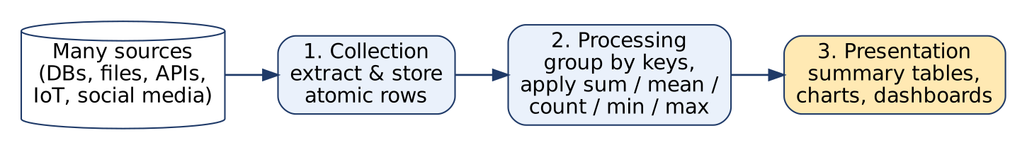
Data aggregation process
- Collection: aggregation tools extract data from multiple sources (databases, files, APIs, IoT devices, social media, call centres) and store it.
- Processing: data is grouped by key variables and aggregation functions are applied (statistical functions, sometimes predictive analytics/ML).
- Presentation: the summarised result is shown as tables, charts, dashboards that give new insight.

2. Common aggregation functions
Function | Meaning | pandas
sum | Total | .sum()
mean | Average | .mean()
median | Middle value | .median()
count | Number of non-null values | .count()
min / max | Smallest / largest | .min(), .max()
std / var | Spread | .std(), .var()
first / last | First / last value in group | .first(), .last()

3. Types of aggregation
- Single-level: group by one key (sales per category).
- Multi-level (hierarchical): group by several keys (sales per category and region).
- Time-based: group by day/week/month (monthly revenue) → reveals trends and seasonality.
- Spatial: totals by country/state.

4. Importance for group operations
- Summarises large datasets into manageable information.
- Gives information about particular groups (by age, profession, income, region).
- Speeds up queries: one aggregate row can stand for thousands of records (used in data warehouses / OLAP).
- Comparison across groups → better decision-making (best region, weakest product).
- Basis for visualization: bar/line/pie charts are drawn from aggregated values.
- Anonymisation: individual personal details are hidden inside group summaries (e.g. average salary by department).
- Supports trend & seasonality analysis through time-based aggregation.

5. Examples
- Voter turnout by state: individual voters are not shown, only totals per candidate.
- Average age of customers by product.
- Number of customers by country.
- Music website: shows CD ads based on the user’s age group aggregate (web personalisation).
df.groupby("category")["sales"].sum() # single-level
df.groupby(["category", "region"])["sales"].agg(["sum", "mean"]) # multi-level
df.resample("M", on="date")["sales"].sum() # time-based
Precautions: check the accuracy of atomic data and ensure enough data is aggregated (counting votes when only 5% are in gives a misleading total).
Uses: finance and business strategy, product planning, pricing, operations optimisation, marketing, statistical analysis.
Conclusion: Data aggregation turns raw rows into group-level insight; combined with GroupBy it is the core of reporting, OLAP and visualization.
Memory trick: “CPP”: Collect, Process, Present. Functions: “Some Men Must Count Money Safely” (Sum, Mean, Median, Count, Min/Max, Std).

3.2 Explain GroupBy mechanics in data aggregation. How does it facilitate data analysis?
★★★ | Asked for max 9 marks → written for 11 | Asked in: 2023 (6), 2024 (9), 2025 (9) | Source: DMV Textbook.pdf, PDF p. 68 (5.2.1 Group by Mechanics), p. 70-72 (Split-Apply-Combine and pandas GroupBy examples)
Variants: “Explain Group by Mechanics technique in data modeling and visualization” (2023, 2024) · “What is the Group by mechanism in data aggregation, and how does it facilitate data analysis?” (2025).
Definition: GroupBy is the operation of dividing a dataset into distinct groups based on the values of one or more key variables and then performing calculations within each group. In pandas it follows the split-apply-combine strategy (term by Hadley Wickham).
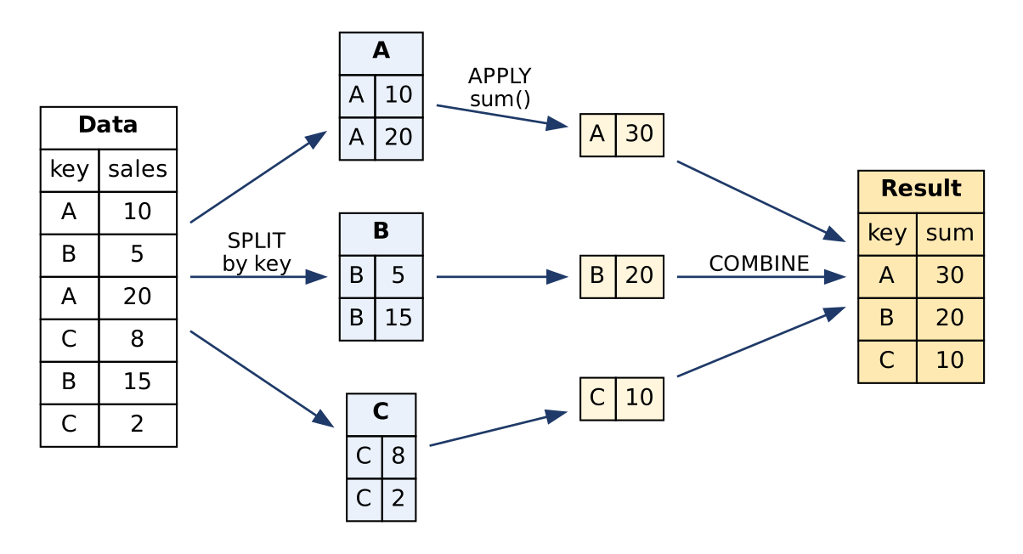
Split-apply-combine with GroupBy

1. Mechanics (how it works)
- Data structure: data in a DataFrame / table: each row = observation, each column = variable.
- Choose key variable(s): usually categorical/discrete (product category, region, customer ID). Keys may be a column name, array, dictionary, Series or function.
- Split: rows with the same key value are put in the same group (A, B, C in the figure).
- Apply: a function is applied to each group independently:
  - Aggregation: sum, mean, count, std → one value per group.
  - Transformation: normalisation, rank, fill missing with group mean → same shape as input.
  - Filtration: keep only groups meeting a condition (groups with > 100 sales).
- Combine: results are merged into a new DataFrame/Series indexed by the group keys.
Diagram explanation: the table is split by key into three groups; sum() is applied to each; the three results are combined into one result table (A = 30, B = 20, C = 10).

2. pandas syntax
grouped = df.groupby("category") # GroupBy object (lazy, nothing computed yet)
grouped["sales"].sum() # aggregation
df.groupby(["category", "region"])["sales"].mean() # multi-level grouping
df.groupby("category").agg({"sales": "sum", "qty": ["mean", "max"]}) # several functions
df.groupby("category")["sales"].transform(lambda x: x / x.sum()) # transformation
df.groupby("category").filter(lambda g: g["sales"].sum() > 100) # filtration
for name, group in df.groupby("category"): print(name, len(group)) # iterate groups

3. Multi-level grouping
Grouping by category and region creates a hierarchical (MultiIndex) result, giving insight such as how each product performs in each region. unstack() turns it into a table for plotting.

4. How GroupBy facilitates data analysis
- Summarises large datasets per group (total sales per category).
- Comparison of groups: find top-performing categories, regions, time periods.
- Pattern & outlier detection within groups.
- Feature engineering: group means/ranks as new features.
- Data cleaning: fill missing values with group-wise mean.
- Feeds visualization: grouped results go straight to bar, line, pie charts.
- Decision-making: resource allocation, marketing strategy, inventory planning.
- More expressive than SQL GROUP BY: any Python function can be applied.

Example
Sales data with category, date, amount → df.groupby("category")["amount"].sum() → Electronics ₹5.2 L, Clothing ₹3.1 L, Grocery ₹1.4 L → plotted as a bar chart → Electronics is the top category.
Conclusion: GroupBy = split by key → apply function → combine results. It is the main tool for group-level analysis in pandas, SQL and Excel.
Memory trick: “S-A-C = Split, Apply, Combine” and the 3 apply types “ATF” (Aggregate, Transform, Filter).

3.3 Explain cross tabulation and its uses with a suitable example
★★★ | Asked for max 9 marks → written for 11 | Asked in: 2023 (8), 2025 (9), 2026 (9) | Source: DMV Textbook.pdf, PDF p. 76 (5.2.5 Cross Tabulation)
Definition: Cross tabulation (a contingency table, “crosstab”) is a technique to analyse the relationship between two (or more) categorical variables. It shows the frequency distribution (counts or percentages) for every combination of categories: one variable forms the rows, the other the columns.
Terminology: Banner = column variable · Stub = row variable · Cell = count for one combination · Marginal totals = row/column totals · Expected values and Chi-square statistic = test of independence.

1. Example: Gender vs “Do you like our product?” (survey of 100 customers)
Gender \ Response | Like | Dislike | Row total
Male | 30 (60%) | 20 (40%) | 50
Female | 40 (80%) | 10 (20%) | 50
Column total | 70 | 30 | N = 100
(Percentages are row percentages.)
Reading: 80% of women like the product compared with 60% of men, so the company should study what male customers dislike.

2. Test of independence (Chi-square)
Expected count: E = (Row total × Column total) / N
- E(Male, Like) = 50 × 70 / 100 = 35; E(Male, Dislike) = 50 × 30 / 100 = 15; similarly Female: 35 and 15.
Chi-square: χ² = Σ (O − E)² / E
= (30−35)²/35 + (20−15)²/15 + (40−35)²/35 + (10−15)²/15 = 0.714 + 1.667 + 0.714 + 1.667 = 4.76
Degrees of freedom = (rows − 1)(columns − 1) = 1. Critical value at 5% = 3.84. Since 4.76 > 3.84, gender and liking are related (not independent).
Symbols: O = observed count, E = expected count, N = grand total.

3. In pandas
pd.crosstab(df["gender"], df["response"], margins=True) # counts + totals
pd.crosstab(df["gender"], df["response"], normalize="index") # row %
from scipy.stats import chi2_contingency; chi2_contingency(table) # test

4. When to use
When you have categorical data: information divided into mutually exclusive groups (gender, region, yes/no answers, product type).

5. Uses / applications
- Survey analysis: customer reviews by region (North, South, East, West).
- Employee engagement & satisfaction: job role vs satisfaction; exit interviews (leaving vs promotion).
- Departmental issues: are complaints concentrated in one department?
- School evaluation surveys: student feedback vs course material / time spent.
- Product research & feedback: how demographics (age, gender, region) feel about a product.
- Medical studies: treatment vs outcome; smoker vs disease.
- Market research: brand preference by age group.

6. Benefits
- Error reduction: large data broken into manageable, representative sub-groups.
- More insights: reveals relationships that would go unnoticed in totals.
- Actionable information: simple tables that managers can act on.
- Easy to visualise: as stacked/grouped bar charts or heat maps.

Crosstab vs pivot table (one line)
A crosstab counts frequencies of category combinations by default; a pivot table aggregates a numeric value (sum/mean) over row and column categories.
Conclusion: Cross tabulation is the simplest way to see how two categorical variables are related; with the chi-square test it shows whether the relationship is statistically significant.
Memory trick: “Cross-tab = Count the Crossings” (rows × columns = every combination). Expected value: “Row × Column ÷ Total”.

3.4 Explain time series basics with a suitable example. How does time-indexed data differ from regular datasets?
★★★ (asked twice at 9 marks) | Asked for max 9 marks → written for 11 | Asked in: 2024 (9, with cross tabulation), 2026 (9) | Source: DMV Textbook.pdf, PDF p. 77-78 (5.2.6 Time Series; 5.3.2 Date and Time Data Types and Tools; 5.3.3 Time Series Basics), p. 78-79 (Date Ranges, Frequencies, Shifting)
Variants: “Explain in detail cross tabulation & Time Series” (2024) · “Explain Time Series Basics with a suitable example and how time indexed data differs from regular datasets” (2026).
Definition: A time series is a sequence of data points collected over successive time intervals, where each data point corresponds to a specific time (timestamp). Examples: daily stock prices, monthly sales, hourly temperature. Used in finance, economics, climate science, IoT.
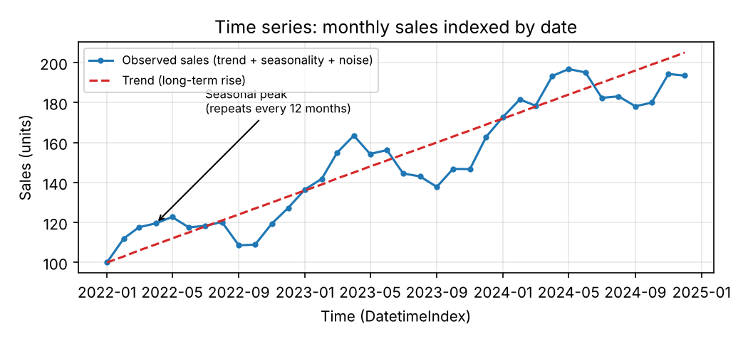
Time series with trend and seasonality
Diagram explanation: the x-axis is time (a DatetimeIndex); the blue line is the observed series; the red dashed line is the trend; the repeating yearly wave is seasonality; small random wiggles are noise.

1. Key concepts (time series basics)
- Trend: long-term upward or downward movement (sales growing every year).
- Seasonality: patterns that repeat at fixed intervals: daily, weekly, yearly (ice-cream sales peak every summer).
- Cyclic pattern: rises and falls without fixed period, e.g. economic/business cycles.
- Irregular / noise: random variation.
- Stationarity: statistical properties (mean, variance, autocorrelation) constant over time; needed for most forecasting models; achieved by differencing or transformation.
- Autocorrelation: correlation of the series with its own lagged values (today vs yesterday).
- White noise: purely random series with no pattern; the benchmark for “no information”.
Decomposition model: Y_{t} = T_{t} + S_{t} + C_{t} + I_{t} (additive) or Y_{t} = T_{t} × S_{t} × C_{t} × I_{t} (multiplicative), where T = trend, S = seasonal, C = cyclic, I = irregular component at time t.

2. Date & time tools (pandas)
- Timestamp (a moment), Period (a span), Timedelta (a duration), DatetimeIndex.
- pd.to_datetime() to parse strings; pd.date_range(start, end, freq="D") for date ranges.
- Frequencies: D (day), W (week), M/MS (month), Q, A/Y, H (hour); regular vs irregular.
- Shifting / lagging: s.shift(1) moves data forward/backward → lag features, % change.
- Resampling: s.resample("M").sum(); time-zone handling: tz_localize, tz_convert (UTC as reference).
- Modeling: ARIMA, seasonal decomposition (STL) for forecasting.

3. Example
dates = pd.date_range("2025-07-01", periods=5, freq="D")
sales = pd.Series([100, 250, 200, 80, 250], index=dates) # time-indexed
sales["2025-07-02":"2025-07-04"] # slice by date
sales.shift(1) # yesterday's sales
sales.pct_change() # daily growth
sales.resample("W").sum() # weekly total

4. Time-indexed data vs regular datasets
No. | Point | Time-indexed (time series) data | Regular (cross-sectional) data
1 | Index | Timestamps / DatetimeIndex | Row numbers or IDs
2 | Order | Order matters; cannot shuffle | Order usually irrelevant
3 | Dependence | Observations depend on past values (autocorrelation) | Observations usually independent
4 | Patterns | Trend, seasonality, cycles | No time patterns
5 | Operations | Resampling, shifting/lags, rolling windows, date slicing, time-zone conversion | Grouping, filtering, sorting
6 | Missing data | Gaps in time; filled by forward-fill/interpolation | Dropped or imputed independently
7 | Train/test split | Chronological split (past → future) | Random split
8 | Goal | Forecasting future values | Classification / comparison at one point in time
9 | Visualization | Line charts, seasonal plots | Bar, scatter, histogram
10 | Example | Daily closing price of a stock for 1 year | Marks of 60 students in one exam
Conclusion: A time series is data ordered and indexed by time; understanding trend, seasonality, stationarity and autocorrelation, and using time-aware tools (date ranges, shifting, resampling), is essential for correct analysis and forecasting.
Memory trick: “TSCI”: “Time Series Components Include” Trend, Seasonal, Cyclic, Irregular. Plus “SAW” = Stationarity, Autocorrelation, White noise.

3.5 Write a short note on pivot tables
★★★ (asked in all 4 papers) | Asked for max 5 marks → written for 7 | Asked in: 2023 (5), 2024 (4.5), 2025 (4.5), 2026 (5) | Source: DMV Textbook.pdf, PDF p. 73-76 (5.2.4 Pivot Tables, Excel steps and two-dimensional pivot table)
Definition: A pivot table is a table of statistics that summarises the data of a larger table (from a database, spreadsheet or BI tool). It groups data by row and column categories and shows an aggregate (sum, average, count) at each intersection.
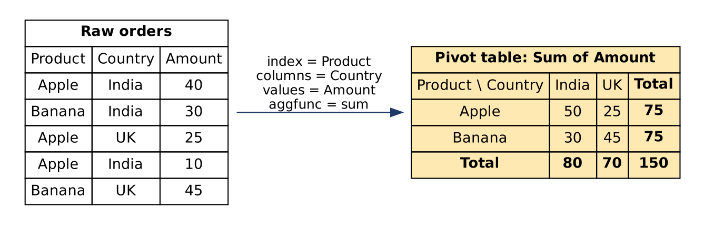
Building a pivot table
Diagram explanation: raw order rows are grouped by Product (rows) and Country (columns); the Amount values are summed in each cell; grand totals are added on the right and bottom.

Components (Excel PivotTable Fields pane)
- Rows: categories shown down the side (Product).
- Columns: categories across the top (Country) → two-dimensional pivot table.
- Values: numeric field to summarise (Amount) with Value Field Settings: Sum, Count, Average, Max, Min.
- Filters: show only a subset (e.g. Country = France).

Creating one
- Excel: click any cell → Insert → PivotTable → drag fields into Rows, Columns, Values, Filters → sort / change summary.
- pandas:
pd.pivot_table(df, index="Product", columns="Country",
values="Amount", aggfunc="sum", margins=True, fill_value=0)

Advantages / uses
- Summarises thousands of rows in seconds without formulas.
- Interactive: drag-and-drop, filter, sort, drill-down.
- Quick comparison (which product sells most in which country).
- Ready input for heat maps and grouped bar charts.
Example (textbook): 213 export orders (Order ID, Product, Category, Amount, Date, Country) → pivot shows Banana is the main export overall, and Apple is the main export to France.
Conclusion: A pivot table is the fastest way to summarise and cross-compare large data by two categories.
Memory trick: “RCVF”: Rows, Columns, Values, Filters (“Real Cats Very Fluffy”).

3.6 Write a short note on periods and period arithmetic
★★★ | Asked for max 5 marks → written for 7 | Asked in: 2023 (5), 2024 (4.5), 2026 (5) | Source: DMV Textbook.pdf, PDF p. 80-81 (5.3.7 Periods and Periods Arithmetic)
Definition: In time-series analysis, a period is a fixed-length span of time, such as a day, month, quarter or year (e.g. “March 2025” covers 1-31 March). It differs from a timestamp, which is a single point in time. In pandas: pd.Period("2025-03", freq="M").

Why periods are useful
- Organise data into regular intervals (monthly, quarterly reporting).
- Calculate monthly averages, identify seasonality, compare periods (Q1 2025 vs Q1 2024).
- Used in resampling, frequency conversion, and financial calculations (compounding per period, NPV).

Period arithmetic (operations on periods)
Operation | Meaning | pandas example | Result
Addition | Move forward n periods | pd.Period("2023-01", "M") + 3 | Period('2023-04', 'M')
Subtraction | Move backward n periods | pd.Period("2023-01", "M") - 1 | Period('2022-12', 'M')
Difference | Number of periods between two periods | pd.Period("2023-06","M") - pd.Period("2023-02","M") | 4 months (<4 * MonthEnds>)
Range | Sequence of periods | pd.period_range("2023-01", "2023-12", freq="M") | 12 monthly periods
Frequency conversion | Change period length | pd.Period("2023", "A-DEC").asfreq("M", how="start") | Period('2023-01', 'M')
Fiscal quarters | Quarters with custom year-end | pd.Period("2024Q4", freq="Q-MAR") | Jan-Mar 2024 quarter of FY ending March
Timestamp conversion | Period ↔ timestamp | p.to_timestamp(), ts.to_period("M") | start of period / its period

Example
months = pd.period_range(start="2023-01", end="2023-12", freq="M")
months[0] + 3 # Period('2023-04', 'M')
months[5] - months[1] # 4 periods apart
Conclusion: Periods represent time spans, and period arithmetic lets us shift, compare and convert them easily for monthly/quarterly analysis.
Exam tip: Clearly write “Timestamp = point in time, Period = span of time”; examiners look for this difference. (The textbook also mentions “multiplying” a monthly period by 3 to get a quarter; in pandas this is done with frequency conversion (asfreq), not multiplication.)

3.7 What are moving window functions? How are they useful in smoothing and analysing time series data?
★ | Asked for max 9 marks → written for 11 | Asked in: 2025 (9) | Source: DMV Textbook.pdf, PDF p. 81-82 (5.3.9 Moving Window Functions; 5.3.9(A) Example)
Definition: Moving window functions are aggregate functions applied to a fixed-size window of consecutive data points that slides along the time axis one step at a time, recalculating the result at every position. They are used to smooth noise and reveal trends in time-series data.
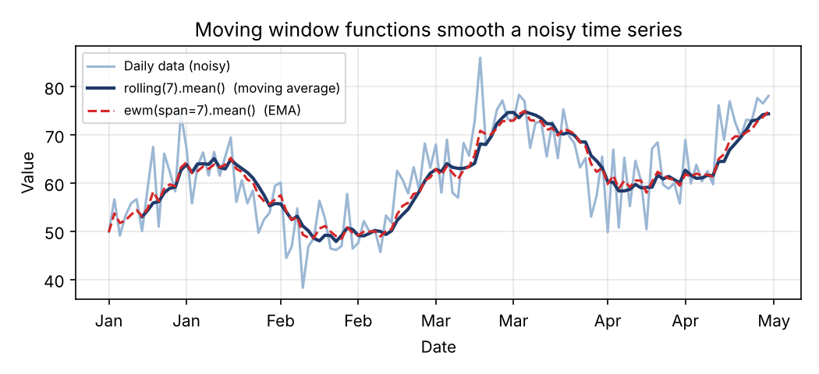
Rolling mean and EMA smoothing
Diagram explanation: the light line is noisy daily data; the dark line is a 7-day rolling mean (each point = average of last 7 days); the red dashed line is the EMA, which reacts faster because it weights recent days more.

1. Basic concept (window of size 3)
Data: 10, 15, 20, 25, 30 → rolling mean (window = 3):
Day | Value | Window used | Rolling mean
1 | 10 | (incomplete) | NaN
2 | 15 | (incomplete) | NaN
3 | 20 | 10, 15, 20 | 15
4 | 25 | 15, 20, 25 | 20
5 | 30 | 20, 25, 30 | 25

2. Types of moving window functions
- Rolling statistics: rolling mean, median, std, min, max (s.rolling(7).std() → volatility).
- Moving average (simple, SMA): SMA_{t} = (x_{t} + x_{t−1} + … + x_{t−n+1}) / n, where n = window size, x_{t} = value at time t.
- Exponential moving average (EMA): EMA_{t} = α·x_{t} + (1 − α)·EMA_{t−1}, with α = 2 / (span + 1); gives exponentially decreasing weights, more weight to recent data (s.ewm(span=7).mean()).
- Rolling sum: cumulative values in a window (7-day total sales, rolling COVID case counts).
- Expanding window: window grows from the start (s.expanding().mean() → running average).
- Custom functions: s.rolling(5).apply(func).

3. Window size
- Large window → smoother curve but slower to react to changes (lag).
- Small window → responsive but sensitive to noise.
- Choose by data frequency: 7 for daily data with weekly pattern, 12 for monthly data with yearly seasonality.

4. Boundary effects
At the start (and with centred windows, the end) there are not enough points → NaN. Handle with min_periods=1, padding, or weighted windows (win_type="triang", "gaussian").

5. Usefulness in smoothing and analysing time series
- Noise reduction: removes random fluctuations → clear trend line.
- Trend identification: e.g. 50-day and 200-day moving averages in stock analysis (crossover signals).
- Volatility measurement: rolling standard deviation (financial risk).
- Anomaly detection: points far from the rolling mean ± 2·rolling std are outliers.
- Feature engineering: rolling mean/sum as inputs to forecasting models.
- Seasonality removal: a 12-month moving average removes yearly seasonality.
s.rolling(window=3).mean() # simple moving average
s.ewm(span=3).mean() # exponential moving average
s.rolling(7, min_periods=1).sum() # rolling 7-day sum
Conclusion: Moving window functions slide a fixed window over time to compute local statistics; they are the simplest and most widely used tools for smoothing, trend detection and volatility analysis.
Memory trick: “Big window = Blurred (smooth), Small window = Sharp (noisy).” EMA = “Extra weight to Most recent Activity.”

3.8 Explain the concept of resampling and its role in data analysis and smoothing
★ | Asked for max 8 marks → written for 10 | Asked in: 2026 (8) | Source: DMV Textbook.pdf, PDF p. 81 (5.3.8 Resampling and Frequency Conversion, with example), p. 77 (resampling overview)
Definition: Resampling is the process of converting a time series from one frequency to another by aggregating (to a lower frequency) or interpolating (to a higher frequency). Frequency conversion means changing data to a specified frequency, e.g. daily → monthly.
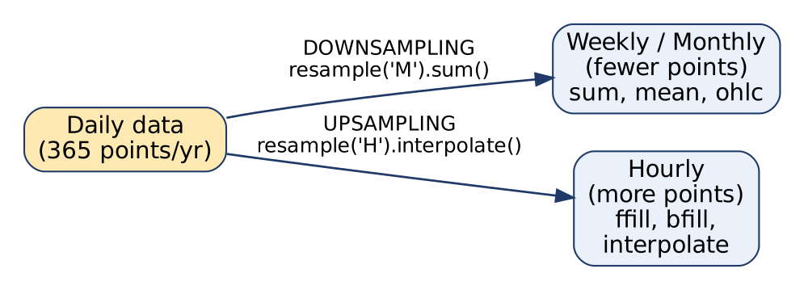
Downsampling and upsampling
Diagram explanation: from daily data, downsampling goes to fewer, coarser points (weekly/monthly) using an aggregate; upsampling goes to more, finer points (hourly) and needs a fill or interpolation method for new empty slots.

1. Types of resampling
Point | Downsampling | Upsampling
Direction | High → low frequency (daily → monthly) | Low → high frequency (daily → hourly)
Number of points | Decreases | Increases (new empty slots)
Method | Aggregation: sum, mean, max, ohlc() | Filling: ffill(), bfill(), interpolate() (linear, polynomial)
Purpose | Summarise, smooth, reduce size | Align with finer data, fill gaps
pandas | s.resample("M").sum() | s.resample("H").interpolate()

2. Steps (pandas)
- Make sure the data has a DatetimeIndex (pd.to_datetime, set_index).
- Call .resample(rule): rule = “W”, “M”, “Q”, “H”, … (like a time-based GroupBy).
- Apply an aggregation (downsampling) or a fill/interpolation method (upsampling).
dates = pd.date_range("2023-01-01", periods=10, freq="D")
daily = pd.Series(range(10), index=dates)
weekly = daily.resample("W").sum() # downsample
hourly = daily.resample("H").interpolate("linear") # upsample

3. Role in data analysis
- Change granularity to match the question (daily transactions → monthly revenue reports).
- Align multiple series with different frequencies (daily sales + monthly ad spend).
- Reduce data size for faster analysis and plotting.
- Handle irregular / missing timestamps by placing data on a regular grid.
- Financial analysis: OHLC (open-high-low-close) bars from tick data.

4. Role in smoothing
- Downsampling averages out day-to-day noise: a monthly mean is much smoother than daily data, so trend and seasonality become visible.
- Combined with moving window functions (3.7) for further smoothing.
- Interpolation in upsampling produces a smooth continuous curve between known points.

Example
Daily website visits for one year (365 noisy points) → resample("M").mean() → 12 points showing a clear rise from January to December and a dip in May (holiday season).
Conclusion: Resampling changes the time frequency of data; downsampling aggregates and smooths, upsampling interpolates and fills, making time series ready for analysis and visualization.
Memory trick: “Down = Divide into buckets & aggregate; Up = Un-fill gaps by interpolation.”

3.9 Explain the steps involved in the split-apply-combine strategy
★ | Asked for max 4 marks → written for 6 | Asked in: 2023 (4) | Source: DMV Textbook.pdf, PDF p. 70-71 (Split-Apply-Combine, Fig. 5.2.3)
Definition: Split-apply-combine is the strategy behind GroupBy: split data into groups, apply a function to each group independently, and combine the results into a new data structure.
(See the split-apply-combine figure in answer 3.2; redraw it here in the exam.)

Steps
- Split: divide the DataFrame into groups based on one or more keys (a column, several columns, a function or a dictionary). Rows with the same key go to the same group. → g = df.groupby("product")
- Apply: apply a function to each group independently:
  - Aggregate (sum, mean, count) → g["sales"].sum()
  - Transform (normalise, fill NA with group mean) → g["sales"].transform("mean")
  - Filter (drop small groups) → g.filter(lambda x: len(x) > 2)
- Combine: merge the per-group results into a single Series or DataFrame, indexed by group keys.

Example
product | sales
A | 10
B | 5
A | 20
B | 15
Split → A: {10, 20}, B: {5, 15} → Apply sum → A = 30, B = 20 → Combine → Series(A=30, B=20).
Conclusion: Split-apply-combine breaks a big problem into small group-wise problems and joins the answers, which is the basis of all group-level analysis.
Memory trick: “SAC: like filling a sack: Split the grains, Apply sorting, Combine in the sack.”

Last-Minute Revision Sheet: Unit 3
Topic | Key points to write
Data aggregation | Summarise rows into group statistics. Process: Collect → Process → Present. Functions: sum, mean, median, count, min, max, std. Single, multi-level, time-based. Uses: OLAP, warehouses, marketing, anonymisation.
GroupBy | Split-apply-combine. Keys = column/array/dict/function. Apply = aggregate, transform, filter (ATF). df.groupby("k")["v"].sum(), .agg({...}), multi-key → MultiIndex.
Cross tabulation | Contingency table of 2 categorical variables; counts/%; margins. pd.crosstab(a, b, margins=True). E = row × col / N; χ² = Σ(O−E)²/E; df = (r−1)(c−1). Uses: surveys, HR, product research.
Time series basics | Data indexed by time. Trend, seasonality, cyclic, irregular; stationarity, autocorrelation, white noise. Y = T + S + C + I. Tools: to_datetime, date_range, shift, resample, tz_convert. Differences table vs regular data.
Pivot tables | Summary table: Rows, Columns, Values (aggfunc), Filters (RCVF). pd.pivot_table(df, index, columns, values, aggfunc, margins=True). Excel: Insert → PivotTable.
Periods | Period = span, Timestamp = point. pd.Period("2023-01","M") + 3 = 2023-04; difference; period_range; asfreq; fiscal quarters Q-MAR.
Moving window | Fixed window slides over time. rolling mean/median/std/sum, SMA = Σx/n, EMA_{t} = αx_{t} + (1−α)EMA_{t−1}, α = 2/(span+1). Big window smooth & laggy. Boundary NaN.
Resampling | Change frequency. Downsample (aggregate: sum/mean/ohlc) vs upsample (ffill/bfill/interpolate). s.resample("M").sum(). Smoothing, alignment, size reduction.
Split-apply-combine | Split by key → apply function per group → combine into new object. SAC.

Assumptions & Gaps
- Exam Unit 3 = question pair Q5/Q6 = syllabus Unit V “Data Aggregation and Analysis” (textbook Chapter 5, PDF p. 67-82).
- All citations are to Textbooks/DMV Textbook.pdf (scanned, OCR’d; PDF page numbers). There are no separate lecture notes in the repo.
- 2024 Q5b is printed as “cross tabulation 67 Time Series”; “67” is taken as a print error for “&”. It is mapped to 3.4 (time series); for the cross-tabulation half, use 3.3.
- Added from standard subject knowledge (not in the textbook): the chi-square worked example and formulas in 3.3 (the textbook names “Chi-Square Statistic” and “Expected Values” only); the additive/multiplicative decomposition formula and the time-series vs regular-data comparison table in 3.4; SMA/EMA formulas, expanding windows and the window-size worked table in 3.7; pandas asfreq/fiscal-quarter examples in 3.6; OHLC and the downsampling/upsampling comparison table in 3.8.
- Textbook point corrected: PDF p. 80 says a monthly period can be “multiplied by 3” to give a quarterly period; pandas does not support multiplying a Period. The answer uses frequency conversion (asfreq) instead and notes this. The textbook’s section on periods also drifts into trigonometric and financial “periods” (PDF p. 80-81); only the time-series meaning is used here, as that is what the exam asks.
- The pivot-table example (Banana/Apple exports) is from the textbook’s Excel example (PDF p. 73-76); the small 5-row pivot diagram is a simplified illustration.
- No question in this unit was missing from the materials; no “⚠ Not found” flags were needed.

