Quantum Artificial Intelligence — Unit 1: Quantum Algorithms (Shor, Grover, Deutsch, Simon, QFT) + in-sem foundations
Exam answers for 70-mark end-sem (2.5 hrs). Each answer is written for (max marks asked + 2). Sources are PDF page numbers of the files in your repo; ⚠ marks content NOT found in your materials.

1. Unit snapshot
No. | Question | Max Marks | Years Asked | Importance
1.1 | Shor's Algorithm (quantum part, example, significance in breaking cryptosystems) | 9 | 2023, 2024, 2025 | ★★★
1.2 | Grover's Algorithm (with example; searching unsorted databases) | 9 | 2023, 2024, 2025 | ★★★
1.3 | Factoring Integers, with example | 9 | 2023, 2024, 2025 | ★★★
1.4 | Analysis of Deutsch Algorithm | 9 | 2023, 2024 | ★★
1.6 | Simon's Algorithm (with example) | 6 | 2023, 2025 | ★★
1.7 | Phase Kick-Back (and its usage) | 6 | 2023, 2025 | ★★
1.10 | Qubit copying circuit | 6 | 2022 (in-sem) | ★
1.11 | Draw quantum circuit diagrams that represent the operations | 6 | 2022 (in-sem) | ★
1.5 | Compare Deutsch algorithm and Deutsch-Jozsa algorithm | 6 | 2025 | ★
1.13 | Time-Evolution of a Closed System | 5 | 2022 (in-sem) | ★
1.14 | Role of quantum entanglement in quantum architecture | 5 | 2022 (in-sem) | ★
1.15 | Hidden subgroup problem for quantum Fourier transform | 5 | 2022 (in-sem) | ★
1.16 | Universal sets of quantum gates | 5 | 2022 (in-sem) | ★
1.17 | Compare order-finding and factoring for Fourier transform | 5 | 2022 (in-sem) | ★
1.8 | Differences in measurement in bases and computational basis | 5 | 2022 (in-sem) | ★
1.9 | Single qubit and multiple qubit gates with diagram | 5 | 2022 (in-sem) | ★
1.12 | How tensor product combines qubit states | 3 | 2022 (in-sem) | ★

2. Must-do first (★★★)
1. Q1.1 Shor's Algorithm (quantum part, example, significance in breaking cryptosystems) — max 9 marks, asked 2023, 2024, 2025
2. Q1.2 Grover's Algorithm (with example; searching unsorted databases) — max 9 marks, asked 2023, 2024, 2025
3. Q1.3 Factoring Integers, with example — max 9 marks, asked 2023, 2024, 2025

3. Full answers (★★★ → ★★ → ★)

Q1.1. Shor's Algorithm (quantum part, example, significance in breaking cryptosystems)
Importance | Max marks asked | Answer written for | Asked in | Source
★★★ | 9 | 11 marks | 2023 Q1a; 2024 Q1a; 2025 Q2a | QAI-ii.pdf p.11–13 (3.6 Shor's algorithm: problem, steps, example); QAI.pdf p.29–31 (QFT, phase estimation, order-finding algorithm), p.32 (factoring & cryptography)

Question wording(s) asked: 2023 Q1a [6]: “Describe Shor's Algorithm with example.” | 2024 Q1a [9]: “Explain Quantum Part of the Shor's Algorithm.” | 2025 Q2a [6]: “Discuss the working of Shor's algorithm with its significance in breaking classical cryptosystems.”
Note: Your textbook's worked example (N = 91, a = 10, QAI-ii.pdf p.12–13) has an arithmetic slip: 10⁵ mod 91 = 82, not 1 (the true period is 6). This answer uses the verified example N = 15.

Definition: Shor's algorithm (Peter Shor, 1994) is a quantum algorithm that factors a large composite integer N in polynomial time. It converts factoring into period (order) finding – finding the smallest r with aʳ ≡ 1 (mod N) – and solves that step on a quantum computer using superposition, modular exponentiation and the Quantum Fourier Transform (QFT).

1. Why it is needed
- The best classical algorithm (General Number Field Sieve) needs super-polynomial (near-exponential) time in the number of digits of N.
- Shor's algorithm needs only about O((log N)³) operations → an exponential speed-up.
- Only the period-finding step is quantum; the rest is classical number theory.

2. Structure of the algorithm
Part | Work done | Type
Step 1 | Choose random a (1 < a < N); if gcd(a, N) ≠ 1 a factor is already found | Classical
Step 2 | Find the period r of f(x) = aˣ mod N | Quantum (QFT)
Step 3 | If r is even and a^(r/2) ≢ −1 (mod N): factors = gcd(a^(r/2) ± 1, N) | Classical
Step 4 | Otherwise repeat with a new a | Classical

3. Quantum part – period finding (detailed)
1. Registers: first (input) register of t qubits with Q = 2ᵗ, N² ≤ Q < 2N², in |0⟩; second (output) register of n = ⌈log₂N⌉ qubits in |1⟩.
2. Superposition: Hadamard on every input qubit → |ψ₁⟩ = (1/√Q) Σₓ |x⟩|1⟩ (all x from 0 to Q−1 at once).
3. Modular exponentiation U_f: |x⟩|y⟩ → |x⟩|y·aˣ mod N⟩ gives |ψ₂⟩ = (1/√Q) Σₓ |x⟩|aˣ mod N⟩ – f is computed for every x in one run (quantum parallelism).
4. Measure the second register (optional, simplifies analysis): we get some value f(x₀); the first register collapses to the periodic state (1/√M) Σⱼ |x₀ + j·r⟩.
5. Inverse QFT on the first register: the periodic pattern interferes so amplitude concentrates on y ≈ k·Q/r (k = 0, 1, …, r−1).
6. Measure the first register to get y; compute y/Q ≈ k/r and use the continued-fractions algorithm to obtain r. Check aʳ mod N = 1; repeat a few times if needed (QAI.pdf p.31).
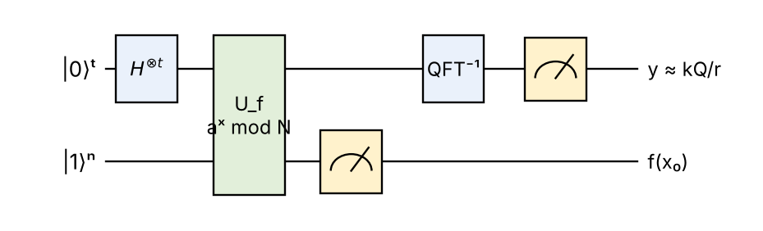
Fig: Quantum circuit for the period-finding part of Shor's algorithm
Components: H⊗t creates all inputs x; U_f (modular exponentiation, a controlled-U^(2ʲ) cascade) writes aˣ mod N into the second register and entangles the registers; measuring the second register leaves a periodic first register; QFT⁻¹ converts period into peaks; final measurement samples a peak.

4. Formulas
QFT: |x⟩ → (1/√Q) Σ_y e^(2πixy/Q) |y⟩ (QAI.pdf p.29)
Period: aʳ ≡ 1 (mod N) ⇒ (a^(r/2) − 1)(a^(r/2) + 1) ≡ 0 (mod N)
Factors: p = gcd(a^(r/2) − 1, N), q = gcd(a^(r/2) + 1, N)
Symbols: N = number to factor, a = random base, r = period/order, Q = 2ᵗ size of input register, y = measured value, gcd = greatest common divisor.

5. Worked example: N = 15
1. Choose a = 7; gcd(7, 15) = 1 ✔.
2. f(x) = 7ˣ mod 15 = 1, 7, 4, 13, 1, 7, 4, 13, … (period r = 4).
3. Quantum part with t = 8 (Q = 256 ≥ 15² = 225): measurement gives y ∈ {0, 64, 128, 192} with probability ¼ each. Suppose y = 192 → y/Q = 192/256 = 3/4 → denominator r = 4.
4. r is even and 7² = 49 ≡ 4 (mod 15), not ≡ −1 ✔.
5. p = gcd(49 − 1, 15) = gcd(48, 15) = 3; q = gcd(49 + 1, 15) = gcd(50, 15) = 5 → 15 = 3 × 5.

6. Significance in breaking classical cryptosystems
- RSA security depends on the difficulty of factoring N = p·q; Diffie–Hellman and ECC depend on discrete logarithms – Shor's method solves both (they are period-finding problems).
- A large fault-tolerant quantum computer would break today's public-key infrastructure (HTTPS, digital signatures, banking).
- Response: post-quantum cryptography (lattice-, code-, hash-based schemes) and quantum key distribution (QAI-ii.pdf p.13).

7. Limitations
- Needs about 2n + 3 logical (error-corrected) qubits and a deep circuit → millions of physical qubits for 2048-bit RSA; so far only small numbers (15, 21) have been factored on real devices.
- Probabilistic: some choices of a fail (r odd or a^(r/2) ≡ −1); success probability ≥ ½ per attempt.
Conclusion: Shor's algorithm = classical reduction + quantum period finding with the QFT; it factors integers in polynomial time and therefore threatens RSA-type cryptography.

💡 Memory trick / Exam tip: “A-R-G”: pick a → find r (quantum) → take gcd. Common mistakes: forgetting gcd(a, N) = 1, forgetting the condition ‘r even and a^(r/2) ≠ −1’, and calling the whole algorithm quantum (only period finding is).

Q1.2. Grover's Algorithm (with example; searching unsorted databases)
Importance | Max marks asked | Answer written for | Asked in | Source
★★★ | 9 | 11 marks | 2023 Q2a; 2024 Q1b; 2025 Q2b | QAI-ii.pdf p.13–15 (Grover's algorithm: classical search problem, quantum search, Fig. 3.9, working, 8-element example, D = 2|s⟩⟨s| − I), p.17–18 (question bank)

Question wording(s) asked: 2023 Q2a [6]: “Describe Grover's Algorithm with example.” | 2024 Q1b [9]: “Describe Grover's Algorithm.” | 2025 Q2b [6]: “Discuss how Grover's algorithm is used in searching in unsorted databases?”
Definition: Grover's algorithm (Lov Grover, 1996) searches an unsorted (unstructured) database of N items for a marked item using about √N oracle queries, instead of the N/2 average (N worst case) needed classically. It works by quantum amplitude amplification and gives a quadratic speed-up.

1. The search problem
- Items are indexed x = 0 … N−1 (N = 2ⁿ, so n qubits). An oracle function f(x) = 1 only for the target w, else 0.
- Classical: no structure to exploit → check items one by one → O(N).
- Quantum: O(√N) queries – proved optimal for unstructured search.

2. Steps of the algorithm (QAI-ii.pdf p.14)
1. Initialise: n qubits in |0…0⟩; apply Hadamard to all → equal superposition |s⟩ = (1/√N) Σₓ |x⟩ (every item has amplitude 1/√N).
2. Oracle U_f (phase flip): U_f|x⟩ = (−1)^f(x)|x⟩ – the sign of the target amplitude becomes negative (implemented with an ancilla in |−⟩ via phase kick-back).
3. Diffusion operator D = 2|s⟩⟨s| − I: ‘inversion about the mean’ – each amplitude a is replaced by 2·mean − a, so the negative (marked) amplitude grows and the others shrink.
4. Repeat the Grover iteration G = D·U_f about k ≈ (π/4)√N times.
5. Measure all qubits → the target w is obtained with high probability.
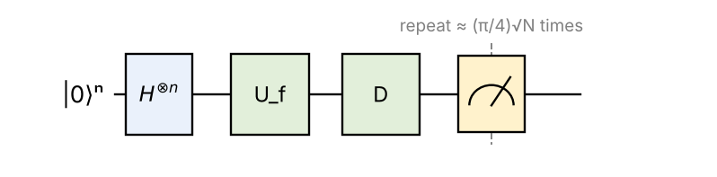
Fig: Grover's circuit (after Fig. 3.9, QAI-ii.pdf p.14): state preparation, oracle, diffusion, measurement
Components: H⊗n = state preparation (all N items at once); oracle = marks the answer by a minus sign (does not reveal it); diffusion = converts the hidden sign into larger amplitude; measurement = reads the amplified item.

3. Worked example: N = 8, target |6⟩ (book example)
Stage | Amplitude of each of the 7 other items | Amplitude of |6⟩ | P(measure 6)
After H (|s⟩) | 0.354 | 0.354 | 12.5 %
After oracle | 0.354 | −0.354 | 12.5 %
After diffusion (iteration 1) | 0.177 | 0.884 | 78.1 %
After iteration 2 | −0.088 | 0.972 | 94.5 %

Calculation of iteration 1: mean = (7 × 0.354 − 0.354)/8 = 0.265. Others: 2(0.265) − 0.354 = 0.177. Target: 2(0.265) + 0.354 = 0.884. Iterations needed ≈ (π/4)√8 ≈ 2. Classically about 4 checks on average.

4. Searching an unsorted database (2025 question)
- Encode each record index as a basis state; a database of 1 million entries needs only 20 qubits.
- The oracle compares the record at index x with the search key (e.g. a phone number) and flips the phase if it matches.
- Grover needs ≈ (π/4)√10⁶ ≈ 785 queries instead of ≈ 500 000 on average classically.

5. Formulas
|s⟩ = (1/√N) Σₓ |x⟩ ; U_f = I − 2|w⟩⟨w| ; D = 2|s⟩⟨s| − I
k_opt ≈ (π/4)√(N/M) (M = number of marked items)
P(success after k iterations) = sin²((2k + 1)θ), where sin θ = √(M/N)

6. Applications and limitations
- Applications: database search, SAT / NP-complete problem solving, minimum finding, collision finding, cryptanalysis (brute-force key search: halves the effective key length, so AES-128 → ~64-bit security), nearest-neighbour search in QML.
- Limitations: only quadratic (not exponential) speed-up; the oracle must be built as a quantum circuit; data must be loaded (QRAM); too many iterations over-rotate and reduce the success probability.
Conclusion: Grover's algorithm finds a marked item among N unsorted items in O(√N) steps by repeating oracle + inversion about the mean – a provably optimal quadratic speed-up.

💡 Memory trick / Exam tip: “Superpose – Mark – Flip about mean – Repeat √N – Measure.” Never write ‘exponential speed-up’ for Grover.

Q1.3. Factoring Integers, with example
Importance | Max marks asked | Answer written for | Asked in | Source
★★★ | 9 | 11 marks | 2023 Q1c; 2024 Q2a; 2025 Q1a | QAI-ii.pdf p.11–13 (integer factorization problem, Shor's solution, 3.7 Factoring integers); QAI.pdf p.31–32 (order-finding and factoring, N = 15 example, significance for cryptography)

Question wording(s) asked: 2023 Q1c [6]: “Explain Factoring Integers, with example.” | 2024 Q2a [9]: “Explain Factoring Integers, with example.” | 2025 Q1a [6]: “Discuss factoring integers with example.”
Definition: Factoring integers means expressing a composite number N as a product of prime numbers (e.g. 15 = 3 × 5, 91 = 7 × 13). Multiplying primes is easy, but recovering them from a large N is believed to be very hard classically; a quantum computer factors efficiently by reducing factoring to order finding (Shor's algorithm).

1. Importance
- RSA cryptography: public key contains N = p·q (617 digits for RSA-2048); security rests on the difficulty of factoring N (QAI.pdf p.32).
- Number theory, primality and cryptanalysis research.

2. Classical methods
Method | Time | Remark
Trial division | O(√N) | Exponential in number of digits
Quadratic sieve / GNFS | exp(c·(ln N)^(1/3)(ln ln N)^(2/3)) | Best known, still super-polynomial
Shor (quantum) | ≈ O((log N)³) | Polynomial

3. Reduction of factoring to order finding
If r is the order of a modulo N (aʳ ≡ 1) and r is even, then aʳ − 1 = (a^(r/2) − 1)(a^(r/2) + 1) ≡ 0 (mod N). N divides the product, but (if a^(r/2) ≢ ±1) divides neither factor, so gcd(a^(r/2) ± 1, N) give non-trivial factors.

4. Algorithm steps
1. If N is even → factor 2. If N = bᵏ (prime power) → classical check.
2. Pick random a, 1 < a < N. If gcd(a, N) > 1 → this gcd is a factor.
3. Quantum order finding: find r with aʳ ≡ 1 (mod N) (superposition + modular exponentiation + inverse QFT + continued fractions).
4. If r is odd or a^(r/2) ≡ −1 (mod N) → go back to step 2 (happens with probability ≤ ½).
5. Output gcd(a^(r/2) − 1, N) and gcd(a^(r/2) + 1, N).
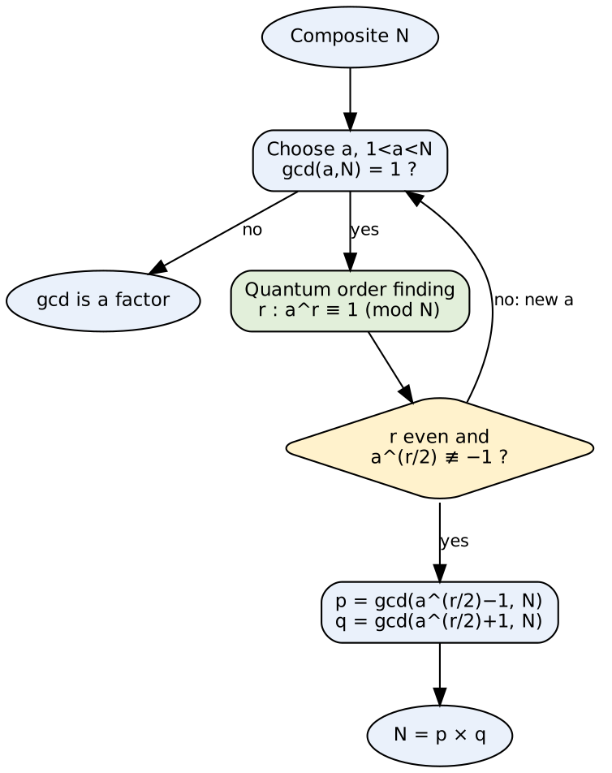
Fig: Flowchart for factoring N via quantum order finding
Blocks: the gcd test handles lucky choices; the green block is the only quantum step; the diamond checks the period is useful; the final gcds give the factors.

5. Example 1 (successful): N = 21, a = 2
- 2ˣ mod 21: 2, 4, 8, 16, 11, 1 → r = 6 (even).
- a^(r/2) = 2³ = 8; 8 ≢ −1 (= 20) mod 21 ✔.
- gcd(8 − 1, 21) = gcd(7, 21) = 7; gcd(8 + 1, 21) = gcd(9, 21) = 3 → 21 = 3 × 7.

6. Example 2 (failure case): N = 15, a = 14
- 14² = 196 ≡ 1 (mod 15) → r = 2, but a^(r/2) = 14 ≡ −1 (mod 15) → gcds are trivial (15 and 1).
- So choose another a (e.g. a = 7 gives r = 4 → factors 3 and 5).

7. Significance
- Efficient quantum factoring breaks RSA → need for post-quantum cryptography (lattice-, code-, hash-based) – QAI-ii.pdf p.13.
Conclusion: Factoring is reduced to finding the period of aˣ mod N; the quantum computer finds the period quickly and the classical gcd step turns it into the prime factors.

💡 Memory trick / Exam tip: “Factoring = Period + gcd.” Always show (i) the formula gcd(a^(r/2) ± 1, N), (ii) the two conditions, (iii) a numeric example.

Q1.4. Analysis of Deutsch Algorithm
Importance | Max marks asked | Answer written for | Asked in | Source
★★ | 9 | 11 marks | 2023 Q2b; 2024 Q2b | QAI-ii.pdf p.5–8 (3.3 Deutsch algorithm: Qiskit steps, circuit, oracle, Hadamards, result on simulator and IBM hardware), p.17 (question bank items 7–9)

Question wording(s) asked: 2023 Q2b [6]: “Discuss analysis of Deutsch algorithm in details.” | 2024 Q2b [9]: “Discuss analysis of Deutsch algorithm in details.”
Definition: Deutsch's algorithm (David Deutsch, 1985) is the first and simplest quantum algorithm. Given a black-box (oracle) function f : {0,1} → {0,1}, it decides whether f is constant (f(0) = f(1)) or balanced (f(0) ≠ f(1)) with one query, whereas any classical algorithm needs two.

1. The problem – four possible functions
Function | f(0) | f(1) | Type | Oracle circuit | Measured q₀
f₁ | 0 | 0 | Constant | nothing | 0
f₂ | 1 | 1 | Constant | X on q₁ | 0
f₃ (identity) | 0 | 1 | Balanced | CNOT q₀→q₁ | 1
f₄ (NOT) | 1 | 0 | Balanced | CNOT + X | 1

2. Classical analysis
- We must compute f(0) and f(1) and compare → 2 queries are unavoidable; one query tells nothing about the global property.

3. Quantum circuit
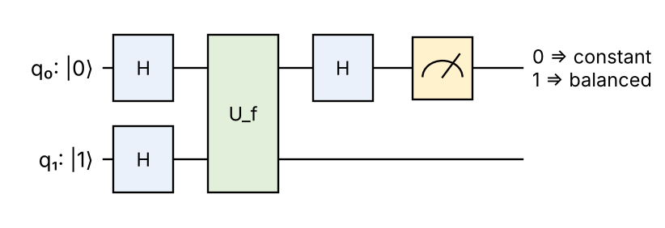
Fig: Deutsch circuit: U_f|x⟩|y⟩ = |x⟩|y ⊕ f(x)⟩
Components: q₀ = input qubit; q₁ = helper (output) qubit, prepared in |1⟩ (book: X gate on q₁); first Hadamards = superposition; U_f = oracle; last Hadamard = interference; meter = read q₀.

4. Step-by-step analysis
1. Initial state: |ψ₀⟩ = |0⟩|1⟩.
2. After H ⊗ H: |ψ₁⟩ = ½ (|0⟩ + |1⟩)(|0⟩ − |1⟩) – both inputs present; helper is |−⟩.
3. Oracle: U_f|x⟩|−⟩ = (−1)^f(x)|x⟩|−⟩ (phase kick-back) ⇒ |ψ₂⟩ = (1/√2)[(−1)^f(0)|0⟩ + (−1)^f(1)|1⟩] ⊗ |−⟩.
4. If f is constant: q₀ = ±(|0⟩ + |1⟩)/√2 = ±|+⟩. If f is balanced: q₀ = ±(|0⟩ − |1⟩)/√2 = ±|−⟩.
5. Final H on q₀: H|+⟩ = |0⟩, H|−⟩ = |1⟩ ⇒ |ψ₃⟩ = ±|f(0) ⊕ f(1)⟩ ⊗ |−⟩.
6. Measure q₀: 0 ⇒ constant, 1 ⇒ balanced – with certainty.

5. Worked example: f = identity (balanced)
|ψ₂⟩ ∝ (+|0⟩ − |1⟩)|−⟩ because f(0)=0 gives +, f(1)=1 gives −. Then H(|0⟩ − |1⟩)/√2 = |1⟩ → measurement 1 → balanced. In the book's Qiskit run the simulator returns 1 with probability 1.000; the IBM 16-qubit device returns 1 with ≈ 0.937 (the rest is hardware noise) – QAI-ii.pdf p.8.

6. Formulas
U_f |x⟩|y⟩ = |x⟩|y ⊕ f(x)⟩ ; U_f |x⟩|−⟩ = (−1)^f(x) |x⟩|−⟩
Result = f(0) ⊕ f(1) (0 constant, 1 balanced)

7. Complexity and significance
Aspect | Classical | Quantum
Queries to f | 2 | 1
Information obtained | f(0) and f(1) separately | Only f(0) ⊕ f(1) (global property)
Key principles | – | Superposition, phase kick-back, interference

- First proof that a quantum computer can beat a classical one on a well-defined task; foundation for Deutsch–Jozsa, Simon and Shor.
- Limitation: toy problem with no direct practical use; speed-up only 2×.

8. Why interference gives the answer
- Both inputs travel through U_f together; the oracle writes f into the signs of |0⟩ and |1⟩.
- Equal signs (constant) interfere constructively on |0⟩; opposite signs (balanced) interfere constructively on |1⟩ – the final H performs this interference.
- So the algorithm never learns f(0) or f(1) individually, only their XOR.
Conclusion: By querying f once on a superposition and using interference, Deutsch's algorithm learns whether f is constant or balanced – a task needing two classical queries.

💡 Memory trick / Exam tip: “H–H, Uf, H, measure: 0 = Constant, 1 = Balanced.” Prepare the helper in |1⟩ (it becomes |−⟩), otherwise no phase kick-back occurs.

Q1.6. Simon's Algorithm (with example)
Importance | Max marks asked | Answer written for | Asked in | Source
★★ | 6 | 8 marks | 2023 Q1b; 2025 Q1b | QAI-ii.pdf p.10–11 (3.5 Simon's algorithm: Simon problem, classical solution, quantum steps, output equations z·s = 0, link to Shor), p.17 (question bank items 13–15)

Question wording(s) asked: 2023 Q1b [6]: “Explain Simon's Algorithm.” | 2025 Q1b [6]: “Describe Simon's algorithm with example.”
Note: Your book writes ‘two registers of n+1 qubits’ (p.10); the standard formulation, used here, has two n-qubit registers.

Definition: Simon's algorithm (Daniel Simon, 1994) solves the Simon problem: given a black-box f : {0,1}ⁿ → {0,1}ⁿ with the promise f(x) = f(y) if and only if y = x or y = x ⊕ s, find the hidden n-bit string s. It needs only O(n) quantum queries, whereas classical algorithms need an exponential number.

1. Classical solution
- Must find a collision f(x) = f(y), x ≠ y; then s = x ⊕ y.
- By the birthday argument this needs about 2^(n/2) queries – exponential in n (QAI-ii.pdf p.10).

2. Steps of Simon's algorithm
1. Initialise two n-qubit registers: |0⟩ⁿ|0⟩ⁿ.
2. Hadamard on the first register: (1/√2ⁿ) Σₓ |x⟩|0⟩ⁿ.
3. Oracle query: (1/√2ⁿ) Σₓ |x⟩|f(x)⟩.
4. Measure the second register → some value f(x₀); the first register collapses to (|x₀⟩ + |x₀ ⊕ s⟩)/√2.
5. Hadamard on the first register: amplitude of |z⟩ ∝ (−1)^(x₀·z)[1 + (−1)^(s·z)] → non-zero only if s·z = 0 (mod 2).
6. Measure the first register to get a string z with z·s = 0.
7. Repeat ~n times to collect n − 1 linearly independent equations; solve them (Gaussian elimination mod 2) to get s.
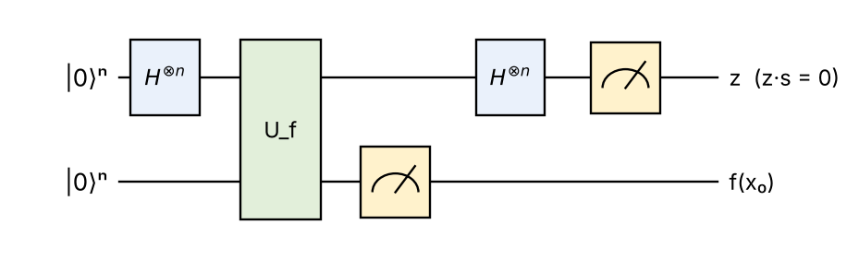
Fig: Simon's algorithm circuit
Components: first H⊗n = all inputs; U_f = oracle; measuring the second register selects one pair {x₀, x₀ ⊕ s}; second H⊗n = interference that keeps only z orthogonal to s; final measurement gives one equation.

3. Worked example: n = 2, s = 11
- Oracle: f(00) = f(11) = A, f(01) = f(10) = B (2-to-1 with s = 11).
- Possible outputs z satisfy z₁s₁ ⊕ z₂s₂ = 0 → z ∈ {00, 11}. z = 00 is trivial; when we get z = 11: s₁ ⊕ s₂ = 0 ⇒ s₁ = s₂.
- Since s ≠ 00 → s = 11. Check: f(01) = f(01 ⊕ 11) = f(10) ✔.

4. Complexity
** | Classical | Quantum (Simon)
Queries | ≈ 2^(n/2) (exponential) | O(n) (polynomial)
Extra work | – | Solve linear equations mod 2: O(n³)

5. Importance
- First algorithm with an exponential quantum speed-up over probabilistic classical algorithms.
- Directly inspired Shor's algorithm (hidden period found by Fourier sampling) – QAI-ii.pdf p.11; it is a hidden subgroup problem over Z₂ⁿ.
Conclusion: Simon's algorithm finds the hidden XOR-period s with O(n) queries by repeatedly sampling strings z with z·s = 0 and solving the resulting linear equations.

💡 Memory trick / Exam tip: “H – Oracle – measure f – H – measure z – solve z·s = 0.”

Q1.7. Phase Kick-Back (and its usage)
Importance | Max marks asked | Answer written for | Asked in | Source
★★ | 6 | 8 marks | 2023 Q2c; 2025 Q2c | QAI-ii.pdf p.4–5 (3.2 Phase kickback: definition, kickback with CNOT gate steps 1–4), p.17 (question bank items 4–6 on usage)

Question wording(s) asked: 2023 Q2c [6]: “Write a short note on: Phase Kick-Back.” | 2025 Q2c [6]: “Write a short note on Phase Kick-Back and its usage.”
Definition: Phase kick-back is the effect in which a phase produced by a controlled operation on the target qubit is transferred (‘kicked back’) to the control qubit. It happens when the target is in an eigenstate of the controlled gate, so the target stays unchanged while the control acquires a relative phase (QAI-ii.pdf p.4).

1. Mechanism
- Controlled-U: |0⟩|u⟩ → |0⟩|u⟩ and |1⟩|u⟩ → |1⟩U|u⟩.
- If U|u⟩ = e^(iφ)|u⟩ (eigenstate), then |1⟩|u⟩ → e^(iφ)|1⟩|u⟩ – the phase can be moved to the control qubit:
(α|0⟩ + β|1⟩) ⊗ |u⟩ → (α|0⟩ + e^(iφ) β|1⟩) ⊗ |u⟩
- The target is not entangled and not changed; the control now carries the information in its relative phase, which a later Hadamard (interference) turns into a measurable bit.

2. Example – kickback with a CNOT
1. |−⟩ = (|0⟩ − |1⟩)/√2 is an eigenstate of X with eigenvalue −1 (X|−⟩ = −|−⟩).
2. So CNOT|x⟩|−⟩ = (−1)ˣ |x⟩|−⟩.
3. Control |+⟩ = (|0⟩ + |1⟩)/√2, target |−⟩: CNOT|+⟩|−⟩ = (|0⟩ − |1⟩)/√2 ⊗ |−⟩ = |−⟩|−⟩.
4. The control changed from |+⟩ to |−⟩ although the CNOT ‘acts on the target’ – the phase was kicked back.
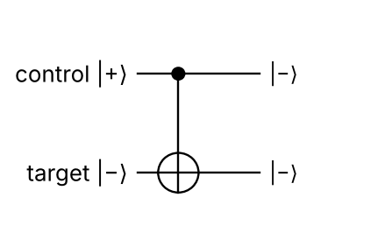
Fig: Phase kick-back with CNOT: |+⟩|−⟩ → |−⟩|−⟩ (control changes, target unchanged)
The book (p.5) shows the same idea with a general state α|00⟩ + β|01⟩ + γ|10⟩ + δ|11⟩: the CNOT exchanges the |10⟩ and |11⟩ amplitudes, and the resulting relative phase on the control later produces interference.

3. Usage
Where used | How kick-back helps
Deutsch / Deutsch–Jozsa | Oracle with helper |−⟩ gives (−1)^f(x)|x⟩ – f encoded as phase
Grover's search | Oracle marks target by phase flip −1
Simon / Bernstein–Vazirani | Phases encode hidden strings, read after H
Quantum Phase Estimation (QPE) | Eigenphase of U kicked back to counting register, read by inverse QFT
Shor's algorithm | Uses QPE on modular multiplication → period

4. Why it matters
- Turns a function value into a phase – the basis of the ‘phase oracle’ trick in almost all quantum algorithms.
- Shows that in quantum circuits ‘control’ and ‘target’ are not one-way roles (CNOT in the |±⟩ basis acts in reverse).
Conclusion: Phase kick-back moves the eigenphase of a controlled gate onto the control qubit; combined with interference it lets quantum algorithms read global properties of functions.

💡 Memory trick / Exam tip: “Target in eigenstate (|−⟩) → phase jumps to control.” Don't write that the target qubit changes – it stays the same.

Q1.10. Qubit copying circuit
Importance | Max marks asked | Answer written for | Asked in | Source
★ | 6 | 8 marks | 2022 Q2a | QAI.pdf p.9 (1.2.5 Qubit copying circuit, no-cloning theorem, teleportation as transfer not copy)

Question wording(s) asked: 2022 Q2a [6]: “Describe Qubit copying circuit.”
Definition: The qubit copying circuit attempts to copy the state of one qubit onto a blank qubit (like classical fan-out). In classical computing copying is easy, but for qubits it is impossible for unknown/arbitrary states – the no-cloning theorem (QAI.pdf p.9). Only known basis states can be copied.

1. Classical copying
- A classical bit b is copied with XOR/CNOT logic: (b, 0) → (b, b). This works because there are only two orthogonal states 0 and 1.

2. Quantum copying circuit with CNOT
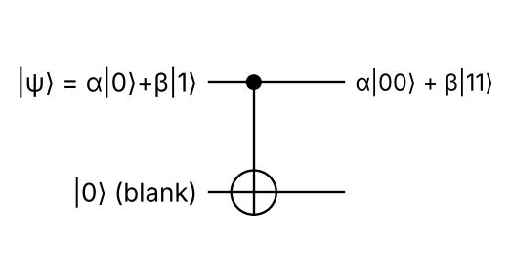
Fig: CNOT used as a ‘copy’ circuit: control = state to copy, target = blank |0⟩
- Basis states copy correctly: |0⟩|0⟩ → |00⟩ and |1⟩|0⟩ → |11⟩.
- Superposition fails: (α|0⟩ + β|1⟩)|0⟩ → α|00⟩ + β|11⟩ (an entangled state).
- A true copy would be (α|0⟩ + β|1⟩)(α|0⟩ + β|1⟩) = α²|00⟩ + αβ|01⟩ + αβ|10⟩ + β²|11⟩. These agree only when αβ = 0, i.e. only for |0⟩ or |1⟩.

3. No-cloning theorem – proof
1. Assume a unitary U copies every state: U|ψ⟩|0⟩ = |ψ⟩|ψ⟩ and U|φ⟩|0⟩ = |φ⟩|φ⟩.
2. Take the inner product of both equations: unitaries preserve inner products, so ⟨φ|ψ⟩ = ⟨φ|ψ⟩².
3. This holds only if ⟨φ|ψ⟩ = 0 or 1 – the two states must be orthogonal or identical.
4. Hence no unitary can copy arbitrary unknown states. (Linearity gives the same result: copying |0⟩ and |1⟩ forces U(α|0⟩+β|1⟩)|0⟩ = α|00⟩+β|11⟩.)

4. Consequences
Area | Consequence
Quantum cryptography | Eavesdropper cannot copy qubits → QKD is secure
Error correction | Cannot use simple repetition; uses entangled codes (α|000⟩ + β|111⟩)
Communication | Teleportation transfers a state (original destroyed), using a Bell pair + 2 classical bits (book p.9)
Computing | No quantum ‘fan-out’; intermediate states cannot be backed up

5. What can be done instead
- Known states can be re-prepared any number of times (we know the recipe).
- Approximate (imperfect) cloning is possible – the optimal universal cloner copies a qubit with fidelity 5/6.
- Orthogonal states (|0⟩, |1⟩) can be copied – this is why classical information can be copied.
Conclusion: The CNOT copier copies only basis states; for a general qubit it produces entanglement, proving that arbitrary quantum states cannot be cloned – they can only be moved by teleportation.

💡 Memory trick / Exam tip: “CNOT copies bits, not qubits – it entangles instead.” Write the αβ = 0 condition.

Q1.11. Draw quantum circuit diagrams that represent the operations
Importance | Max marks asked | Answer written for | Asked in | Source
★ | 6 | 8 marks | 2022 Q2b | QAI.pdf p.8–9 (quantum circuit: components – qubits, gates, entanglement, measurement, registers; computational process; representation: wires, time left→right, layers), p.6–7 (gate symbols)

Question wording(s) asked: 2022 Q2b [6]: “Draw quantum circuits diagram that represents the operations.”
Note: The paper asks to draw circuits ‘that represent the operations’, but the operations are not given in the paper (its only embedded image is a website watermark). Standard example operations (Bell state, SWAP, GHZ) are drawn.

Definition: A quantum circuit is a visual representation of a sequence of quantum operations (gates) on qubits. Horizontal lines are qubits (wires), boxes/symbols are gates, and time flows from left to right; gates in the same column (layer) act simultaneously (QAI.pdf p.8–9).

1. Components and process (book p.8)
- Qubits / quantum registers – wires, initial state written at left (usually |0⟩).
- Quantum gates – unitary boxes (H, X, Z …) and controlled gates (● control, ⊕ target).
- Entanglement – created by multi-qubit gates.
- Measurement – meter symbol at the end, gives classical bits.
- Process: initialisation → gate application (layers) → measurement.

2. Circuit (a): Bell-state preparation
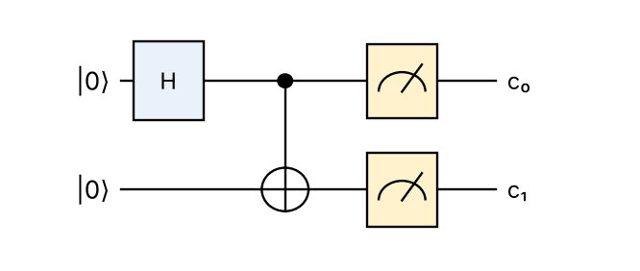
Fig: |00⟩ → H → (|00⟩ + |10⟩)/√2 → CNOT → (|00⟩ + |11⟩)/√2; outcomes 00 or 11 (½ each)

3. Circuit (b): SWAP from three CNOTs
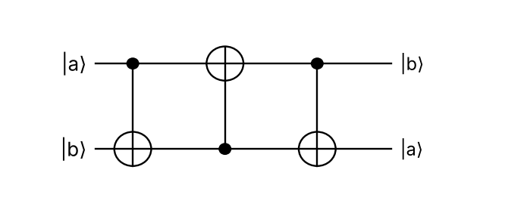
Fig: SWAP = CNOT(0→1) · CNOT(1→0) · CNOT(0→1): |a, b⟩ → |a, a⊕b⟩ → |b, a⊕b⟩ → |b, a⟩

4. Circuit (c): 3-qubit GHZ state
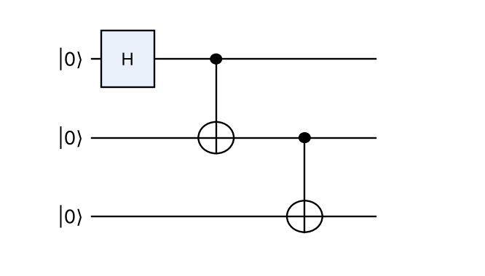
Fig: GHZ circuit: |000⟩ → (|000⟩ + |111⟩)/√2

5. Rules for drawing
1. Draw one wire per qubit and label its initial state.
2. Place gates in time order, one column per layer.
3. Connect controls (●) and targets (⊕) by a vertical line.
4. End with measurement symbols and label classical outputs.

6. Symbols used in circuit diagrams
Symbol | Meaning
── (single line) | Qubit wire (time flows left → right)
══ (double line) | Classical bit wire (after measurement)
Box with letter (H, X, Z, U) | Single-qubit (or multi-qubit) unitary gate
● connected to ⊕ | CNOT: control (●) and target (⊕)
● connected to ● | CZ (controlled phase)
× connected to × | SWAP gate
Meter (dial) symbol | Measurement in the computational basis
/ⁿ on a wire | Bundle of n qubits (register)

7. State evolution of circuit (a) – explained
1. Start |00⟩.
2. H on q₀: (|0⟩ + |1⟩)/√2 ⊗ |0⟩ = (|00⟩ + |10⟩)/√2 – superposition.
3. CNOT (q₀ control): |10⟩ → |11⟩, so state = (|00⟩ + |11⟩)/√2 – entangled Bell state.
4. Measurement: 00 or 11 with probability ½ each; never 01 or 10 (perfect correlation).
Conclusion: Quantum circuits show an algorithm as wires (qubits) and gates in time order; the Bell, SWAP and GHZ circuits are the standard examples to remember.

💡 Memory trick / Exam tip: “Wires → initial states → gates column by column → meters.”

Q1.5. Compare Deutsch algorithm and Deutsch-Jozsa algorithm
Importance | Max marks asked | Answer written for | Asked in | Source
★ | 6 | 8 marks | 2025 Q1c | QAI-ii.pdf p.5–8 (Deutsch algorithm), p.8–10 (3.4 Deutsch–Jozsa algorithm: steps, output, 3-bit example), p.17 (question bank item 10)

Question wording(s) asked: 2025 Q1c [6]: “Compare Deutsch algorithm and Deutsch-Jozsa algorithm.”
Definition: Deutsch's algorithm decides whether a 1-bit function is constant or balanced with one query. The Deutsch–Jozsa (DJ) algorithm (Deutsch and Jozsa, 1992) generalises this to an n-bit function f : {0,1}ⁿ → {0,1} that is promised to be either constant or balanced (QAI-ii.pdf p.8).

Basis of comparison | Deutsch algorithm | Deutsch–Jozsa algorithm
Proposed by / year | David Deutsch, 1985 | David Deutsch and Richard Jozsa, 1992
Input size | 1 bit: f : {0,1} → {0,1} | n bits: f : {0,1}ⁿ → {0,1}
Number of possible inputs | 2 | 2ⁿ
Promise on f | Constant or balanced (always true for 1 bit) | Constant or balanced (exactly half 0s, half 1s)
Qubits used | 2 (1 input + 1 helper) | n + 1 (n input + 1 helper)
Initial state | |0⟩|1⟩ | |0⟩^⊗n |1⟩
Gates before oracle | H ⊗ H | H^⊗(n+1)
Gates after oracle | H on input qubit | H^⊗n on input register
Classical queries (deterministic) | 2 | 2ⁿ⁻¹ + 1 in the worst case
Quantum queries | 1 | 1
Output rule | q₀ = 0 → constant; 1 → balanced | All-zero string 0ⁿ → constant; any other string → balanced
Speed-up | 2× (small) | Exponential over deterministic classical
Relationship | Special case (n = 1) | Generalisation of Deutsch

Deutsch–Jozsa circuit
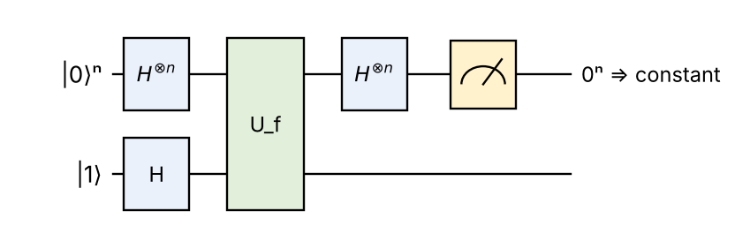
Fig: Deutsch–Jozsa circuit (Deutsch's circuit is the case n = 1)
Example (book p.9–10): n = 3, constant f(x) = 0 for all 8 inputs → after the final H⊗3 the register returns to |000⟩ → constant. For a balanced f the result is a non-zero string such as 011.

Common working principle
- Superposition of all inputs, phase kick-back from the |−⟩ helper (oracle adds (−1)^f(x)), interference from the final Hadamards, measurement of the input register.

Steps side by side
Step | Deutsch | Deutsch–Jozsa
1. Prepare | |0⟩|1⟩ | |0…0⟩|1⟩
2. Superpose | H on both qubits | H on all n+1 qubits
3. Query | U_f once | U_f once
4. Interfere | H on q₀ | H⊗n on input register
5. Measure | q₀ | n input qubits

Conclusion: Deutsch's algorithm is the n = 1 case of Deutsch–Jozsa; both use a single oracle query, but DJ shows an exponential advantage over deterministic classical algorithms.

💡 Memory trick / Exam tip: “Deutsch = 1 bit, DJ = n bits; both 1 query; DJ: all-zeros = constant.”

Q1.13. Time-Evolution of a Closed System
Importance | Max marks asked | Answer written for | Asked in | Source
★ | 5 | 7 marks | 2022 Q3a | QAI.pdf p.23–24 (2.2.2 Time-evolution of a closed system: evolution postulate, unitary U(t), Schrödinger equation, Hamiltonian; open systems)

Question wording(s) asked: 2022 Q3a [5]: “Describe Time-Evolution of a Closed System.”
Definition: A closed quantum system is isolated from its environment – no exchange of energy, information or particles and no measurement. Its time evolution is described by a unitary operator U(t) (the Evolution Postulate) and is governed by the Schrödinger equation (QAI.pdf p.23).

1. Evolution postulate
|ψ(t)⟩ = U(t, t₀) |ψ(t₀)⟩ , U†U = I

2. Schrödinger equation
iħ ∂|ψ(t)⟩/∂t = H |ψ(t)⟩ ⇒ U(t) = e^(−iH(t − t₀)/ħ) (time-independent H)
- i = √−1; ħ = h/2π (reduced Planck constant); |ψ(t)⟩ = state vector at time t.
- H (Hamiltonian) = total-energy operator; it is Hermitian (H = H†), which makes U unitary.
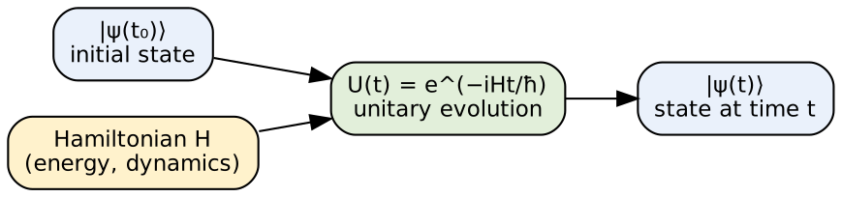
Fig: Time evolution of a closed quantum system

3. Properties
- Deterministic: given |ψ(t₀)⟩ and H, |ψ(t)⟩ is exactly predictable – randomness appears only at measurement.
- Reversible: U⁻¹ = U† exists.
- Norm-preserving: total probability stays 1.
- Quantum gates are evolutions: each gate (H, X, CNOT) is a unitary U = e^(−iHt/ħ) produced by applying a suitable Hamiltonian for a set time.

4. Example
H = (ħω/2)Z gives U(t) = diag(e^(−iωt/2), e^(iωt/2)). Starting from |+⟩ the state becomes (e^(−iωt/2)|0⟩ + e^(iωt/2)|1⟩)/√2 – the relative phase ωt grows, i.e. the qubit rotates around the z-axis of the Bloch sphere (Larmor precession).
Closed system | Open system (book p.24)
Isolated from environment | Interacts / is measured
Unitary, deterministic, reversible | Non-unitary, probabilistic (noise, decoherence)
Schrödinger equation | Quantum operations / master equations

5. Link to quantum computing
- A quantum algorithm is a designed time evolution: the control system switches Hamiltonians on and off so that the total U equals the desired circuit.
- Because evolution is unitary, quantum computation is reversible – no information is erased until measurement.
- Real qubits are not perfectly closed: coupling to the environment causes decoherence, which is why error correction is needed.
Conclusion: A closed quantum system evolves unitarily according to the Schrödinger equation; this deterministic, reversible evolution is exactly what quantum gates implement.

💡 Memory trick / Exam tip: “Closed ⇒ Unitary ⇒ Schrödinger (iħ dψ/dt = Hψ).”

Q1.14. Role of quantum entanglement in quantum architecture
Importance | Max marks asked | Answer written for | Asked in | Source
★ | 5 | 7 marks | 2022 Q3b | QAI.pdf p.20–22 (quantum architecture, Fig. 2.1 layered architecture, framework – entanglement), p.28 (quantum entanglement, Bell states, ‘spooky action’, applications)

Question wording(s) asked: 2022 Q3b [5]: “Describe role of quantum entanglement in quantum architecture.”
Definition: Quantum entanglement is a correlation in which the joint state of two or more qubits cannot be written as a product of individual states, e.g. the Bell state |Φ⁺⟩ = (|00⟩ + |11⟩)/√2 (QAI.pdf p.28). In quantum architecture – the layered structure from algorithms down to physical qubits (Fig. 2.1, p.21) – entanglement is the main resource that gives quantum computers their power.

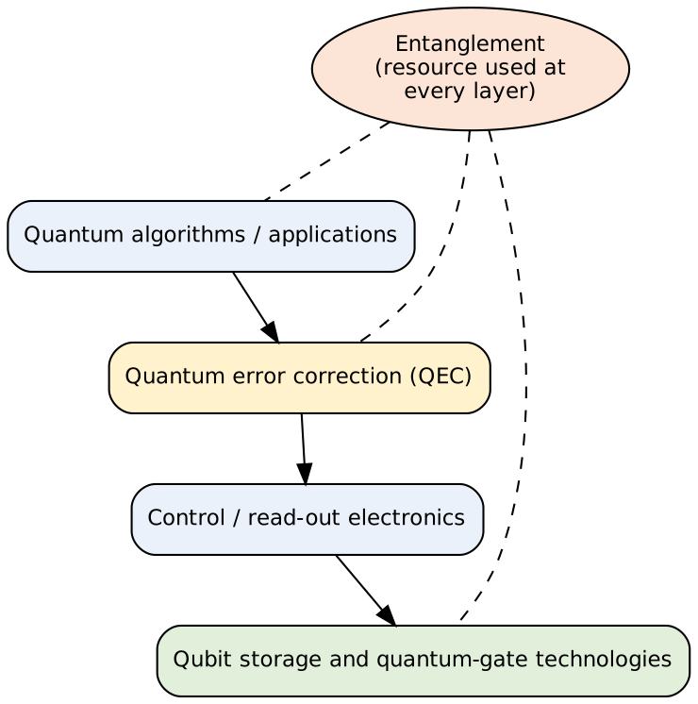
Fig: Layered quantum architecture (after Fig. 2.1, QAI.pdf p.21) with entanglement as a cross-layer resource

Role of entanglement in each layer
Layer / function | Role of entanglement
Algorithms | Entangled registers give quantum parallelism and interference (Shor: input–output registers entangled; Grover)
Communication | Teleportation, dense coding and QKD (E91) run on shared Bell pairs (book p.28)
Quantum error correction | A logical qubit is an entangled code state over many physical qubits; syndromes are read without disturbing data
Control / read-out | Entangling gates (CNOT, CZ) are the hardest operations to control; correlated measurements verify entanglement
Physical qubits | Hardware must couple qubits to create entanglement with high fidelity; this quality limits machine size
Networking / scaling | Entanglement distribution links separate processors (quantum repeaters, distributed computing)

Bell states (maximally entangled)
|Φ±⟩ = (|00⟩ ± |11⟩)/√2 , |Ψ±⟩ = (|01⟩ ± |10⟩)/√2
- Measuring one qubit instantly fixes the other’s result, whatever the distance (‘spooky action at a distance’, verified by Bell-inequality tests).
- Challenge: entanglement is fragile – decoherence destroys it, so the architecture must isolate and correct qubits.

Example – entanglement at work (teleportation)
Two distant processors share |Φ⁺⟩. A Bell measurement on one side plus two classical bits lets the other side recover any qubit state – entanglement is used as a communication channel between modules (QAI.pdf p.10–12). The same mechanism (gate teleportation) is used to connect qubits that are not physically adjacent on a chip.
Conclusion: Entanglement links all layers of a quantum computer – it powers algorithms, communication and error correction, and its fidelity limits the hardware.

💡 Memory trick / Exam tip: “Entanglement = the glue (and the fuel) of quantum architecture.”

Q1.15. Hidden subgroup problem for quantum Fourier transform
Importance | Max marks asked | Answer written for | Asked in | Source
★ | 5 | 7 marks | 2022 Q4a | QAI.pdf p.33–34 (2.3.6 General applications of QFT – the Hidden Subgroup Problem; role of QFT: superposition, interference, amplitude amplification)

Question wording(s) asked: 2022 Q4a [5]: “Describe hidden sub group problem for quantum Fourier transform.”
Definition: Hidden Subgroup Problem (HSP): given a group G and a function f : G → X that is constant on each coset of an unknown subgroup H and different on different cosets, find H. It generalises period finding, Simon's problem and discrete logarithms, and the Quantum Fourier Transform solves it efficiently for abelian groups (QAI.pdf p.33).

1. Steps of the QFT-based algorithm
1. Superposition over G: (1/√|G|) Σ_g |g⟩|0⟩.
2. Query f: (1/√|G|) Σ_g |g⟩|f(g)⟩ – all group elements evaluated at once.
3. Measure the second register: the first register collapses to a coset state (1/√|H|) Σ_(h∈H) |g₀ + h⟩.
4. Apply QFT over G: interference cancels everything except elements of H⊥ (characters trivial on H); the random shift g₀ only adds a phase.
5. Measure → a random element of H⊥.
6. Repeat O(log |G|) times and compute H classically (linear algebra).
Fig: QFT-based solution of the hidden subgroup problem

2. Why the QFT works (book p.34)
- Quantum parallelism: all candidates in superposition.
- Interference: wrong subgroups cancel, the correct one is reinforced.
- Amplitude amplification further raises the success probability.

3. Special cases
Group G | Hidden subgroup H | Problem / algorithm
Z₂ⁿ | {0, s} | Simon's problem
Z (or Z_Q) | multiples of r | Period / order finding → Shor's factoring
Z_N × Z_N | {(k, −k·log) } | Discrete logarithm (breaks Diffie–Hellman, ECC)
Non-abelian (S_n, dihedral) | various | Graph isomorphism, lattice problems – still open

4. Example – Simon's problem as an HSP
G = Z₂ⁿ (n-bit strings with XOR), hidden subgroup H = {0, s}. f is constant on cosets {x, x ⊕ s}. Fourier sampling over Z₂ⁿ is just H⊗n, and it returns z with z·s = 0 – exactly the elements of H⊥. Collecting n − 1 such z determines H, i.e. s.
Conclusion: The hidden subgroup problem unifies the major exponential quantum speed-ups; Fourier sampling with the QFT reveals the hidden subgroup in polynomial time for abelian groups.

💡 Memory trick / Exam tip: “Superpose – Query – Measure f – QFT – Measure – Solve.” Name Simon and Shor as special cases.

Q1.16. Universal sets of quantum gates
Importance | Max marks asked | Answer written for | Asked in | Source
★ | 5 | 7 marks | 2022 Q4b | QAI.pdf p.26–27 (universal set of quantum gates: Hadamard, phase S, π/8 (T), CNOT; approximation to arbitrary precision; efficiency of gate sets)

Question wording(s) asked: 2022 Q4b [5]: “Explain universal sets of quantum gates.”
Definition: A set of quantum gates is universal if any unitary operation on any number of qubits can be approximated to arbitrary accuracy by a finite circuit of gates from that set (QAI.pdf p.27).

1. Standard universal set (book)
- Hadamard (H), phase (S), π/8 gate (T) = diag(1, e^(iπ/4)) and CNOT.
- H, S, T give all single-qubit operations (approximately); CNOT adds the two-qubit interaction needed for entanglement.

2. Other universal sets
Gate set | Notes
{H, T, CNOT} | Minimal common set (S = T²)
Clifford {H, S, CNOT} + T | Used in fault-tolerant computers; Clifford alone is NOT universal (classically simulable – Gottesman–Knill)
All single-qubit gates + CNOT | Exactly universal (any unitary decomposes exactly)
{Toffoli, H} | Universal (with real amplitudes)
Classical {NAND} | Classical analogue of universality

3. Why universality works
1. Any n-qubit unitary can be decomposed into two-level unitaries, and these into single-qubit gates + CNOTs.
2. Any single-qubit gate can be approximated by sequences of H and T (rotations about two non-parallel axes by an irrational angle).
3. Solovay–Kitaev theorem: accuracy ε needs only O(logᶜ(1/ε)) gates – so approximation is efficient.
4. Error: if V approximates U, E(U, V) = max ‖(U − V)|ψ⟩‖ must be ≤ ε (book p.27).

4. Example – building CZ from H and CNOT
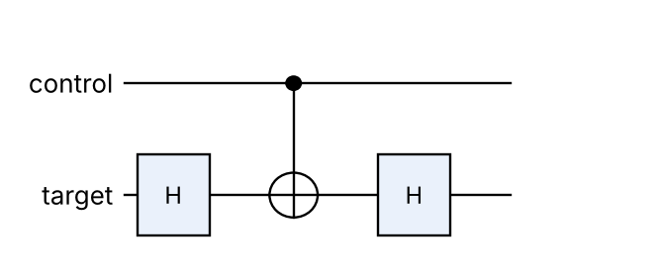
Fig: CZ = (I ⊗ H) · CNOT · (I ⊗ H), since HXH = Z
Similarly Z = HXH and SWAP = 3 CNOTs – every gate reduces to the universal set.

5. Importance
- Hardware designers implement only a few high-fidelity gates; compilers (e.g. Qiskit transpiler) rewrite every algorithm into this native universal set.
- In fault-tolerant machines Clifford gates are cheap and T gates are expensive (magic-state distillation), so T-count measures algorithm cost.
Conclusion: A small universal set such as {H, S, T, CNOT} is enough to build any quantum algorithm; hardware therefore needs to implement only these gates well.

💡 Memory trick / Exam tip: “H, T, CNOT – the magic three.” Remember: Clifford gates alone are not universal; T makes them universal.

Q1.17. Compare order-finding and factoring for Fourier transform
Importance | Max marks asked | Answer written for | Asked in | Source
★ | 5 | 7 marks | 2022 Q4c | QAI.pdf p.30–32 (phase estimation, 2.3.3 order-finding and factoring, order-finding algorithm steps 1–11, factoring & cryptography)

Question wording(s) asked: 2022 Q4c [5]: “Compare order-finding and factoring for Fourier transform.”
Definition: Order finding: given coprime integers a and N, find the smallest positive r with aʳ ≡ 1 (mod N). Factoring: decompose composite N into primes. Both are hard classically; factoring reduces to order finding, which the QFT / phase estimation solves efficiently (QAI.pdf p.31–32).

Basis | Order finding | Factoring
Problem | Smallest r: aʳ ≡ 1 (mod N) | Find prime factors of N
Input | a and N (coprime) | Composite N
Output | Integer r (order/period) | Non-trivial factors p, q
Nature | Periodicity of f(x) = aˣ mod N | Number decomposition
Use of QFT | Directly: phase estimation of U|y⟩ = |ay mod N⟩, eigenphases s/r | Indirectly: calls order finding
Classical part | Continued fractions to get r from measured phase | gcd(a^(r/2) ± 1, N), random choice of a
Quantum complexity | Polynomial in log N | Polynomial (Shor)
Classical complexity | No efficient algorithm known | Super-polynomial (GNFS)
Relationship | Core subroutine | Solved by reduction to order finding
Application | Period finding, discrete log | Breaking RSA

Order-finding algorithm (book p.31)
1. Choose n with 2ⁿ > 2r (n = ⌈2 log N⌉ suffices); control register |0⟩ⁿ, target register |1⟩.
2. Apply QFT (Hadamards) to the control register.
3. Apply controlled-U^(2ʲ) (modular exponentiation) between registers.
4. Apply inverse QFT to the control register; measure x ≈ 2ⁿ·s/r.
5. Continued fractions → s/r → candidate r; repeat, take LCM; check aʳ mod N = 1.
Link (example): order of 2 mod 21 is r = 6 → gcd(2³ ± 1, 21) = 7, 3 → 21 = 3 × 7.

Quantum phase-estimation circuit used for order finding
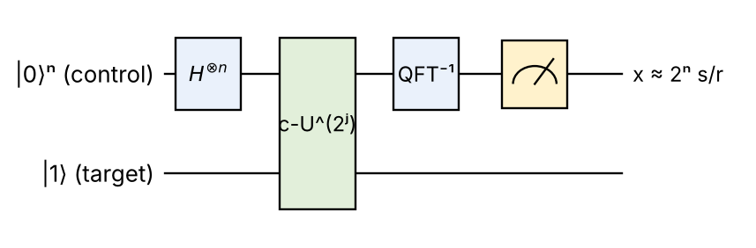
Fig: Order finding = phase estimation of U|y⟩ = |ay mod N⟩; measured value ≈ 2ⁿ·s/r
Explanation: the eigenvalues of U are e^(2πis/r); H⊗n + controlled powers of U kick these phases back to the control register; QFT⁻¹ turns the phase s/r into a binary number; continued fractions give r.
Conclusion: Order finding is the quantum engine (QFT-based) and factoring is the application obtained by a simple classical reduction.

💡 Memory trick / Exam tip: “Order finding is the engine, factoring is the car.”

Q1.8. Differences in measurement in bases and computational basis
Importance | Max marks asked | Answer written for | Asked in | Source
★ | 5 | 7 marks | 2022 Q1a | QAI.pdf p.7–8 (1.2.3 Measurements in Bases vs Computational Basis: (a) computational basis, (b) measurements in other bases), p.4–5 (|+⟩, |−⟩ from Hadamard), p.27 (quantum measurement, collapse)

Question wording(s) asked: 2022 Q1a [5]: “Describe the differences in measurement in bases and computational basis.”
Definition: Measurement extracts classical information from a qubit by projecting its state onto an orthonormal basis; the state collapses to one basis state with probability given by the squared amplitude (Born rule). Measurement can be done in the computational basis {|0⟩, |1⟩} or in other (custom) bases such as {|+⟩, |−⟩} (QAI.pdf p.7–8).

1. Computational-basis measurement
- Basis states |0⟩ and |1⟩ (Z-basis, poles of the Bloch sphere).
- For |ψ⟩ = α|0⟩ + β|1⟩: result 0 with probability |α|², result 1 with probability |β|²; afterwards the qubit is |0⟩ or |1⟩.

2. Measurement in other bases
- The qubit is read in a custom basis, e.g. |±⟩ = (|0⟩ ± |1⟩)/√2, which are superpositions of computational states (book p.8).
- Hardware only measures in Z, so we first apply a basis-change gate (H for the ± basis) and then measure.
- P(+) = |α + β|²/2, P(−) = |α − β|²/2 – depends on the relative phase of α and β.
Point | Computational basis | Other basis (e.g. Hadamard ±)
Basis vectors | |0⟩, |1⟩ | |+⟩, |−⟩ (or any orthonormal pair)
Probabilities for α|0⟩+β|1⟩ | |α|², |β|² | |α+β|²/2, |α−β|²/2
How performed | Directly | Rotate (apply H), then measure
Information obtained | Magnitudes of amplitudes | Relative phase information
State after measurement | |0⟩ or |1⟩ | |+⟩ or |−⟩
Bloch-sphere axis | z-axis | x-axis (y-axis for |±i⟩)
Measuring |+⟩ | Random: 50 % / 50 % | Always ‘+’ (certain)
Measuring |0⟩ | Always 0 (certain) | Random: 50 % / 50 %
Typical use | Reading final results of algorithms | BB84 key distribution, Deutsch-type interference, tomography

3. Example
State |ψ⟩ = |+⟩ = (|0⟩ + |1⟩)/√2. Computational basis: P(0) = P(1) = ½ – looks random. ± basis: P(+) = |1/√2 + 1/√2|²/2 = 1 – fully predictable. Same state, different basis → completely different results.
Born rule: P(k) = |⟨k|ψ⟩|² ; Σₖ P(k) = 1
Conclusion: The computational basis reveals amplitude magnitudes while other bases reveal phase; choosing the basis is a key design decision in quantum algorithms and cryptography.

💡 Memory trick / Exam tip: “Same state, different basis, different answer.” To measure in the ± basis: apply H, then measure.

Q1.9. Single qubit and multiple qubit gates with diagram
Importance | Max marks asked | Answer written for | Asked in | Source
★ | 5 | 7 marks | 2022 Q1b | QAI.pdf p.3–7 (1.2.1 single-qubit gates I, X, Y, Z, H with examples; multiple-qubit gates CNOT, SWAP, CZ with examples; Table 1.1 circuit symbols), p.26–27 (S, T gates)

Question wording(s) asked: 2022 Q1b [5]: “Explain Single qubit and multiple qubit gates with diagram.”
Definition: Quantum gates are unitary operations that change qubit states. Single-qubit gates act on one qubit (2×2 unitary matrices); multiple-qubit gates act on two or more qubits (4×4, 8×8 …) and can create entanglement (QAI.pdf p.3–7).

1. Single-qubit gates
Gate (symbol) | Matrix (rows) | Action / example
Identity (I) | [1 0; 0 1] | No change: I|0⟩ = |0⟩
Pauli-X (NOT) | [0 1; 1 0] | Bit flip: X|0⟩ = |1⟩, X|1⟩ = |0⟩
Pauli-Y | [0 −i; i 0] | Bit + phase flip: Y|0⟩ = i|1⟩, Y|1⟩ = −i|0⟩
Pauli-Z | [1 0; 0 −1] | Phase flip: Z|1⟩ = −|1⟩
Hadamard (H) | (1/√2)[1 1; 1 −1] | Superposition: H|0⟩ = |+⟩, H|1⟩ = |−⟩
Phase S / T | [1 0; 0 i] / [1 0; 0 e^(iπ/4)] | Phase π/2 / π/4 on |1⟩

2. Multiple-qubit gates
Gate | Action | Example (book)
CNOT | Flips target if control = |1⟩ | CNOT|01⟩ = |01⟩, CNOT|11⟩ = |10⟩
SWAP | Exchanges two qubit states | SWAP|01⟩ = |10⟩
CZ (controlled-phase) | Phase −1 if both qubits are |1⟩ | CZ|01⟩ = |01⟩, CZ|11⟩ = −|11⟩
Toffoli (CCNOT) | Flips target if both controls are |1⟩ | CCNOT|110⟩ = |111⟩

3. Circuit diagram
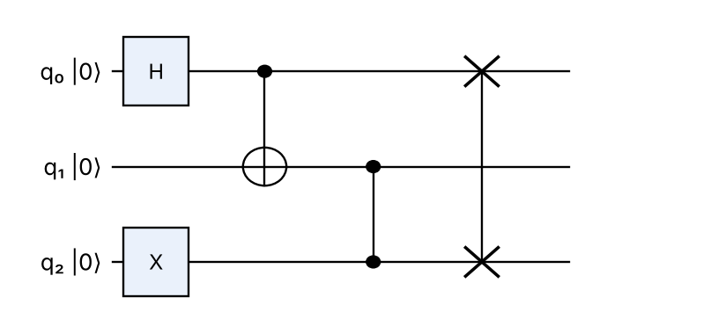
Fig: Single-qubit gates (H, X: boxes) and multi-qubit gates (CNOT ●–⊕, CZ ●–●, SWAP ×–×)
Components: a box on one wire is a single-qubit gate; ● is a control; ⊕ is the CNOT target; ●–● is CZ; ×–× is SWAP. H followed by CNOT here creates the Bell state (|00⟩ + |11⟩)/√2 on q₀, q₁.
Every gate is unitary: U†U = I (reversible, preserves total probability).

4. Properties of quantum gates
- Unitary and reversible (unlike classical AND/OR), so the number of input and output qubits is equal.
- Represented by matrices; a circuit's overall operation = product of gate matrices (right to left).
- Pauli gates X, Y, Z are rotations by π about the x, y, z axes of the Bloch sphere; H swaps the x and z axes.
Conclusion: Single-qubit gates rotate one qubit (flip, phase, superposition); multi-qubit gates such as CNOT and CZ correlate qubits and generate entanglement – together they build every quantum circuit.

💡 Memory trick / Exam tip: “X flips, Z phases, H superposes, CNOT entangles.” Always state the matrix and one example per gate.

Q1.12. How tensor product combines qubit states
Importance | Max marks asked | Answer written for | Asked in | Source
★ | 3 | 5 marks | 2022 Q2c | QAI.pdf p.13–14 (1.4.2 Products and tensor products; separable vs entangled; tensor product of states and operators), p.24 (composition of systems postulate)

Question wording(s) asked: 2022 Q2c [3]: “Describe how tensor product combines qubit states?”
Definition: The tensor product (⊗) combines the state spaces of separate quantum systems into the state space of the composite system: for qubits |a⟩ and |b⟩ the joint state is |a⟩ ⊗ |b⟩ (QAI.pdf p.13, composition postulate p.24).

How it combines qubit states
1. Dimensions multiply: an m-dimensional and an n-dimensional space give an m × n-dimensional space (the Cartesian product would give only m + n) – book p.13.
2. Element rule: c = a ⊗ b has elements c(ij) = a(i) · b(j).
3. Basis states: |0⟩⊗|0⟩ = |00⟩ = [1,0,0,0]ᵀ, |01⟩ = [0,1,0,0]ᵀ, |10⟩ = [0,0,1,0]ᵀ, |11⟩ = [0,0,0,1]ᵀ.
4. General states: (a₀|0⟩ + a₁|1⟩) ⊗ (b₀|0⟩ + b₁|1⟩) = a₀b₀|00⟩ + a₀b₁|01⟩ + a₁b₀|10⟩ + a₁b₁|11⟩.
5. n qubits → 2ⁿ amplitudes (exponential growth).
6. Operators: gate A on qubit 1 and B on qubit 2 = A ⊗ B; e.g. X on the first qubit = X ⊗ I.
Example: |+⟩ ⊗ |0⟩ = (|00⟩ + |10⟩)/√2. A state that can be written as a tensor product is separable; one that cannot, e.g. (|00⟩ + |11⟩)/√2, is entangled (book p.13).
Conclusion: The tensor product builds multi-qubit states by multiplying amplitudes, giving a 2ⁿ-dimensional space in which entangled states also exist.

💡 Memory trick / Exam tip: “Multiply every amplitude by every amplitude; can't factor it ⇒ entangled.”

4. Last-minute revision sheet

Key definitions
- Shor: factoring via quantum period finding (H, aˣ mod N, QFT⁻¹, continued fractions) + gcd(a^(r/2) ± 1, N).
- Grover: unstructured search O(√N); oracle phase flip + diffusion D = 2|s⟩⟨s| − I; k ≈ (π/4)√N.
- Deutsch / DJ: constant vs balanced with ONE query; 0 (all-zero) = constant.
- Simon: f(x) = f(x ⊕ s); measure z with z·s = 0; solve n − 1 equations.
- Phase kick-back: eigenphase of target moves to control (|−⟩ helper).
- Measurement bases: Z gives |α|², |β|²; ± basis gives |α ± β|²/2.
- No-cloning: CNOT copies |0⟩,|1⟩ but turns α|0⟩+β|1⟩ into α|00⟩+β|11⟩.
- Tensor product: dims multiply, c(ij) = a(i)b(j); non-factorable = entangled.
- Closed system: unitary evolution, iħ ∂ψ/∂t = Hψ.
- HSP: f constant on cosets of hidden H; QFT finds H (Simon, Shor special cases).
- Universal gates: {H, S, T, CNOT}.

Formulas
aʳ ≡ 1 (mod N); factors = gcd(a^(r/2) ± 1, N); QFT|x⟩ = (1/√Q) Σ e^(2πixy/Q)|y⟩
Grover: P = sin²((2k+1)θ), sin θ = 1/√N
U_f|x⟩|−⟩ = (−1)^f(x)|x⟩|−⟩ ; Deutsch result = f(0) ⊕ f(1)
Classical queries: Deutsch 2, DJ 2ⁿ⁻¹+1, Simon ~2^(n/2); Quantum: 1, 1, O(n)
U = e^(−iHt/ħ), U†U = I

Memory tricks
- Shor = A-R-G (a, r, gcd). Grover = Superpose-Mark-Flip-Repeat-Measure.
- Deutsch = H, Uf, H → 0 Constant / 1 Balanced. Simon = z·s = 0.
- Gates: X flips, Z phases, H superposes, CNOT entangles.
- Speed-ups: Shor/Simon/DJ exponential; Grover quadratic only.

5. Assumptions & gaps
- Unit 1 = Q1/Q2 of the 2023–2025 end-sems (quantum algorithms) plus 10 questions from the 2022 in-sem (foundations) mapped here by topic; they are rated ★ (asked once in a 30-mark paper).
- No lecture notes exist in the repo; textbook terminology (QAI.pdf, QAI-ii.pdf) is followed. Both books are scanned, so text was read by OCR and every formula was re-checked against standard theory.
- Textbook corrections: (i) the Shor example N = 91, a = 10 (QAI-ii.pdf p.12–13) is arithmetically wrong (10⁵ mod 91 = 82; true order 6) – verified examples N = 15 and N = 21 are used; (ii) Simon's registers are written as n+1 qubits in the book – the standard two n-qubit registers are used.
- 2022 Q2b (‘Draw quantum circuits diagram that represents the operations’): the operations are not printed in the paper (the only embedded image is a website watermark), so standard circuits (Bell, SWAP, GHZ) are drawn.
- Correction from the earlier version: measurement in other bases (Q1.8) IS in your book (QAI.pdf p.7–8) and is now cited instead of flagged.
- Marks rule (max + 2): Shor, Grover, Factoring, Deutsch = 11 marks; Simon, Phase kick-back, Deutsch-vs-DJ, Copying circuit, Circuit diagrams = 8; other in-sem items = 7; tensor product = 5.
Questions flagged ⚠ (not found in your materials): none

