Quantum Artificial Intelligence — Unit 3: Quantum Communication, Cryptography and Error Correction
Exam answers for 70-mark end-sem (2.5 hrs). Each answer is written for (max marks asked + 2). Sources are PDF page numbers of the files in your repo; ⚠ marks content NOT found in your materials.

1. Unit snapshot
No. | Question | Max Marks | Years Asked | Importance
3.1 | Quantum Teleportation (with example; significance in quantum communication) | 9 | 2022, 2024, 2025 | ★★★
3.2 | Quantum Dense Coding | 9 | 2023, 2024, 2025 | ★★★
3.3 | Quantum Cryptography (and secure communication) | 8 | 2023, 2024, 2025 | ★★★
3.4 | Quantum Key Distribution (process / steps) | 6 | 2023, 2025 | ★★
3.5 | Classical Three-Bit Code | 5 | 2023, 2025 | ★★
3.6 | Fault Tolerance | 5 | 2023, 2025 | ★★
3.7 | Noise and error models in quantum systems | 8 | 2024 | ★
3.8 | Practical challenges and limitations of error model encoding | 6 | 2023 | ★
3.9 | Mixed States and General Quantum Operations | 5 | 2022 (in-sem) | ★

2. Must-do first (★★★)
1. Q3.1 Quantum Teleportation (with example; significance in quantum communication) — max 9 marks, asked 2022, 2024, 2025
2. Q3.2 Quantum Dense Coding — max 9 marks, asked 2023, 2024, 2025
3. Q3.3 Quantum Cryptography (and secure communication) — max 8 marks, asked 2023, 2024, 2025

3. Full answers (★★★ → ★★ → ★)

Q3.1. Quantum Teleportation (with example; significance in quantum communication)
Importance | Max marks asked | Answer written for | Asked in | Source
★★★ | 9 | 11 marks | 2022 Q1c; 2024 Q5a; 2025 Q6a | QAI.pdf p.9–12 (quantum teleportation: Bell pair, Bell measurement, two classical bits, correction gates, Bell states p.10)

Question wording(s) asked: 2022 Q1c [5]: “Demonstrate quantum teleportation with suitable example.” | 2024 Q5a [9]: “Explain Quantum Teleportation in detail.” | 2025 Q6a [6]: “Discuss the concept of quantum teleportation and its significance in quantum communication.”
Definition: Quantum teleportation is a protocol that transfers the unknown state of one qubit to another qubit at a distant place, without physically sending the qubit, using a shared entangled (Bell) pair and two classical bits (QAI.pdf p.10).

1. Requirements
- Sender Mahesh (Alice) holds qubit A = |ψ⟩ = α|0⟩ + β|1⟩ (unknown), receiver Ramesh (Bob) is far away.
- A shared Bell pair |Φ⁺⟩ = (|00⟩ + |11⟩)/√2: one half with Alice, the other half with Bob.
- A classical channel to send 2 bits.

2. Steps
1. Entanglement generation: create the Bell pair (H + CNOT) and distribute one qubit to each party.
2. Bell measurement (Alice): apply CNOT (control = |ψ⟩, target = her Bell qubit), then Hadamard on |ψ⟩.
3. Measure both of Alice's qubits → two classical bits (m₁, m₂).
4. Classical communication: Alice sends m₁m₂ to Bob.
5. Correction (Bob): apply X^(m₂) then Z^(m₁) to his qubit → Bob's qubit becomes exactly α|0⟩ + β|1⟩.
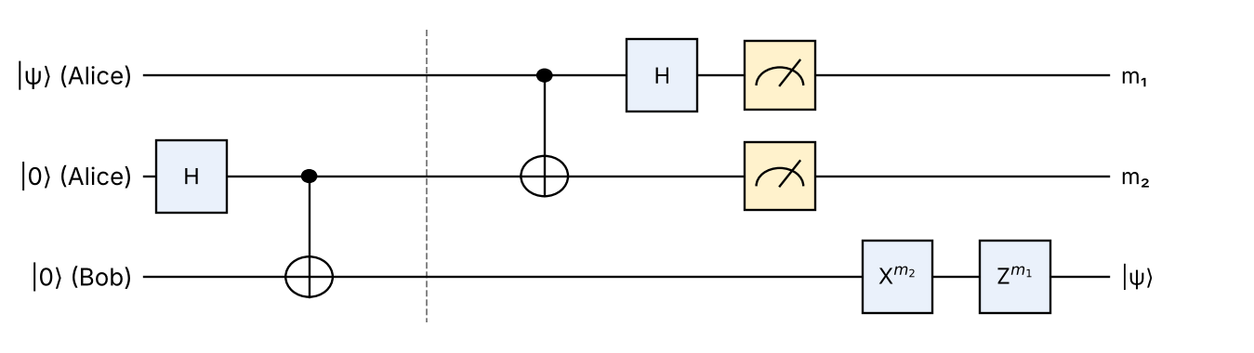
Fig: Teleportation circuit: Bell pair (cols 1–2), Bell measurement (cols 3–5), classical-controlled corrections on Bob's qubit
Components: H + CNOT on the middle/bottom wires make the Bell pair; CNOT + H + measurement on the top two wires is the Bell measurement; X and Z boxes are applied by Bob only if the received bits are 1.

3. Mathematics
|ψ⟩|Φ⁺⟩ = (α|0⟩+β|1⟩)(|00⟩+|11⟩)/√2
After CNOT and H: ½ [ |00⟩(α|0⟩+β|1⟩) + |01⟩(α|1⟩+β|0⟩) + |10⟩(α|0⟩−β|1⟩) + |11⟩(α|1⟩−β|0⟩) ]
Alice's bits (m₁ m₂) | Bob's qubit before correction | Correction by Bob
00 | α|0⟩ + β|1⟩ | None (I)
01 | α|1⟩ + β|0⟩ | X
10 | α|0⟩ − β|1⟩ | Z
11 | α|1⟩ − β|0⟩ | X then Z (ZX)

4. Example
Let |ψ⟩ = 0.6|0⟩ + 0.8|1⟩. Each of the four outcomes occurs with probability ¼. If Alice gets 10, Bob holds 0.6|0⟩ − 0.8|1⟩; applying Z gives 0.6|0⟩ + 0.8|1⟩ = |ψ⟩. Bob gets the same state in every case.

5. Important points / significance
- No cloning: Alice's original qubit is destroyed by the measurement – the state is moved, not copied.
- No faster-than-light signalling: Bob's state is useless until the 2 classical bits arrive.
- Uses: quantum communication / quantum internet, quantum repeaters, distributed quantum computing, gate teleportation, fault-tolerant computing.
- Transfers 1 qubit using 1 ebit + 2 classical bits.

6. Significance in quantum communication
Application | Role of teleportation
Quantum internet | Moves qubits between network nodes without sending fragile photons over long lossy links
Quantum repeaters | Entanglement swapping (teleporting entanglement) extends Bell pairs over long distances
Distributed quantum computing | Teleports qubits/gates between separate processors (modular machines)
Secure communication | The quantum state never travels through the channel, so it cannot be intercepted
Experiments | Ground-to-satellite teleportation over ~1400 km (Micius satellite, 2017)

Resource equation: 1 ebit (shared Bell pair) + 2 classical bits ⇒ 1 qubit transferred.
Conclusion: Teleportation moves an unknown qubit state using entanglement plus two classical bits; it is the basic building block of quantum communication.

💡 Memory trick / Exam tip: “Entangle – Bell-measure – Call (2 bits) – Correct (X, Z).” Remember: no copying, no faster-than-light.

Q3.2. Quantum Dense Coding
Importance | Max marks asked | Answer written for | Asked in | Source
★★★ | 9 | 11 marks | 2023 Q6a; 2024 Q6a; 2025 Q5c | Not in your materials

Question wording(s) asked: 2023 Q6a [6]: “Explain in short Quantum Dense Coding.” | 2024 Q6a [9]: “Explain in short Quantum Dense Coding.” | 2025 Q5c [6]: “Explain quantum dense coding.”
Source status: ⚠ Not found in your materials. Standard textbook answer. (Related background: Bell states and CNOT/Hadamard, QAI.pdf p.10; teleportation, p.10–12.)

Definition: Quantum dense (superdense) coding is a protocol that lets Alice send two classical bits to Bob by transmitting only one qubit, using a previously shared entangled pair. It is the ‘reverse’ of teleportation (teleportation: 1 qubit ← 2 bits).

1. Steps
1. Entanglement: a source creates |Φ⁺⟩ = (|00⟩ + |11⟩)/√2; first qubit goes to Alice, second to Bob.
2. Encoding (Alice): to send bits b₁b₂ she applies a gate to her qubit only (table below).
3. Transmission: Alice sends her single qubit to Bob.
4. Decoding (Bob): apply CNOT (control = Alice's qubit, target = his qubit), then Hadamard on Alice's qubit.
5. Measurement: Bob measures both qubits and obtains b₁b₂ exactly.
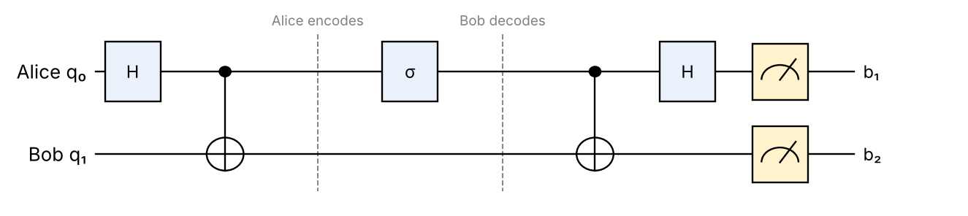
Fig: Dense-coding circuit (σ = I, X, Z or ZX chosen by the 2 message bits)
Message b₁b₂ | Alice's gate | State sent / received | Bob's result after CNOT + H
00 | I | (|00⟩+|11⟩)/√2 = Φ⁺ | 00
01 | X | (|01⟩+|10⟩)/√2 = Ψ⁺ | 01
10 | Z | (|00⟩−|11⟩)/√2 = Φ⁻ | 10
11 | ZX (iY) | (|01⟩−|10⟩)/√2 = Ψ⁻ | 11

Explanation: the four Bell states are mutually orthogonal, so Bob can distinguish them perfectly; Alice's local gate selects one of the four. A single qubit can therefore carry 2 bits because of the entanglement it shares.

2. Important points
- Classical capacity doubles: 2 bits per qubit sent (cost: 1 shared ebit).
- Without entanglement, 1 qubit can carry only 1 classical bit (Holevo bound).
- Eavesdropper intercepting Alice's qubit alone learns nothing (the qubit alone is maximally mixed) – useful for secure communication.
- Experimentally demonstrated with photons.
Point | Teleportation | Dense coding
Sends | 1 qubit state | 2 classical bits
Uses | 1 ebit + 2 classical bits | 1 ebit + 1 qubit

3. Derivation for message 10
1. Shared state |Φ⁺⟩ = (|00⟩ + |11⟩)/√2.
2. Alice applies Z to her qubit: (|00⟩ − |11⟩)/√2 = |Φ⁻⟩; she sends her qubit to Bob.
3. Bob applies CNOT: |00⟩ → |00⟩, |11⟩ → |10⟩ ⇒ (|00⟩ − |10⟩)/√2 = |−⟩|0⟩.
4. Bob applies H to the first qubit: H|−⟩ = |1⟩ ⇒ state |10⟩.
5. Measurement gives 10 – exactly Alice's message.

4. Applications and limitations
- Proposed by Bennett and Wiesner (1992); first demonstrated with entangled photons (1996).
- Applications: doubling channel capacity, secure transmission (one intercepted qubit reveals nothing), building block for quantum networks.
- Limitations: entanglement must be distributed in advance (it ‘pre-pays’ one qubit); entangled pairs decohere in storage; the four Bell states must be measured perfectly.

5. Why it is possible
Without entanglement one qubit can carry at most one classical bit (Holevo bound). The shared Bell pair supplies the second bit in advance: Alice's local gate rotates the joint two-qubit state among four orthogonal Bell states, and orthogonal states can be distinguished perfectly by Bob's Bell measurement.
Conclusion: Dense coding doubles the classical information per transmitted qubit by exploiting shared entanglement.

💡 Memory trick / Exam tip: “2 bits in 1 qubit: I, X, Z, ZX → 00, 01, 10, 11.” Decode = CNOT then H.

Q3.3. Quantum Cryptography (and secure communication)
Importance | Max marks asked | Answer written for | Asked in | Source
★★★ | 8 | 10 marks | 2023 Q6b; 2024 Q5b; 2025 Q5a | Not in your materials (only one-line mentions: QAI-ii.pdf p.2 – quantum key distribution as a cryptographic application; QAI.pdf p.22, p.28 – cryptography as an application of entanglement; QAI.pdf p.32, QAI-ii.pdf p.13 – Shor threat to RSA)

Question wording(s) asked: 2023 Q6b [6]: “Discuss in detail Quantum cryptography.” | 2024 Q5b [8]: “Describe Quantum cryptography and secure communication in detail.” | 2025 Q5a [6]: “Discuss in detail quantum cryptography.”
Source status: ⚠ Not found in your materials. Standard textbook answer.

Definition: Quantum cryptography uses the laws of quantum mechanics (superposition, measurement disturbance, no-cloning) to secure communication. Its best-known application is Quantum Key Distribution (QKD), which lets two parties share a secret key whose secrecy is guaranteed by physics, not by computational difficulty.

1. Why needed
- Classical public-key cryptography (RSA, ECC) is based on hard maths problems and is broken by Shor's algorithm (QAI.pdf p.32).
- Quantum cryptography remains secure even against quantum computers.

2. Principles that give security
- Measurement disturbs the state: reading a qubit in the wrong basis changes it → eavesdropping is detectable.
- No-cloning theorem: an eavesdropper cannot copy unknown qubits.
- Heisenberg uncertainty: non-orthogonal states cannot be perfectly distinguished.
- Entanglement correlations (E91) provide shared random bits.
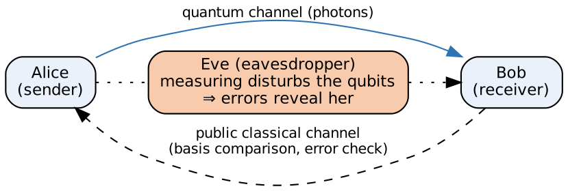
Fig: Setup of quantum key distribution

3. Main techniques
Technique | Idea
BB84 (QKD) | Random bits in random bases; sifting; error check; privacy amplification
E91 | Uses entangled pairs; Bell-inequality test detects eavesdropping
B92 | Two non-orthogonal states only
Secure communication | Key from QKD used in a one-time pad (perfectly secret) or AES
Quantum random numbers, digital signatures, quantum secure direct communication | Other applications

4. Secure communication with QKD
1. Alice and Bob run QKD → identical secret key K (length ≥ message).
2. Alice computes ciphertext C = M ⊕ K (one-time pad) and sends it over any channel.
3. Bob recovers M = C ⊕ K. If Eve was present, the error rate in QKD exceeds threshold and the key is discarded.

5. Classical vs quantum cryptography
Point | Classical (RSA) | Quantum (QKD)
Security basis | Computational hardness | Laws of physics
Quantum-computer safe? | No (Shor) | Yes
Eavesdropping | Undetectable | Detectable (disturbance)
Needs | Computers | Single-photon source/detectors, fibre / free-space link
Limits | — | Distance (photon loss), cost, key rate, trusted nodes

6. Attacks and counter-measures
Attack | Counter-measure
Intercept–resend | Detected by raised error rate (≈ 25 % in BB84)
Photon-number splitting (multi-photon pulses) | Decoy-state protocol
Detector / side-channel attacks | Measurement-device-independent QKD, device certification
Man-in-the-middle | Authenticated classical channel (pre-shared key)

7. Real-world use
- Swiss election results protected by QKD (2007); Beijing–Shanghai QKD backbone (~2000 km, trusted nodes); satellite QKD with Micius (China, 2017); commercial systems (ID Quantique, Toshiba).

8. Quantum cryptography vs post-quantum cryptography
Point | Quantum cryptography (QKD) | Post-quantum cryptography (PQC)
Basis | Physics (no-cloning, disturbance) | New hard maths problems (lattices, codes, hashes)
Hardware | Photon sources, detectors, fibre/satellite | Ordinary computers – software upgrade
Security | Information-theoretic (unconditional) for key exchange | Computational – believed secure against quantum attacks
Range | Limited distance, needs special links | Works over the existing Internet

Conclusion: Quantum cryptography uses quantum principles (no-cloning, measurement disturbance) to detect eavesdropping and generate unconditionally secure keys.

💡 Memory trick / Exam tip: “BB84 + One-Time-Pad = unbreakable.” Don't confuse QKD (key exchange) with encrypting the message.

Q3.4. Quantum Key Distribution (process / steps)
Importance | Max marks asked | Answer written for | Asked in | Source
★★ | 6 | 8 marks | 2023 Q5b; 2025 Q6b | Not in your materials

Question wording(s) asked: 2023 Q5b [6]: “Describe Quantum Key Distribution in short.” | 2025 Q6b [6]: “Describe with appropriate steps quantum key distribution process.”
Source status: ⚠ Not found in your materials. Standard textbook answer.

Definition: Quantum Key Distribution (QKD) is a method in which two parties (Alice, Bob) generate a shared random secret key using qubits sent over a quantum channel; any eavesdropping disturbs the qubits and is detected. The first protocol is BB84 (Bennett–Brassard, 1984).

1. BB84 process (steps)
1. Random bits & bases: Alice picks random bits and, for each, a random basis: rectilinear (+) {|0⟩,|1⟩} or diagonal (×) {|+⟩,|−⟩}.
2. Encode & send: she sends the qubit (photon) to Bob through the quantum channel (+: 0→|0⟩, 1→|1⟩; ×: 0→|+⟩, 1→|−⟩).
3. Measure: Bob measures each qubit in a randomly chosen basis.
4. Sifting: over a public classical channel they announce bases (not bits) and keep only the positions where the bases match (~50 %).
5. Error estimation: they compare a random sample of the sifted key; a high QBER (> ~11 %) means eavesdropping → abort.
6. Reconciliation & privacy amplification: correct remaining errors and shorten the key so Eve's information is negligible → final secret key.
Fig: BB84 quantum key distribution process

2. Example
Qubit no. | 1 | 2 | 3 | 4 | 5 | 6 | 7 | 8
Alice bit | 0 | 1 | 1 | 0 | 1 | 0 | 0 | 1
Alice basis | + | + | × | + | × | × | + | ×
Bob basis | + | × | × | × | × | + | + | +
Bases match? | ✔ | ✘ | ✔ | ✘ | ✔ | ✘ | ✔ | ✘
Key bit | 0 | – | 1 | – | 1 | – | 0 | –

Sifted key = 0110. If Eve intercepts and resends in random bases, she picks the wrong basis half the time and then causes an error in 50 % of those → 25 % error in the sifted key, which Alice and Bob detect.

3. Why secure
- No-cloning: Eve cannot copy; measurement disturbs; basis is revealed only after Bob has measured.

4. Other QKD protocols
- E91 (Ekert 1991): source sends entangled pairs to Alice and Bob; they measure in random bases; matching bases give correlated key bits; a Bell-inequality test on the rest reveals any eavesdropper.
- B92: uses only two non-orthogonal states.
- Practical limits: key rate falls with fibre distance (≈ 100–200 km without repeaters) because photons are lost.
Conclusion: QKD (BB84) produces a shared secret key; the presence of an eavesdropper is revealed by an increased error rate.

💡 Memory trick / Exam tip: “Send – Measure – Sift – Check – Distil.” Only bases are announced publicly, never bit values.

Q3.5. Classical Three-Bit Code
Importance | Max marks asked | Answer written for | Asked in | Source
★★ | 5 | 7 marks | 2023 Q5c; 2025 Q6c | Not in your materials

Question wording(s) asked: 2023 Q5c [5]: “Discuss the Classical Three-Bit Code.” | 2025 Q6c [5]: “Write a note on classical three bit code.”
Source status: ⚠ Not found in your materials. Standard textbook answer.

Definition: The classical three-bit (repetition) code protects one bit against a single bit-flip error by sending it three times: 0 → 000 and 1 → 111. The receiver decodes by majority voting. It is the starting point for quantum error correction.

1. Encoding and decoding
Logical bit | Codeword sent | Received (1 error) | Majority decoding
0 | 000 | 100, 010, 001 | 0 ✔
1 | 111 | 011, 101, 110 | 1 ✔
0 | 000 | 110, 101, 011 (2 errors) | 1 ✘ (fails)

Fig: Three-bit repetition code

2. Error probability
P(no decoding error) = (1−p)³ + 3p(1−p)²
P(error after decoding) = 3p²(1−p) + p³ ≈ 3p² (better than p if p < ½)
Symbols: p = probability that a single bit flips. Example: p = 0.1 → error after decoding = 3(0.01)(0.9) + 0.001 = 0.028 < 0.1.

3. Relation to quantum codes
- Quantum states cannot be copied (no-cloning), so the quantum version encodes α|0⟩+β|1⟩ → α|000⟩+β|111⟩ using two CNOTs (entanglement, not copying).
- Errors are found by measuring parity (syndrome) operators Z₁Z₂ and Z₂Z₃ without measuring the data, then corrected with X – this corrects one bit-flip. Phase flips need a similar Hadamard-rotated code (Shor's 9-qubit code combines both).
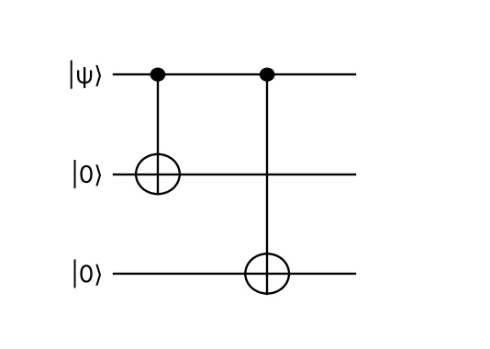
Fig: Quantum 3-qubit bit-flip encoder: α|0⟩+β|1⟩ → α|000⟩+β|111⟩

4. Limitations
- Corrects only one error; fails for two or more flips; costs 3× bandwidth (rate 1/3).

5. Syndrome table (quantum 3-qubit bit-flip code)
Error | Z₁Z₂ | Z₂Z₃ | Correction
None | +1 | +1 | I
Flip on qubit 1 | −1 | +1 | X₁
Flip on qubit 2 | −1 | −1 | X₂
Flip on qubit 3 | +1 | −1 | X₃

The parities tell which qubit flipped without revealing α or β, so the superposition is preserved – the quantum version of majority voting.
Conclusion: The three-bit code reduces error from p to ≈3p² by redundancy and majority vote; its idea (redundancy + syndrome) underlies quantum error correction.

💡 Memory trick / Exam tip: “Repeat ×3, vote majority: fixes 1 flip, fails on 2.”

Q3.6. Fault Tolerance
Importance | Max marks asked | Answer written for | Asked in | Source
★★ | 5 | 7 marks | 2023 Q6c; 2025 Q5b | Only passing mention: QAI.pdf p.21 (QEC layer in architecture), QAI-ii.pdf p.4 (large-scale fault-tolerant quantum computers are challenging)

Question wording(s) asked: 2023 Q6c [5]: “Write a short Note on Fault Tolerance.” | 2025 Q5b [5]: “Write a short note on Fault Tolerance.”
Source status: ⚠ Not found in your materials. Standard textbook answer.

Definition: Fault-tolerant quantum computation is the design of quantum circuits so that errors in gates, state preparation, measurement and storage do not spread uncontrollably; a computation of any length can be made reliable if the physical error rate is below a threshold.

1. Why needed
- Qubits suffer decoherence and gate errors (~10⁻³ now); algorithms like Shor need ~10⁹ operations → errors must be actively corrected.
- Quantum error correction (QEC) itself uses faulty gates – so the correction circuits must be fault tolerant.

2. Key techniques
1. QEC codes: encode a logical qubit in many physical qubits (Shor 9-qubit, Steane 7-qubit, surface code).
2. Transversal gates: gate applied qubit-by-qubit across code blocks so an error cannot spread within a block.
3. Fault-tolerant syndrome extraction with verified ancilla qubits; repeat syndrome measurement.
4. Concatenation / code scaling: codes within codes lower the logical error rate doubly-exponentially.
5. Magic-state distillation: to build non-transversal gates such as T for universality.
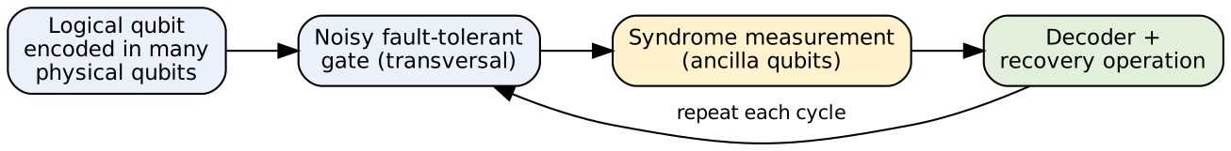
Fig: Fault-tolerant computation cycle

3. Threshold theorem
If physical error rate p < p_threshold (≈ 10⁻² for surface code),
logical error after one level of concatenation p_L ≈ c·p² → arbitrarily long computation with polylog overhead.

4. Challenges
- Huge overhead (hundreds–thousands of physical qubits per logical qubit), fast decoders, high-fidelity gates, qubit connectivity.

5. Examples of fault-tolerant codes
- Steane [[7,1,3]] code: 7 physical qubits per logical qubit, corrects any single-qubit error; CNOT, H and S are transversal.
- Surface code: qubits on a 2-D grid with only nearest-neighbour checks; threshold ≈ 1 %; used by Google and IBM experiments (logical error falls as the code grows).
- Concatenated codes: level-k encoding gives p_L ≈ p_th (p/p_th)^(2^k).
Conclusion: Fault tolerance combines error-correcting codes with carefully designed gates so that reliable large quantum computations are possible below the error threshold.

💡 Memory trick / Exam tip: “Encode – Compute transversally – Check syndrome – Correct – Stay below threshold.”

Q3.7. Noise and error models in quantum systems
Importance | Max marks asked | Answer written for | Asked in | Source
★ | 8 | 10 marks | 2024 Q6b | QAI.pdf p.3 (decoherence), p.20 and p.24–26 (open systems, noise, general quantum operations / CPTP maps, Kraus operators)

Question wording(s) asked: 2024 Q6b [8]: “Explain Noise and error models in quantum systems.”
Source status: Partly ⚠ not found: your book only introduces noise/decoherence and quantum operations; the specific named error models below (bit-flip, phase-flip, depolarising, amplitude/phase damping) are standard textbook knowledge.

Definition: Noise is any unwanted interaction (with the environment or imperfect control) that disturbs a quantum state; decoherence is loss of superposition/entanglement. Error models describe this mathematically as a quantum operation (channel) ℰ(ρ) = Σ Eₖ ρ Eₖ† with Σ Eₖ†Eₖ = I (CPTP map, Kraus operators – QAI.pdf p.26).

1. Sources of noise
- Decoherence (T₁ relaxation, T₂ dephasing), imperfect gates, state-preparation and measurement (readout) errors, crosstalk, leakage out of the qubit subspace.

2. Common error models
Model | Effect on qubit | Kraus operators (p = error prob.)
Bit-flip | |0⟩ ↔ |1⟩ (X error) with prob. p | √(1−p) I, √p X
Phase-flip | |1⟩ → −|1⟩ (Z error) | √(1−p) I, √p Z
Bit-phase flip | Y error | √(1−p) I, √p Y
Depolarising | State replaced by maximally mixed state I/2 with prob. p | √(1−3p/4) I, √(p/4) X, Y, Z
Amplitude damping (T₁) | Energy loss |1⟩ → |0⟩ with prob. γ | E₀ = [[1,0],[0,√(1−γ)]], E₁ = [[0,√γ],[0,0]]
Phase damping / dephasing (T₂) | Loss of phase coherence, populations unchanged | E₀ = [[1,0],[0,√(1−λ)]], E₁ = [[0,0],[0,√λ]]

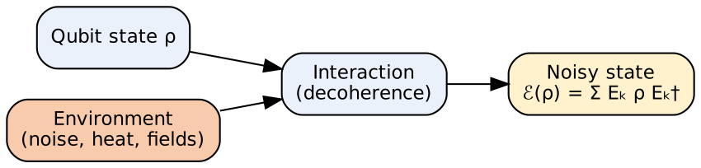
Fig: Noise as interaction with the environment (open system)

3. Remarks
- Pauli (bit/phase-flip, depolarising) errors are discrete, so error-correcting codes can handle them; any single-qubit error is a combination of I, X, Y, Z.
- Coherence times and gate fidelities (error rates ~10⁻³) decide how deep a circuit can run on NISQ devices.
- Used to simulate noisy circuits (e.g. Qiskit noise models) and to design codes.

4. Effect on the Bloch sphere
Channel | Geometric effect
Bit-flip | Shrinks the y and z components; x-axis preserved
Phase-flip / dephasing (T₂) | Shrinks x, y components → state moves towards z-axis (superposition lost)
Depolarising | Shrinks the whole sphere uniformly towards the centre (I/2)
Amplitude damping (T₁) | Pulls every state towards the north pole |0⟩ (energy loss)

5. Formulas and example
Depolarising: ℰ(ρ) = (1 − p) ρ + p · I/2
Bit-flip: ℰ(ρ) = (1 − p) ρ + p XρX
Coherence decays as e^(−t/T₂); excited population decays as e^(−t/T₁)
Example: |+⟩ under phase-flip with p = 0.5 becomes ½|+⟩⟨+| + ½|−⟩⟨−| = I/2 – completely mixed, all phase information lost. Typical superconducting qubits have T₁, T₂ ≈ 50–300 µs and two-qubit gate errors ≈ 0.5–1 %, which limits circuit depth.

6. Handling noise
- Error correction (codes + fault tolerance), error mitigation (zero-noise extrapolation, readout calibration), dynamical decoupling, better materials and isolation.

7. Other practical error models
- Readout (measurement) error: a |1⟩ is recorded as 0 with probability p₁₀ (and vice versa) – modelled by a confusion matrix.
- Crosstalk / correlated errors: a gate on one qubit disturbs neighbours.
- Leakage: the system leaves the {|0⟩, |1⟩} subspace (e.g. to |2⟩ in transmons).
Conclusion: Noise is modelled by completely-positive trace-preserving maps; the bit-flip, phase-flip, depolarising and damping channels capture the main error types.

💡 Memory trick / Exam tip: “Bit = X, Phase = Z, Depolarising = all, T₁ = energy loss, T₂ = phase loss.”

Q3.8. Practical challenges and limitations of error model encoding
Importance | Max marks asked | Answer written for | Asked in | Source
★ | 6 | 8 marks | 2023 Q5a | Not in your materials

Question wording(s) asked: 2023 Q5a [6]: “What are some practical challenges and limitations associated with error model encoding in quantum computing.”
Source status: ⚠ Not found in your materials. Standard textbook answer. (Interpretation: the question is read as the practical challenges/limits of encoding qubits into error-correcting codes against an error model.)

Definition: Error model encoding means encoding logical qubit(s) into a larger number of physical qubits (a quantum error-correcting code) designed for an assumed error model (e.g. independent bit/phase flips), so that errors can be detected and corrected. Practically this faces several challenges.

Practical challenges and limitations
Challenge | Explanation
No-cloning | The qubit cannot simply be copied (unlike classical repetition); encoding must use entangling gates (CNOT networks)
Qubit overhead | A logical qubit needs 5–1000+ physical qubits (Steane: 7, Shor: 9, surface code: hundreds) – current devices have too few
Errors in the encoder itself | Encoding/syndrome circuits are made of noisy gates and may introduce new errors (need fault-tolerant design)
Measurement without disturbance | Syndrome must be measured without reading the data; needs extra ancilla qubits and repeated measurement
Continuous & unknown errors | Real errors are continuous and correlated, not just independent X/Z flips; the assumed model may not match the hardware
Correlated noise, leakage, crosstalk | Break the independence assumption on which codes work
Threshold requirement | Physical error rate must be below the threshold (~10⁻²–10⁻³) or encoding makes things worse
Decoding speed & connectivity | Fast classical decoders and nearest-neighbour qubit layouts are needed; latency limits operation
Cost of universal gates | Non-transversal T gates need costly magic-state distillation

Example – why the error model matters
The 3-qubit bit-flip code α|000⟩ + β|111⟩ corrects any single X error, but a single Z (phase) error gives α|000⟩ − β|111⟩, which has the same syndrome as ‘no error’ – the code silently fails. Real hardware has both errors, so larger codes (Shor 9-qubit, Steane 7-qubit, surface code) are needed – increasing overhead.

Mitigation strategies
- Characterise the hardware noise first (tomography / benchmarking) and choose codes matching it (e.g. biased-noise codes).
- Fault-tolerant syndrome extraction, repeated measurements, fast decoders (machine-learning decoders).
- Error mitigation on NISQ devices when full encoding is too expensive.
Conclusion: Error-model encoding is powerful but limited by no-cloning, huge qubit overhead, imperfect encoders and mismatch between assumed and real noise.

💡 Memory trick / Exam tip: “No-clone, Overhead, Imperfect gates, Threshold.”

Q3.9. Mixed States and General Quantum Operations
Importance | Max marks asked | Answer written for | Asked in | Source
★ | 5 | 7 marks | 2022 Q3c | QAI.pdf p.25–26 (mixed states, density operator, partial trace, general quantum operations, CPTP maps, Kraus operators)

Question wording(s) asked: 2022 Q3c [5]: “Explain Mixed States and General Quantum Operations.”
Definition: A pure state is described by a single ket |ψ⟩. A mixed state is a statistical ensemble of pure states (system is in |ψᵢ⟩ with probability pᵢ) and is described by a density operator ρ (QAI.pdf p.25). General quantum operations (quantum channels) describe how states change under noise, measurement and interaction with the environment.

1. Mixed states
Pure: ρ = |ψ⟩⟨ψ| (Tr ρ² = 1)
Mixed: ρ = Σᵢ pᵢ |ψᵢ⟩⟨ψᵢ|, Σ pᵢ = 1 (Tr ρ² < 1)
Properties: ρ Hermitian, positive semi-definite, Tr ρ = 1
- Example: ρ = ½|0⟩⟨0| + ½|1⟩⟨1| = I/2 (maximally mixed) – different from the pure state |+⟩ although both give 50/50 in the Z basis.
- Partial trace: for a composite system AB, ρ_A = Tr_B(ρ_AB) describes subsystem A alone. For the Bell state, ρ_A = I/2 – entangled parts look mixed.

2. General quantum operations
ℰ(ρ) = Σₖ Eₖ ρ Eₖ†, Σₖ Eₖ† Eₖ = I (Kraus operators Eₖ)
- Represented as completely positive, trace-preserving (CPTP) maps – outcomes' probabilities stay valid (QAI.pdf p.26).
- Describe open systems, measurement, noise and decoherence (unitary evolution is the special case ℰ(ρ) = UρU†).
- Example – bit-flip channel: ℰ(ρ) = (1−p)ρ + p XρX.
Fig: A general quantum operation as unitary + partial trace
Pure state | Mixed state
Single ket |ψ⟩ | Ensemble {pᵢ, |ψᵢ⟩}
Complete knowledge | Incomplete knowledge / entanglement with environment
Tr ρ² = 1 | Tr ρ² < 1
Unitary evolution | Quantum operations (CPTP)

3. Worked example – partial trace of a Bell state
ρ_AB = |Φ⁺⟩⟨Φ⁺| with |Φ⁺⟩ = (|00⟩ + |11⟩)/√2. Tracing out B: ρ_A = ½(|0⟩⟨0| + |1⟩⟨1|) = I/2. So although the pair is in a pure state, each qubit alone is maximally mixed (Tr ρ_A² = ½) – entanglement appears as mixedness of the parts.
Conclusion: Mixed states (density operators) describe incomplete knowledge or open systems, and general quantum operations (CPTP maps) describe how they evolve.

💡 Memory trick / Exam tip: “Pure = ket, Mixed = density matrix, Channel = Kraus sum.”

4. Last-minute revision sheet

Key definitions
- Teleportation: 1 unknown qubit moved with 1 Bell pair + 2 classical bits; corrections X^m₂ Z^m₁.
- Dense coding: 2 classical bits sent with 1 qubit + 1 Bell pair; Alice applies I/X/Z/ZX; Bob CNOT + H.
- Quantum cryptography / QKD (BB84): random bits & bases → sift → check QBER → privacy amplification; Eve gives 25 % errors.
- Three-bit code: 0→000, 1→111, majority vote; error ≈ 3p².
- Fault tolerance: QEC + transversal gates; works below threshold.
- Noise models: bit-flip X, phase-flip Z, depolarising, amplitude damping (T₁), phase damping (T₂).
- Mixed state: ρ = Σ pᵢ|ψᵢ⟩⟨ψᵢ|; channel: ℰ(ρ) = Σ EₖρEₖ†.

Formulas
|Φ⁺⟩ = (|00⟩ + |11⟩)/√2 ; bits → correction: 00 I, 01 X, 10 Z, 11 ZX
P(error, 3-bit code) = 3p²(1 − p) + p³
Tr ρ = 1 ; Tr ρ² = 1 (pure) ; Σ Eₖ†Eₖ = I
QBER with intercept-resend Eve = 25 %

Memory tricks
- Teleportation: Entangle – Bell-measure – Call – Correct.
- Dense coding: 2 bits in 1 qubit; teleportation: 1 qubit with 2 bits (opposite).
- BB84: Send – Measure – Sift – Check – Distil.
- Never say teleportation is faster than light; never say state is copied.

5. Assumptions & gaps
- Unit 3 = Q5/Q6 of 2023–2025 (quantum communication, cryptography, error correction), plus teleportation (2022 in-sem Q1c) and mixed states/quantum operations (2022 in-sem Q3c) mapped here by topic.
- Your materials cover only: teleportation (QAI.pdf p.9–12) and mixed states / general quantum operations (QAI.pdf p.25–26), plus passing mentions of decoherence/QEC. Everything else in this unit is marked ⚠ and written from standard knowledge (dense coding, quantum cryptography, QKD, classical three-bit code, fault tolerance, error-model encoding challenges); no citation to your files is claimed for them.
- Q3.7 (noise & error models) is only partly covered (decoherence and Kraus operators in the book; named models from standard knowledge).
- Q3.8 wording is ambiguous: interpreted as challenges of encoding qubits in error-correcting codes against an assumed error model.
- Teleportation notation: the book names qubits A, B, C inconsistently (p.10–11); standard notation (q₀ message, q₁ Alice's half, q₂ Bob's half; corrections X^m₂ Z^m₁) is used.
- Answer lengths follow (max marks + 2): Teleportation, Dense coding = 11; Cryptography, Noise models = 10; QKD, Error-encoding = 8; Three-bit code, Fault tolerance, Mixed states = 7.
Questions flagged ⚠ (not found in your materials): Q3.2 Quantum Dense Coding; Q3.3 Quantum Cryptography (and secure communication); Q3.4 Quantum Key Distribution (process / steps); Q3.5 Classical Three-Bit Code; Q3.6 Fault Tolerance; Q3.7 Noise and error models in quantum systems (partly); Q3.8 Practical challenges and limitations of error model encoding

