Machine Learning — Unit 3 Exam Answers
Unit 3: Ensemble Learning (Syllabus Unit V)
SPPU B.E. (AI & DS) 2019 Pattern, Course 417521 · Exam: 70 marks, 2.5 hours · Paper unit = question pair (Q1/Q2 → Unit 1, Q3/Q4 → Unit 2, Q5/Q6 → Unit 3, Q7/Q8 → Unit 4).
Each answer is written for (X + 2) marks, where X = highest marks ever asked. Sources cite your PDFs by file name and PDF page number.

1. Unit Snapshot
No. | Question | Max Marks | Years Asked | Importance
U3-1 | What is ensemble learning? Explain its need, advantages and limitations, and any two ensemble techniques. | 9 | Nov-Dec 2023, Nov-Dec 2024, Nov-Dec 2025 | ★★★
U3-2 | Explain the voting ensemble and the different types of voting mechanisms. | 9 | Nov-Dec 2023, Nov-Dec 2024, Nov-Dec 2025 | ★★★
U3-3 | Explain the stacking approach of ensemble learning with example. What methods are used for variance reduction in stacking? | 9 | Nov-Dec 2024, Nov-Dec 2025 | ★★★
U3-4 | Explain the Adaptive Boosting (AdaBoost) algorithm in detail. | 6 | Nov-Dec 2023, Nov-Dec 2025 | ★★
U3-5 | Explain the Random Forest ensemble method with an example. | 6 | Nov-Dec 2023, Nov-Dec 2025 | ★★
U3-6 | Differentiate between Homogeneous and Heterogeneous ensemble methods, with examples. | 6 | Nov-Dec 2023, Nov-Dec 2025 | ★★
U3-7 | Explain Gradient Boosting ensemble learning technique. | 9 | Nov-Dec 2024 | ★
U3-8 | Differentiate the Bagging and Boosting approaches of ensemble learning. | 6 | Nov-Dec 2023 | ★

2. Must-Do First (★★★)
- U3-1 — What is ensemble learning? Explain its need, advantages and limitations, and any two ensemble techniques. (9 M)
- U3-2 — Explain the voting ensemble and the different types of voting mechanisms. (9 M)
- U3-3 — Explain the stacking approach of ensemble learning with example. What methods are used for variance reduction in stacking? (9 M)

3. Full Answers

U3-1. What is ensemble learning? Explain its need, advantages and limitations, and any two ensemble techniques.
Importance: ★★★ | Max asked: 9 M → write for 11 M | Asked in: Nov-Dec 2023, Nov-Dec 2024, Nov-Dec 2025
Source: ML Unit 3-6.pdf, pp. 68–71 (Sec. 5.1 Introduction, 5.1.1 Need of Ensemble Learning, advantages and limitations; book pp. 5-1 to 5-4) and pp. 75–77 (bagging, boosting).
Asked as: What is the ensemble learning? Explain any two ensemble learning techniques. (Nov-Dec 2023 Q6(b), 6 M) | Explain Following with respect to Ensemble learning. i) Need of Ensemble Learning ii) Advantages of Ensemble methods iii) Ensemble learning limitations (Nov-Dec 2024 Q5(a), 9 M) | Explain the concept of ensemble learning. Why is ensemble learning considered beneficial in machine learning? (Nov-Dec 2025 Q5(a), 6 M)

Definition
Ensemble learning combines the predictions of multiple base models (weak learners) to produce one stronger, more accurate and more stable model. Idea: "wisdom of the crowd" – many models together make fewer errors than any single model.
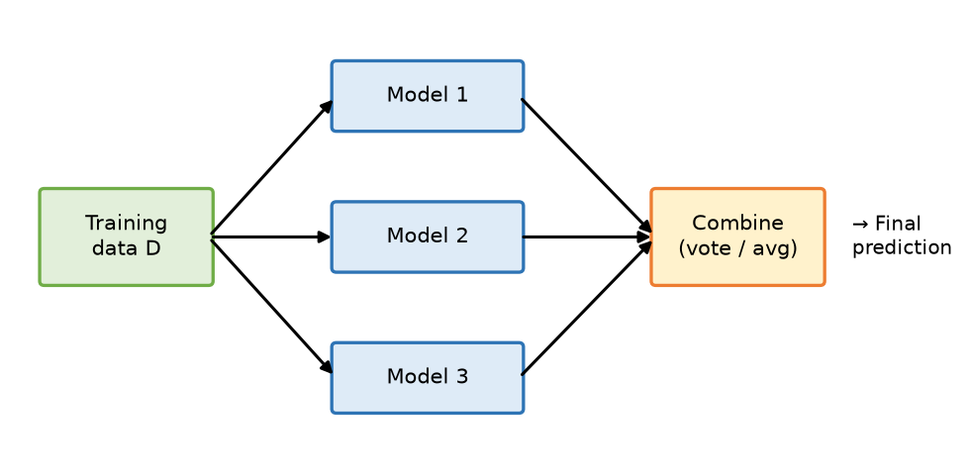
Fig. General ensemble: several models trained on data, outputs combined
- Training data D: given to every base model (same or resampled).
- Model 1…n: base learners (same or different algorithms).
- Combine: voting (classification) or averaging (regression) → final prediction.

1. Need of Ensemble Learning (why it is beneficial)
1. Reduce variance – single deep trees overfit; averaging many reduces it (bagging).
2. Reduce bias – weak learners combined sequentially become strong (boosting).
3. Improve accuracy & generalisation – errors of different models cancel out.
4. Robustness / stability – less sensitive to noise and to a particular training sample.
5. Handle complex problems – different models capture different patterns.
6. Bias–variance trade-off: Error = Bias² + Variance + Noise; ensembles lower one or both.

2. Advantages of Ensemble Methods
- Higher predictive accuracy (win most ML competitions, e.g., Kaggle).
- Less overfitting (bagging/random forest), less underfitting (boosting).
- Works for both classification and regression; handles imbalanced / high-dimensional data well.
- Gives feature importance (random forest) and confidence via vote share.

3. Limitations of Ensemble Learning
- More computation & memory – many models to train and store.
- Less interpretable ("black box") than a single decision tree.
- Slower prediction in real-time systems.
- Gains are small if base models are highly correlated (make same errors).
- Boosting can overfit noisy data; more hyper-parameters to tune.

4. Two Ensemble Techniques
1. Bagging (Bootstrap Aggregating):
- Create several bootstrap samples (random sampling with replacement).
- Train one model (usually a decision tree) on each, in parallel.
- Combine by majority vote / average → reduces variance. Example: Random Forest.
2. Boosting:
- Train models sequentially; each new model focuses on the errors of previous ones (increases weights of misclassified samples).
- Combine by weighted vote → reduces bias. Examples: AdaBoost, Gradient Boosting, XGBoost.
- (Others: Stacking – meta-learner on base predictions; Voting – combine different algorithms.)

Example
Predicting loan default: a single decision tree gives 80 % accuracy; a random forest of 100 trees gives 88 % because individual tree errors average out.

Conclusion
Ensemble learning trades extra computation for higher accuracy and stability by combining many models; bagging fights variance and boosting fights bias.
Memory trick: "Bagging = Parallel, ↓Variance; Boosting = Sequential, ↓Bias" (B-P-V, B-S-B). Limitations = "CIS": Cost, Interpretability, Speed.

U3-2. Explain the voting ensemble and the different types of voting mechanisms.
Importance: ★★★ | Max asked: 9 M → write for 11 M | Asked in: Nov-Dec 2023, Nov-Dec 2024, Nov-Dec 2025
Source: ML Unit 3-6.pdf, pp. 72–74 (Sec. 5.2 Voting Ensemble, 5.2.1 Types of Voting: max voting, averaging, weighted averaging; book pp. 5-5 to 5-7).
Asked as: Explain different types of voting mechanisms in ensemble learning. (Nov-Dec 2023 Q5(b), 6 M) | Explain any three voting mechanism in ensemble learning. (Nov-Dec 2024 Q6(b), 9 M) | Describe the concept of a voting ensemble. What are the different types of voting techniques? (Nov-Dec 2025 Q6(b), 6 M)

Definition
A voting ensemble combines predictions of several different models (usually heterogeneous – e.g., logistic regression, decision tree, SVM) trained on the same data; the final output is decided by voting (classification) or averaging (regression).
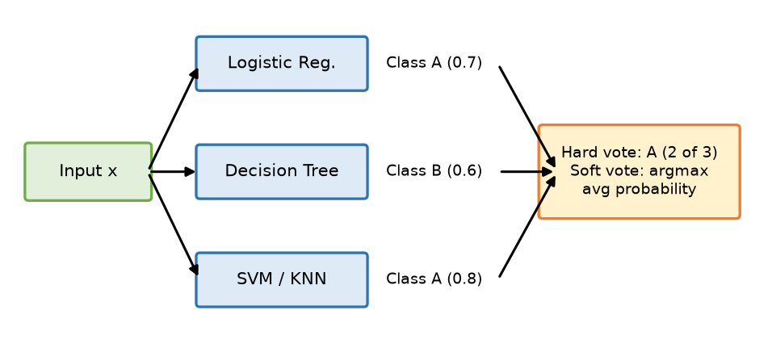
Fig. Voting ensemble: three classifiers vote for the final class
- Input x: given to every base classifier.
- Base classifiers: each predicts a class (and probability).
- Voting block: hard vote picks the majority label; soft vote picks the class with highest average probability.

1. Max Voting (Hard / Majority Voting)
- Used for classification. Each model gives one class label; class with most votes wins.
ŷ = mode{ h₁(x), h₂(x), …, hₘ(x) }
- Example: Model1 = A, Model2 = B, Model3 = A → A (2 of 3).
- Variants: plurality voting (most votes, even < 50 %) and absolute majority (> 50 % needed, else no decision).

2. Soft Voting
- Each model gives class probabilities; average them and pick the highest.
ŷ = argmaxₖ (1/m) Σᵢ Pᵢ(k | x)
- Example: P(A) = 0.7, 0.4, 0.8 → avg 0.63; P(B) = 0.3, 0.6, 0.2 → avg 0.37 → A.
- Usually better than hard voting when models are well-calibrated.
- Your textbook groups voting types as Max Voting, Averaging, Weighted Averaging; soft voting is averaging of class probabilities.

3. Weighted Averaging (Weighted Voting)
- Better models get higher weights wᵢ (based on validation accuracy).
ŷ = argmaxₖ Σᵢ wᵢ · [hᵢ(x) = k] (or weighted average of probabilities)
- Example: weights 0.5, 0.2, 0.3 with votes A, B, B → A = 0.5, B = 0.5 → tie broken by highest-weight model.

4. Averaging (for regression / probabilities)
- Simple average ŷ = (1/m) Σ ŷᵢ, or weighted average Σ wᵢŷᵢ.
- Example: house price predictions 50, 52, 54 L → 52 L.
Type | Uses | Rule
Max voting (hard) | Labels | Most votes
Plurality | Labels | Largest count (no 50 % needed)
Soft | Probabilities | Highest average probability
Weighted averaging | Labels / probs + weights | Highest weighted score
Averaging | Numeric outputs | Mean / weighted mean

5. Advantages
- Simple; improves accuracy if base models are accurate and diverse; reduces risk of picking one bad model.

Conclusion
Voting is the simplest ensemble – hard voting counts labels, soft voting averages probabilities, weighted voting trusts better models more.
Memory trick – "HSW-A": Hard (heads count), Soft (sum of probabilities), Weighted (wise get more), Average (for numbers).

U3-3. Explain the stacking approach of ensemble learning with example. What methods are used for variance reduction in stacking?
Importance: ★★★ | Max asked: 9 M → write for 11 M | Asked in: Nov-Dec 2024, Nov-Dec 2025
Source: ML Unit 3-6.pdf, pp. 79–80 (stacking frame, meta-learner, cross-validation; variance reduction; book pp. 5-12, 5-13).
Asked as: Elaborate stacking approach of ensemble with example. (Nov-Dec 2024 Q5(b), 9 M) | Discuss the concept of stacking in ensemble learning. What are the different methods used for variance reduction in stacking? (Nov-Dec 2025 Q5(b), 6 M)

Definition
Stacking (Stacked Generalisation) is a heterogeneous ensemble in which several base models (level-0) are trained on the data and their predictions are used as input features for a meta-model (level-1, meta-learner) that learns how to best combine them.
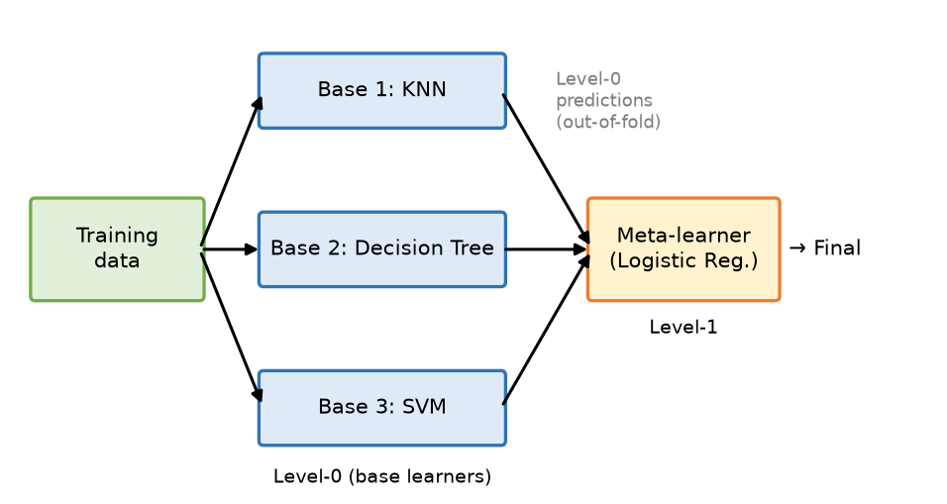
Fig. Stacking: base learners' predictions feed a meta-learner
- Level-0 base learners: different algorithms (KNN, decision tree, SVM) trained on the training set.
- Level-0 predictions: produced on held-out (out-of-fold) data to avoid leakage.
- Meta-learner (Level-1): a simple model (often logistic/linear regression) trained on these predictions to give the final output.

1. Steps of Stacking
1. Split the training data into K folds.
2. For each base model, train on K−1 folds and predict on the held-out fold (out-of-fold predictions); repeat for all folds.
3. Collect out-of-fold predictions of all base models → new feature matrix (one column per model).
4. Train the meta-learner on this matrix with the original targets.
5. Retrain each base model on the full training data.
6. Prediction: base models predict on test data → their outputs go to the meta-learner → final prediction.

2. Example
Predict whether a customer will buy (Yes/No):
- Base models: KNN → 0.62, Decision Tree → 0.80, SVM → 0.55 (probability of Yes).
- Meta-learner (logistic regression) learned weights, e.g., 0.2, 0.6, 0.2 → combined score ≈ 0.70 → Yes.
- The meta-learner learns that the tree is most reliable for this data.

3. Variance Reduction Methods in Stacking
1. Averaging over independent models (textbook): if base models are trained on independent data, averaging them reduces variance without increasing bias (the bagging idea).
2. K-fold cross-validated (out-of-fold) predictions – meta-learner never sees predictions on data the base model was trained on → reduces overfitting/variance.
3. Diverse base learners – different algorithms make uncorrelated errors, so combining reduces variance.
4. Simple / regularised meta-learner – logistic/ridge regression (L1/L2) prevents the level-1 model from overfitting.
5. Bagging the base models (e.g., use random forest as a base learner) or averaging predictions across folds for test data.
6. Blending – use a separate hold-out set for level-1 training; use probabilities instead of hard labels (smoother features).

4. Advantages / Disadvantages
- + Usually more accurate than any single base model or simple voting; uses strengths of different algorithms.
- − Complex, computationally expensive, harder to interpret; risk of data leakage if CV is not used.

Conclusion
Stacking learns how to combine models: diverse base learners make predictions and a meta-learner, trained on out-of-fold predictions, gives the final output.
Memory trick: "Stack = Students + Teacher" – students (base models) answer, the teacher (meta-learner) decides whom to trust. Variance reduction = "CV, Diversity, Simple meta".

U3-4. Explain the Adaptive Boosting (AdaBoost) algorithm in detail.
Importance: ★★ | Max asked: 6 M → write for 8 M | Asked in: Nov-Dec 2023, Nov-Dec 2025
Source: ML Unit 3-6.pdf, pp. 77–80 (boosting, AdaBoost, AdaBoost stump; book pp. 5-10 to 5-13). Weight-update formulas are the standard ones (the OCR of the formula lines was unreadable).
Asked as: Explain AdaBoost algorithm in detail. (Nov-Dec 2023 Q5(c), 6 M) | Explain the Adaptive Boosting (AdaBoost) algorithm in detail. (Nov-Dec 2025 Q6(c), 6 M)

Definition
AdaBoost (Adaptive Boosting), proposed by Freund & Schapire, is a sequential boosting algorithm that combines many weak learners (usually decision stumps – one-level trees) into a strong classifier. After each round it increases the weights of misclassified samples so the next learner focuses on hard examples.
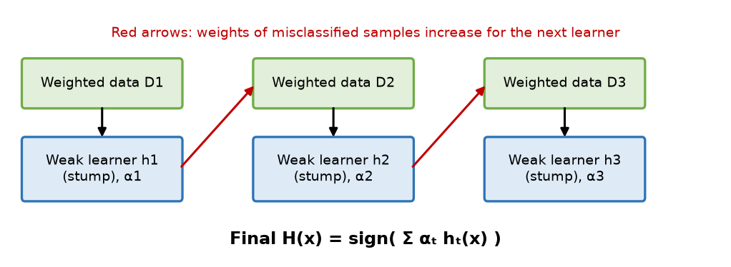
Fig. AdaBoost: re-weighted data and weak learners combined by weighted vote
- Weighted data D₁, D₂, D₃: same samples, weights updated each round.
- Weak learner hₜ: stump trained on weighted data; gets a "say" αₜ.
- Red arrows: misclassified samples get higher weights.
- Final H(x): sign of the weighted sum of all weak learners.

1. Algorithm (binary labels yᵢ ∈ {−1, +1})
1. Initialise weights of N samples equally: wᵢ = 1/N.
2. For t = 1 to T:
(a) Train weak learner hₜ on data weighted by wᵢ.
(b) Compute weighted error:
εₜ = Σ wᵢ · [hₜ(xᵢ) ≠ yᵢ]
(c) Compute learner weight (amount of say):
αₜ = ½ ln( (1 − εₜ) / εₜ )
(d) Update sample weights:
wᵢ ← wᵢ · exp( −αₜ yᵢ hₜ(xᵢ) )
- Misclassified → weight increases; correct → weight decreases.
(e) Normalise weights so Σwᵢ = 1.
3. Final strong classifier:
H(x) = sign( Σₜ αₜ hₜ(x) )

2. Example
10 samples, each weight 0.1. Stump-1 misclassifies 3 → ε₁ = 0.3, α₁ = ½ ln(0.7/0.3) = 0.42. The 3 wrong samples' weights rise (0.1 × e^0.42 ≈ 0.152) and the 7 correct ones fall (0.1 × e^−0.42 ≈ 0.066); after normalising, wrong ones ≈ 0.167, correct ones ≈ 0.071. Stump-2 therefore concentrates on those 3 samples.

3. Advantages / Disadvantages
- + Simple, few parameters (T); high accuracy from weak learners; reduces bias; less prone to overfitting on clean data; gives feature importance.
- − Sensitive to noise and outliers (they get huge weights); sequential → cannot parallelise; weak learner must be better than random (ε < 0.5).

4. Applications
- Face detection (Viola–Jones), spam filtering, customer churn, medical diagnosis.

Conclusion
AdaBoost adaptively re-weights samples and weights learners by accuracy, turning many weak stumps into one strong classifier.
Memory trick – "W-E-A-U-N": Weights equal → Error → Alpha → Update → Normalise. Common mistake: forgetting the ½ and ln in αₜ.

U3-5. Explain the Random Forest ensemble method with an example.
Importance: ★★ | Max asked: 6 M → write for 8 M | Asked in: Nov-Dec 2023, Nov-Dec 2025
Source: ML Unit 3-6.pdf, pp. 81–85 (Sec. 5.4 Random Forest Ensemble, advantages; book pp. 5-14 to 5-18).
Asked as: Explain random forest ensembles with an example. (Nov-Dec 2023 Q6(c), 6 M) | Describe the Random Forest ensemble method in detail. (Nov-Dec 2025 Q5(c), 6 M)

Definition
Random Forest is a bagging-based homogeneous ensemble of many decision trees, where each tree is trained on a bootstrap sample and, at each split, considers only a random subset of features. The final output is the majority vote (classification) or average (regression) of all trees.
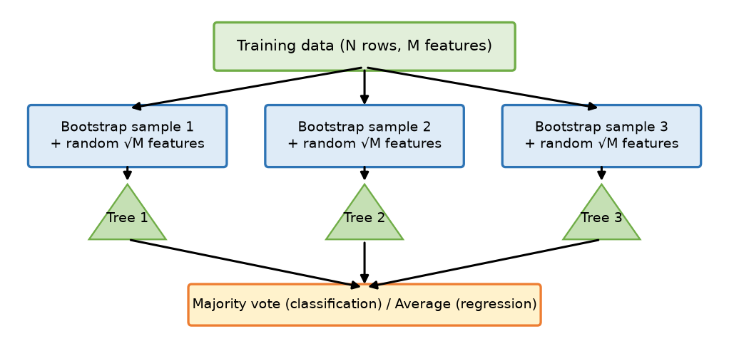
Fig. Random Forest: bootstrap samples + random features → many trees → vote
- Bootstrap sample: N rows drawn with replacement for each tree (≈ 63 % unique rows).
- Random features: at each node only m ≈ √M features (classification) are tried → trees become decorrelated.
- Trees 1…n: fully grown, unpruned decision trees.
- Vote / average: combines tree outputs.

1. Algorithm
1. Choose number of trees n_estimators (e.g., 100) and features per split m (√M or M/3).
2. For each tree: draw a bootstrap sample of size N from the training data.
3. Grow a decision tree; at each node select m random features and choose the best split (Gini / entropy) among them.
4. Grow the tree to maximum depth (no pruning).
5. Predict: pass a new sample through all trees → majority vote / mean.
6. (Out-of-bag (OOB) samples – rows not in a tree's bootstrap – estimate test error without a separate validation set.)

2. Example
Predict "Play Tennis?" with features Outlook, Temperature, Humidity, Wind; 3 trees:
- Tree 1 (Outlook, Humidity) → Yes; Tree 2 (Wind, Temp) → No; Tree 3 (Outlook, Wind) → Yes.
- Majority vote → Yes (2 of 3).

3. Advantages
- High accuracy; reduces overfitting/variance of single trees.
- Handles missing values, large and high-dimensional data; works for classification & regression.
- Gives feature importance; OOB error estimate; trees train in parallel.

4. Disadvantages
- Many trees → slow prediction, large memory; less interpretable than one tree.
- Can be biased toward features with many levels; not good at extrapolation in regression.

5. Applications
- Banking (loan default, fraud), medicine (disease prediction), e-commerce recommendation, remote sensing.

Conclusion
Random Forest = bagging + random feature selection + decision trees; the randomness makes trees diverse, and voting gives an accurate, robust model.
Memory trick: "Random rows + Random columns = Random Forest." Two randomness sources: bootstrap rows and feature subsets.

U3-6. Differentiate between Homogeneous and Heterogeneous ensemble methods, with examples.
Importance: ★★ | Max asked: 6 M → write for 8 M | Asked in: Nov-Dec 2023, Nov-Dec 2025
Source: ML Unit 3-6.pdf, p. 71 (homogeneous and heterogeneous ensemble methods; book p. 5-4).
Asked as: Compare Homogeneous and Heterogeneous ensemble methods. (Nov-Dec 2023 Q6(a), 6 M) | Differentiate between homogeneous and heterogeneous ensemble methods. provide examples of each type. (Nov-Dec 2025 Q6(a), 6 M)

Definition
In a homogeneous ensemble all base learners use the same algorithm (diversity comes from different data samples/weights); in a heterogeneous ensemble base learners use different algorithms (diversity comes from different learning methods).
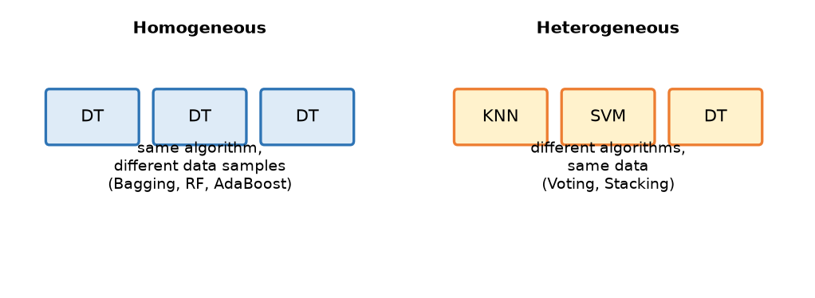
Fig. Homogeneous (same algorithm) vs heterogeneous (different algorithms)
Basis | Homogeneous ensemble | Heterogeneous ensemble
Base learners | Same type (e.g., all decision trees) | Different types (KNN, SVM, DT, NB)
Source of diversity | Different data subsets / sample weights / features | Different algorithms (inductive biases)
Training data | Bootstrap samples or re-weighted data | Usually the same full dataset
Combination | Voting / averaging / weighted sum | Voting or a meta-learner
Typical methods | Bagging, Random Forest, AdaBoost, Gradient Boosting | Voting classifier, Stacking, Blending
Implementation | Easier, one algorithm to tune | More complex, many algorithms to tune
Error correlation | Higher (similar models) | Lower (different models)
Example | Random Forest of 100 trees for loan approval | LR + SVM + KNN voting for spam detection

Conclusion
Homogeneous ensembles get diversity from data, heterogeneous ensembles from algorithms; both aim to combine diverse models for better accuracy.
Memory trick: Homo = same (homogeneous milk – one type); Hetero = different. Homo → Bagging/Boosting; Hetero → Voting/Stacking.

U3-7. Explain Gradient Boosting ensemble learning technique.
Importance: ★ | Max asked: 9 M → write for 11 M | Asked in: Nov-Dec 2024
Source: ⚠ Not found in your materials. Standard textbook answer. (Gradient Boosting is only listed in the syllabus/contents on p. 68 of ML Unit 3-6.pdf; no explanation was found in the text.)
Asked as: Describe ensemble learning. Explain Gradient Boosting ensemble learning techniques. (Nov-Dec 2024 Q6(a), 9 M)

Definition
Ensemble learning combines multiple models for better accuracy. Gradient Boosting is a sequential boosting technique in which each new weak learner (a small regression tree) is trained to predict the residual errors (negative gradients of the loss) of the current ensemble, and is added with a learning rate η. It performs gradient descent in function space.
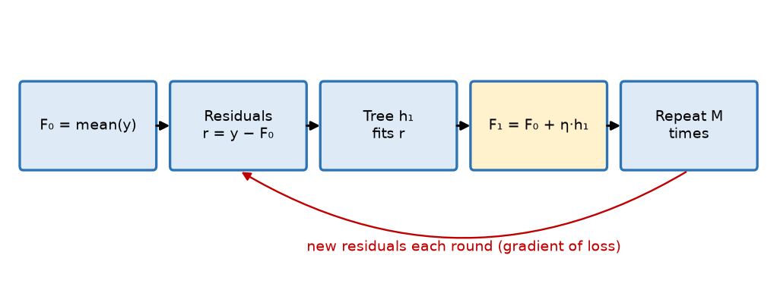
Fig. Gradient Boosting: start with mean, fit trees to residuals, add with learning rate
- F₀: initial prediction (mean of y for squared loss).
- Residuals: errors of the current model = negative gradient.
- Tree hₘ: fitted to residuals. Update: Fₘ = Fₘ₋₁ + η·hₘ. Repeat M times.

1. Algorithm (regression, squared loss L = ½(y − F)²)
1. Initialise F₀(x) = mean(y).
2. For m = 1 to M:
(a) Compute pseudo-residuals:
rᵢ = −∂L(yᵢ, F(xᵢ)) / ∂F(xᵢ) = yᵢ − Fₘ₋₁(xᵢ)
(b) Fit a weak learner (shallow tree) hₘ(x) to the residuals rᵢ.
(c) Update the model:
Fₘ(x) = Fₘ₋₁(x) + η · hₘ(x)
- η = learning rate (0.01–0.3), controls step size.
3. Output final model F_M(x).

2. Example
Predict salary (in ₹ L) for 3 people: actual = 10, 14, 18.
1. F₀ = mean = 14; residuals = −4, 0, +4.
2. Tree h₁ learns residuals ≈ −4, 0, +4; with η = 0.5: F₁ = 14 + 0.5 × (−4, 0, 4) = 12, 14, 16.
3. New residuals = −2, 0, +2 → tree h₂ → F₂ = 11, 14, 17 … predictions move closer to 10, 14, 18 each round.

3. Key Hyper-parameters
- n_estimators (M), learning rate η, max_depth of trees (3–8), subsample (stochastic GB).
- Small η + more trees = better generalisation.

4. Advantages / Disadvantages
- + Very high accuracy; works with any differentiable loss (regression, classification, ranking); handles mixed data; feature importance.
- − Sequential → slow training; overfits if too many trees/large η; many hyper-parameters; sensitive to outliers (with squared loss).
- Popular implementations: XGBoost, LightGBM, CatBoost.

5. AdaBoost vs Gradient Boosting (quick)
AdaBoost | Gradient Boosting
Re-weights samples | Fits residuals (gradients)
Exponential loss | Any differentiable loss
Learner weight αₜ | Learning rate η

Conclusion
Gradient Boosting builds the model step by step, each tree correcting the residual errors of the previous ensemble, giving state-of-the-art accuracy on tabular data.
Memory trick: "Mean → Residual → Tree → Add (×η) → Repeat" (MR-TAR). GB = "gradient descent with trees".

U3-8. Differentiate the Bagging and Boosting approaches of ensemble learning.
Importance: ★ | Max asked: 6 M → write for 8 M | Asked in: Nov-Dec 2023
Source: ML Unit 3-6.pdf, pp. 75–77 (bagging: bootstrapping and aggregation; boosting; book pp. 5-8 to 5-10). Comparison table is standard.
Asked as: Differentiate the Bagging and Boosting approach of ensemble learning. (Nov-Dec 2023 Q5(a), 6 M)

Definition
Bagging (Bootstrap Aggregating) trains models independently in parallel on bootstrap samples and averages them; Boosting trains models sequentially, each focusing on the errors of the previous ones, and combines them by weighted vote.
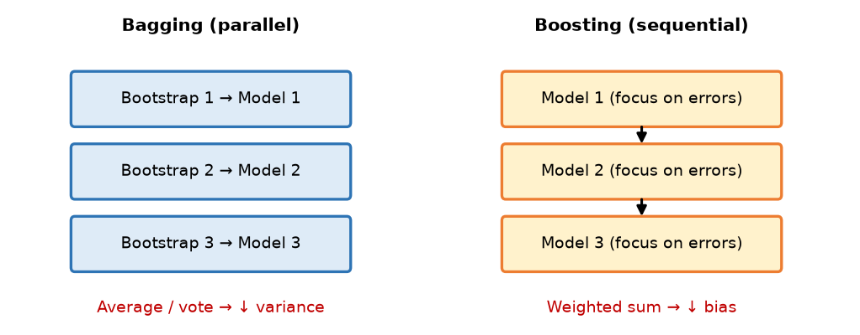
Fig. Bagging (parallel, independent) vs Boosting (sequential, error-focused)
Basis | Bagging | Boosting
Full form / idea | Bootstrap Aggregating – average many models | Convert weak learners into a strong learner
Training order | Parallel, independent | Sequential, each depends on previous
Data sampling | Random bootstrap samples with replacement | Same data, re-weighted (misclassified ↑) or residuals
Model weights | Equal weight to every model | Weighted by performance (αₜ)
Main goal | Reduce variance (overfitting) | Reduce bias (underfitting) (and variance)
Base learner | Strong, complex learners (deep trees) | Weak learners (stumps, shallow trees)
Combination | Majority vote / simple average | Weighted vote / weighted sum
Noise / outliers | Robust | Sensitive (outliers get high weight)
Overfitting risk | Low | Higher if too many rounds
Speed | Fast (parallelisable) | Slower (sequential)
Examples | Random Forest, Bagged trees | AdaBoost, Gradient Boosting, XGBoost

Conclusion
Use bagging when a model overfits (high variance) and boosting when it underfits (high bias); both are homogeneous ensembles.
Memory trick: "Bagging = Bag of independent votes; Boosting = Boost the weak one by one."

4. Last-Minute Revision Sheet

Key Definitions
- Ensemble: combine many base learners → better accuracy & stability ("wisdom of crowd").
- Bagging: bootstrap samples, parallel, equal vote → ↓ variance (Random Forest).
- Boosting: sequential, focus on errors, weighted vote → ↓ bias (AdaBoost, GBM, XGBoost).
- Stacking: base learners (level-0) + meta-learner (level-1) on out-of-fold predictions.
- Voting: hard (labels), soft (probabilities), weighted, averaging.
- Homogeneous = same algorithm; heterogeneous = different algorithms.
- Random Forest = bagging + random feature subset at each split.

Formulas
Item | Formula
Hard vote | ŷ = mode{h₁(x), …, hₘ(x)}
Soft vote | ŷ = argmaxₖ (1/m)ΣPᵢ(k|x)
AdaBoost error | εₜ = Σwᵢ[hₜ(xᵢ) ≠ yᵢ]
AdaBoost learner weight | αₜ = ½ ln((1 − εₜ)/εₜ)
AdaBoost weight update | wᵢ ← wᵢ·exp(−αₜyᵢhₜ(xᵢ)), then normalise
AdaBoost final | H(x) = sign(Σαₜhₜ(x))
Gradient boosting | rᵢ = yᵢ − Fₘ₋₁(xᵢ); Fₘ = Fₘ₋₁ + η·hₘ
Bias–variance | Error = Bias² + Variance + Noise

Memory Tricks
- B-P-V / B-S-B: Bagging-Parallel-Variance; Boosting-Sequential-Bias.
- Voting = HSW-A; AdaBoost = W-E-A-U-N; GB = MR-TAR.
- Stacking = Students + Teacher; RF = random rows + random columns.
- Ensemble limitations = CIS (Cost, Interpretability, Speed).

5. Assumptions & Gaps
- Unit mapping: Q5/Q6 of each paper are taken as Unit 3 (= syllabus Unit V, Ensemble Learning).
- 2023 Q6(b) "What is ensemble learning? Explain any two techniques" is merged with the 2024/2025 concept/need questions (U3-1); bagging and boosting are given as the two techniques.
- 2024 Q6(a) asks to "describe ensemble learning" plus Gradient Boosting; the ensemble definition is in U3-1 and repeated briefly in U3-7.
- ⚠ Not found: U3-7 Gradient Boosting is only listed in the syllabus (p. 68); the answer is a standard textbook answer.

