Data Modeling and Visualization: Unit 2 Exam Answers
Unit 2 (Q3/Q4): Data Visualization and Data Wrangling | Syllabus Unit IV

Unit Snapshot
No. | Question | Max Marks | Years Asked | Importance
2.1 | Force-directed techniques in graph layout (with MDS) | 9 | 2023, 2024, 2025 | ★★★
2.2 | Process / key steps of data wrangling | 9 | 2023, 2024, 2025 | ★★★
2.3 | Multidimensional scaling (MDS) and its role in visualizing high-dimensional data | 9 | 2025, 2026 | ★★
2.4 | Pulling under constraints model | 8 | 2024, 2026 | ★★
2.5 | Reshaping and pivoting | 8 | 2024, 2026 | ★★
2.6 | Functions available in matplotlib | 7 | 2023, 2026 | ★★
2.7 | Graph layout techniques (any two with examples) | 6 | 2023, 2026 | ★★
2.8 | Seaborn vs matplotlib (and pandas) | 6 | 2025, 2026 | ★★
2.9 | Bipartite graph and its applications | 6 | 2023 | ★
2.10 | Combining vs merging data sets; when to use each | 6 | 2025 | ★
2.11 | Differentiate force-directed techniques and MDS | 4 | 2023 | ★
Must-do first (★★★): 2.1 Force-directed techniques · 2.2 Data wrangling. (FD + MDS together appear in all 4 papers, so also do 2.3 and 2.11 right after.)
All answers are written for (highest marks + 2). Source = Textbooks/DMV Textbook.pdf (scanned; PDF page numbers).

Full Answers

2.1 Explain force-directed techniques in graph layout (and their relation to MDS)
★★★ | Asked for max 9 marks → written for 11 | Asked in: 2023 (7), 2024 (9), 2025 (8) | Source: DMV Textbook.pdf, PDF p. 64-66 (4.4.1 Graph Layout Techniques; Force-directed Techniques and Multidimensional Scaling)
Variants: “Explain in detail force-directed techniques in multidimensional Scaling” (2023) · “Explain the Force-directed Techniques and Multidimensional Scaling in detail” (2024) · “What are Force-directed Techniques in Graph Layout, and how do they help in visualizing complex data structures?” (2025).
Definition: Force-directed techniques are graph-layout algorithms that simulate physical forces: nodes repel each other like charged particles, and edges act like springs pulling connected nodes together. The algorithm moves nodes until the forces are in equilibrium, giving a layout with few edge crossings and node overlaps.

1. Basic idea (physical model)
- Repulsive force between every pair of nodes → nodes spread out, no overlap.
- Attractive (spring) force along each edge → connected nodes stay close.
- Equilibrium (minimum energy) → final positions; clusters of tightly linked nodes appear naturally.

2. Algorithm (steps)
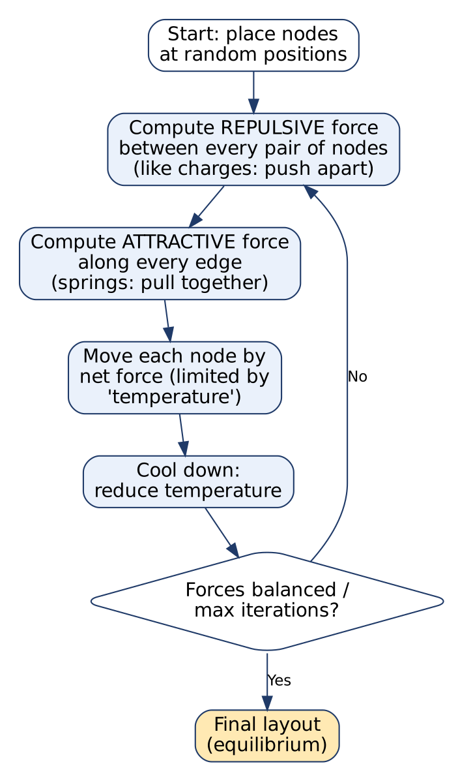
Force-directed layout algorithm
- Place all nodes at random positions.
- For each pair of nodes, compute the repulsive force.
- For each edge, compute the attractive (spring) force.
- Add the forces and move each node in the direction of the net force; the step size is limited by a temperature.
- Cool down: reduce the temperature so movements become smaller.
- Repeat until forces are balanced or the maximum number of iterations is reached.
Diagram explanation: the loop (steps 2-5) runs many times; the diamond checks for convergence; the output is the equilibrium layout.

3. Formulas (Fruchterman-Reingold model)
- Ideal edge length: k = C · √(Area / n)
- Attractive force: f_{a}(d) = d² / k
- Repulsive force: f_{r}(d) = − k² / d
where d = distance between two nodes, n = number of nodes, Area = drawing area, C = constant. (Eades’ spring model: spring force = c₁ · log(d / c₂), repulsion = c₃ / d².)

4. Popular force-directed algorithms
- Eades spring embedder (1984): the first spring model.
- Fruchterman-Reingold: balances attraction between connected nodes and repulsion between all nodes (named in the textbook).
- Kamada-Kawai: treats graph-theoretic distances as ideal spring lengths and minimises an energy (cost) function; preserves overall topology.
- Pulling under constraints (see 2.4): FD + extra constraints.

5. How they help in visualizing complex data structures
- Reveal clusters / communities (e.g. friend groups in social networks).
- Show central (hub) nodes and bridges.
- Produce symmetric, aesthetically pleasing layouts automatically.
- Work for any general graph without needing a hierarchy.
- Interactive: the user can drag a node and the layout re-balances.

6. Relation to MDS
- Both place objects so that layout distance reflects relationship.
- Kamada-Kawai is effectively MDS on graph distances: it tries to make the drawn distance equal the shortest-path distance, which is exactly MDS’s goal (see 2.3, 2.11).

Advantages / Disadvantages
Advantages | Disadvantages
Simple, intuitive (physics analogy) | Slow for large graphs: O(n²) repulsion per iteration
Good symmetry, shows clusters | Can get stuck in local minima
No prior structure needed | Result changes with random start
Easy to make interactive | “Hairball” for very dense graphs
Applications: social-network analysis, biological (protein-interaction) networks, web-link graphs, knowledge graphs. Tools: NetworkX spring_layout(), Gephi, D3.js force layout, Cytoscape.
Conclusion: Force-directed techniques turn the structure of a network into geometry, using a simple attraction-repulsion model to reveal clusters and relationships.
Memory trick: “Nodes are magnets, edges are springs” (Repel all, Attract linked, Move, Cool, Repeat: “RAM-CR”).

2.2 Explain the process / key steps of data wrangling
★★★ | Asked for max 9 marks → written for 11 | Asked in: 2023 (4), 2024 (9), 2025 (5) | Source: DMV Textbook.pdf, PDF p. 59-60 (4.2 Data Wrangling)
Variants: “Describe the key steps involved in the process of data wrangling” (2023, 2025) · “Explain the process of data wrangling in detail” (2024).
Definition: Data wrangling (also called data munging or data preprocessing) is the process of cleaning, transforming and preparing raw data into a format suitable for analysis. Raw data is usually messy, unstructured, with errors, missing values and inconsistencies.
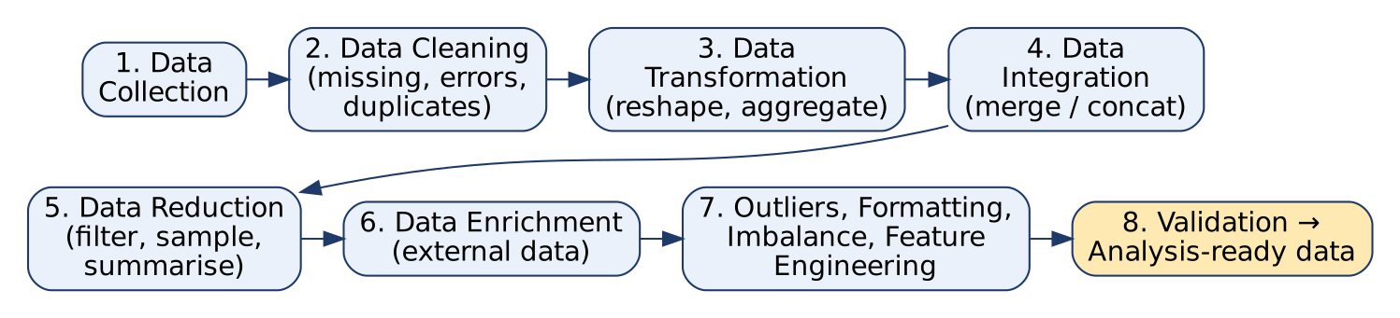
Data wrangling process

Steps of data wrangling
- Data collection (gathering): get raw data from databases, files, APIs, web scraping.
- Data cleaning: identify and correct errors, handle missing data (drop / fill with mean, median, mode), standardise formats (dates, units, case), remove duplicates.
- Data transformation: convert data into the required format: reshaping (pivot/melt), aggregating, creating new variables, encoding categories.
- Data integration: combine data from different sources into one unified dataset (merge/join, concatenate).
- Data reduction: reduce size while keeping essential information: filtering, sampling, summarising, dropping irrelevant columns.
- Data enrichment: add external data or extra information to improve quality (e.g. add city population to sales data).
- Handling outliers: detect (box plot, z-score, IQR) and treat outliers that may skew results.
- Data formatting: correct data types (numeric, categorical, datetime).
- Handling imbalanced data: fix class imbalance (oversampling e.g. SMOTE, undersampling).
- Feature engineering: create new features (e.g. age from date_of_birth, month from timestamp).
- Validation & documentation: check ranges, uniqueness, consistency; record every step for reproducibility.
Diagram explanation: the top row makes the data correct and unified; the bottom row makes it compact, rich and model-ready; the final box is the analysis-ready dataset.

Example (pandas)
df = pd.read_csv("sales.csv") # collect
df = df.drop_duplicates() # clean
df["city"] = df["city"].str.title().fillna("Unknown")
df["date"] = pd.to_datetime(df["date"]) # format
df = df.merge(cities, on="city", how="left") # integrate / enrich
monthly = df.groupby(df["date"].dt.month)["amount"].sum() # transform / reduce

Tools
Python: pandas, NumPy · R: dplyr, tidyr · GUI: OpenRefine, Trifacta, Excel Power Query.

Importance
- Garbage in, garbage out: models and charts are only as good as the data.
- Analysts typically spend 60-80% of their time on wrangling.
- Ensures accurate, consistent and reliable analysis and better decisions.
Conclusion: Data wrangling converts messy raw data into clean, structured, analysis-ready data; it is the most time-consuming but most important step of the data pipeline.
Memory trick: “Can Clever Teams Integrate, Reduce, Enrich Our Final Insights Fast?”: Collect, Clean, Transform, Integrate, Reduce, Enrich, Outliers, Format, Imbalance, Feature engineering.

2.3 What is multidimensional scaling (MDS)? Explain its role in visualizing high-dimensional data
★★ | Asked for max 9 marks → written for 11 | Asked in: 2025 (9), 2026 (6) | Source: DMV Textbook.pdf, PDF p. 65-66 (Multidimensional Scaling); p. 51 (Higher-Dimensional Displays)
Variants: “Describe the concept of Multidimensional Scaling and its role in Data Visualization” (2025) · “What is multidimensional scaling (MDS) and how MDS helps in visualizing high dimensional data” (2026).
Definition: Multidimensional Scaling (MDS) is a dimensionality-reduction technique that represents objects as points in a low-dimensional space (2-D or 3-D) such that the distances between points match the original (high-dimensional) distances or dissimilarities as closely as possible.
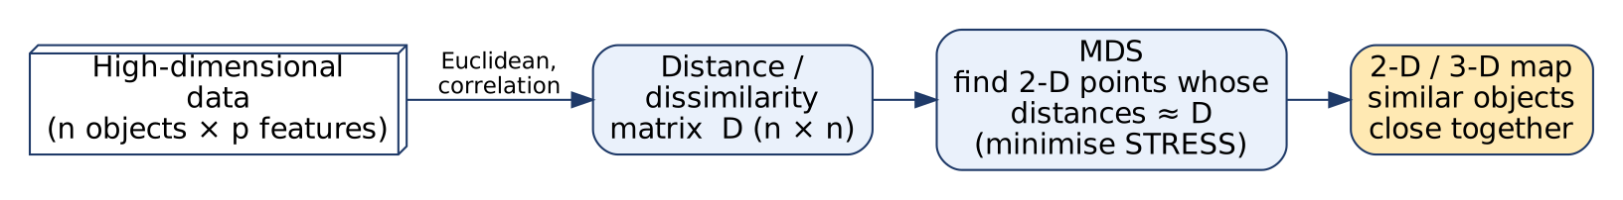
MDS process
Diagram explanation:
- High-dimensional data: n objects each with p features (p can be 50, 100, …), impossible to plot directly.
- Distance matrix D: pairwise dissimilarities δ_{ij} using Euclidean or correlation distance (MDS can also start directly from a given dissimilarity matrix, e.g. survey ratings).
- MDS: searches for 2-D coordinates whose distances d_{ij} ≈ δ_{ij} by minimising stress.
- Output map: similar objects appear close together, dissimilar ones far apart.

Steps (classical / metric MDS)
- Compute the n × n distance matrix D = [δ_{ij}].
- Square the distances and apply double centering: B = −½ · J · D⁽²⁾ · J, where J = I − (1/n)·11ᵀ.
- Find the eigenvalues and eigenvectors of B.
- Take the top m (= 2) eigenvalues Λ_{m} and eigenvectors E_{m}; coordinates X = E_{m} · Λ_{m}^{½}.
- Plot X as a scatter plot.

Stress (goodness of fit)
Stress = √[ Σ (d_{ij} − δ_{ij})² / Σ d_{ij}² ]
where δ_{ij} = original dissimilarity, d_{ij} = distance in the low-dimensional map. Lower stress = better fit (Kruskal’s guide: < 0.05 excellent, < 0.1 good, > 0.2 poor).

Types of MDS
- Classical (Torgerson) MDS: Euclidean distances, eigen-decomposition (same result as PCA on Euclidean data).
- Metric MDS: preserves actual distance values (iterative stress minimisation).
- Non-metric MDS: preserves only the rank order of dissimilarities (good for ratings / ordinal data).

Role in visualizing high-dimensional data
- Reduces p dimensions to 2-D/3-D so data can be shown as a scatter plot.
- Reveals clusters, groups and outliers.
- Shows similarity structure: which products, customers or genes are alike.
- Works with any distance measure, even when only similarities (not features) are available.
- In graph visualization, MDS on shortest-path distances gives a node layout (link to force-directed methods).

Example
Distances between 10 Indian cities (road km) → MDS → a 2-D map that looks almost like the real map of India. Similarly, customer-preference data → MDS → brands that customers see as similar appear close together (market positioning map).
from sklearn.manifold import MDS
X2 = MDS(n_components=2, dissimilarity="euclidean").fit_transform(X)
plt.scatter(X2[:,0], X2[:,1])

Advantages / Limitations
- + Simple, intuitive output; works with any dissimilarity; non-metric version handles ordinal data.
- − Slow for large n (n × n matrix); axes have no direct meaning; result can be rotated/flipped; may lose information if stress is high.
Applications: marketing (perceptual maps), psychology, bioinformatics (gene expression), document similarity, graph layout.
Conclusion: MDS turns a table of distances into a picture, preserving similarity so that hidden patterns in high-dimensional data become visible in 2-D.
Memory trick: “MDS = Map from Distance Sheet” (like drawing a map of cities from a road-distance table).

2.4 Write a short note on the pulling under constraints model
★★ | Asked for max 8 marks → written for 10 | Asked in: 2024 (8), 2026 (6) | Source: DMV Textbook.pdf, PDF p. 66 (The Pulling under Constraints Model)
Definition: The Pulling Under Constraints (PUC) model is an approach used in force-directed graph layout that adds constraints on node and edge positions (based on graph properties or user-defined rules) to the usual attraction-repulsion forces. Nodes are pulled towards positions that satisfy the constraints, giving a more controlled, structured layout.

1. Why it is needed
- Plain force-directed layouts of complex graphs can become chaotic: tangled “hairballs”, oscillating nodes, no meaningful order.
- PUC imposes structure and control, giving more informative and organised visualizations.
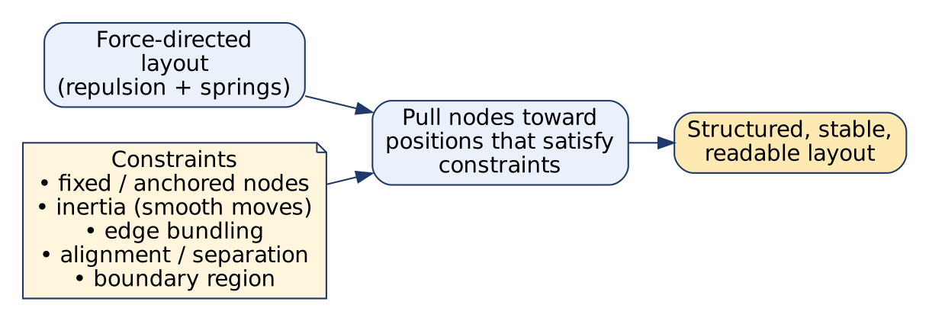
Pulling under constraints model
Diagram explanation: the normal force model and a set of constraints both act on each node; the node is pulled to a position that balances the forces while respecting the constraints; the result is a stable, readable layout.

2. Key features / constraints
- Fixed positions: some nodes are anchored at predefined positions and not moved by forces (e.g. root of a hierarchy, known geographic locations).
- Inertial constraints: inertia is added to node motion so nodes move smoothly, resisting sudden jumps; this stabilises the layout and reduces oscillations.
- Edge bundling: many edges between the same groups are bundled into one curved path, reducing visual clutter in dense graphs.
- Alignment / separation constraints: nodes can be forced to lie on the same horizontal/vertical line or keep a minimum gap (e.g. parent above child).
- Region / boundary constraints: groups of nodes kept inside a given area (cluster boxes).

3. Working (steps)
- Start with a force-directed layout (repulsion + springs).
- Compute forces and tentative new positions.
- Project / pull each node back to the nearest position that satisfies all constraints.
- Apply inertia (damping) to smooth movement.
- Repeat until stable.

4. Example
A company org-chart network: the CEO node is fixed at the top, each department is constrained to its own region, levels are aligned horizontally, and the many email links between two departments are bundled. The result is readable, unlike a plain spring layout.

5. Applications
Social networks, biological networks, large-scale datasets, hierarchical/organisational graphs, metro/transport maps, software dependency graphs.
Advantages: structured and predictable layouts, user control, stable (less jitter), less clutter. Limitation: extra computation; too many constraints can conflict.
Conclusion: PUC = force-directed layout + rules. The forces give a natural layout; the constraints make it meaningful and stable.
Memory trick: “FIBAR”: Fixed positions, Inertia, Bundling of edges, Alignment, Region constraints.

2.5 Explain reshaping and pivoting and their importance in data visualization
★★ | Asked for max 8 marks → written for 10 | Asked in: 2024 (8), 2026 (6) | Source: DMV Textbook.pdf, PDF p. 60 (4.2.1 Hierarchical Indexing; 4.2.2 Combining and Merging Data Sets, Reshaping and Pivoting)
Variants: “Explain importance of reshaping and pivoting in data visualization” (2024) · “Write short notes on Reshaping and pivoting” (2026).
Definition: Reshaping means changing the layout (structure) of a dataset (rows ↔ columns) without changing its values. Pivoting is a type of reshaping that turns unique values of a column into new columns (long → wide), optionally aggregating values.
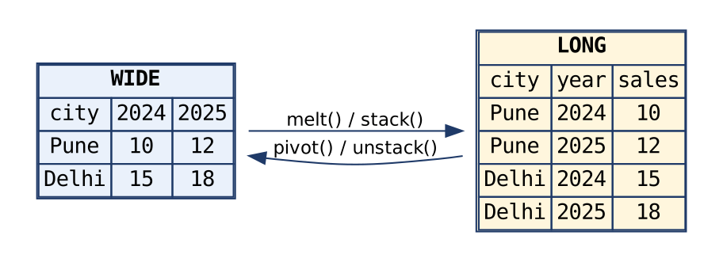
Wide vs long format
Diagram explanation: Wide format has one row per entity and one column per year; long (tidy) format has one row per observation (city, year, sales). melt()/stack() convert wide → long; pivot()/unstack() convert long → wide.

1. Reshaping operations (pandas)
Operation | Direction | pandas function | Example
Pivot | Long → wide | df.pivot(index, columns, values) | rows = city, columns = year
Pivot table | Long → wide with aggregation | pd.pivot_table(df, index, columns, values, aggfunc="sum") | total sales per city per year
Melt | Wide → long | pd.melt(df, id_vars, value_vars) | year columns → one “year” column
Stack | Columns → inner row index | df.stack() | makes a MultiIndex Series
Unstack | Inner row index → columns | s.unstack() | reverse of stack
Hierarchical indexing (MultiIndex): multiple index levels (e.g. Region → Year) let 2-D tables hold higher-dimensional data; stack/unstack move levels between rows and columns.

2. Example
long = pd.melt(wide, id_vars="city", var_name="year", value_name="sales")
wide2 = long.pivot(index="city", columns="year", values="sales")

3. Importance in data visualization
- Libraries expect a certain shape: Seaborn/Plotly prefer long (tidy) data (hue="year"), while heat maps and pandas .plot() need wide data.
- Comparison across categories: pivoted tables put categories side by side for grouped bar charts.
- Heat maps need a matrix (rows × columns) → created by pivoting.
- Summarisation: pivot_table aggregates (sum, mean) before plotting, reducing data size.
- Time-series plots: pivot dates to rows and series to columns → multi-line chart.
- Cleaner, tidier data: one variable per column, one observation per row → fewer errors.
- Multi-dimensional analysis using hierarchical indexes.
Conclusion: Reshaping and pivoting put data in the right shape for the chart, making visualization easy, correct and efficient.
Memory trick: “Melt makes it Long; Pivot makes it wide (P for Panorama).” Stack ↓ (columns go down into rows), Unstack ↑.

2.6 Discuss various functions available in matplotlib
★★ | Asked for max 7 marks → written for 9 | Asked in: 2023 (7), 2026 (6) | Source: DMV Textbook.pdf, PDF p. 61-62 (Data Visualization Matplotlib; Colors, Markers and Line Styles; matplotlib configuration)
Introduction: Matplotlib is the most popular Python library for 2-D plotting, created by John D. Hunter. It produces static, interactive and publication-quality plots, and is used through the matplotlib.pyplot module (import matplotlib.pyplot as plt).
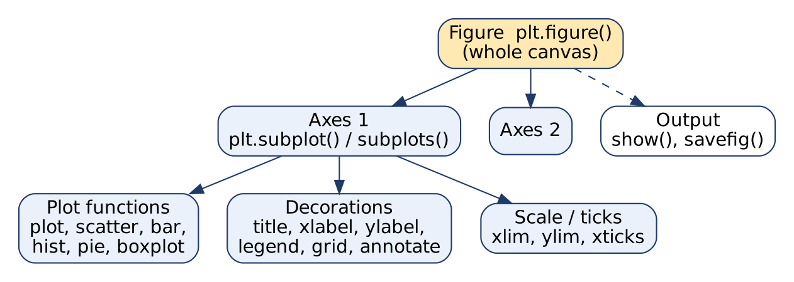
Matplotlib structure and functions
Diagram explanation: a Figure is the whole canvas; it holds one or more Axes (plots); each Axes contains plot elements, decorations and scales; finally the figure is shown or saved.

Functions (grouped)
Group | Function | Purpose
Figure & layout | plt.figure(figsize=(w,h)) | Create a new figure
 | plt.subplot(r,c,i), plt.subplots(r,c) | Multiple plots in a grid
Plot types | plt.plot(x, y, 'g--o') | Line plot (colour, line style, marker string)
 | plt.scatter(x, y) | Scatter plot
 | plt.bar() / plt.barh() | Vertical / horizontal bar chart
 | plt.hist(data, bins=10) | Histogram
 | plt.pie(sizes, labels=...) | Pie chart
 | plt.boxplot(data) | Box-and-whisker plot
 | plt.imshow(), plt.contour() | Image / heat map, contour plot
Labels & decoration | plt.title(), plt.xlabel(), plt.ylabel() | Title and axis labels
 | plt.legend() | Legend
 | plt.grid(True) | Grid lines
 | plt.text(), plt.annotate() | Text / arrow annotations
Axes & ticks | plt.xlim(), plt.ylim() | Axis range
 | plt.xticks(), plt.yticks() | Tick positions and labels
Styling / config | color=, linestyle='dashed', marker='o' | Colours, line styles, markers
 | plt.rc('figure', figsize=(10,10)) | Global settings (rc params), also matplotlibrc file
 | plt.style.use('ggplot') | Ready-made styles
Output | plt.show() | Display the plot
 | plt.savefig('fig.png', dpi=300) | Save as PNG, PDF, SVG

Example
import matplotlib.pyplot as plt
x = [1, 2, 3, 4]; y = [10, 20, 15, 25]
plt.plot(x, y, 'g--o', label="Sales") # green dashed line, circle markers
plt.title("Quarterly Sales"); plt.xlabel("Quarter"); plt.ylabel("₹ lakh")
plt.legend(); plt.grid(True); plt.savefig("sales.png"); plt.show()
Features: works with NumPy/pandas, integrates with IPython/Jupyter (zoom and pan toolbar), highly customisable, many output formats; Seaborn and pandas plotting are built on it.
Conclusion: Matplotlib offers low-level, complete control over every plot element through simple pyplot functions, which makes it the foundation of Python visualization.
Memory trick: “F-P-L-A-S-O”: Figure, Plot types, Labels, Axes/ticks, Style, Output.

2.7 Explain graph layout techniques in data visualization (any two with examples)
★★ | Asked for max 6 marks → written for 8 | Asked in: 2023 (6), 2026 (6) | Source: DMV Textbook.pdf, PDF p. 64-65 (4.4.1 Data and Graphs, Graph Layout Techniques)
Variants: “Explain effective graph layout techniques in data visualization” (2023) · “Describe any two layout techniques used in graph visualization with examples” (2026).
Definition: Graph layout techniques are methods to decide the positions of nodes (vertices) and edges of a graph on a 2-D or 3-D plane, so that the graph is clear, has minimum overlaps and edge crossings, and shows meaningful patterns or structures.
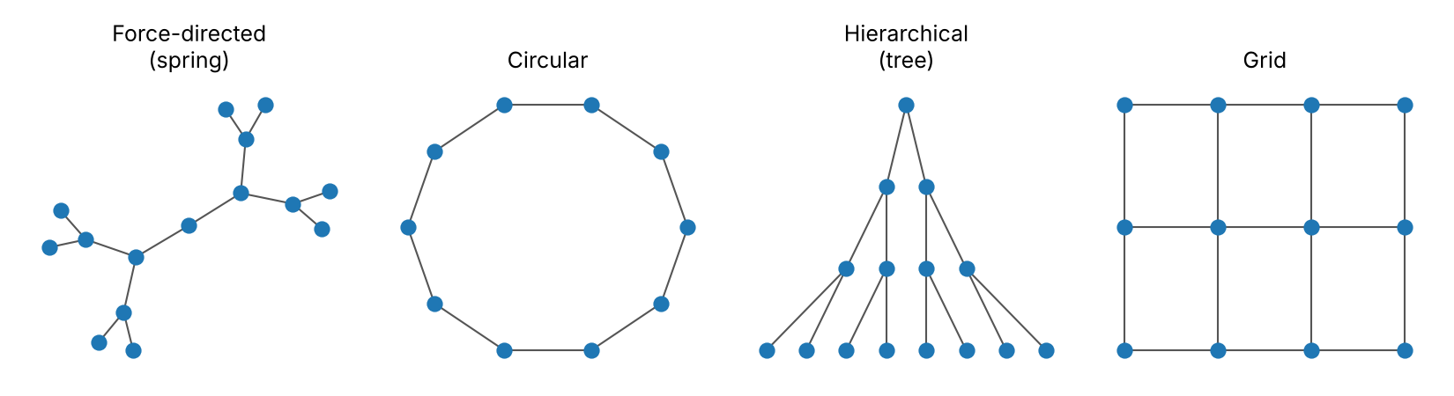
Common graph layouts

Layout techniques
- Force-directed layout: nodes repel, edges act as springs; finds equilibrium (see 2.1). Example: social-network friend clusters.
- Circular layout: nodes placed on a circle (ordered by attribute). Example: cyclic processes, ring networks, showing connections between departments.
- Hierarchical (tree) layout: nodes in levels, parent above child. Example: organisation chart, decision tree, file system.
- Layered (Sugiyama) layout: nodes in horizontal/vertical layers, edges mostly point one way. Example: DAGs, flowcharts, workflow pipelines.
- Kamada-Kawai layout: minimises an energy/cost based on graph distances; preserves topology and reduces crossings.
- Fruchterman-Reingold layout: a force-directed algorithm balancing attraction (connected nodes) and repulsion (all nodes).
- Spectral layout: uses eigenvectors of the adjacency / Laplacian matrix; good for clustering and community detection.
- Grid layout: nodes on a regular grid; simple, consistent for small graphs. Example: sensor networks, pixel/mesh graphs.
Diagram explanation: the same idea (nodes + edges) looks very different under each layout: the spring layout reveals branches, the circular layout shows the cycle, the tree layout shows levels, and the grid layout shows regular structure.

Example (NetworkX)
pos = nx.spring_layout(G) # or nx.circular_layout(G), nx.kamada_kawai_layout(G)
nx.draw(G, pos, with_labels=True)

Choosing a layout
Depends on graph type (tree, DAG, cyclic, general), size, and insight needed (clusters → force-directed; hierarchy → tree; cycles → circular). Tools: NetworkX (Python), Cytoscape, Gephi, Graphviz.
Conclusion: The right layout makes a network readable; force-directed and hierarchical layouts are the most commonly used.
Memory trick: “FC-HL-KF-SG” → “Fancy Cats Hate Loud Kids, Friendly Silent Guests” (Force, Circular, Hierarchical, Layered, Kamada-Kawai, Fruchterman-Reingold, Spectral, Grid).

2.8 Compare matplotlib, pandas and seaborn for data visualization. What is seaborn and its advantages over matplotlib?
★★ | Asked for max 6 marks → written for 8 | Asked in: 2025 (6), 2026 (6) | Source: DMV Textbook.pdf, PDF p. 61-63 (Plotting with Pandas and Seaborn; Python Visualization Tool Ecosystem)
Variants: “How does matplotlib compare to pandas and seaborn in terms of Data Visualization capabilities?” (2025) · “What is seaborn? Discuss the advantages over matplotlib.” (2026).
Definition: Seaborn is a high-level statistical visualization library built on top of Matplotlib. It works directly with pandas DataFrames and creates attractive, informative statistical plots with less code.
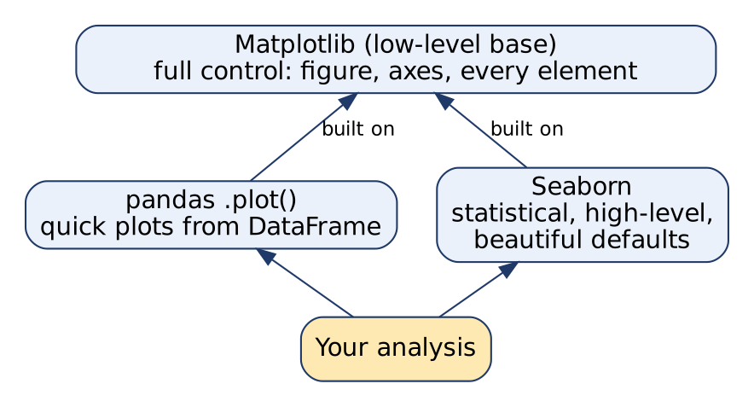
Relationship of the three libraries
Diagram explanation: Matplotlib is the base layer; pandas .plot() and Seaborn are higher-level layers that call Matplotlib internally, so Matplotlib functions can still be used to fine-tune their plots.

Comparison
Point | Matplotlib | pandas plotting | Seaborn
Level | Low-level, full control | High-level wrapper | High-level, statistical
Input | Lists / NumPy arrays | DataFrame / Series | DataFrame (column names)
Code needed | Most code | One line: df.plot() | Short: sns.boxplot(x=, y=, data=)
Default look | Plain | Plain (Matplotlib defaults) | Attractive themes & palettes
Statistical plots | Manual | Basic (hist, box, kde) | Built-in: regression, violin, pair, heat map, distribution
Grouping by category | Manual loops | Limited | Automatic via hue, col, row
Customisation | Unlimited | Moderate | Good + Matplotlib for details
Best for | Publication-quality custom figures | Quick EDA of a DataFrame | Statistical EDA, multi-variable comparison

Advantages of Seaborn over Matplotlib
- Less code for complex plots (one line for a grouped box plot).
- Beautiful default themes and colour palettes (sns.set_theme()).
- Direct DataFrame support: use column names; automatic axis labels.
- Built-in statistical functions: regression lines with confidence intervals (regplot), kernel density (kdeplot), aggregation with error bars (barplot).
- Special plots: pairplot, heatmap, violinplot, jointplot, FacetGrid.
- Automatic grouping with hue, col, row for multi-variable comparison.
Limitations of Seaborn: fewer plot types for non-statistical graphics, less fine control, slower for very large data; you still need Matplotlib for detailed customisation.

Example
import seaborn as sns
tips = sns.load_dataset("tips")
sns.boxplot(x="day", y="total_bill", hue="sex", data=tips) # one line
The same plot in pure Matplotlib needs manual grouping, positioning and a legend (10+ lines).
Conclusion: Use Matplotlib for full control, pandas for quick plots of DataFrames, and Seaborn for fast, beautiful statistical plots; they work best together.
Memory trick: “Matplotlib = Manual, Pandas = Pronto (quick), Seaborn = Statistical & Stylish.”

2.9 Explain bipartite graph and its applications
★ | Asked for max 6 marks → written for 8 | Asked in: 2023 (6) | Source: DMV Textbook.pdf, PDF p. 66 (Bipartite Graphs)
Definition: A bipartite graph (bigraph) is a graph whose vertex set V can be divided into two disjoint sets U and V such that every edge connects a vertex in U to a vertex in V; there are no edges within the same set.
Formally: G = (U ∪ V, E), U ∩ V = ∅, and every edge (u, v) ∈ E has u ∈ U, v ∈ V.
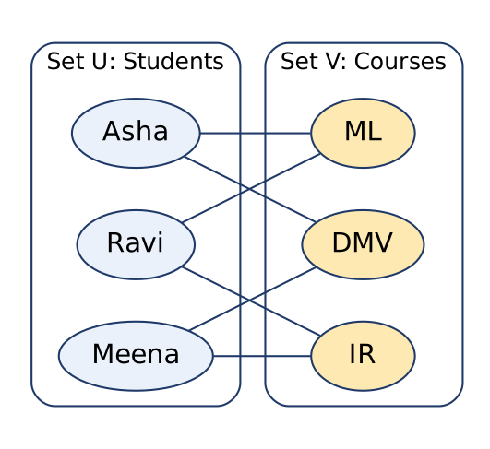
Bipartite graph: students and courses
Diagram explanation: left set U = students, right set V = courses; each edge means “student enrolled in course”. No student-student or course-course edges exist.

Properties
- A graph is bipartite if and only if it has no odd-length cycle (no triangles).
- It is 2-colourable: colour U one colour and V another; no edge joins the same colour.
- Complete bipartite graph K_{m,n}: every vertex of U is joined to every vertex of V; it has m × n edges.
- Sum of degrees in U = sum of degrees in V = |E|.
- Can be checked using BFS/DFS 2-colouring in O(V + E).

Applications
- Matching problems: students ↔ courses, employees ↔ tasks, advertisers ↔ target customers (maximum matching).
- Recommendation systems: users ↔ items (edge = purchase / rating); used in collaborative filtering.
- Social-network analysis: people ↔ groups/communities (memberships, affiliations).
- Transportation networks: suppliers ↔ consumers, flow of goods.
- Resource allocation: tasks ↔ workers, funds ↔ projects.
- Information retrieval: documents ↔ terms.

Visualization
Place one set on the left and the other on the right (two-column layout) with edges crossing between them; heavy edges can be bundled or shown as a matrix (heat map).
Conclusion: Bipartite graphs model relationships between two different types of entities, which is why they are central to matching and recommendation problems.
Exam tip: Your textbook (PDF p. 66) states that bipartite graphs are always “planar”. This is not true in general: K_{3,3} is bipartite but not planar. Write “no odd cycles” as the key property and avoid writing “always planar”.

2.10 Explain the differences between combining and merging data sets. When should each be used?
★ | Asked for max 6 marks → written for 8 | Asked in: 2025 (6) | Source: DMV Textbook.pdf, PDF p. 60 (4.2.2 Combining and Merging Data Sets)
Introduction: Combining (concatenation) stacks data frames together along an axis (rows or columns). Merging (joining) combines data frames based on common key column(s), like a SQL join.
No. | Point | Combining (Concatenation) | Merging (Join)
1 | Meaning | Stack data frames one below or beside another | Match rows using common key values
2 | pandas function | pd.concat([df1, df2], axis=0/1) (also combine_first) | pd.merge(df1, df2, on="key", how=...), df.join()
3 | Basis | Position / index alignment | Key column(s) values
4 | Structure needed | Same columns (axis=0) or same index (axis=1) | At least one common key column
5 | Types | Vertical (rows), horizontal (columns) | inner, outer, left, right joins
6 | Result size | rows = sum of rows (axis=0) | Depends on matches; can grow (one-to-many)
7 | Missing matches | Fills NaN for non-shared columns | Depends on join type (inner drops, outer keeps with NaN)
8 | SQL analogy | UNION ALL | JOIN
9 | Example | Jan sales + Feb sales → one table | Orders + customer details on customer_id

When to use which
- Use combining when datasets have the same structure and you are adding more records (monthly files, data from several branches) or adding columns with the same index.
- Use merging when datasets hold different information about the same entities and must be linked by a key (orders ↔ customers, students ↔ marks).

Example
all_sales = pd.concat([jan, feb], axis=0) # combine
full = pd.merge(orders, customers, on="customer_id", how="left") # merge
Conclusion: Concat = stack by position; Merge = link by key. Choose concat to append, merge to enrich.
Memory trick: “Concat stacks, Merge matches.”

2.11 Differentiate force-directed techniques and multidimensional scaling
★ | Asked for max 4 marks → written for 6 | Asked in: 2023 (4) | Source: DMV Textbook.pdf, PDF p. 65-66 (Difference between Force-directed Techniques and MDS)
Introduction: Both techniques place objects in 2-D so that distance shows relationship, but force-directed methods lay out graphs, while MDS reduces the dimensions of general data.
No. | Point | Force-directed techniques | Multidimensional scaling (MDS)
1 | Purpose | Graph layout (draw networks nicely) | Dimensionality reduction and similarity visualization
2 | Input | Graph: nodes + edges | Distance / dissimilarity matrix (or high-dimensional data)
3 | Principle | Physics: repulsion between nodes, springs on edges | Preserve pairwise distances in low dimension
4 | Objective | Reach force equilibrium (min energy), few crossings | Minimise stress (distance mismatch)
5 | Method | Iterative simulation | Eigen-decomposition (classical) or iterative optimisation
6 | Output | Node positions for drawing a network | 2-D/3-D coordinates (scatter plot)
7 | Scope | Specific to graphs | General: any objects with distances
8 | Examples | Fruchterman-Reingold, Eades, Kamada-Kawai | Classical, metric, non-metric MDS
9 | Application | Social networks, protein networks | Market perception maps, gene data, city maps
Conclusion: Force-directed = draw a network; MDS = map high-dimensional similarity. (Kamada-Kawai links the two: it is MDS applied to graph distances.)
Memory trick: “Force → Friends network; MDS → Map of Distances.”

Last-Minute Revision Sheet: Unit 2
Topic | Key points to write
Force-directed | Nodes repel, edges = springs, iterate to equilibrium. FR: f_{a} = d²/k, f_{r} = −k²/d, k = C√(A/n). Algorithms: Eades, Fruchterman-Reingold, Kamada-Kawai. Pros: clusters, symmetry. Cons: O(n²), local minima. “RAM-CR”
Data wrangling | Collect, Clean, Transform, Integrate, Reduce, Enrich, Outliers, Format, Imbalance, Feature engineering, Validate. “Garbage in, garbage out”.
MDS | Distances → low-dim map. Classical: B = −½ J D² J, eigenvectors, X = E Λ^{½}. Stress = √[Σ(d−δ)²/Σd²], < 0.1 good. Types: classical, metric, non-metric.
PUC model | FD + constraints: Fixed nodes, Inertia, edge Bundling, Alignment, Region → “FIBAR”. Stable, structured layout.
Reshaping & pivoting | Wide ↔ long. melt/stack (→ long), pivot/unstack (→ wide), pivot_table (aggregate). MultiIndex. Needed for heat maps, grouped bars, seaborn hue.
Matplotlib functions | figure, subplot(s), plot, scatter, bar, hist, pie, boxplot, imshow, title, xlabel, ylabel, legend, grid, annotate, xlim, xticks, rc, style.use, show, savefig. “F-P-L-A-S-O”
Graph layouts | Force-directed, circular, hierarchical, layered (DAG), Kamada-Kawai, Fruchterman-Reingold, spectral (eigenvectors), grid. NetworkX, Cytoscape.
Seaborn vs Matplotlib | Seaborn = high-level, statistical, built on Matplotlib, DataFrame input, nice themes, hue/col, pairplot/heatmap/violin. Matplotlib = low-level, full control. pandas = quick .plot().
Bipartite graph | Two disjoint sets, edges only across. No odd cycles, 2-colourable, K_{m,n} has mn edges. Uses: matching, recommendation, social groups, transport, resource allocation.
Concat vs merge | Concat stacks by position (pd.concat, axis 0/1); merge matches by key (pd.merge, inner/outer/left/right).
FD vs MDS | FD: graph layout, physics, equilibrium. MDS: dimensionality reduction, distance matrix, stress.

Assumptions & Gaps
- Exam Unit 2 = question pair Q3/Q4 = syllabus Unit IV “Data Visualization and Data Wrangling” (textbook Chapter 4, PDF p. 59-66).
- All citations are to Textbooks/DMV Textbook.pdf (scanned, OCR’d; PDF page numbers). There are no separate lecture notes in the repo.
- Added from standard subject knowledge (not in the textbook): Fruchterman-Reingold / Eades force formulas (2.1); classical-MDS eigen-decomposition steps, stress formula and Kruskal thresholds, MDS types (2.3); the alignment/separation and region constraints and the step-wise working of PUC (2.4; the textbook lists fixed positions, inertial constraints and edge bundling); bipartite properties 2-5 (2.9); most Matplotlib function names beyond plot, colours/markers/line styles and rc configuration (2.6; the textbook covers only these and the pandas .plot() methods); the comparison tables in 2.8 and 2.10 beyond what the textbook states.
- Textbook error flagged: PDF p. 66 says bipartite graphs “are planar”. This is false in general (K_{3,3} is bipartite and non-planar); the answer gives the correct statement.
- 2024 Q3a (“Force-directed Techniques and MDS in detail”) is mapped to 2.1; for the MDS half, also write the key points of 2.3.
- No question in this unit was missing from the materials; no “⚠ Not found” flags were needed.

