INDEX

Chapter 1 | Includes the introduction of our project. It contains Objectives and Motivation of this work.
Chapter 2 | Includes the Literature Survey for this work. It also contains Problem Definition and Discussion.
Chapter 3 | Includes the system requirements and specification which includes the data, functional and non-functional requirements of the system.
Chapter 4 | Includes the system design description where the system architecture, hardware and software interfaces, a detailed description of different features along with the UML diagrams are specified.
Chapter 5 | Includes the implementation details where the pseudo code of the important modules is specified.
Chapter 6 | Includes the testing which specifies how the different modules of the project are tested for its correct working.
Chapter 7 | Includes the results and conclusion of the work.

Chapter 1

Introduction

DataHive is a web application developed using various programming languages such as Python, Flask, jQuery, JavaScript, HTML, CSS, SCSS, and Vue.js. The application is designed to collect details from students, such as personal information, academic records, and other necessary details, and process them efficiently to generate leaving certificates for the students.
The motivation behind this project is to provide a more efficient and user-friendly system for generating leaving certificates for students. Traditionally, the process of generating leaving certificates has been manual, time-consuming, and prone to errors. The automated process of DataHive eliminates the possibility of human error and reduces the time and effort required to generate leaving certificates.
The problem statement for this project is to design and develop a system that collects and processes student details to generate leaving certificates. The system should be user-friendly, efficient, and secure, ensuring that sensitive information is protected.
This report is organized to provide a comprehensive overview of the DataHive project. It includes a detailed description of the project's features, technologies used, system architecture, and deployment. Additionally, the report outlines the challenges faced during the development process, the solutions implemented, and future recommendations for the project's improvement.

  - Objectives

The primary objectives of the DataHive project are as follows:
- To design and develop a user-friendly and efficient web application that collects student details and processes them to generate leaving certificates.
- To ensure the security of the application by implementing proper encryption methods and user authentication techniques.
- To provide an intuitive user interface that simplifies the process of collecting student details and generating leaving certificates.
- To optimize the application's performance by using caching techniques and optimizing database queries.
- To thoroughly test the application to ensure it works as intended and is free from bugs and errors.
- To provide comprehensive documentation for the application that includes instructions on how to set up and use the web app.

  - Motivation

In the case of DataHive, the traditional methods of generating leaving certificates only focus on the information provided by the students. However, this information may not always be sufficient for generating accurate and reliable leaving certificates. Hence, DataHive incorporates the use of contextual information along with the data features to improve the retrieval process.
Furthermore, DataHive takes into account the underlying structure of the student data, which is often clustered or manifold. This structure is useful for identifying label consistency, which implies that students who share similar characteristics or belong to the same cluster or manifold are likely to have the same semantic label.
By leveraging the underlying structure information of the student data, DataHive can provide a more accurate and reliable system for generating leaving certificates, even in the absence of label information. This ensures that the leaving certificates generated are comprehensive and relevant to the students' academic records and personal information.
1.3 Hardware and Software Requirements
1.3.1 Hardware Requirements:

- Hard Disk : Minimum of 40 GB.
- System : Intel Core i3 processor or higher.
- Monitor : Minimum 15-inch VGA colour monitor.
- Mouse : Logitech or any other compatible mouse.
- RAM : Minimum of 2GB.

1.3.2 Software Requirements:

- Operating system : Windows 10 or higher.
- Coding Language : Python, HTML, CSS, JavaScript, Vue.js, Flask, jQuery
- IDE : Visual Studio Code, or any other compatible IDE.
- Database : PostgreSQL or any other compatible DBMS

Chapter 2

Literature Survey

Data management is an essential aspect of modern organizations. With the explosion of digital data, there is a growing need to manage data effectively for decision-making and strategic planning. The traditional methods of data management have proven to be inadequate in dealing with the volume and complexity of digital data. Therefore, new techniques and tools are required to manage the vast amounts of data being generated every day.
The primary goal of data management is to store, organize, and retrieve data efficiently. To achieve this goal, various techniques and tools are being developed. In this literature survey, we will discuss some of the recent research works in data management.
[1] T. S. Jayram et al. proposed a new approach for data management called "Data Sketching". It is a technique that allows queries to be answered efficiently by processing a small summary of the data instead of the entire dataset. This technique is useful for large datasets where traditional methods are not practical.
[2] J. M. Hellerstein et al. proposed a declarative language called "CQL" for managing data. It allows users to specify high-level queries and transformations on data without worrying about the implementation details. CQL is useful for managing complex data and has been used in various applications such as scientific data management.
[3] Y. Xia et al. proposed a technique for managing large-scale data called "DataCube". It is a multidimensional index structure that allows fast data retrieval and aggregation. DataCube is useful for OLAP (Online Analytical Processing) applications and has been used in various domains such as finance, healthcare, and e-commerce.

In conclusion, data management is a critical area of research with many challenges and opportunities. The recent advancements in data management have enabled organizations to manage their data effectively and efficiently. However, there is still much to be done to address the growing complexity and volume of digital data
2.1 Problem Statement
Managing large amounts of data is a significant challenge for organizations, particularly in today's data-driven world. Traditional methods of managing data, such as manual data entry and text-based searches, are becoming increasingly insufficient in handling the ever-increasing volumes of data. As a result, there is a growing need for efficient data management systems that can handle large volumes of data, extract meaningful insights, and facilitate data-driven decision-making.
DataHive aims to address these challenges by providing a comprehensive data management system that integrates various data sources and enables efficient data storage, retrieval, and analysis and certificate generation. However, there are still several challenges to be addressed, such as ensuring data accuracy and integrity, reducing computational complexity, and optimizing data retrieval and analysis. Therefore, the problem statement for DataHive is to develop a robust and efficient data management system that can handle large volumes of data, ensure data accuracy and integrity, and provide optimized data retrieval and analysis capabilities.

2.1.1 Problem Explanation
DataHive is a software application designed to manage student data and generate leaving certificates. The current process of collecting and processing student data is time-consuming and error-prone, leading to delays in the certificate generation process. The problem is further compounded by the lack of a centralized system to store and access student data, which results in data redundancy and inconsistencies across different departments.
The goal of DataHive is to streamline the student data management process by providing a centralized system that can collect, store, and process student data efficiently. The software application should be able to extract relevant information from various data sources and combine it into a single database. It should also allow for easy data retrieval, modification, and deletion by authorized personnel.
Additionally, DataHive should automate the process of generating leaving certificates by providing pre-designed templates that can be customized based on the student's information. The software should ensure the accuracy and consistency of the information presented on the certificate, while also adhering to regulatory requirements.
Overall, the aim of DataHive is to improve the efficiency and accuracy of the student data management process, reduce errors and delays, and provide a reliable and secure platform for generating leaving certificates.
2.1.2 Problem Discussion
The idea initially proposed was to extract the primitive features of a query image and compare them to those of database images. Color and texture are the image features that are under consideration.
Color and texture distance metrics are used for comparison. In the end metrics are performed subsequently to retrieve database images that are similar to the query.
Every specific feature uses a specific algorithm for extraction and matching.

Chapter 3

System Requirements and Specification

In this chapter System Requirements and Specification establishes the requirements for DataHive. System requirements specify the users with functional and non-functional requirements.
3.1 Purpose of the document
The purpose behind the System Requirements and Specification document is to describe the resources and management of those resources used in the design of the system. This System Requirements and Specification will further provide details regarding the functional and performance related requirements of the algorithm.
3.2 General Description
In this section we try to focus on the description of the users who uses the system along with their characteristics. It specifies the product.
3.2.1 Users and their Characteristics
The users of DataHive are school administrators, teachers, and staff who are responsible for generating leaving certificates for students. The characteristics of these users are as follows:
- They are familiar with basic computer operations and can use a computer proficiently.
- They have access to the student database and can retrieve student information.
- They have knowledge about the school's leaving certificate requirements and policies.
- They are responsible for verifying the accuracy of the leaving certificates before printing and distributing them to students.
- They require a user-friendly interface to input and process student information efficiently.
- They need a reliable system to generate accurate leaving certificates
3.2.2 Product Perspective
DataHive is a data management system that collects, processes, and generates leaving certificates for students. The system is designed to be used by educational institutions such as schools and colleges. The product perspective of DataHive can be described as follows:
- System Interfaces: The system has a user-friendly interface that allows users to input and retrieve data easily. The interface is designed to be simple and intuitive, so that even users with minimal technical knowledge can use the system.
- Hardware Interfaces: DataHive can be accessed from any device that has an internet connection, such as desktop computers, laptops, and mobile devices.
- Software Interfaces: The system uses various software tools to collect, process, and manage data. These tools include Python/HTML/CSS, Visual Studio Code, and PostgreSQL.
- User Characteristics: The primary users of DataHive are school administrators, teachers, and staff who are responsible for managing student data and generating leaving certificates. These users have varying levels of technical expertise, so the system is designed to be accessible to users with different levels of proficiency.
- Design Goals: The main design goals of DataHive are to provide a secure and efficient way to manage student data, automate the process of generating leaving certificates, and improve the overall efficiency of the school administration.
- User Environment: DataHive is designed to be used in a school environment, where there are multiple users with varying levels of technical expertise. The system is designed to be accessible from any device with an internet connection, making it easy for users to access and manage data from anywhere.
- Assumptions and Dependencies: DataHive assumes that the school has a reliable internet connection and that users have access to the necessary hardware and software to use the system. The system depends on the accuracy and completeness of the data entered by users, as well as the availability of the necessary software tools to manage and process the data.

3.2.3 Functional Requirements
- User Management: The system should have a user management module that allows authorized users to log in, view, and manage their profile information.
- Data Collection: The system should allow users to input student data such as name, address, contact information, and other relevant details necessary for generating leaving certificates.
- Data Validation: The system should have a data validation feature that ensures the accuracy of the data entered by the user.
- Certificate Generation: The system should allow users to generate leaving certificates based on the student data entered.
- Certificate Customization: The system should provide options for customizing the leaving certificate format according to the user's preferences.
- Search and Retrieval: The system should have a search and retrieval feature that allows users to search for specific student data and retrieve the corresponding leaving certificate.
- Reporting: The system should provide various reporting features, such as generating reports on leaving certificates issued, students enrolled, etc.
- Backup and Recovery: The system should have a backup and recovery feature that ensures the security of the data in case of system failure or data loss.
- Security: The system should provide adequate security measures to prevent unauthorized access, data breaches, and other security threats.
- Integration: The system should integrate with other systems, such as student information systems, to ensure the accuracy of data entered and reduce data entry redundancies.

3.2.4 Data Requirements
Student Information: The system requires student information such as name, age, gender, date of birth, contact information, and other personal details.
Academic Records: The system should be able to store academic records of students such as the classes attended, grades obtained, attendance records, and other academic-related information.
Leaving Certificate Details: DataHive should be able to store leaving certificate details such as the date of issue, the name of the student, grades obtained, and other relevant information.
Staff Information: The system should also be able to store information about the school staff such as their name, age, gender, designation, contact information, and other personal details.
3.2.5 User View of Product Use
- The user launches the DataHive application and is presented with a user-friendly interface.
- The user selects the option to input student data.
- The user is prompted to enter the necessary student data such as name, date of birth, and academic performance.
- The user submits the student data.
- DataHive processes the student data and generates a leaving certificate.
- The user can view and print the generated leaving certificate.
- The user can also select the option to view and edit the stored student data.
- The user can search and retrieve specific student data based on various search criteria such as name or date of birth.
- The user can export the student data to various file formats such as Excel or PDF.
- The user can securely store and backup the student data in the cloud or on-premise servers.

Chapter 4

System Design Description

The DataHive system is designed to collect student data, process it, and generate leaving certificates. The system consists of several modules that work together to accomplish this task. The modules are:
- Data Collection Module: This module is responsible for collecting student data from various sources such as registration forms, academic records, and attendance records.
- Data Processing Module: This module is responsible for processing the collected data to generate the required information for the leaving certificate. It includes modules for calculating grades, attendance, and other relevant information.
- Certificate Generation Module: This module is responsible for generating the leaving certificate using the processed data. It includes modules for designing the certificate template, adding the relevant information, and generating the final certificate in the desired format.
- User Management Module: This module is responsible for managing user access and permissions to the system. It includes modules for user authentication, user roles and permissions, and user activity logging.
- Reporting Module: This module is responsible for generating reports on student data and certificate generation. It includes modules for creating custom reports, exporting reports in various formats, and scheduling automatic report generation.
The DataHive system is designed to be user-friendly and easy to use. The user interface is designed to be intuitive and simple, with clear navigation and easy-to-understand instructions. The system is also designed to be scalable, with the ability to handle large amounts of student data and generate certificates for multiple students simultaneously.
The system is built using modern web technologies and is designed to be highly available and secure. It is hosted on a cloud-based infrastructure with redundant backups and disaster recovery mechanisms in place to ensure high availability and data security.
Overall, the DataHive system is designed to be a reliable, scalable, and user-friendly solution for collecting student data, processing it, and generating leaving certificates.

4.1 Preliminary Design
DataHive is a system that collects student data, processes it, and generates leaving certificates. The system will have a user interface that allows users to input student information, including personal details, academic performance, and attendance records. The system will store this information in a database.
The system will also have modules for processing the collected data, which includes calculating grades, attendance, and generating a report card. It will then generate leaving certificates for the students based on their academic performance and attendance records.
The system will have security features to ensure that the data is protected and accessible only to authorized users. It will also have backup and recovery mechanisms to ensure that the data is not lost in case of a system failure.
In terms of technology, the system will use programming languages such as Python and JavaScript for the development of the user interface and the backend functionality. It will use a database management system such as MySQL or PostgreSQL to store and manage the student data. It may also use machine learning algorithms to automate certain processes and improve the accuracy of the generated certificates.
4.1.1 Layout of Student Database Management System
- Dashboard: The dashboard should contain all the necessary tabs for the user to navigate through the system. The tabs should be categorized by function, such as "Students", "LC ", "Departments", etc.
- Student Information Form: This form should allow the user to input student information such as name, date of birth, address, contact information, and other relevant details. The form should also allow the user to upload the student's photo.
- Course Information Form: This form should allow the user to input course information such as course name, course code, instructor name, course schedule, etc.
- Reports: The system should allow the user to generate reports based on various criteria such as student grades, attendance, course completion, etc.
- Search Functionality: The system should have a search functionality that allows the user to search for a particular student, course, or report.
- Security: The system should have robust security measures in place to protect student information from unauthorized access or modification. The user should be required to authenticate themselves before accessing the system.

4.1.2 Technology used
- Programming Language: Python is used as the primary programming language for developing the DataHive system.
- Web Framework: Flask is used as the web framework for building the web application and providing the user interface for DataHive.
- Database Management System: PostgreSQL is used as the database management system for storing and managing the student data and leaving certificates generated by the system.
- Object-Relational Mapping (ORM) Tool: SQLAlchemy is used as the ORM tool for accessing the PostgreSQL database.
- Front-End Technologies: HTML, CSS, and JavaScript are used for building the front-end of the web application and providing a user-friendly interface.
- Security Technologies: Security measures such as encryption, password protection, and secure authentication mechanisms are implemented to ensure the confidentiality and integrity of the student data.
4.2 Architectural Strategies
Here we will discuss about the architecture of DataHive for generating LC which includes the following topics:
- The modules of the recognition system.
- Interfaces.
- Context level Data flow diagram.
- Data Collection Module: This module is responsible for collecting the student data which includes personal information, academic records, and other relevant details.
- Data Storage Module: This module is responsible for storing the collected data in a secure and organized manner. It should be designed in a way that it can efficiently manage a large amount of data.
- Data Processing Module: This module is responsible for processing the collected data and generating leaving certificates based on certain predefined criteria.
- User Management Module: This module is responsible for managing user access to the system. It includes features such as user authentication, authorization, and role-based access control.
- Reporting Module: This module is responsible for generating various reports based on the processed data. It should allow users to filter and sort data according to their requirements.
- Backup and Recovery Module: This module is responsible for creating regular backups of the data and ensuring that the data can be recovered in case of any system failure or data loss.
- Security Module: This module is responsible for ensuring the security of the system and the data. It includes features such as access control, encryption, and data privacy.
- Leaving Certificate Generating Module : Collects data form database and generates leaving certificate

4.3 System Interaction diagrams
Data Flow Diagram:
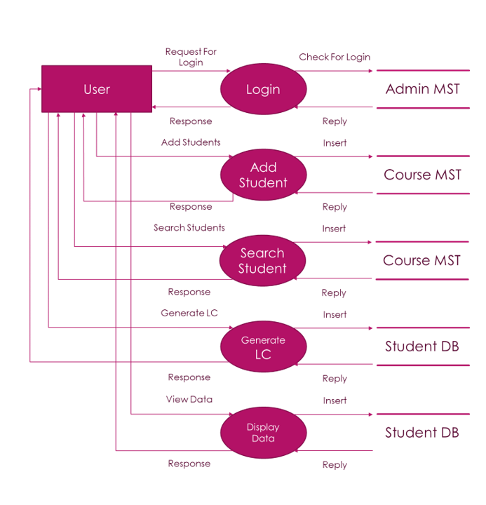
Figure 4.3.1: Data Flow Diagram for system

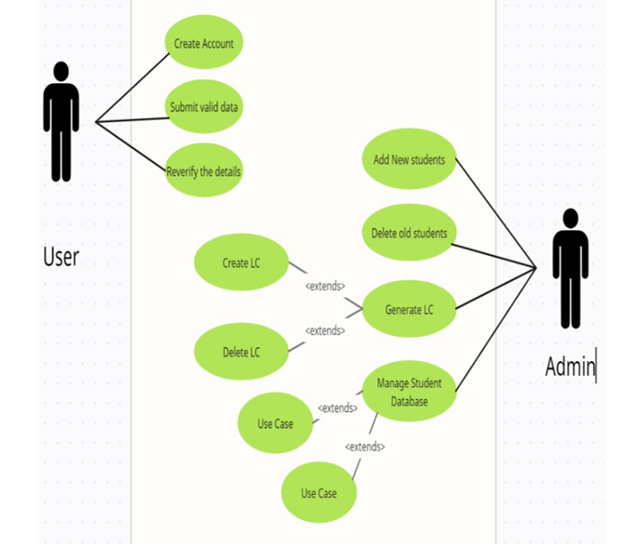
Figure 4.3.2: Use Case for system

4.4 Schedule of the project activities
We have identified various tasks and activities that are required to carry out our work. The following Gantt chart shows timeline of various activities starting in the month of august to its completion. It depicts all the stages from information gathering to testing and documentation.

Chapter 5

Implementation

Implementation is the process of converting a system design into an operational module. It is the key stage in achieving a working system. So, it must be carefully planned and controlled. The implementation of a system is done after the development effort is completed. The system is implemented using Flask.
Steps for implementation:
- Visit https://www.ms-man7.onrender.com
- Create your account by signing up, If already a user just login.
- Add,Update,Delete Student data.
- Generate Leaving Certificate using that data.
This chapter presents the implementation details for all modules that are:
Module 1: Admin (Administrator) Module
Module 2: User Module

  - Admin Module
In this module administrator adds student data, update, delete the database and generate LC. The database is updated by adding student data by staff. In the web page we can see a message when data gets successfully uploaded. Later the user can select the student data from the database.

  - User Module
In this module user fills the authentic data by provided google form and submits to the admin.

Chapter 6

Testing

This chapter gives the outline of the testing methods that are carried out a get a error free system. Quality can be achieved by testing the product using different techniques at different phases of the project development.

6.1 Testing process
Testing is an important piece of software development. This process certifies whether the product that is developed in tune with the standards that it was designed to. It considers building of test cases alongside which the product has to be tested. In some cases test cases are done based on the system requirements specified for the product/software which is to be developed.

6.2 Testing objectives
The main objectives of testing process are as follows:
- Testing is a process of execution of a program with the intent of finding an error.
- A good test case is having high probability of finding the undiscovered error.
- A successful test uncovers yet undiscovered error.
- Testing should be planned well before the design.
- Testing should not reinvent the wheels.
- Testing should start in the small and move towards outward.

6.3 Testing Levels
Testing is carried out in different levels. Each level of testing aims to test different aspects of the system.

6.3.1 Unit Testing
The software build is a collection of individual modules. Each module performs a unique function. In this kind of testing exact flow of control for each module is verified. With detailed design Considerations used as a guide important control paths are tested to uncover errors within the boundary of the module.
The Unit Test can be conducted in parallel for multiple modules.
Table 6.1 shows the test conducted on the basic module of the system i.e. insertion of the new student data.
Steps | Action | Expected Results
Step 1 | Execution of app.py as show in snapshot1 of Appendix A. | The project is opened in web browser.
Step 2 | Execution of index.html | The Snapshot3 of Appendix displayed which functionality provided to registered users.
Step 3 | Provide a authentic data of student to generate a valid LC | After getting authentic data students LC was successfully generated.

Table 6.1: Showing the details of test conducted on the basic module of the system

6.3.2 Integration testing
The second level of testing is called integration testing. In this phase class tested modules are added into subsystems which are then tested. The goal here is to see if all the modules can be integrated properly. We have integrated all the classes and have checked for compatibility. Errors obtained are identified and debugged.

6.3.3 System Testing
At this level, the entire web application is tested to ensure that it functions as intended. The goal of system testing is to identify and resolve any issues or bugs in the application before it is deployed to users. The following test cases were executed to ensure the system is functioning correctly:
- User registration: A new user account was created by filling out the registration form and submitting it. The database was checked to ensure that the new user's details were stored correctly.
- User login: The user logged in using the email address and password they provided during registration. The system was checked to ensure that the user was directed to the correct page.
- User profile: The user's profile page was accessed to verify that the correct information was displayed.
- Image upload: An image was uploaded to the system using the upload form. The system was checked to ensure that the image was stored correctly and displayed on the correct page.
- Logout: The user logged out of the system. The system was checked to ensure that the user was directed to the correct page.
By executing these test cases, we can ensure that the web application functions correctly and is free of any bugs.
Input Validation Testing:
- Test to verify that all input fields in the e-data entry form accept valid data.
- Test to verify that all required fields are filled and the form cannot be submitted until all required fields are filled.
- Test to verify that invalid inputs are handled appropriately and error messages are displayed to the user.
Leaving Certificate (LC) Generation Testing:
- Test to verify that the system can generate a unique LC for a user.
- Test to verify that the system can check if an LC has already been generated for a user and display the existing LC.
- Test to verify that the LC generation process includes all necessary information such as the user's enrollment number and additional details added in the e-data leaving form.
Authentication and Authorization Testing:
- Test to verify that only authenticated users can access the e-data entry form and e-data leaving form.
- Test to verify that unauthorized users cannot access the LC generation feature.
- Test to verify that only authorized users can generate an LC for a specific user.
- User Interface and Usability Testing:
- Test to verify that the user interface is user-friendly and easy to use.
- Test to verify that the system responds to user inputs in a timely and accurate manner.
- Test to verify that the system provides clear and concise error messages to the user in case of errors.
Performance Testing:
- Test to verify that the system can handle multiple requests at the same time without any performance issues.
- Test to verify that the system response time is within acceptable limits.
- Test to verify that the system can handle large amounts of data without any performance issues.
Chapter 7

Results and Conclusion

Snapshots

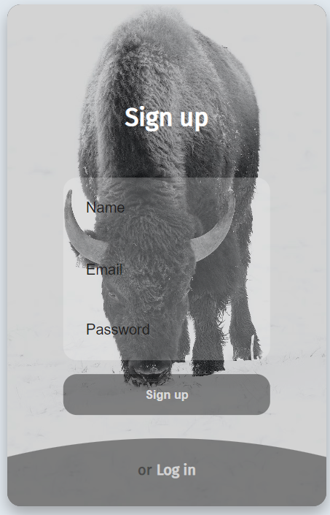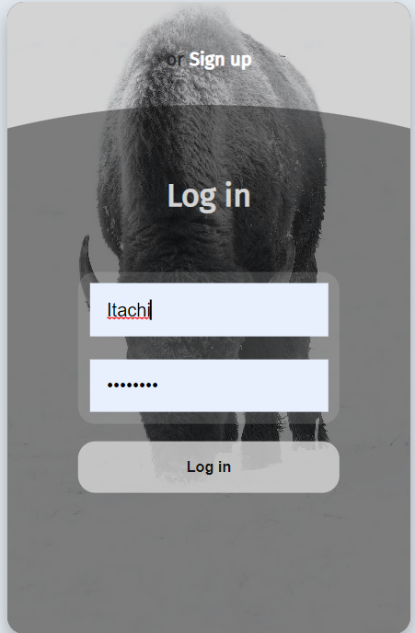

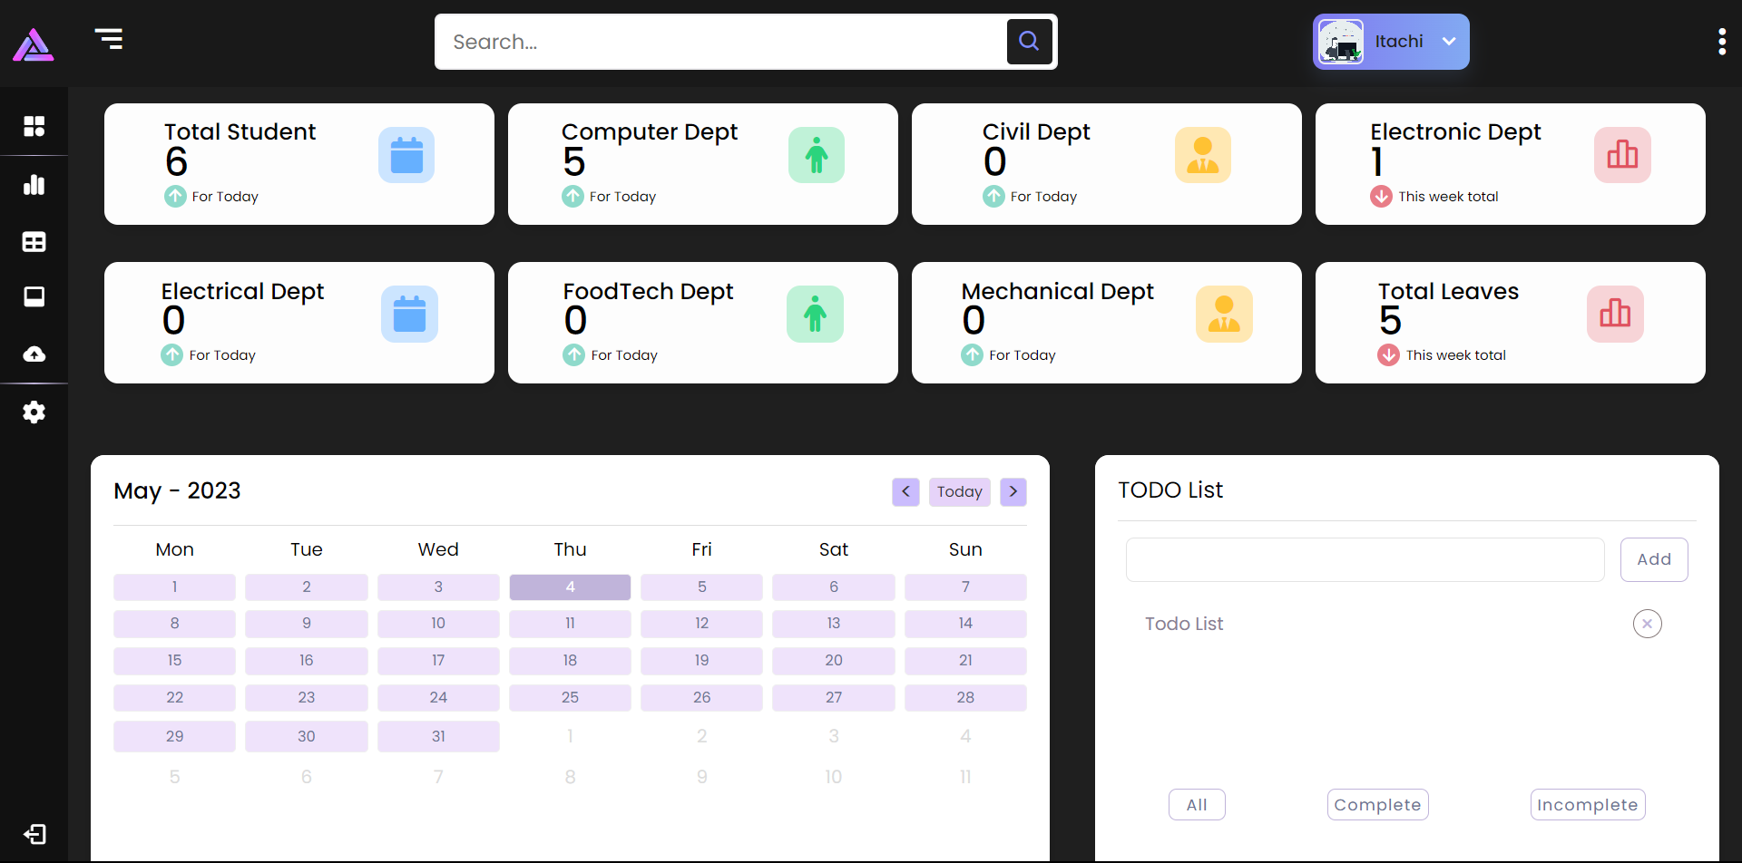

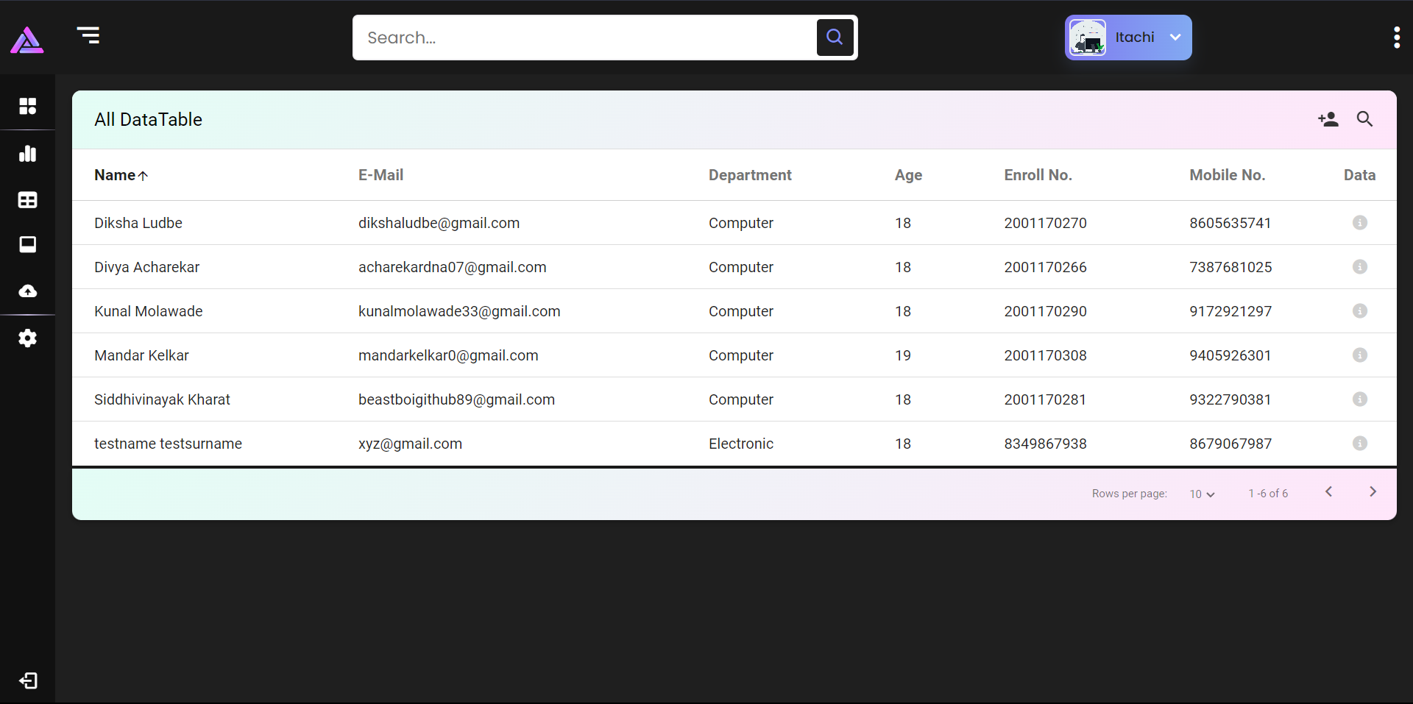
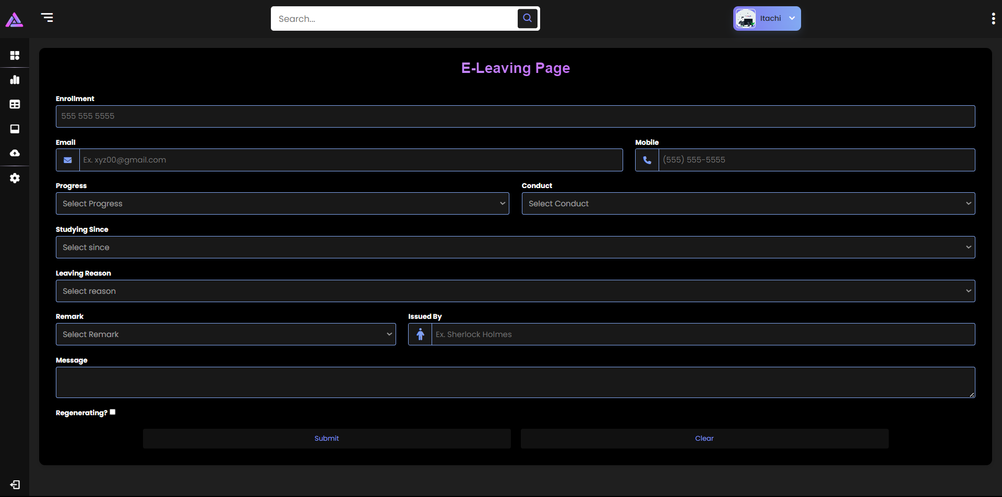
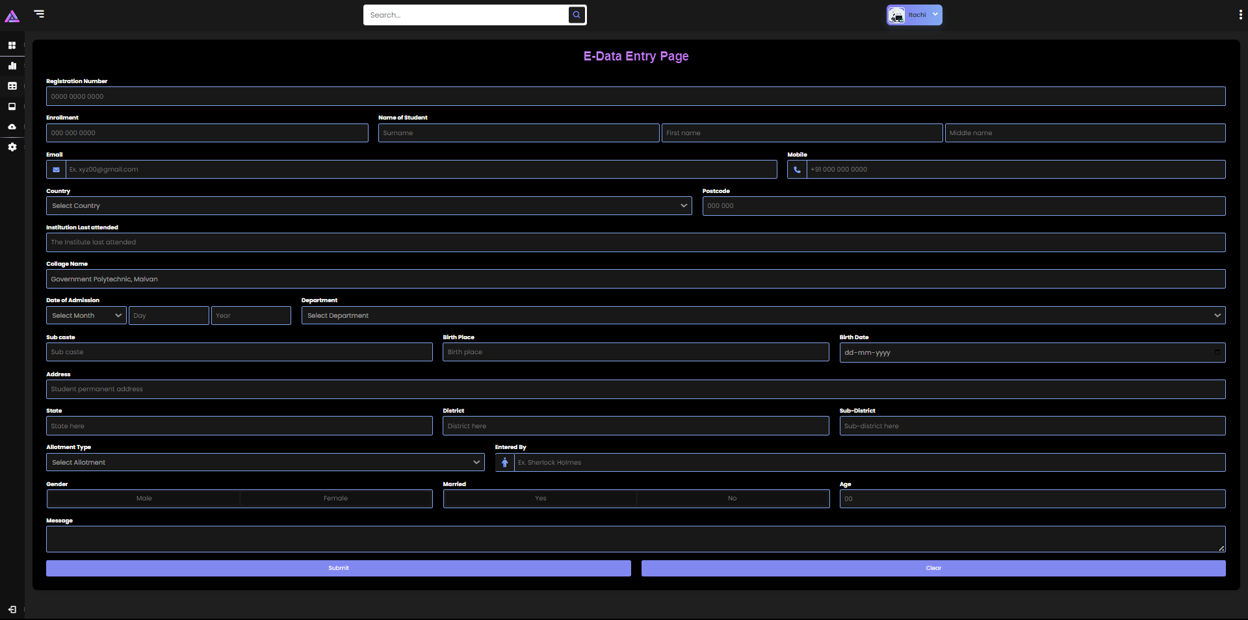

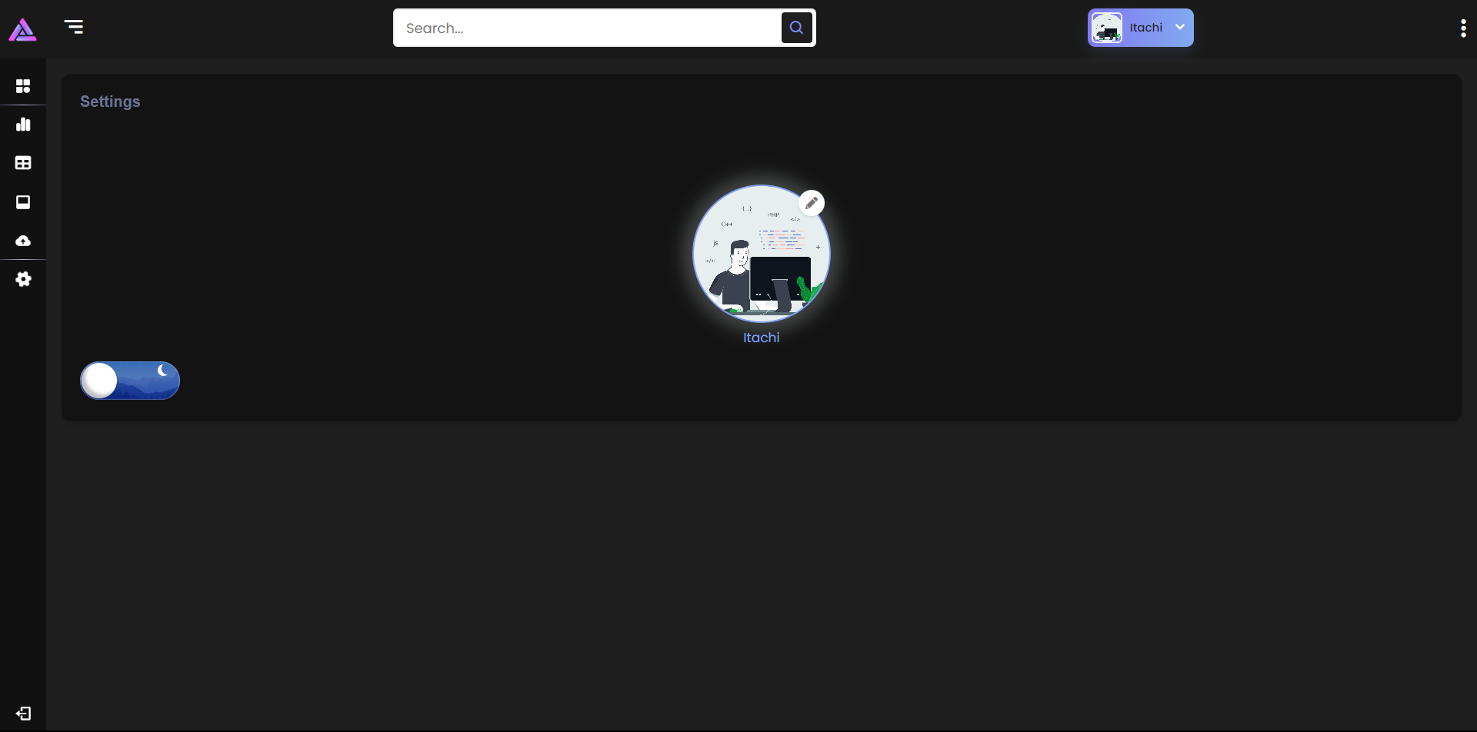
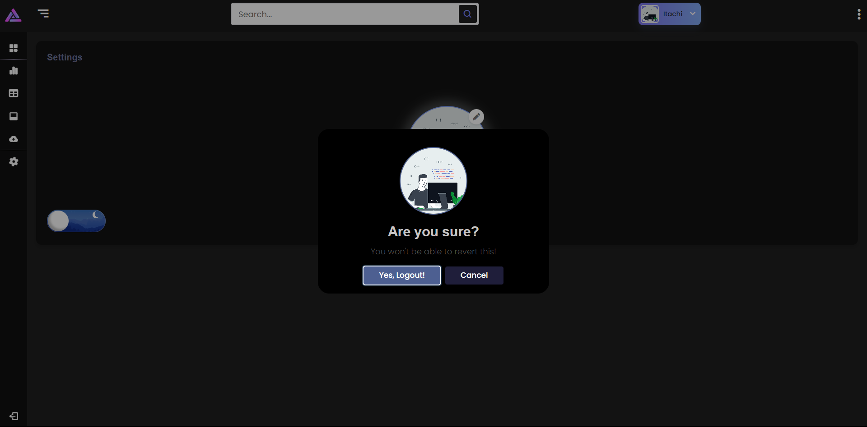
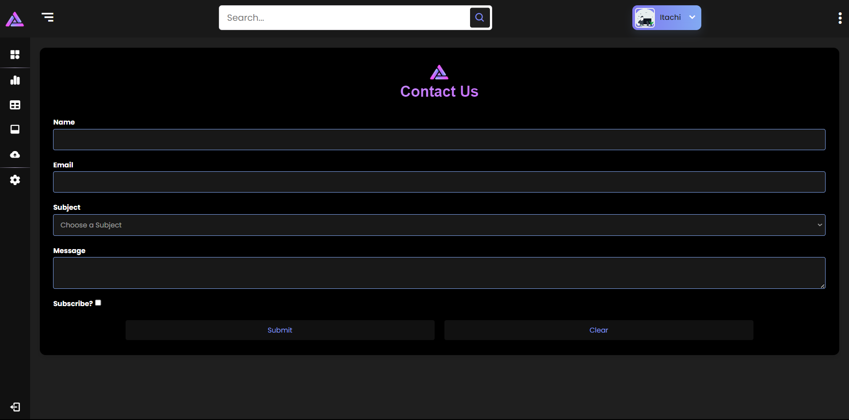

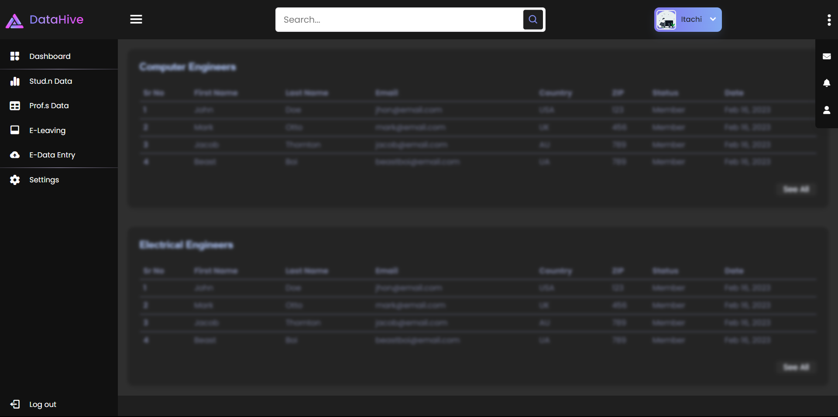
Generated Demo LC:


