 

INSTITUTE FOR ADVANCED COMPUTING AND

SOFTWARE DEVELOPMENT AKURDI,PUNE

DocumentationOn

**AIRLINE RESERVATION SYSTEM**

PG-DAC FEB 2020

*Submitted By:*

**Group No: 37**

**Names & roll numbers**

1)Vishal Uppin : 1103

2)Mandar Tamboli : 1042

**PrashantKarhale Mr.Kashinath PatilCentre Coordinator ProjectGuide**

# Table of Contents

**//not changed**

1. Introduction 1
   1. DocumentPurpose 2
   2. ProblemStatement 2
   3. ProductScope 2
   4. Aim&Objectives 2
2. OverallDescription 3
   1. ProductPerspective 3
   2. Benefits of Airline Reservation System 3
   3. Userand Characteristics 3
   4. OperatingEnvironment 3
   5. Design andImplementation Constraints 3
3. RequirementsSpecification 4
   1. ExternalInterface Requirements 4

3.3Non-FunctionalRequirements 12

1. SystemDiagram 11
   1. ActivityDiagram 11
   2. DataFlowDiagram 13
   3. ClassDiagram 15
   4. UseCaseDiagram 16
   5. ERDiagram 16
2. Conclusion 19
   1. FutureScope 19
3. References 20

# 1. Introduction

Airline reservation systems were first introduced in the late 1950s as relatively simple standalone systems to control flight inventory, maintain flight schedules, seat assignments and aircraft loading. The modern airline reservation system is comprehensive suite of products to provide a system that assists with a variety of airline management tasks and service customer needs from the time of initial reservation through completion of the flight.

One of the most common modes of travel is traveling by air. Customers who wish to travel by air nowadays have a wide variety of airlines and a range of timings to choose from. Nowadays competition is so fierce between airlines that there are lot of discounts and a lot of luxuries given to customers that will give an edge to that particular airline.

The World Wide Web has become tremendously popular over the last decade, and currently most of the airlines have made provision for online reservation of their flights. The Internet has become a major resource for people looking for making reservations online without the hassle of meeting travel agents. My Project intends to serve these purposes. It intends to check all the available airline databases and return a string of results, which can help them in their travel plans.

## Document Purpose

The main purpose of this software is to reduce the manual errors involved in the airline reservation process and make it convenient for the customers to book the flights as when they require such that they can utilize this software to make reservation, modify reservations or cancel a particular reservation.

The name of the software is “AIRLINE RESERVATION SYSTEM”. This software provides options for viewing different flights available with different timings for a particular date and provides customers with the facility to book a ticket, modify or cancel a particular reservation.

## ProblemStatement

## To create an airline reservation system where a traveler can request all flight information as per their journey dates. They can get information regarding time, cost, etc. all at the same time. Once registration is done now user can use the application for booking flights and can provide his source and destination locations and then the application will give the list of all flights along with its price.

## Existing System

The effectiveness of the system depends on the way in which the data is organized.In the existing system, much of the data is entered manually and it can be very time consuming. When records are accessed frequently, managing such records becomes difficult. Therefore, organizing data becomes difficult. The major limitations are:

* Modifications are complicated
* Much time consuming
* Error prone
* Unauthorized access of data

## ProposedSystem

The proposed system is better and more efficient than existing

System by keeping in mind all the drawbacks of the present system to provide a permanent to them.

The primary aim of the new system is to speed up the transactions. User friendliness is another peculiarity of the proposed system. Messages are displayed in message boxes to make the system user friendly. The main Advantage of the proposed system is the reduction in labor as it will be possible so search the details of various places. Every record is checked for completeness and accuracy and then it is entered into the database. The comments and valid messages are provided to get away redundant data.

Another important feature of the proposed system is the data security provided by the system. The main objectives of the proposed system are:

* Complex functions are done automatically
* Processing time can be minimized
* J2EE Technology used for the development of theapplication.
* Simple and easy to manage
* Chances of errors reduced
* Faster and more accurate than the existing system
* Easy for handling reports
* Web-platform means that the system will be available for access 24/7 except when there is a temporary server issue which is expected to beminimal.

The proposed system is complete software for Airline Reservation System, Which is more efficient, reliable, faster and accurate for processing.

## Aims & Objectives

Specific goals are: -

* Toproduceaweb-basedsystemthatallowtheadmintoaddflight andprovide functionalities to itsroute.
* To ease travellers to book flight from anywhere&anytime.

## Benefits of Airline ReservationSystem

* Ask to book tickets.
* Saves physically moving time and money.
* Provides every information about flight.
* Currently available for Domestic Airlines.
* It is very easy touse.
* It increases the efficiency of the management at offering quality services to the customers.
* It provides custom features development and support with theapplication.

## Users and Characteristics:

* + 1. Admin:
       - Admin can login to the system.
       - View the list of all Flight in the database.
       - Add new flight details.
       - Delete flight details.
       - Update flight details.
    2. Flight Passengers:
       - Flight passenger can login to the system.
       - View his/her details.
       - View updated list of available flights.
       - View total generated ticket and bill.

## 

## Operating Environment:

* + 1. ServerSide:

**Processor:** Intel® Xeon® processor 3500 series

**HDD:** Minimum 500GB Disk Space

**RAM:** Minimum 2GB **OS:** Windows 10 **Database:** MySQL

Client Side (minimum requirement):

**Processor:** Intel Dual Core

**HDD:** Minimum 80GB Disk Space

**RAM:** Minimum 1GB

**OS:** Windows 10

**Software Requirement Specifications (SRS):**

**Definations**:

SRS: Software Requirement Specification

ARS: Airline Reservation System

**Overview**:

This system provides an easy solution to passenger's to book the ticket without going to any agent or somewhere else.

**Additional Information:**

The system work on internet server, so it will be operated by any end user to book the ticket with login portal.

This system prevents the corruption as well as adulteration of goods.

**General Description:**

The Airline Reservation System project is an implementation of a general Airline Ticketing website like Orbitz, which helps the customers to search the availability and prices of various domestic airline tickets available with the reservations.

**Functional Requirements:**

This section provides requirement overview of the system. Various functional modules that can be implemented by

the system will be-

**Description**:

The software has two parts. User part and admin part. User part is sued as front end and admin part is backend. Admin is nothing but airline persons. It will allow passengers to access database and allow new Passengers to sign up for online access.

This platform will allow passenger to search for flights that are available between two travel cities.(Departure city and Arrival city) on the date of journey.It will list out of all the flight's details like flight no,name,price and duration of journey etc. After search the system display list of available flights and allows Passenger to choose a particular flight. Then the system checks for the availability of seats on the flight. If the seats are available then the system allows the passenger to book a seat. Otherwise it asks the user to choose another flight.

To book a flight the system asks the Passenger to enter his details such as name, address, city, state, and credit card number and contact number. Then it checks the validity of card and book the flight and update the airline database and user database. The system also allows the Passenger to cancel his/her reservation, if any problem occurs.

The main purpose of this software is to reduce the mannual errors involved in the airline reservation process and make it convenient for the Passengers to book the flights.

**Technical Issues:**

This system will work on client-Server architecture. It will require an internet server.

The system should support some commonly used browser such as Chrome etc.

Interface Requirement Various interfaces for the product could be

1.Login Page

2.Registration form

The passenger/admin may select the different options which will be open in another screen as

1.Login Page

2.Registration Form

**Hardware Interface:**

The System must run over the internet,

64 bit-Windows Platform.

**Software Interface:**

The system is on server so it requires the any scripting language like JSP,Bootstrap,CSS. Programming language used is Java.

The system require Database also for the store the any transaction of the system MySql.

System also require DNS (Domain Name space) for the naming on the internet.

At the end-user need web browser for interact with the system.

**Performance Requirement:**

There is no performance requirement in this system, because the server request and response to client is totally based on internet connection of end user.

**Design Constrains:**

This system should be developed using Standard Web Page Development Tool , which conforms GUI standards such like HTML,CSS.

**Non-Functional Requirements**

**1.Security:**

The system must automatically log out all customers after a period of inactivity.

The system should not leave any cookies on the customer's computer containing user's password.

The system's back-end servers shall only be accessible to authenticated administrators.

Sensitive data will be encrypted before being sent over insecure connections like internet.

The proper firewalls should be developed to avoid intrusions from the internal or external sources.

**2.Reliability:**

The system provides storage of all databases on redundant computers with automatic switchover.

The main pillar of reliability of the system is the backup of the database

which is continuously maintained and update to reflect the most recent changes.

**3.Availability:**

The system should be available at all times.Meaning the user can access it using web browser,

only restricted by the down time of the server on which the system runs.

In case of a of a hardware failure or database corruption, a replacement page will be shown.

uptime : It mean 24 * 7 availability

100%--------------

99.9%

99.999%

99.9999%

**4.Maintainability:**

The application is to be designed so that it is easily maintained, Also it should allow incorporating new requirements in any module of system Backups for database are available.

**5.Portability:**

The application is HTML and scripting language based (JavaScript). So the end user part is fully portable and any system using

any web browser should be able to use the features of the system,including any hardware platform that is available

or will be available in the future.

An end-user is used this system on an OS; either it is Windows or Linux.

The System shall run on PC, Laptops .etc.

The technology should be transferable to different environments easily.

**6.Accessibility:**

Only registered users should be allowed to book the tickets after authentications.

**7.Policies:**

The system should adhere to all the legal formalities of the particular city.

The system should maintain security related to sensitive data.

**8.Efficiency:**

The system should provide good throughput and response to multiple users without burdening the system by using appropriate number of servers.

**9.Safety:**

Software should not harm ethical and environmental conditions of the end users machine.

**10.Modularity:**

The system should have user friendly interface.

It should be easily updated,modified and reused.

**Preliminary Schedule:**

**1. Passenger Interaction:**

1.Login

2.Search for flight

3.Search for fare

4.Reserve flight type (1)One way (2)round trip

5.Make Reservation

6.Modify flight

7.Cancel flight

8.Logout

**2. Admin Interaction:**

1.Admin login

2.Delete/cancel a flight

3.Modify flight information

4.Modify user reservation

5.Maintain user information

6.View user information

7.Admin logout

## Design and ImplementationConstraints:

* The application will use Java, JavaScript and CSS as main web technologies.
* HTTP and FTP protocols are used as communication protocols. FTP is used to upload the web application in live domain and the client can access it via HTTP protocol.
* Several types of validations make this web application a secured one and SQL Injections can also be prevented.
* Since Airline Reservation System is a web-based application, internet connection must be established.
* The Airline Reservation System will be used on PC’s and will function via internet or intranet in any web browser.

# SpecificRequirement

## External Interface Requirements:

* + 1. User Interfaces:
* All the users will see the same page when they enter in this website. This page asks the users a username and a password.
* After being authenticated by correct username and password, user will be redirect to their corresponding profile where they can do variousactivities.

Hardware Interfaces:

* No extra hardware interfaces areneeded.
* The system will use the standard hardware and data communicationresources.

ApplicationInterfaces:

**OS:** Windows 10

**Web Browser:**

The system is a web-based application; clients need a modern web browser such as Mozilla Firebox, Internet Explorer, Opera, and Chrome. The computer must have an Internet connection in order to be able to access the system.

* + 1. CommunicationsInterfaces:
* This system uses communication resources which includes but not limited to, HTTP protocol for communication with the web browser and web server and TCP/IP network protocol with HTTPprotocol.
* This application will communicate with the database that holds all the booking information. Users can contact with server side through HTTP protocol by means of a function that is called HTTP Service. This function allows the application to use the data retrieved by server to fulfill the request fired by the user.

# SystemDesign

## E-R Diagram

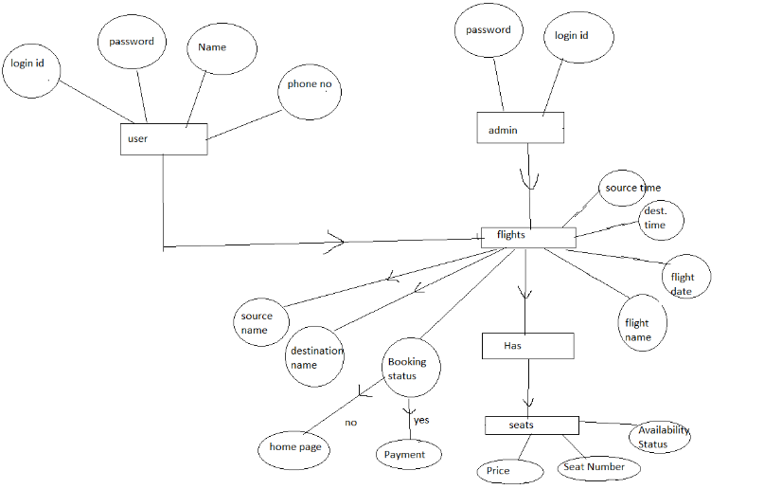



**Figure 1: Activity Diagram**

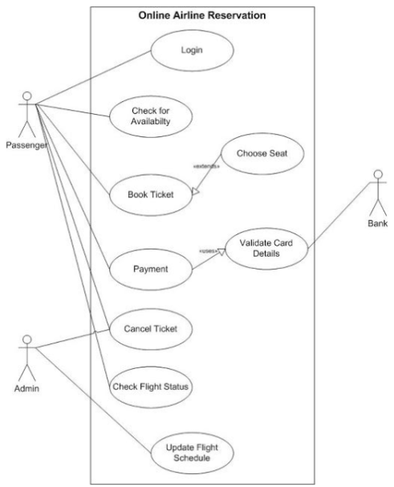

**Usecase Diagram**

# TableStructure

## flights:

|  |  |  |  |  |  |
| --- | --- | --- | --- | --- | --- |
| Field | Type | Null | Key | Default | Extra |
| Id | int | NO | PRI | NULL | Auto_increment |
| destinationPlace | varchar(255) | YES |  | NULL |  |
| sourcePlace | varchar(255) | YES |  | NULL |  |

## booking:

|  |  |  |  |  |  |
| --- | --- | --- | --- | --- | --- |
| Field | Type | Null | Key | Default | Extra |
| Id | int | NO | PRI | NULL | Auto_increment |
| Flight | int | YES |  | NULL |  |
| Username | varchar(255) | NO |  | NULL |  |

## accounts:

|  |  |  |  |  |  |
| --- | --- | --- | --- | --- | --- |
| Field | Type | Null | Key | Default | Extra |
| Id | int | NO | PRI | NULL | Auto_increment |
| email | varchar(255) | YES |  | NULL |  |
| password | varchar(255) | YES |  | NULL |  |
| Username | varchar(255) | YES |  | NULL |  |

**Bill:**

|  |  |  |  |  |  |
| --- | --- | --- | --- | --- | --- |
| Field | Type | Null | Key | Default | Extra |
| b_amount | number(11) | NO | PRI | NULL |  |
| b_gendate | Date | NO |  | NULL |  |

# Conclusion & FutureScope

The Airline reservation system has been a way of minimizing the clerical work, which is almost a routine and consumes the most precious time. This AIRLINE RESERVATION SYSTEM has been an attempt to help the user to minimize his workload along with minimizing the paper works and saving of time .The system has been developed in a way to make it very user friendly. It provides an on-line message and an error detection and error messages every time the user needs. Any person having a little bit of window based can run this system without any pain. As a FUTURE ENHANCEMENT we have decided to further enhance with a seat reservation available. It is to fulfill passengers request to sit where they prefer. They are allowed to choose their seat whether near to window’s seat or in the middle.

# 7.0 References

* <http://www.google.com>
* <http://www.microsoft.com>
* <http://www.programmer2programmer.net>
* <http://www.codeproject.com>
* <http://www.slideshare.net>
* <http://www.1000projects.com>
* <http://www.firstload.com>