Technical Description – Mandrel Processing Application
Source file: final_mandrel.ipynb

1. Application Overview
The application reads extrusion production measurements from SQL Server, enriches them with recipe information, calculates theoretical and OD-adjusted mandrel boundaries, validates startup and final mandrels, assigns fixed mandrel lengths, and inserts the processed records into dbo.Ex2_report_dev. The implementation contains both full-reload functionality and incremental duplicate detection.

2. End-to-End Processing Sequence
- Open a trusted SQL Server connection.
- Initialize MandrelProcessor and determine the next Pos number.
- Optionally truncate the target table for a full reload.
- Load existing target keys and available program/order combinations.
- Load and clean one order's production data.
- Calculate theoretical mandrel numbers from reverse cumulative production.
- Adjust boundaries using OD drops and production-length optimization.
- Remove an initial startup mandrel when interruption rules are satisfied.
- Remove the final mandrel when its calculated length is below the configured minimum.
- Assign fixed mandrel lengths and cumulative order length.
- Recalculate mandrel numbers using fixed-length boundaries.
- Filter duplicates and insert new records in batches.
- Print processing statistics and close the connection.

3. Function-by-Function Documentation

1. __init__()
Initializes a MandrelProcessor instance with the active database connection. It obtains the next Pos value from the target table and initializes the in-memory existing-key collection, which is populated when run() starts.
Code screenshot:
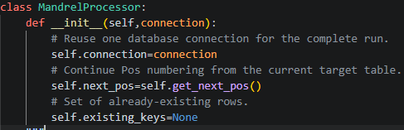
Implementation notes: __init__() is used within the application's SQL extraction, mandrel calculation, validation, or loading workflow as shown in the supplied source.

2. clear_target_table()
Truncates dbo.Ex2_report_dev, commits the deletion, closes the cursor, and resets Pos numbering to 1. This is destructive and should only be used for an intentional full reload.
Code screenshot:
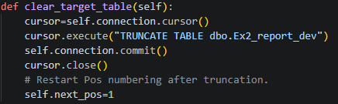
Implementation notes: clear_target_table() is used within the application's SQL extraction, mandrel calculation, validation, or loading workflow as shown in the supplied source.

3. get_next_pos()
Queries the target table for MAX(Pos)+1. If the table is empty, ISNULL makes the starting value 1. The result is returned as an integer.
Code screenshot:
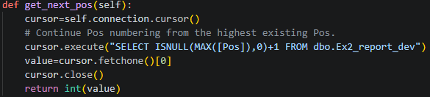
Implementation notes: get_next_pos() is used within the application's SQL extraction, mandrel calculation, validation, or loading workflow as shown in the supplied source.

4. get_existing_keys()
Loads existing timestamp, program, and order combinations from the target table from START_DATE onward. It normalizes timestamps and strings, removes invalid timestamps, and returns a set of tuples for fast duplicate checks.
Code screenshot:
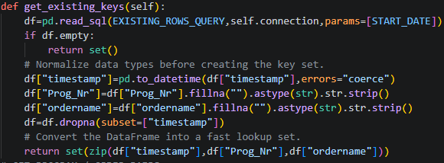
Implementation notes: get_existing_keys() is used within the application's SQL extraction, mandrel calculation, validation, or loading workflow as shown in the supplied source.

5. get_prog_order_pairs()
Reads all distinct program/order combinations from the source table, filters blank values, removes duplicates, sorts the combinations, and returns a clean DataFrame for processing.
Code screenshot:
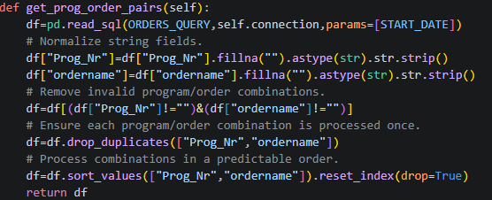
Implementation notes: get_prog_order_pairs() is used within the application's SQL extraction, mandrel calculation, validation, or loading workflow as shown in the supplied source.

6. load_order_data()
Loads one program/order combination from SQL Server in CHUNK_SIZE batches. It concatenates the chunks, converts timestamps and numeric recipe fields, replaces comma decimal separators, removes invalid negative production lengths, and sorts the data chronologically.
Code screenshot:
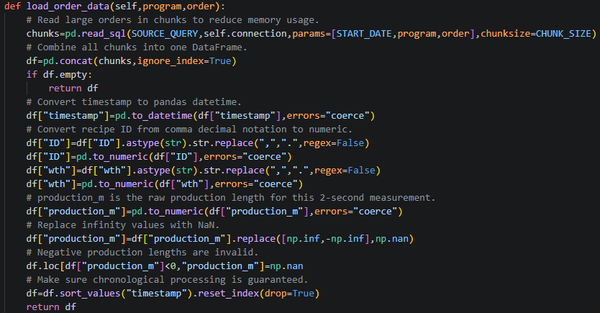
Implementation notes: load_order_data() is used within the application's SQL extraction, mandrel calculation, validation, or loading workflow as shown in the supplied source.

7. get_segment_length()
Filters rows within a half-open time interval [start_time, end_time) and sums production_m. Missing production values are treated as zero.
Code screenshot:
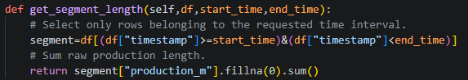
Implementation notes: get_segment_length() is used within the application's SQL extraction, mandrel calculation, validation, or loading workflow as shown in the supplied source.

8. calculate_final_mandrel_lengths()
Selects mandrel_no and production_m, converts them to numeric values, removes invalid rows, groups by mandrel number, sums production length, rounds to two decimals, and returns one calculated length per mandrel.
Code screenshot:
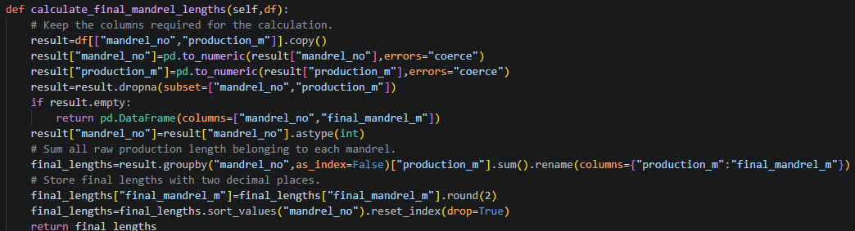
Implementation notes: calculate_final_mandrel_lengths() is used within the application's SQL extraction, mandrel calculation, validation, or loading workflow as shown in the supplied source.

9. calculate_initial_mandrels()
Works backward from the end of the order using reverse cumulative production length. Each MANDREL_LENGTH interval is converted into a theoretical mandrel number. Exact boundary cases are adjusted and the numbering is clipped to start at 1.
Code screenshot:
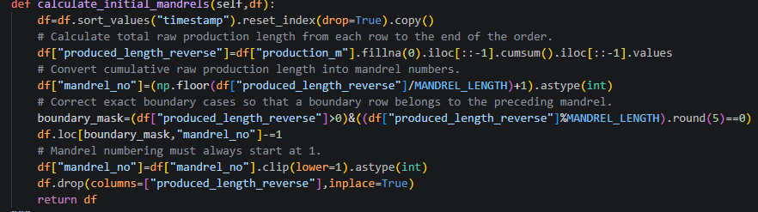
Implementation notes: calculate_initial_mandrels() is used within the application's SQL extraction, mandrel calculation, validation, or loading workflow as shown in the supplied source.

10. adjust_mandrel_boundaries()
Detects theoretical mandrel changes, smooths OD using a rolling mean, calculates OD changes, and derives a robust threshold using MAD. Significant OD drops near theoretical boundaries are considered as candidate boundaries. Candidate boundaries are optionally optimized using neighboring segment-length error, duplicates are removed, and the final mandrel numbers are reassigned chronologically.
Code screenshot:
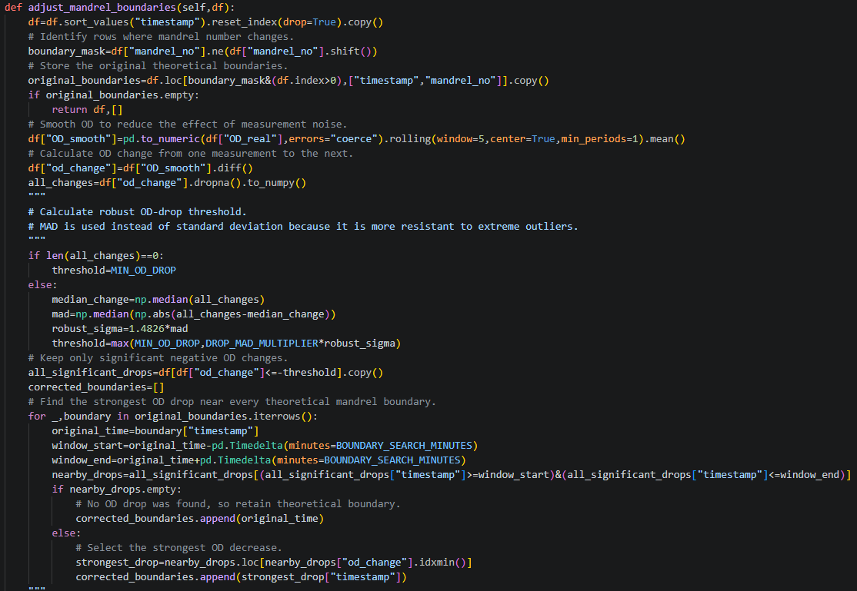
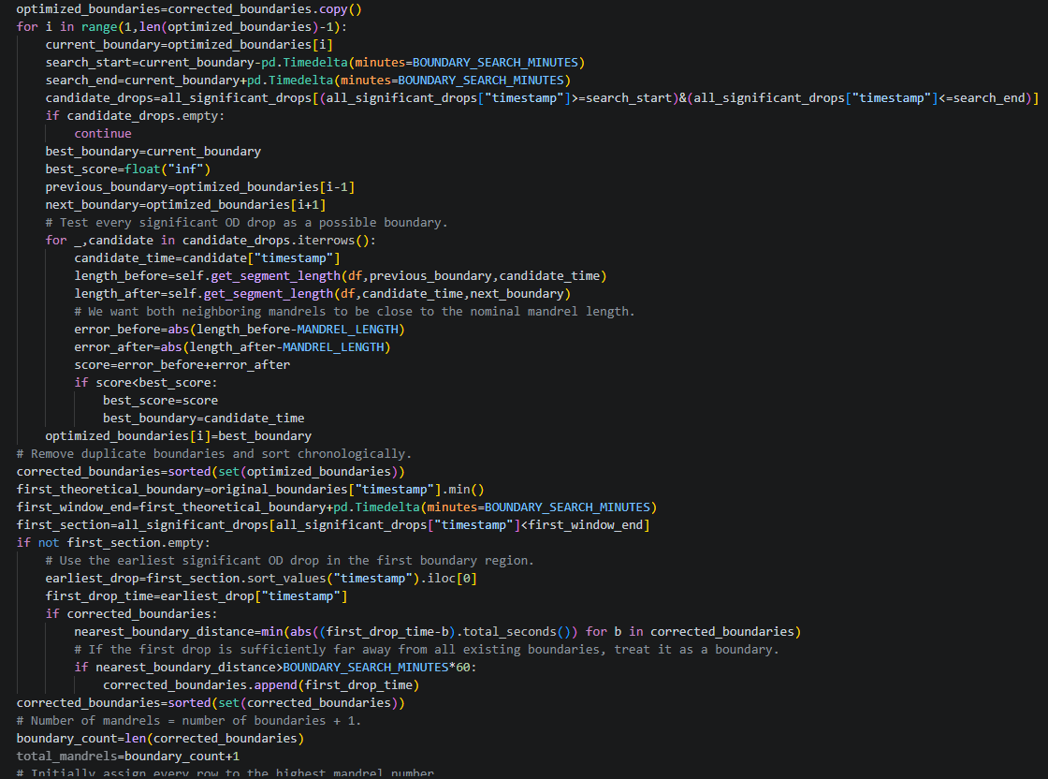
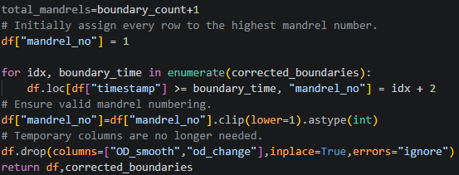
Implementation notes: adjust_mandrel_boundaries() is used within the application's SQL extraction, mandrel calculation, validation, or loading workflow as shown in the supplied source.

11. remove_initial_short_mandrel()
Checks whether enough mandrels exist, detects the first production start and an interruption based on OD, validates the interruption timing and duration, and removes the highest mandrel when it is identified as an initial short startup mandrel.
Code screenshot:
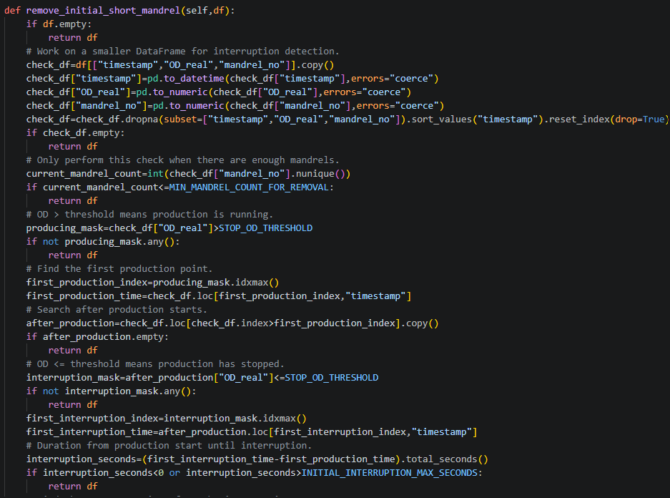
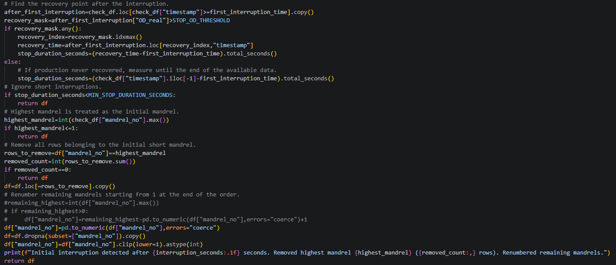
Implementation notes: remove_initial_short_mandrel() is used within the application's SQL extraction, mandrel calculation, validation, or loading workflow as shown in the supplied source.

12. remove_short_last_mandrel()
Calculates each mandrel's production length and examines the highest mandrel number. If that final mandrel is shorter than MIN_LAST_MANDREL_LENGTH, its rows are removed.
Code screenshot:
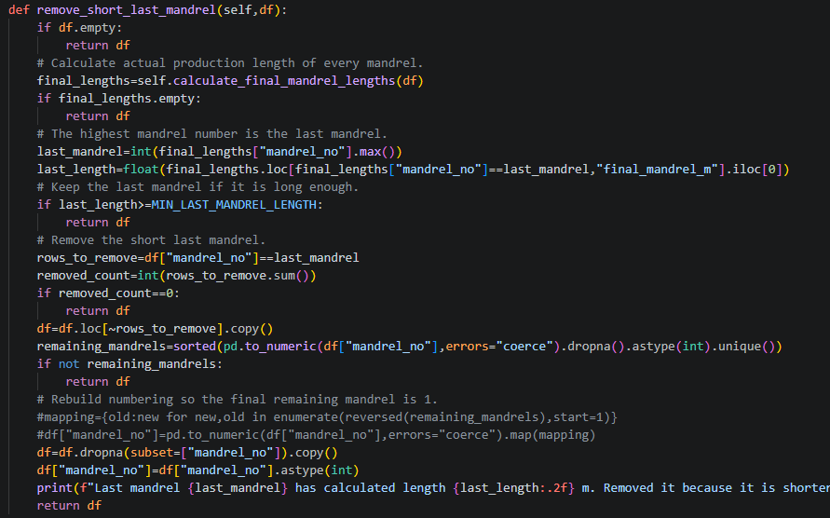
Implementation notes: remove_short_last_mandrel() is used within the application's SQL extraction, mandrel calculation, validation, or loading workflow as shown in the supplied source.

13. assign_fixed_mandrel_lengths()
Maps each mandrel number to its calculated total length, rounds the result, and clips it to MIN_MANDREL_LENGTH and MAX_MANDREL_LENGTH. The fixed value is assigned to all rows belonging to that mandrel.
Code screenshot:
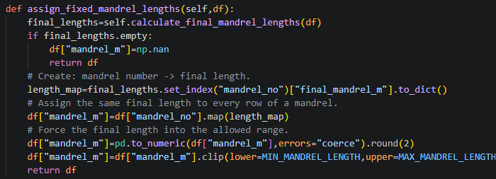
Implementation notes: assign_fixed_mandrel_lengths() is used within the application's SQL extraction, mandrel calculation, validation, or loading workflow as shown in the supplied source.

14. calculate_cumulative_order_length()
Sorts the data by timestamp, converts invalid production lengths to zero, prevents negative values, and calculates the cumulative production length in total_m_order.
Code screenshot:
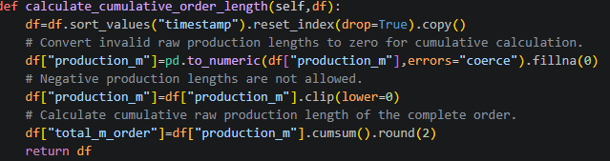
Implementation notes: calculate_cumulative_order_length() is used within the application's SQL extraction, mandrel calculation, validation, or loading workflow as shown in the supplied source.

15. recalculate_mandrel_numbers()
Builds cumulative boundaries from the distinct mandrel_m values and uses numpy.searchsorted to assign each row a new mandrel number based on total_m_order. The temporary column is then removed.
Code screenshot:
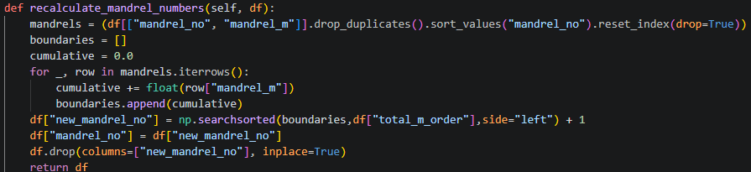
Implementation notes: recalculate_mandrel_numbers() is used within the application's SQL extraction, mandrel calculation, validation, or loading workflow as shown in the supplied source.

16. process_order()
Runs the complete pipeline for one program/order: load data, calculate theoretical mandrels, adjust boundaries, remove invalid startup and last mandrels, assign fixed lengths, calculate cumulative length, recalculate numbers, normalize fields, validate numeric columns, and prepare the final DataFrame for insertion.
Code screenshot:
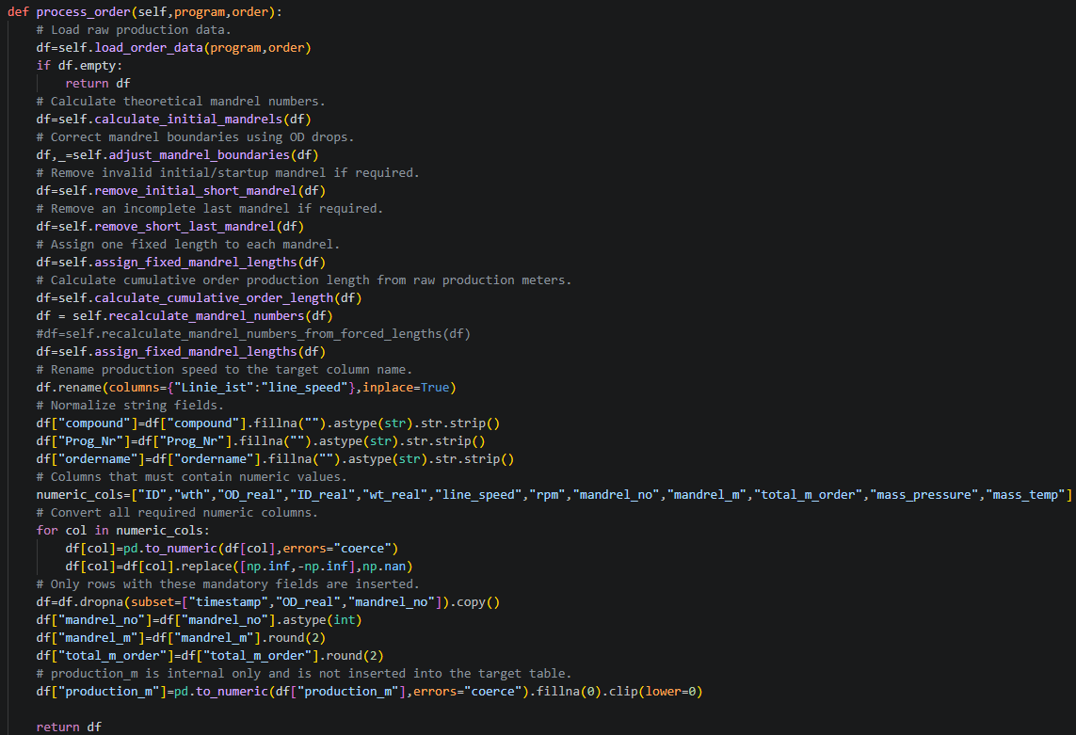
Implementation notes: process_order() is used within the application's SQL extraction, mandrel calculation, validation, or loading workflow as shown in the supplied source.

17. filter_new_rows()
Creates the same timestamp/program/order key used by get_existing_keys and keeps only rows not already present in the in-memory existing_keys set.
Code screenshot:
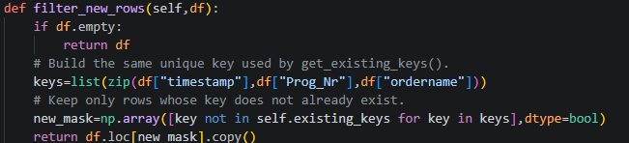
Implementation notes: filter_new_rows() is used within the application's SQL extraction, mandrel calculation, validation, or loading workflow as shown in the supplied source.

18. prepare_insert_data()
Selects the columns required by the target table, creates a copy, inserts sequential Pos values at the beginning, advances the next_pos counter, and returns the insert-ready DataFrame.
Code screenshot:
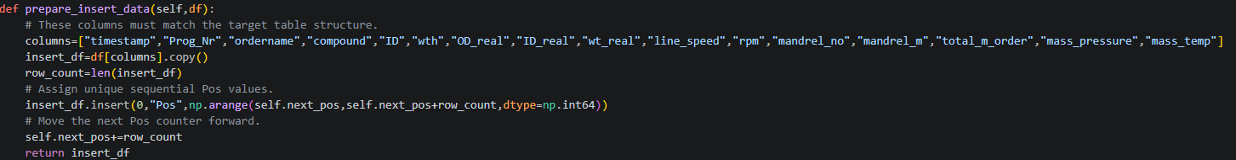
Implementation notes: prepare_insert_data() is used within the application's SQL extraction, mandrel calculation, validation, or loading workflow as shown in the supplied source.

19. insert_order()
Prepares rows for insertion, builds an INSERT statement with a NOT EXISTS guard, converts pandas missing values to SQL NULL, inserts records in INSERT_BATCH_SIZE batches, commits each batch, updates the in-memory key set, and returns the number of processed rows.
Code screenshot:
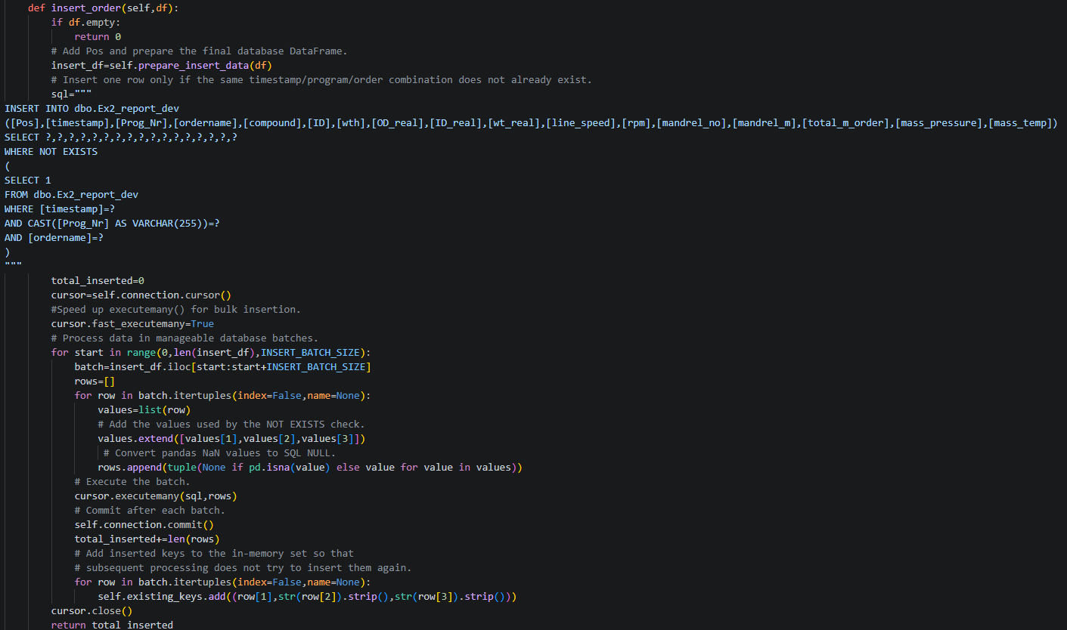
Implementation notes: insert_order() is used within the application's SQL extraction, mandrel calculation, validation, or loading workflow as shown in the supplied source.

20. run()
Loads existing keys, retrieves all program/order pairs, processes each combination, filters duplicates, inserts new rows, tracks new/updated/unchanged order statistics, rolls back failed orders, and prints a final summary.
Code screenshot:
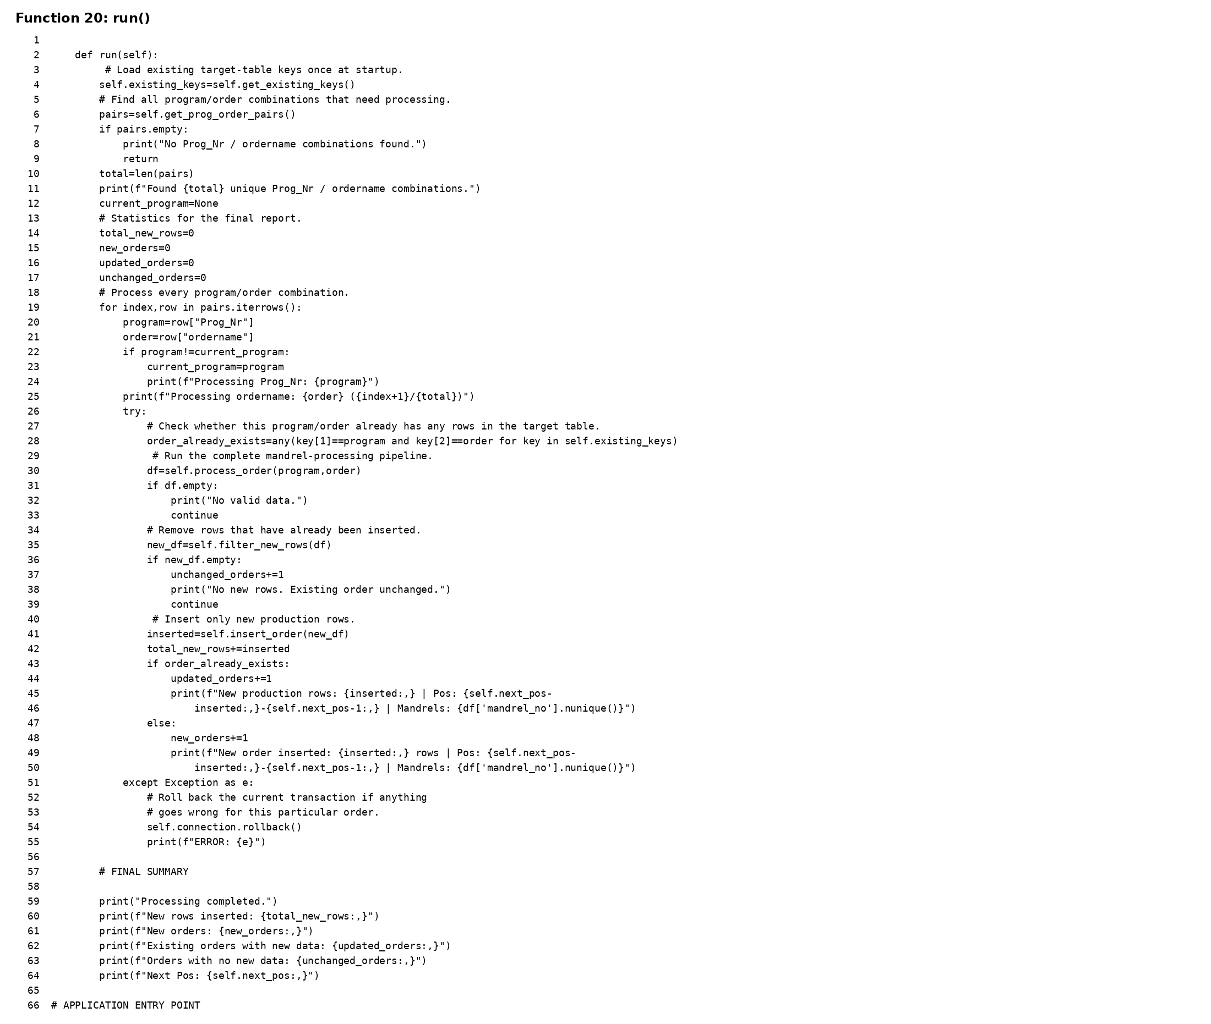
Implementation notes: run() is used within the application's SQL extraction, mandrel calculation, validation, or loading workflow as shown in the supplied source.

21. main()
Creates the SQL Server connection, instantiates MandrelProcessor, calls clear_target_table as currently written, and starts run(). It handles fatal errors with rollback and always closes the connection in finally.
Code screenshot:
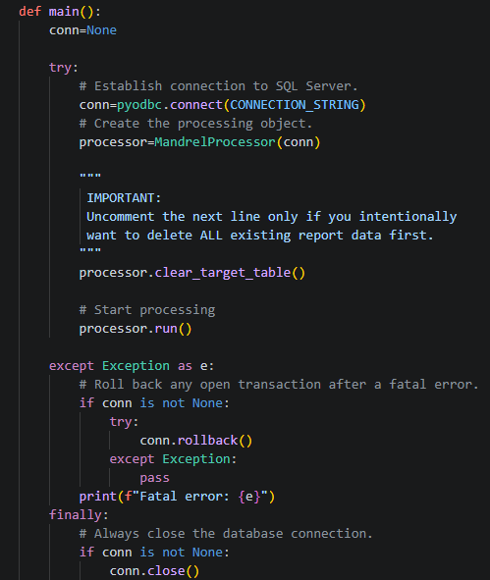
Implementation notes: main() is used within the application's SQL extraction, mandrel calculation, validation, or loading workflow as shown in the supplied source.

4. Important Implementation Observations
- main() currently calls processor.clear_target_table(). This means the target table is truncated whenever the script runs, so incremental processing will not retain prior rows unless this call is intentionally disabled.
- The duplicate check uses timestamp + Prog_Nr + ordername as the logical key. This assumes that this combination uniquely identifies a production measurement.
- The SQL INSERT statement also includes a NOT EXISTS check, providing a second duplicate-protection layer.
- The code prints that remaining mandrels were renumbered after removal, but the actual reversal/mapping logic is commented out in both removal functions. The current implementation preserves the existing mandrel numbers after deleting rows.
- assign_fixed_mandrel_lengths() clips calculated lengths to the configured range. This changes the stored mandrel_m value if a calculated length falls outside the range.
- recalculate_mandrel_numbers() uses the cumulative fixed lengths as boundaries. Because the fixed lengths may be clipped, the recalculated numbering can differ from the original segmentation.
- The code contains commented-out alternative logic for recalculating mandrel numbers. Those alternatives are not executed in the current implementation.

5. Configuration Summary
Parameter | Current Value | Purpose
MIN_MANDREL_LENGTH | 40.3 | Lower clipping limit for mandrel_m
MAX_MANDREL_LENGTH | 40.8 | Upper clipping limit for mandrel_m
MANDREL_LENGTH | 40.8 | Nominal theoretical mandrel length
MIN_LAST_MANDREL_LENGTH | 25.0 | Minimum final mandrel length
BOUNDARY_SEARCH_MINUTES | 2 | OD-drop search window
MIN_OD_DROP | 0.05 | Minimum significant OD decrease
DROP_MAD_MULTIPLIER | 6.0 | MAD threshold multiplier
STOP_OD_THRESHOLD | 1.0 | OD threshold for production state
MIN_STOP_DURATION_SECONDS | 60 | Minimum interruption duration
INITIAL_INTERRUPTION_MAX_SECONDS | 200 | Maximum start-to-interruption duration
MIN_MANDREL_COUNT_FOR_REMOVAL | 6 | Minimum mandrel count for startup removal
CHUNK_SIZE | 50,000 | SQL read chunk size
INSERT_BATCH_SIZE | 100 | Database insert batch size

