System Design Document - Online Movie Ticketing System (Epic 2687)
Azure DevOps Epic 2687

1. Introduction

1.1 Purpose
Moviegoers today cannot reliably reserve a specific seat for a specific screening online, and cinema operators lose revenue when seats are double-sold or when abandoned checkouts lock unsold inventory. This System Design Document defines the implementation-ready design for the Online Movie Ticketing System (Azure DevOps Epic 2687), a responsive web solution that lets customers discover movies, browse showtimes across cinemas, select seats on an interactive seat map, pay online and receive a QR-coded e-ticket, while cinema operations staff manage catalogue, scheduling and pricing and gate attendants validate tickets at entry.

1.2 Scope
- Functional Scope: Movie discovery and showtime browsing (Feature 2688), seat selection and concurrency-safe seat-hold management (Feature 2692), checkout, payment and QR e-ticket issuance (Feature 2696), customer account, booking history and cancellation with refund initiation (Feature 2700), and cinema operations administration with gate-side ticket validation (Feature 2704).
- Non-Functional Scope: HTTPS-only transport, JWT bearer authentication with role-based permission checks enforced server-side, deny-by-default authorization on all administrative and gate endpoints, salted password hashing, gateway-hosted payment fields so no card data ever touches platform code, signature-verified payment webhooks, immutable audit logging with correlation IDs, and PCI-DSS SAQ-A scope reduction through hosted fields.
- In-Scope Integrations: Third-party payment gateway (payment intent creation plus signed webhook callback), transactional email service for e-ticket delivery, Azure Key Vault for secrets and JWT signing keys, and Application Insights plus Log Analytics for telemetry.
- Out-of-Scope Items: Native mobile applications, physical turnstile or barcode hardware integration, loyalty or coupon engines, food and beverage ordering, dynamic surge pricing, and third-party aggregator distribution channels.
- Assumptions & Constraints: The cancellation cut-off period and any cancellation penalty percentage are explicitly flagged as an open question on User Story 2703 and are modelled here as configurable platform settings rather than hard-coded values. Seat-hold duration and maximum seats per transaction are likewise configuration-driven. The payment gateway is assumed to support hosted payment fields, idempotent webhooks keyed on gatewayReference, and server-to-server refunds. Measurable availability and latency targets were not supplied by the requester; the values stated in Section 4.3 are architecture assumptions requiring business confirmation.

1.3 Methodology
Delivery follows an Agile Scrum cadence with two-week sprints, with requirements traced from Epic 2687 through five Features and seventeen User Stories, each carrying Given/When/Then acceptance criteria that act directly as design verification points. Design review proceeds in three gates: architecture review of this document, API contract review before backend implementation, and a security design review before the first production deployment. Significant choices (service-oriented monolith over microservices, database-enforced seat uniqueness, hosted payment fields) are recorded as Architecture Decision Records in docs/architecture/epic-2687/. Tooling comprises Azure DevOps for work-item traceability, GitHub for version-controlled architecture and code artifacts, Mermaid rendered to PNG for all diagrams, and GitHub Actions for build and deployment automation.

2. System Architecture

2.1 Software Architecture
The solution is a layered, service-oriented monolith deployed as containers. A monolith is chosen deliberately over microservices because the seat-hold and booking workflow requires a single transactional boundary: the guarantee that a seat is never double-sold is enforced by a database unique constraint on (showId, seatId) across active holds and confirmed bookings, which is far cheaper and safer to maintain inside one transactional store than across distributed services with compensating transactions.
The presentation layer is a React 18 TypeScript single-page application that renders the catalogue, the SVG/grid seat map with live seat status, the checkout summary, the account area, the role-gated admin console and the camera-based gate scanner view. It holds the access token in memory and refreshes it through an httpOnly cookie, never persisting the token in local storage.
The application layer is a .NET 8 ASP.NET Core Web API exposing versioned /api/v1 endpoints. Authentication and RBAC middleware validates issuer, audience, expiry and signature on every protected call before dispatching to CatalogueService, SeatHoldService, PricingService, PaymentService, BookingService, TicketService and IdentityService. A hosted background worker (HoldExpiryWorker) scans for SeatHold rows whose status is Active and whose expiresUtc has passed, transitions them to Expired and returns their seats to sale, writing an audit entry with a correlation ID for each release.
The data layer is a relational store holding the JSON-shaped entities Movie, Cinema, Screen, Show, ShowPricing, Seat, SeatHold, Booking, Payment, Ticket, Refund, User and AuditLog. Integration with the payment gateway is outbound HTTPS for intent creation and inbound signature-verified webhooks for settlement; e-tickets are dispatched through the transactional email service, and a failed dispatch never reverses a Confirmed booking.
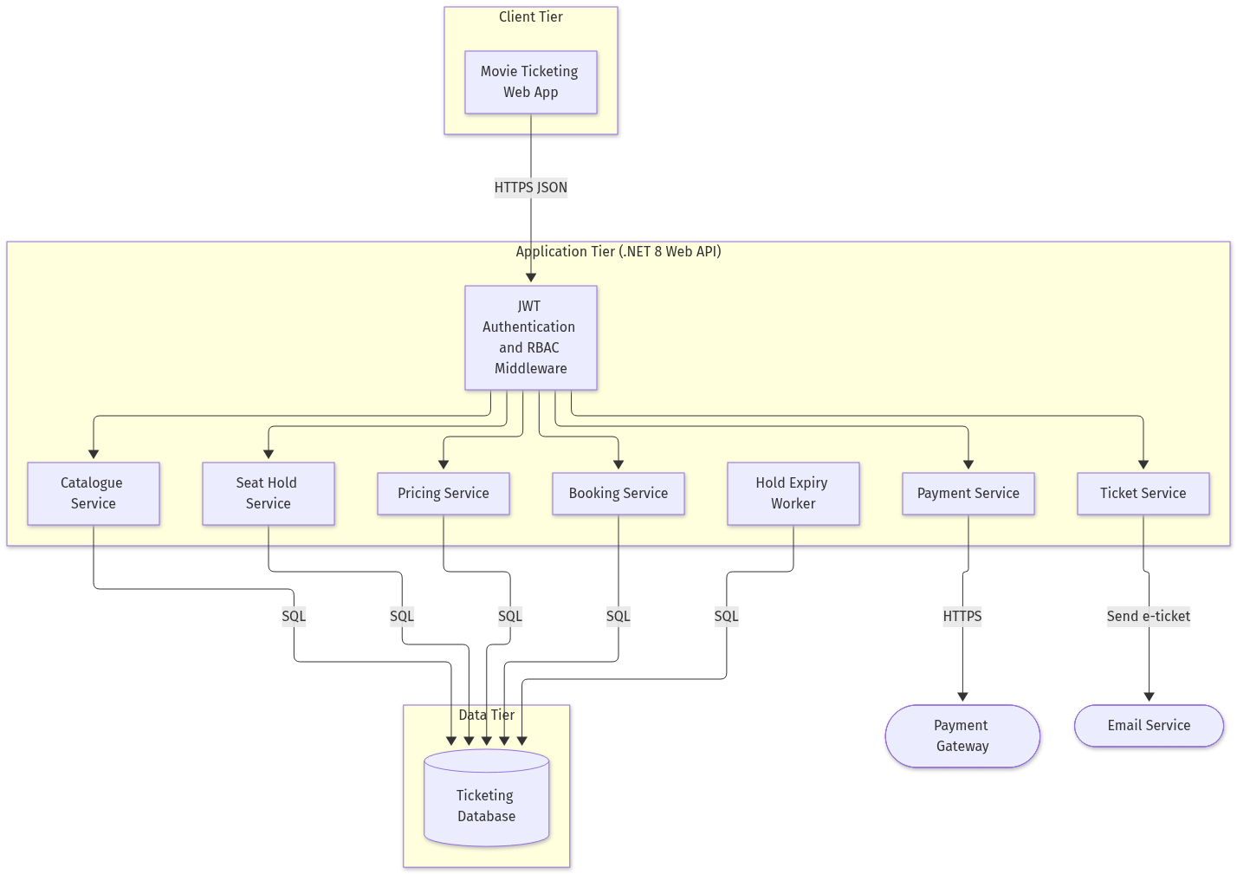
Solution Architecture
Source artifact: docs/architecture/epic-2687/solution-architecture.png
![Solution Architecture](high-level-solution-architecture.png)
*Caption: The high-level solution architecture shows how customer, operations and gate traffic funnels through one authentication and RBAC boundary into discrete backend services sharing a single transactional database, with the payment gateway and email service as the only external dependencies in the booking critical path.*
Fallback: If the image cannot be rendered, the Mermaid source is version-controlled at docs/architecture/epic-2687/high-level-solution-architecture.mmd. Textually: React web app to JWT/RBAC middleware to {Catalogue, SeatHold, Pricing, Payment, Ticket, Booking} services to Ticketing Database; PaymentService to Payment Gateway; TicketService to Email Service; HoldExpiryWorker to Ticketing Database.

System Context
![System Context](system-context.png)
*Caption: Three human actors (Moviegoer, Cinema Operations Manager, Gate Attendant) interact over HTTPS with the web app, which calls the API; the API integrates with the payment gateway, the email service and the observability platform.*

Component View
![Component Diagram](component-diagram.png)
*Caption: Frontend pages map one-to-one onto API controllers and the documented endpoints from the user stories, including GET /api/v1/movies, POST /api/v1/shows/{showId}/holds, POST /api/v1/orders/quote, POST /api/v1/payments/intent and POST /api/v1/gate/tickets/validate.*

Data Model
![Data Model](data-model.png)
*Caption: The entity-relationship model carries every field named in the acceptance criteria, including SeatHold.expiresUtc, Booking.bookingReference, Payment.gatewayReference, Ticket.qrPayload and Refund.status.*

Security and RBAC
![Security and RBAC](security-rbac.png)
*Caption: Anonymous access is limited to catalogue and showtime reads; all other endpoints deny by default and additionally verify resource ownership against the userId claim in the JWT.*

3. Detailed Design

3.1 Software Detailed Design
Module breakdown. CatalogueService serves paged movie listings, case-insensitive partial title search with exact genre and language matching, and showtime queries that exclude shows whose startUtc is in the past. SeatHoldService creates holds inside a database transaction protected by the unique constraint on (showId, seatId); the loser of a concurrent race receives HTTP 409 with a seat-unavailable error code while exactly one caller receives HTTP 201 with holdId and expiresUtc. PricingService computes the order quote as one line item per held seat plus subtotal, convenience fee and tax, guaranteeing grandTotal = subtotal + convenienceFee + taxAmount, and returns the same amounts for the remaining life of the hold. PaymentService creates the gateway payment intent and processes the inbound webhook. BookingService converts a hold into a Confirmed booking, marks seats booked and sets hold status to Converted. TicketService generates a unique qrPayload per ticket and dispatches the e-ticket email. IdentityService performs registration, login, refresh and role assignment.
Key algorithms. Seat holding: begin transaction, re-read seat status for the show, attempt insert of hold rows, on unique-constraint violation roll back and return 409, on success commit and return expiresUtc. Hold expiry: batch scan of Active holds past expiresUtc, per-hold try/catch so that a failure on one hold never aborts the batch, each release audited with holdId, showId, seat identifiers and a correlation ID, and never containing payment card data. Ticket validation: load ticket by qrPayload; if status = Issued and the show has not ended, flip to Used and return valid; if already Used return invalid with reason already-used; if the parent booking is cancelled return invalid with reason cancelled. Every scan attempt is recorded with attendantId, ticketId, result and timestamp.
API contracts. All responses use problem-details JSON on error. Representative mappings: GET /api/v1/movies/{movieId} returns 404 problem details for an unknown movie; GET /api/v1/movies/search returns 400 with a field-level validation error naming pageSize when it exceeds the configured maximum; POST /api/v1/orders/quote returns 403 for a hold owned by another user and 410 with a hold-expired code for an expired hold; POST /api/v1/admin/movies returns 409 when retirement is attempted on a movie with future scheduled shows; POST /api/v1/admin/shows returns 409 with a schedule-conflict code on an overlapping screen window and 400 for any negative category price; POST /api/v1/bookings/{bookingId}/cancel returns 422 with a not-eligible code outside the configured cancellation cut-off.
Error handling, idempotency, retries and caching. Webhook processing is idempotent on gatewayReference: repeated deliveries create exactly one Booking and subsequent deliveries return HTTP 200 without duplicates, while a webhook whose signature fails verification returns HTTP 401, is rejected and logged as a security failure with no card data exposed. Outbound gateway and email calls use exponential backoff with jitter over three attempts; a failed e-ticket email leaves the booking Confirmed, keeps the ticket retrievable in the account area and logs the failure with a correlation ID. A failed gateway refund retains the Refund record with status Failed for operator follow-up. Seat-map reads are cached for a short TTL and invalidated on every hold, booking, cancellation and expiry event so that a seat booked by another customer after render surfaces as 409 plus a refreshed map.
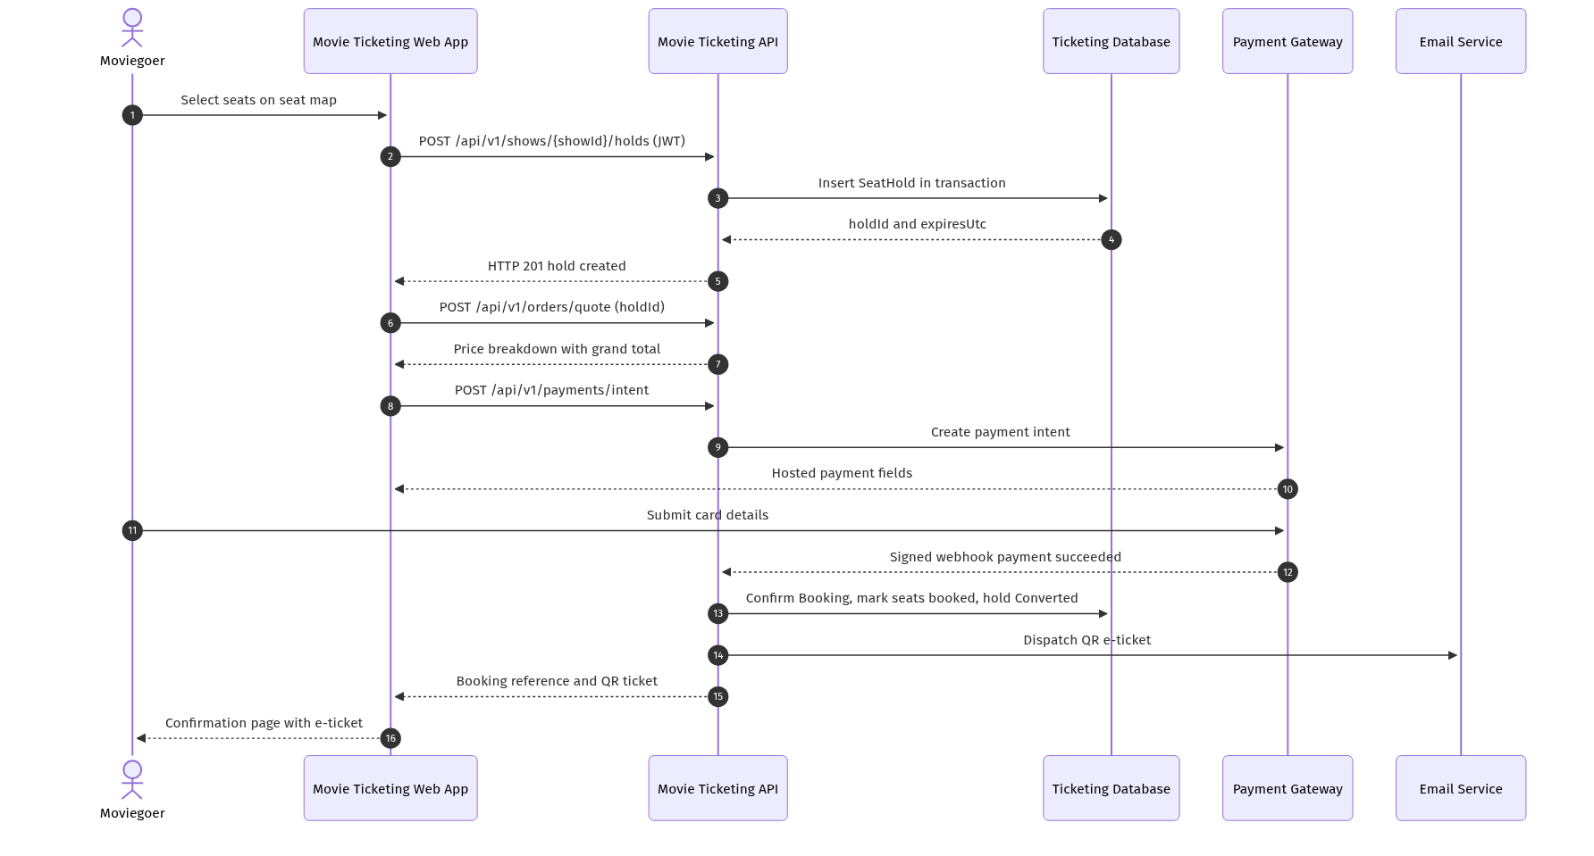
Critical Workflow Sequence
Source artifact: docs/architecture/epic-2687/sequence.png
![Critical Workflow Sequence](sequence-booking-flow.png)
*Caption: The end-to-end booking flow from seat selection through hold creation, quoting, hosted-field payment and signed webhook settlement to QR e-ticket delivery. It is the single most concurrency-sensitive path in the system and drives the transactional design.*
Fallback: Mermaid source at docs/architecture/epic-2687/sequence-booking-flow.mmd; textually, Moviegoer to Web App to API (hold) to DB to API (quote) to API (payment intent) to Gateway to webhook to API (confirm booking) to Email Service to confirmation page.

4. Technical Design Specification

4.1 Integration Plan
- Payment gateway integration uses two contracts: POST /api/v1/payments/intent (server-to-server intent creation returning a client secret consumed by gateway-hosted fields) and POST /api/v1/payments/webhook (inbound, HMAC signature verified, idempotent on gatewayReference); owner: Payments squad.
- Transactional email integration dispatches the e-ticket containing booking reference, movie, cinema, screen, showtime and seat labels to the account email address; dispatch failure is non-blocking and raises an alert after 3 consecutive failures; owner: Platform squad.
- Internal data contracts are JSON DTOs versioned under /api/v1: OrderQuote { holdId, lineItems[], subtotal, convenienceFee, taxAmount, grandTotal, currency }, SeatHold { holdId, showId, seatIds[], userId, createdUtc, expiresUtc, status }, Booking { bookingId, bookingReference, userId, showId, seatIds[], amountPaid, status }.
- Authentication for all internal calls is a JWT bearer token validated for issuer, audience, expiry and signature; gateway calls authenticate with an API key resolved at runtime from Azure Key Vault; webhook calls authenticate by signature only and never by IP allow-list alone.
- Measurable integration checkpoints: contract tests green for all 4 external operations, webhook replay test proving exactly-one Booking across 5 duplicate deliveries, signature-tampering test returning HTTP 401, and a 24-hour soak confirming zero orphaned Active holds after expiry processing.

4.2 Configuration Checklist
- Platform settings: SeatHold:DurationMinutes, Booking:MaxSeatsPerTransaction, Cancellation:CutOffHours, Cancellation:PenaltyPercent, Pricing:ConvenienceFeePercent, Pricing:TaxPercent are all configuration-driven, none hard-coded; the cut-off and penalty values remain pending business confirmation on User Story 2703.
- Secrets in Azure Key Vault: JwtSigningKey, PaymentGateway:ApiKey, PaymentGateway:WebhookSecret, Email:ApiKey, Sql:ConnectionString; secrets are referenced only through managed identity and never committed to source control.
- Azure resources: App Service plan asp-movieticketing-<env>, web app app-movieticketing-web-<env>, API app-movieticketing-api-<env>, worker app-movieticketing-worker-<env>, sql-movieticketing-<env>, redis-movieticketing-<env>, kv-movieticketing-<env>, appi-movieticketing-<env>.
- Runtime versions pinned: .NET 8 LTS, React 18, Node 20 build toolchain, Entity Framework Core 8, SQL compatibility level 160, container base image digest-pinned and patched monthly.
- Infrastructure is deployed as version-controlled Bicep modules with remote state and per-environment parameter files (dev, test, prod); no portal-only configuration is permitted, and drift is detected by a nightly what-if run.

4.3 Service Level Agreement
- Availability target 99.9% monthly for the booking path (catalogue, seat map, hold, quote, payment, ticket), measured by synthetic transactions every 60 seconds.
- Latency targets: seat-map read p95 at or below 500 ms, hold creation p95 at or below 400 ms, order quote p95 at or below 300 ms, ticket validation p95 at or below 300 ms at the gate, all measured server-side excluding gateway time.
- Recovery objectives: RTO 1 hour and RPO 5 minutes, supported by point-in-time restore on the SQL database and geo-redundant backups retained for 35 days.
- Maintenance window Tuesdays 02:00-04:00 UTC, with zero-downtime slot swaps required for any release touching the booking path during peak release windows (Friday to Sunday).
- Escalation SLAs: Sev-1 (seats double-sold, payments failing, gate validation down) acknowledged within 15 minutes and mitigated within 4 hours; Sev-2 within 1 hour and 1 business day; Sev-3 next business day.

4.4 Security & Compliance Architecture
- Network segmentation: public traffic terminates at Azure Front Door with WAF managed rules; the API and worker sit behind private endpoints to SQL, Redis and Key Vault, with no public database exposure.
- Encryption standards: TLS 1.2 or higher in transit on every hop, AES-256 Transparent Data Encryption at rest, and salted password hashing only; plaintext passwords and password hashes are never returned by any endpoint.
- Key rotation: JWT signing keys rotated every 90 days with overlapping validity, gateway and email API keys rotated every 180 days, all rotations automated through Key Vault with versioned references.
- Compliance mapping: PCI-DSS SAQ-A scope is achieved because card data is captured exclusively in gateway-hosted fields; GDPR obligations are met through purpose-limited retention of personal data and audit evidence of access; audit records are immutable and exportable.
- Policy enforcement: deny-by-default authorization on every admin and gate endpoint, ownership checks against the userId claim for all customer resources, HTTP 403 plus a logged authorization-failure event on violation, and secret-scanning plus dependency-scanning gates in CI.

4.5 Workflow, Orchestration & Scheduling
- Booking workflow steps: select seats, create hold (transactional, unique-constrained), quote order, create payment intent, gateway settlement, signed webhook, confirm booking, generate ticket, dispatch e-ticket email.
- Orchestration is in-process within the .NET 8 API using scoped transactions; no external workflow engine is introduced, which keeps the seat-uniqueness guarantee inside one commit boundary.
- Hold-expiry scheduling: hosted background service executes every 30 seconds, processes holds in batches of 200, and is idempotent so that overlapping executions cannot double-release a hold.
- Retries and backoff: 3 attempts with exponential backoff and jitter for gateway and email calls; webhook processing itself is never retried destructively because it is idempotent on gatewayReference.
- Failure-handling paths: per-hold try/catch so a single failure never aborts the batch; failed refunds persist with status Failed for operator follow-up; every failure is logged with a correlation ID that ties frontend, API, worker and gateway records together.

4.6 Release Management & Environment Strategy
- Pipelines: GitHub Actions workflows for build-and-test, container publish, and environment deploy, each triggered on pull request, merge to main, and tagged release respectively.
- Branching strategy: trunk-based development on main with short-lived feature/* branches, mandatory pull-request review, and no direct pushes to main.
- Environment promotion: dev on every merge, test on a green integration suite, prod only after UAT approval; the same immutable container digest is promoted across all three environments.
- Artifact versioning: semantic versioning MAJOR.MINOR.PATCH with the Git short SHA appended to the container tag, and database migrations versioned and applied forward-only.
- Rollback: production deploys use App Service staging slots with swap; rollback is a reverse swap targeted at under 5 minutes, and any migration that is not backward compatible must ship behind a feature flag.

4.7 Testing Strategy & Quality Gates
- Testing stages: unit, integration (API plus database), contract tests against a gateway sandbox, end-to-end UI journeys, concurrency tests, and accessibility checks on the seat map.
- Automation coverage thresholds: minimum 80% line coverage overall and 90% on SeatHoldService, PricingService, PaymentService and TicketService; the build fails below threshold.
- Concurrency gate: an automated test firing 50 simultaneous hold requests for the same seat must produce exactly one HTTP 201 and 49 HTTP 409 responses before any release to test.
- Defect severity rules: no open Sev-1 or Sev-2 defects may be promoted to production; Sev-3 defects require a documented workaround and a scheduled fix sprint.
- Performance benchmarks: load test sustaining 500 concurrent seat-map users and 100 bookings per minute while holding p95 latency within the Section 4.3 targets and zero double-sold seats.
![CI/CD Pipeline](cicd-pipeline.png)
*Caption: The CI/CD pipeline enforces the quality and security gates described above between every environment promotion.*

5. Implementation Plan

5.1 Phased Rollout Strategy
- Week 1-2: Provision dev infrastructure via Bicep (App Service, SQL, Redis, Key Vault, Application Insights), scaffold the .NET 8 solution and the React 18 app, and establish the CI pipeline with coverage and secret-scanning gates. Advancement criterion: a health-probe deployment succeeds end to end.
- Week 3-4: Implement the data model and Feature 2688 (movie discovery and showtime browsing) including the public read endpoints. Advancement criterion: anonymous catalogue and showtime browsing passes all acceptance criteria of Stories 2689, 2690 and 2691.
- Week 5-6: Implement Feature 2700 identity (registration, login, refresh, RBAC middleware). Advancement criterion: protected routes reject expired tokens with HTTP 401 and the refresh flow succeeds.
- Week 7-9: Implement Feature 2692 (seat map, hold creation, hold-expiry worker). Advancement criterion: the 50-concurrent-request seat test yields exactly one success, and zero orphaned holds remain after a 24-hour soak.
- Week 10-12: Implement Feature 2696 (quote, payment intent, signed webhook, booking confirmation, QR ticket). Advancement criterion: duplicate webhook delivery creates exactly one Booking and signature tampering returns HTTP 401.
- Week 13-14: Implement Feature 2700 booking history and cancellation with refund initiation. Advancement criterion: cancellation outside the configured cut-off returns HTTP 422 and seats are returned to sale inside it.
- Week 15-16: Implement Feature 2704 (admin catalogue, show scheduling with overlap detection, seat-category pricing, gate validation). Advancement criterion: overlapping schedule returns HTTP 409 and a used ticket rescans as already-used.
- Week 17: Deploy to test, run the full regression, load and accessibility suites. Advancement criterion: all Section 4.7 gates green.
- Week 18: UAT with cinema operations and gate staff, security design review sign-off, and penetration test remediation. Advancement criterion: no open Sev-1 or Sev-2 defects.
- Week 19-20: Pilot production release to a single cinema using slot-swap deployment, monitor for one full weekend cycle, then roll out to all cinemas. Advancement criterion: zero double-sold seats and availability within the 99.9% target during the pilot.

5.2 Teams and Security Roles
- Product Owner owns the backlog of Epic 2687 and signs off the open cancellation cut-off and penalty decision before Week 13.
- Solution Architect owns this document, the ADRs and the API contract review gate; approval is required before backend implementation of each feature.
- Frontend squad owns the React 18 application, seat-map accessibility and token handling; it has Contributor scope on the web app resource in dev only.
- Backend squad owns the .NET 8 API, the hold-expiry worker and database migrations; it has Contributor scope in dev and test, and read-only in prod.
- Platform/DevOps engineer owns Bicep modules, pipelines, slots and Key Vault access policies; it is the only role with deployment rights to prod, exercised through pipeline identity rather than interactive access.
- Security engineer owns the threat model, dependency and secret scanning gates, key rotation schedule and the pre-production security review sign-off.
- QA lead owns the regression, concurrency, load and accessibility suites and holds the authority to block promotion on any failed quality gate.
- Application roles in production are Moviegoer (own bookings and tickets only), CinemaOperationsManager (catalogue, scheduling, pricing), GateAttendant (ticket validation only) and SupportOperator (read-only booking lookup plus refund follow-up).
- Escalation path: on-call engineer, then backend squad lead, then Solution Architect, then Product Owner, with Sev-1 paging the on-call engineer within 15 minutes.
- Access reviews of all production role assignments and Key Vault policies are performed quarterly and evidenced in the audit log.

6. Effort & Schedule Estimation

6.1 Estimation Approach
Estimation combines story points on a Fibonacci scale assigned during backlog refinement, T-shirt sizing at feature level for early capacity planning, and three-point (Optimistic/Realistic/Pessimistic) estimates for the two highest-risk areas. Feature sizing: Movie Discovery (M, 13 points), Seat Selection and Seat-Hold (L, 26 points), Checkout and Payment (L, 29 points), Customer Account and Cancellation (M, 18 points), Cinema Operations and Gate Validation (M, 21 points), giving 107 points in total. Three-point estimates: seat-hold concurrency 2.5 / 3.0 / 4.5 weeks and payment-gateway integration 2.5 / 3.0 / 5.0 weeks, producing PERT expectations of approximately 3.2 and 3.3 weeks respectively. A velocity of 12 points per two-week sprint for one cross-functional squad underpins the 20-week schedule, with a 15% contingency reserve held against gateway sandbox availability.

6.2 Timeline & Milestones
- M1 Foundations ready: Week 1 to Week 2; no upstream dependency; on the critical path because every later milestone deploys through this pipeline.
- M2 Discovery and identity complete: Week 3 to Week 6; depends on M1; partially parallelisable between frontend and backend.
- M3 Seat-hold concurrency proven: Week 7 to Week 9; depends on M2; firmly on the critical path as the booking flow cannot be built on an unproven hold mechanism.
- M4 Payment and e-ticket complete: Week 10 to Week 12; depends on M3 and on payment-gateway sandbox credentials; on the critical path with the highest external dependency risk.
- M5 Operations, UAT and production pilot: Week 13 to Week 20; depends on M4 and on the business decision regarding the cancellation cut-off and penalty; the critical path runs M1, M3, M4, M5.

7. Assumptions & Dependencies

7.1 Assumptions
- The cancellation cut-off period and cancellation penalty percentage are unresolved on User Story 2703 and are implemented as configurable settings; business confirmation is required before Week 13.
- Seat-hold duration and the maximum number of seats per transaction are configurable platform settings because no numeric values were supplied in the requirements.
- A single relational database provides the transactional boundary for seat uniqueness; horizontal scaling is achieved by scaling the stateless API tier rather than sharding the booking store.
- The payment gateway supports hosted payment fields, idempotent signed webhooks and server-initiated refunds; this keeps the platform in PCI-DSS SAQ-A scope.
- Availability and latency targets in Section 4.3 are architecture assumptions derived from a typical consumer booking workload and require business confirmation.
- Azure App Service is the hosting target consistent with the baseline technology stack; no on-premises deployment is planned.

7.2 External Dependencies
- Payment gateway vendor: sandbox and production credentials, webhook signing secret, and a documented refund API, required by Week 10.
- Transactional email provider: verified sending domain, SPF/DKIM records and API key, required by Week 11.
- Azure platform team: subscription, resource group, managed identities and network policy approval, required by Week 1.
- Cinema operations business owners: confirmed cancellation cut-off, penalty percentage, seat categories and convenience-fee and tax rates, required by Week 13.
- Security and compliance function: threat-model review and penetration-test slot booked for Week 18.

8. Appendices

8.1 Additional Diagrams
- !High-Level Flow
![High-Level Flow](high-level-solution-architecture.png)
*Caption: Logical component flow for Epic 2687 from the React client through the RBAC boundary to the transactional data store.*
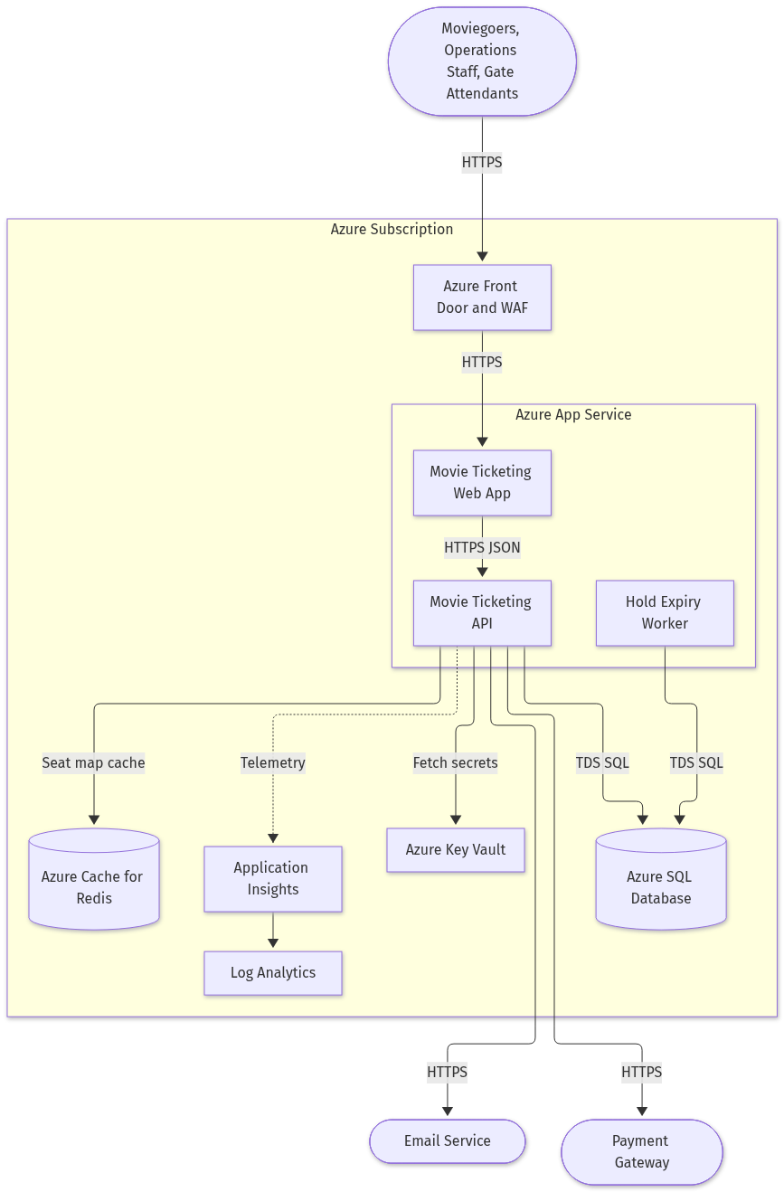
Deployment Diagram
Source artifact: docs/architecture/epic-2687/deployment.png
![Deployment Diagram](deployment.png)
*Caption: Azure deployment topology covering Front Door and WAF, App Service hosted web, API and expiry worker, Azure SQL, Redis cache, Key Vault and Application Insights with Log Analytics.*
CI/CD Pipeline
Source artifact: docs/architecture/epic-2687/cicd.png
![CI/CD Pipeline](cicd-pipeline.png)
*Caption: Build, scan, package and promote pipeline with the UAT approval gate and the slot-swap rollback path that protects the booking flow in production.*
- !Security and RBAC
![Security and RBAC](security-rbac.png)
*Caption: Role-to-endpoint authorization map for Moviegoer, Cinema Operations Manager and Gate Attendant, including anonymous catalogue access and ownership enforcement.*
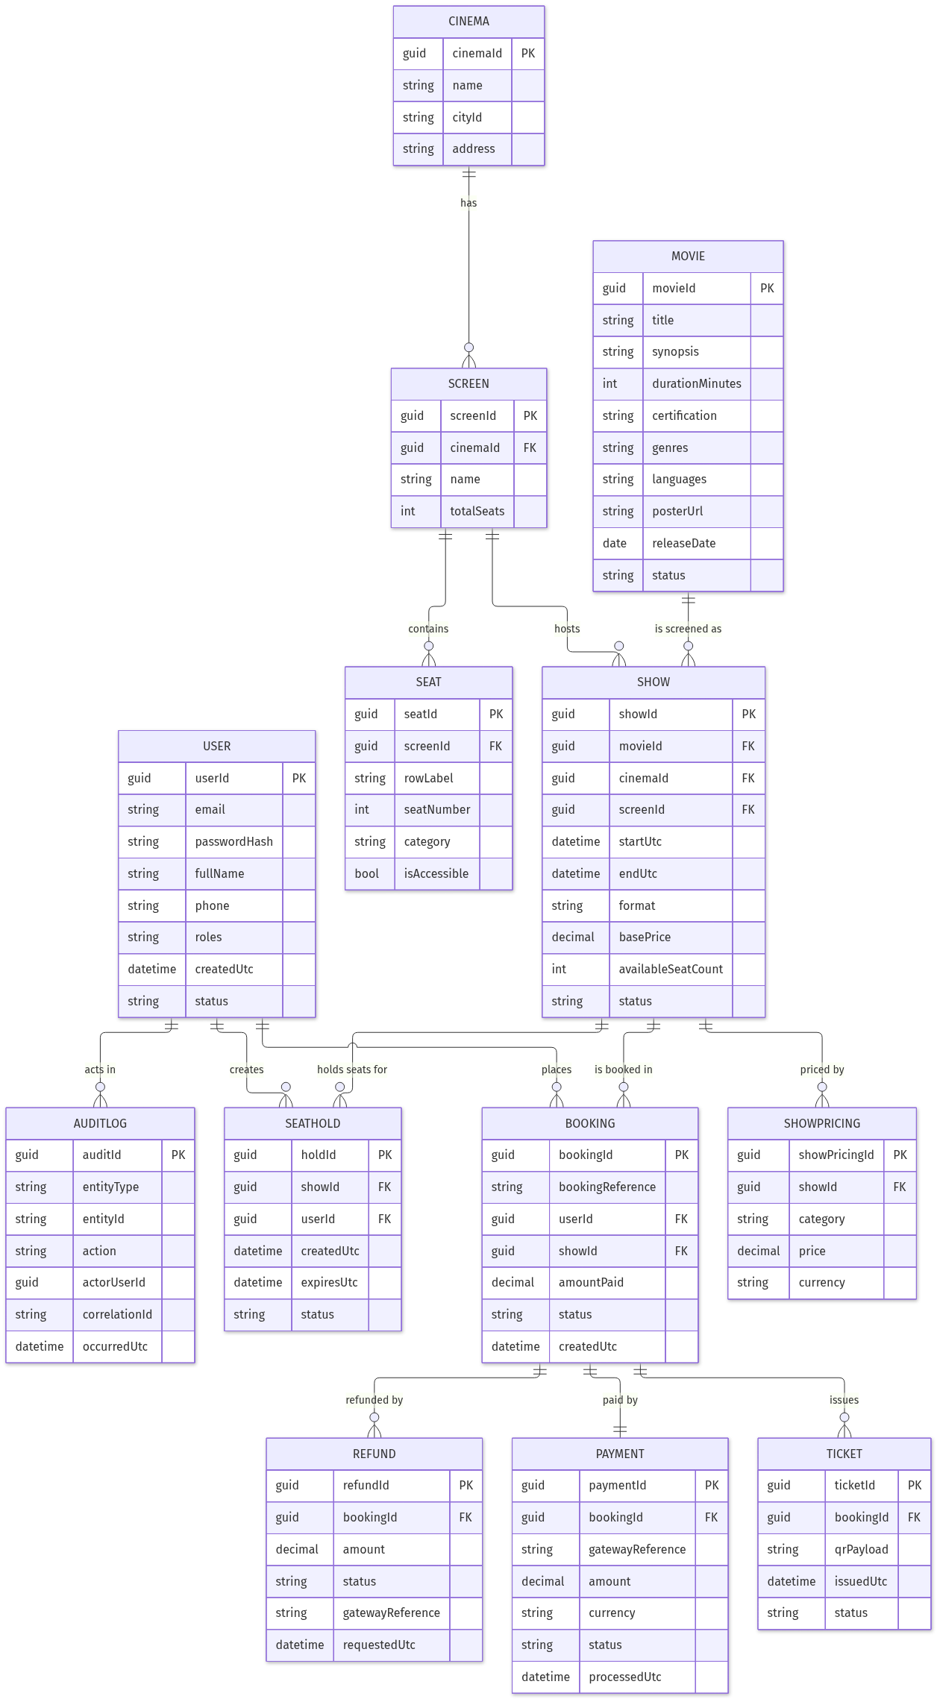
Data Model
Source artifact: docs/architecture/epic-2687/data-model.png
![Data Model](data-model.png)
*Caption: Entity-relationship model covering User, Movie, Cinema, Screen, Show, ShowPricing, Seat, SeatHold, Booking, Payment, Ticket, Refund and AuditLog.*
Fallback: All Mermaid sources are version-controlled alongside the rendered PNG files in docs/architecture/epic-2687/ and can be re-rendered if any image is unavailable.

