Introduction

A production-ready biometric attendance system using ESP32 microcontroller with R305 fingerprint sensor, powered by a Node.js/Express backend, MongoDB database, and a modern React frontend with real-time updates via Socket.io.

2. Objective
The primary objective of this project is to develop a real-time biometric attendance tracking system using an ESP32 microcontroller paired with a fingerprint sensor. The system aims to:
- Replace traditional paper based or manual attendance methods with an automated, tamper proof solution.
- Enable accurate and fast identification of individuals using fingerprint biometrics.
- Provide a live web-based dashboard displaying attendance records in real time.
- Integrate IoT hardware (ESP32) with a cloud connected web application for seamless data flow.
- Reduce proxy attendance and improve institutional accountability.

3. Tools Used

3.1 Hardware
- ESP32 Microcontroller: Wi-Fi enabled microcontroller for fingerprint sensor interfacing and data transmission
- Fingerprint Sensor (R305s): for biometric enrollment and verification

3.2 Project Management / Scheduling Tools
- Trello: Agile sprint board for task management and sprint tracking
- GitHub Projects: Version history and issue tracking

3.3 CASE Tools (UML Diagrams)
- draw.io: for Use Case, Class, and Sequence diagram creation

3.4 Version Control / Agile Tools
- Git: distributed version control
- GitHub: remote repository and collaboration

3.5 Testing Tools
- Postman — API endpoint testing
- Browser DevTools — frontend debugging and network monitoring

3.6 Development Environment
- VS Code — primary code editor
- Arduino IDE — ESP32 firmware development
- Node.js / npm — backend runtime and package management

3.7 Technology Stack

Layer | Technology
Frontend | HTML, CSS, JavaScript (React JS)
Backend | Node.js + Express.js
Database | MongoDB Atlas
Hardware | ESP32 + Fingerprint Sensor (R305s)
Hosting | Vercel (Frontend), Render (Backend)
Communication | HTTP / WebSocket / MQTT

4. Introduction
The ESP32 Fingerprint Attendance System is an IoT-based web application designed to automate and modernize the attendance tracking process in educational institutions or workplaces. Traditional attendance methods are prone to human error, proxy attendance, and inefficient record-keeping. This project addresses these challenges by combining biometric authentication with real-time web technology.

At the hardware level, an ESP32 microcontroller interfaces with a fingerprint sensor to capture and verify fingerprints. Upon successful identification, the ESP32 transmits the attendance data to a backend server over Wi-Fi. A live dashboard hosted on the web displays this data in real-time, allowing administrators and instructors to monitor attendance without any manual input.

Key features of the system include real-time attendance logging, a clean web-based dashboard showing present/absent status, biometric enrollment and management, and cloud-based data storage for persistence and accessibility. The system is built using modern web technologies on the software side and ESP32 firmware on the hardware side, making it a full-stack IoT project.

5. Requirements

5.1 User Requirements
- Students should be able to mark their attendance by placing their finger on the fingerprint scanner.
- The system should recognize registered students and log the time of their attendance automatically.
- Administrators should be able to view a dashboard showing who is present or absent.
- New students should be able to enroll their fingerprint into the system.
- The attendance dashboard should update in real-time without needing to refresh the page.
- Administrators should be able to export or view attendance history.

5.2 System Requirements
- ESP32 with Wi-Fi capability to communicate with the backend via HTTP or MQTT.
- Fingerprint sensor capable of storing and matching fingerprint templates.
- Backend server exposing REST API endpoints for attendance logging and retrieval.
- Database to persist attendance records with timestamps and user IDs.
- Frontend hosted on a web server with WebSocket or polling support for real-time updates.
- System should handle concurrent requests and respond within 2 seconds.

5.3 Functional Requirements

ID | Requirement
FR-01 | System shall allow fingerprint enrollment for new users
FR-02 | System shall authenticate users by matching fingerprint against stored templates
FR-03 | System shall log attendance with user ID, date, and timestamp
FR-04 | System shall display real-time attendance data on the web dashboard
FR-05 | System shall allow admin to view attendance history filtered by date or student
FR-06 | System shall indicate unknown fingerprint attempts with an alert

5.4 Non-Functional Requirements

ID | Requirement
NFR-01 | Performance: Fingerprint matching must complete within 1 second
NFR-02 | Reliability: System uptime should be at least 99% during operating hours
NFR-03 | Security: Only enrolled fingerprints can mark attendance; no spoofing
NFR-04 | Usability: Dashboard must be responsive and accessible on mobile and desktop
NFR-05 | Scalability: System should support at least 100 registered users
NFR-06 | Maintainability: Code must be modular and version-controlled on GitHub

6. Design and System Modeling

6.1 UML Diagrams
Use Case Diagram
The main actors in the system are the Student, Administrator, and ESP32 Device. Key use cases include:
- Student: Place finger on sensor, Receive attendance confirmation
- ESP32 Device: Capture fingerprint, Match fingerprint, Send attendance data
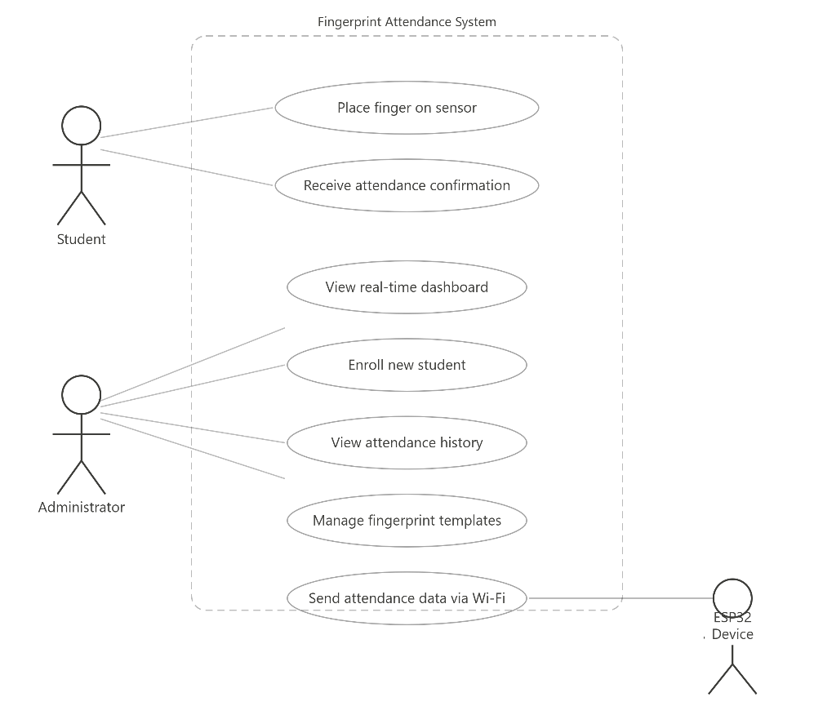
- Administrator: View dashboard, Enroll new student, View attendance history, Export records

Figure: Use Case Diagram of Fingerprint Attendance System

Class Diagram (Key Classes)

Class | Key Attributes | Key Methods
Student | studentId, name, rollNo, fingerprintId | enroll(), getAttendance()
AttendanceRecord | recordId, studentId, timestamp, date, status | log(), getByDate()
FingerprintSensor | sensorId, capacity | capture(), match(), store()
ESP32Controller | ipAddress, wifiSSID | connect(), sendData()
Dashboard | records[], students[] | render(), filterByDate()

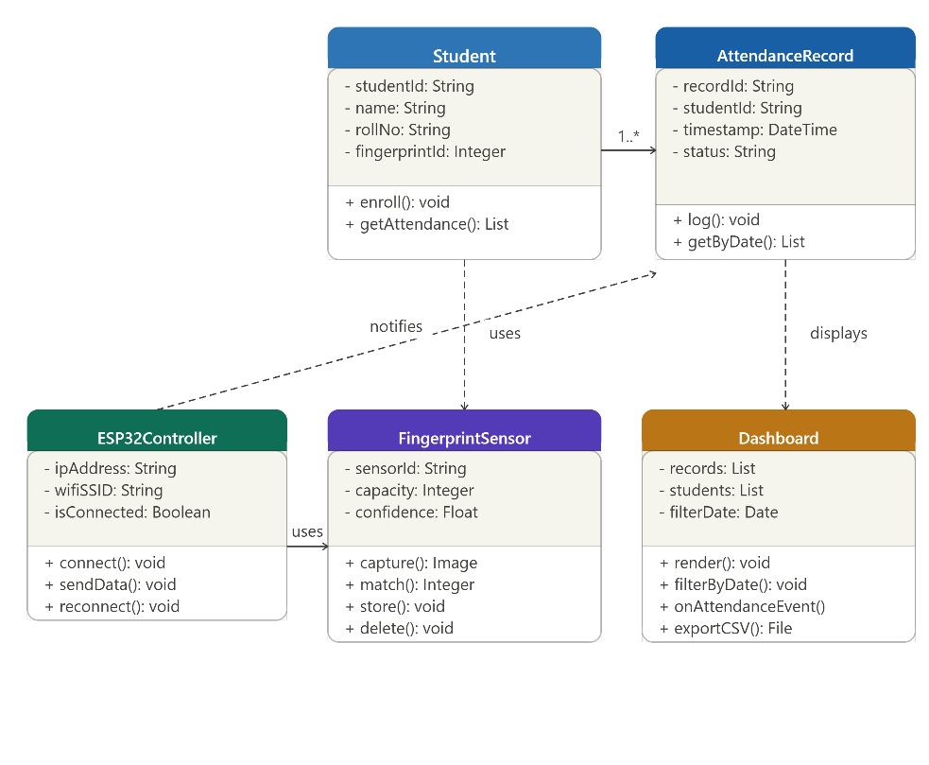

Figure: Class Diagram of Fingerprint Attendance System

Sequence Diagram — Attendance Marking Flow
- Student places finger on fingerprint sensor
- ESP32 captures fingerprint image
- ESP32 matches fingerprint against stored templates
- If match found: ESP32 sends POST request to backend API with studentId and timestamp
- Backend saves attendance record to database
- Backend emits real-time event (WebSocket) to frontend dashboard
- Dashboard updates to show student as present
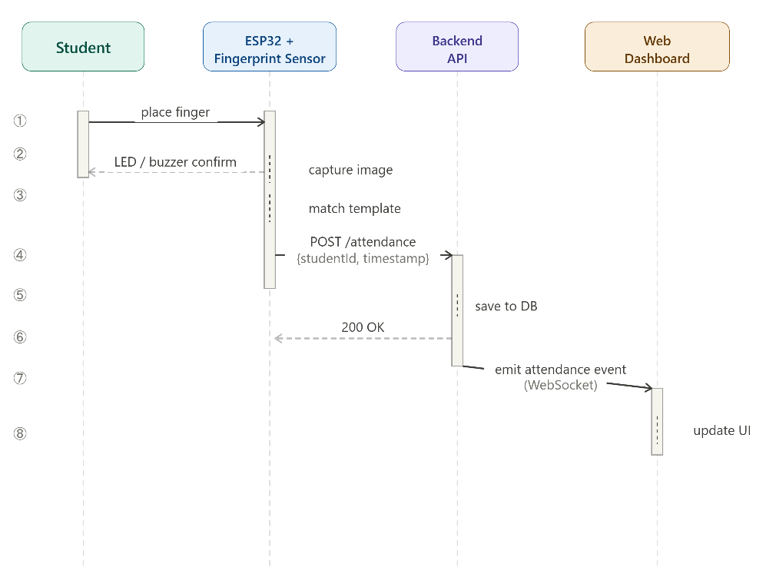

Figure: Sequence Diagram of Attendance Marking Flow

6.2 Architectural Overview
The system follows a 3-tier IoT architecture:
Tier | Component | Responsibility
Perception Layer | ESP32 + Fingerprint Sensor | Biometric capture and matching
Network Layer | Wi-Fi / HTTP / WebSocket | Data transmission between hardware and server
Application Layer | Backend API + Web Dashboard | Data processing, storage, and visualization
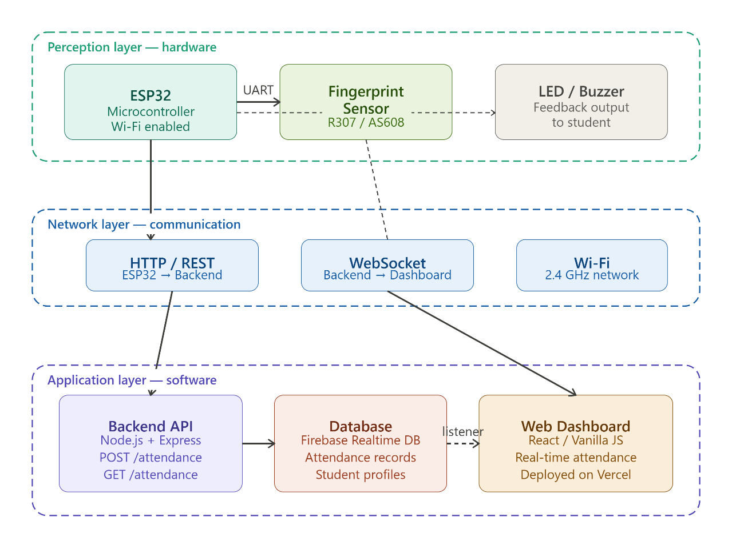

Figure: Architectural Overview of Fingerprint Attendance System

7. Implementation

7.1 Agile Development Process
The project was developed using an Agile (Scrum-inspired) methodology with 5 one-week sprints. A product backlog was maintained on Trello and GitHub was used for version control throughout.

Sprint | Goal | Deliverable
Sprint 1 | Project setup and hardware testing | ESP32 + sensor communication verified
Sprint 2 | Fingerprint enrollment and matching firmware | Working enrollment and match logic on ESP32
Sprint 3 | Backend API development | REST endpoints for logging and retrieving attendance
Sprint 4 | Frontend dashboard development | Real-time dashboard displaying live attendance data
Sprint 5 | Testing, bug fixes, and deployment | Deployed system on Vercel + final documentation

7.2 Development Details
ESP32 Firmware:
- Written in C++ using Arduino framework via Arduino IDE.
- Handles Wi-Fi connection, fingerprint capture, template matching, and HTTP POST to backend
Backend:
- Node.js + Express.js REST API
- Endpoints: POST /attendance (log attendance), GET /attendance (retrieve records), POST /enroll (register new fingerprint ID)
- Database: MongoDB Atlas for real-time sync with frontend
Frontend:
- Responsive web dashboard hosted on Vercel
- Displays student attendance status in real-time using WebSocket / Firebase listeners
- Shows present/absent counts, timestamps, and student names

8. Testing

8.1 Types of Testing Performed
- Unit Testing — individual functions tested (fingerprint match logic, API endpoints)
- Integration Testing — ESP32 to backend communication tested end-to-end
- System Testing — full flow from fingerprint scan to dashboard update verified
- User Acceptance Testing — tested with sample users for ease of use

8.2 Test Cases and Results

TC # | Test Case | Input | Expected Output | Result
TC-01 | Valid fingerprint attendance | Enrolled finger placed on sensor | Attendance logged, dashboard updates | PASS
TC-02 | Unknown fingerprint | Unregistered finger placed on sensor | Alert: fingerprint not recognized | PASS
TC-03 | Enroll new student | Admin submits studentId + places finger | New template stored in sensor | PASS
TC-04 | Dashboard real-time update | Attendance logged via ESP32 | Dashboard reflects change within 2s | PASS
TC-05 | View attendance history | Admin selects date filter | Records for selected date displayed | PASS
TC-06 | Duplicate attendance | Same finger scanned twice in one session | Second scan ignored or flagged | PASS
TC-07 | Wi-Fi disconnection | ESP32 loses Wi-Fi mid-session | Error logged; reconnection attempted | PASS

9. Observations and Discussion

9.1 Results and Screenshots
The deployed web dashboard (accessible at https://fingerprint-attendance-system-gray.vercel.app/) successfully demonstrates the real-time attendance tracking interface. The dashboard renders attendance records, shows student status, and updates dynamically upon new entries.

Login Page:
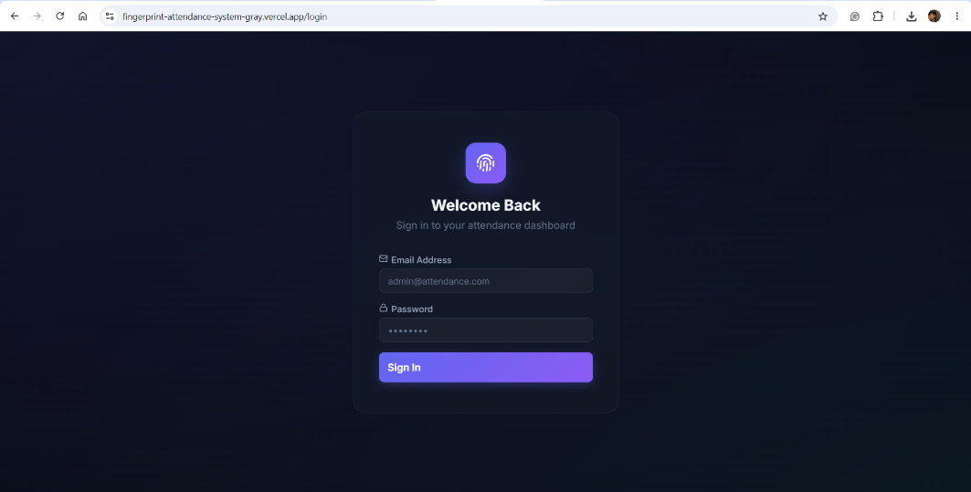

Dashboard:
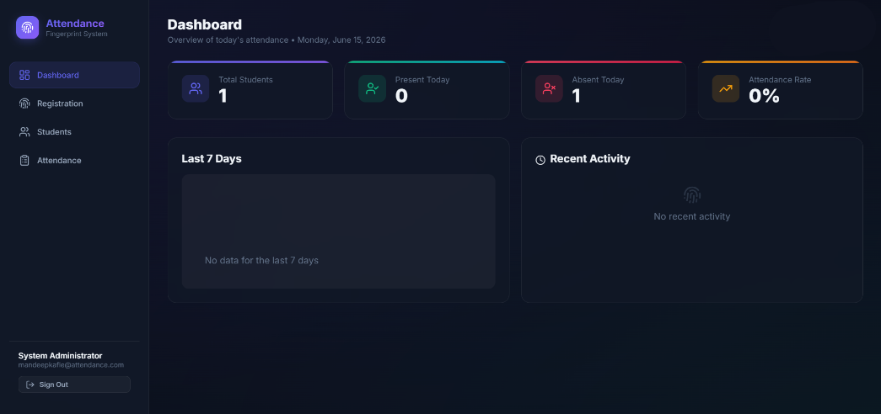

Registration:
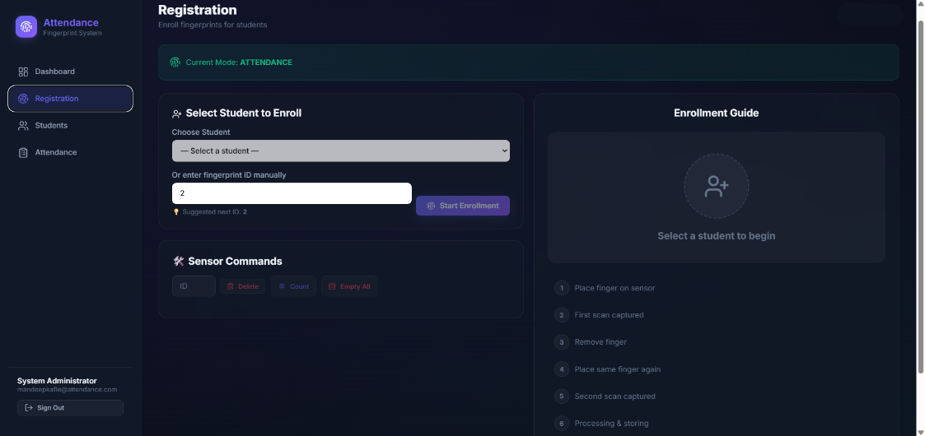

Students:
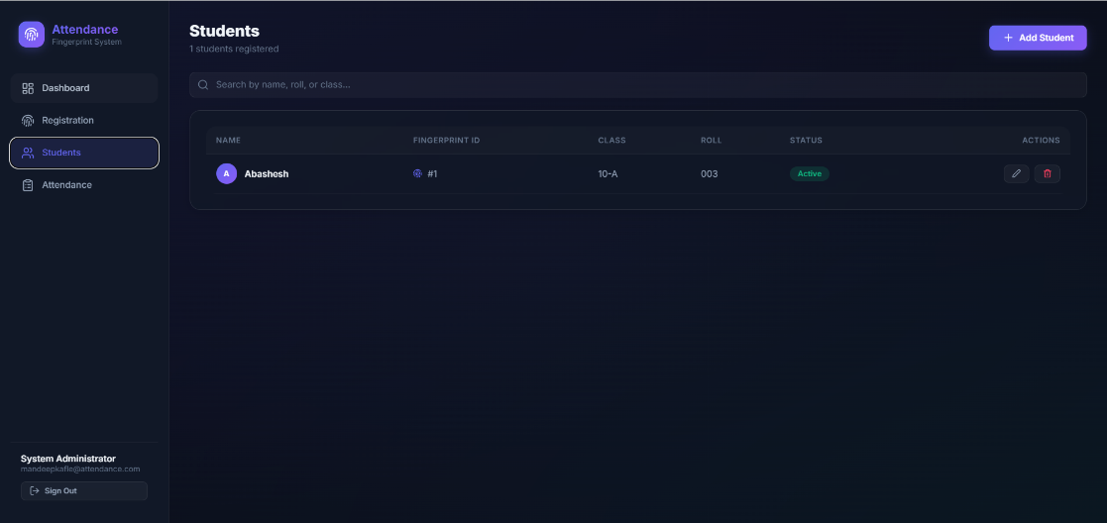

Attendance:

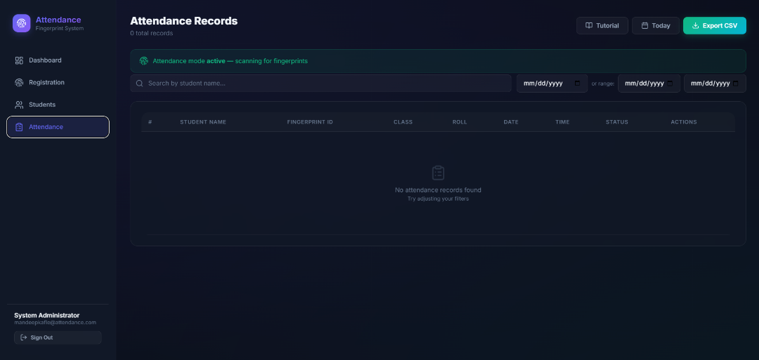

9.2 Challenges Faced
- ESP32 Wi-Fi stability — intermittent disconnections required implementing a reconnection loop in firmware.
- Fingerprint sensor sensitivity — false rejections occurred with dry fingers; resolved by adjusting confidence threshold.
- Real-time sync latency — initial polling approach caused delay; replaced with WebSocket/Firebase listener for instant updates.
- CORS issues — backend API required proper CORS headers for frontend communication.

9.3 Insights and Improvements
- The system could be extended with face recognition as a secondary biometric for higher security.
- Adding SMS or email notifications when a student is marked absent would improve utility.
- A mobile app companion would make the dashboard more accessible for teachers on the go.
- Implementing offline storage on the ESP32 would handle scenarios where Wi-Fi is unavailable.

10. Conclusion
This project successfully demonstrates the design and implementation of a real-time ESP32-based fingerprint attendance system. By integrating IoT hardware with a modern web stack, the system eliminates the inefficiencies of manual attendance and provides administrators with an instant, reliable view of attendance data.

Throughout the project, an Agile development approach was followed, enabling iterative improvements and early detection of issues. The system was developed across five sprints — covering hardware firmware, backend API, frontend dashboard, and final testing and deployment.

Key learning outcomes from this project include hands-on experience with ESP32 programming, REST API design, real-time web development using WebSockets, Agile project management, and the practical challenges of IoT system integration. The project reinforced how software engineering principles apply equally in embedded and web development contexts.

Future enhancements could include multi-factor biometrics, mobile notifications, and offline resilience to make the system production-ready for real institutional deployment.

