WIRELESS COMMUNICATIONS

ASSIGNMENT – II

Mandeep Sarangal

251000108

1. **Consider a cellular service provider in London, Ontario is allocated the spectrum bandwidth for 210 channels (210*50Khz = 10.5Mhz), and its coverage area is divided into 21 cells, as show in Figure 1.**

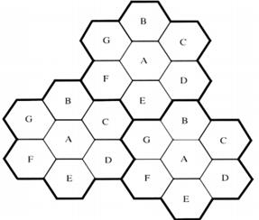

Cellular communication system for Question 1

**(a) Determine the maximum of active users can be supported at same time when there is NO frequency reuse.**

Each cell can support 10 users, if the distribution of the active users is even.

Therefore, active users supported = 21 x 10 = 210

**(b) Determine the system capacity with cluster size of 7 and 3, respectively.**

For cluster size of 7: All cells are grouped into cluster of 7 cells and each cluster employs all of the frequencies. This means that the capacity is increased by a factor of 3.

Therefore, Capacity = 210 x 3 = 630 channels

For cluster size of 3: All cells are grouped into cluster of 3 cells and each cluster employs all of the frequencies. This means that the capacity is increased by a factor of 7.

Therefore, Capacity = 210 x 7 = 1470 channels

**(c) Explain why the system capacity in (b) is increased, compared with (a). Discuss how to choose the cluster size in a cellular network.**

For a mode of operation which is full-duplex, a radio channel contains a pair of channel frequencies, each of which is transmitted at a frequency. The radio channel F1 is used to call one cell in the geographical area C1 with the coverage radius R, and F1 can be used again in another cell with the distance D and the coverage radius R.

Theoretically, K should be larger, however, the total number of channels allocated is fixed. If K is too large, the number of channels allocated to each cell in the K cells will decrease, and if the total number of channels in the K cells is divided as K increases, the relay efficiency decreases. Similarly, if a group of channels in the same area is assigned to two different working networks, the system frequency efficiency will be reduced. Therefore, the question now is how to obtain a minimum K value under the condition of satisfying the system performance. To solve it, it is necessary to estimate the co-channel interference and select the minimum frequency reuse distance D to reduce co – channel interference. When the conditions are satisfied, the number of cells constituting the unit radio zone group K = i2 + ij + j2.

**(d) What is link budget analysis in wireless communications? Discuss its applications in wireless communications network deployment.**

When a Signal travels from a transmitter to receiver, there are events like gain and loss during signal transmission through mediums like cable, fiber etc. A Link budget analysis is an account of all such gains and losses. The attenuation of the transmitted signal due to propagation, as well as the antenna gains, feed line and miscellaneous losses are also accounted for. Arbitrarily varying channel gains such as fading are taken into account by adding some margin depending on the anticipated severity of its effects. A link budget equation would look like as follows:

Power Received (dB) = Power Transmitted (dB) + Gains (dB) − Losses (dB)

In practical situations like Deep Space Telecommunications, Weak signal DXing etc. other sources of signal loss must also be accounted for. The transmitting and receiving antennas may be partially cross-polarized. The cabling between the radios and antennas may introduce significant additional loss.

Also, Guided media such as coaxial and twisted pair electrical cable, radio frequency waveguide and optical fiber have losses that are exponential with distance. The path loss will be in terms of dB per unit distance. This means that there is always a crossover distance beyond which the loss in a guided medium will exceed that of a line-of-sight path of the same length. Long distance fiber-optic communication became practical only with the development of ultra- transparent glass fibers. A typical path loss for single mode fiber is 0.2 dB/km, far lower than any other guided medium.

Because of building obstructions such as walls and ceilings, propagation losses indoors can be significantly higher. This occurs because of a combination of attenuation by walls and ceilings, and blockage due to equipment, furniture, and even people.

**Link Budget Applications**

* In communications like Earth-Moon-Earth, link budgets are important. High power and high gain antennas must be used as the path loss is huge over an enormous return distance of 770,000 kilometers.
* The Voyager Program spacecraft have the highest known path loss and lowest link budgets of any telecommunications circuit. Although the Deep Space Network has been able to maintain the necessary technological advances to maintain the link, the received field strength is still very weak.

**2. Consider a cellular communication network.**

**(a) Explain the concept of frequency reuse in cellular communication network.**

Frequency reuse is the practice of splitting an area into smaller regions that do not overlap so that each utilizes the full range of frequencies without interference. The introduction of this concept was a major step in the development of mobile phone technology. Before the advent of cellular phones, radio telephones and other mobile communications devices relied on a single, central antenna tower to service an entire city. Each phone required a large antenna powerful enough to transmit a signal over the potentially great distance to that tower. In addition, there was a limit to the amount of phone traffic that could be supported at a given time because each tower only offered a limited number of channels.

After some good amount of research, it was realized that they could increase the cap on the number of simultaneous users by applying their current technology to a smaller scale. Accordingly, they introduced frequency reuse. Mobile communications providers increased the total number of towers and reduced the size of each one's service area. Although each tower had a limited number of channels, the non- overlapping nature of the service areas allowed the same frequency to be used in each one without interference. By doing so, mobile communications providers greatly expanded the number of potential users.

**(b) Explain the need for handoff process in cellular communications and discuss how to choose a proper handoff threshold.**

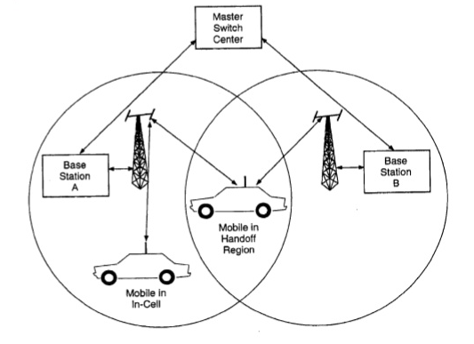

In Cellular communication, when a mobile user is on a call and travels from one area of coverage or cell to another cell, the call should be transferred to the new cell’s base station. Failing which, the call will be dropped because the link with the current base station becomes too weak as the mobile recedes. This ability for transference in cellular communication is called handoff

Two types of handoff:

**Hard handoff**

With hard handoff, the link to the prior base station is terminated before or as the user is transferred to the new cell’s base station. That is to say that the mobile is linked to no more than one base station at a given time. Initiation of the handoff may begin when the signal strength at the mobile received from base station 2 is greater than that of base station 1. The signal strength measures are really signal levels averaged over a chosen amount of time. This averaging is necessary because of the Rayleigh fading nature of the environment in which the cellular network resides. A major problem with this approach to handoff decision is that the received signals of both base stations often fluctuate. When the mobile is between the base stations, the effect is to cause the mobile to wildly switch links with either base station. The base stations bounce the link with the mobile back and forth. Hence the phenomenon is called ping- ponging.

**Soft handoff**

Soft handoff technology is used by code-division multiple access (CDMA) systems. Older networks use frequency division multiplex (FDM) or time division multiplex (TDM). In CDMA, all repeaters use the same frequency channel for each mobile phone set, no matter where the set is located. Each set has an identity based on a code, rather than on a frequency (as in FDM) or sequence of time slots (as in TDM). Because no change in frequency or timing occurs as a mobile set passes from one base station to another, there are practically no dead zones. As a result, connections are almost never interrupted or dropped.

**Comparison**

Soft handoff is advantageous over hard handoff because the mobile does not lose contact with the system during handoff execution. Ping ponging is eliminated and an extra measure of performance is obtained through diversity combining to mitigate fading. Furthermore, more control may be given to the mobile in handoff decisions. This autonomous handoff decision ability, selection diversity, and inherent improvement of reliable handoffs with fewer unnecessary decisions, make soft handoff an attractive choice meriting further study as it is being used in third generation CDMA.

**(c) Discuss all possible interferences in cellular communications network and their causes.**

Anything which modifies, or disrupts a signal as it travels along a channel between a source and a receiver is called interference. The term typically refers to the addition of unwanted signals to a useful signal. The term typically refers to the addition of unwanted signals to a useful signal. Interference is at least an occasional problem with most types of radio equipment, including wireless microphones. The effects of interference range from being a minor annoyance to making the wireless system completely unusable. Serious interference is not as common as is sometimes assumed, especially when some simple precautions are taken.

Types of interference:

*Radio frequency interference* is caused by radio and TV transmitters, communications equipment, cable television systems and other types of equipment that generate radio frequency energy as part of their operation.

*Electrical interference* is caused by computers and digital equipment, heavy electrical equipment, lighting systems, faulty electrical devices, etc.

*Inter modulation* is a type of interference caused by the internal combination of strong radio signals in wireless receivers.

Simply knowing which type of interference is present helps avoid wasting time on unproductive approaches and greatly simplifies the process of finding the real source of the problem.

**(d) Use the following figure and explain the worst scenario of co-channel interference in cellular communication. Discuss how the frequency reuse ratio of a cellular network is determined. The free space signal propagation model can be used.**

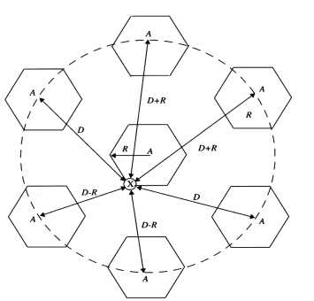

The first tier of co-channel cells for a cluster size of N = 7. When the mobile is at the cell boundary of point X, it experiences worst case co-channel interference on the forward channel. The marked distances between the mobile and different co-channel cells are based on approximations made for easy analysis.

For N = 7, the co-channel reuse ratio Q is 4.6, and the worst-case S/I is approximated as 49.56 (17 dB) whereas an exact solution yields 17.8 dB

Hence for a seven-cell cluster, the S/I ratio is slightly less than 18 dB for the worst case.

To design the cellular system for proper performance in the worst case, it would be necessary to increase N to the next largest size,

This obviously entails a significant decrease in capacity, since 12-cell reuse offers a spectrum utilization of 1/12 within each cell, whereas seven-cell reuse offers a spectrum utilization of 1/7. In practice, a capacity reduction of 7/12 would not be tolerable to accommodate for the worst- case situation which rarely occurs. From the above discussion, it is clear that co-channel interference determines link performance, which in turn dictates the frequency reuse plan and the overall capacity of cellular systems.

**3. Both analog and digital modulation schemes are widely used in wireless communication systems.**

**(a) Explain why modulation techniques are important for wireless communications.**

The modulation process consists of two signals: the modulating signal and the carrier. The modulating signal is nothing but the baseband signal or information signal while the carrier is a high frequency sinusoidal signal. In the modulation process, some parameter of the carrier wave, like amplitude, frequency or phase is varied with respect to the modulating signal. The resultant modulated signal is then transmitted. At the receiver end the received signal is demodulated and gets the original information signal back.

The carrier wave carries the information signal from the transmitter to receiver in the process of modulation. Baseband transmission has many limitations which can be overcome using modulation. The baseband signal is translated i.e., shifted from low frequency to high frequency during modulation. This frequency shift is proportional to the frequency of carrier.

Some advantages of Modulation:

*Increase in range of communication*

The frequency of baseband signal is low, and the low frequency signals cannot travel long distance when they are transmitted. They get heavily attenuated. The attenuation reduces with increase in frequency of the transmitted signal, and they travel longer distance. The modulation process increases the frequency of the signal to be transmitted. Therefore, it increases the range of communication.

*Increase in Range of Communication*

The frequency of baseband signal is low, and the low frequency signals cannot travel long distance when they are transmitted. They get heavily attenuated. The attenuation reduces with increase in frequency of the transmitted signal, and they travel longer distance. The modulation process increases the frequency of the signal to be transmitted. Therefore, it increases the range of communication.

*Prevents mixing of signals*

If the baseband sound signals are transmitted without using the modulation by more than one transmitter, then all the signals will be in the same frequency range. Therefore, all the signals get mixed together and a receiver cannot separate them from each other. Hence, if each baseband sound signal is used to modulate a different carrier then they will occupy different slots in the frequency domain. This is how modulation prevents signals from mixing.

**(b) Discuss the differences between analog and digital modulation principles.**

The main difference between analog modulation and digital modulation is in the manner that they transmit data. With analog modulation, the input needs to be in the analog format, while digital modulation needs the data in a digital format. There are differences in the input signal and as a result the output signal is also quite different. In analog modulation, any value between the maximum and minimum is considered to be valid. It is not so with digital modulation as only two values are considered valid; one value to represents 1 and another to represent 0. Everything else is considered as noise and hence ignored. Since most signals that we transmit are analog in nature, like one’s voice, it is far simpler to do analog modulation than digital. If you want to transmit a voice using digital modulation, you’d need to pass it through an analog-to-digital converter before transmission and a digital-to- analog converter at the receiver to recover the original signal. Both the cost and complexity to transmit the signal increases with additional steps of digital modulation.

Digital modulation has greater fidelity over analog transmission. With analog modulation, any noise or interference that falls in the given frequency bandwidth gets mixed with the actual signal. Although there are a number of ways to mitigate noise, it will still cause some amount of degradation. Because digital modulation only recognizes 0’s and 1’s, any noise is virtually eliminated once the receiver discerns whether a “0” or a “1” was transmitted. The output signal will be literally identical to what was transmitted, unless the signal is very badly distorted. There are a number of other modulation techniques under both analog modulation and digital modulation, each with its own strengths and weaknesses. Each technique has its basic commonalities of transmitting either a digital or analog signal.

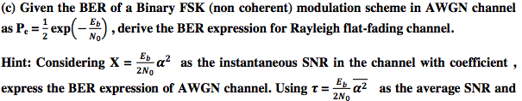

../Screen%20Shot%202018-04-10%20at%2011.02.59%20AM.png

Transmitted Signal =

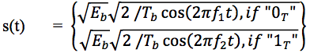

Received signal =

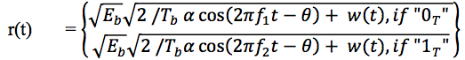

In the following development of the optimum receiver, both the random amplitude,../Screen%20Shot%202018-04-10%20at%2010.50.59%20AM.png and phase../Screen%20Shot%202018-04-10%20at%2010.52.13%20AM.png are completely unknown at the receiver. This type of non coherent demodulation is commonly used due to its simple implementation. If the channel fading is sufficiently slow, then it is possible to estimate the random phase from the received signal.

**../Screen%20Shot%202018-04-10%20at%2011.05.28%20AM.png**

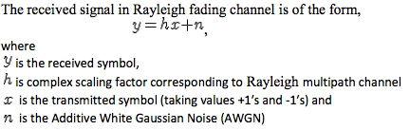

The channel is flat fading – In simple terms, it means that the multipath channel has only one tap. So, the convolution operation reduces to a simple multiplication. The channel is randomly varying in time – meaning each transmitted symbol gets multiplied by a randomly varying complex number . Since is modeling a Rayleigh channel, the real and imaginary parts are Gaussian distributed having mean 0 and variance 1/2. The noise has the Gaussian probability density function with

 with  and 

Also, the channel is known at the receiver. Equalization is performed at the receiver by dividing

the received symbol by the apriori known i.e.

 where  is the additive noise scaled by the channel coefficient

Bit Error Rate, If you recall, in the post on BER computation in AWGN, the probability of error for transmission of either +1 or -1 is computed by integrating the tail of the Gaussian probability density function for a given value of bit energy to noise ratio.

The bit error rate: 

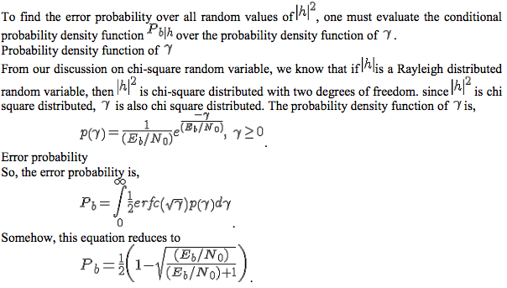

../Screen%20Shot%202018-04-10%20at%2011.17.38%20AM.png

**4. Orthogonal Frequency Division Multiplexing (OFDM) is generally considered as one of the premier transmission technologies for broadband wireless communications.**

**(a) Discuss the general principle of OFDM and its advantages when compared with single carrier modulation.**

Orthogonal frequency-division multiplexing (OFDM) is a method of encoding digital data on multiple carrier frequencies. OFDM has developed into a popular scheme for wideband digital communication, used in applications such as digital television and audio broadcasting, DSL Internet access, wireless networks, power line networks, and 4G mobile communications. OFDM is a frequency-division multiplexing (FDM) scheme used as a digital multi- carrier modulation method. A large number of closely spaced orthogonal sub-carrier signals are used to carry data on several parallel data streams or channels. Each sub-carrier is modulated with a conventional modulation scheme (such as quadrature amplitude modulation or phase-shift keying) at a low symbol rate, maintaining total data rates similar to conventional single- carrier modulation schemes in the same bandwidth.

The primary advantage of OFDM over single-carrier schemes is its ability to cope with severe channel conditions (for example, attenuation of high frequencies in a long copper wire, narrowband interference and frequency-selective fading due to multipath) without complex equalization filters.

Channel equalization is simplified because OFDM may be viewed as using many slowly modulated narrowband signals rather than one rapidly modulated wideband signal. The low symbol rate makes the use of a guard interval between symbols affordable, making it possible to eliminate inter symbol interference (ISI) and utilize echoes and time-spreading (on analogue TV these are visible as ghosting and blurring, respectively) to achieve a diversity gain, i.e. a signal-to-noise ratio improvement. This mechanism also facilitates the design of single frequency networks(SFNs), where several adjacent transmitters send the same signal simultaneously at the same frequency, as the signals from multiple distant transmitters may be combined constructively, rather than interfering as would typically occur in a traditional single- carrier system.

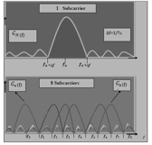

**(b) Draw the block diagram of an OFDM system with FFT/IFFT based modulation/demodulation, in-band pilots and cyclic prefix insertion.**

In OFDM system, here an input data symbols are supplied into a channel encoder that data are mapped onto BPSK/QPSK/QAM constellation. The data symbols are converted from serial to parallel and using Inverse Fast Fourier Transform (IFFT) to achieve the time domain OFDM symbols. Time domain symbols can be represented as:

xn = IFFT {Xk} = 1 2 −1 =0 0 ≤ ≤ N – 1 (1)

Where, Xk is the transmitted symbol on the kth subcarriers N is the number of subcarriers Time domain signal is cyclically extended to prevent Inter Symbol Interference (ISI) from the former OFDM symbol using cyclic prefix

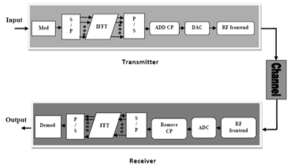

The Digital to Analog Converter (DAC) is performed to convert the baseband digital signal into analog signal. This operation is executed in DAC block of diagram. Then, the analog signal is proceeded to the Radio Frequency (RF) frontend. The RF frontend performs operations after receiving the analog signal. The signal is up converted to RF frequencies using mixer and amplified by using Power Amplifier (PAs) and then transmitted through antennas. At the receiver side, the received signal is down converted to base band signal by RF front end. The analog signal is digitized and resampled by the Analog to Digital Converter(ADC). The ADC is used to digitize the analog signal and re-samples it. In the figure, frequency and time synchronization block are not shown because of simplicity. Cyclic prefix is removed from the signal in frequency domain. This step is done by the Fast Fourier Transform (FFT) block. The received symbols in the frequency domain can be represented as:

Y (k) = H (k) Xm (k) + W (k)- (2) where, Y (k) is the received symbol on the k th subcarrier, H (k) is the frequency response of the channel on the same subcarrier and W (k) is the additive noise added to kth , subcarrier which is generally assumed to be Gaussian random variable with zero mean and variance of 2 .

Thus, simple one tap frequency domain equalizers can be employed to get the transmitted symbols. After FFT signals are deinterleaved and decoded to recover the original signal.

**(c) Explain how equalization is achieved in OFDM system.**

When either the channel time variation is absent, i.e., for LTI multipath channels, or it can be neglected, the channel impulse response (CIR) is constant over time. Hence, becomes [HT[k]]n, m = h[0, (n – m) mod L], i.e., HT [k] = HT is circulant and constant over the OFDM blocks. In this scenario, the CP not only eliminates the ISI, which could be removed by any kind of sufficiently long guard interval, e.g., by trailing zeros. In addition, the CP induces a time – domain circular convolution of the transmitted signal with the CIR, which corresponds to a scalar multiplication in the discrete frequency domain. Because the columns of the DFT matrix, which linearly precodes the OFDM data, are eigenvectors of circulant matrices, the eigenvalue decomposition of HT is given by HT = WH∧ W. Consequently, HF[k] = HF = ∧ is diagonal, which shows that in LTI channels there is no ICI. A continuous – time interpretation of OFDM systems is that, for every OFDM block, the lth symbol is transmitted in the frequency domain by a sinc function centered on the lth subcarrier. The zeros of this sinc function are located on the other equispaced subcarriers, which guarantees ICI – free reception by DFT spectrum sampling. It is easy to derive

../Screen%20Shot%202018-04-10%20at%2012.08.38%20PM.png

i.e., HF contains on its diagonal the DFT of the CIR. Due to the diagonal frequency – domain channel matrix, the input – output relation can be expressed as

../Screen%20Shot%202018-04-10%20at%2012.10.29%20PM.png

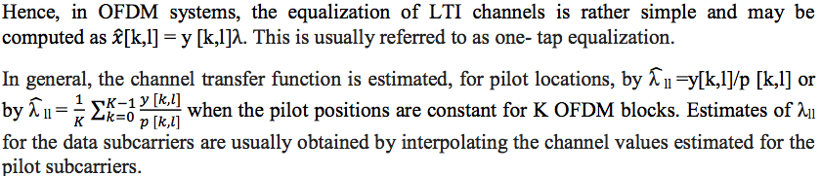

**(d) What is Peak-to-average power ratio (PAPR) in OFDM and elaborate on the main problems associated with this.**

The OFDM technique divides the total bandwidth into many narrow sub-channels and sends data in parallel. It has various advantages, such as high spectral efficiency, immunity to impulse interference and, frequency selective fading without having powerful channel equalizer. But one of the major drawbacks of the OFDM system is high PAPR. OFDM signal consists of lot of independent modulated subcarriers, which are created the problem of PAPR. It is impossible to send this high peak amplitude signals to the transmitter without reducing peaks. So, we have to reduce high peak amplitude of the signals before transmitting. A major source for reducing energy costs is to increase the efficiency of the high-power amplifier (HPA) in the radio frequency (RF) front end of the base stations. However, efficiency of the HPA is directly related to the peak-to-average power ratio (PAPR) of the input signal.

The problem especially becomes serious in orthogonal frequency-division multiplexing (OFDM) multicarrier transmission, which is applied in many important wireless standards such as the Third- Generation Partnership Project (3GPP) Long-Term Evolution Advanced (LTE-A) standard m. The PAPR problem still prevents OFDM from being adopted in the uplink of mobile communication standards, and, besides power efficiency, it can also place severe constraints on output power and therefore coverage in the downlink. The design challenge In OFDM transmission, many subcarriers (constructively or destructively) add up at a time that causes large fluctuations of the signal envelope; a transmission that is free from any distortion requires linear operation of HPA over a range N times the average power. As practical values of subcarriers are large, these high dynamics afford HPA operation well below saturation so that most of the supply power is wasted with deleterious effect on either battery life time in mobile applications (uplink) or energy cost of network operation (downlink). In practice, these values are not tolerable, and from a technology viewpoint it is also challenging to provide such a large linear range. Hence, the HPA output signal is inevitably cut off at some point relative to the averagepower (clipping level) leading to in-band distortion in the form of intermodulation terms and spectral regrowth into adjacent channels. The effect is illustrated where the distorted OFDM signal and corresponding impact on the signal points are depicted. The PAPR problem brings up several challenges for the system designer: one challenge is to adjust HPA parameters (HPA backoff, digital pre-distortion) in some specific way so that power efficiency is traded against nonlinear distortion, which effects the data transmission on a global scale. How to capture this tradeoff by a suitable metric on a component level is not clear yet. Special HPA architectures such as Doherty and others can help to improve on this tradeoff. We also mention that other design constraints such as costs might prevent specific architectures. A second challenge is to process the baseband signal by peak power reduction algorithms in such a way that the key figures of merit in the aforementioned tradeoff are improved. This alternating procedure makes it apparent that the PAPR problem involves joint optimization of HPA, pre-distortion, and a signal processing unit. This interplay has only been marginally addressed so far, let alone in the context of multiuser systems equipped with multiple antennas such as LTE-A.

**5. Channel equalization techniques play a major role in restoration of original signal at the receiver eliminating different types of interferences.**

**(a) Please explain the main function of an equalizer in a communication system. Extend your answer to both time and frequency domain equalization.**

In communication, equalization is the reversal of distortion incurred by a signal transmitted through a channel. Equalizers are used to render the frequency response—for instance of a telephone line—*flat* from end-to-end. When a channel has been equalized the frequency

Domain attributes of the signal at the input are faithfully reproduced at the output. Telephones, DSL lines and television cables use equalizers to prepare data signals for transmission.

Equalizers are critical to the successful operation of electronic systems such as analog broadcast television. In this application, the actual waveform of the transmitted signal must be preserved, not just its frequency content. Equalizing filters must cancel out any group delay and phase delay between different frequency components.

Time- and frequency-domain per-tone equalization techniques for orthogonal frequency division multiplexing (OFDM) transmission over time- and frequency-selective channels. We present one mixed time- and frequency-domain equalizer (MTFEQ) and one frequency-domain per-tone equalizer. The MTFEQ consists of a one-tap time-varying (TV) time-domain equalizer (TEQ), which converts the doubly selective channel into a purely frequency-selective channel, followed by a one-tap frequency-domain equalizer (FEQ), which then equalizes the resulting frequency- selective channel in the frequency-domain. The frequency-domain per-tone equalizer (PTEQ) is then obtained by transferring the TEQ operation to the frequency-domain. While the one-tap TEQ of the MTFEQ optimizes the performance on all subcarriers in a joint fashion, the PTEQ optimizes the performance on each subcarrier separately. This results into a significant performance improvement of the PTEQ over the MTFEQ, at the cost of a slight increase in complexity.

**(b) Discuss the operation of ZF and MMSE equalizer. Use diagrams if needed.**

Zero Forcing Equalizer refers to a form of linear equalization algorithm used in communication systems which applies the inverse of the frequency response of the channel. This form of equalizer was first proposed by Robert Lucky.

The Zero-Forcing Equalizer applies the inverse of the channel frequency response to the received signal, to restore the signal after the channel. It has many useful applications. For example, it is studied heavily for IEEE 802.11n (MIMO) where knowing the channel allows recovery of the two or more streams which will be received on top of each other on each antenna. The name Zero Forcing corresponds to bringing down the inter symbol interference (ISI) to zero in a noise free case. This will be useful when ISI is significant compared to noise.

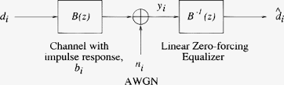

One computationally efficient method of forming an inverse filter is the zero-forcing technique. To formulate a set of FIR inverse filter coefficients, a training signal consisting of an impulse is transmitted over the channel. By solving a set of simultaneous equations based on the received sample values, a set of coefficients can be determined to force all but the center tap of the filtered response to 0. This means the N–1 samples surrounding the center tap will not contribute ISI. The main advantage of this technique is that the solution to the set of equations is reduced to a simple matrix inversion. The major drawback of ZFE is that the channel response may often exhibit attenuation at high frequencies around one-half the sampling rate (the folding frequency). Since the ZFE is simply an inverse filter, it applies high gain to these upper frequencies, which tends to exaggerate noise. A second problem is that the training signal, an impulse, is inherently a low-energy signal, which results in a much lower received signal-to-noise ratio than could be provided by other training signal types.

Advantage over ZF Equalization the MMSE criterion ensures an optimum trade–off between residual ISI in d[k] and noise enhancement. Therefore, MMSE equalizers achieve a significantly lower BEP compared to ZF equalizers at low–to–moderate SNRs.

A minimum mean square error (MMSE) estimator is an estimation method which minimizes the mean square error (MSE), which is a common measure of estimator quality, of the fitted values of a dependent variable. In the Bayesian setting, the term MMSE more specifically refers to estimation with quadratic loss function. In such case, the MMSE estimator is given by the posterior mean of the parameter to be estimated. Since the posterior mean is cumbersome to calculate, the form of the MMSE estimator is usually constrained to be within a certain class of functions. Linear MMSE estimators are a popular choice since they are easy to use, calculate,

and very versatile. It has given rise to many popular estimators such as the Wiener-Kolmogorov filter and Kalman filter.

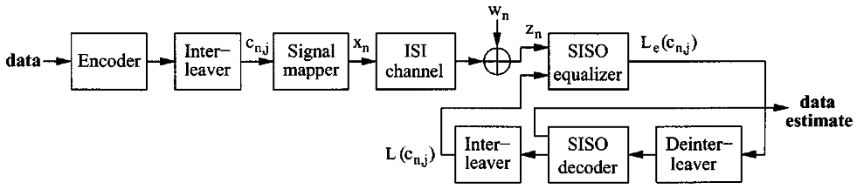

**(c) Describe the principle of decision feedback equalization (DFB).**

A decision feedback equalizer (DFE) is a filter that uses feedback of detected symbols to produce an estimate of the channel output. The DFE is fed with detected symbols and produces an output which typically is subtracted from the output of the linear equalizer. As in the case of linear equalizers the DFE consists of a real FIR filter, if the transmitted symbols are real, or a complex FIR filter if the symbols are complex.

Since the DFE can only estimate the post-cursors, typically it needs to be used in combination with a linear equalizer. During the steady-state operation, the DFE contains an estimate of the impulse response of the channel or of the convolution of the channel with the linear equalizer, if a linear equalizer is used as well. Since the DFE copies the channel output and the DFE output is subtracted from the incoming signal, it can compensate for severe amplitude distortion without increasing the noise in the highly-distorted frequency bands.

As in the case of a linear equalizer, usually DFE coefficients are updated with the LMS algorithm. When both a linear equalizer and a DFE are used, the adaptation algorithm needs to be designed properly to take advantage of the features of the two equalizers and to avoid equalization conflicts.

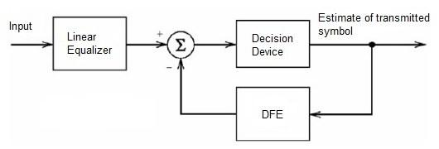

**(d) Briefly explain the concept of blind equalization.**

Blind equalization is a digital signal processing technique in which the transmitted signal is inferred (equalized) from the received signal, while making use only of the transmitted signal statistics. Hence, the use of the word blind in the name. Blind equalization is essentially blind deconvolution applied to digital communications. Nonetheless, the emphasis in blind equalization is on online estimation of the equalization filter, which is the inverse of the channel impulse response, rather than the estimation of the channel impulse response itself. This is due to blind deconvolution common mode of usage in digital communications systems, as a mean to extract the continuously transmitted signal from the received signal, with the channel impulse response being of secondary intrinsic importance. The estimated equalizer is then convolved with the received signal to yield an estimation of the transmitted signal.

**6. Please briefly answer the following questions.**

**(a) What is multiple access technique in digital communications? Please compare the principle, advantage and disadvantage of the three major multiple access techniques.**

Multiple access techniques are used to allow a large number of mobile users to share the allocated spectrum in the most efficient manner. As the spectrum is limited, so the sharing is required to increase the capacity of cell or over a geographical area by allowing the available bandwidth to be used at the same time by different users. This is done without disturbing the quality services of the existing customers.

FDMA, TDMA and CDMA are the three major multiple access techniques that are used to share the available bandwidth in a wireless communication system. Depending on how the available bandwidth is allocated to the users these techniques can be classified as narrowband and wideband systems. In wireless communication systems, it is often desirable to allow the subscriber to send simultaneously information to the base station while receiving information from the base station. A cellular system divides any given area into cells where a mobile unit in each cell communicates with a base station. The main aim in the cellular system design is to be able to increase the capacity of the channel i.e. to handle as many calls as possible in a given bandwidth with a sufficient level of quality of service. There are several different ways to allow access to the channel. These includes mainly the following: 1) Frequency division multiple- access (FDMA) 2) Time division multiple-access (TDMA) 3) Code division multiple-access (CDMA)

**Frequency Division Multiple Access**:

The FDMA is the simplest scheme used to provide multiple access. It separates different users by assigning a different carrier frequency. Multiple users are isolated using bandpass filters. In FDMA, signals from various users are assigned different frequencies, just as in an analog system. Frequency guard bands are provided between adjacent signal spectra to minimize crosstalk between adjacent channels. The advantages and disadvantages of FDMA with respect to TDMA or CDMA are:

**Advantages**

1. Capacity can be increased by reducing the information bit rate and using an efficient digital speech coding scheme.

2. Technological advances required for implementation are simple. A system can be configured so that improvements in terms of a lower bit rate speech coding could be easily incorporated.

3. Hardware simplicity, because multiple users are isolated by employing simple bandpass filters.

**Disadvantages**

1. The system architecture based on FDMA was implemented in first generation analog systems such as advanced mobile phone system (AMPS) or total access communication system (TACS).

The improvement in capacity depends on operation at a reduced signal-to-interference (S/I) ratio. But the narrowband digital approach gives only limited advantages in this regard so that modest capacity improvements could be expected from the allocated spectrum.

2. The maximum bit-rate per channel is fixed and small, inhibiting the flexibility in bit-rate capability that may be a requirement for computer fi le transfer in some applications in the future.

3. Inefficient use of spectrum, in FDMA if a channel is not in use, it remains idle and cannot be used to enhance the system capacity.

4. Crosstalk arising from adjacent channel interference is produced by nonlinear effects.

**Time Division Multiple Access:**

In a TDMA system, each user uses the whole channel bandwidth for a fraction of time compared to an FDMA system where a single user occupies the channel bandwidth for the entire duration. In a TDMA system, time is divided into equal time intervals, called slots. User data is transmitted in the slots. Several slots make up a frame. Guard times are used between each user’s transmission to minimize crosstalk between channels. Each user is assigned a frequency and a time slot to transmit data. The data is transmitted via a radio-carrier from a base station to several active mobiles in the downlink. In the reverse direction (uplink), transmission from mobiles to base stations is time-sequenced and synchronized on a common frequency for TDMA. The preamble carries the address and synchronization information that both the base station and mobile stations use for identification

In a TDMA system, the user can use multiple slots to support a wide range of bit rates by selecting the lowest multiplexing rate or multiple of it. This enables supporting a variety of voice coding techniques at different bit rates with different voice qualities. Similarly, data communications customers could use the same kinds of schemes, choosing and paying for the digital data rate as required. This would allow customers to request and pay for a bandwidth on demand. Depending on the data rate used and the number of slots per frame, a DMA system can use the entire bandwidth of the system or can employ an FDD scheme. The resultant multiplexing is a mixture of frequency division and time division. The entire frequency band is divided into a number of duplex channels (about 350 to 400 kHz). These channels are deployed in a frequency-reuse pattern, in which radio-port frequencies are assigned using an autonomous adaptive frequency assignment algorithm. Each channel is configured in a TDM mode for the downlink direction and a TDMA mode for the uplink direction.

The advantages and disadvantages of TDMA are:

**Advantages**

1. TDMA permits a flexible bit rate, not only for multiples of the basic single channel rate but also submultiples for low bit rate broadcast-type traffic.

2. TDMA offers the opportunity for frame-by-frame monitoring of signal strength/bit error rates to enable either mobiles or base stations to initiate and execute handoffs.

3. TDMA, when used exclusively and not with FDMA, utilizes bandwidth more efficiently because no frequency guard band is required between channels.

4. TDMA transmits each signal with sufficient guard time between time slots to accommodate time inaccuracies because of clock instability, delay spread, transmission delay because of propagation distance, and the tails of signal pulse because of transient responses.

**Disadvantages**

1. For mobiles and particularly for hand-sets, TDMA on the uplink demands high peak power in transmit mode, that shortens battery life.

2. TDMA requires a substantial amount of signal processing for matched filtering and correlation detection for synchronizing with a time slot.

3. TDMA requires synchronization. If the time slot synchronization is lost, the channels may collide with each other.

4. One complicating feature in a TDMA system is that the propagation time for a signal from a mobile station to a base station varies with its distance to the base station.

**Channel Division Multiple Access**

CDMA is another pure digital technique. It is also known as spread spectrum because it takes the digitized version of an analog signal and spreads it out over a wider bandwidth at a lower power level. This method is called direct sequence spread spectrum (DSSS) as well. The digitized and compressed voice signal in serial data form is spread by processing it in an XOR circuit along with a chipping signal at a much higher frequency. In the CDMA IS-95 standard, a 1.2288- Mbit/s chipping signal spreads the digitized compressed voice at 13 kbits/s. The chipping signal is derived from a pseudorandom code generator that assigns a unique code to each user of the channel. This code spreads the voice signal over a bandwidth of 1.25 MHz. The resulting signal is at a low power level and appears more like noise. Many such signals can occupy the same channel simultaneously. For example, using 64 unique chipping codes allows up to 64 users to occupy the same 1.25-MHz channel at the same time. At the receiver, a correlating circuit finds and identifies a specific caller’s code and recovers it.

The third generation (3G) cell-phone technology called wideband CDMA (WCDMA) uses a

similar method with compressed voice and 3.84-Mbit/s chipping codes in a 5-MHz channel to allow multiple users to share the same band.

**Advantages**

1. Efficient practical utilization of fixed frequency spectrum.

2. Flexible allocation of resources.

3. Many users of CDMA use the same frequency, TDD or FDD may be used.

4. Multipath fading may be substantially reduced because of large signal bandwidth.

5. No absolute limit on the number of users, Easy addition of more users.

6. Better Signal Quality

**Disadvantages**

1. As the number of users increases, the overall quality of service decreases 

2. Self-jamming

3. Near- Far- problem arises.

**(b) Discuss why diversity is needed in wireless systems. Briefly explain the spatial, temporal, frequency, and polarization diversity techniques.**

Diversity technique is used to decreased the fading effect and improve system performance in fading channels. Instead of transmitting and receiving the desired signal through one channel, we obtain **L** copies of the desired signal through **M** different channels. The idea is that while some copies may undergo deep fades, others may not. We might still be able to obtain enough energy to make the correct decision on the transmitted symbol.

**Spatial / Space diversity:**

This diversity technique uses multiple antennas at the transmitting and Reception side. So, L antennas to receive L copies of the transmitted signal. The antennas should be spaced far enough apart so that different received copies of the signal undergo independent fading. This is Different from frequency diversity and temporal diversity; no additional work is required on the transmission end and no additional bandwidth or transmission time is required. However, physical constraints may limit its applications. Spatial diversity can be employed to combat both frequency selective fading and time selective fading. The spatial diversity increased the SNR.

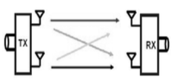

**Time / Temporal diversity:**

Another approach to achieve diversity is to transmit the desired signal in L different periods of time, i.e., each symbol is transmitted L times. The intervals between transmission of the same symbol should be at least the coherence time(∆T) c. so that different copies of the same symbol undergo independent fading. Optimal combining can also be obtained with the maximum ratio combiner. Notice that sending the same symbol L times is applying the (L,1) repetition code. Actually, non-trivial coding can also be used. Error control coding, together with interleaving, can be an effective way to combat time selective (fast)fading.

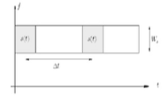

**Frequency / Multipath Diversity:**

The diversity can be achieved by modulating information signal through L different carrier frequencies. Each carrier should be separated from the others by at least the coherence bandwidth (∆f) c so that different copies of the signal undergo independent fading. This L independently faded copies are “optimally” combined at the receiver to construct the original signal. The optimal combiner is the maximum ratio combiner, which will be introduced later. Frequency diversity can be used to combat frequency selective fading.

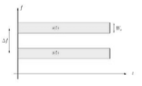

**Polarization Diversity:**

In polarization diversity, the electric and magnetic fields of the signal carrying the information are modified and many such signals are used to send the same information. Thus, orthogonal type of Polarization is obtained.

**Angle Diversity/ Pattern Diversity / Direction Diversity:**

This diversity system needs a number of directional antennas those responds independently to wave propagation. An antenna response to a wave propagates at a specific angle and receives a faded signal which is uncorrelated with other signals. The procedure to obtain angle diversity is to fix antennas with narrow beam widths different sector in the system. Then the arriving multi- paths from the different beam directions are resolved and combined advantageously. This procedure not only creates diversity but also increases the antenna gain and reduces interference by providing angular discrimination.

**(c) What is combining diversity. Discuss the concepts maximum ratio combining and equal gain combining.**

It is important to combine the uncorrelated faded signals which were obtained from the diversity branches to get proper diversity benefit. The combing system should be in such a manner that improves the performance of the communication system like the signal-to-noise ratio (SNR) or the power of received signal. Mainly, the combining should be applied in reception; however, it is also possible to apply in transmission. Following are the various diversity combining methods available, out of these MRC, EGC and SC are mainly used.

**Maximal Ratio Combining (MRC):**

Maximal-Ratio Combining (MRC)In the MRC combining technique needs summing circuits, weighting and co-phasing. The signals from different diversity branches are co-phased and weighted before summing or combining. The weights have to be chosen as proportional to the respective signals level for maximizing the combined carrier-to-noise ratio (CNR). The applied weighting to the diversity branches has to be adjusted according to the SNR. For maximizing the SNR and minimizing the probability of error at the output combiner, signal of dth diversity branch is weighted before making sum with others by a factor, cd*/ σ2n,d . Here σ2n, d is noise variance of diversity branch dth and cd* complex conjugate of channel gain. As a result, the phase-shifts are compensated in the diversity channels and the signals coming from strong diversity branches which has low level noise are weighted more comparing to the signals from the weak branches with high level of noise. The term σ2n, d in weighting can be neglected conditioning that σ2n,d has equal value for all d.

Then the realization of the combiner needs the estimation of gains in complex channel and it does not need any estimation of the power of noise. This is a very useful combining process to combat channel fading. This is the best combining process which achieves the best performance improvement comparing to other methods. The MRC is a commonly used combining method to improve performance in a noise limited communication systems where the AWGN and the fading are independent amongst the diversity branches.

**Equal-gain Combining (EGC):**

The EGC is similar to MRC with an exception to omit the weighting circuits. The performance improvement is little bit lower in EGC than MRC because there is a chance to combine the signals with interference and noise, with the signals in high quality which are interference and noise free. EGC’s normal procedure is coherently combined the individual signal branch but it non-coherently combine some noise components according. MRC is the most ideal diversity combining but the scheme requires very expensive design at receiver circuit to adjust the gain in every branch. It needs an appropriate tracking for the complex fading, which very difficult to achieve practically. However, by using a simple phase lock summing circuit, it is very easy to implement an equal gain combining. The EGC can employ in the reception of diversity with coherent modulation. The envelope gains of diversity channels are neglected in EGC and the diversity branches are combined here with equal weights but conjugate phase. The structure of equal-gain combining (EGC) is as following since there is no envelope gain estimation of the channel.

**(d) Discuss the impact of impairments of wireless communication channels including background noise, interference and amplifier distortion and the corresponding counter- measures in wireless communications system design.**

In the wireless system, the physical medium corresponds to free-space in which the electromagnetic wave propagates. As in any electrical/electronic system, the wireless signals are subjected to corruption by the inevitable presence of noise at the transmission and reception ends as well as along the transmission medium.

Apart from the device/system based electronic noise (such as thermal noise) corrupting the signal, certain characteristics of EM propagation in the mobile environment would also impair the signals under transmission. Such impairments arise from signal fading due to scattering, reflection, and refraction effects that the EM wave may face during propagation and attenuation of EM energy as a result of absorption by rain, snow etc.

With the result, for robust implementation of wireless communication, the receiver technology is being trimmed continuously through available techniques and devices. Thus, all along the passage of information transfer, from the transmitter through the channel to the receiver, there exists a host of noise sources, which may introduce undesirable effects to the signal being transported.

Interference and noise Interference and noise are by-products of precipitation in the air, metals in the environment, and a variety of other anomalies. Error correction techniques are needed to fix Foliage. Foliage can be a source of interference because the water in leaves absorbs radio signals. Weather effects Weather can cause interference, particularly in the higher frequencies, where each radio wave is smaller than a drop of rain. Environmental obstacles Radio signals cannot penetrate various materials, so walls, desks, buildings, hills, vehicles, and other environmental obstacles can affect the performance of radio. Range and electrical power Range and electrical power are considerations because more radio power is required to increase the range or to compensate for poor path quality.

**Amplitude distortion**

Amplitude distortion is distortion occurring in a system, subsystem, or device when the output amplitude is not a linear function of the input amplitude under specified conditions.

**Harmonic distortion**

Harmonic distortion adds overtones that are whole number multiples of a sound wave's frequencies. Nonlinearities that give rise to amplitude distortion in audio systems are most often measured in terms of the harmonics (overtones) added to a pure sine wave fed to the system. Harmonic distortion may be expressed in terms of the relative strength of individual components, in decibels, or the root mean square of all harmonic components: Total harmonic distortion (THD), as a percentage. The level at which harmonic distortion becomes audible depends on the exact nature of the distortion. Different types of distortion (like crossover distortion) are more audible than others (like soft clipping) even if the THD measurements are identical. Harmonic distortion in radio frequency applications is rarely expressed as THD.

**Frequency response distortion**

Non-flat frequency response is a form of distortion that occurs when different frequencies are amplified by different amounts in a filter. For example, the non-uniform frequency response curve of AC-coupled cascade amplifier is an example of frequency distortion. In the audio case, this is mainly caused by room acoustics, poor loudspeakers and microphones, long loudspeaker cables in combination with frequency dependent loudspeaker impedance, etc.

**Phase distortion**

This form of distortion mostly occurs due to electrical reactance. Here, all the components of the input signal are not amplified with the same phase shift, hence making some parts of the output signal out of phase with the rest of the output.

**Group delay distortion**

Can be found only in dispersive media. In a waveguide, phase velocity varies with frequency. In a filter, group delay tends to peak near the cut-off frequency, resulting in pulse distortion. When analog long distance trunks were commonplace, for example in 12 channel carrier, group delay distortion had to be corrected in repeaters.

**Correction of Distortion**

As the system output is given by y(t) = F(x(t)), then if the inverse function F−1 can be found, and used intentionally to distort either the input or the output of the system, then the distortion is corrected.

An example of a similar correction is where LP/vinyl recordings or FM audio transmissions are deliberately pre-emphasized by a linear filter, the reproducing system applies an inverse filter to make the overall system undistorted.

Correction is not possible if the inverse does not exist—for instance if the transfer function has flat spots (the inverse would map multiple input points to a single output point). This produces an uncorrectable loss of information. Such a situation can occur when an amplifier is overdriven—causing clipping or slew rate distortion when, for a moment, the amplifier characteristics alone and not the input signal determine the output.

**Cancellation of even-order harmonic distortion**

Many symmetrical electronic circuits reduce the magnitude of even harmonics generated by the non-linarites of the amplifier's components, by combining two signals from opposite halves of the circuit where distortion components that are roughly the same magnitude but out of phase