Python Live Project

Web Scraper was a web scraping application built ul python, django, API’s and beautifulsoup. The application gathers data from the web that’s relevant to the user. It includes weather, entertainment, sports and more.

I changed login page using Html and Css.

Using this before

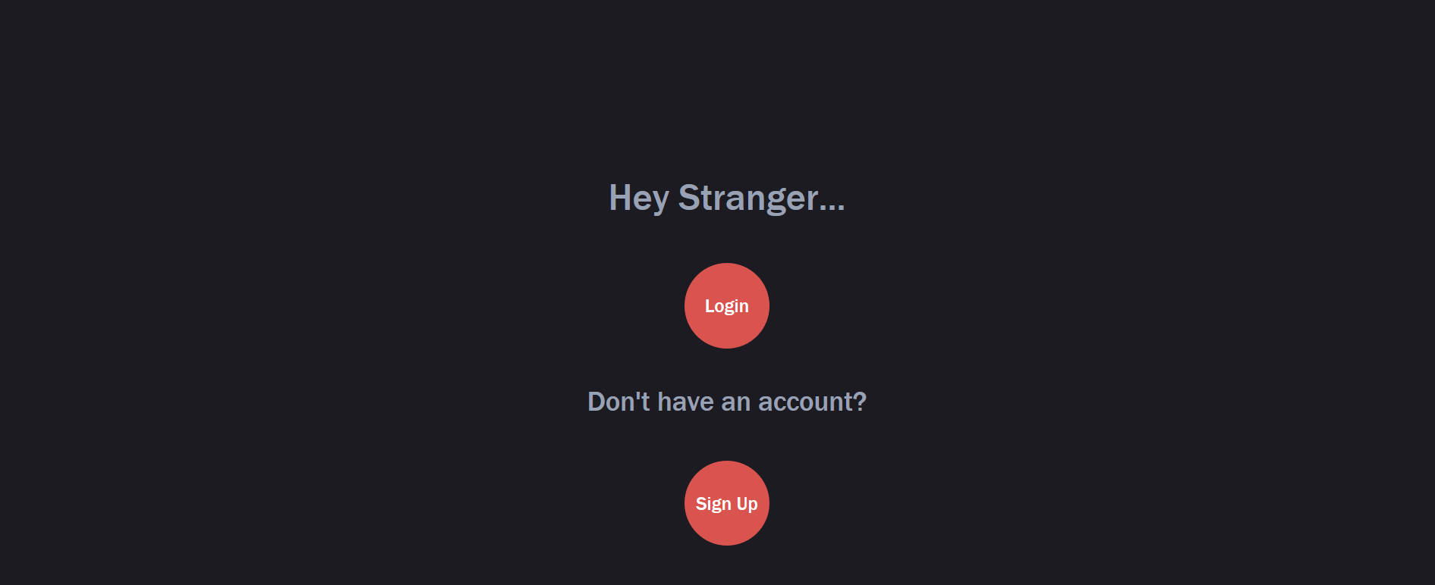

After Editing with CSS and HTMl

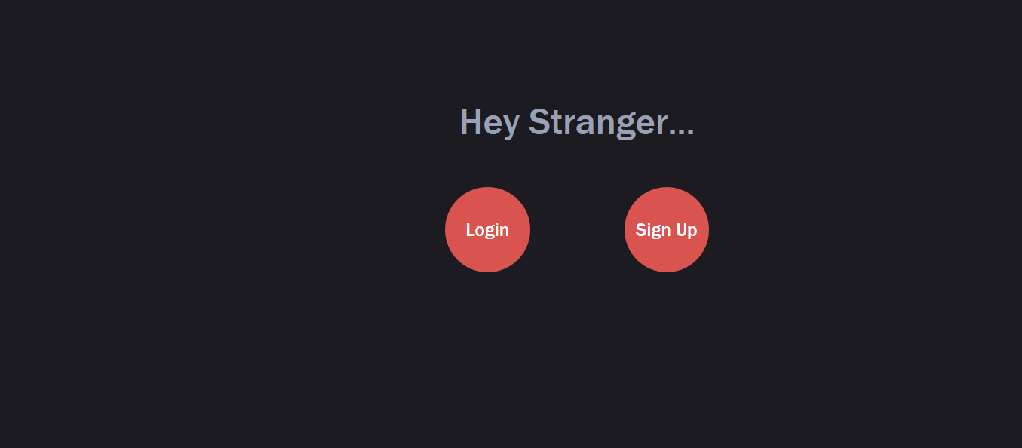

**This is my code that I used**

no-touch .hi-icon-effect-8 .hi-icon:hover:before {  
 background: rgba(255, 255, 255, 0.05);  
 -webkit-transform: scale(0.93);  
 -moz-transform: scale(0.93);  
 -ms-transform: scale(0.93);  
 transform: scale(0.93);  
 color: #fff;  
 animation: sonarEffect 1.3s ease-in-out 75ms infinite;  
  
}   
  
.hi-icon-effect-8 .hi-icon:hover:after {  
 -webkit-animation: sonarEffect 1.3s ease-out 75ms;  
 -moz-animation: sonarEffect 1.3s ease-out 75ms;  
 animation: sonarEffect 1.3s ease-in-out .1s infinite;  
}

**HTML Code**

<**div class="container hi-icon-wrap hi-icon-effect-8"**>  
 <**h1**>Hey Stranger...</**h1**>  
 <**div class="row justify-content-md-center"**>  
 <**div class="col col-lg-2"**>  
 <**a class="hi-icon" href="{% url 'login' %}"**>Login</**a**>  
 </**div**>  
 <**div class="col col-lg-2"**>  
 <**a class="hi-icon" href="{% url 'signup' %}"**>Sign Up</**a**>  
 </**div**>  
 </**div**>  
 </**div**>  
</**div**>

**After changing color**

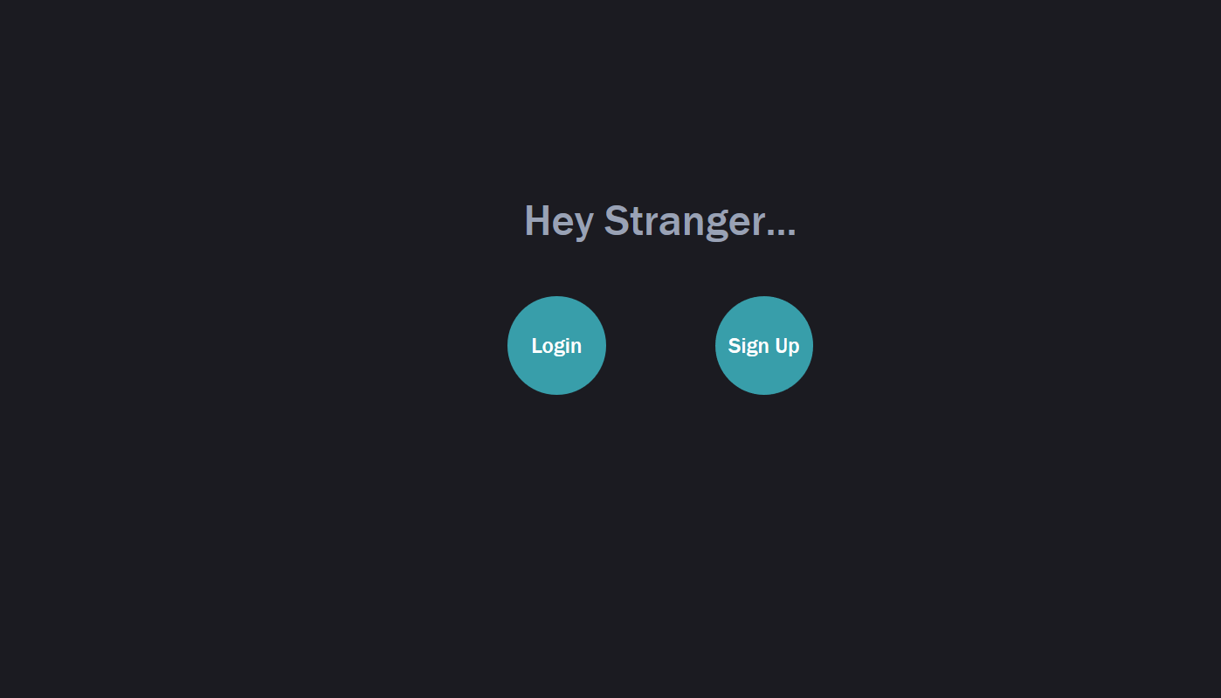

**Adding navbar to space App**

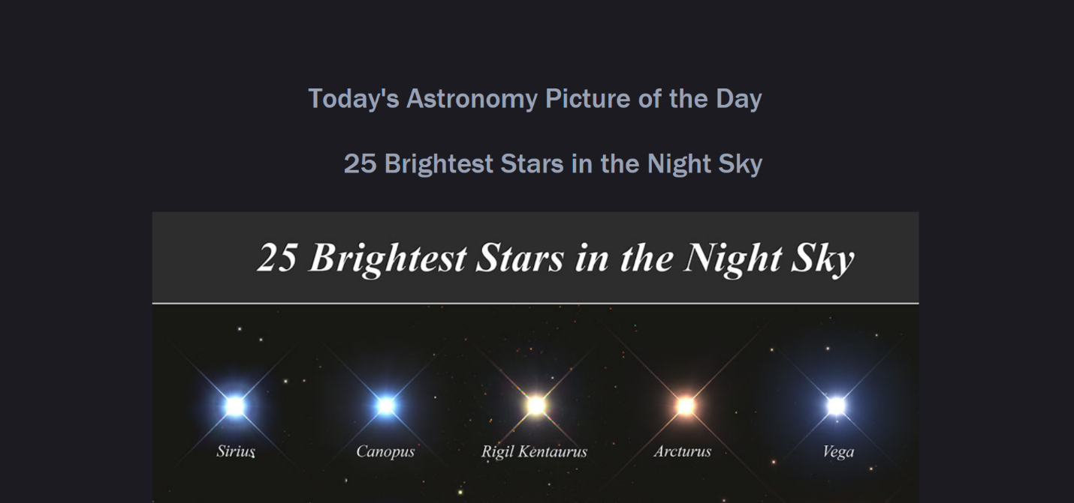

After changing nav

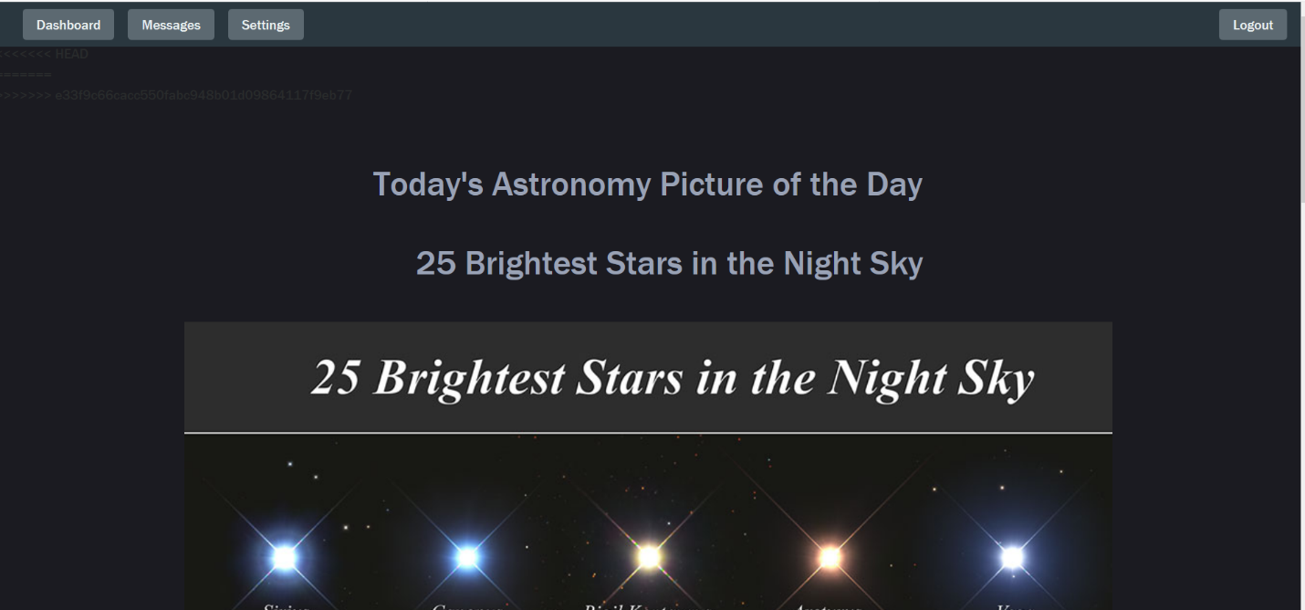

By including nav bar into Space.Html

With {% include “nav.html” %}

**Show Five Podcast using webScraper**

**Before**

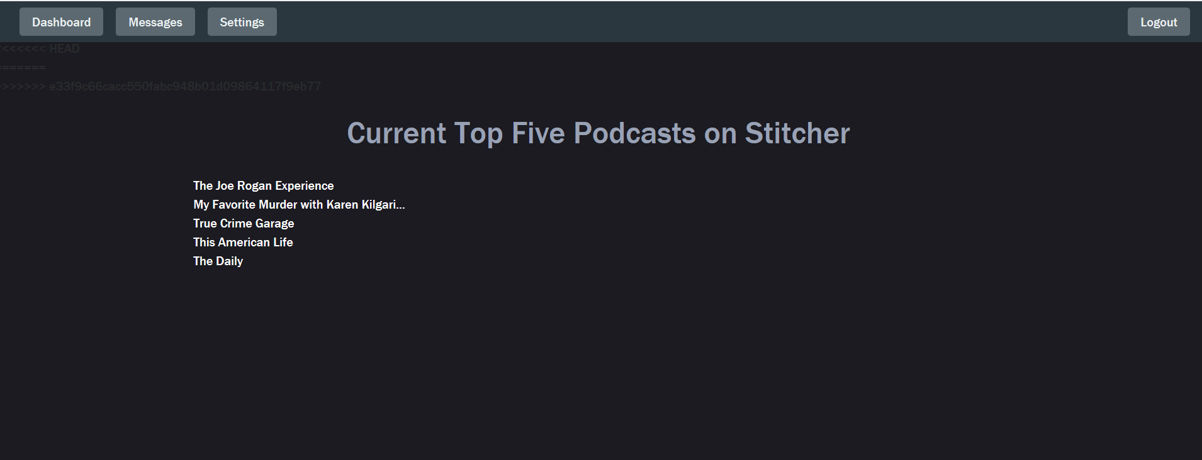

**After Extracting more information using Json-Api**

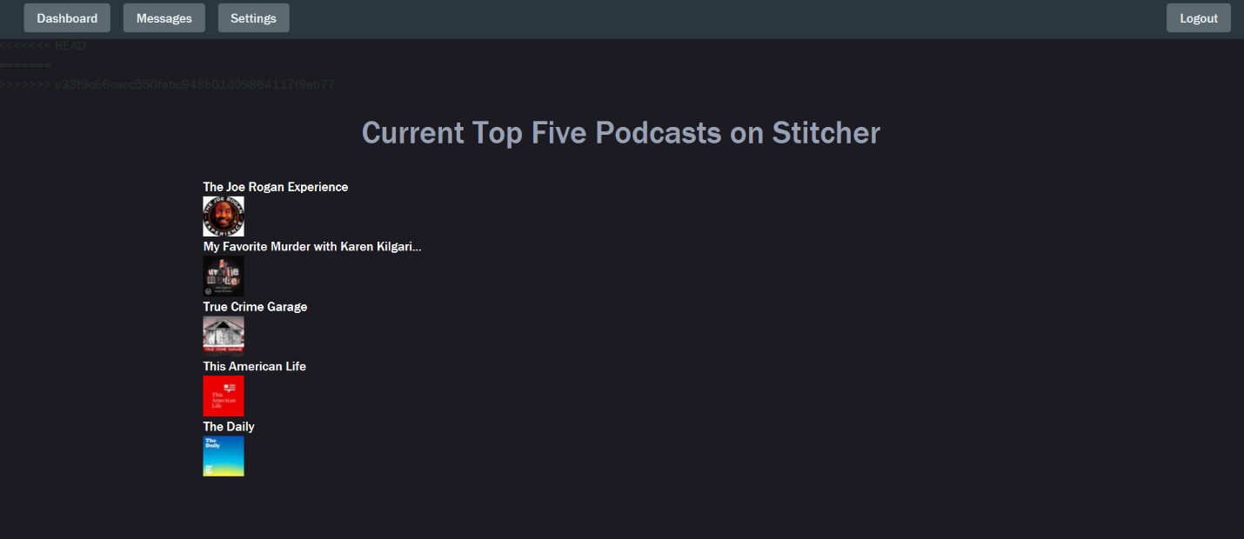

Code for extracting this data using aPi

import re

import requests

from django.shortcuts import render

from bs4 import BeautifulSoup

from urllib.request import urlopen

from urllib.error import HTTPError

def get_top5(request):

url = "https://www.stitcher.com/stitcher-list/get-js.php"

data = requests.get(url).text

titles = re.findall(r"[\n\r].*showName\":.\"\s*([^\n\r]*)\"", data)

details = re.findall(r"[\n\r].*seouri\":.\"\s*([^\n\r]*)\"", data)

images_tags = re.findall(r"[\n\r].*imageURL\":.\"\s*([^\n\r]*)\"", data)

#showing some more details

category = re.findall(r"[\n\r].*category\":.\"\s*([^\n\r]*)\"", data)

#getting delta value

delta = re.findall(r"[\n\r].*delta\":.\"\s*([^\n\r]*)\"", data)

#getting rank

rank = re.findall(r"[\n\r].*rank\":.\"\s*([^\n\r]*)\"", data)

#choose html.parser for getting image

#soup=BeautifulSoup(data,'html.parser')

#find image tag into source page

#images_tags=soup.findAll('imageURL')

#src=images_tags.get('src')

top_five = {"podcasts": []}

for index, title in enumerate(titles[:10]):

top_five["podcasts"].append({"title": title, "details": details[index],"image":images_tags[index],"category":category[index],"delta":delta[index],"rank":rank[index]})

return render(request, "Podcast/podcast.html", top_five)

And HTMl code for this

<**div class="container"**>  
 <**section class="section"**>  
 <**ol**>  
 {% for podcast in podcasts %}  
 <**a href="https://stitcher.com/{{ podcast.details }}"**>  
 <**li**>{{ podcast.title }}</**li**>  
  
 </**a**>  
 <**li**>  
 <**div**><**img src={{podcast.image}}**>  
 <**p style="**align:center;**"**> Category:{{podcast.category}}</**p**>  
 <**p**>Delta:{{podcast.delta}}</**p**>  
 <**p**>Rank:{{podcast.rank}}</**p**>  
 </**div**>  
 </**li**>  
  
  
 {% endfor %}  
 </**ol**>

**Adding New APP into Web ScraperAPP IS Restaurant**

**Adding View**

import re

import requests

from django.shortcuts import render

import json

**# Create your views here**.

def get_top10(request):

api_key="xOM7Blat-aEandu_HcS_p0l01LI71bkFltgP4Ppk0yIiB2UjYGyw6nqgAt1sbCC9wtLcJ35EyzZjEsdZlk39JhZo5Bf7bHweDZaowRY6M9egK4KR_Z_QJ3T4msYTXXYx"

headers = {'Authorization': 'Bearer %s' % api_key}

url='https://api.yelp.com/v3/businesses/search'

# In the dictionary, term can take values like food, cafes or businesses like McDonalds

params = {'term':'seafood','location':'New York City'}

req = requests.get(url, params=params, headers=headers)

parsed = json.loads(req.text)

businesses = parsed["businesses"]

#items={}

#items={"bussinesses":[]}

return render(request,'Restaurant/restaurant.html',{"results":businesses[:10]})

#id = business["id"]

'''url = "https://api.yelp.com/v3/businesses/" + id + "/reviews"

req = requests.get(url, headers=headers)

parsed = json.loads(req.text)

reviews = parsed["reviews"]

#print("--- Reviews ---")

for review in reviews:

reviews.render("User:", review["user"]["name"], "Rating:", review["rating"], "Review:", review["text"], "\n")'''

**Adding Html File For it**

{% extends 'base.html' %}

{% load static from staticfiles %}

{% block title %}Top 10 Restaurants{% endblock %}

{% block content %}

{% include 'nav.html' %} <!--Add navigation to restaurant html-->

<section class="hero is-primary">

<div class="hero-body">

<div class="container">

<h1 class="title">

Current Top Ten Restaurants

</h1>

</div>

</div>

</section>

<div class="container">

<section class="section">

<ol>

{% for biz in results %}

<img src={{biz.image_url}} style="width:150px;height:150px;"></img>

<p>Name:{{biz.name}}</p>

<p>City:{{biz.location.city}}</p>

<p>Phone:{{biz.phone}}</p>

<p>Rating:{{biz.rating}}</p>

{% endfor %}

</ol>

</section>

</div>

{%include 'footer.html' %}

{% endblock %}

**Adding Model For Saving Data**

from django.db import models

# Create your models here.

from django.db import models

class Restaurant(models.Model):

business = models.CharField(max_length = 60)

#image = models.CharField(max_length=250)

def __str__(self):

return self.title

**Adding Icon Of Restaurant to Home Page**

<**div class="col-lg-3 col-md-3 col-xs-3 thumb"**>  
 <**a href= '/restaurant'style="**color:#5b5b5b**"**><**i class="fas fa-utensils fa-5x"**></**i**><**br**>Resturant</**a**>  
</**div**>

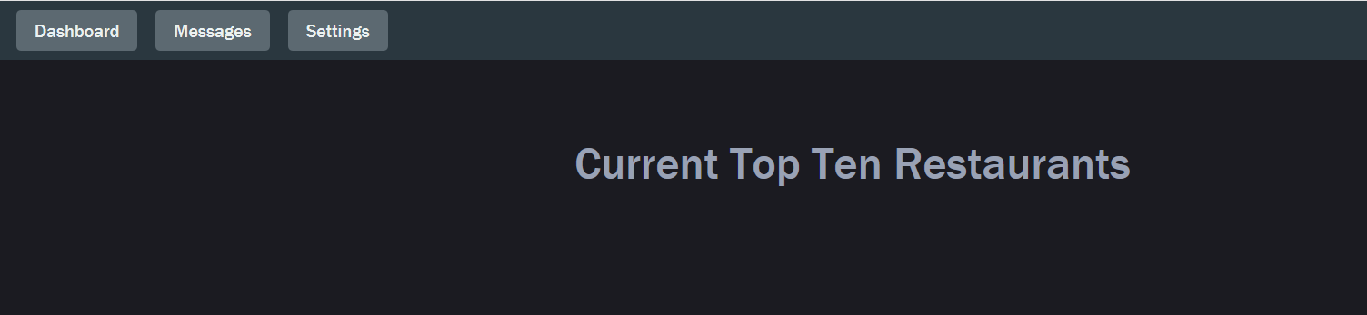

**Extract Data of Top Ten SeaFood Restaurants using Yelp Api**

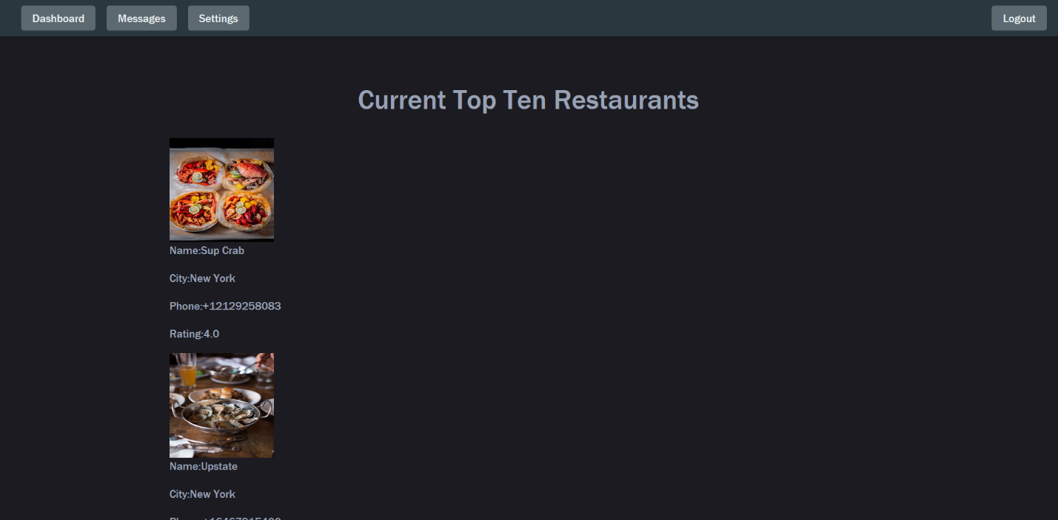

**Changing Weather App It will shows Current weather with icon**

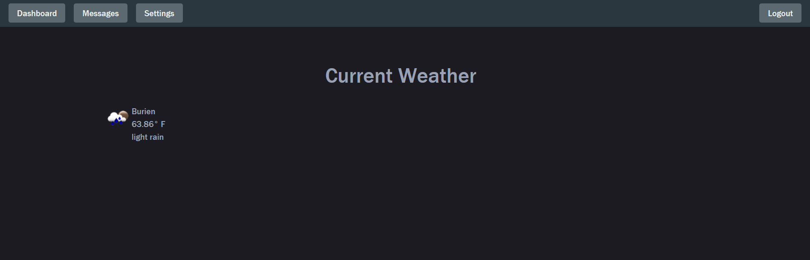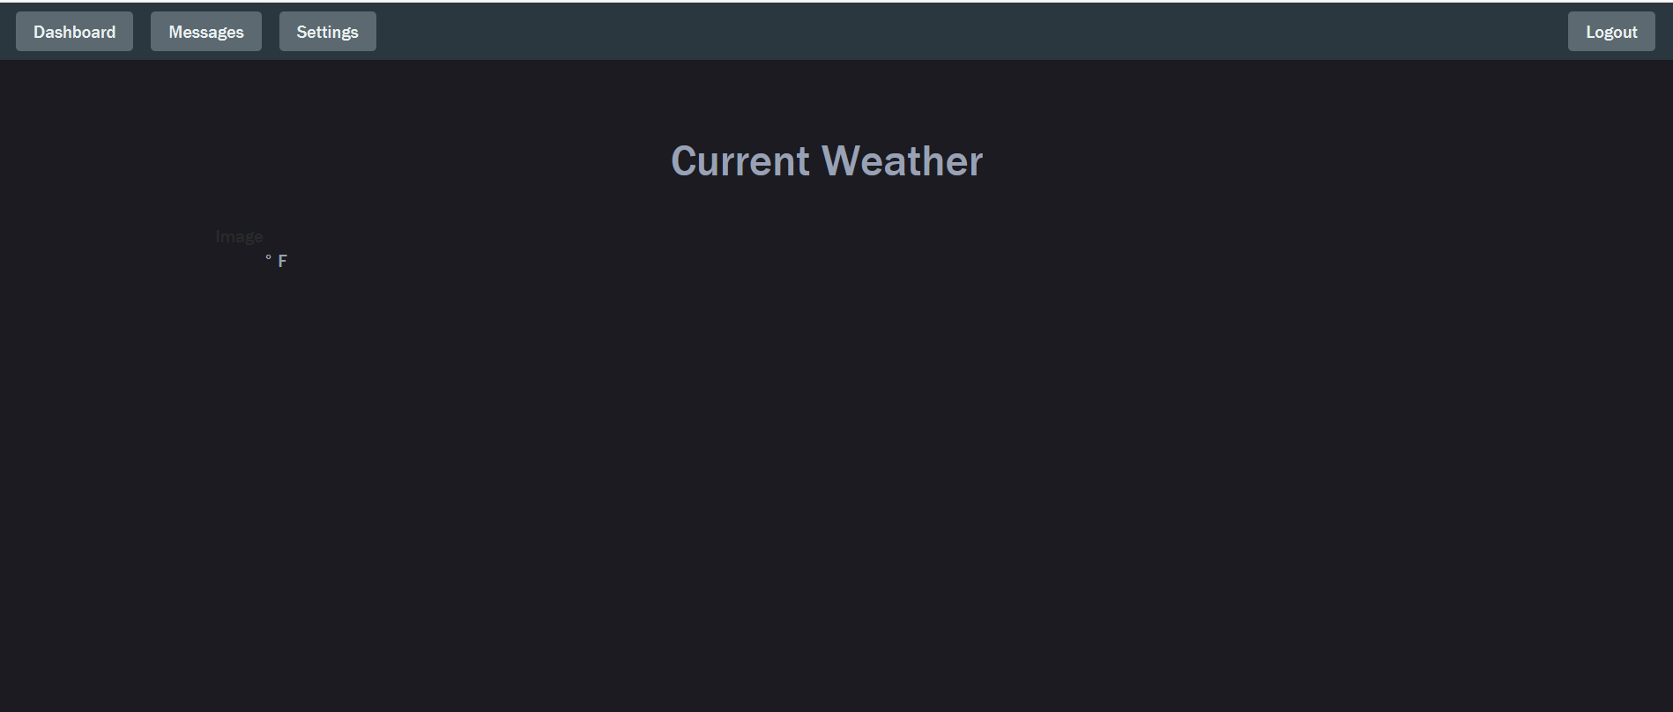

**Images Before And After the changes into Weather App**

<**div class="media-content"**>  
 <**div class="content"**>  
 <**p**>  
 <**span class="subtitle"**>{{ current_info.city }}</**span**>  
 <**br**>  
 <**span class="subtitle"**>{{ current_info.temperature }}**&#176;** F</**span**>  
 <**br**> {{ current_info.description }}  
 </**p**>  
 </**div**>  
</**div**>

**Before and After the changes into html File**

<**div class="media-content"**>  
 <**div class="content"**>  
 <**p**>  
 <**span class="subtitle"**>{{ Zip_weather.city }}</**span**>  
 <**br**>  
 <**span class="subtitle"**>{{ Zip_Weather.temperature }}**&#176;** F</**span**>  
 <**br**> {{ Zip_weather.description }}  
 </**p**>  
 </**div**>  
</**div**>

**Show Traffic Directions in Traffic App**

**After Make Changes it looks like this**

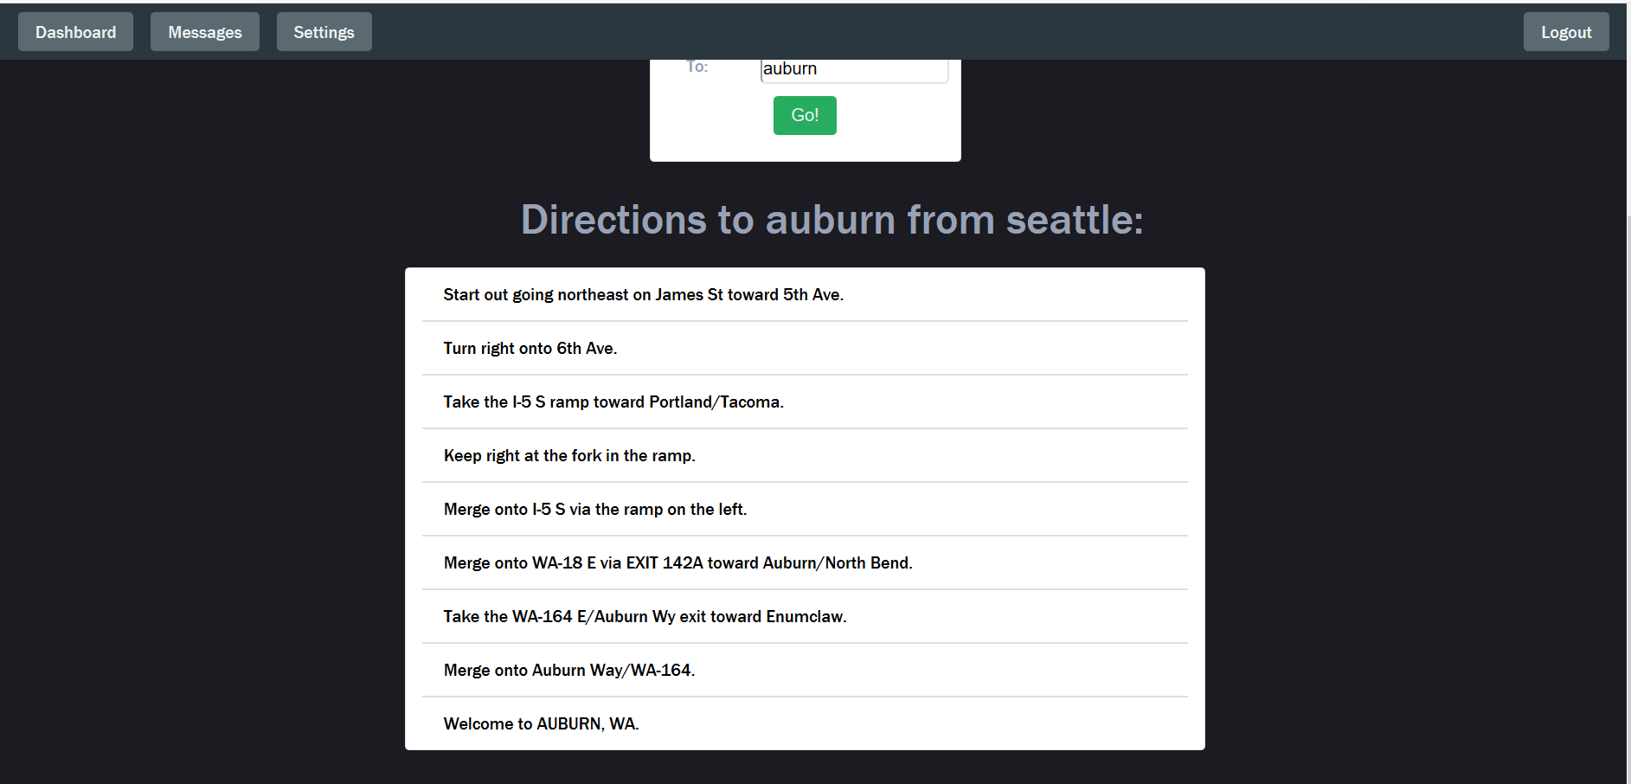

**Before Changes**

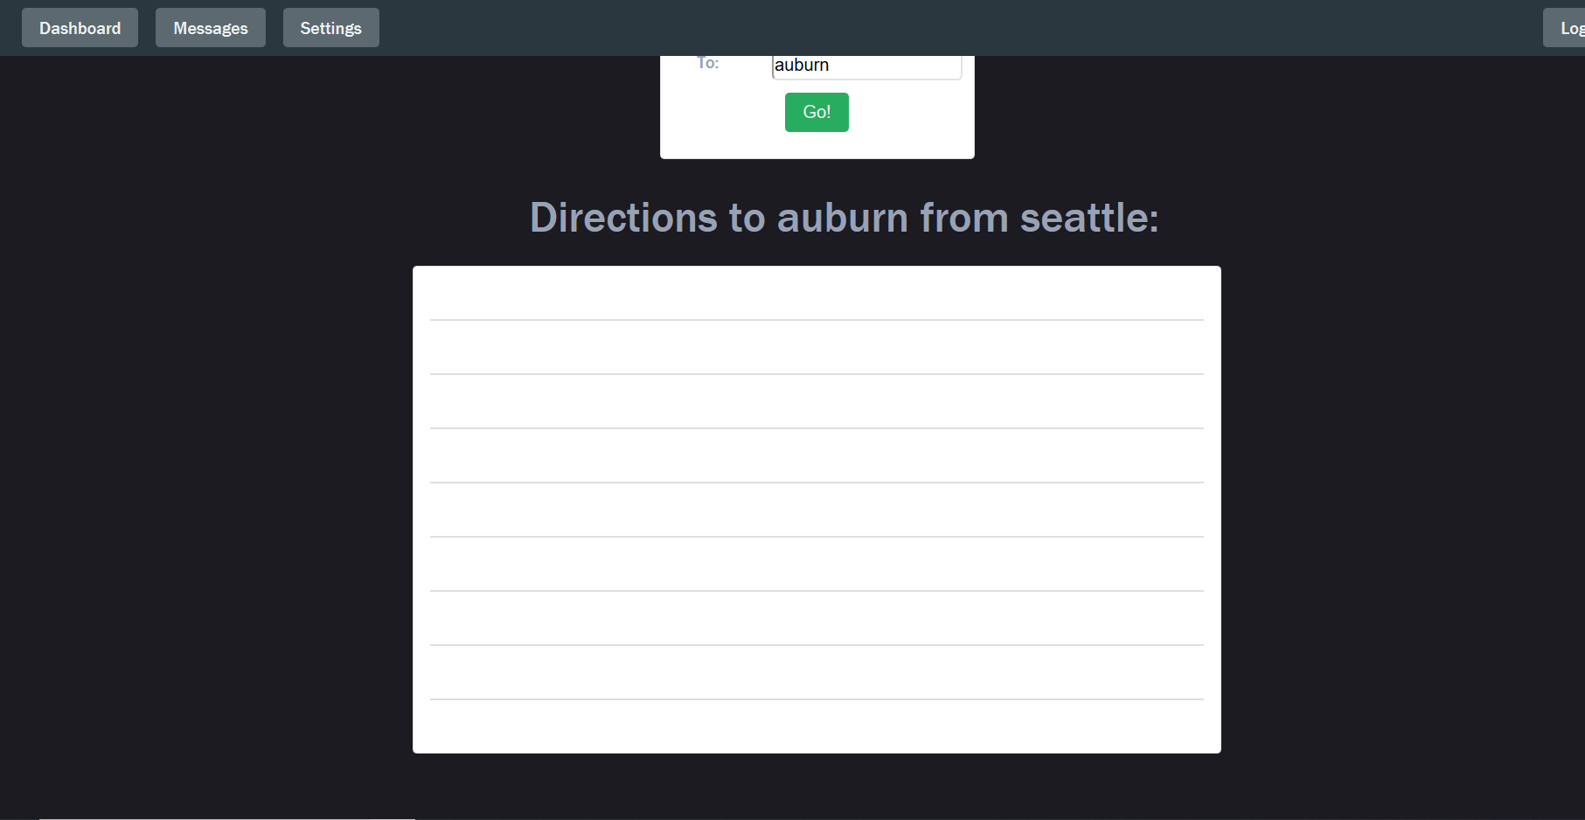

By Giving TextColor to this

.map {  
 color:var(--text-color);  
}

**Changing Icons and color of icons**

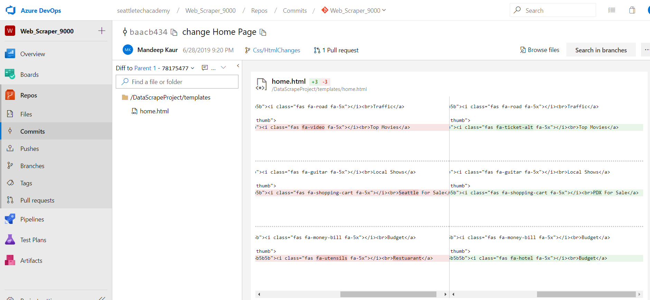

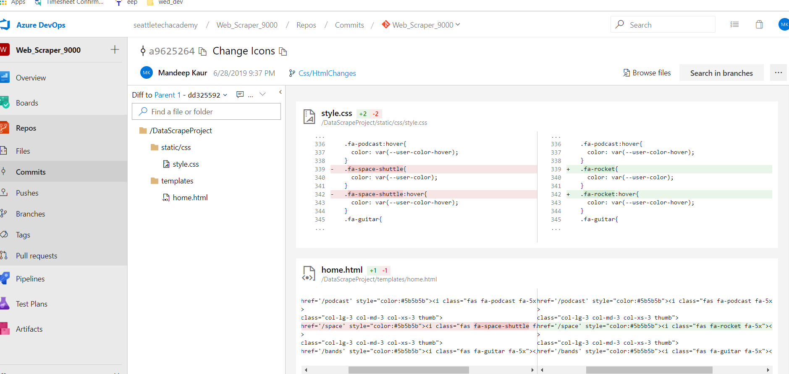

After Make changes into Css and Html File.

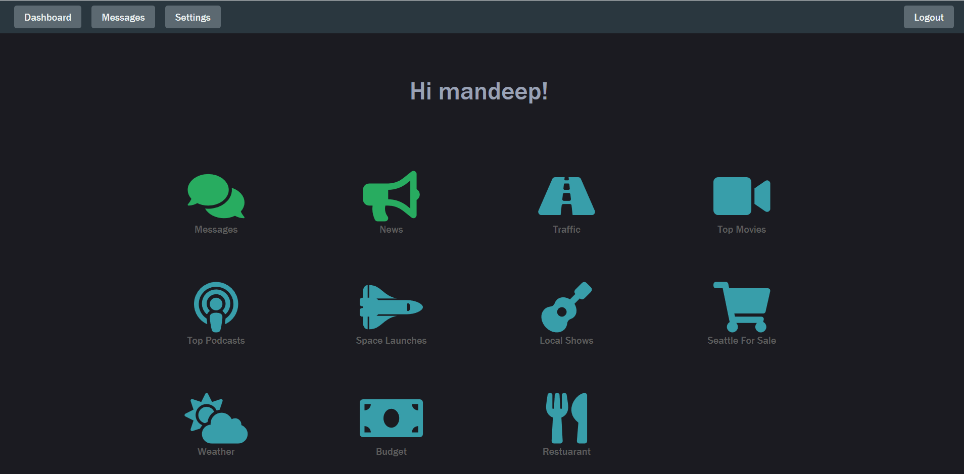

Before Changes the Home page look like as.

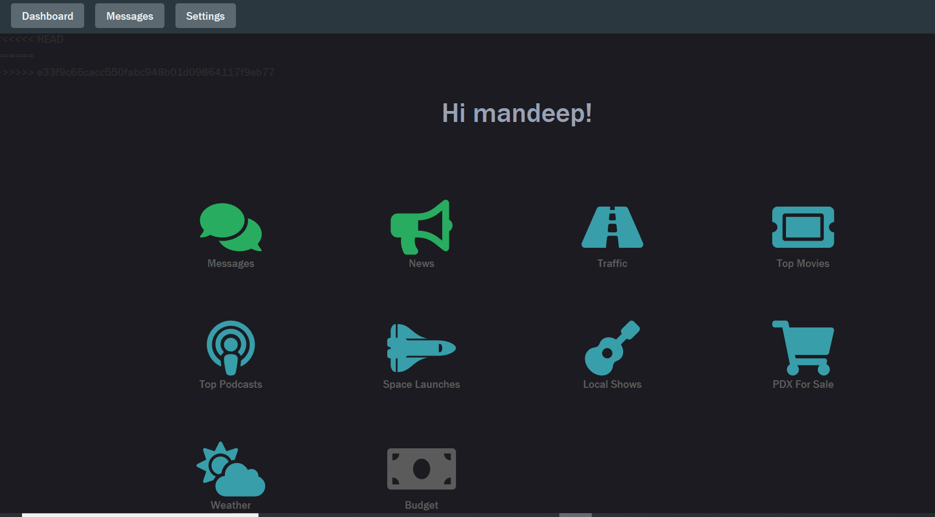

**Scraping more data into movie App**

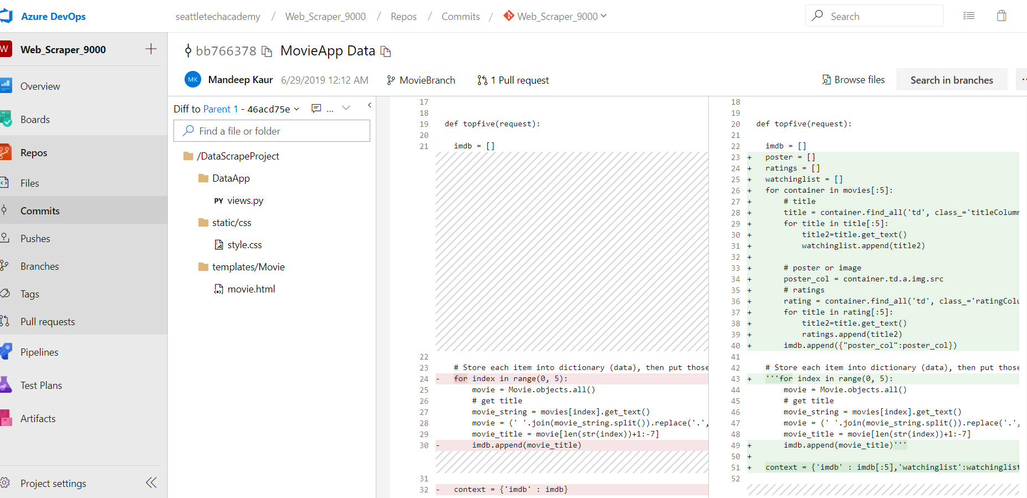

Before and after

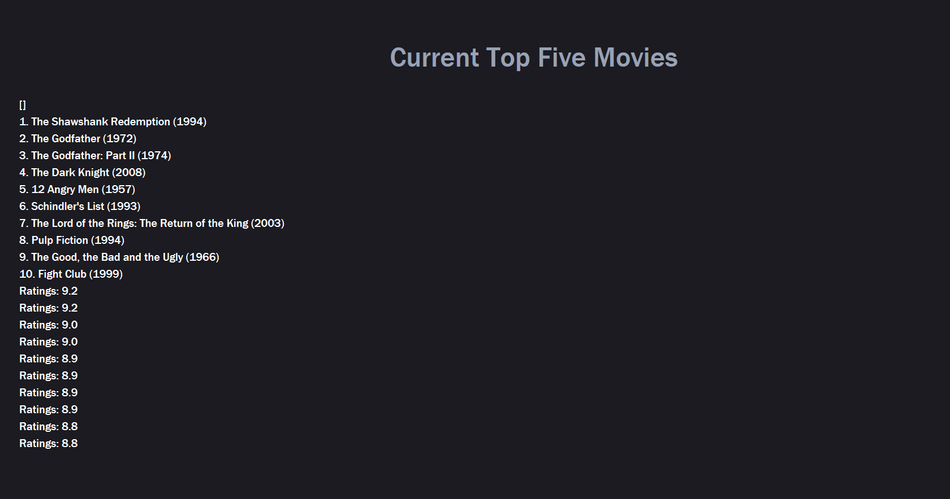

**Adding Footer to All Apps**

<**footer style="**color:#5b5b5b**"**>  
 <**section id="footer" class="text-center"**>  
 **&nbsp;&nbsp; &copy;** 2019 Seattle Tech Academy  
 </**section**>  
</**footer**>

By adding Include It to all html file with

{% include “footer.html” %}

**Show Actual Map with Narrative in Html**

{% extends 'base.html' %}  
{% block title %}Directions{% endblock %}  
  
{% block content %}  
{% include "nav.html" %}  
<**div class="container"**>  
  
 <**h1**>Enter your current location and destination!</**h1**>  
 <**div class="card mx-auto mt-4 py-4 text-center" style="**width: 18rem**"**>  
 <**div class="row"**>  
 <**div class="col-sm"**>  
 <**p** >From:</**p**>  
 </**div**>  
 <**div class="col-md"**>  
 <**input type="text" id="to"**>  
 </**div**>  
 </**div**>  
 <**div class="row"**>  
 <**div class="col-sm"**>  
 <**p** >To:</**p**>  
 </**div**>  
 <**div class="col-md"**>  
 <**input type="text" id="from"**>  
 </**div**>  
 </**div**>  
 <**input type="submit" onclick="showmap(),showvalue()" class="btn default-button message-buttons" value="Go"**>  
 </**div**>  
 *<!--Supplies To and From text to traffic info-->* <**div class="directions text-danger"**>  
 <**h2 id="show"**></**h2**>  
 </**div**>  
  
 *<!--Supplies list of directions-->* <**div class="container card col-8 text-dark" style="**margin-bottom: 60px**"**>  
  
 </**div**>  
  
 <**div class="directions" style="**margin-bottom: 60px**"**>  
 </**div**>  
 <**div class="container" id="map" style="**width: 100%; height: 830px;position:relative;**"**>  
 </**div**>  
  
 <**script type="text/javascript"**>  
 function showvalue(){  
 var to = document.getElementById("to").value;  
 var from=document.getElementById("from").value;  
 var greet=document.getElementById("show").innerHTML="Directions to "+to+" from "+from+".";  
  
 }  
 function showmap() {  
 L.mapquest.key = 'qGyMswGafi2puTNqSP91ETXcNRDFrAyG';  
  
 addDirections();  
  
 function addDirections() {  
 var directions = L.mapquest.directions();  
 directions.route({  
 start: document.getElementById('to').value,  
 end: document.getElementById('from').value,  
 options: {  
 enhancedNarrative: true  
 }  
 }, createMap);  
 }  
  
 function createMap(err, response) {  
  
 var map = L.mapquest.map('map', {  
 center: [0, 0],  
 layers: L.mapquest.tileLayer('map'),  
 zoom: 7  
 });  
  
 var directionsLayer = L.mapquest.directionsLayer({  
 directionsResponse: response  
 }).addTo(map);  
  
 var narrativeControl = L.mapquest.narrativeControl({  
 directionsResponse: response,  
 compactResults: false,  
 interactive: true  
 });  
  
 narrativeControl.setDirectionsLayer(directionsLayer);  
 narrativeControl.addTo(map);  
 }  
 }  
 </**script**>  
</**div**>  
  
{%include 'footer.html' %}  
{% endblock %}

Before and After

