**Geo Tracking of Waste and Triggering Alerts and Mapping Areas with High Waste Index**

This project consists of two modules

User Module: In this module user can upload waste images and add location details.

Here student asking to display location in map but the problem is to display location in map we need to have latitude and longitude values then only we can display exact location in map and we don’t have any sensor or devices to track latitude and longitude. So we can’t use maps.

Waste Collector Module: In this module waste collectors will upload video and this video will start playing and we need to consider this video as its playing from webcam or drone. Video player continuously scan images to find pattern match between current location and user uploaded waste images. If pattern in video matched with user uploaded waste images then application will inform to waste collector via bounding boxes.

Note: here we are matching images using pattern match technique which is not 100% reliable for matching. If two different images having little similar pattern or colour then this technique will detect the match. So sometime two different images can also raise output as match.

Screen shots

First run user module by clicking on ‘Run_User_Module.bat’ file to get below screen

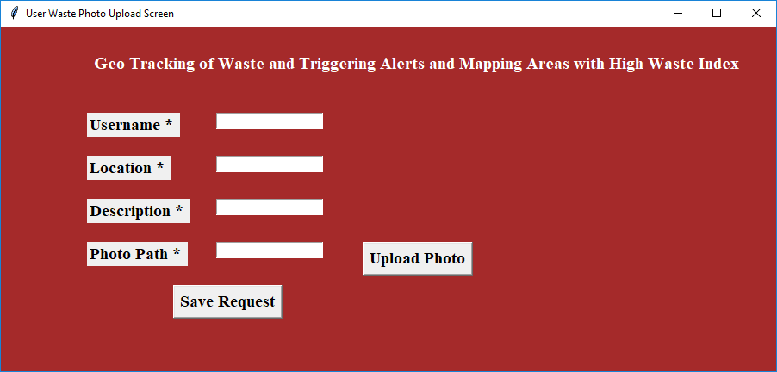

Using above screen user will enter location details with waste upload image

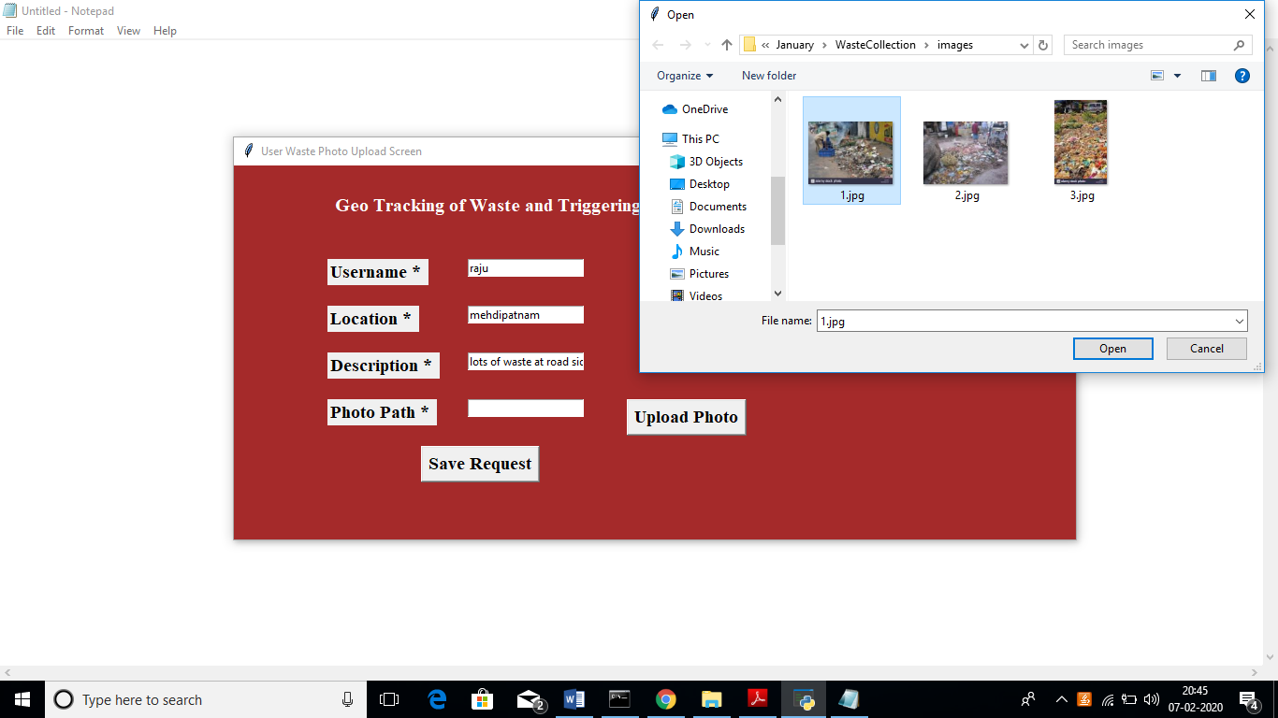

In above screen I entered some details and uploading waste image, after upload image will get below screen

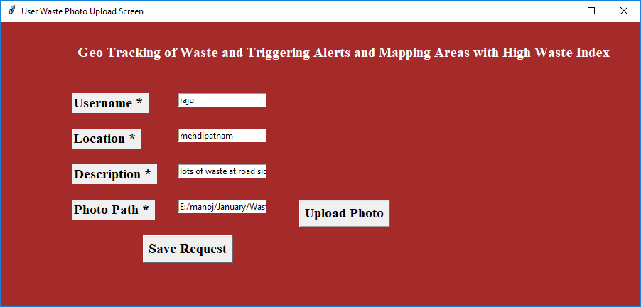

Now click on ‘Save Request’ button to send request to waste collectors

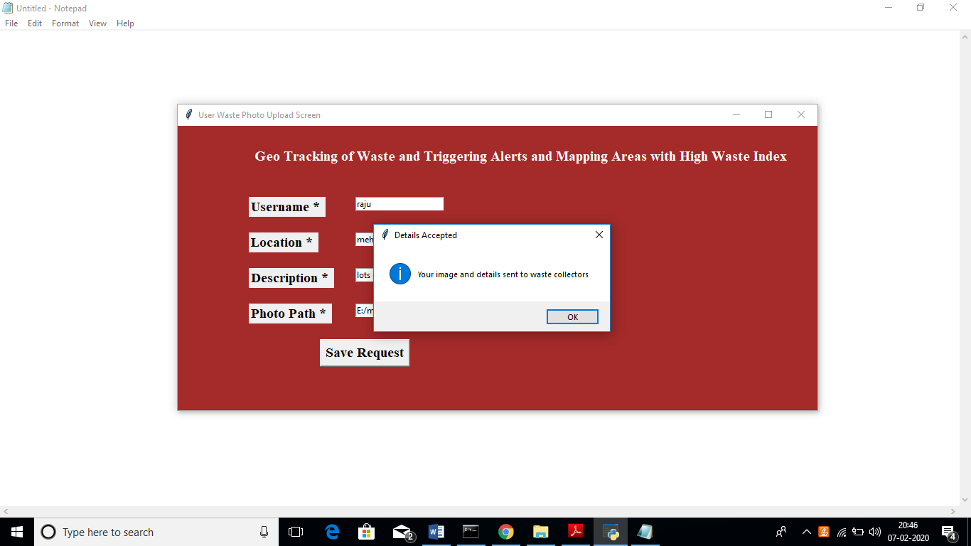

In above screen we can see user request details saved. Now close this application and run waste collector module by double click on ‘Run_Waste_Collector.bat’ file to get below screen

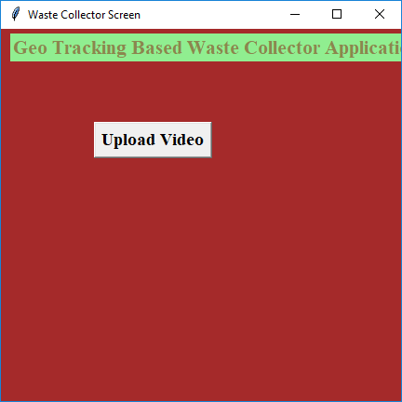

In above screen click on ‘Upload Video’ button and upload video

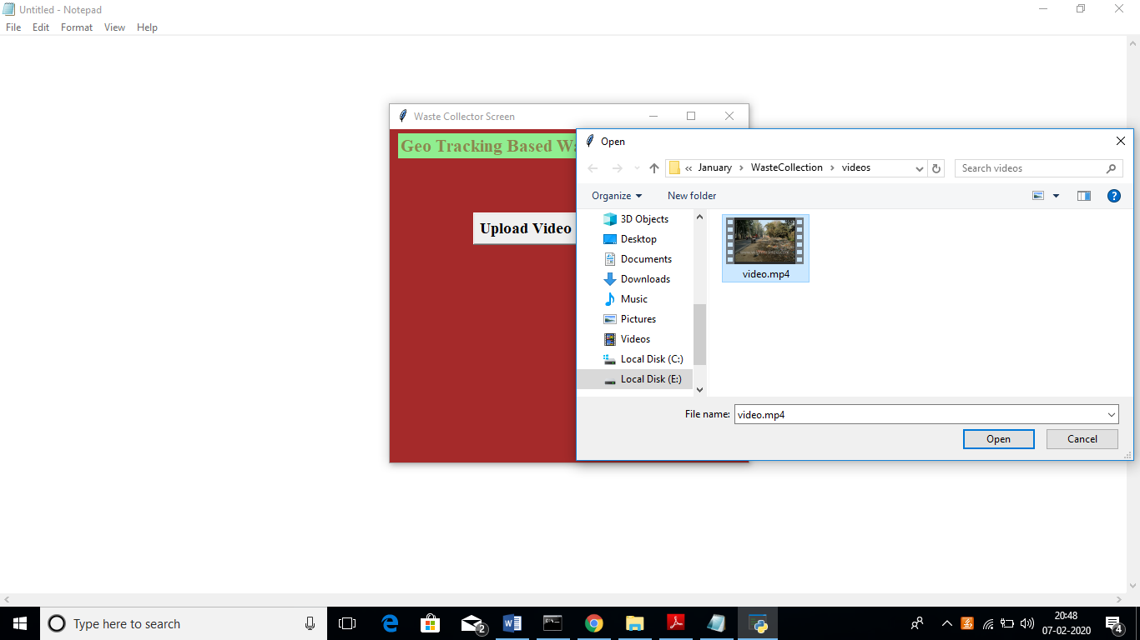

In above screen I am uploading one video and after uploading video will get below screen

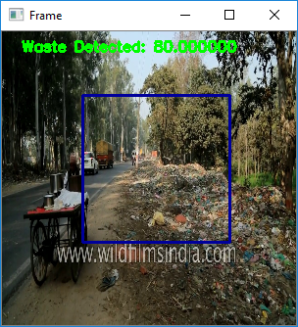

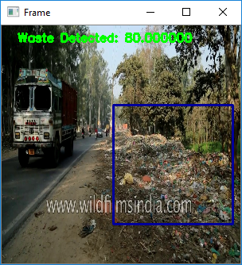

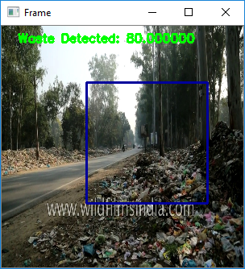

In above screen video starts playing and simultaneously it starts matching pattern with images to inform waste collectors.