Miguel Ricardo Anderson (netId: mra21)

CompSci 201 – Assignment Analysis for DNA

03/24/2016

# Part 1

The running time of SimpleStrand's cutAndSplice method is O(n + Bl). Your task is to provide empirical data in the form of graphs, tables, and/or regression equations which demonstrate this relationship. Please also include the process you used to obtain your data, particularly how you solved the n/B relationship.

|  |  |  |  |
| --- | --- | --- | --- |
| **Value** | **Description Given** | **In my words** | **In code** |
| N | the length of the original strand | Length of text file supplied to DNABenchmark | Dna length |
| B | the number of occurrences of the enzyme | The number of occurances of the string that is to be replaced. This is close to the value (myAppends) for myAppends is increased every time a splicee is added where an enzyme used to be | ~myAppends |
| I | the splicee length | The length of characters of the string that replaces every iteration of the enzyme | Splicee |

Here are some trials that show how time is affected when **N and B are increased and I is held constant**. Each n-th trial is has N’=n*N and B’=n*B with reference to the first trial.

|  |  |  |  |  |  |
| --- | --- | --- | --- | --- | --- |
| **dna length** | **append times** | **splicee** | **recomb** | **N+B*I** | **time** |
| 320160 | 90 | 4,096 | 504,210 | 688,800 | 0.002 |
| 640320 | 180 | 4,096 | 1,008,420 | 1,377,600 | 0.004 |
| 960480 | 270 | 4,096 | 1,512,630 | 2,066,400 | 0.006 |
| 1280640 | 360 | 4,096 | 2,016,840 | 2,755,200 | 0.008 |

Result: the times follow this pattern and when this is repeated over several different I, or splicee, values we graph the results to see all linear trends. See Part 3 for full summary of SimpleStrand’s cutAndSplice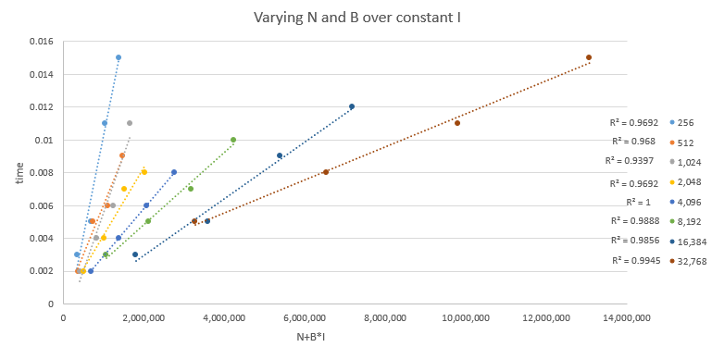

Now let’s examine what happens when **N and I are increased and B is held constant**:

|  |  |  |  |  |  |
| --- | --- | --- | --- | --- | --- |
| **dna length** | **append times** | **splicee** | **recomb** | **N+B*I** | **time** |
| 320160 | 90 | 65536 | 3269010 | 6218400 | 0.005 |
| 646560 | 90 | 131072 | 6544530 | 12443040 | 0.009 |
| 972960 | 90 | 262144 | 12769170 | 24565920 | 0.019 |
| 1299360 | 90 | 524288 | 24892050 | 48485280 | 0.036 |

Result: this also follows the linear trend, see the graph below for a summary of different cases

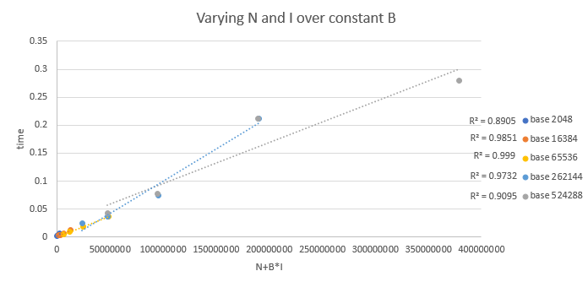  
  
O(N+B*I) correctly labels the runtime of cutAndSplice in SimpleStrand. The way change N and B individually in the text files is to add the characters “a”, “c”, “g”, and “t” but never in the order of the enzyme. This will ensure the length increases but the occurrences of the enzyme doesn’t. To change B without changing N all one has to do is insert the enzyme in place of other parts of the text file (replace not add). This will raise occurrences of the enzyme yet not lengthen the text file.

To create these graphs I copy/pasted either text full of the enzyme or text with “a”, “c”, “g”, and “t” but not exactly the enzyme at the end of the text file.

Part 2

This graph summarizes my results (the dna length column denotes whether I used ecoli.txt input file or ecoli_small.txt input file:

|  |  |  |  |
| --- | --- | --- | --- |
| **dna length** | **heap** | **largest recomb** | **time** |
| 320160 | -Xmx512M | 47,505,810 | 0.063 |
| 320160 | -Xmx1024M | 94,691,730 | 0.132 |
| 320160 | -Xmx2048M | 189,063,570 | 0.275 |
| 320160 | -Xmx4096M | 377,807,250 | 0.534 |
| 320160 | -Xmx8192M | 755,294,610 | 1.89 |
| 4639221 | -Xmx512M | 46,906,071 | 0.101 |
| 4639221 | -Xmx1024M | 89,176,791 | 0.15 |
| 4639221 | -Xmx2048M | 173,718,231 | 0.284 |
| 4639221 | -Xmx4096M | 342,801,111 | 0.533 |
| 4639221 | -Xmx8192M | 680,966,871 | 1.944 |

With increases in heap the largest recomb possible increases by nearly factors of 2 each time. They are linearly proportional. These values are also linearly proportional to the time which is shown by this graph.

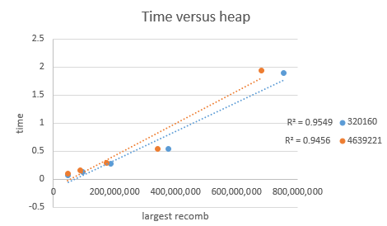

The runtime is therefore O(n) with n being the largest string size under the circumstances.

# Part 3

Benchmark your LinkStrand's cutAndSplice implementation.

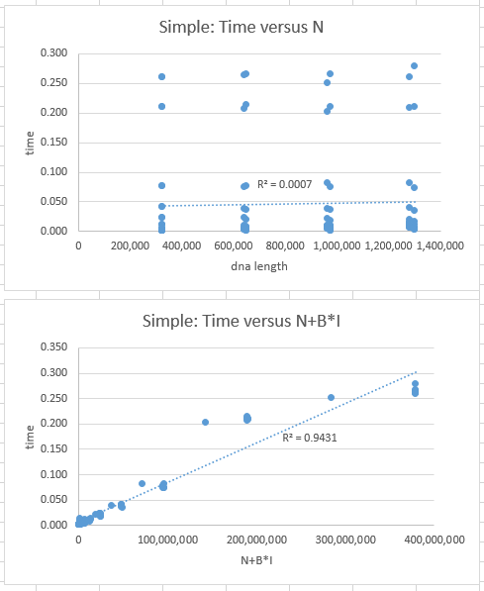 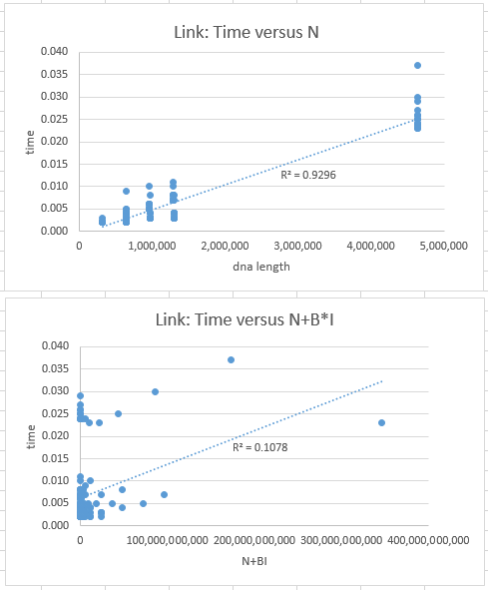

These graphs summarize the cutAndSplice runtime: SimpleStrand is O(N+B*I) while LinkStrand is O(N). My hypothesis for the reason LinkStrand does not have a runtime dependence on B or I is because the act of splicing is O(1) in a LinkedList in java. The culprit of this is the .append method. In SimpleStrand this requires much more time than for in LinkedList all you have to do is redirect the last node but in SimpleStrand a StringBuilder and new String is needed because Strings are immutable.