The Exercise:
To complete the exercise successfully, you will need to do the following tasks:

- Perform simple calculations to create automated running totals.
- Open the Cost worksheet.
- Calculate the total number of units sold in January and February.
- Calculate the difference between the number of units sold in April and May.
- Calculate the total income earned in March.
- Calculate the average number of units sold in January and February.
- Find the automated running total of units sold by using a reference cell value.

- Count cells in a range.
- Open the Order History worksheet.
- Find the number of orders from New York using the COUNT() function.
- Find the number of products not ordered from Chicago using the COUNTBLANK() function.
- Find the number of products from California with an order value of “14” using the COUNTIF() function.

- Work with built-in functions to perform data calculations.
- Open the Shipping worksheet.
- Calculate the gift amount for Kivell using the IFS() function.
- Find the delivery day of the order for Kivell using the SWITCH() function.
- Find the maximum cost with the shipping time value as “1” using the MAXIFS() function.
- Calculate the average shipping cost using the AVERAGEIFS() function.
- Calculate the expenses incurred in a day for Kivell’s order using the QUOTIENT() function.
- Calculate the balance expenses incurred in a day for Kivell’s order using the MOD() function.

- Configure the default formula options.
- Open a new worksheet.
- Activate the R1C1 reference style using the Excel Options window.
- Deactivate the Formula AutoComplete feature using the Excel Options window.

Process for completing the exercise:
Perform simple calculations to create automated running totals

- Open the workbook.

- Select the Cost worksheet. Observe the data on the worksheet.

- Select cell B8.

- To find the sum of units sold in January and February, in the formula bar, type =C2+C3, and press Enter. The result is displayed in cell B8.

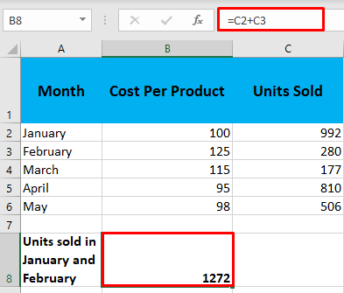

- Select cell B10.

- To find the difference between the number of units sold in April and May, in the formula bar, type =C5-C6, and press Enter. The result is displayed in cell B10.

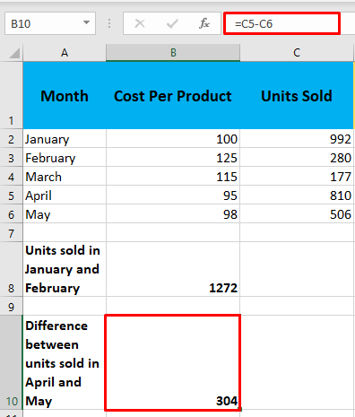

- Select the cell D8.

- To find the total income earned in March, in the formula bar, type =B4*C4, and press Enter. The result is displayed in cell D8.

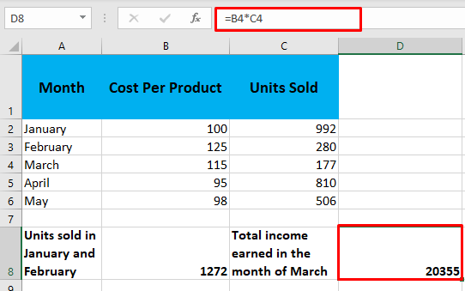

- Select the cell D10.

- To find the average number of units sold in January and February, in the formula bar, type =B8/2 and press Enter. The result is displayed in cell D10.

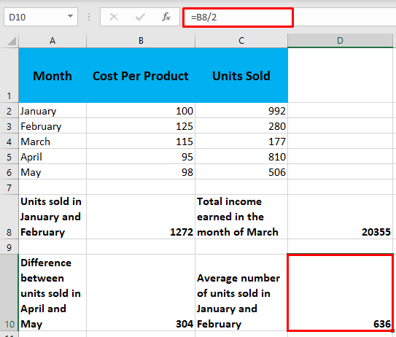

- Select cell D2.

- To find the automated running total of units sold by using a reference cell value, in the formula bar, type =SUM(C2, C3) and press Enter. The result is displayed in cell D2.

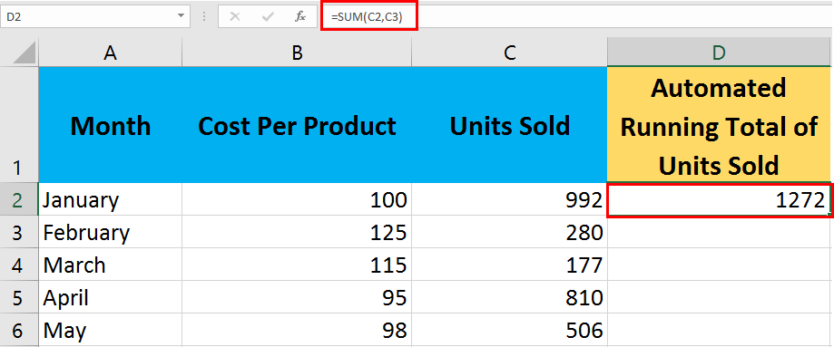

- To find the automated running totals of units sold from January to May, select cell D2. A black fill handle is displayed at the bottom right corner of the cell.

- To get the result, drag the fill handle downwards from cells D3 to D6. The cells from D3 to D6 are filled automatically with the running totals.

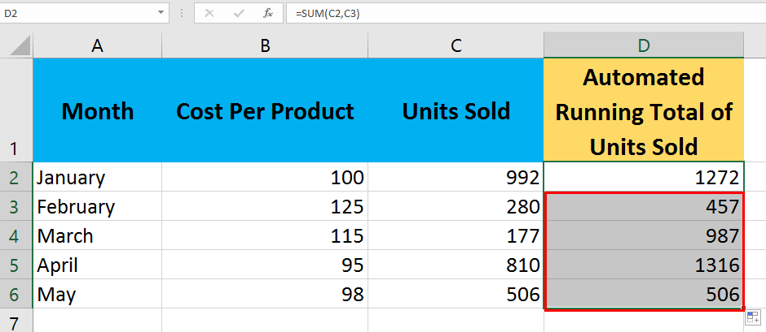

Count cells in a range.

- Select the Order History worksheet. Observe the data on the worksheet.

- Select cell B14.

- To find the number of orders from New York, in the formula bar, type =COUNT(C2:C11) and press Enter. The result is displayed in cell B14.

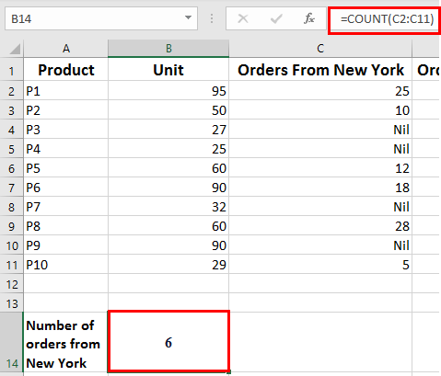

- Select cell B15.

- To find the number of products not ordered from Chicago, in the formula bar, type =COUNTBLANK(D2:D11) and press Enter. The result is displayed in cell B15.

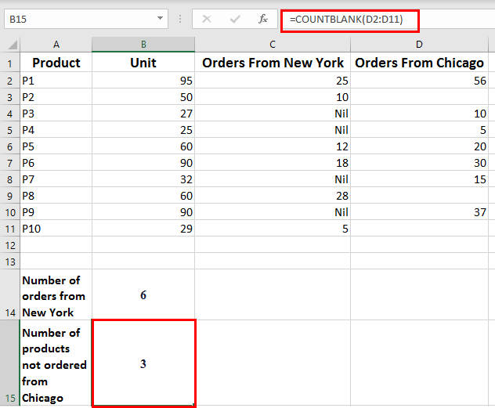

- Select cell B16.

- To find the number of products from California with an order value of “14”, in the formula bar, type =COUNTIF(E2:E11,"=14") and press Enter. The result is displayed in cell B16.

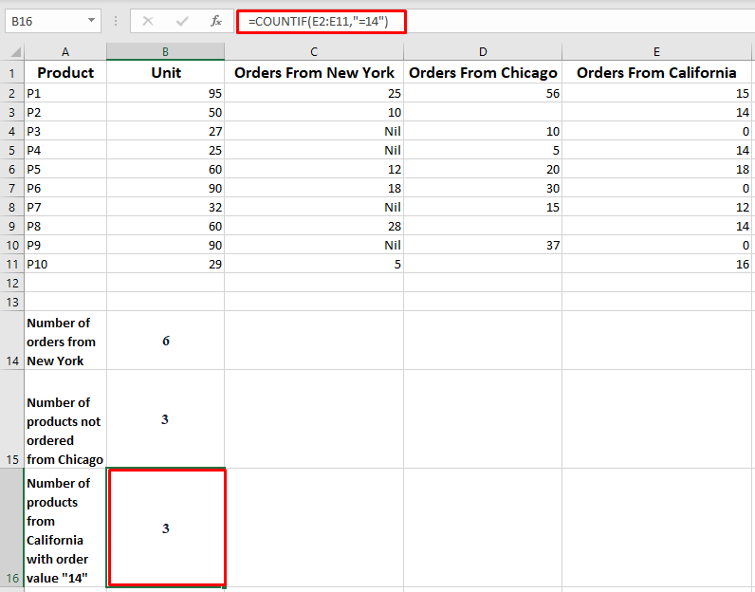

Work with built-in functions to perform data calculations.

- Select the Shipping worksheet. Observe the data on the worksheet.

- Select cell F2.

- To calculate the gift amount for Kivell, in the formula bar, type =IFS(C2>850,"25",C2>650,"20",C2>450,"15",C2>250,"10",TRUE,"F") and press Enter. The result is displayed in cell F2.

The gift amount for each Order ID is calculated as follows:

Total Cost | Gift Amount
>850 | 25
>650 | 20
>450 | 15
>250 | 10

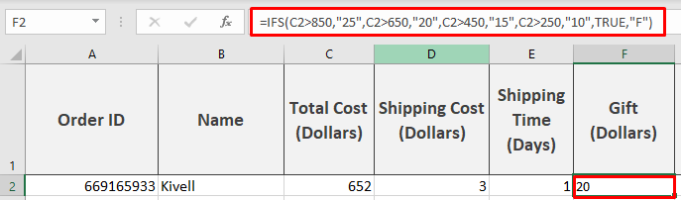

- Select cell G2.

- To find the delivery day of the order for Kivell, in the formula bar, type =SWITCH(E2,1,"Next Day",0,"Same Day","No match") and press Enter. The result is displayed in cell G2.

The delivery day of an order is calculated as follows:

Shipping Time | Delivery Day
0 | Same Day
1 | Next Day

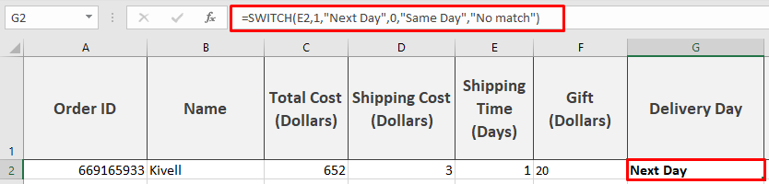

- Select cell E17.

- To find the average shipping cost, in the formula bar, type =AVERAGEIFS(D2:D15, D2:D15, ">0", D2:D15, "<5") and press Enter. The result is displayed in cell E17.

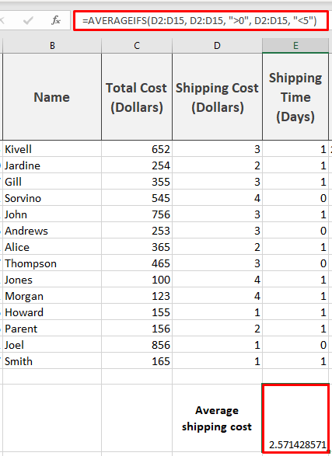

- Select cell B17.

- To find the maximum cost with the shipping time value considered as “1”, in the formula bar, type =MAXIFS(C2:C15,E2:E15,1) and press Enter. The result is displayed in cell B17.

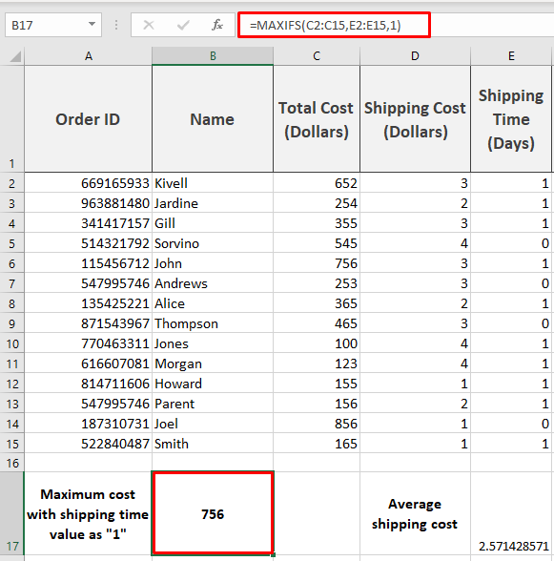

- Select the cell H2.

- To find the expenses incurred in a day for Kivell’s order, in the formula bar, type =QUOTIENT(C2+D2,30) and press Enter. The result is displayed in the cell H2.

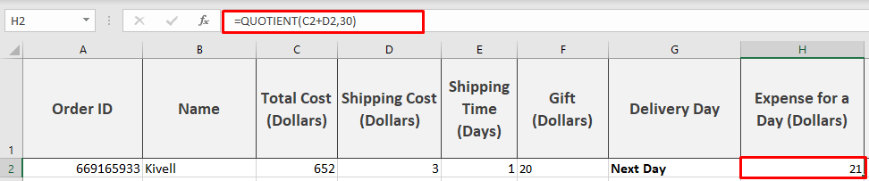

- Select the cell I2.

- To calculate the balance expenses incurred in a day for Kivell’s order, in the formula bar, type =MOD(C2+D2,30) and press Enter. The result is displayed in cell I2.

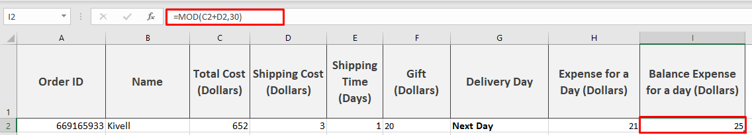

Configure the default formula options.

- To open a new blank worksheet, on the sheet tab at the bottom of the workbook, click the (+) sign.

- A new blank worksheet, Sheet1, opens.

- Click the File tab and click Options.

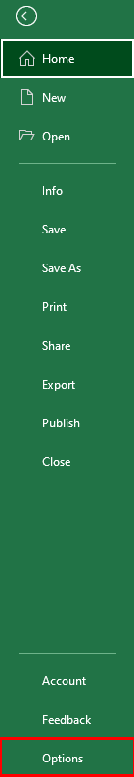

- The Excel Options window appears.

- On the left pane, click Formulas.

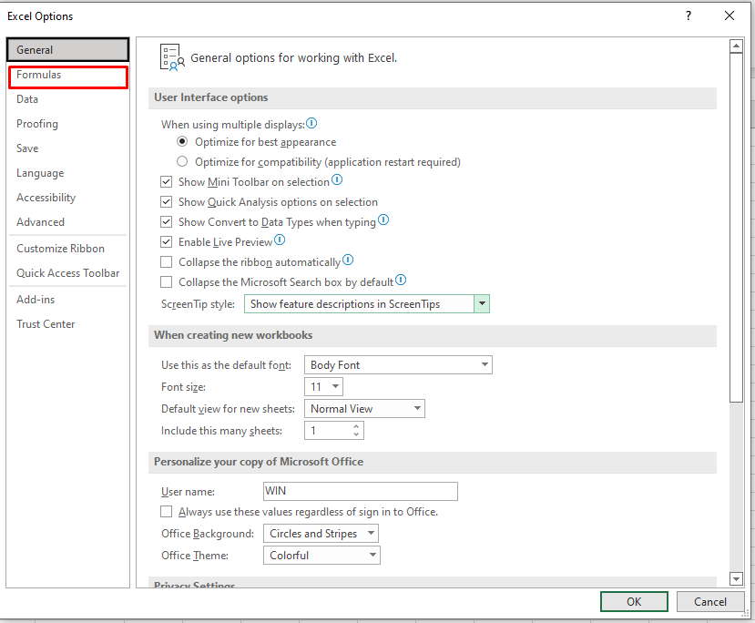

- On the right pane, under Working with formulas, click the R1C1 reference style checkbox and click OK.
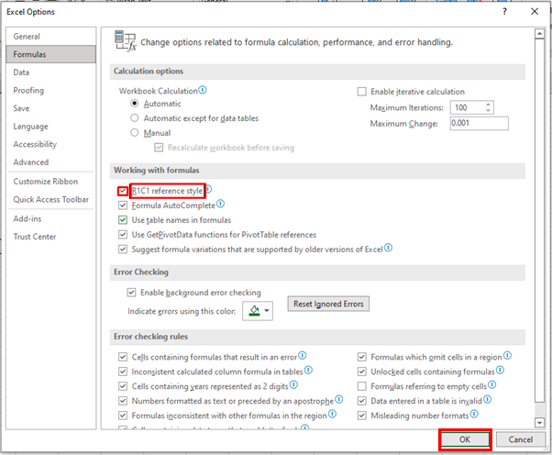

- On the worksheet, cell A1 is selected by default.

- In the Name Box, observe the R1C1 reference style of referencing the cell A1. The columns are numbered instead of alphabets.

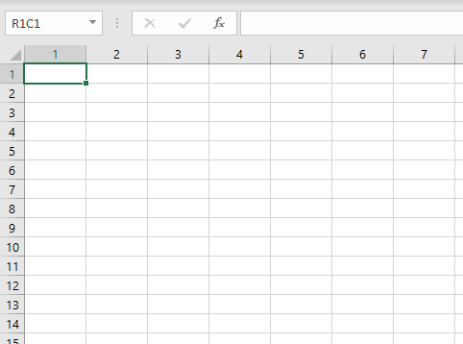

- To get the list of possible formulas provided by the Formula Autocomplete feature, click the cell R1C1 and type =AV.

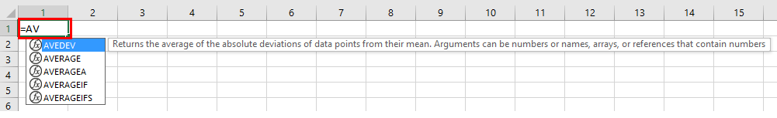

- Click the File tab and click Options.

- The Excel Options window appears.

- On the left pane, click Formulas.

- On the right pane, under Working with formulas, click to clear the Formula AutoComplete and R1C1 reference style checkboxes and click OK.

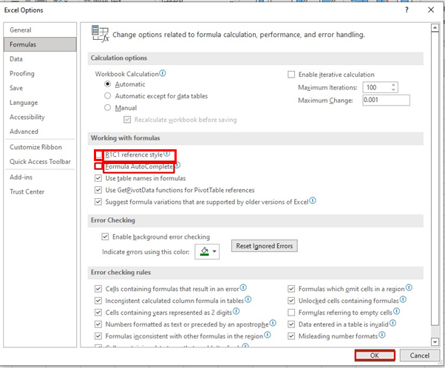

- Observe cell A1. The formula is not displayed automatically, and there is an error.

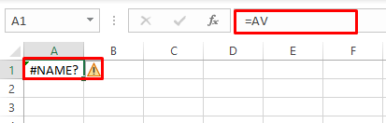

- Close the workbook.

- Exit the Excel application.

