Graphics Citation

Mandi Roberts-Boyster

WGD251

November Session

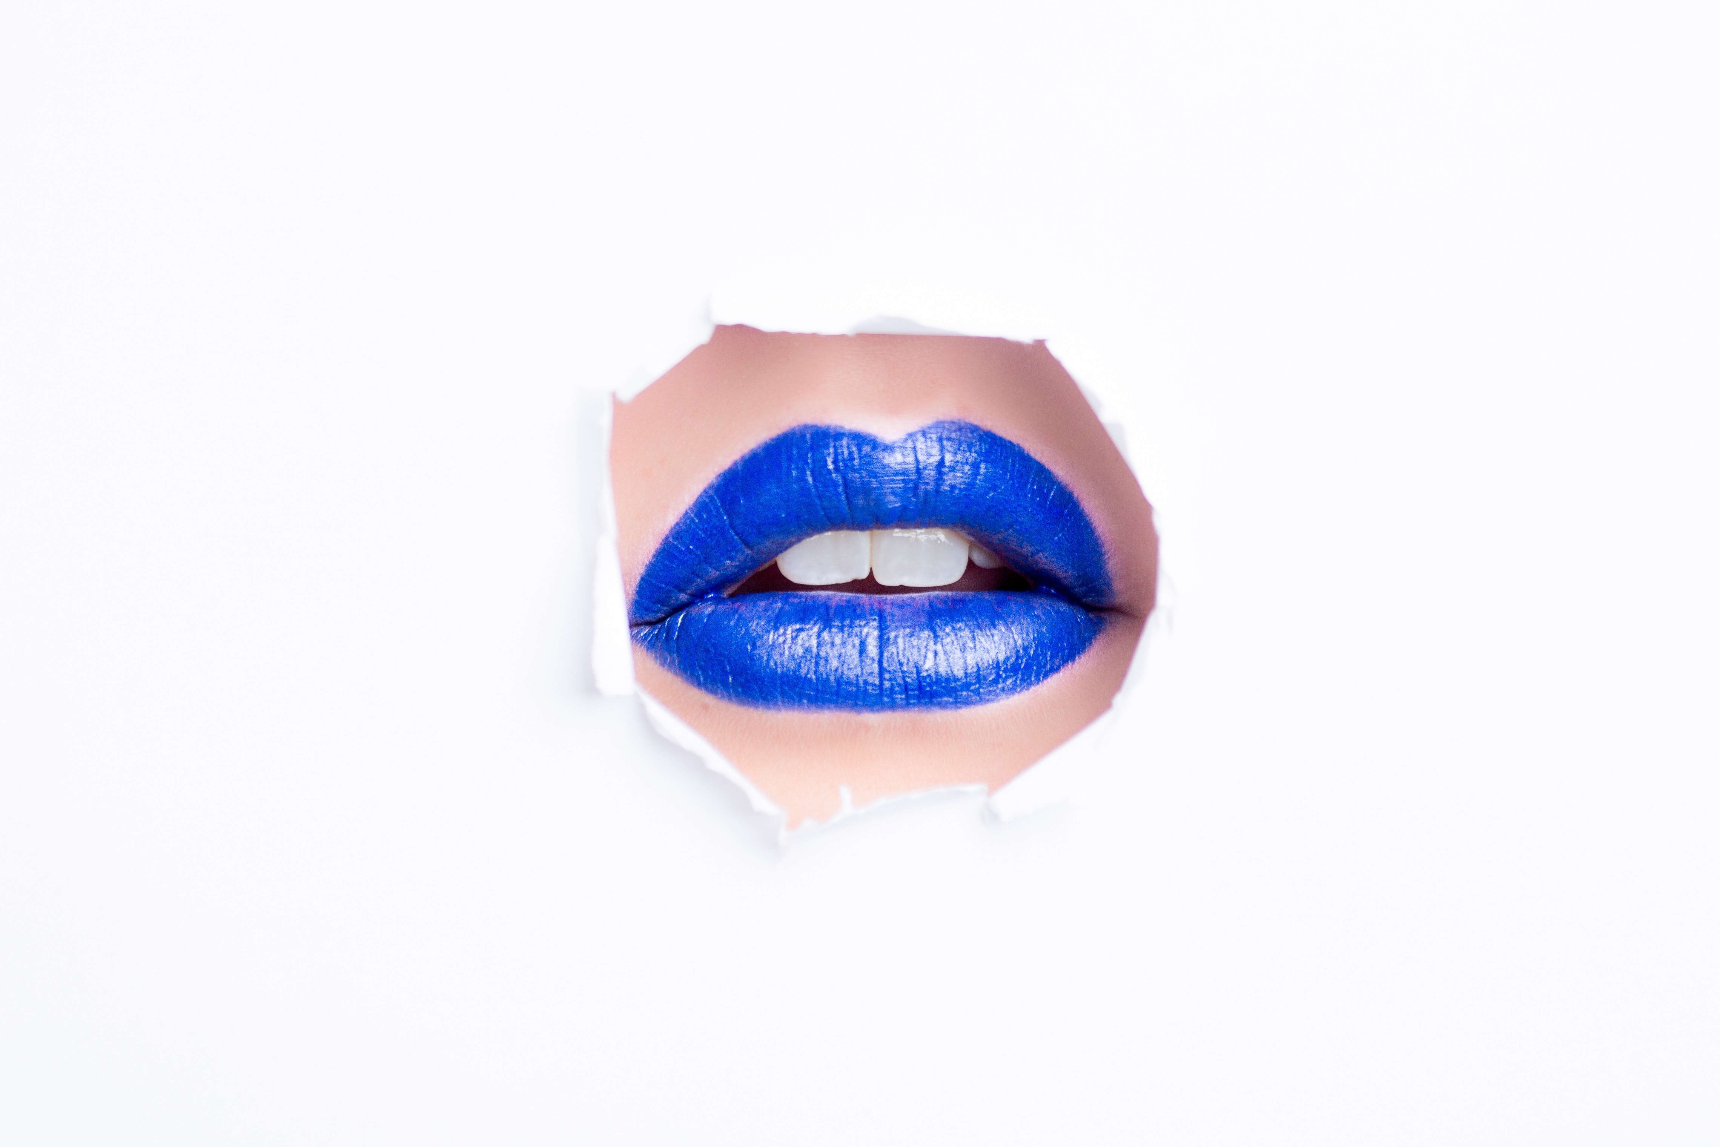Public Domain

Magni,Oleg(2018)(<https://www.pexels.com/photo/blue-lipstick-922625/>) art-beautiful-beauty-922625.jpg

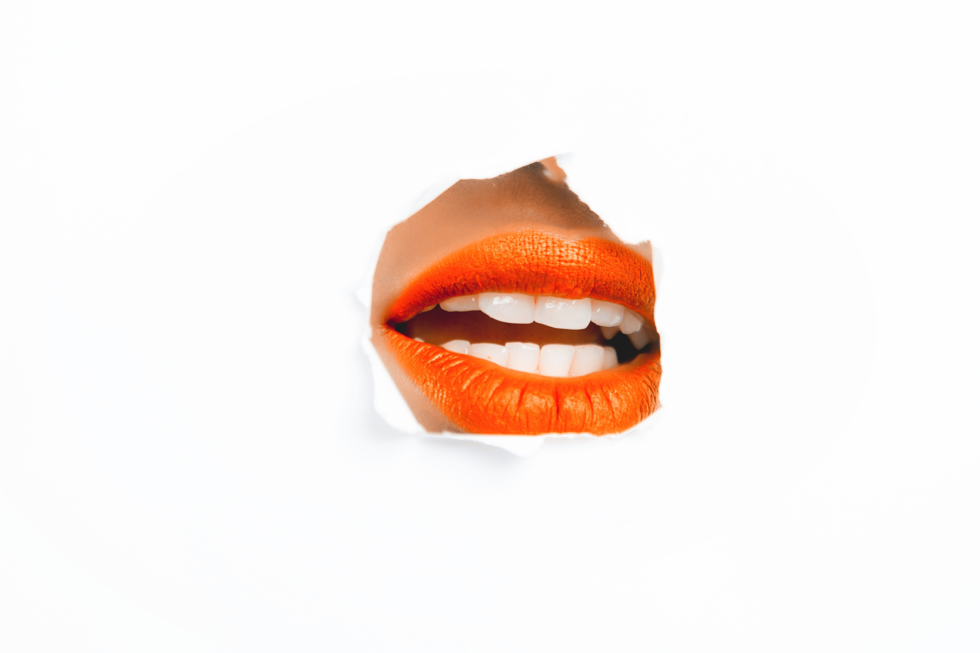Public Domain

Magni,Oleg(2018)(<https://www.pexels.com/photo/woman-with-orange-lipstick-925300/>) beauty-close-up-color-925306.jpg

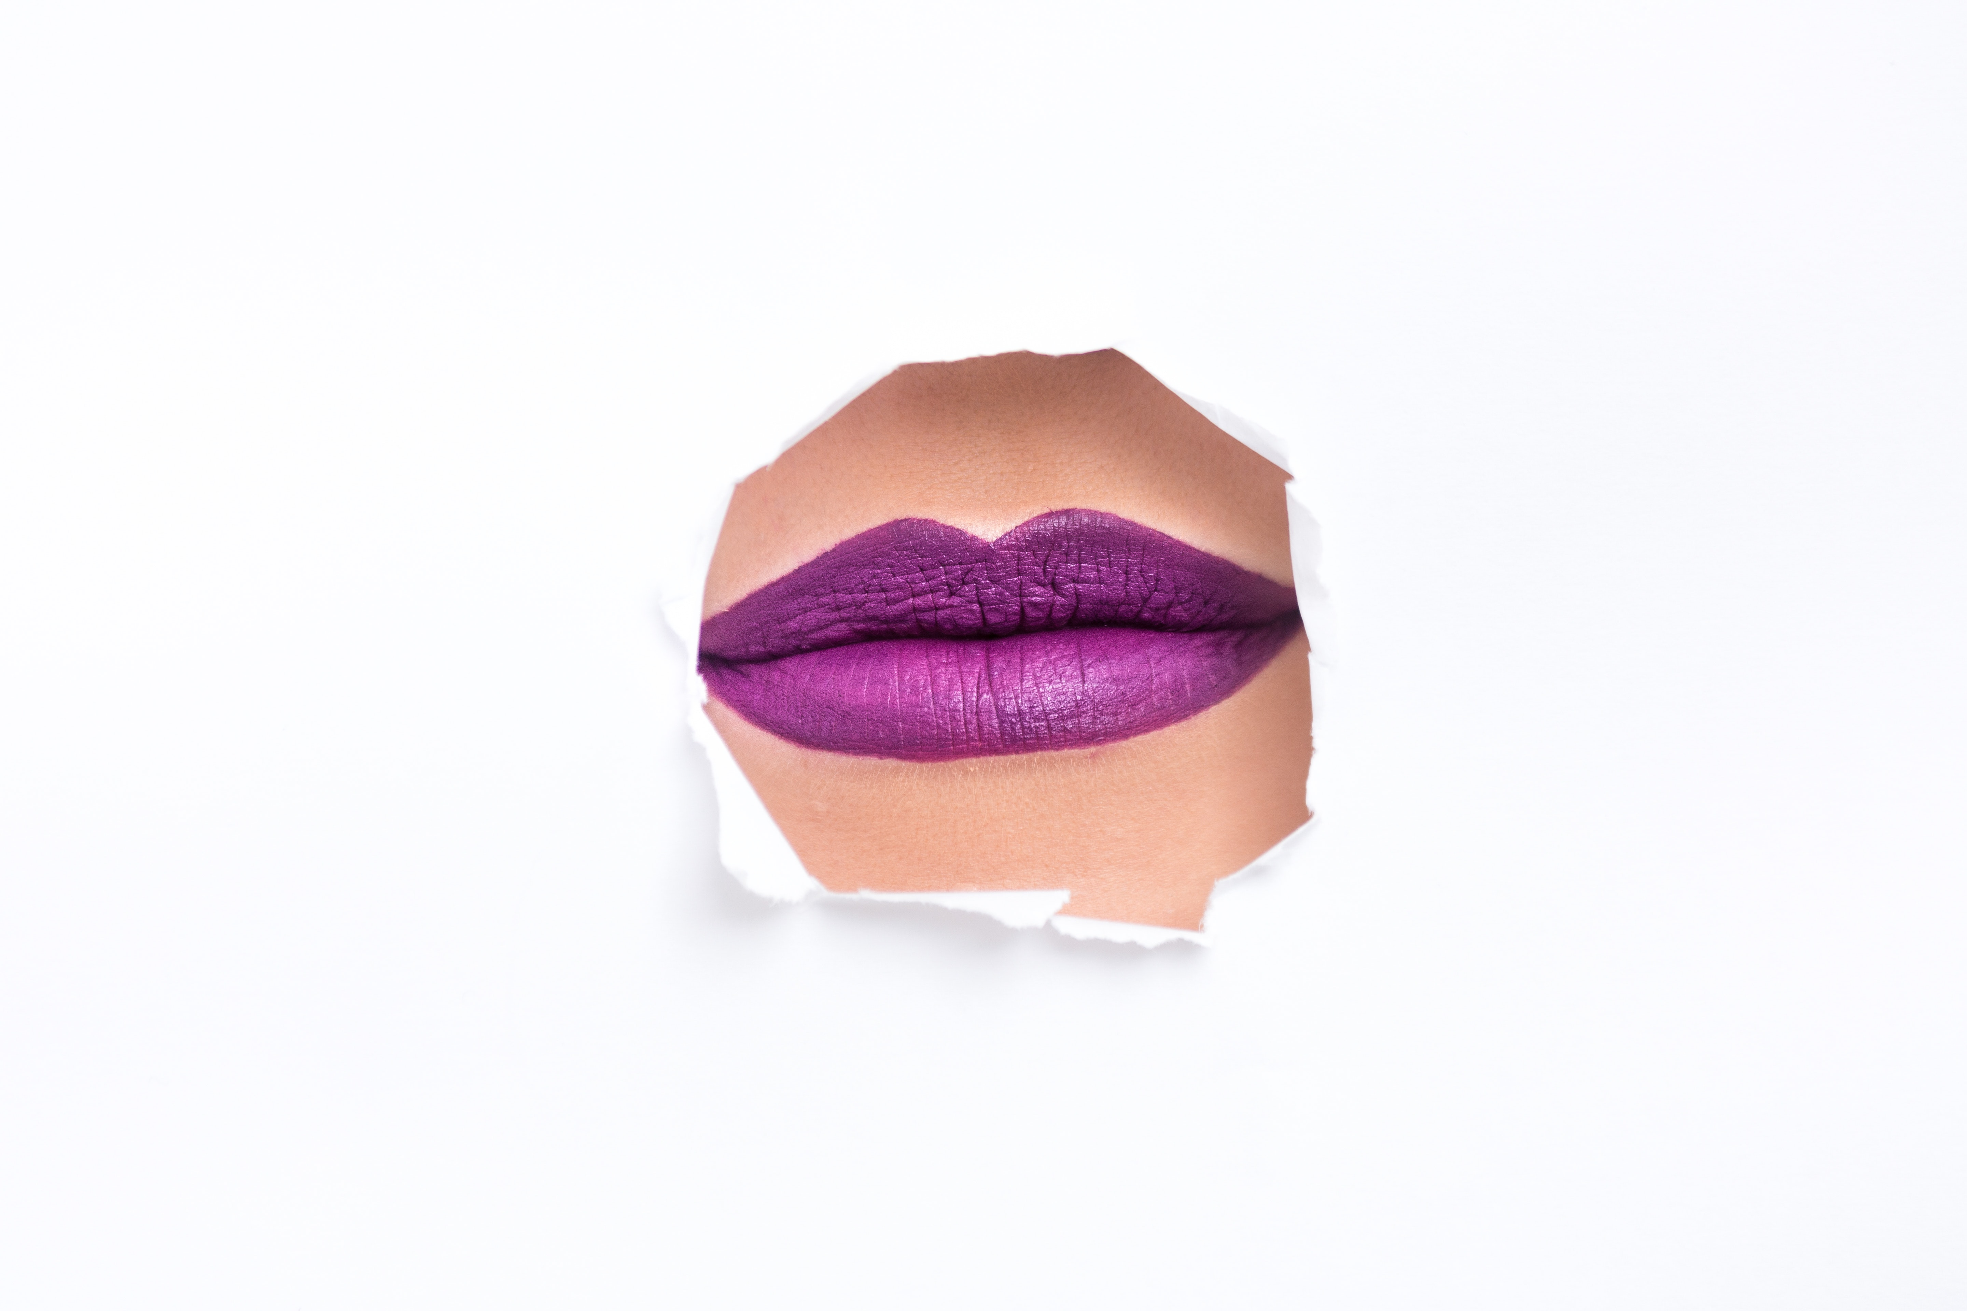

Public Domain

Magni,Oleg(2018)

(https://www.pexels.com/photo/purple-lipstick-922471/)

beauty-close-up-color-922471.jpg