Citations

Mandi Boyster

WGD251

November Session

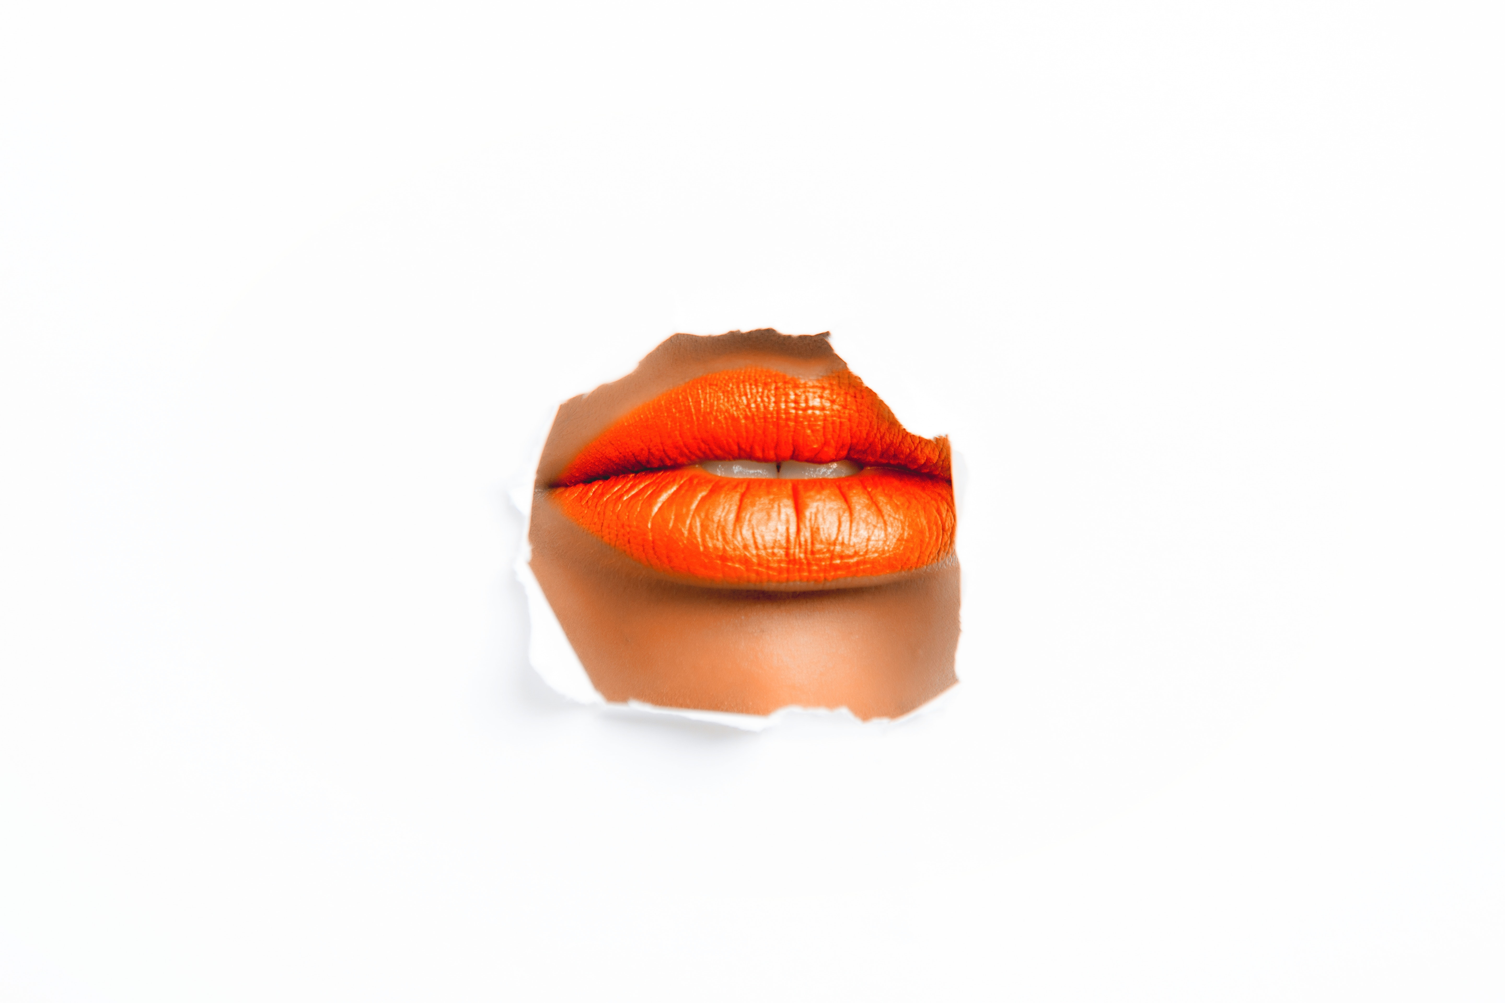

Public Domain

Magni,Oleg(2018)(<https://www.pexels.com/photo/woman-with-orange-lipstick-925300/>) [color-cutout-detail-925300.jpg](https://www.pexels.com/photo/woman-with-orange-lipstick-925300/)color-cutout-detail-925300.jpg)

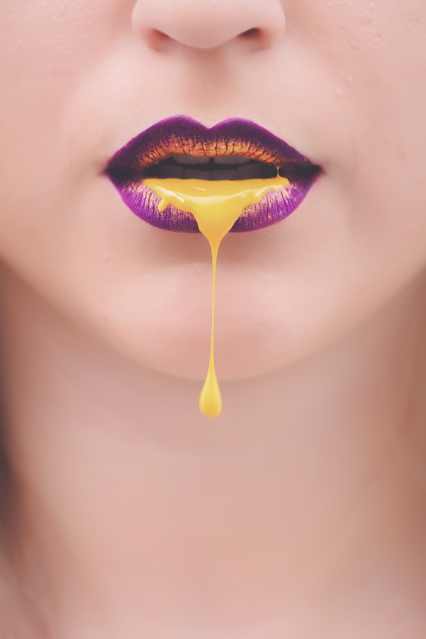

Public Domain

Magni,Oleg(2018)(<https://www.pexels.com/photo/women-s-purple-and-yellow-lips-with-yellow-liquid-922470/>) beautiful-beauty-chin-922470.jpg

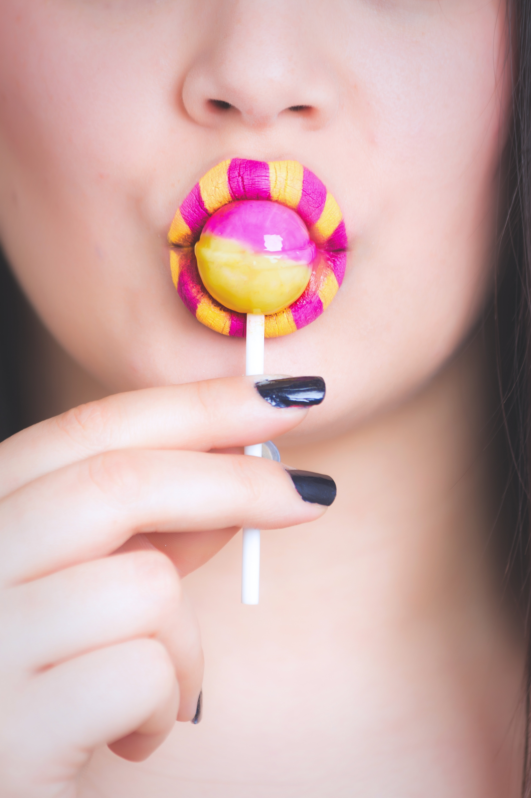

Magni,Oleg(2018)(<https://www.pexels.com/photo/woman-eating-pink-and-yellow-lollipop-922635/>) beauty-candy-close-up-922635.jpg