Reconnaissance and Enumeration Report
Course: ITC 4610 Penetration Testing
Prepared by: Mandip Amgain
Date: February 23, 2026
Professor: Betty J. Lauer

1. Introduction
The purpose of this assignment is to conduct passive and active reconnaissance against a controlled virtualized sandbox environment. This phase of a penetration test is critical for identifying the attack surface, mapping the network hierarchy, and discovering specific service versions that may contain exploitable vulnerabilities.
1.1 Environment Overview
The lab environment consists of an isolated internal network named Pentest_Internal_Net using the private IP range 100.64.0.0/24. The systems involved include:
- Kali Linux: The primary attacker platform.
- Windows Server 2019: Acting as the Domain Controller (DNS/DHCP).
- Metasploitable2: A Linux-based target designed with intentional vulnerabilities.
- Windows 7: A legacy domain-joined client system.

2. Passive Reconnaissance
Passive reconnaissance involves gathering information without directly interacting with the target’s systems, thereby minimizing the attacker’s digital footprint.
2.1 Tools and Features
- WHOIS: Used to query public record information and domain ownership.
- nslookup: A tool for IP address and device name searches.
- theHarvester: Used to find email addresses and infrastructure details for an organization.
2.2 Methodology and Findings
In this lab, nslookup was utilized to verify the internal DNS structure of the pentest.lab domain.
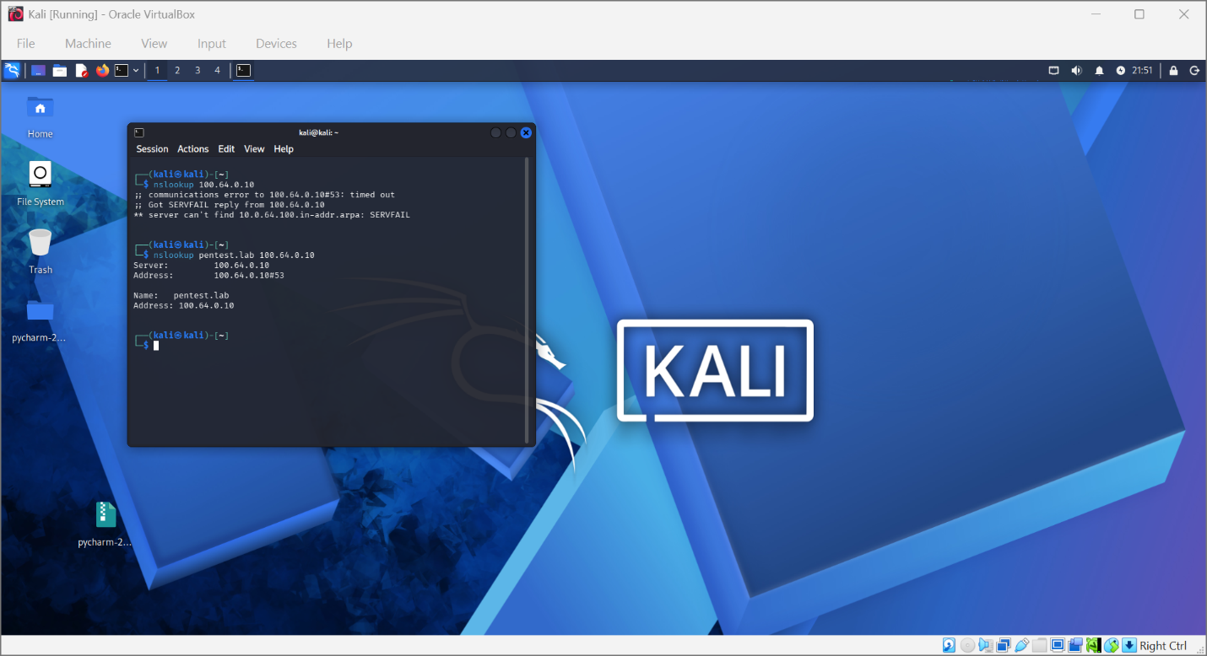
Figure 1: Successful nslookup resolution showing pentest.lab mapping to 100.64.0.10.
Analysis: The tool successfully identified the Domain Controller at 100.64.0.10. Initial attempts failed due to service connectivity issues, which were resolved by manually pointing the attacker's DNS settings to the server.

3. Active Reconnaissance
Active reconnaissance involves direct interaction with the target systems to identify open ports and active services.
3.1 Tools and Features
- Nmap: A command-line tool used for network discovery and service version detection.
- Wireshark: A graphical scanner used for real-time packet analysis and traffic monitoring.
- Netcat: A "banner grab" tool used to manually identify service headers.
3.2 Traffic Analysis
Wireshark was used to monitor communication between the Kali Linux attacker and the Windows Server.
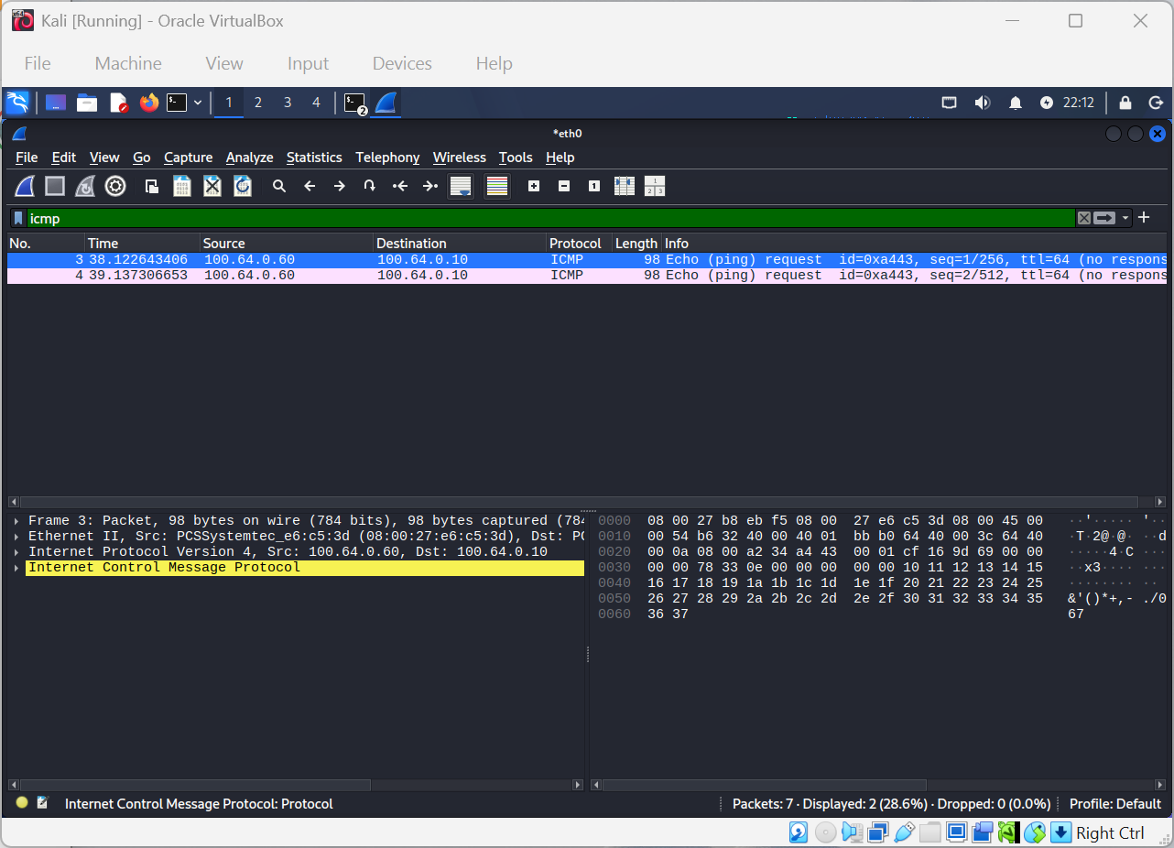
Figure 2: Wireshark capture showing ICMP (Ping) traffic between 100.64.0.60 and 100.64.0.10.
Analysis: This capture verified that the network layer was fully functional despite initial DHCP failures.

4. Enumeration: List of Findings
Enumeration is the process of extracting detailed information about the target's services.
4.1 Detailed Service Mapping
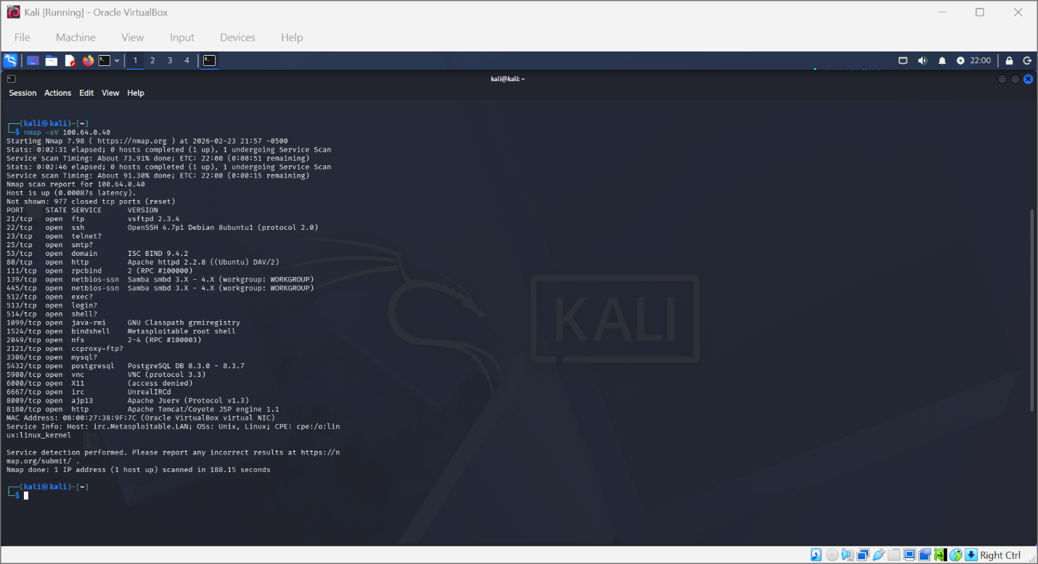
Figure 3: Nmap version scan (-sV) results for the Metasploitable2 target (100.64.0.40).

Table 1: Below is the consolidated data gathered from Nmap, Netcat, and nslookup:
Target Host | OS / Role | Open Ports | Identified Service & Version | Vulnerability Notes
100.64.0.10 | Win Server 2019 / Domain Controller | 53, 88, 389, 445 | DNS (ISC BIND), Kerberos, LDAP, SMB | Primary target for Active Directory attacks.
100.64.0.40 | Metasploitable2 / Vulnerable Linux | 21, 22, 25, 80, 3306 | vsFTPd 2.3.4, OpenSSH 4.7p1, Apache 2.2.8, MySQL | Contains multiple high-risk service backdoors (vsFTPd).
100.64.0.30 | Windows 7 / Legacy Client | 135, 139, 445 | RPC, NetBIOS, SMB | Legacy system susceptible to SMB exploits (like EternalBlue).
100.64.0.50 | DVWA / Vulnerable Web App | 80 | Apache httpd (via PHP 5.2.4) | Prime target for web-app testing (SQLi, XSS).

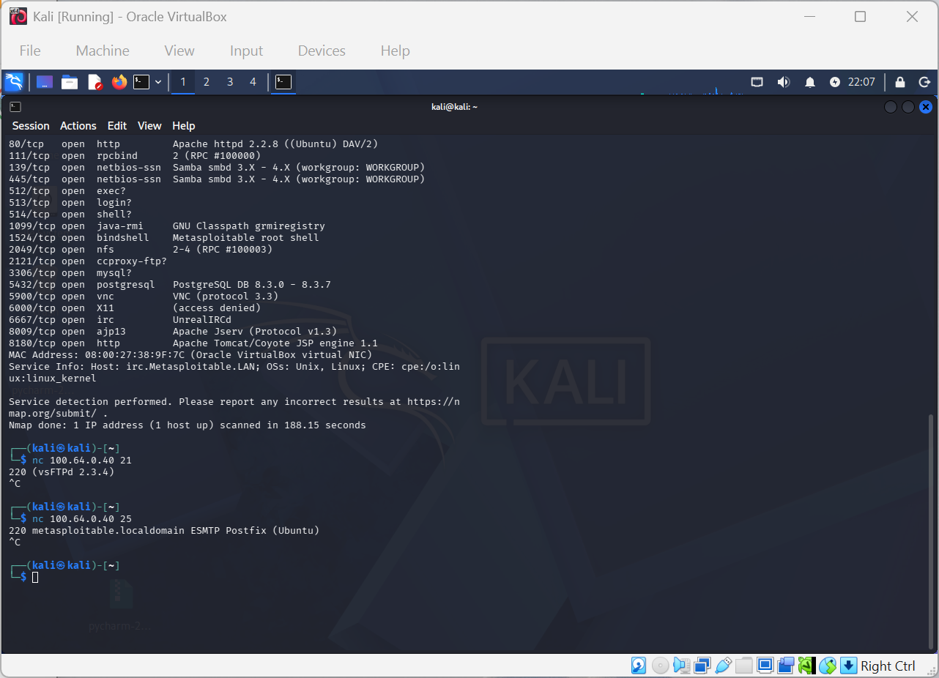
Figure 4: Manual banner grabbing using Netcat confirmed the vsFTPd 2.3.4 version string.

5. Network Management and Troubleshooting
A significant portion of the reconnaissance phase involved resolving environment configuration issues.
- DHCP Failures: Multiple systems, including Windows 7, initially defaulted to APIPA addresses (169.254.x.x).
- Resolution: Static IP addresses were manually assigned (e.g., 100.64.0.30 for Windows 7) to ensure they remained within the internal network range.

6. Conclusion
The reconnaissance phase successfully mapped the internal lab environment. By combining passive DNS queries with active Nmap scans and banner grabbing, a detailed list of vulnerable services was established for further exploitation testing.

