Mandira Ghimire

[Ghimiremandira35@gmail.com](mailto:Ghimiremandira35@gmail.com)

January 27, 2025

**Git Installation and Verification**

**Git Installation Verification:**

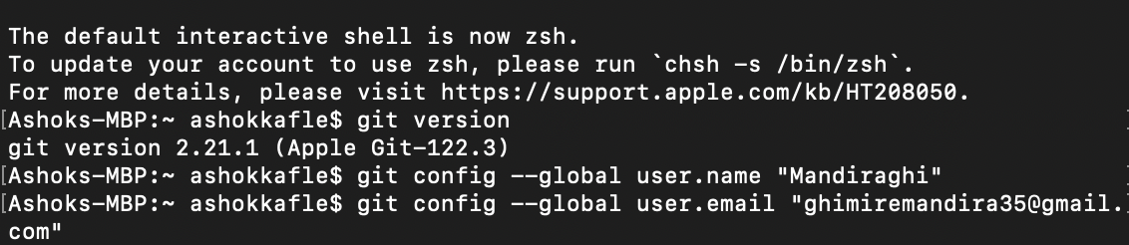

**Git Configuration:  
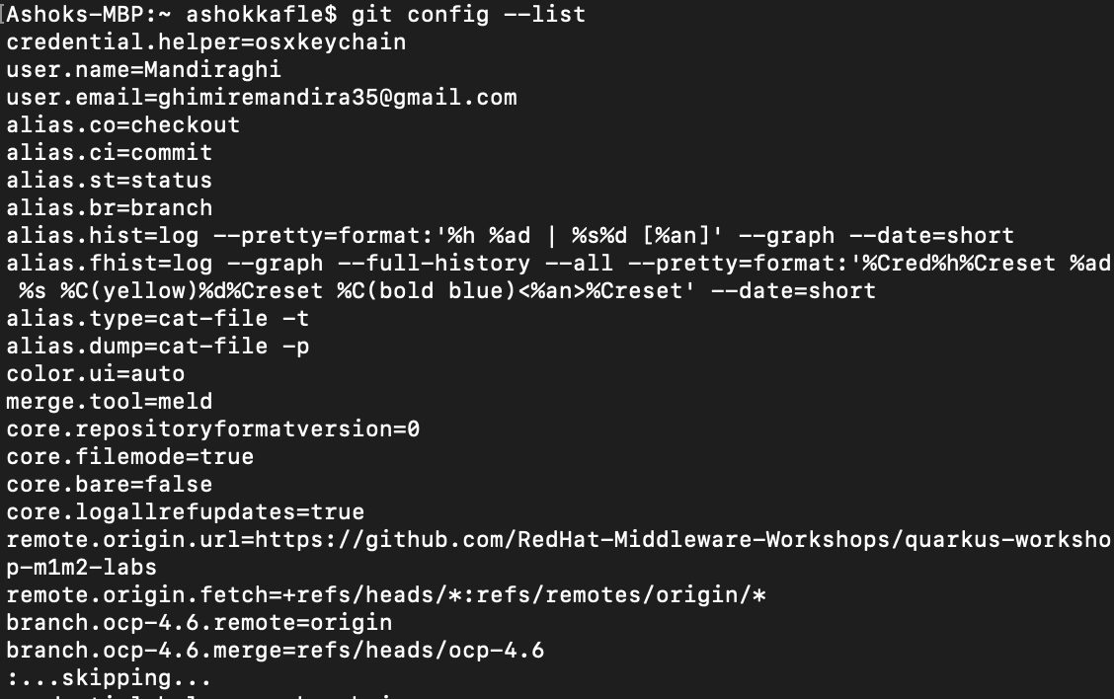**

**Git Profile:** <https://github.com/Mandiraghi>   
**

**Github Repository Link:**

**SSH Key Generate**

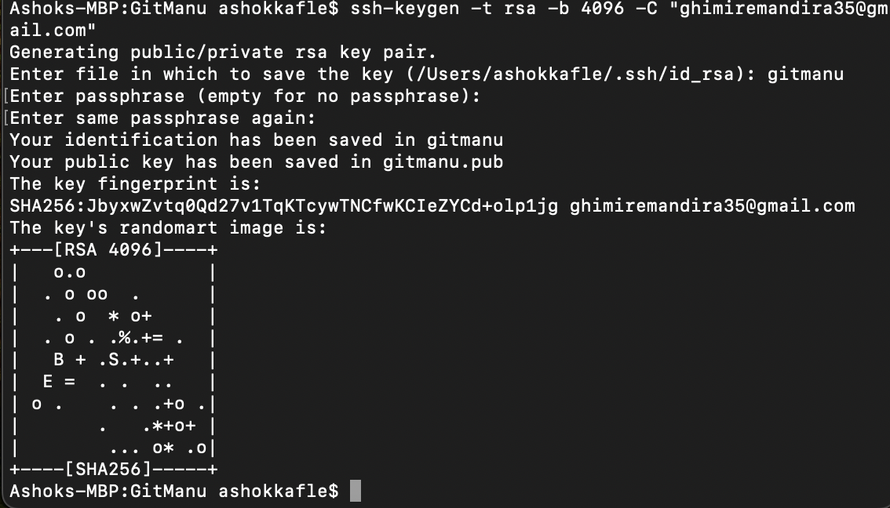

**Repository : Clone, add, commit, push**

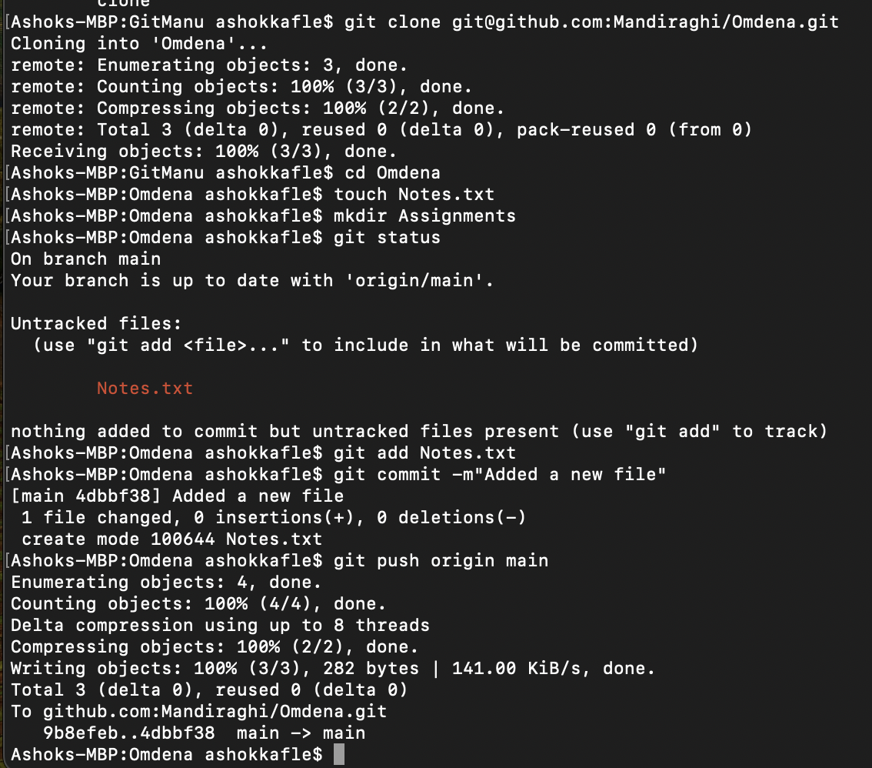

**Create Branch and modify and push  
**

**Pull Request :**

**Merge:**

