**END USER DOCUMENTATION**

Easy appointment

TABLE OF CONTENT

Contents

Customers 2

How to add Customer 2

How to delete the existing appointment 2

How to add Customer 2

# Set up username and password

First you should set up your Easy Appointment with the username and password. After that you can login to the system with the same username and password like shown in the figure below.

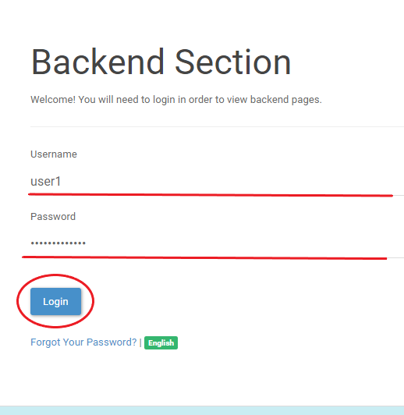

# Customers

## How to add Customer

Click on the customers page at the top of the bar.

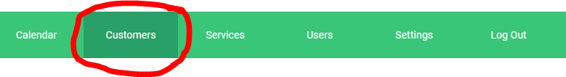

Then, Click add button.

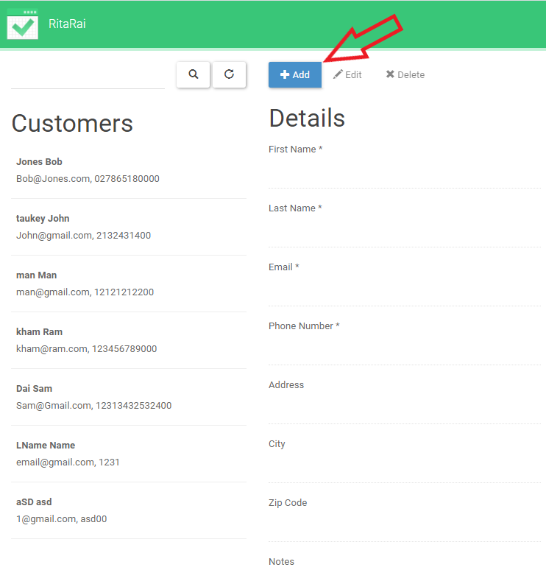

Now, you can fill the details and fill the customer details as shown in the figure.

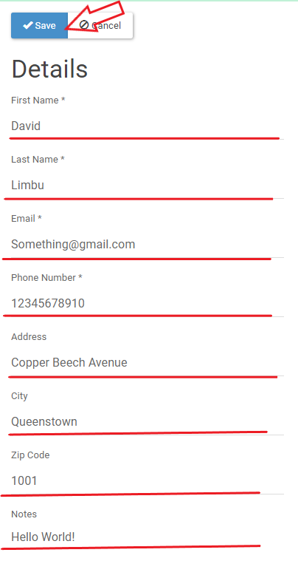

Then, click save button to add customer as shown above.

## SEARCH AND EDIT OR DELETE CUSTOMERS

You can search or select the individual customers by their Name which is shown in the figure as underline or you can select from the list on the left as shown in the figure which is inside the rectangle area.

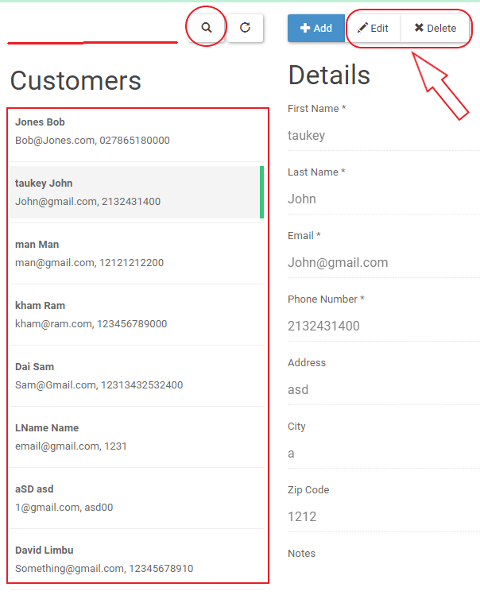

Also, beside the add button you can see edit and delete buttons as indicated by arrow in the picture above.

After you click the edit button you can edit the details of the customers then save it.

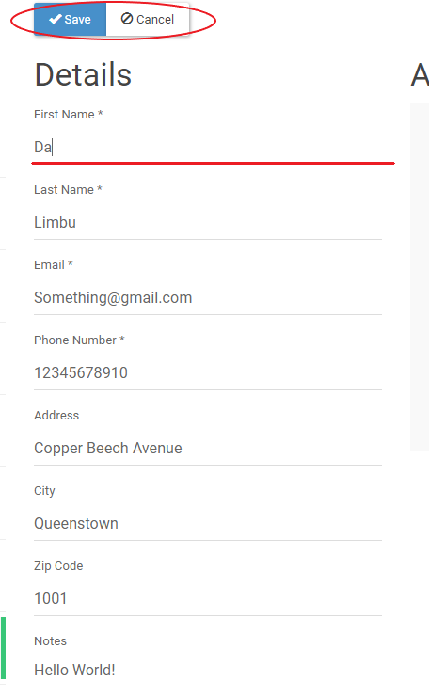

To delete the existing customers, click the delete button next to edit button.

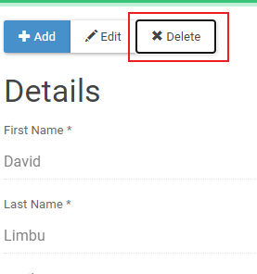

And you will see the confirmation box for deleting.

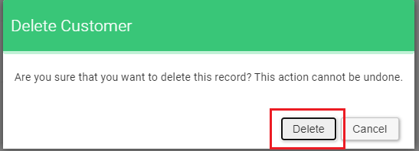

Then, click the delete button.

# Users

There are three types of user on Easy Appointment i.e. Providers, Secretaries and Admins.

## Add Provider

If you click on the Users in the first page is Provider page.

# Calendar



## How to add an Appointment?

Step 1: Click on +Appointment.

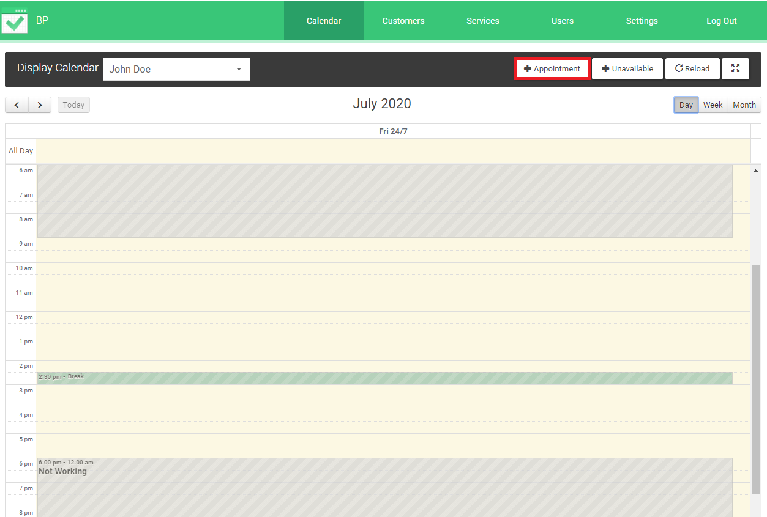

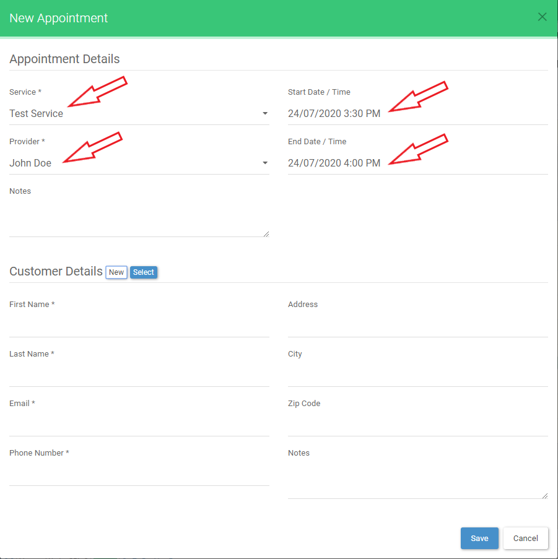

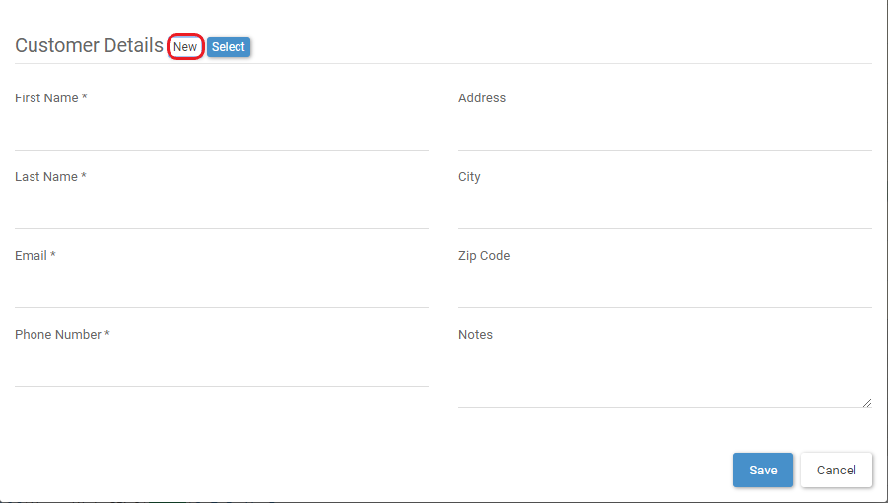

OR

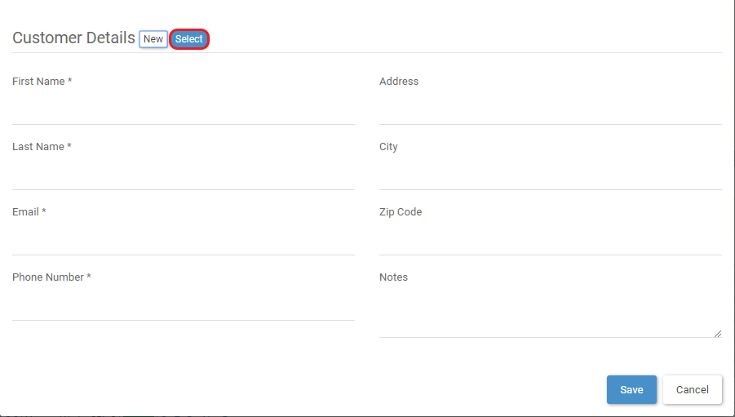

How to add Unavailable Slot?

How to check Routine?