

Student name: Adya Sharma (20183106)| Group: ME-A | 15th June’20

Motilal Nehru National Institute of Technology, Allahabad

Heat and Mass Transfer Laboratory

SUbmitted to- Prof. Vineed Narayan

**Experiment 7**

# **Emissivity Measurement Apparatus**

* **AIM:** To determine the emissivity of a grey surface at different temperatures.
* **THEORY:** According to Stefan-Boltzmann law, the radiation emitted by a black body is proportional to the fourth power of the absolute temperature.

**Q = σAT4,**

**σ – Stefan Boltzmann Constant = 5.6697 X 10-8 W/m2K4**

**EMISSIVE POWER:** The emissive power Eb of a black surface is defined as the energy emitted by the surface per unit time, per unit area.

**BLACK BODY:** A black body is one which is capable of absorbing all the incident radiation. At the same time a black body is a perfect emitter. For example, Nickel-black, Ice etc.

**GREY BODY:** A grey body is one which absorbs only a definite percentage of incident radiation. For example, Brass etc.

**EMISSIVITY:** Emissivity of a surface is a measure of how it emits radiant energy in comparison with a black body at the same temperature, or emissivity of a surface is a ratio of emissive power of the surface to the emissive power of a perfect black body at the same temperature.

**ε = E/E0**

**ε= Emissivity**

**E= Emissive power of the grey body**

**E0 = Emissive power of the perfect black body.**

* **EXPERIMENTAL SETUP:** The experimental setup consists of two brass discs of the same size, one of which is non-black and the other is black with heating coils at the bottom of the disc. The plates are kept in an enclosure to provide a surrounding a surrounding of undisturbed natural convection. The heat input to the heaters is varied by different dimmer stats and input is shown on a common Wattmeter. The temperatures of the plates (discs) are measured by thermocouples with temperature indicator. One of the plates is made black by applying a thick layer of lamp black, while the other plate whose emissivity is to be measured is non-black. Seven thermocouples are provided with the setup, T1, T2 and T3 on the non-black surface. T4, T5 and T6 on the surface of the black disc and T7 inside the enclosure.
* **EXPERIMETNTAL PROCEDURE:**

1. Connect the electric mains.
2. Operate the dimmer stat and give the power input to the plates.
3. Adjust same heat input to surfaces say 50V by using toggle switches for heater 1 and heater 2.
4. When steady state is reached (say after about 30 minutes) note down the temperatures T1 to T6 by rotating the temperature selector switch.
5. Note down the chamber temperature T7.
6. Repeat the experiment for different surface temperatures.

* **OBSERVATIONS:**

|  |  |  |  |  |  |  |  |  |  |
| --- | --- | --- | --- | --- | --- | --- | --- | --- | --- |
|  |  |  |  | | |  | | |  |
| **Voltage**  **(V)** | **Current**  **I(A)** | **Wattage**  **W=V X I** | **Temp of surface(˚C)** | | | **Temp of surface(˚C)** | | | **T7** |
| **T1** | **T2** | **T3** | **T4** | **T5** | **T6** |
| **60** | **0.27** |  | **64.1** | **64.7** | **63.9** | **71.0** | **70.5** | **71.5** |  |
| **70** | **0.32** |  | **73.3** | **73.9** | **72.9** | **82.9** | **82.6** | **83.3** |  |
| **80** | **0.37** |  | **89.0** | **89.9** | **89.1** | **102.1** | **102.5** | **102.9** |  |

* **SPECIMEN CALCULATIONS:**

1. **Heat Input** qi = V X I = 16.2 W

qi = 16

1. **Average temperature of the specimen brass surface**

TS = T1 + T2 + T3

3

TS = 71 ˚C

1. **Average temperature of the specimen brass surface**

TB = T4 + T4 + T5

3

TB = 64.23˚C

1. **Chamber ∞ ambient temperature**, T∞ = 35.5˚C
2. **Determination of emissivity ε of the brass( grey) surface**

εb = (T4B - T4∞)/(T4S – T4∞) = 0.64

* **RESULT:**

Average emissivity of the brass (grey) surface εavg = 0.57

**EMISSIVITY MEASUREMENT APPARATUS**

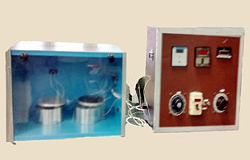

**Experiment 8**

# **Thermal Conductivity Of Insulating Powder**

**AIM**:

To determine thermal conductivity of insulating powder.

**THEORY:**

In many heat transfer equipments, heat loss to surroundings is to be maintained. In such cases they are lagged by materials of lower thermal conductivity, which are referred to as insulators. Powders have the advantage that they can take any shape between any two conforming surfaces. In addition its conductivity will be much lower than that of the solid from which the powder has been made. This is because of very large amount of air space in between particles, which have much lower thermal conductivity values. Thermal conductivity of such material is a complicated function of the geometry of the particles, particle thermal conductivity, the nature of heat transfer, conduction, convection and radiation in air spaces, which is determined by the air space size and temperature level etc.

Thus it is very difficult to estimate and almost in all practical cases it is measured experimentally. The setup provided is one such apparatus to find thermal conductivity. The radial heat conduction through spherical wall is given by

Q= $\frac{4πKr_{o}r_{i}(T_{i}-T_{o})}{(r_{o}-r_{i})}$

Where

Q=Rate of heat conducted in Warts

K=Thermal conductivity of the material in W/m-K

$r_{o}$ =Outer radius of the sphere in m

$r_{i}$ =Inner radius of the sphere in m

$T_{i}$ =Inner surface temperature in $℃$

$K=\frac{Q(r_{o}-r_{i})}{4πr_{o}r_{i}(T_{i}-T_{o})}$ W/m.K

**DESCRIPTION OF THE APPARATUS:**

The apparatus consists of thin walled concentric spheres of copper.

The inner copper sphere houses the heating coil. The insulation powder (Asbestos powder - lagging material) is packed between the two spheres. The power given to heating coil is measured by voltmeter and ammeter and can be varied by using dimmerstat. There are ten $(T_{i}-T_{o})$ thermocouples embedded on the outer sphere. Thermal conductivity of insulating powder can be find out by taking the temperature readings of these thermocouples.

**DIAGRAM:**

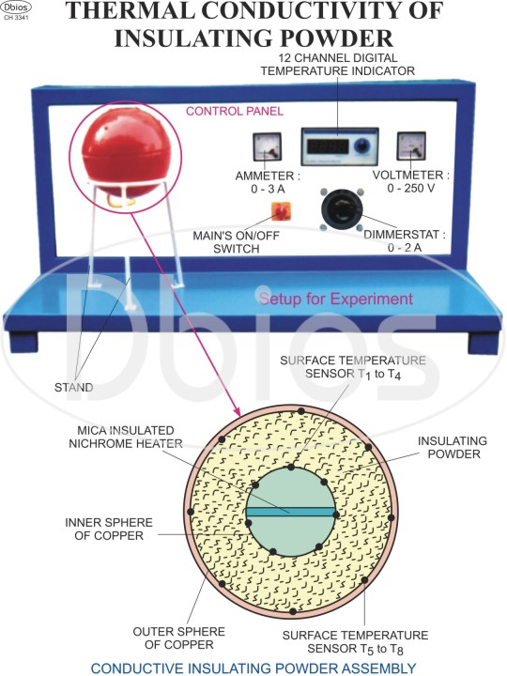

**SPECIFICATIONS:**

1) Radius of inner copper sphere = 50mm

2) Radius of outer copper sphere =100mm

3) Voltmeter:0-300 V

4) Ammeter 2-0 A

5) Temperature indicator 0-300 °C

6) Dimmerstat 0-2 A, 0-300V

7) Heater coil- Strip Heating Sandwiched between mica sheets

8) Thermocouples No $T_{1}$ to $T_{4}$ embedded on the inner sphere to measure

9) Thermocouples No $T_{5}$ to $T_{8}$ embedded on the outer sphere to measure $T_{o}$

10)Insulating powder - Asbestos magnesia commercially available powder.Packed between the two spheres

**PROCEDURE:**

1) Switch on the main power supply 20 AC single phase 50 Hz.

2) lncrease slowly the input to heater by the dimmerstat starting from zero volt position.

3) Adjust input to any value between 20 to 60 watt by Voltmeter and Ammeter.

4) See that this input remains constant.

5) Thermocouple readings are taken when the steady state ha been reached.

**OBSERVATION TABLE:**

1. Voltmeter Reading V= 61V

Ammeter Reading I= 0.24A

Heater Input Q=VI Watts= 14.64W

|  |  |  |  |  |
| --- | --- | --- | --- | --- |
| **Inner Sphere**  **Temperature ($℃$)** | | | | **Mean input temperature $$T_{i}=\frac{T_{1}+T_{2}+T_{3}+T_{4}}{4}$$** |
| $$T_{1}$$ | $$T_{2}$$ | $$T_{3}$$ | $$T_{4}$$ |
| 48.9 | 48.5 | 44.5 | 45.7 | 46.75 |

|  |  |  |  |  |
| --- | --- | --- | --- | --- |
| **Outer Sphere**  **Temperature($℃$)** | | | | **Mean output temperature $$T_{o}=\frac{T_{5}+T_{6}+T_{7}+T_{8}}{4}$$** |
| $$T_{5}$$ | $$T_{6}$$ | $$T_{7}$$ | $$T_{8}$$ |
| 22.7 | 22.8 | 22.5 | 22.7 | 22.675 |

**B**) Voltmeter Reading, V= 78V

Ammeter Reading, I= 0.31A

Heater Input Q=VI Watts= 24.18W

|  |  |  |  |  |
| --- | --- | --- | --- | --- |
| **Inner Sphere Temperature** | | | | **Mean input temperature $$T_{i}=\frac{T_{1}+T_{2}+T_{3}+T_{4}}{4}$$** |
| $$T_{1}$$ | $$T_{2}$$ | $$T_{3}$$ | $$T_{4}$$ |
| 73.9 | 73.4 | 66.9 | 67.8 | 70.5 |

|  |  |  |  |  |
| --- | --- | --- | --- | --- |
| **Outer Sphere Temperature** | | | | **Mean output temperature $$T_{o}=\frac{T_{5}+T_{6}+T_{7}+T_{8}}{4}$$** |
| $$T_{5}$$ | $$T_{6}$$ | $$T_{7}$$ | $$T_{8}$$ |
| 26.7 | 26.8 | 26.6 | 27.0 | 26.775 |

1. Voltmeter Reading V= 97

Ammeter Reading I= 0.40

Heater Input Q=VI Watts= 38.8W

|  |  |  |  |  |
| --- | --- | --- | --- | --- |
| **Inner Sphere Temperature** | | | | **Mean input temperature $$T_{i}=\frac{T_{1}+T_{2}+T_{3}+T_{4}}{4}$$** |
| $$T_{1}$$ | $$T_{2}$$ | $$T_{3}$$ | $$T_{4}$$ |
| 96.8 | 96.3 | 88 | 89.3 | 92.6 |

|  |  |  |  |  |
| --- | --- | --- | --- | --- |
| **Outer Sphere Temperature** | | | | **Mean output temperature $$T_{o}=\frac{T_{5}+T_{6}+T_{7}+T_{8}}{4}$$** |
| $$T_{5}$$ | $$T_{6}$$ | $$T_{7}$$ | $$T_{8}$$ |
| 29.1 | 29.3 | 29.3 | 29.7 | 29.35 |

**CALCULATIONS:**

Thermal conductivity of insulating powder is calculated by using the equation

$K=\frac{Q(r_{o}-r_{i})}{4πr_{o}r_{i}(T_{i}-T_{o})}$ W/m.K

For A)

$K=\frac{Q(r_{o}-r_{i})}{4πr_{o}r_{i}(T_{i}-T_{o})}$ W/m.K

$$K=\frac{14.64(100-50)×{10}^{-3}}{4π×100×50×{10}^{-6}(46.75-22.675)}$$

$K=$ 0.48391 W/mK

Similarly,

For B)

$K=$ 0.44006478 W/mK

For C)

$K=$ 0.488173 W/mK

Therefore,

$$K_{avg}=\frac{0.48391+0.44007+0.48817}{3}$$

$K_{avg}=$ 0.47072 W/mK

**RESULT:**

**Value of thermal conductivity of insulating powder is 0.47072 W/mK.**

**PRECAUTIONS:**

1) Use Stabilized AC Single phase supply only.

2)Always keep the dimmerstat at zero position before start and increase the voltage slowly.

3)Operate the sector switch of temperature gently

**Experiment 9**

# **Heat Flow through Lagged Pipe**

**AIM:**

To plot the radial temperature distribution and to determine the thermal conductivity of pipe insulation.

**THEORY:**

Equations for the steady state radial heat conduction team inside to outside of a hollow cylinder can be written as

$$Q=\frac{2πkL(T_{1}-T_{2})}{ln⁡(\frac{r_{2}}{r_{1}})}$$

Where

$r_{1}$ = Inner radius hollow cylinder

$r_{2}$ = Outer radius of hollow cylinder

$T_{1}$ = Temperature of the inner surface ($℃$)

$T_{2}$ = Temperature of the outer surface ($℃$)

L = Length of the cylinder

k= Thermal conductivity of the cylinder material in W/mK.

Q=Heat flow rate in W

**APPARATUS :**

The apparatus consists of a metal cylinder inside which an electric heater coil wound uniformly on a silica cylinder is placed. The metal cylinder is insulated with pipe with thicker insulation so that the end losses will be negligible and heat flow is only radial. The radial temperature distributions within the insulation are measured by a number of Iron-constantan thermocouples placed at equal angular intervals at different ratio.

**EXPERIMENTAL SET UP:**

The apparatus consists of two concentric pipes inside a casing.The space between the inner and outer pipes is filled up with an insulating material whose thermal conductivity is to be determined. The heating coil is provided in the inner sphere. The power supply to the heating coil is adjusted by using dimmerstat, chromel-alumel thermocouples are used to measure the temperatures at various locations. Thermocouples 1-3 measure the temperature of the outer surface of the inner pipe, thermocouples 4-6 which are placed equidistant from the centre measure the temperature of inner insulating material layer, thermocouples 7 -9 on the outer surface of outer pipe and thermocouple 10 - 12 which are placed equidistant from the centre in the outer insulating material layer.

**DIAGRAM:**

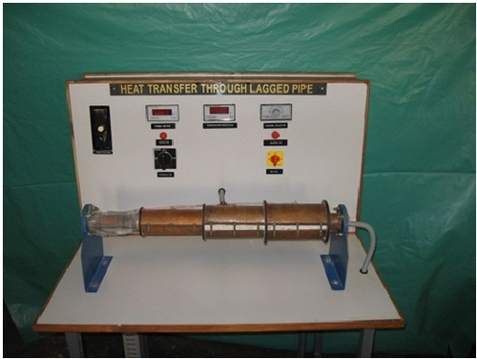

Fig-Lagged Pipe Apparatus Experimental Setup

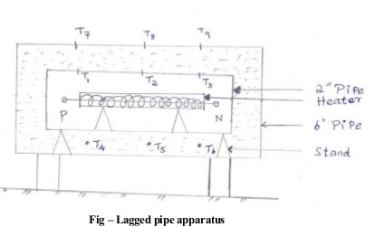

**SPECIFICATIONS:**

1. Inner radius of inner pipe:25 mm

2. Outer radius of inner pipe, : 28 mm

3. Inner radius of outer pipe : 50 mm

4. Outer radius of outer pipe, : 53 mm

5. Radius at which thermocouples 4 - 6 are placed, : 37.5 mm

6. Radius at which thermocouples 10 - 12 are placed, R: 62.5 mm

7. Length of the specimen. L: 50 cm

**EXPERIMENTAL PROCEDURE:**

1.The heater is put on and the wattage is maintained at some desired value.

2. Readings of the thermocouples are taken at regular intervals until steady state is reached.

3. The steady state temperatures are then recorded.

The procedure is then repeated for different wattages to the input heater.

**FORMULAE:**

Mean temperature of the outer surface of inner pipe, $T_{1}=\frac{{TC}_{1}+{TC}_{2}+{TC}_{3}}{3}$

Mean temperature at radius $R_{2}$, $T_{2}=\frac{{TC}_{4}+{TC}_{5}+{TC}_{6}}{3}$

Mean temperature of the outer surface of outer pipe, $T_{3}=\frac{{TC}_{7}+{TC}_{8}+{TC}_{9}}{3}$

Mean temperature at radius $R_{4}$, $T_{4}=\frac{{TC}_{10}+{TC}_{11}+{TC}_{12}}{3}$

Equation for the steady radial heat conduction through pipe insulation considering radius $R_{1}$ and $R_{2}$ can be written as

$$Q=\frac{2πk_{1}L(T_{1}-T_{2})}{ln⁡({R_{2}}/{R_{1}})}$$

$$k_{1}=\frac{Q ln⁡({R_{2}}/{R_{1}})}{2πL(T_{1}-T_{2})}$$

Where

$R_{1}$ = Outer radius of inner pipe, 28mm

$R_{2}$ = Radius of insulation at which thermocouples 4-6 are placed, 37.5mm

$T_{1}$ = Temperature of the outer surface of the inner pipe($℃$)

$T_{2}$ = Temperature of the insulation at radius $R_{2}$ ($℃$)

L = Length of the cylinder, 50cm

k= Thermal conductivity of the cylinder material in W/mK

Q=Heat flow rate per unit time in W

Equation for the steady state radial heat conduction through pipe insulation considering radius $R_{3}$ and $R_{4}$ can be written as:

$$Q=\frac{2πk_{1}L(T_{3}-T_{4})}{ln⁡({R_{4}}/{R_{3}})}$$

$$k_{2}=\frac{Q ln⁡({R_{4}}/{R_{3}})}{2πL(T_{3}-T_{4})}$$

Where

$R_{3}$ = Outer radius of OUTER pipe, 53mm

$R_{2}$ = Radius of insulation at which thermocouples 10-12 are placed, 62.5mm

$T_{3}$ = Temperature of the outer surface of the outer pipe($℃$)

$T_{4}$ = Temperature of the insulation at radius $R_{4}$ ($℃$)

L = Length of the cylinder, 50cm

k= Thermal conductivity of the cylinder material in W/mK

Q=Heat flow rate per unit time in W

Assuming the heater input to be equal to the heat flow rate through the lagging material , the local temperature ‘T’ is plotted against the local radius ‘R’. Choosing any two points preferably those well within the insulation ,the value of ‘k’ can be calculated using equation (1) and (2).

**OBSERVATION TABLE:**

|  |  |  |  |  |  |  |  |  |  |  |  |
| --- | --- | --- | --- | --- | --- | --- | --- | --- | --- | --- | --- |
| **S.No** | **V**  **(V)** | **I**  **(A)** | $${TC}_{1}$$ | $${TC}_{2}$$ | $${TC}_{3}$$ | $${TC}_{4}$$ | $${TC}_{5}$$ | $${TC}_{6}$$ | $${TC}_{7}$$ | $${TC}_{8}$$ | $${TC}_{9}$$ |
| **1)** | 60 | 0.26 | 65.2 | 52.6 | 51.1 | 29.4 | 29.0 | 28.6 | 24.9 | 25.1 | 24.9 |
| **2)** | 73 | 0.32 | 90.2 | 70.6 | 68.6 | 36.8 | 36.1 | 35.4 | 28.2 | 28.7 | 28.4 |
| **3)** | 80 | 0.36 | 113.5 | 88.3 | 86.0 | 45.0 | 43.7 | 42.8 | 31.7 | 32.4 | 31.9 |

Here, ${TC}_{n}$ is in $℃$.

$R_{1}$ = 25mm

$R_{2}$ = 50mm

$R_{3}$ = 75mm

**CALCULATIONS:**

1. For V=60V

Q=15.6W

$T_{1}$ =56.3 $℃$; $T_{2}$ =29 $℃$; $T_{3}$ =24.967 $℃$

$k_{1}$**=**0.1261 W/mK

$k_{2}$**=**0.4992 W/mK

1. For V=73V

Q=23.36W

$T_{1}$ =76.467 $℃$; $T_{2}$ =36.1 $℃$; $T_{3}$ =28.43 $℃$

$k_{1}$**=**0.1276 W/mK

$k_{2}$**=**0.3931 W/mK

1. For V=80V

Q=28.8W

$T_{1}$ =95.933 $℃$; $T_{2}$ =43.83 $℃$; $T_{3}$ =92 $℃$

$k_{1}$**=**0.1219 W/mK

$k_{2}$**=**0.3142 W/mK

Here in each of the three cases,

$$T_{1}=\frac{{TC}_{1}+{TC}_{2}+{TC}_{3}}{3}$$

$$T_{2}=\frac{{TC}_{4}+{TC}_{5}+{TC}_{6}}{3}$$

$$T_{3}=\frac{{TC}_{7}+{TC}_{8}+{TC}_{9}}{3}$$

Also,

$k_{1}=\frac{Q ln⁡({R_{2}}/{R_{1}})}{2πL(T_{1}-T_{2})}$

$$k_{2}=\frac{Q ln⁡({R_{3}}/{R_{2}})}{2πL(T_{2}-T_{3})}$$

**RESULT:**

**Thermal conductivity, $k_{1}$ =0.1252W/mK and $k_{2}$ =0.4021W/Mk**

**PRECAUTIONS:**

1. Give adequate time to the apparatus to reach the steady state.
2. Take the readings only when temperature values become constant i.e, when steady state is reached.

**GRAPH:**

**Experiment 10**

# **Parallel Flow/Counter Flow Heat Exchanger**

* **AIM:** To determine LMTD, effectiveness and overall heat transfer coefficient for parallel and counter flow heat exchanger.
* **THEORY:** Heat exchanger is a device in which heat is transferred from one fluid to another.

Common examples of heat exchangers are:

1. Condensers and boilers in steam plant.
2. Inter coolers and pre-heaters.
3. Automobile radiators.
4. Regenerators.

* **CLASSIFICATION OF HEAT EXCHANGERS:**

1. **Based on the nature of heat exchange process:**
2. Direct contact type - Here the heat transfer takes place by direct mixing of hot and cold fluids.
3. Indirect contact heat exchangers – Here the two fluids are separated through a metallic wall, ex. Regenerators, Recuperators etc.
4. **Based on the relative direction of fluid flow:**
5. Parallel flow heat exchanger – Here both hot and cold fluids flow in the same direction.
6. Counter flow heat exchanger – Here hot and cold fluids flow in opposite direction.
7. Cross flow heat exchanger – Here the two fluids cross one another.

* **LOGARITHMIC MEAN TEMPERATURE DIFFERENCE (LMTD)**

This is defined as that temperature difference which, if constant, would give the same rate of heat transfer as usually occurs under variable conditions of temperature difference.

**FOR PARALLEL FLOW:**

LMTD = $\frac{\left(T_{ho}-T_{co} \right)-(T_{hi}- T_{ci )}}{\ln{\frac{(T_{ho}-T_{co})}{(T_{hi}-T_{ci})}}}$ = $\frac{θ_{2}- θ_{1}}{\ln{\frac{θ_{2}}{θ_{1}}}}$ OR $\frac{H_{TD}-L_{TD}}{ln\frac{H_{TD}}{L_{TD}}}$

where, HTD = higher temperature difference

LTD = lower temperature difference

Tho = outlet temperature of hot fluid

Tco = outlet temperature cold fluid

Thi = inlet temperature of hot fluid

Tci = inlet temperature cold fluid

**FOR COUNTER FLOW:**

LMTD = $\frac{\left(T_{hi}-T_{ci}\right)-(T_{ho}-T_{ci})}{\ln{\frac{(T_{hi}-T_{co})}{(T_{ho}-T_{ci})}}}$ = $\frac{θ_{2}- θ_{1}}{ln\frac{θ_{2}}{θ_{1}}}$

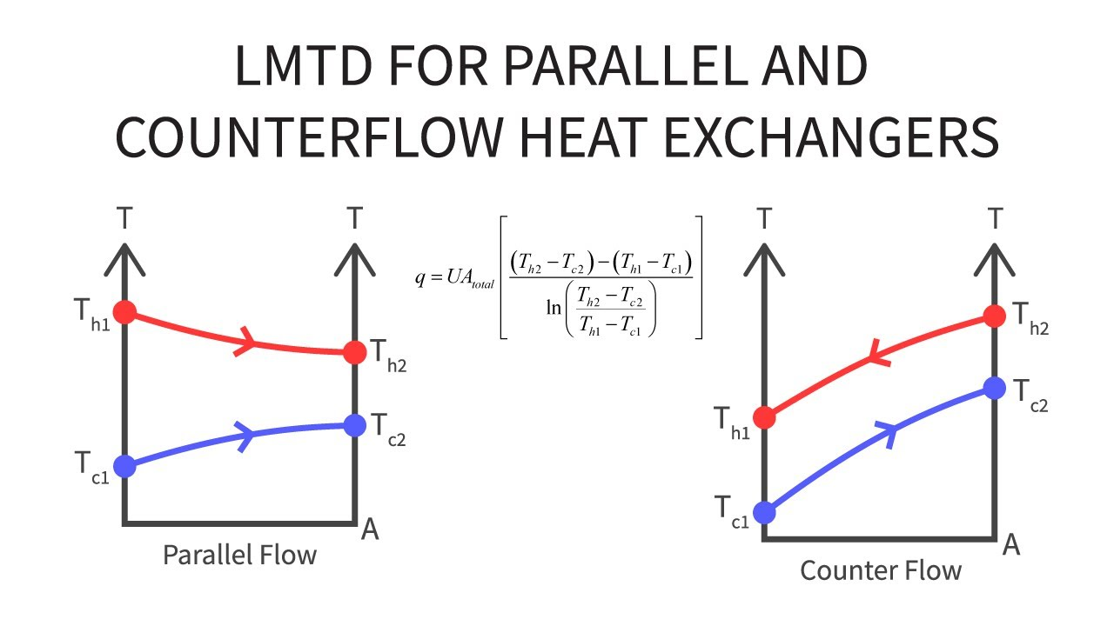

**OVERALL HEAT TRANSFER COEFFICIENT:**

The rate of heat transfer between hot and cold fluid is given by

Q = Uo Ao X LMTD

where Uo is overall heat transfer coefficient based on the outer

surface area of tubes, W/m2 K

Ao is the total outer surface area of tubes, m2

**EFFECTIVENESS:**

Effectiveness of a heat exchanger is defined as the ratio of actual heat transfer rate to the theoretical maximum possible heat transfer rate.

Effectiveness: ε = Q/Qmax

* **DESCRIPTION OF THE APPARATUS:**

The apparatus consists of a concentric tube heat exchanger. The hot fluid namely hot water is obtained from the Geyser (heater capacity 3Kw) & it flows through the inner tube. The cold fluid i.e. cold water can be admitted at any one of the ends enabling the heat exchanger to run as a parallel flow or as a counter flow exchanger. Measuring jar used for measure flow rate of cold and hot water. This can be adjusted by operating the different values provided. Temperature of the fluid can be measured using thermocouples with digital display indicator. The outer tube is provided with insulation to minimize the heat loss to the surroundings.

* **PROCEDURE:**

1. First switch ON the unit panel.
2. Start the flow of cold water through the annulus and runs the exchanger as counter flow or parallel flow.
3. Switch ON the geyser provided on the panel & allow to flow through the runner tube, regulating the valve.
4. Adjust the flow rate of hot water and cold water by using rotameters & valves.
5. Keep the flow rate same till steady conditions are reached.
6. Note down the temperatures.

* **OBSERVATION TABLE:**

**PARALLEL FLOW:**

|  |  |  |  |  |
| --- | --- | --- | --- | --- |
|  |  |  |  |  |
| S.No | Hot water flow rate m  Kg/s | Cold water flow rate m  Kg/s | Temp of cold water in ˚C | Temp of hot water in ˚C |
|  |  |  |  |  |
|  |  |  |  |  |

**COUNTER FLOW:**

|  |  |  |  |  |
| --- | --- | --- | --- | --- |
| S.No | Hot water flow rate m  Kg/s | Cold water flow rate m  Kg/s | Temp of cold water in ˚C | Temp of hot water in ˚C |
|  |  |  |  |  |
|  |  |  |  |  |
|  |  |  |  |  |

* **EQUATIONS USED:**

1. **Heat Transfer from hot water**

**Q = mh Cph (Thi – Tho) watt**

**mh = mass flow rate of hot water kg/sec**

**Cph = Specific heat of hot water = 4186.8J kg-K**

1. **Heat gain by the cold fluid**

**Q = mc Cpc (Tci – Tco) watt**

**mc = mass flow rate of cold water kg/sec**

**Cpc = Specific heat of cold water = 4186.8J kg-K**

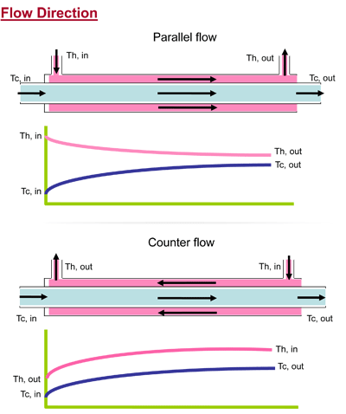

**Experiment 1**

# **Study of the Heat Transfer in pin fin apparatus**

* **AIM:**

1. To determine the variation in temperature along the length of pin fin under forced convection.
2. To determine the value of heat transfer coefficient under forced condition and to find
3. Theoretical values of temperature along the length of fin.
4. Effectiveness and efficiency of the pin for insulated and boundary condition.

* **THEORY:** The heat transfer from the heated fins to ambience is given by the relation q = hA∆T, to increase q either h is increased or surface area is increased. In some cases it’s not feasible to increase h and temperature difference T so the only way to increase q is by increasing surface area. The surface is increased by attaching extra material in the form of rod. “This extra material attached is called the extended surface of the fins.
* **FORMULA USED:**

Temperature distribution along the length of fins

= $\frac{θ}{θ_{0}}$ = $\frac{T-T_{∞}}{T_{0}-T_{∞}}$ = $\frac{coshm(L-x)}{\cos{hmL}}$

where, T = temp. at any distance x on the fin.

T0 = temp at x=0

T∞ = ambient temperature

L = length of the fin = 150 mm

m = √ $\frac{h_{c}P}{kA}$ h= convective heat transfer coefficient

P= perimeter of the fin

A= Area of the fin

k = Thermal Conductivity of the fin

Effectiveness is given by ε = √ $\frac{Pk}{h_{c}A}$ tanhmL

Efficiency is given by η = $\frac{tanhmL}{mL}$

* **EXPERIMENTAL PROCEDURE:**

1. Connect the equipment to electric power supply.
2. Keep the thermocouple selector switch to any position.
3. Turn the dimmer stat knob clockwise and adjust the power input to the heater to the desired value.
4. Switch ON the blower.
5. Set the air flow rate at any desired value by adjusting the difference in mercury or water levels in the manometer.
6. Allow the unit to stabilize.
7. Turn the thermocouple selector switch clockwise and note down the temperature T to T.
8. Note down the difference in level of the manometer.
9. Repeat the experiment for different power input of the heater.

**PIN FIN APPARATUS**

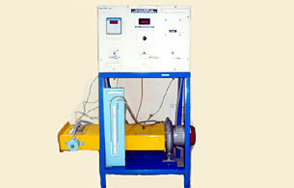

* **OBSERVATION TABLE:**

|  |  |  |  |  |  |  |  |  |  |
| --- | --- | --- | --- | --- | --- | --- | --- | --- | --- |
| Voltmeter  in  Volts | Ammeter  in  Amps | Power  in  Watts | Manometer  In mm of Hg | Temperature reading in ˚C | | | | | |
| T | T | T | T | T | T |
| 58 | 0.28 | 16.52 | 5.3 | 82 | 57.5 | 51.8 | 46.3 | 42.4 | 18 |
| **69** | **0.33** | **22.44** | **5.6** | **94.1** | **62.3** | **54.8** | **47.6** | **42.8** | **15.3** |
| **81** | **0.40** | **32.4** | **3.9** | **131.2** | **87.7** | **76.6** | **66.4** | **58.1** | **15** |

* **SPECIMEN CALCULATION:**

1. **Velocity of orifice = V0 = CD √ \***

**where, ρw = density of the manometric fluid = 103kg/m3**

**ρa=density of air = 1.17kg/m3**

**β= do / dp = 0.52**

**where, do = diameter of Orifice = 0.02m**

**dp = Internal diameter pipe = 3.81cm**

**here, Vo = 18.09 m/s**

1. **Average Surface Temperature of Fin is given by,**

**T = $\frac{T_{1}+T_{2}+T_{3}+T_{4}+T_{5}+T_{6}}{6}$**

**Ts = 49.667˚C**

1. **T∞ = Ambient temperature = 27.1˚C**
2. **T = Mean Temperature = $\frac{T_{S}+T_{∞}}{2}$, T = 38.38˚C**

**T1 = 75.49˚C**

**T2 = 49.52 ˚C**

**T3 = 42.91 ˚C**

**T4 = 42.90 ˚C**

**T5 = 35.36 ˚C**

**Effectiveness of Fin = 38.13**

**Efficiency = 0.6901**

* **RESULT:**

1. **The effectiveness and efficiency of pin fin for insulated & boundary conditions are**
2. **At 58V and 0.28A, the effectiveness and efficiency are 38.13 and 0.6901.**
3. **At 60V and 0.33A, the effectiveness and efficiency are 42.25 and 0.74.**
4. **At 81V and 0.40V, the effectiveness and efficiency are 42.37 and 0.74446.**

|  |  |  |
| --- | --- | --- |
| (I) |  |  |
| **Distance x in m** | **Temp from exp in ˚C** | **Temp from calculation in ˚C** |
| **0.02** | **67.3** | **60.77** |
| **0.05** | **59.6** | **48.11** |
| **0.08** | **53.2** | **40.32** |
| **0.11** | **48.2** | **35.94** |
| **0.14** | **42.4** | **38.13** |

|  |  |  |
| --- | --- | --- |
| (II) |  |  |
| **Distance x in m** | **Temp from exp in ˚C** | **Temp from calculation in ˚C** |
| **0.02** | **94.1** | **87.74** |
| **0.05** | **62.3** | **54.79** |
| **0.08** | **54.8** | **46.64** |
| **0.11** | **47.6** | **40.37** |
| **0.14** | **42.8** | **36.81** |

(III)

|  |  |  |
| --- | --- | --- |
|  |  |  |
| **Distance x in m** | **Temp from exp in ˚C** | **Temp from calculation in ˚C** |
| **0.02** | 131.2 | 121.0 |
| **0.05** | 87.7 | 74.7 |
| **0.08** | 76.6 | 61.95 |
| **0.11** | 66.4 | 52.76 |
| **0.14** | 58.1 | 46.63 |