# javascript

===全等：不仅要值相等还要类型相等才会返回true

==值等：只要是值等就会返回true

Eg：

|  |
| --- |
| Var a=”1”; var b=1; 使用a==b是返回true但是使用===全等就是返回false了 |

Javascript的类型检查：

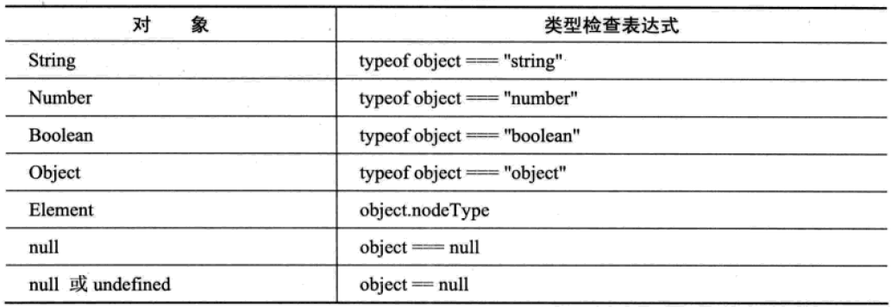

用于在控制台打印信息的一些方法：

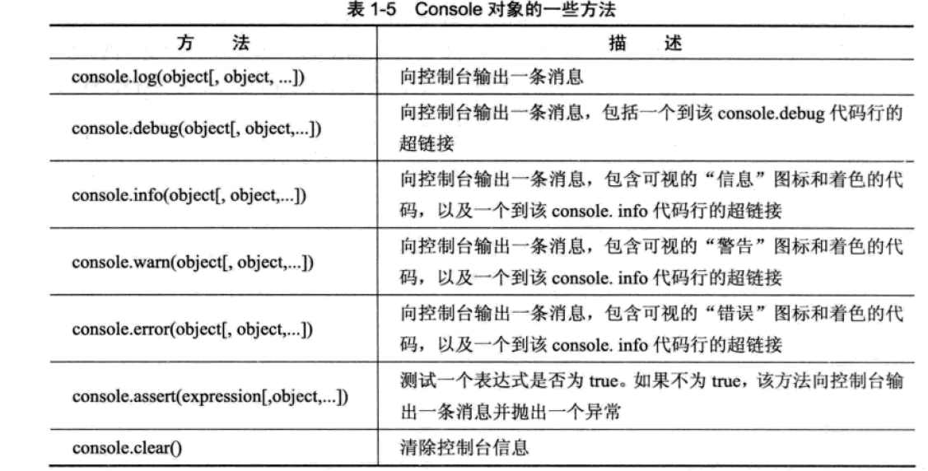

理解boolean类型的值：

|  |
| --- |
| Boolean的值有true和false在判断条件中：空字符串、NAN值、null、undifirend、数值0、和关键字false都被当成false来处理 |

|  |
| --- |
| 1. |

|  |
| --- |
| 1. |

|  |
| --- |
| 1. |

|  |
| --- |
| 1. |

|  |
| --- |
| 1. |

|  |
| --- |
| 1. |

|  |
| --- |
| 1. |

|  |
| --- |
| 1. |

|  |
| --- |
| 1. |

|  |
| --- |
| 1. |

|  |
| --- |
| 1. |

|  |
| --- |
| 1. |

|  |
| --- |
| 1. |

|  |
| --- |
| 1. |

|  |
| --- |
| 1. |

|  |
| --- |
| 1. |