# SVN服务器的创建

1. 创建一个根目录用根目录来存放所有的SVN的工程
2. 启动SVN→svnserve –d –r D:demo/svn/root（这个命令需要安装subversion并配置path环境变量（subversion的bin目录））可以用svnserve –help 来查看帮助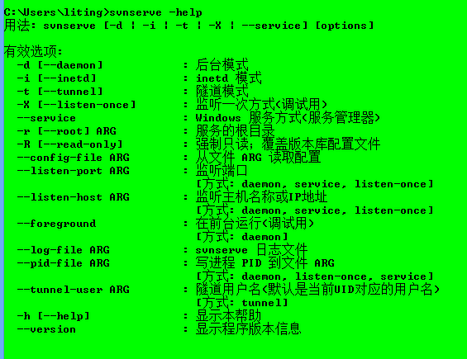这里注意windows系统并不支持以后台（-d运行）怎样加到windows系统的后台？可以创建windows系统的服务

Sc create创建windows系统的服务sc delete删除windows系统的服务

通过sc create –help查看怎样创建windows系统服务

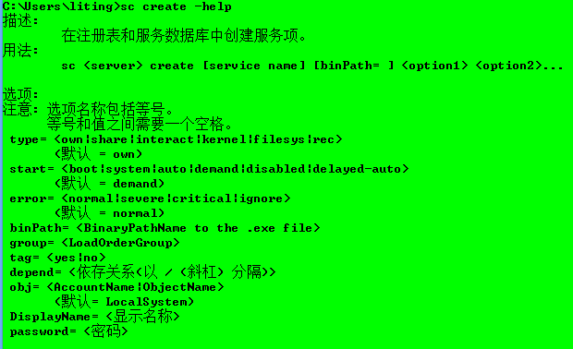

提示可以通过netstat –na来查看windows系统的后台运行的端口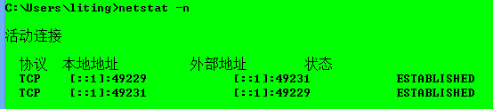

我们用sc sreate 命令创建后台程序（最好以管理员身份运行cmd）

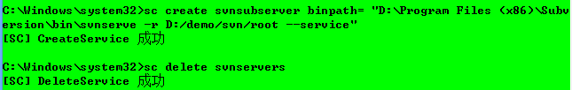

这里指定的（subversion/bin目录下的svnserve路径不要出错否则找不到指定的服务）

最后的的—server是说明要以windows服务方式运行（服务管理器）

创建成功之后windows系统就有了你创建的



这里也可以通过netstat –na来查看有没有svn的后台端口（3690）

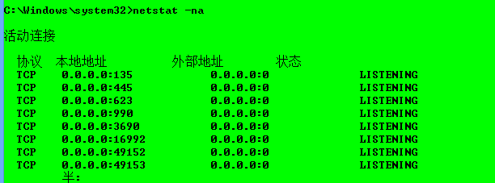

1. 创建工厂（必会）

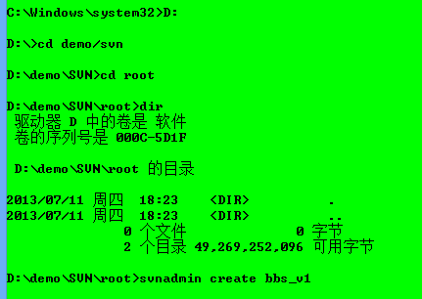

进入到目录下用svnadmin create 工厂名

这时可以看到目录中有了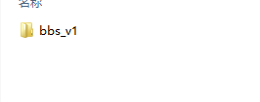

里面的文件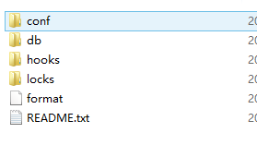

这里面配置文件在conf里面主要配置项目的权限

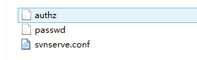

Authz

|  |
| --- |
| ### This file is an example authorization file for svnserve.  ### Its format is identical to that of mod_authz_svn authorization  ### files.  ### As shown below each section defines authorizations for the path and  ### (optional) repository specified by the section name.  ### The authorizations follow. An authorization line can refer to:  ### - a single user,  ### - a group of users defined in a special [groups] section,  ### - an alias defined in a special [aliases] section,  ### - all authenticated users, using the '$authenticated' token,  ### - only anonymous users, using the '$anonymous' token,  ### - anyone, using the '*' wildcard.  ###  ### A match can be inverted by prefixing the rule with '~'. Rules can  ### grant read ('r') access, read-write ('rw') access, or no access  ### ('').  [aliases]  # joe = /C=XZ/ST=Dessert/L=Snake City/O=Snake Oil, Ltd./OU=Research Institute/CN=Joe Average  [groups]  # harry_and_sally = harry,sally  # harry_sally_and_joe = harry,sally,&joe  # [/foo/bar]  # harry = rw  # &joe = r  # * =  # [repository:/baz/fuz]  # @harry_and_sally = rw  # * = r |

Password

|  |
| --- |
| ### This file is an example password file for svnserve.  ### Its format is similar to that of svnserve.conf. As shown in the  ### example below it contains one section labelled [users].  ### The name and password for each user follow, one account per line.  [users]  # harry = harryssecret  # sally = sallyssecret |

Svnserve.conf

|  |
| --- |
| ### This file controls the configuration of the svnserve daemon, if you  ### use it to allow access to this repository. (If you only allow  ### access through http: and/or file: URLs, then this file is  ### irrelevant.)  ### Visit http://subversion.tigris.org/ for more information.  [general]  ### These options control access to the repository for unauthenticated  ### and authenticated users. Valid values are "write", "read",  ### and "none". The sample settings below are the defaults.  # anon-access = read  # auth-access = write  ### The password-db option controls the location of the password  ### database file. Unless you specify a path starting with a /,  ### the file's location is relative to the directory containing  ### this configuration file.  ### If SASL is enabled (see below), this file will NOT be used.  ### Uncomment the line below to use the default password file.  # password-db = passwd  ### The authz-db option controls the location of the authorization  ### rules for path-based access control. Unless you specify a path  ### starting with a /, the file's location is relative to the the  ### directory containing this file. If you don't specify an  ### authz-db, no path-based access control is done.  ### Uncomment the line below to use the default authorization file.  # authz-db = authz  ### This option specifies the authentication realm of the repository.  ### If two repositories have the same authentication realm, they should  ### have the same password database, and vice versa. The default realm  ### is repository's uuid.  # realm = My First Repository  [sasl]  ### This option specifies whether you want to use the Cyrus SASL  ### library for authentication. Default is false.  ### This section will be ignored if svnserve is not built with Cyrus  ### SASL support; to check, run 'svnserve --version' and look for a line  ### reading 'Cyrus SASL authentication is available.'  # use-sasl = true  ### These options specify the desired strength of the security layer  ### that you want SASL to provide. 0 means no encryption, 1 means  ### integrity-checking only, values larger than 1 are correlated  ### to the effective key length for encryption (e.g. 128 means 128-bit  ### encryption). The values below are the defaults.  # min-encryption = 0  # max-encryption = 256 |

本地建完项目可以使用svn import命令导入到我们的svn服务器中。（多个客户端就可以使用了）

我们这里可以修改svnserve.conf文件下的

设置为匿名用户也可以写（蓝色的那行（#号是注释））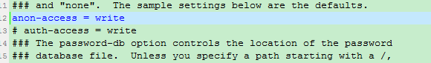

这里再用svn import –m “信息” 项目 svn://localhost/bbs_v1(协议：//localhost/服务器我们建好的工程名)

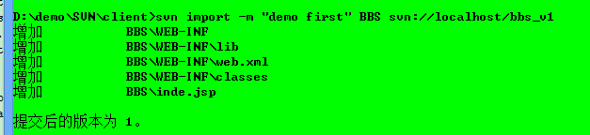

提交之后在服务器的db文件夹中增加了一些文件

