Shadow Protocol - Game Design Document
“Every crime writes its own story. Every mission learns from you.”
— Shadow Protocol ⚡

1. Game Overview
Shadow Protocol is a next-gen, AI-driven multiplayer tactical game featuring two opposing teams: Team A - COPS (FBI/Tactical Agents) and Team B - CRIMINALS (Heist Crews/Underground Syndicates). The game supports matches ranging from 1v1 to massive 50v50 battles with adaptive AI-driven missions, dynamic objectives, and evolving narratives.

🎮 GAMEPLAY DESIGN: Shadow Protocol

🧩 1. Core Game Concept
Two opposing forces —
Team A: COPS (FBI / Tactical Agents)
Team B: CRIMINALS (Heist Crews / Black Ops / Underground Syndicates)
Every match begins in their respective lobbies, simulating real-world prep and tension.
- COPS HQ: Tactical base with mission boards, loadout selection, briefing room.
- CRIMINAL HUB: Hidden safehouse or hideout (changes each mission — docks, penthouses, abandoned subway, etc.).
Each match = AI-generated mission event → triggered simultaneously to both sides.

🚨 2. Mission Flow
Let’s map a full round from start → end 👇

⏱️ Phase 1: Prep & Briefing (15–20 seconds)
- Both teams see their environment and loadout options.
- A crime event alert pops up on both screens.
  - Criminals see “Objective: Steal nuclear canisters and escape in truck before timer ends.”
  - Cops see “Objective: Secure the facility and prevent criminals from extracting nuclear canisters.”
- Countdown begins — 10 seconds before the mission activates.

🎯 Phase 2: Mission Start
- Map: The AI generates the location dynamically (warehouse, port, lab, factory, etc.).
- Time starts ticking — 10–15 min per mission depending on scale (can scale up to 30 min in 50v50).

Team B (Criminals)
- Spawns near the objective site.
- Must complete multiple sub-tasks:
  - Breach security gate
  - Load cargo / steal asset / plant bomb / hack system
  - Escape or defend for extraction timer

Team A (Cops)
- Spawns farther away, but with vehicles or tactical drones.
- Must:
  - Trace the crime source (AI pings hints — camera alerts, sounds, etc.)
  - Locate and stop criminals
  - Diffuse bombs / intercept cargo / arrest key targets

⚔️ Phase 3: Mid-Mission Dynamics
This is where the AI Director shines.
- Adjusts events in real time:
  - Police reinforcements or roadblocks spawn if criminals dominate.
  - Criminal side gets distraction AI missions (e.g., fake smoke bomb alerts).
  - Weather can change — fog, rain, blackout.
- Dynamic objectives appear:
  - “New order: criminals reroute truck — intercept at docks!”
  - “FBI satellite malfunction — comms delay 20 seconds.”
AI keeps every match unique and unpredictable.

🏁 Phase 4: Win / Lose Conditions
Condition | Outcome
Cops defuse bomb / intercept escape | 🏆 Cops Win
Criminals complete their mission (load/escape/plant) | 💣 Criminals Win
Timer runs out without success | ⚖️ Draw – both gain partial XP
Team wipeout (all dead before completion) | 🩸 Opposite Team Wins
After match:
- XP distributed based on rank, contribution, and survival time.
- Rank Director AI updates your progression.

💼 3. Examples of Missions (AI-Generated)
Mission | Criminal Objective | Cop Objective | Location Type
💣 Nuclear Heist | Steal nuclear canisters, load truck, escape | Stop the truck / defuse bomb | Industrial warehouse
💎 Diamond Extraction | Break into vault, steal artifact | Reinforce vault / capture criminals | Museum / luxury skyscraper
💻 Data Breach | Hack FBI satellite for blackmail data | Restore power / protect servers | Cyber lab
🚛 Convoy Ambush | Destroy FBI transport, steal weapon crates | Defend convoy, eliminate attackers | Highway / outskirts
🔥 Hostage Chaos | Capture VIP & demand ransom | Rescue VIP, neutralize threat | Hotel or metro hub

⚙️ 4. Difficulty & Scaling System
The AI adjusts mission scope automatically based on:
- Number of players (1v1 → 50v50)
- Rank tiers
- Player success rate over last 5 matches
Player Count | Mission Type | Map Size | Example
1v1 / 4v4 | Micro-ops | Small block / building | “Silent Breach”
10v10 / 20v20 | Multi-phase | City sector | “Power Grid Takeover”
30v30 / 50v50 | Full operation | Urban district / port | “Global Containment Mission”

🔫 5. Loadout & Progression
Each faction has its own upgrade tree:
- COPS: precision rifles, drones, stun gear, armored vehicles.
- CRIMINALS: explosives, stealth gear, hacking tools, getaway vehicles.
- Unlock new tiers via rank system (as explained before).
- Custom weapon crafting via AI blueprint generator (personalized guns tuned to player style).

🧠 6. AI-Driven Enhancements
- Mission AI: Generates random objectives + dialogue for immersion.
- Director AI: Controls pacing, weather, and dynamic objectives.
- Learning AI: Remembers each player’s preferred playstyle and adjusts difficulty accordingly.
- Dialogue AI: Voice-acted mission briefings via GPT-voice integration.

🎥 7. Cinematic Flow
- Mission intros shown like news reports — “BREAKING: FBI traces major crime network…”
- Mid-mission updates through AI radio chatter.
- End of mission → AI narrator summarizes outcome dynamically:
“The criminals escaped with classified materials. The FBI has declared red alert for future operations.”

🧩 8. Future Expansions
- Storyline seasons (AI creates seasonal crime networks).
- City-scale operations: multiple teams playing different missions that interconnect.
- Leaderboards & rank divisions (Regional, Global).

2. Gameplay Flow (Structured Text)
Step-by-step breakdown of the player experience, from lobby to post-mission:
1. Lobby Phase: Players join via matchmaking or private lobby. Teams are auto-assigned.
2. Mission Alert Phase: AI Director generates objectives; briefing displayed (voice or text).
3. Deployment Phase: Players deploy to AI-generated map; mission timer starts (10–30+ mins).
4. Mission Phase Active: Teams complete objectives; AI Director manages dynamic objectives, enemy AI, events.
5. Win/Loss Determination: CRIMINALS or COPS win; draw if timer expires.
6. Post-Mission Phase: AI generates mission summary, highlights, narrative recap.
7. XP & Rank Update: XP distributed based on performance; ranks update, unlocking new gear.
8. Return to Lobby: Players review stats, upgrade gear, view rewards.
9. Queue for Next Mission: Select new mission time; AI Director generates next mission. Loop repeats.
Notes: Perspective switching (FPS/TPS), AI scales difficulty based on rank, player count, and mission time. Bots fill empty slots up to 50v50.
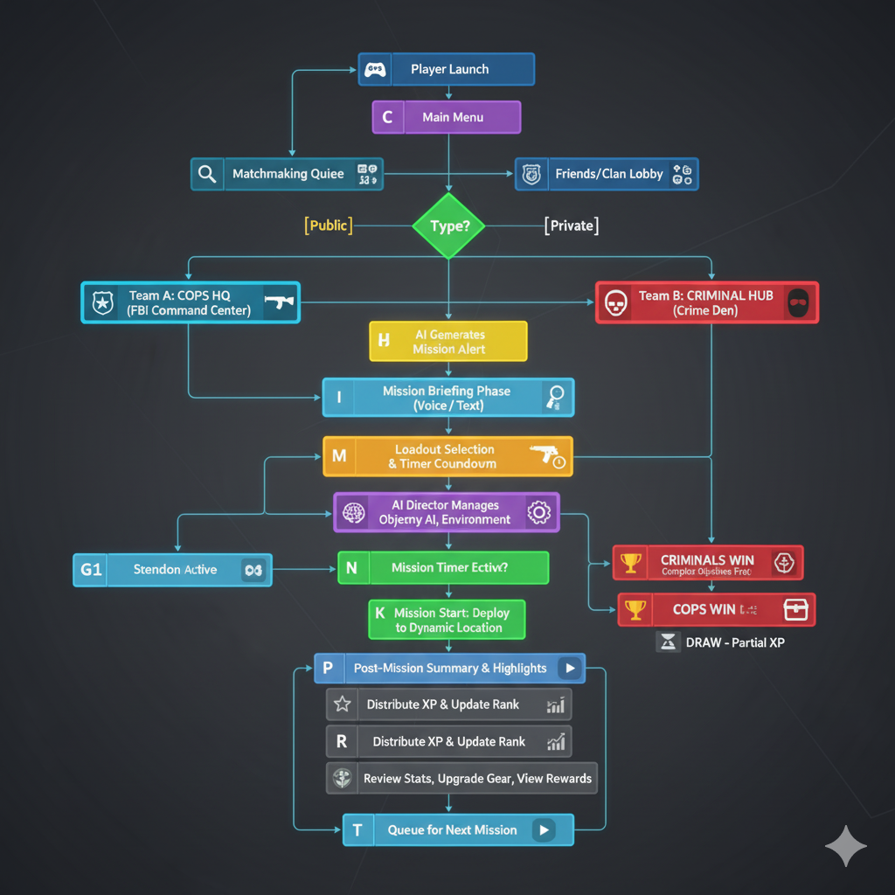

3. Mission Lifecycle Loop
Detailed mission loop including timers, objectives, win/loss logic, and progression:
- Lobby Phase
- Mission Alert Phase
- Deployment Phase
- Mission Phase Active
- Win/Loss Determination
- Post-Mission Summary
- XP & Rank Update
- Return to Lobby / Gear Upgrade
- Queue for Next Mission
Notes: Supports 1v1 to 50v50, adaptive AI, player perspective switching.

Shadow Protocol – Mission Lifecycle Loop

1️⃣ Lobby Phase
- Players join via public matchmaking or private lobby.
- Players are auto-assigned to Team A (COPS) or Team B (CRIMINALS).
- Players review stats, select weapons/kits, and prepare.

2️⃣ Mission Alert Phase
- AI Director generates the mission scenario.
- Briefing displayed: voice (serious/military) or text-only HUD.
- Timer: 10–15 seconds to read and plan.

3️⃣ Deployment Phase
- Players are deployed to the mission location (AI-generated map).
- Mission timer starts (player-selected: 10, 20, 30+ minutes).

4️⃣ Mission Phase Active
- Teams work to complete objectives:
  - CRIMINALS: Steal, plant, hack, escape.
  - COPS: Intercept, defuse, secure, arrest.
- AI Director Functions:
  - Dynamic objectives/subtasks
  - Adaptive enemy AI & NPC bots (fills empty slots)
  - Environmental effects & mid-mission events

5️⃣ Win/Loss Determination
- CRIMINALS win: Complete mission before COPS.
- COPS win: Prevent mission completion or neutralize criminals.
- Draw: Timer expires without completion.

6️⃣ Post-Mission Phase
- AI generates dynamic summary:
  - Team performance
  - Key highlights
  - Narrative recap

7️⃣ XP & Rank Update
- XP awarded based on:
  - Objective completion
  - Kills / assists
  - Survival time
  - Teamwork / contributions
- Ranks updated → unlock new weapons, kits, abilities.

8️⃣ Return to Lobby / Gear Upgrade
- Players return to HQ / Crime Den.
- Review stats, upgrade gear, view rewards.

9️⃣ Next Mission Queue
- Players select next mission time scale.
- AI Director generates the next mission.
- Loop repeats — the cycle continues.

Notes:
- Player perspective can switch first-person ↔ third-person anytime.
- AI Director dynamically adjusts difficulty, mission complexity, and enemy behavior based on rank, time selection, and player count.
- Loop supports 1v1 → 50v50 matches seamlessly.

4. AI Mission Director Architecture
The AI Director controls mission generation, difficulty scaling, adaptive objectives, NPC/bot behavior, "
"and dynamic narrative to ensure each match is unique and challenging.
Components:
- Mission Generator: Procedurally generates missions, objectives, and events.
- Difficulty Scaler: Adjusts AI skill, objectives, hazards based on rank and player count.
- Bot Controller: Fills empty slots with adaptive AI bots.
- Narrative & Voice System: Generates mission briefings (voice or text).
- Event Manager: Triggers environmental and mid-mission events.
- Data Analytics Module: Tracks player performance for adaptive scaling.
Workflow:
1. Lobby Data Input (player counts, ranks, platform)
2. Mission Generation (objectives, map, events)
3. Bot Assignment
4. Mission Monitoring (enemy AI, objectives, environment, mid-mission events)
5. Narrative & Voice Updates
6. Post-Mission Processing (summary, XP, rank)
7. Feedback Loop (analytics feed future missions and difficulty)
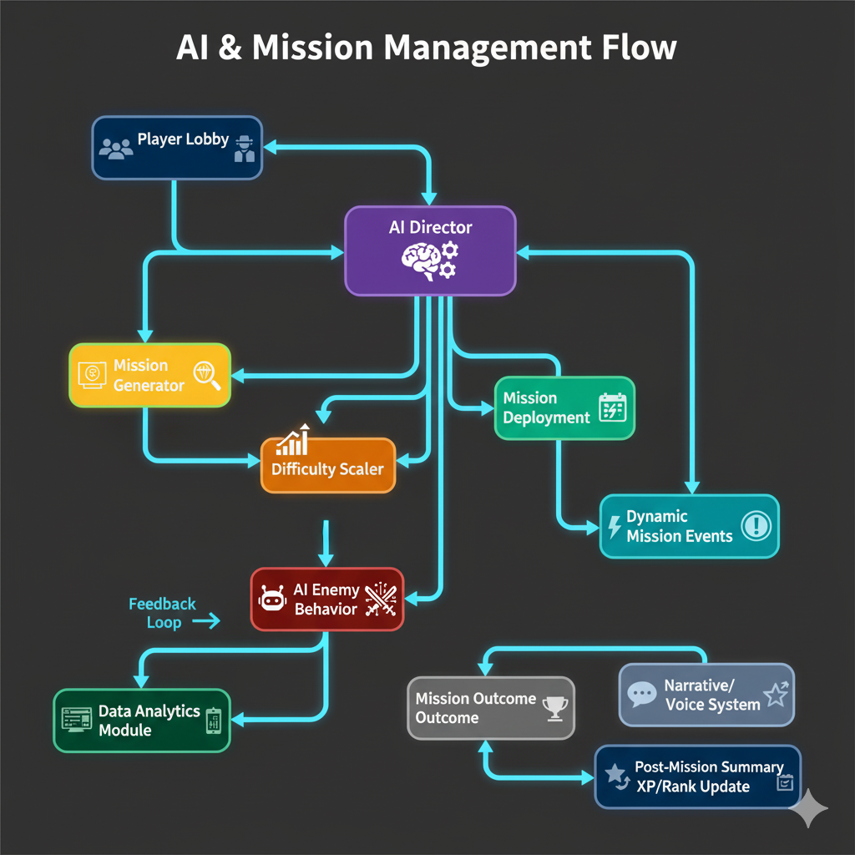

Shadow Protocol – AI Mission Director Architecture

1️⃣ Overview
The AI Mission Director is the core system controlling:
- Mission generation
- Difficulty scaling
- Adaptive objectives
- NPC / bot behavior
- Dynamic narrative
It ensures every mission is unique, challenging, and immersive, for any match size (1v1 → 50v50).

2️⃣ Components
Component | Function
Mission Generator | Procedurally generates mission objectives, map layouts, sub-goals, and dynamic events using GPT-style models.
Difficulty Scaler | Adjusts enemy AI behavior, mission complexity, environmental hazards, and objective count based on player rank, skill, and team size.
Bot Controller | Fills empty player slots with AI bots; adapts their behavior to match human teammates or opponents; uses reinforcement learning for tactics.
Narrative & Mission Voice System | Generates dynamic voice briefings and text updates; supports serious military voice and text-only modes.
Event Manager | Manages mid-mission events (weather, alerts, environmental hazards, mission twists); coordinates with Mission Generator.
Data Analytics Module | Tracks player performance, win/loss stats, and playstyle; feeds data into Difficulty Scaler and Mission Generator for adaptive progression.

3️⃣ Workflow (Step-by-Step)
- Lobby Data Input – Receives player counts, ranks, and platform info.
- Mission Generation – Mission Generator creates objectives, map, and dynamic events.
- Bot Assignment – Bot Controller fills missing slots for full-scale battles.
- Mission Monitoring – AI Director continuously adjusts:
  - Enemy AI tactics
  - Objective difficulty
  - Environmental effects
  - Mid-mission events
- Narrative & Voice Updates – AI delivers briefings, alerts, and mission commentary.
- Post-Mission Processing – Generates dynamic summary, calculates XP, updates ranks.
- Feedback Loop – Data Analytics feeds results back to improve future mission generation and difficulty scaling.

4️⃣ Integration Notes
- Communicates with game client via server-authoritative API.
- Works across all platforms: PC, console, mobile.
- Scales from small matches to 50v50 large battles.
- Adaptive AI ensures missions are balanced, challenging, and replayable.

5. Rank & Progression System
Players gain XP based on performance, objectives, kills/assists, and teamwork.
Ranks unlock new weapons, kits, and abilities.
AI adjusts difficulty and mission complexity as ranks increase.
- Recruit → Operative → Specialist → Elite Agent → Shadow Commander

Founder: Manideep Goud Gouraram
master’s Student in Analytics & Systems, University of Bridgeport, CT, USA
Concept Owner: Manideep Goud Gouraram
Date Created: October 28, 2025
Signature: MANIDEEP GOUD GOURARAMs

