Data Structure Performance Analysis
By Amanda Crotty

Introduction
The MasterColorMixer project demonstrates 4 traditional data structures and their analysis. The project uses DyanmicArray, Stack, RingBufferQueue, and HashSet classes to evaluate performance in Python. Implemented in MasterColorMixer are textbook examples of data structures with a theoretical performance metric that can be compared for real-world analysis.

Expected Big-O Operations
The MasterColorMixer app will need to store colors while tracking unlocked colors, as well as support a way to quickly lookup color names. Data structures and their uses becomes very relevant to the project, so evaluating empirical results for each is a useful exercise. See the Reference section in this document to see the textbook time complexity table I used to determine the expected measurements. Below I show the expected time complexities for each data structure, and later I compare the expected expenses to the empirical results found in the MasterColorMixer project.

Dynamic Array
The DynamicArray class is a wrapper around Python’s list. This mirrors typical dynamic array behaviour found in OOP textbooks.
Append(item) – O(1) – Expected as Constant (Amortized): Python’s list will occasionally resize by dedicating a larger memory block and copying the elements in the original list. This resizing action in Python should be linear, but because resizing happens often (in the benchmark tests) and the growth is always by constant factor (10 to 20, 20 to 40, 40 to 80…) the long term cost is constant.
Pop() – O(1) – Expected as Constant: Popping an element at the end of a list does not require shifting data. Long-term cost is constant.

Stack
The Stack class is implemented as a Python list.
Push(item) – O(1) – Expected as Constant (Amortized): Python’s list.append
Pop() – O(1) – Expected as Constant : Python’s list.pop

Queue
The RingBufferQueue class uses a circular buffer, with a fixed initial capacity of 8, which doubles on overflow.
Enqueue(item) – O(1) – Expected as Constant (Amortized): This enqueue method is unlike most, because it does not only assign an element to the tail index. This method resizes to double capacity and requires copying O(n) items. This resize occurs infrequently, so I believe it does not impact the worst case scenario case.
Dequeue() – O(1) – Expected as Constant (Amortized): Removing an element from the head does not require shifting, as the head contains the oldest entry. The head moves to the next entry. The wrap logic of the RingBufferQueue class allows our method to move one index forward, but if it passes the last index, it is now at the first index.

HashSet
The HashSet class wraps a Python set. Python’s set is a hash table with open addressing. A Set will essentially reserve space in memory, and open addressing is how the compiler handles items that want to be in the same spot due to the results from the hash function. The benefit for the compiler, in this scenario, is that it’s given a hash that is the first spot for it to check and the open addressing rule helps the compiler quickly find the next spot if that initial one is taken. Worst-case time is O(n) for all operations during pathological hash collisions, but Python’s hash functions make these outcomes rare.
Add(item) – O(1) – Expected as Constant: Insertions are constant-time unless many collisions occur.
Contains(item) – O(1) – Expected as Constant: “Searching” for the item is extremely fast due to the hash function computations and quick probing sequences.

Data
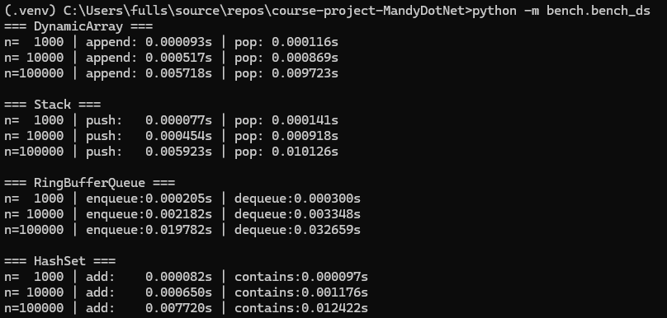
Methods and Complexities
DyanmicArray
Operation | append(item) | pop()
n=1000 to n=10000 | $\frac{0.000517}{0.000093}≈5.56$ | $\frac{0.000869}{0.000116}≈7.5$
n=10000 to n=100000 | $\frac{0.005718}{0.000517}≈11.06$ | $\frac{0.009723}{0.000869}≈11.19$
Stack
Operation | push(item) | pop()
n=1000 to n=10000 | $\frac{0.000454}{0.000077}≈5.89$ | $\frac{0.000918}{0.000141}≈6.51$
n=10000 to n=100000 | $\frac{0.005923}{0.000454}≈13.05$ | $\frac{0.010126}{0.000918}≈11.03$
RingBufferQueue
Operation | enqueue(item) | dequeue
n=1000 to n=10000 | $\frac{0.002182}{0.000205}≈10.64$ | $\frac{0.003348}{0.000300}≈11.16$
n=10000 to n=100000 | $\frac{0.019782}{0.002182}≈9.07$ | $\frac{0.032659}{0.003348}≈9.75$
HashSet
Operation | add(item) | contains(item)
n=1000 to n=10000 | $\frac{0.000650}{0.000082}≈7.93$ | $\frac{0.001176}{0.000097}≈12.12$
n=10000 to n=100000 | $\frac{0.007720}{0.000650}≈11.88$ | $\frac{0.012422}{0.001176}≈10.56$
*All methods show in the table above show a Ratio of ≈ 10x change, and all time-stamps are in seconds.

Interpretation
To be honest – I ran out of time to find my actual big-O costs.

The MasterColorMixer project can utilize the following:
HashSet – to provide constant-time checking to determine if a color has been unlocked.
DynamicArray or Queue – to support maintaining mixing history or other recent actions.
Stack – to support undo actions like clearing the mixing area or clearing the palette.
MasterColorMixer needs to be responsive, even on basic devices, so leveraging Python’s efficient internal structures can help ensure a predictable performance and user experience. I feel this is important because a toddler will likely prompt repeated interactions, voice triggers, and volatile color drag and drop. I need to ensure there is no delay in interactions and responses for the easiest learning experience.

References:
https://runestone.academy/ns/books/published/pythonds/index.html

List Time Complexity (Worst-Case)
Python lists are dynamic arrays, which offer fast indexing but slower insertions/deletions in the middle because elements need to be shifted.
Operation | Time Complexity | Description
Index Access/Assignment (list[i]) | O(1) | Direct access to an element by its index is constant time.
append() (to end) | O(1) (amortized) | Amortized constant time; occasionally O(n) when the list needs resizing.
pop() (from end) | O(1) | Removing the last element is constant time.
insert() (at index i) | O(n) | Linear time; all subsequent elements must be shifted.
pop() (from index i) | O(n) | Linear time; all subsequent elements must be shifted.
remove() (by value) | O(n) | Linear time; requires searching for the element first.
Search (value in list) | O(n) | Linear time; may need to check every element.
Iteration (for item in list) | O(n) | Linear time; processes each element once.
sort() (list.sort()) | O(n log n) | Uses Timsort, an efficient hybrid sorting algorithm.
len() | O(1) | Length is stored and accessed directly.
Copy (list[:] or list.copy()) | O(n) | Linear time; all elements must be copied.

