Through the eyes of the teacher

This document is a supplement to the paper and shows first graphs findings from the pilot study.

# 1 State of research

Teaching and classroom management are multidimensional settings in which teachers have to respond immediately to events as they develop (Barnes 2004). The different interests and abilities of students must be managed in a way that maximizes the active learning time of students and minimizes disruptions whilst teaching. Learning to develop such classroom management skills and to teach effectively is a complicated and complex process (Wolff, Jarodzka, and Boshuizen 2017).

During teaching, teachers must be able to select from a variety of visual and acoustic impressions to focus their attention on the essential and to distinguish between relevant and irrelevant events. This ability is called professional vision and is a key component of teacher expertise and successful teaching (Barth 2017). Eye tracking technology has become a reliable means to study teachers’ visual focus of attention (Pouta, Lehtinen, and Palonen 2020; Bogert 2016; Wolff, Jarodzka, and Boshuizen 2017)

Educational research has repeatedly shown that there are differences between experienced and novice teachers in terms of perception and behavioral competencies (Barth 2017; Bogert 2016; Wolff, Jarodzka, and Boshuizen 2017). For example, experts direct their attention more often and more evenly to all students, whereas novices only direct their attention to some students. The frequency and duration of fixations as eye movement are decisive (Stuermer et al. 2017). Mobile eye-tracking technology has also shown that experienced teachers distribute their focus more efficiently to solve tasks (Jarodzka et al. 2010). Furthermore, in contrast to novices, experts are able to focus their attention on the entire class and guide the class while giving feedback to individual students and answering questions (Cortina et al. 2015).

## 1.1 Research questions

The aim of the pilot study was to investigate whether there are differences in how expert and novice teachers manage scripted classroom disruptions. The disruptions were experimentally varied using a previously written script. Thus, our aim was to find out whether differences in the allocation of attention between expertise groups can be detected in this controlled context.

In order to answer this question, the hypothesis was formulated that teachers with more professional experience not only notice more disruptions but also notice them faster. In the hypothesis, therefore, it is necessary to check what has already been shown in the research literature: In complex teaching situations, experts have a more structured and elaborate professional knowledge than novices in order to perceive and interpret relevant events and to act appropriately (Berliner 2001; Lachner, Jarodzka, and Nückles 2016).

# 2 Methods

We report how we determined our sample size, all data exclusions (if any), all manipulations, and all measures in the study.

## 2.1 Participants

For the sample recruitment of the subjects (N = 48, experts n = 24, novices n = 24), schools in the city of Leipzig in Saxony were contacted. The institutions as well as the subjects were informed in detail about the aim and intention of the study in advance. Participation in the study was voluntary and only took place after written consent has been given.

Table 2.1:

Demographic Informationand and Teaching Experience

|  |  |  |  |  |  |  |  |  |  |  |
| --- | --- | --- | --- | --- | --- | --- | --- | --- | --- | --- |
| group | N | Male | M age | Min age | Max age | SD age | M exp. | Min exp. | Max exp. | SD exp. |
| expert | 2 | 1 | 47.50 | 44 | 51 | 4.95 | 20.00 | 15.00 | 25.00 | 7.07 |
| novice | 6 | 2 | 25.67 | 20 | 33 | 4.89 | 0.68 | 0.00 | 1.50 | 0.68 |

The selection of the subjects was based on extreme groups, whereby professional experience is the crucial criterion for the selection of experts or novices. Novices were recruited as teachers who have been working in the teaching profession for no more than 3 years, whereas experts were considered to have professional experience of 10 years or more (Messner and Reusser 2000).

## 2.2 Data collection

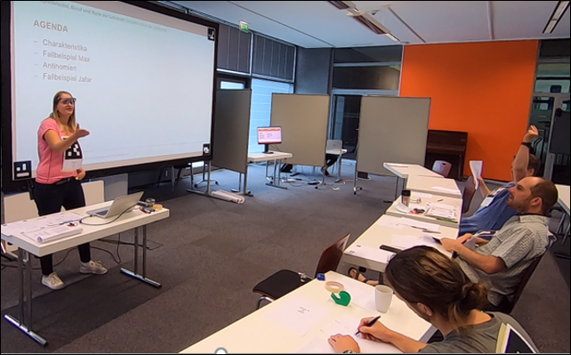

Figure 2.1: Example for set up during a mini-lesson

For this study, scripted mini-lessons with n = 2 experts and n = 6 novices were recorded in the mobile Lab of the Empirical School and Classroom Research at the University of Leipzig. The subjects were divided into groups of four, so the study was conducted on two different sessions. All participants were asked to hold a 10-minute lesson. The duration of each appointment was approximately 2h: per group 10min briefing, 4 x 10min mini-lessons, 10min technical preparation and follow-up and 4x 10min transition points between the lessons and answering the questionnaire.

One person from the group of 4 acted as a teacher, the other three subjects acted as the class. The subjects, who represented the class, were given behavioral instructions in a pre-written script to simulate typical events and disruptions in the classroom (e.g. putting their heads on the table, chatting, looking at their mobile phones, etc.).

The lesson disruptions were displayed as instructions during the lesson for all “students” but not the teacher. In order to avoid learning effects, the disruptions in each lesson were distributed pseudo-randomly over the short teaching phase. In addition, the order of the data collection was taken into account in the analyses and variance caused by order was controlled.

By using mobile eye-trackers, the gaze and behavior of the experts and novices was recorded during the lesson. In addition, the speech and sounds and voices were recorded with an audio recorder installed in the middle of the Lab. Movements, facial expressions and gestures of the subjects were recorded by four cameras from different angles. One camera was installed to film the class from the side. Two more cameras were installed on the blackboard and at the end of the Lab to film the teacher and class from the front and back. Furthermore, the fourth camera was installed in such a way that only facial expressions and gestures of the teacher were recorded, which enables a semi-automated analysis of the movement sequences.

The lessons recorded on video were coded in a post-hoc procedure with a coding software by previously trained raters. The statistical data have been analyzed by using the program RStudio [Link: <https://rstudio.com/>].

## 2.3 Measures

### 2.3.1 Questionnaire Data

*Describe how we collect questionnaire data (paper or online). Add some basic information about the structure of the questionnaire.*

The evaluation after each mini-lesson was conducted using paper questionnaires. Time needed to complete the questionnaire was about 5 minutes. The scales on the quality of teaching are a validated questionnaire (Helmke et al. (2014)). Whereas the scales on the teacher’s presence behaviour were derived from the research literature (Brophy (1986); Kiel et al. (2013); Kounin (2006); Marzano (2007); Nolting (2012)) and were used in the pilot for the first time.

The following scales were assessed:

1. Classroom management
2. Positive climate and motivation
3. Clarity and structuredness
4. Activation and support
5. Presence: posture/gaze
6. Presence: voice
7. Presence: verbal and non-verbal intervention
8. Natural behaviour

The table provides an overview over the mean, the range and standard deviation of all scales for novices and experts.

*Mean values of all scales*

|  |  |  |  |  |  |
| --- | --- | --- | --- | --- | --- |
| group | scale | M scale | min scale | max sclae | SD scale |
| expert | Activation and support | 3.33 | 2.00 | 4.00 | 0.80 |
|  | Clarity and structuredness | 3.70 | 1.00 | 4.00 | 0.73 |
|  | Classroom management | 3.23 | 1.00 | 4.00 | 0.90 |
|  | Natural behaviour | 3.57 | 2.00 | 4.00 | 0.63 |
|  | Positive climate and motivation | 3.60 | 2.00 | 4.00 | 0.62 |
|  | Presence: posture/gaze | 3.29 | 1.00 | 4.00 | 0.92 |
|  | Presence: verbal and non-verbal intervention | 3.07 | 2.00 | 4.00 | 0.78 |
|  | Presence: voice | 3.57 | 2.00 | 4.00 | 0.63 |
| novice | Activation and support | 2.23 | 0.00 | 4.00 | 1.39 |
|  | Clarity and structuredness | 3.35 | 1.00 | 4.00 | 0.76 |
|  | Classroom management | 2.82 | 1.00 | 4.00 | 0.90 |
|  | Natural behaviour | 3.13 | 2.00 | 4.00 | 0.71 |
|  | Positive climate and motivation | 3.11 | 0.00 | 4.00 | 0.90 |
|  | Presence: posture/gaze | 2.95 | 0.00 | 4.00 | 0.95 |
|  | Presence: verbal and non-verbal intervention | 2.88 | 1.00 | 4.00 | 0.97 |
|  | Presence: voice | 3.30 | 2.00 | 4.00 | 0.74 |

The individual items of a scale were further represented in graphs.

1. Classroom management 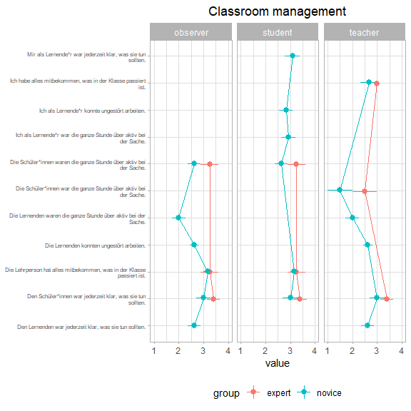
2. Positive climate and motivation 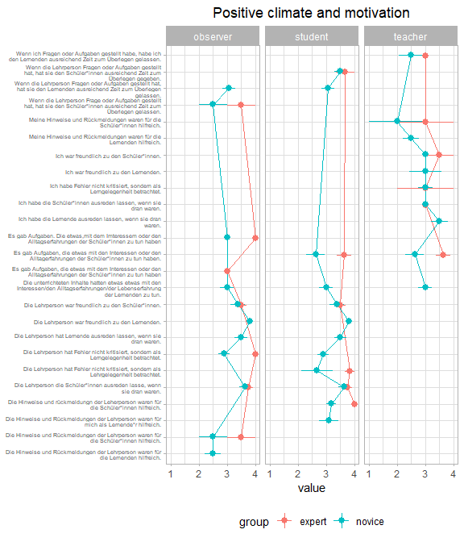
3. Clarity and structuredness 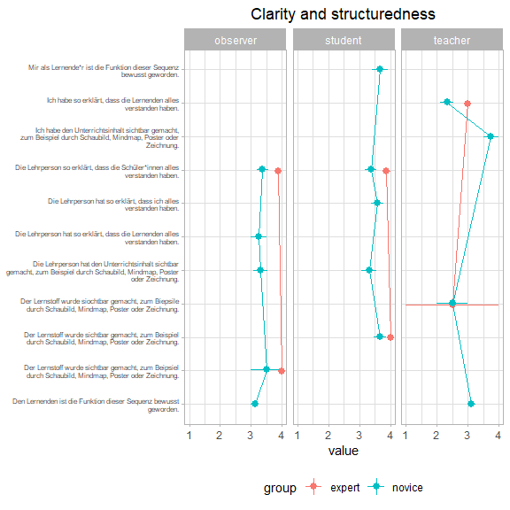
4. Activation and support 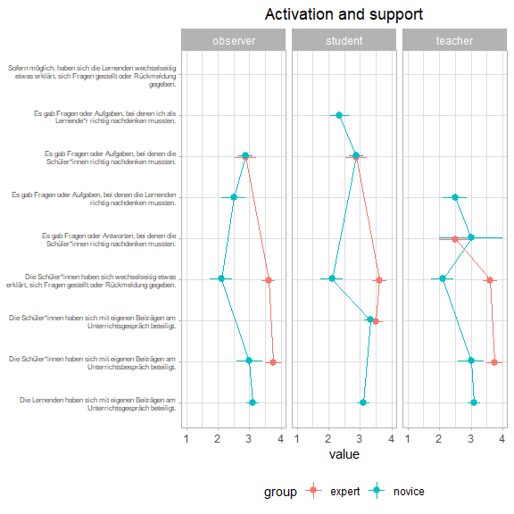

(5) Presence: posture/gaze

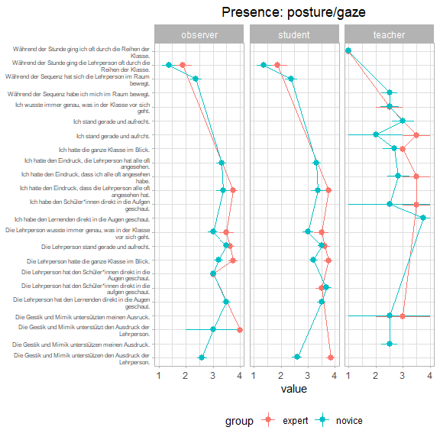

(6) Presence: voice

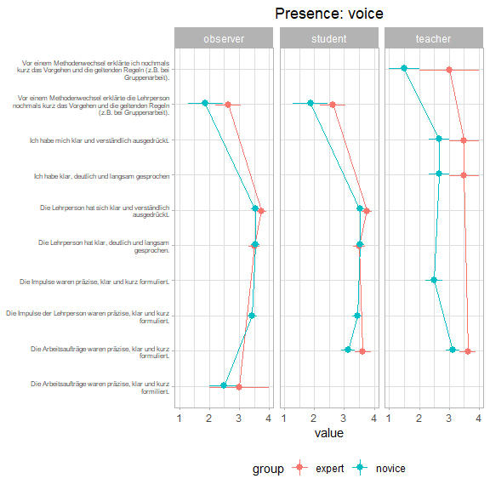

(7) Presence: verbal and non-verbal intervention

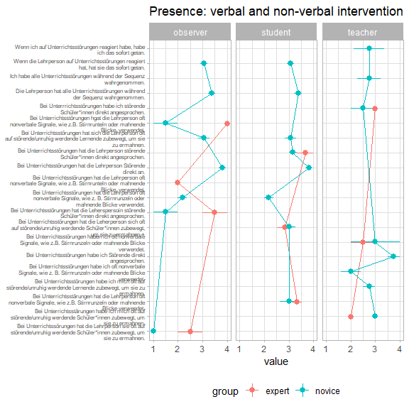

(8) Natural behaviour 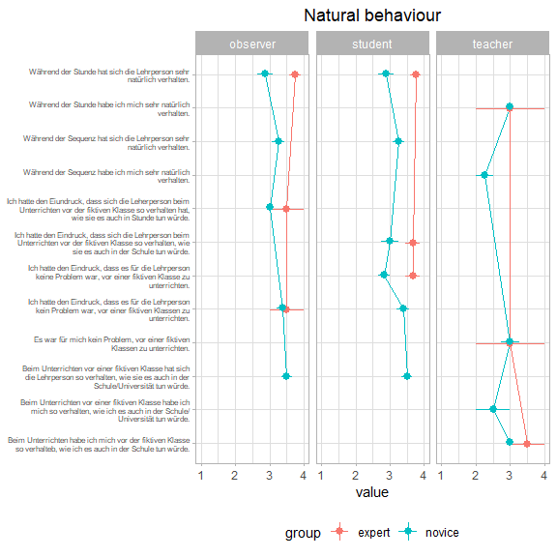

In addition, we plotted all scales. Graph provides boxplots and individual data for experts and novices.

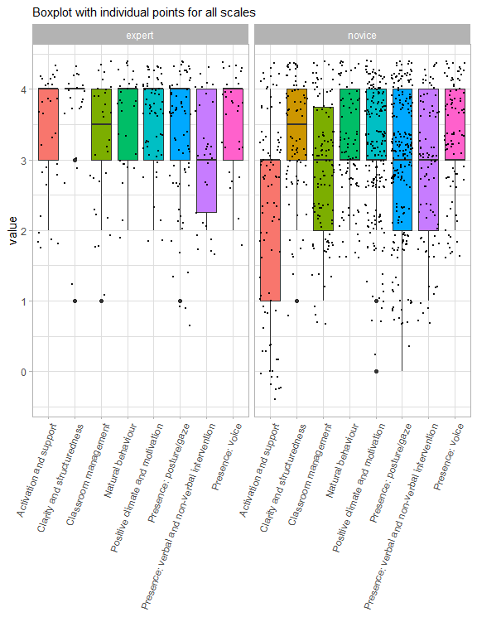

Furthermore, the duration of the speaking time during the lesson was estimated in the questionnaire by external and self-assessment. The following graph shows the duration of speaking time for experts and novices evaluated by the observer, the students and the teacher.

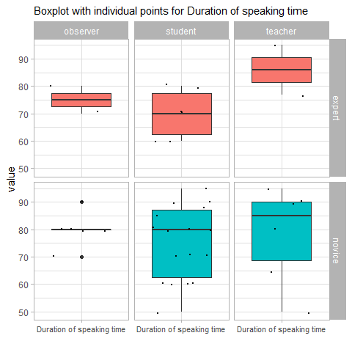

### 2.3.2 Eye-tracking equipment

A binocular Tobii Pro Glasses 2 eye-tracker consisting of a wearable head unit and a recording unit was used to record the eye movements. The head unit is a measuring device with different sensitive sensors. A high-definition scene camera captures a full HD video and an integrated microphone records the surrounding sounds. Infrared light illuminators support the eye tracking sensors which record the eye orientation. The videos were recorded with a sampling rate of 50 Hz and a video resolution with 1920 x 1080 at 25 frames per second. The scene camera has a field of view of 90 deg. in 16:9 format (82 deg. horizontal and 52 deg. vertical) and has a frame dimension of 179 x 159 x 57mm (width x depth x height). The Tobii Pro Glasses Controller software was used to record and calibrate the eye movements.

The Tobii Pro Glasses 2 software allows for non-screen based recordings of a participants’ attention while moving in real-world settings. The recordings of the glasses contain both HD-video from the subjects’ perspective as well as the respective gaze data mapped onto the video. In order to map multiple recordings to AOIs, it is necessary to import the eye-tracking recordings into the Tobii Pro Analyzer software. Also, it is necessary to create a reference image of the scene in which one wishes to plot the gaze data (i.e. snapshot). Once the snapshot is imported, the gaze recordings of multiple recordings can be mapped to the reference image and analyzed in aggregated form. Tobii Pro does not allow to do AOI based analyses within Pro Lab. Also, the dependency on snapshot reference images makes this approach impractical when working in different settings, i.e. different classrooms with various participants. Finally, mapping gaze to people or any moving objects complicated the analyses further.

## 2.4 Data analysis

We used R [Version 4.0.3; R Core Team (2019)] and the R-packages *}dplyr* [@}R-dplyr], *forcats* [Version 0.5.0; Wickham (2020a)], *ggplot2* [Version 3.3.2; Wickham (2016)], *papaja* [Version 0.1.0.9997; Aust and Barth (2020)], *papayar* (Muschelli 2016), *purrr* [Version 0.3.4; Henry and Wickham (2020)], *readr* [Version 1.4.0; Wickham, Hester, and Francois (2018)], *stringr* [Version 1.4.0; Wickham (2019)], *tibble* [Version 3.0.4; Müller and Wickham (2021)], *tidyr* [Version 1.1.2; Wickham (2020b)], and *tidyverse* [Version 1.3.0; Wickham et al. (2019)] for all our analyses.

Lorem ipsum dolor sit amet, consetetur sadipscing elitr, sed diam nonumy eirmod tempor invidunt ut labore et dolore magna aliquyam erat, sed diam voluptua. At vero eos et accusam et justo duo dolores et ea rebum. Stet clita kasd gubergren, no sea takimata sanctus est Lorem ipsum dolor sit amet. Lorem ipsum dolor sit amet, consetetur sadipscing elitr, sed diam nonumy eirmod tempor invidunt ut labore et dolore magna aliquyam erat, sed diam voluptua. At vero eos et accusam et justo duo dolores et ea rebum. Stet clita kasd gubergren, no sea takimata sanctus est Lorem ipsum dolor sit amet.

# 3 Results

### 3.0.1 Questionnaire Data

*Start entering descriptives and plots here* Lorem ipsum dolor sit amet, consetetur sadipscing elitr, sed diam nonumy eirmod tempor invidunt ut labore et dolore magna aliquyam erat, sed diam voluptua. At vero eos et accusam et justo duo dolores et ea rebum. Stet clita kasd gubergren, no sea takimata sanctus est Lorem ipsum dolor sit amet. Lorem ipsum dolor sit amet, consetetur sadipscing elitr, sed diam nonumy eirmod tempor invidunt ut labore et dolore magna aliquyam erat, sed diam voluptua. At vero eos et accusam et justo duo dolores et ea rebum. Stet clita kasd gubergren, no sea takimata sanctus est Lorem ipsum dolor sit amet.

Lorem ipsum dolor sit amet, consetetur sadipscing elitr, sed diam nonumy eirmod tempor invidunt ut labore et dolore magna aliquyam erat, sed diam voluptua. At vero eos et accusam et justo duo dolores et ea rebum. Stet clita kasd gubergren, no sea takimata sanctus est Lorem ipsum dolor sit amet. Lorem ipsum dolor sit amet, consetetur sadipscing elitr, sed diam nonumy eirmod tempor invidunt ut labore et dolore magna aliquyam erat, sed diam voluptua. At vero eos et accusam et justo duo dolores et ea rebum. Stet clita kasd gubergren, no sea takimata sanctus est Lorem ipsum dolor sit amet.

# 4 Discussion

Lorem ipsum dolor sit amet, consetetur sadipscing elitr, sed diam nonumy eirmod tempor invidunt ut labore et dolore magna aliquyam erat, sed diam voluptua. At vero eos et accusam et justo duo dolores et ea rebum. Stet clita kasd gubergren, no sea takimata sanctus est Lorem ipsum dolor sit amet. Lorem ipsum dolor sit amet, consetetur sadipscing elitr, sed diam nonumy eirmod tempor invidunt ut labore et dolore magna aliquyam erat, sed diam voluptua. At vero eos et accusam et justo duo dolores et ea rebum. Stet clita kasd gubergren, no sea takimata sanctus est Lorem ipsum dolor sit amet.

# 5 References

Aust, Frederik, and Marius Barth. 2020. *papaja: Create APA Manuscripts with R Markdown*. <https://github.com/crsh/papaja>.

Barnes, Douglas. 2004. “The Significance of Teachers’ Frames for Teaching.” In *Teachers and Teaching*, 16–38. Routledge.

Barth, Victoria L. 2017. *Professionelle Wahrnehmung von Störungen Im Unterricht*. Springer.

Berliner, David C. 2001. “Learning about and Learning from Expert Teachers.” *International Journal of Educational Research* 35 (5): 463–82.

Bogert, Niek J van den. 2016. *On Teachers’ Visual Perception and Interpretation of Classroom Events Using Eye Tracking and Collaborative Tagging Methodologies*. Technische Universiteit Eindhoven.

Brophy, Jere. 1986. “Classroom Management Techniques.” *Education and Urban Society* 18 (2): 182–94.

Cortina, Kai S, Kevin F Miller, Ryan McKenzie, and Alanna Epstein. 2015. “Where Low and High Inference Data Converge: Validation of CLASS Assessment of Mathematics Instruction Using Mobile Eye Tracking with Expert and Novice Teachers.” *International Journal of Science and Mathematics Education* 13 (2): 389–403.

Helmke, Andreas, Tuyet Helmke, Gerlinde Lenske, G Pham, Anna-Katharina Praetorius, Friedrich-Wilhelm Schrader, and Manuel AdeThurow. 2014. “Unterrichtsdiagnostik Mit EMU.” *Aus-Und Fortbildung Der Lehrkräfte in Hinblick Auf Verbesserung Der Diagnosefähigkeit, Umgang Mit Heterogenität Und Individuelle Förderung*, 149–63.

Henry, Lionel, and Hadley Wickham. 2020. *Purrr: Functional Programming Tools*. <https://CRAN.R-project.org/package=purrr>.

Jarodzka, Halszka, Katharina Scheiter, Peter Gerjets, and Tamara Van Gog. 2010. “In the Eyes of the Beholder: How Experts and Novices Interpret Dynamic Stimuli.” *Learning and Instruction* 20 (2): 146–54.

Kiel, Ewald, Anne Frey, Sabine Weiß, and Sabine Weiss. 2013. *Trainingsbuch Klassenführung*. Vol. 3992. UTB.

Kounin, Jacob S. 2006. *Techniken Der Klassenführung*. Waxmann Verlag.

Lachner, Andreas, Halszka Jarodzka, and Matthias Nückles. 2016. “What Makes an Expert Teacher? Investigating Teachers’ Professional Vision and Discourse Abilities.” *Instructional Science* 44 (3): 197–203.

Marzano, Robert J. 2007. *The Art and Science of Teaching: A Comprehensive Framework for Effective Instruction*. Ascd.

Messner, Helmut, and Kurt Reusser. 2000. “Die Berufliche Entwicklung von Lehrpersonen Als Lebenslanger Prozess.” *Beiträge Zur Lehrerinnen-Und Lehrerbildung* 18 (2): 157–71.

Muschelli, John. 2016. *Papayar: View Medical Research Images Using the Papaya JavaScript Library*. <https://CRAN.R-project.org/package=papayar>.

Müller, Kirill, and Hadley Wickham. 2021. *Tibble: Simple Data Frames*. <https://CRAN.R-project.org/package=tibble>.

Nolting, Hans-Peter. 2012. *Störungen in Der Schulklasse*. Beltz.

Pouta, Maikki, Erno Lehtinen, and Tuire Palonen. 2020. “Student Teachers’ and Experienced Teachers’ Professional Vision of Students’ Understanding of the Rational Number Concept.”

R Core Team. 2019. *R: A Language and Environment for Statistical Computing*. Vienna, Austria: R Foundation for Statistical Computing. <https://www.R-project.org/>.

Stuermer, Kathleen, Tina Seidel, Katharina Mueller, Janina Häusler, and Kai S Cortina. 2017. “What Is in the Eye of Preservice Teachers While Instructing? An Eye-Tracking Study about Attention Processes in Different Teaching Situations.” *Zeitschrift für Erziehungswissenschaft* 20 (1): 75–92.

Wickham, Hadley. 2016. *Ggplot2: Elegant Graphics for Data Analysis*. Springer-Verlag New York. <https://ggplot2.tidyverse.org>.

———. 2019. *Stringr: Simple, Consistent Wrappers for Common String Operations*. <https://CRAN.R-project.org/package=stringr>.

———. 2020a. *Forcats: Tools for Working with Categorical Variables (Factors)*. <https://CRAN.R-project.org/package=forcats>.

———. 2020b. *Tidyr: Tidy Messy Data*. <https://CRAN.R-project.org/package=tidyr>.

Wickham, Hadley, Mara Averick, Jennifer Bryan, Winston Chang, Lucy D’Agostino McGowan, Romain François, Garrett Grolemund, et al. 2019. “Welcome to the tidyverse.” *Journal of Open Source Software* 4 (43): 1686. <https://doi.org/10.21105/joss.01686>.

Wickham, Hadley, Jim Hester, and Romain Francois. 2018. *Readr: Read Rectangular Text Data*. <https://CRAN.R-project.org/package=readr>.

Wolff, Charlotte E, Halszka Jarodzka, and Henny PA Boshuizen. 2017. “See and Tell: Differences Between Expert and Novice Teachers’ Interpretations of Problematic Classroom Management Events.” *Teaching and Teacher Education* 66: 295–308.