***Working with this manuscript:::***

The methods/analysis/results section and supplements of the paper will be written in Rmarkdown which allows the publishing of a fully reproducible manuscript (data and analysis code). In order to write the intro and discussion together in google docs in a way that can be quickly merged with the manuscript, here are some things to consider while writing:

* ***General****:*
  + note that formatting like bold or italics will not be preserved in the markdown manuscript unless its marked with the respective syntax:
    - one * for italics: *example* → *example*
    - two times * for bold print: **example** → **example**
* ***Headlines****:*
  + All headlines are marked with # (# heading)
  + smaller subheadings are created by adding # (## subheading level 2; ### subheading level 3)
* ***Citations***
  + if you are in a hurry, just past the DOI of the respective paper in brackets. I’ll sort it out later.
  + If you want to be a real sweetheart and add a full citation:
    - go to googlescholar and search the paper
    - click on the citation icon and then select bibtex
    - copy the entire bibtex entry into the googledoc named “manuscript_bibtex”. it's in the same google-folder as this document
    - copy the citation ID from the bibtex-code (that would be the entry after the first curly bracket and before the first comma. Its usually firstauthor+year+firstwordtitle (e.g. tomasello2010origins)
    - add the citation in text by using the following syntax: [@paperID]
      * e.g....as discussed in previous work [@tomasello2010origins]

**Thanks for your patience!**

**## Present Investigation**

The aim was to investigate whether HR measures assessed by a Fitbit Charge 4 are a suitable and effective method to **(1)** map teachers course of arousal over the course of a five phase lab study, including a micro teaching unit,  and **(2)**  examine whether HR measures can be predicted by teachers’ teaching experience and self-reported data on cognitive appraisal during the micro teaching unit.

Within the time frame of approximately two hours, we investigated five intervals with a duration of 10-minutes each: In the (1) pre-teaching phase, the participants were prepared for the following micro teaching unit and familiarized with the setting. During the (2) teaching phase, the participants taught a 15-minute self-prepared lesson to a "class" of three actors that simulated nine classroom events. In the (3) post-teaching phase, the participants answered questionnaires, followed by the (4) interview phase, in which they watched the video of their 15-minute lesson. In the (5) end phase, the participant answered another questionnaire.

According to previous findings that fitness trackers can be used as a low-cost, non-invasive method of measuring HR [hajj2022wrist; @fuller2020reliability] and that different HRs of teachers can be measured in different teaching phases [@donker2020associations; @junker2021potential], we formulate the hypotheses as follows:

**Hypothesis 1**. In the first step, we exploratively looked at the HR trend throughout the entire study. We expected a similar course for the comparison of standardized versus non-standardized HR values, with both courses starting with a slope, then showing a peak, followed by a sharp decline (**Hypothesis 1a**). In the second step, we looked at the four phases separately and presumed the highest mean HR in the (2) teaching phase and lower mean values in all other phases (**Hypothesis 1b**). Moreover, we expected an increase in HR in the (1) pre-teaching phase as the first phase and a decrease in the following phases (**Hypothesis 1c**).

**Hypothesis 2**. We examined the effects of teaching experience and cognitive appraisal as self-reported data during the micro teaching unit on teachers’ HR responses. With respect to teaching experience, we expected a lower HR in teachers with more teaching experience (**Hypothesis 2a**). Concerning the cognitive appraisal, we expected higher HR values for teachers who felt more disrupted (**Hypotheses 2b**). In contrast, individuals with high confidence in dealing with disruptions would have a lower mean HR in the four phases (**Hypothesis 2c**). When considering the three predictors in concert, we expected teaching experience and self-reported data to remain substantial predictors (**Hypothesis 2d**).

**# Method**

**## Participants**

The sample consisted of *N* = 81 pre- and in-service teachers. The participants were recruited via personal contact, email lists and flyers. From the originally assessed data of 84 participants, three participants were excluded from the analyses due to insufficient data quality, yielding the analysis sample of 81.

The participants (*n* = 52 women, *n* = 29 man) had a mean age of 31 years (*SD* = 10.90; range: 19-60) and an average teaching experience of 5.64 years (*SD* = 9.46; range: 0-37). A percentage of 14.81/70.37/9.88% of the participants stemmed from school forms of primary/secondary/special educational needs schools.

**## Procedure and Setting**

The whole study had a duration of approximately two hours (for detailed information about the procedure, see Fig. 1).

Ein Bild, das Text, Diagramm, Reihe, Screenshot enthält.
**Fig. 1.**Procedure of the two-hours study.

Within this timeframe, teachers taught a 15-minute self-prepared lesson to an audience of three actors who simulated typical classroom events (see Fig. 2).

Ein Bild, das Mobiliar, Stuhl, Kleidung, Schuhwerk enthält.

**Fig. 2.**Setting of the 15-minute micro teaching unit. *Note.* The setting included three actors as the class (left) and a teacher (right).

Subsequently, the participants filled out questionnaires and were interviewed about the previously taught lesson while watching selected sequences of the lesson on video (see Fig. 3).

Ein Bild, das Mobiliar, Zeichnung, Entwurf, Tisch enthält.
**Fig. 3.** Setting of the interview. *Note.* The experimenter and participant watched the previously taught lesson on video.

We selected five 10-minute intervals of theoretical interest over the course of this two-hours study: (1) pre-teaching phase, (2) teaching phase, (3) post-teaching phase, (4) interview phase and (5) end phase. The individual phases are described in detail in the analysis section.

After the experimenter welcomed the participants and put on the watch, the procedure of the study was briefly explained and written consent to voluntarily participate in the study was requested. Next, the participants were asked to prepare the necessary materials for the lesson (connecting the laptop to the beamer, preparing worksheets, etc.). Once the preparation was completed, a warm-up phase took place to familiarize the participants with the laboratory setting and the actors. This warm-up phase consisted of two parts: In the first part, the participants and the three actors playfully learned each other's names. The second part involved getting into conversation with each other by asking short questions guided by interests (e.g., about hobbies or favorite places). The preparation time before the lesson started lasted 10-15 minutes on average. Most participants spent this time standing and slightly moving during the warm-up game.

After the preparation and warm-up, the participants started the 15-minute micro teaching unit teaching a self-prepared lesson to three trained actors. During the lesson, the actors simulated nine typical classroom events of three different categories (see Table ## in Appendix ## for all events). To avoid sequency effects of the order of the events and the performing actors we used a fully balanced Latin square design. The actors received instructions on a screen, primarily visible only to them, every one and a half minute on what event to perform. However, the events did not start until two and a half minutes after the participants started teaching to ensure a short period of familiarization with the setting. The events should be executed for 30 seconds, unless there was a reaction from the participants. The actors were trained to stop the disruptive behavior as soon as the teachers intervened. To ensure that the participants did not exceed the time, the time management in the micro-teaching unit was regulated by the experimenter by showing timecards of the remaining time to the participants. The lesson lasted about 20 minutes on average. The participants’ position was mostly standing and moving during the lesson.

After the micro teaching unit, the participants as well as the actors were given a short questionnaire on demographics and teaching quality of the lesson. The completion of the questionnaire took approximately 10 minutes. Most participants completed the questionnaire in a seated position.

Subsequently, the participants watched the video of the lesson. The experimenter stopped the video each time one of the nine events happened and asked several questions. First, participants were asked to describe the disruption and then to evaluate to the disruptiveness of the event on a 11-point rating scale (= disruption factor). In a next step, participants were asked to explain their chosen score between 0 and 10 for the disruption factor. Subsequently, the subjects were asked to first describe their reaction to an event and then to justify their reaction. The experimenter then asked the participants first to evaluate the confidence they had in dealing with the disruption on a 11-point rating scale (= confidence factor) and secondly, to again to explain the chosen value for the confidence factor. The interview lasted 45-60 minutes on average. The participants’ position in this phase was seated during the interview.

After the interview, the participants answered a second questionnaire mainly seated and in a calm position. The completion of the questionnaire lasted approximately 10-15 minutes.

All study procedures were carried out in accordance with the ethical standards of the University’s Institutional Review Board and the authors received a positive vote on the study procedures from the Ethics Committee. All participants were informed in detail about the aim and intention of the study prior to testing. Participation was voluntary and only took place after written consent had been given.

**## Variables**

**### Teaching Experience**

The participants’ teaching experience was assessed as a part of sociodemographic data via an online questionnaire using SoSci Survey (Version 3.1.06; Leiner, 2019) and made available on www.soscisurvey.de. Participants were asked to enter their work experience excluding the traineeship year as a numerical value in an open input field.

**### Heart Rate**

We used a Fitbit Charge 4 to measure the teachers’ HR. In line with the manufacturer's instructions, the device was attached a finger’s width above the participants’ wrist bone [@fitbitnd]. To determine the HR, the Fitbit flashes green LEDs many times per second and uses light-sensitive photodiodes to measure the volume changes in the capillaries and then calculates how many times the heart beats per minute (BPM).

**### Cognitive appraisal**

Cognitive appraisal was assessed for each of the nine disruptions by two items with a 11-point rating scale, ranging from 0 (not at all) to 10 (extremely). For each scale, the mean was calculated over the nine items. One item (= disruption factor) referred to the disruptiveness of the event (How disruptive was this event for you?); the other item (= confidence factor) referred to the participants’ confidence in dealing with the event (How confident did you feel, dealing with this event?).

**## Data analysis**

We conducted all analysis with R [@RStudio2020]. For analyzing the HR data, we selected five 10-minute intervals of theoretical interest over the course of this two-hours study: (1) pre-teaching phase, (2) teaching phase, (3) post-teaching phase, (4) interview phase and (5) end phase (see Fig. ##).

The first interval, the (1) pre-teaching phase, was calculated from the moment the Fitbit watch was put, which happened after the participants were welcomed. In this phase, the participants were familiarized with the setting. The second interval, the (2) teaching phase, began with the participants’ teaching activity of the self-prepared lesson. To record this interval, it was necessary for the experimenter to note the time displayed on the fitness tracker. To ensure that the participants' HR was recorded while they had already started teaching, another two minutes were added to the noted time. The (3) post-teaching phase began immediately after the end of the teaching lesson where the participants answered the first questionnaire. The (4) interview phase was the mid-10 minutes between end of lesson and the time where the watch was taken off to ensure all participants were being interviewed. The (5) end phase were the last 10 minutes before the participants took off the watch where the participants answered the second questionnaire.

We selected five phases based on theoretical interest: Previous studies have shown that teachers' HR differs according to teaching phase [@donker2020associations; @junker2021potential]. We therefore chose these five intervals from the overall study to investigate whether the HR of teachers in different activity and movement phases can be recorded using a Fitbit watch. Of highest relevance in our study was the (2) teaching phase, as it is within this phase that we capture participants’ HR during the teaching activity. In this context, it is important to note that we explicitly chose the first 10 minutes of teaching, as previous studies revealed that the first minutes of the lesson start are essential regarding teacher-student interaction [@donker2018quantitative; @claessens2017positive]. In the (1) pre-teaching and (3) post-teaching phases, as the name suggests, we wanted to find out if and how the HR changed before and after the teaching activity. The remaining phases, the (4) interview and (5) end phases, were primarily control phases to record the HR while the participants were neither just before, nor during, nor just after the teaching activity. We decided to choose 10-minute intervals because 10 minutes was the minimum duration of all five phases, so we ensured the comparability of the phases for all participants. This decision was in line with previous research regarding the analysis of photoplethysmography (PPG) data. Thus, @lu2008can confirmed in their study that 10-minute intervals are a useful duration for analyzing PPG data.

For testing Hypothesis 1a, where we looked at the HR trend throughout the entire study and compared standardized versus non-standardized HR values, we first z-standardized the unstandardized values in BPM to account for individual differences in the baseline HR. Thus, resulting values can be interpreted as differences from the overall HR mean in standard deviations. Second, we calculated means, standard deviations and the range of teachers’ unstandardized and standardized HR in the entire study and in the different phases. Third, we displayed the anticipated trend for the mean HR in BPM and the standardized HR over the course of the entire study.

For testing Hypothesis 1b, where we looked at the five phases separately to identify the HR peak, we first conducted a one-way between subjects analysis of variance (ANOVA) with repeated measures. For this analysis, the mean HR was first calculated using the standardized HR per phase. This mean was then used as the dependent variable for the ANOVA. Second, we calculated *t*-tests with planned contrasts and the effect size *d* [@cohen1988new] to test for differences in standardized HR using HR means between the (2) teaching phase and the other four phases.

For testing Hypothesis 1c, where we looked at the increase and decrease of the phases, we conducted a linear estimation of the increase and decrease in HR over time. To this end, we used fixed intercept-fixed random slope regression [@gelman2006data] to estimate linear intercepts and slopes for all individuals which were averaged across all individuals.[1]

In Hypotheses 2, we researched the effects of teaching experience and cognitive appraisal as self-reported data during the micro teaching unit on teachers’ HR responses. In a first step, we investigated the influence of teaching experience on the participants’ standardized mean HR for the (1) pre-teaching phase, the (2) teaching phase, the (3) post-teaching phase, the (4) interview phase, and the (5) end phase by linear regression models (Hypothesis 2a). In the next step, we augmented the models by the self-reported data on the disruptiveness of the events (**Hypothesis 2b**) and on the participants’ confidence in dealing with the events (Hypothesis 2c), while controlling for the shared variance with teaching experience. In the last step, we conducted multiple regression models that considered the effects of the three predictors on the standardized mean HR in concert (Hypothesis 2d).

**# Results**

**## Heart rate course**

Concerning our first hypothesis, where we looked at the HR trend throughout the entire study and compared standardized versus non-standardized HR values, we displayed the trend of the course of HR during the entire study. Means, standard deviations and the range of 81 teachers’ unstandardized and standardized HR in the entire study and in the different phases are shown in Table XX.

Table XX

*M, SD and Range of 81 Teachers’ HR for the Entire Study and the Individual Phases (Unstandardized in BPM/z-standardized)*

|  |  |  |  |  |
| --- | --- | --- | --- | --- |
| Phase | *M* | *SD* | Min | Max |
| Overall course | 90.09/0.04 | 15.76/0.99 | 51/-4.03 | 164/-4.56 |
| (1) Pre-teaching phase | 96.28/0.48 | 14.11/0.88 | 56/-3.56 | 139/3.24 |
| (2) Teaching phase | 100.80/0.85 | 16.23/0.77 | 63/-2.18 | 164/4.37 |
| (3) Post-teaching phase | 93.61/0.27 | 14.01/0.76 | 60/-2.17 | 150/3.06 |
| (4) Interview phase | 82.32/-0.72 | 11.85/0.74 | 51/-2.51 | 132/4.39 |
| (5) End phase | 77.95/-1.07 | 11.14/0.57 | 50/-2.68 | 120/2.96 |

Based on the HR values shown in Table XX, the participants started with a comparatively high mean HR already in the (1) pre-teaching phase. The numerically highest mean HR measure was in the (2) teaching phase and the lowest mean HR measure was in the (5) end phase. A decrease in HR for the following phases, the (3) post-teaching, the (4) interview and the (5) end phase, can be observed after the (2) teaching phase.

Fig. XX a. shows the unstandardized mean HR in BPM and Fig. XX b. shows the standardized mean HR over the entire course of the study of approximately two hours.

Figure XX

*Overall Course of the HR in BPM and z-standardized*

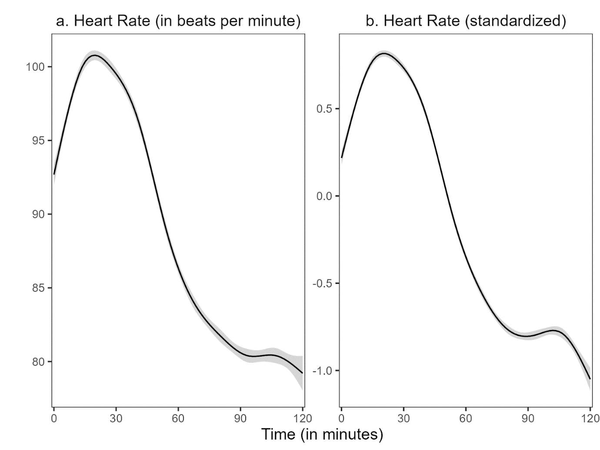

*Note:* The shadow around the line represents the 99% confidence interval. The confidence interval shown refers to the HR measurement points during the entire study period. We used the ggplot2 package (v3.3.3; Wickham, 2016) to calculate the moving average of the course.

The values in Table XX as well as Fig. XX a. and Fig. XX b. clearly showed that in reference to the course of the HR, the HR increased in the (1) pre-teaching phase, had numerically the highest value in the (2) teaching phase and decreased in the following phases, the (3) post-teaching, the (4) interview and the (5) end phase. Comparing the values in Table XX and both courses in Fig. XX a and Fig. XX b., it is apparent that the course of the non-standardized mean HR is similar to the course of the standardized mean HR.

Referring to Hypothesis 1b, where we wanted to identify the HR peak, the standardized mean HR differed statistically significant for the different phases, *F*(4, 400) = 257.50, p < .05, *f* = 1.60 (large effect). The standardized mean HR in the (2) teaching phase compared to the (1) pre-teaching phase was significantly higher, *t*(1) = 32.71, *p* < .05, *d* = 0.82 (large effect). When comparing the standardized mean HR between the (2) teaching phase and the (3) post-teaching phase, the results revealed a statistically significant difference between these two phases, *t*(1) = 32.00, *p* < .05, *d* = 1.34 (large effect) as well as the comparison between (2) teaching and (4) interview phase, *t*(1) = 453.47, *p* < .05, *d* = 3.37 (large effect). The standardized mean HR in the (2) teaching phase compared to the (5) end phase was significantly higher as well, *t*(1) = 511.89, *p* < .05, *d* = 4.68 (large effect).

Figure XX

*1% Confidence Interval in Each Phase*

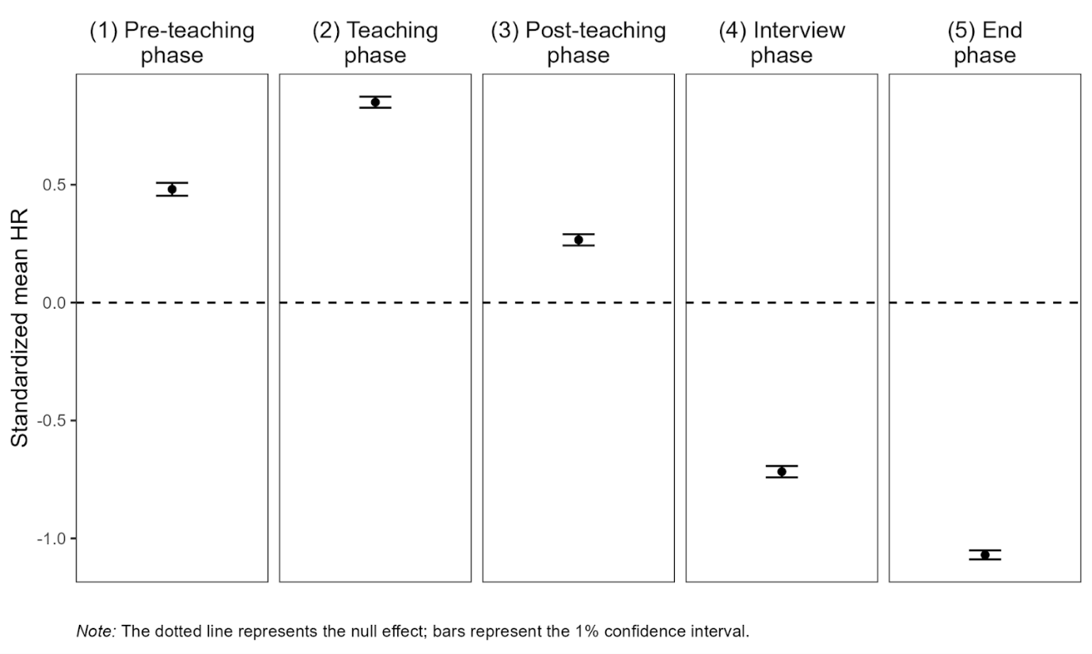

Fig. XX showed the mean standardized HR for the five different phases. In the (1) pre-teaching phase, the mean HR was already relatively high compared to the other phases. In the (2) teaching phase, the highest value was recorded numerically, whereas it dropped in the (3) post-teaching phase and the lowest values were recorded in the following phases, the (4) interview and the (5) end phase. In summary, the trend, which showed up in the entire course of the standardized mean HR in Fig. XX b, can be found in Fig. XX as well. We can see the highest mean HR in the (2) teaching phase and lower mean values in all other phases which can be confirmed by statistically significant differences (see results from Hypotheses 1b).

In Hypothesis 1c, we wanted to investigate the question of how high the participants’ HR was at the beginning of each phase and how steeply it increased and decreased during the phases. Therefore, we estimated the mean intercepts and mean slopes for all participants for each phase.

The descriptive results with the time measurement points, the mean intercepts and mean slopes and the standard deviation for each phase are shown in Table XX.

Table XX

*Descriptive Statistics* *(*n, M, SD*)* *for the Mean Intercepts and the Mean Slopes for the Different Phases for all Individuals*

|  |  |  |  |
| --- | --- | --- | --- |
| Phase | n1 | *M* | SD |
| (1) Pre-teaching phase | 6896 | 0.052/0.085* | 0.820/0.133 |
| (2) Teaching phase | 7150 | 1.025*/-0.039* | 0.690/0.108 |
| (3) Post-teaching phase | 6664 | 0.549*/-0.060* | 0.547/0.101 |
| (4) Interview phase | 6287 | -0.617*/-0.022 | 0.614/0.070 |
| (5) End phase | 5990 | -1.004*/-0.012 | 0.500/0.074 |
| *Note.* * *p* < .05, 1All measurement time points for all participants per phase were included in the calculations to display an overall trend for each phase for the increase and decrease of the HR. Note that the variance in the number of aggregated measurement points stemmed from the variation in the number of HR measurement points from each participant that were collected via Fitbit. The Fitbit generally measured the HR in five second intervals but sometimes, the watch was not able to measure correctly due to movement or too loose attachment of the bracelet, resulting in fewer measurement points in a specific interval. | | | |

Table XX shows that mean intercepts differed significantly from zero for all phases except the (1) pre-teaching phase meaning that at the beginning of the (1) pre-teaching phase, the teachers were moderately excited, whereas at the beginning in all other phases they were either more or less excited. On average, the mean slopes were negative for all phases but the (1) pre-teaching phase, which means that the participants’ mean HR increased over the course of the (1) pre-teaching phase. By contrast, the participants’ mean HR decreased in the (3) post-teaching phase. The mean slope was significantly different from zero for the first three phases which means that HR increased or decreased significantly only in the first three phases. In the last two phases, the (4) interview phase and (5) final phase, there was no significant increase or decrease in mean HR.

Fig. XX

*Linear Estimation With Mean Intercepts and Mean Slopes for Standardized Mean HR in Each Phase*

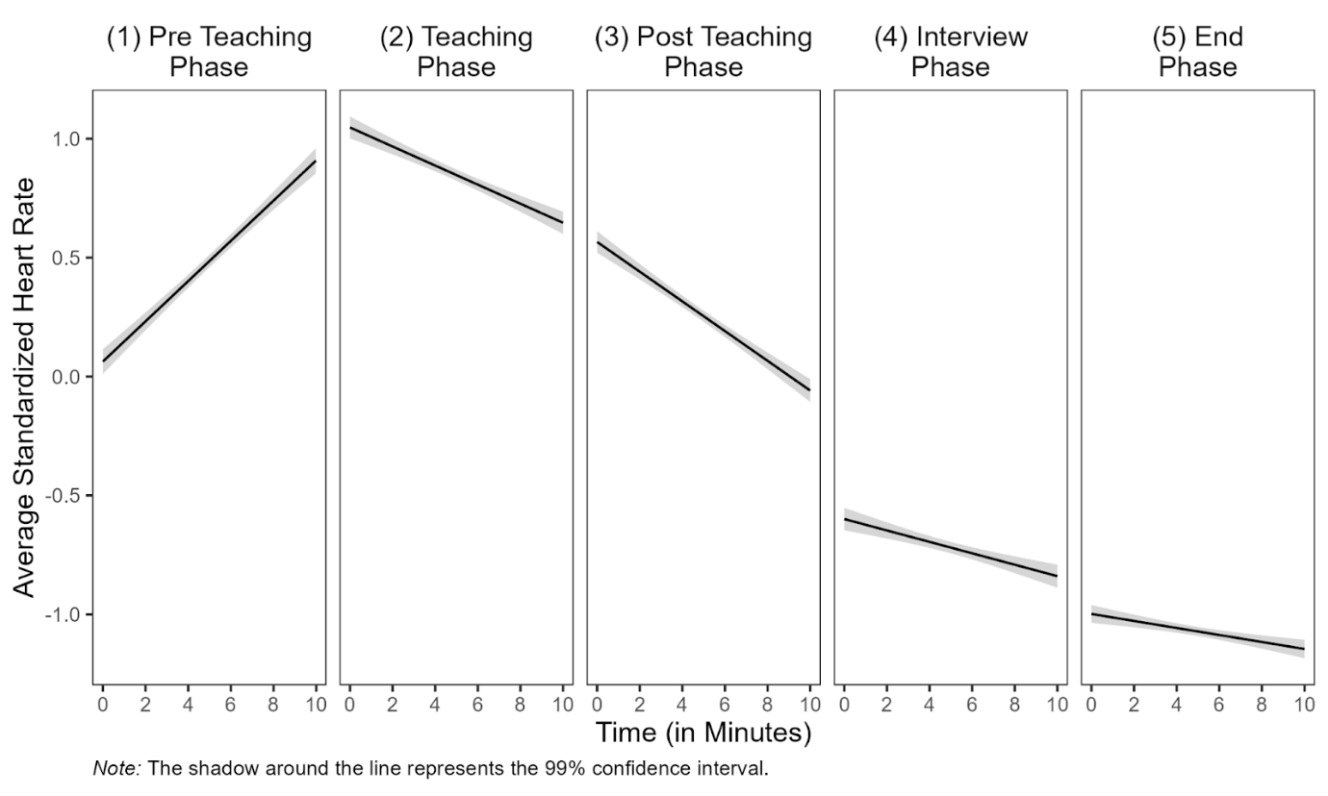

The values of Table XX could be supported by Fig. XX, where we can see the linear estimation for standardized mean HR for the five different phases. If we look at the mean intercept in each phase, we see in the (1) pre-teaching phase that the mean HR started there approximately at zero, means the mean HR of the participants were moderate at the beginning of this phase. In the (2) teaching phase, the mean intercept started significantly higher than zero, so it is evident that the participants' mean HR was highest at the beginning of this phase compared to all other phases. In the subsequent phases, the (3) post-teaching phase, the (4) interview phase and the (5) end phase, the mean intercepts decreased, implying that the participants’ mean HR at the beginning of these remaining phases kept decreasing. Looking at the mean slopes regarding the values in Table XX, only the (1) pre-teaching phase showed a significant increase in mean HR and the (2) teaching phase and (3) post-teaching phase showed a significant decrease in HR during both phases. In the remaining phases, the (4) interview phase and (5) end phase, there was no significant increase or decrease in HR.

Furthermore, the trend of the entire course of HR can also be represented in this Fig. XX. We see a strong slope in the (1) pre-teaching phase and a decrease in the following phases. In the (4) interview and (5) end phase there is hardly any slope left.

**## Prediction of Mean HR With Teaching Experience and Self-Report Data:**

To examine bivariate correlations between all variables and thus identify any suppressor effects in the regression, the correlations were first calculated and presented in Table XX.

Table XX

*Partial Correlations Between Standardized Mean HR and the Predictor Variables Teaching Experience, Disruption Factor and Confidence Factor for the Five Different Phases*

|  |  |  |  |  |
| --- | --- | --- | --- | --- |
| Variable | 1 | 2 | 3 | 4 |
| (1) Pre-teaching phase |  |  |  |  |
| 1 HR | − | − .18 | − .10 | − .03 |
| 2 TE |  | − | − .26* | .34* |
| 3 DF |  |  | − | − .24* |
| 4 CF |  |  |  | − |
| (2) Teaching phase |  |  |  |  |
| 1 HR | − | 0.03 | − .19 | − .02 |
| 2 TE |  | − | − .23* | .36* |
| 3 DF |  |  | − | − .25* |
| 4 CF |  |  |  | − |
| (3) Post-teaching phase |  |  |  |  |
| 1 HR | − | .00 | .24* | .11 |
| 2 TE |  | − | − .23* | .35* |
| 3 DF |  |  | − | − .27* |
| 4 CF |  |  |  | − |
| (4) Interview phase |  |  |  |  |
| 1 HR | − | .21 | − .05 | − .04 |
| 2 TE |  | − | − .22* | .36* |
| 3 DF |  |  | − | − .25* |
| 4 CF |  |  |  | − |
| (5) End phase |  |  |  |  |
| 1 HR | − | .10 | .05 | − .11 |
| 2 TE |  | − | − .25* | .36* |
| 3 DF |  |  | − | − .24* |
| 4 CF |  |  |  | − |
| *Note.* HR = standardized mean HR, TE = teaching experience, DF = disruption factor, CF = confidence factor, * *p* < .05. | | | | |

Table XX showed that only in the (3) post-teaching phase, the standardized mean HR as the dependent variable correlated significantly with one predictor variable, the disruption factor (*r* = .24). The teaching experience and the self-report data (disruption factor, confidence factor) correlated significantly in all phases. Moreover, the disruption and confidence factor correlated significantly as well in all phases.

The predictions of the participants’ standardized mean HR with teaching experience for all phases as well as the predictions with teaching experience and self-report data for all phases except the (1) pre-teaching phase are shown in Table XX.

Table XX

*Multiple linear regression of Standardized Mean HR as Dependent Variable with Predictor Variables (Teaching Experience, Disruption Factor, Confidence Factor) for all phases*

|  |  |  |  |  |  |  |  |  |
| --- | --- | --- | --- | --- | --- | --- | --- | --- |
|  | *Dependent Variable: Standardized Mean HR* | | | | | | | |
|  | Model 1 | | Model 2 | | Model 3 | | Model 4 | |
|  | Est. | *p* | Est. | *p* | Est. | *p* | Est. | *p* |
| **(1) Pre-teaching Phase** |  |  |  |  |  |  |  |  |
| Teaching  Experience | .001 (.005) | .12 |  |  |  |  |  |  |
| Constant | 0.52* (0.06) | <.05 |  |  |  |  |  |  |
| **(2) Teaching Phase** |  |  |  |  |  |  |  |  |
| Teaching  Experience | .005 (.005) | .34 | .002 (.005) | .73 | .005  (.006) | .42 | .003  (.006) | .67 |
| Disruption  Factor |  |  | -.062 (.041) | .13 |  |  | -.065  (.042) | .13 |
| Confidence  Factor |  |  |  |  | .004 (.046) | .92 | -.014 (.047) | .76 |
| Constant | 0.813* (0.057) | <.05 | 1.150* (0.227) | <.05 | 0.778* (0.349) | .03 | 1.274* (0.471) | .01 |
| **(3) Post-teaching Phase** |  |  |  |  |  |  |  |  |
| Teaching  Experience | .002 (.005) | .70 | .002 (.005) | .76 | -.003 (.006) | .55 | -.001  (.006) | .22 |
| Disruption  Factor |  |  | .073 (.040) | .07 |  |  | .084*  (.041) | .04 |
| Confidence  Factor |  |  |  |  | .027 (.045) | .55 | .051 (.046) | .27 |
| Constant | 0.272* (0.005) | <.05 | -0.122 (0.222) | .59 | 0.069 (0.343) | .84 | -0.570 (0.457) | .22 |
| **(4) Interview Phase** |  |  |  |  |  |  |  |  |
| Teaching  Experience | .012* (.006) | .03 | .011 (.006) | .06 | .013* (.006) | .04 | .012  (.007) | .07 |
| Disruption  Factor |  |  | -.020 (.044) | .60 |  |  | -.024  (.047) | .61 |
| Confidence  Factor |  |  |  |  | -.010 (.050) | .85 | -.016 (.052) | .76 |
| Constant | 0.793* (0.062) | <.05 | -0.684 (0.252) | <.05 | -0.721 (0.382) | .06 | -0.541 (0.522) | .30 |
| **(5) End Phase** |  |  |  |  |  |  |  |  |
| Teaching  Experience | .002 (.004) | .67 | .003 (.005) | .58 | .004 (.005) | .46 | .004 (.005) | .43 |
| Disruption  Factor |  |  | 0.019 (0.035) | .60 |  |  | .011 (.037) | .76 |
| Confidence  Factor |  |  |  |  | -.035 (.039) | .38 | -.032 (.041) | .44 |
| Constant | -1.075* (0.049) | <.05 | -1.176* (0.199) | <.05 | -0.811 (0.300) |  | -0.897* (0.411) | .03 |
| *Note*. We examined the effect of teaching experience and self-reported data on teachers’ standardized mean HR in different phases. In Model 1, we entered the teaching experience as a predictor for all five phases. In Model 2, we entered the disruption factor and in Model 3, the confidence factor as predictors while controlling for the shared variance with teaching experience. In Model 4, we considered the effects of the three predictors on the standardized mean HR in concert.  * *p* < .05, Standard error in parentheses. | | | | | | | | |

Regarding **Hypothesis 2a**, the prediction of the participants’ mean HR for the (1) pre-teaching, the (2) teaching, the (3) post-teaching, the (4) interview, and the (5) end phase with teaching experience revealed only for the (4) interview phase a significant result (*b* = 0.012, *p* < .05).

When controlling the teaching experience for shared variance with the self-reported data (**Hypothesis 2b**), the multiple linear regression shown in Table XX revealed a significant effect for the (3) post-teaching phase when predicting the HR with teaching experience and controlling for the disruption factor (*b* = 0.084, *p* < .05). Furthermore, the multiple linear regression revealed significant effects for the (4) teaching phase when predicting the HR with teaching experience when controlling for the confidence factor (*b* = 0.013, *p* < .05).

When considering the effects of the three predictors on the standardized mean HR in concert (**Hypothesis 2c**), the multiple linear regression revealed only for the (3) post-teaching phase a significant effect (b = 0.084, p < .05).

1. Although this procedure does not account for nonmonotonic progressions in individual HR, a graphical evaluation reveals that the linear estimates fit well for most of the cases (see XX in the appendix).