**# Introduction**

In the educational context, there is a particular interest in finding adequate indicators and quantitatively measurable parameters for teacher stress and burnout [@fisher2011; @ junker2021]. Previous research on teacher stress often focused on the psychological experience of stress using self-report questionnaires with single-item measures [@chaplain2008; @goker2012] or questionnaires with multiple scales [@fimian1990; @liu2020]. However, self-reported data in the measurement of stress raises concerns about the validity and accuracy of causal inferences for several reasons, including response biases such as social desirability [@razavi2001self] or recall bias [@van2016accuracy]. Because self-reported data fail to capture actual physiological stress responses in real-life situations, ambulatory assessment methods using a variety of assessments are recommended e.g., collecting additional physiological measures such as HR as objective data [@trull2013ambulatory; @ wettstein2020ambulatory]. Furthermore, HR as a physiological measurement provides researchers with objective insights into teachers’ affectivity and stress levels without interrupting the teaching process [@donker2018; @runge2020].

To date, the studies measuring teachers’ HR as an indicator of stress in teaching-learning settings mostly use very expensive and intrusive electrocardiographs [@sperka1995; @scheuch1997psychophysische; @donker2018; @junker2021; @huang2022class], revealing that teacher-centered activities and typical stressors are leading to an increase in HR. However, the recording of HR in an educational context requires the use of inexpensive and non-invasive instruments. Wrist-worn fitness trackers have the potential to be such a useful tool [@ferguson2015]. In contrast to occasional clinical observations, they allow the collection of big data over a longer period, whereby wrist-worn wearables are less intrusive than complex medical devices (e.g., electrocardiograms) that have to be attached to the body [@godfrey2018z]. In the last decade, commercial wearables such as fitness trackers have become increasingly popular and accepted among the wider population [@park2020user]. In addition to the ease of use, perceived usefulness, and enjoyment [@peng2022acceptance], these devices are equipped with biosensors providing users with behavioral (e.g., step count, distance walked) and physiological data (e.g., HR, skin temperature). The general public is thus offered the opportunity to use low-cost, lightweight devices to monitor their physical activity and health routines in their everyday life.

It can be assumed that teachers also wear such fitness trackers as private individuals, recording physiological data like HR during teaching. Wearable technology has been explored in various fields, including medicine [@hughes2023wearable; @yetisen2018wearables], sports [@secckin2023review; @ adesida2019exploring], and entertainment [@helmer2009smart; @cciccek2015wearable]. Yet, in educational contexts, research is sparse [@de2017towards]. Although some studies investigate how wearables can help teachers monitor student activity [@quintana2016keeping], there is a notable research gap regarding teachers’ use of wrist-worn wearables.

Given the high stress levels in the teaching profession [@johnson2005experience], fitness trackers could help analyze HR to understand the causes of stress and strain. One of the reasons for the augmented stress is that teachers are confronted with a multitude of demands in their everyday work, some of which exceed their available resources and therefore make it difficult to cope with various stressors such as classroom disruptions [@montgomery2005meta]. The extent of the strain depends on the subjective appraisal of the objective demands placed on the individual about available resources [@kyriacou2001]. It is therefore particularly important for teachers in the teaching profession to have sufficient personal and professional resources at their disposal [@cramer2018belastung], whereby, for example, professional knowledge about classroom management reduces the risk of stress [@klusmann2012berufliche]. Teachers’ characteristics such as professional experience in turn have an impact on the development of classroom management skills and thus also on the appraisal processes, as these skills develop during professional experience [@ophardt2017klassenmanagement; @wolff2015keeping].

To better understand how stressors like classroom disruptions affect teachers and their stress responses in terms of an increased HR, it would be helpful for educational researchers to track teachers’ HR using affordable and non-intrusive tools like fitness trackers. To gain a clearer insight into how these facets intertwine and contribute to teacher stress, @wettstein2021 suggested monitoring physiological parameters before, during, and after teaching sessions. Therefore, this study investigated if wrist-based fitness trackers are useful to monitor teachers’ HR during different phases, including a teaching unit. We also looked at whether teachers’ teaching experience and their appraisal of disruptions and confidence in the classroom could explain differences in HR measurements.

**## Fitness Trackers as a Method to Assess HR as an Indicator of Stress**

Wearables (also referred to as wearable devices, wearable computers, or wearable electronics, @cciccek2015wearable) are defined as electronic devices that are either directly worn on the body or loosely attached to a person and integrated into clothing or accessories to serve as a convenient all-in-one solution [@godfrey2018z]. Essentially, wearables such as fitness trackers are designed to be worn continuously by users, gathering data such as location, movements, and vital signs via wireless sensors enabling users to interact with these devices anytime and anywhere [@cheng2017underlying]. These gadgets are characterized by attributes such as hands-free operatable, portable, useful, reliable, practical, multi-functional, mobile, socially acceptable, etc. [@cciccek2015wearable, p. 46].

In the last decades, fitness trackers have become widely popular and accepted as a mass product by the population [@park2020user]. Several factors contribute to widespread acceptance: Fitness trackers monitor various aspects of physical activity like HR, distance, steps, and calories burned, providing valuable insights into users’ daily activity and cardiovascular health, supporting them in setting personalized fitness and health goals [@nuss2021effects] or providing information about stress levels [@hao2018chrv]. Further advantages are the portable, non-invasive nature of these devices, the ease of use, and especially, the low costs compared to complex laboratory methods for determining vital parameters such as HR, blood pressure, skin temperature, or physical activity [@hajj2023].

The blend of these factors positions fitness trackers as an ideal technology for use not only in healthcare, entertainment, and fitness [sinha2019taxonomy] but also in education as they offer added benefits for formal and informal learning environments for both students and teachers [@de2017towards]. However, in most studies, the focus is on students, especially to detect students’ skills and enhance their performance [@koutromanos2020use]. Despite the enormous potential of wearables, there is a desideratum of studies that deal with important recorded parameters and in particular their significance for teachers.

One important health parameter assessed by most wrist wearables is HR measurement [@scalise2018wearables]. HR indicates the number of heartbeats within a certain time interval, which is usually heartbeats per minute and is therefore expressed in min-1 or beats per minute (BPM) [@hottenrott2007]. HR can be detected and measured using various methods via wearables, including sensors based on electrocardiogram (ECG) or phonocardiogram (PCG) [@mukhopadhyay2017wearable]. Another uncomplicated and inexpensive technique to measure HR via fitness trackers is photoplethysmography (PPG) [@castaneda2018review]. This optical method assesses HR by flashing green or red lights to measure changes in blood volume [@allen2007photoplethysmography].

Physiologically, HR is regulated and influenced on short-time intervals by the autonomic nervous system which is divided into two distinct components: the sympathetic and the parasympathetic nervous system [@pham2021]. An increase in the activity of the sympathetic, known as the “quick response” system, results in HR being speeded up (“fight or flight”) [@taelman2009influence]. Therefore, an increase in HR can be regarded as an indicator of increasing stress on the cardiovascular system as stress-induced excitation of the sympathetic nervous system leads to activation of the cardiovascular system [@kyriacou1978]. In contrast, increased activity of the parasympathetic as the counterpart known as the “relaxed response” system, has the effect of slowing down the HR (“rest and digest”) [@battipaglia2015]. At rest, the average HR of adults typically ranges from 60 to 80 BPM [@sammito2015guideline].

In addition to the autonomic nervous system and genetic factors, human HR is influenced by numerous external factors such as social, personal, psychological, environmental, and behavioral factors [@wang2022]. Furthermore, it depends largely on the intensity of strain “in response to physical and mental workload” [@sammito2015guideline, p. 1]. Physical and mental strain are therefore factors that directly influence HR and lead to an increase in HR [@custodis2014heart].

**## Teacher Stress and Important Resources**

An increased HR as an indicator of stress is particularly essential in the teaching-learning context, as the teaching profession is one of the most stressful professions compared to other occupational groups, facing a variety of stressors during everyday work [@smith2000; @herman2020; @schult2014belastet]. According to @kyriacou1978, teacher stress can be defined as

“a response of negative affect […] usually accompanied by potentially pathogenic physiological and biochemical changes (such as increased heart rate […]) resulting from aspects of the teacher’s job and mediated by the perception that the demands made upon the teacher constitute a threat to his self-esteem or well-being and by coping mechanisms activated to reduce the perceived threat.” (p. 2).

This definition of teacher stress is based on the ideas of the integrative framework of the transactional stress model by Lazarus and colleagues [@lazarus1981stressbezogene; @lazarus1984stress]. Lazarus’ stress theory initially served as a model, which @kyriacou1978 subsequently modified and tailored to the teaching-learning environment [@dick2013belastung]. For our study, we adapted the model of @van2006stress who made slight modifications to the model of @kyriacou1978.

In general, the model highlights the interaction between an individual and the environment, whereby stress refers to any event that exceeds a person's adaptive resources [@lazarus1990theory]. It has been shown that there are important connections between stress and resources on the one hand and stress-induced health issues on the other [@krause2013messung], which is why the investigation of teacher stress is highly relevant. As classroom disruptions are one of the most influential stressors and key risk factors for teacher health [@boyle1995structural; @aloe2014multivariate], the model will be explained using an example situation based on the relevance of the issue (see @dick2013belastung):

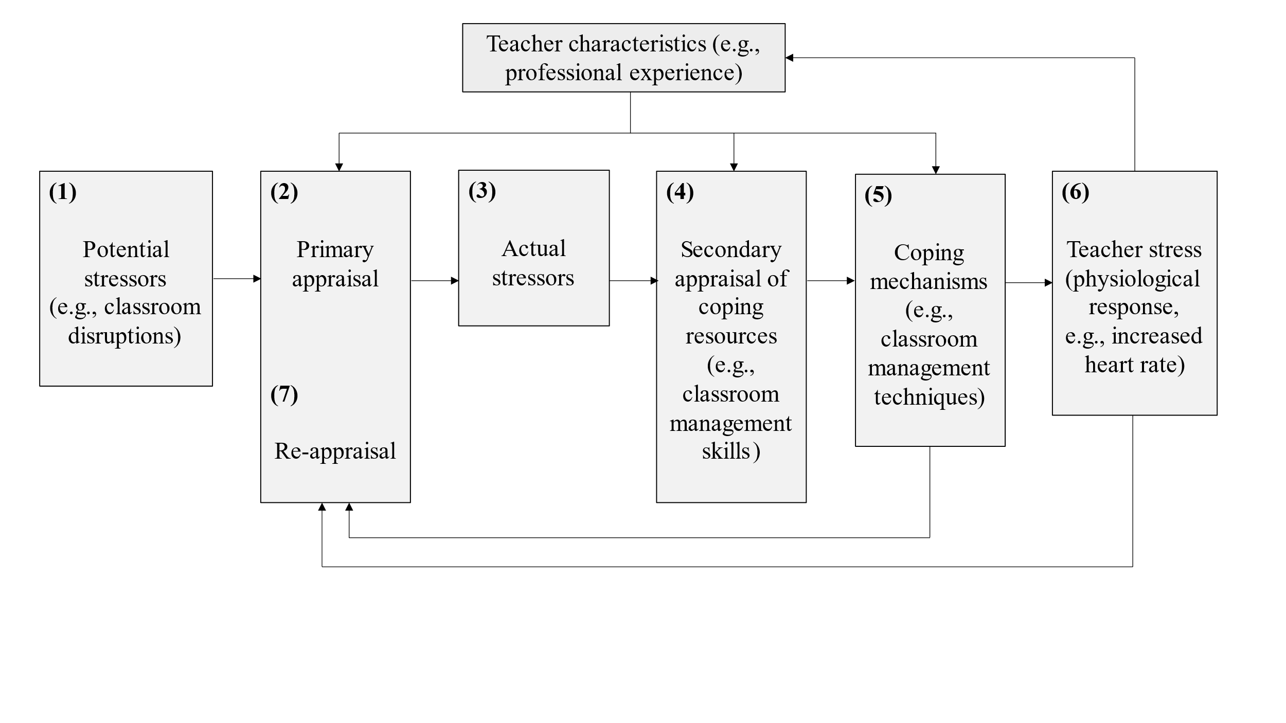

*Figure 1* A model of teacher stress (adapted from van Dick 2006, p.37, modified by the author)

A teaching unit with classroom demands such as classroom disruptions is an objective aspect of teachers’ work and represents potential occupational stress factors in the teaching profession (see Fig. 1, box 1; @karner2021teachers). When classroom disruptions occur, the first step is for teachers to subjectively appraise how disruptive the event is (see Fig. 1, box 2). A classroom disruption can therefore be perceived positively as a challenge, considered to be irrelevant, or negatively as a potential threat. The stress model only continues in the last case when potential stressors are evaluated as actual stressors (see Fig. 1, box 3).

In the next step, during the second subjective appraisal (see Fig. 1, box 4), teachers consider whether they have sufficient resources available to feel confident in dealing with the stressors. In the best case, teachers have both external (e.g., supportive colleagues) and internal (e.g., classroom management skills) resources at their disposal. A lack of resources and coping mechanisms can lead to negative personal and vocational consequences such as burnout, high turnover, and premature retirement [@jalongo2006; @unterbrink2007; @aloe2014]. These correlations are not surprising, as teaching is characterized as multidimensional, simultaneous, immediate, unpredictable, public, and shared [@doyle2013ecological]. Lessons and, in particular, classroom disruptions are unpredictable and multifaceted. All of these circumstances place several demands on teachers and require a high level of knowledge and competence from the teacher [@klieme2008concept]. These professional competencies encompass, among other things, teachers’ specific knowledge and skills about classroom management and can be understood as a diverse toolbox of strategies, techniques, and measures for the teacher to navigate the challenging environment of the classroom [@konig2016teacher].

Additionally, during both primary and secondary appraisal processes, teachers’ characteristics, such as teaching experience (see Fig. 1, upper box), play a particularly important role and have a decisive influence on classroom management skills. Particularly teachers with less teaching experience are overwhelmed by the simultaneity and complexity of teaching [@ophardt2017klassenmanagement; @wolff2015keeping; @ klusmann2012berufliche]. Skills in dealing with teaching events are closely related to the cognitive load of teachers. These classroom management skills develop, among other things, through growing teaching experience, as teachers attempt to cluster experienced classroom events into patterns and formulate appropriate action alternatives. According to @wolff2021classroom, such cognitive processes can be understood as mental classroom management scripts. Accordingly, especially for beginning teachers, the teaching profession seems to be very demanding and stressful. In particular the first five years, between 40 and 50 percent of beginning teachers change careers for a variety of reasons such as disciplinary problems with students [@ingersoll2003]. @fisher2011 investigated the extent to which age or teaching experience and job dissatisfaction are associated with an increased risk of burnout and stress among teachers. The results revealed that teachers with less professional experience had higher burnout scores and that years of professional experience, burnout, and satisfaction in the teaching profession are statistically significant predictors of teacher stress.

Based on the evaluation of resources and their characteristics, teachers will try to cope with classroom disruptions (see Fig 1., box 5) and, for example, use classroom management strategies to stop the disruption. If teachers are unable to cope, they experience stress (see Fig. 1, box 6). Teacher stress is mainly characterized as a reaction to negative affect (e.g., anger or depression), which is generally followed by other symptoms that can be seen as reactions to teacher stress. The response of negative affect can be among other things a physiological stress reaction, such as an increased HR [huang2022class; @kyriacou1978]. Based on the resource appraisal and the successful or unsuccessful coping with the stressor, the stressor will be appraised again (see Fig. 1, box 7).

For our research goals, we are particularly interested in potential stressors in the classroom such as classroom disruptions (see Fig. 1, box 1), the different appraisal processes, how disruptive disruptions are perceived (see Fig. 1, box 2), and how confident teachers feel in coping with them (see Fig. 1, box 4). In addition to the teaching experience (see Fig. 1, upper box), we want to investigate the impact of these aspects on the physiological component in terms of an increased HR (see Fig. 1, box 6), which can be interpreted as an indicator of stress based on existing research [@clays2011perception; @schubert2009effects].

**## HR in Teaching-Learning Contexts**

To better understand the interlinking of these facets and the cause of teacher stress, @wettstein2021 recommended measuring physiological parameters before, during as well as after teaching. For this reason, it is particularly important to look at the course of teachers’ HR, for example by recording measures not only during the teaching unit but also before and after the strain phase. In the following section, we will therefore outline certain studies relevant to our research question that recorded teachers’ HR, with studies first that used expensive and intrusive ECG, before moving on to studies that used wearables with PPG.

The results of the studies using ECG revealed that HR as an indicator of stress can be used to map different HR courses during teaching depending on the teachers’ activity. The HR increased especially during teacher-centered activities when teachers had to take a leading position in the student-teacher interaction [@sperka1995; @scheuch1997psychophysische; @donker2018; @junker2021]. @sperka1995 for example recorded the HR of 16 pre-service teachers during their first lesson. The results showed that the first lesson is linked to significantly increased psychophysiological activation in terms of an increased HR. The activation effect was particularly prominent at the beginning of the lesson and decreased over the course of the lesson due to the pre-service teachers’ active coping processes, meaning that the active management of the interaction with the students helped the teachers regulate their HR. Other studies that also measured teachers’ HR using ECG identified typical potential predictors for increased HR values such as typical stressors, e.g., class size [@huang2022class] or low student engagement and motivation [@junker2021]. @junker2021 for example recorded the HR of 40 teachers using an Ambulatory Monitoring System with seven electrodes during a real classroom lesson to find out to what extent main stressors within the classroom (e.g., low student engagement and motivation, teacher-centered activities) can predict teachers’ HR as an indicator of physiological stress during teaching. @junker2021 provided evidence that teacher stress caused by those stressors during teaching can be quantitatively measured by an increase in HR.

In addition to these studies that measured HR using cost-intensive and intrusive ECG devices, there are a few studies that used low-cost, wrist-worn fitness trackers to investigate HR trends in teaching-learning situations [@Darnell2019; @chalmers2021]. @Darnell2019 for example measured the HR of 15 medical college students using wrist-worn devices during lecture classes. The analysis revealed a constant decrease in HR from the beginning to the end of a lecture, whereas the HR peak was reached during active learning sessions. The researchers proposed the first robust measurements of HR changes during lectures and recommended using personal fitness trackers during various phases of learning and teaching. In another study, @chalmers2021 examined the usability of the average HR measured with a Fitbit fitness tracker of 30 medical students and 30 normative participants to identify physiological changes during stress tasks, whereas the average HR increased significantly between the resting and stress phases for both groups. Even though the participants in these studies were learners and did not teach any lessons themselves, the results are relevant to our study as it can be shown that a) HR can be recorded using fitness trackers in a learning unit and b) HR changes over the course of the learning unit during activating or stress phases.

So far, only one study has combined both aspects of recording teachers’ HR by wrist-worn wearables [@runge2020]: A Fitbit fitness tracker was used to assess HR as an indicator of stress in four teachers. They concluded that stress in the teaching profession can be mapped using fitness trackers’ indicators. In particular, it was found that the combination of a high number of steps, a high HR, and short sleep is an indicator of stress and that poor student behavior is the stressor that is perceived most frequently. It should be noted that the generalizability of the results is limited due to the small sample size of four participants.

In summary, studies revealed that teachers’ (and students’) HR changed, depending on the activity and stressors during teaching, whereby teacher-centered phases, in particular, led to an increase in HR [@sperka1995; @scheuch1997psychophysische; @donker2018; @junker2021]. Furthermore, it could be shown that HR as an indicator of stress can be mapped using low-cost, non-intrusive fitness trackers in learning situations, and HR increases in activating phases and even before stress occurs [@Darnell2019; @chalmers2021]. However, none of the previous studies have looked at the cause of stress assessed with fitness trackers in a comparatively large sample, taking into account a) the course of the HR in different phases (before, during, and after teaching) and b) other parameters such as appraisal processes and teaching experience. Thus, there is a need for further research.

**## Present Investigation**

The present investigation was part of a larger project targeting the development of classroom management in teachers. The study was carried out in a classroom at the university that served as the lab.

Within the time frame of approximately two hours, we distinguished five phases of our study: In the (1) pre-teaching phase, the participants were welcomed, prepared for the following micro-teaching unit, and familiarized with the setting. During the (2) teaching phase, the participants taught a 15-minute self-prepared micro-teaching unit to a "class" of three actors that performed nine (possibly disruptive) classroom events (e.g., chatting with a neighbor, heckling, looking at the phone; see Table ## in the supplementary material for an overview and categorization of all events; also see Fig## for a depiction of the laboratory setting of the micro-teaching unit). The actors received standardized instructions on a screen (only visible to the actors, but not to the participants) to perform a classroom event every one and a half minutes. While teaching, participants wore eye-tracking glasses, and additionally, their lessons were recorded by cameras. In the (3) post-teaching phase, the participants answered several questionnaires, followed by the (4) interview phase, in which they watched the video of their 15-minute unit and answered questions about the (disruptive) classroom events. In the (5) end phase, the participant answered another questionnaire. These conditions were identical for all participants. During the entire study, the participants wore a fitness tracker, while the HR measurements provided the database for the present investigation.

Thus, the goals of the present study were twofold:

(1) The first research goal was to investigate whether HR measures assessed by wrist-based fitness trackers are a suitable and effective method for mapping teachers’ HR over the course of a five-phase lab study, including a micro-teaching unit.

In the first step, we therefore exploratively described the participants’ overall HR trend during the two-hour study interval and examined whether z-standardization of the participants’ mean HR can serve as a useful method to account for individual differences in baseline HR. Regarding the HR trend of the entire course of the study, we expected participants´ HR to gradually increase during the pre-teaching phase, to peak during the teaching phase, and to gradually decrease during the remaining time interval. Furthermore, we expected to observe the same trends in both standardized and non-standardized mean HR values.

In the second step, we selected five corresponding intervals with a length of ten minutes each out of the five phases and examined the levels of and the changes in HR of the five intervals separately. We presumed the highest HR levels in the micro-teaching unit and regarding HR changes, we expected an increase at the beginning of the study and a decrease in the following phases.

(2) The second research goal was to examine whether variance in HR measures can be explained by teachers’ teaching experience, and by self-reported cognitive appraisal (disruption appraisal and confidence appraisal) of classroom events. We expected all three variables (teaching experience, disruption appraisal, and confidence appraisal) to be significant predictors for the HR measurements in the different phases.

**# Method**

**## Participants**

The sample consisted of *N* = 84 pre- and in-service teachers from Germany who had been recruited via personal contact, email lists, and flyers. The data of three participants was lost due to failed data transmission, yielding an analysis sample of *n* = 81.

The participants of the analysis sample (*n* = 52 women, *n* = 29 men) reported a mean age of 30.95 years (*SD* = 10.90; range: 19-60) and an average teaching experience of 5.64 years (*SD* = 9.46; range: 0-37).

**## Setting and Procedure**

The study was carried out in accordance with the ethical standards and the approval of the University’s Institutional Review Board. All participants were informed in detail about the aims and intention of the study prior to testing. Participation was voluntary and only took place after written consent had been given.

**Figure 1**

*Procedure of the two-hour-long study.*

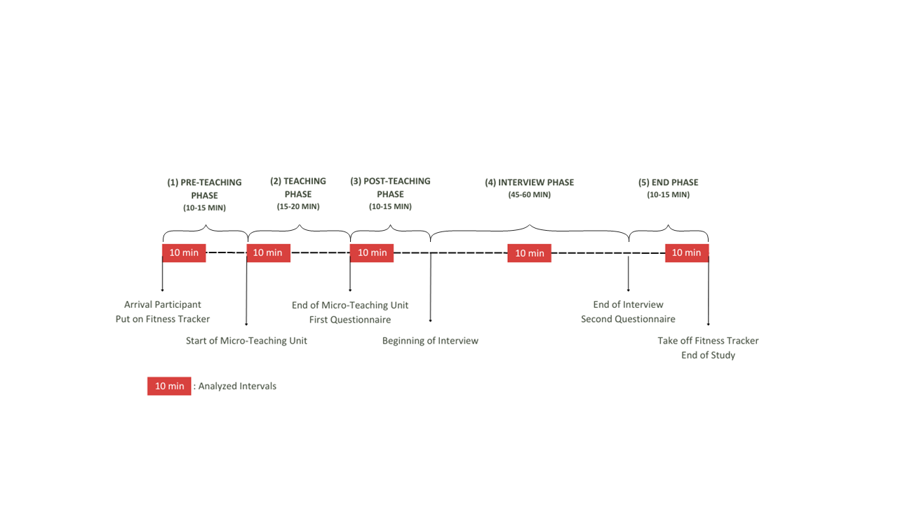

The whole study had a duration of approximately two hours and consisted of five phases: (1) *pre-teaching phase*, (2) *teaching phase*, (3) *post-teaching phase*, (4) *interview phase*, and (5) *end phase* (please refer to Fig. 1 for a timeline). In the (1) *pre-teaching phase*, the experimenter welcomed the participants and helped them to put on the fitness tracker. This was followed by a warm-up session to familiarize the participants with the laboratory setting and the class. This phase took about 10-15 minutes and participants spent this time mostly standing or slowly walking around. During the (2) *teaching phase*, the participants held their self-prepared micro teaching unit to a class of three trained actors that performed nine classroom events. The teaching unit was video-recorded and lasted about 15-20 minutes. Participants spent this time mostly standing or slowly walking around. After having completed the micro-teaching unit, in the (3) *post-teaching phase*, participants were seated at a desk and filled in questionnaires. Moreover, in the post-teaching phase, the participants were given the opportunity to take a break after teaching, for example to use the restroom, drink or rest. This phase took approximately 10-15 minutes. In the (4) *interview phase*, the participants then watched the video of their own teaching together with the experimenter. While doing so, they were given a Stimulated Recall Interview (SRI), during which they answered questions about their cognitive appraisal of the classroom events (see instrument section; also see Fig## in the supplementary material for a depiction of the interview setting). The interview lasted about 45-60 minutes and the participants’ position was seated. The (5) *end phase* lasted about 10-15 minutes and participants answered in a seated position another questionnaire irrelevant to this study.

**## Instruments**

**### Fitness Tracker**

To measure the teachers’ HR, we used a wrist-based fitness tracker. The model was a Fitbit Charge 4. In line with the manufacturer's instructions [@fitbitnd], the device was attached a finger’s width above the participants’ nondominant hand´s wrist bone. The tracker works by flashing green LEDs hundreds of times per second, using light-sensitive photodiodes catching the light that is reflected back, and from that information calculating volume changes in the capillaries. From this, the tracker calculates how many times the heart beats per minute. HR measurements are generated at least every 15 seconds[1]. The raw data that can be extracted from the tracker lists the time stamps of all measurements and the estimated HR in beats per minute (BPM) for each time stamp.

**### Questionnaire**

In the *post-teaching phase*, the teachers answered questionnaires: a brief computer-based questionnaire assessing sociodemographic data (e.g., teaching experience, gender, studied school type, studied school subjects, extracurricular teaching activities), and a short knowledge test that is irrelevant to the present study. All in all, completion of the questionnaires took about 10 minutes.

**### Stimulated Recall Interview**

The SRI took place in the *interview phase*, in which the participants watched their recorded eye tracking video of the lesson from the ego perspective indicating the participants’ gaze point. The experimenter stopped the video each time one of the nine classroom events happened and asked a total of eight questions, five of which were open and three closed. We assessed – among other questions irrelevant to this study – with two closed questions the teachers’ cognitive appraisal of the classroom events that took place during the *teaching phase* in terms of how subjectively disruptive they were (disruption appraisal) and how confident the participants felt dealing with them (confidence appraisal) with one item each. Accordingly, teachers indicated their subjective amount of disruption and confidence for each of the nine classroom events on an 11-point rating scale, ranging from 0 (not at all) to 10 (extremely). The SRI lasted 45-60 minutes on average.

**## Variables**

**### Heart Rate Data and Heart Rate Intervals**

The anonymous HR data was synced via Bluetooth to a commercial Fitbit account. Subsequently, the intraday second-by-second data was exported as a CSV file for each session using the open-source software PulseWatch (Ricci, n.d.), and linked to the participant. To account for individual differences in the baseline HR, we first z-standardized the BPM values from the unstandardized mean HRs. To do this, we first calculated the means and standard deviations of the unstandardized mean HRs based on all values that were available for an individual. Subsequently, we calculated the difference of all measures to the mean and divided these values by the standard deviation. As a consequence, the resulting unstandardized mean HR values can be interpreted as differences from the overall HR mean in standard deviation units.

Since our aim was to explore teachers’ HR between study phases, we decided to aggregate HR over a typical interval within each phase. To keep intervals comparable in duration, we selected intervals with a length of 10 minutes each. Previous research has indicated that 10-minute intervals are a useful duration for analyzing PPG data [@lu2008can]. The intervals were selected based on the following rules: The (1) pre-teaching interval comprised the first 10 minutes after the fitness tracker had been put on. The (2) teaching interval started two minutes after the teacher had started the teaching unit. This interval was of highest relevance to our study. We explicitly chose an early 10-minutes interval within the *teaching phase*, as previous studies revealed that the beginning of a lesson is essential and demanding regarding teacher-student interaction [@donker2018quantitative; @claessens2017positive]. The (3) post-teaching interval started immediately after the end of the teaching unit. The (4) interview interval was defined as the mid-10 minutes between the end of the teaching unit and the time point where the fitness tracker was taken off. This definition ensured that all participants were being interviewed during this interval. The (5) end interval comprised the last 10 minutes before the fitness tracker was taken off.

**### Teaching Experience**

The participants’ teaching experience was assessed as a part of sociodemographic data. Participants stated their work experience in years (excluding the traineeship year).

**### Subjective appraisal of the classroom events and coping processes**

The subjective disruption and confidence appraisals assessed in the SRI on an 11-point rating scale were averaged across the nine classroom events as we were not interested in individual classroom events, but only in the expected mean level of arousal during the *teaching phase*. Regarding the model (see Fig. 1), the disruption appraisal was used to assess the evaluation of the stressor (see Fig. 1, box 2). The confidence appraisal, in contrast, referred to the resources available for coping with the stressors (see Fig. 1, box 4).

**## Data analysis and Hypotheses**

We conducted all analyses with R [@RStudio2020].

**Research goal 1**. The first research goal included mapping teachers’ HR before, during, and following a micro-teaching unit in the course of a five-phase lab study.

Regarding the teachers’ HR trend over the course of the entire study, we expected the participants to show an initial increase in their HR, followed by a peak during the *teaching phase* and a decrease for the remaining phases. Therefore, we displayed the HR trend over the course of the entire study.

Furthermore, we wanted to examine whether z-standardization of the participants’ mean HR is a useful method to account for individual differences in the baseline HR. We expected trends of standardized mean HR values to show a comparable course to the non-standardized mean HR values. To this end, we visually compared the unstandardized and standardized HR trend.

To accomplish the second part of our first research goal, which examined the HR levels and changes during the different phases, we first selected five corresponding intervals with a length of ten minutes each out of the five phases and examined the levels of and the changes in HR of the five intervals separately. Referring to the HR levels, we assumed the highest HR level in the *teaching interval* and lower levels in all other intervals, because the level of arousal should be highest while teaching (**Hypothesis 1a**). For testing Hypothesis 1a, we initially conducted a one-way ANOVA with repeated measures as an omnibus test. The dependent variable comprised the standardized HR mean for each interval. In order to identify the highest HR level, we subsequently conducted *t*-tests with planned contrasts as post-hoc tests, accompanied by the effect size *d* [@cohen1988new]. Specifically, we tested the differences between the (2) teaching interval and the other four intervals.

Note that mean HR was calculated at the subject level of *n* = 81 participants (see Table 1), whereas the mean slope and mean intercept estimates are based on all values at all measurement time points (see Table 2).

Regarding HR changes, we expected an increase during the (1) pre-teaching interval as the participants’ arousal might increase in preparation for the teaching unit and a decrease in the following intervals, because of habituating to the situation (**Hypothesis 1b**). In testing Hypothesis 1b we conducted a linear estimation of the increase or decrease in HR over time. To this end, we used fixed intercept fixed slope regression models [@gelman2006data] for each interval to estimate intercepts and linear slopes for all individuals which were then averaged across individuals.[2]

**Research goal 2**. In addressing our second research goal, we examined the effects of teaching experience and cognitive appraisal of disruptive classroom events on teachers’ HR during the five phases.

First, we considered teaching experience. We expected lower HR levels and less steep HR changes for teachers with more teaching experience (**Hypothesis 2a**). Therefore, we investigated the effect of solely teaching experience on participants’ HR levels and HR changes for each of the five intervals by linear regression models (Hypotheses 2a).

Second, we considered cognitive appraisal. We expected higher HR levels and steeper HR changes for teachers who felt more disrupted by the events (**Hypotheses 2b**), but lower HR levels and less steep HR changes for teachers who felt more confident in dealing with the events (**Hypothesis 2c**). Therefore, we separately augmented the models by either the disruption appraisal of the events (Hypothesis 2b) or by the confidence appraisal of dealing with the events (Hypothesis 2c), while controlling for the shared variance with teaching experience.[3]

Lastly, we considered all three predictors (teaching experience, disruption appraisal, confidence appraisal) in concert and expected them to remain substantial predictors (**Hypothesis 2d**). Therefore, we examined the effects of the three predictors in concert (Hypothesis 2d).

**# Results**

**## Research goal 1: Mapping HR Over Study Phases**

The first part of our first research goal was to map the participants’ overall HR trend and explore whether z-standardization of participants’ mean HR is a useful method to account for individual differences in the baseline HR. Means, standard deviations, and range of teachers’ unstandardized and standardized HR are shown in Table 1. Fig. 2 a. and b. displays the unstandardized mean HR in BPM and the standardized mean HR, respectively. Referring to the participants’ overall HR trend, HR initially increased, peaked, and then decreased. Comparing the unstandardized and standardized HR trends revealed a high similarity of the overall courses.

**Table 1**

*Mean HR (*M*), standard deviations HR (*SD*), and Range of Teachers’ HR Over the Course of the Entire Study and the Five Intervals (Unstandardized in BPM/z-standardized)*

|  |  |  |  |  |  |
| --- | --- | --- | --- | --- | --- |
| Interval | *M HR* | *SD HR* | Min | Max | |
| Overall Course | 90.09/0.041 | 15.76/0.991 | 51/-4.03 | 164/4.56 | |
| (1) Pre-Teaching Interval | 96.28/0.48 | 14.11/0.88 | 56/-3.56 | 139/3.24 | |
| (2) Teaching Interval | 100.80/0.85 | 16.23/0.77 | 63/-2.18 | 164/4.37 | |
| (3) Post-Teaching Interval | 93.61/0.27 | 14.01/0.76 | 60/-2.17 | 150/3.06 | |
| (4) Interview Interval | 82.32/-0.72 | 11.85/0.74 | 51/-2.51 | 132/4.39 | |
| (5) End Interval | 77.95/-1.07 | 11.14/0.57 | 50/-2.68 | 120/2.96 | |
| 1 Please note that *M* and *SD* of the overall course were subject to rounding differences in the statistic software RStudio [@RStudio2020]. | | | | |

**Figure 2**

*Overall Course of the HR with the Unstandardized HR in BPM Shown in Fig. a. and the z-standardized HR Shown in Fig. b.*

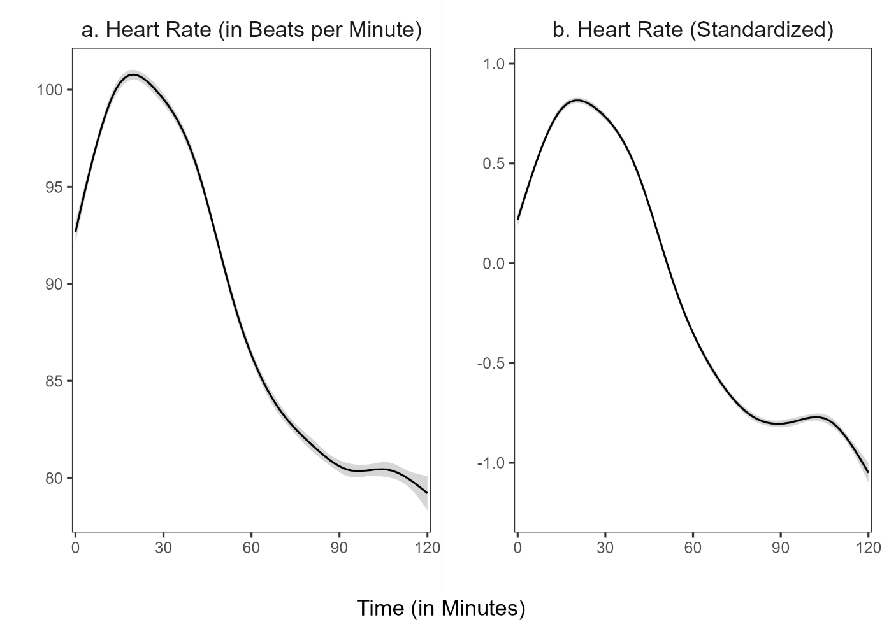

*Note:* The shadow around the line represents the 95% confidence interval. The confidence interval shown refers to the HR measurement points during the entire study period. We used the ggplot2 package (v3.3.3; Wickham, 2016) to calculate the moving average of the course.

The second part of our first research goal was to locate the HR peak, testing the hypothesis that HR will peak during the micro-teaching unit (Hypothesis 1a). Repeated measures ANOVA revealed that the standardized HR means of the intervals differed statistically significantly between intervals, *F*(4, 400) = 257.50, *p* < .05, *f* = 1.60 (large effect). Post-hoc contrasts indicated that the standardized mean HR was significantly higher in the (2) teaching interval compared to the (1) pre-teaching interval, *t*(1) = 32.71, *p* < .05, *d* = 0.82 (large effect). Moreover, the standardized HR mean of the (2) teaching interval was significantly higher than in the (3) post-teaching interval, *t*(1) = 32.00, *p* < .05, *d* = 1.34 (large effect), the (4) interview interval, *t*(1) = 453.47, *p* < .05, *d* = 3.37 (large effect), and the (5) end interval, *t*(1) = 511.89, *p* < .05, *d* = 4.68 (large effect). Thus, as hypothesized, HR peaked in the (2) teaching interval (see Fig. 3).

**Figure 3**

*Standardized Mean HR for the Five Intervals*

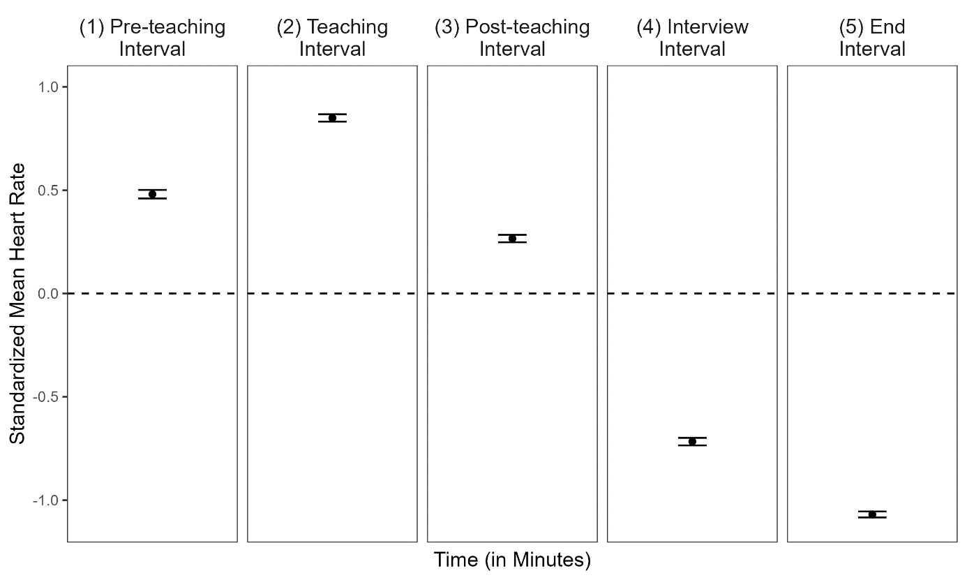

*Note:* The dotted line represents the grand mean. Error bars represent the 95% confidence interval around the mean.

Next, we examined the HR changes within each interval to test whether we would find a positive slope in the pre-teaching and negative slopes in the post-teaching, interview, and end phases (Hypothesis 1b). The mean intercepts and mean slopes, complemented by their standard deviations for each interval, are shown in Table 2; the graphical representation of the slopes is displayed in Figure 4. The slope means of the (1) pre-teaching interval was significantly positive, indicating a rising HR for this interval. In contrast, the slope means of the (2) teaching interval and (3) post-teaching interval were significantly negative, indicating a decreasing HR. For the last two intervals, the (4) interview interval and (5) end interval, the slope mean was also negative but did not differ significantly from zero.

**Table 2**

*Descriptive Statistics* *(*n, M, SD*)* *for the Mean Intercepts and the Mean Slopes for the Different Intervals for all Individuals*

|  |  |  |  |  |  |
| --- | --- | --- | --- | --- | --- |
| Interval | n1 | *M (SD)* | | *p* | |
|  |  | Intercept | Slope | Intercept | Slope |
| (1) Pre-teaching interval | 6896 | 0.052 (0.820) | 0.085* (0.133) | .57 | < .05 |
| (2) Teaching interval | 7150 | 1.025* (0.690) | -0.039* (0.108) | < .05 | < .05 |
| (3) Post-teaching interval | 6664 | 0.549* (0.547) | -0.060* (0.101) | < .05 | < .05 |
| (4) Interview interval | 6287 | -0.617* (0.614) | -0.022 (0.070) | < .05 | .01 |
| (5) End interval | 5990 | -1.004* (0.500) | -0.012 (0.074) | < .05 | .14 |
| *Note.* * *p* < .05  1All measurement points per interval for all participants. Note that the variation in *n* stem from the variation in the number of collected data points by the fitness tracker. | | | | | |

**Figure 4**

*Graphical Display of the Mean Slopes of the Standardized Mean HR for Each Interval*

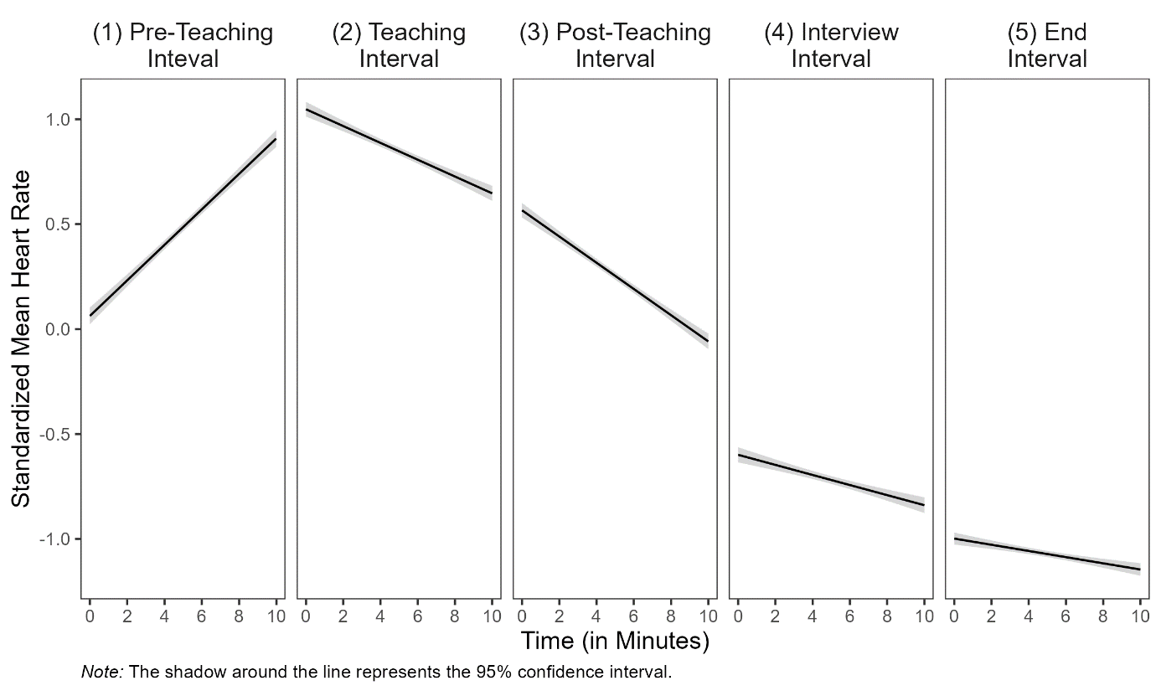

**## Research Goal 2: Prediction of Standardized Mean HR and Slopes With Teaching Experience and Self-Report Data**

Correlations among HR, teaching experience, disruption appraisal, and confidence appraisal are presented separately for the five intervals in Table 3. Correlations between HR and the other constructs were mostly very small and statistically non-significant. Correlations between teaching experience and appraisals were substantial and in the expected direction.

Teaching experience significantly predicted mean HR only in the *interview interval* (*b* = .012, *p* < .05, Table 4, Interview Interval, Model 1), indicating higher mean HR for teachers with more teaching experience. HR generally increased in the *pre-teaching interval* (see Table 2). However, teaching experience significantly predicted the magnitude of participants’ HR increase in the *pre-teaching interval* (*b* = -.004, *p* < .05, Table 4, Pre-Teaching Interval, Model 1), indicating less steep HR changes in teachers with more teaching experience. These findings are in line with Hypothesis 2a.

Adding the disruption appraisal while controlling for the shared variance with teaching experience (testing **Hypothesis 2b**) revealed a significant effect for participants’ HR changes for teaching experience as a predictor in the *interview interval* (*b* = -.001, *p* < .05, Table 4, Interview Interval, Model 2), indicating less steep HR changes in teachers with more teaching experience while controlling for the disruption appraisal.

Adding the confidence appraisal while controlling for the shared variance with teaching experience (testing **Hypothesis 2c**), teaching experience significantly predicted mean HR in the *interview interval (b* = .013, *p* < .05, Table 4, Interview Interval, Model 3), indicating higher mean HRs for teachers with more teaching experience while controlling for the confidence appraisal.

When considering the effects of the three predictors in concert (testing **Hypothesis 2d**), mean HR was significantly predicted by disruption appraisal in the *post-teaching interval* (*b* = 0.084, *p* < .05, Table 4, Post-Teaching Interval, Model 4), indicating higher mean HR for teachers who reported higher disruption appraisal (controlling for all other factors). Furthermore, HR changes were significantly predicted by disruption appraisal in the *end interval* (*b* = .015, *p* < .05, Table 3, End Interval, Model 4), indicating steeper HR changes for teachers that reported higher disruption appraisal (controlling for all other factors).

**Table 3**

*Correlations Between Standardized Mean HR and the Predictor Variables Teaching Experience, Disruption Appraisal, and Confidence Appraisal for the Five Intervals*

|  |  |  |  |
| --- | --- | --- | --- |
| Variable | 1 | 2 | 3 |
| (1) Pre-teaching Interval |  |  |  |
| 1 HR | − |  |  |
| 2 TE | − .17 | − |  |
| 3 DA | − .01 | − .36* | − |
| 4 CA | − .10 | .44* | − .37* |
| (2) Teaching Interval |  |  |  |
| 1 HR | − |  |  |
| 2 TE | .11 | − |  |
| 3 DA | − .20 | − .36* | − |
| 4 CA | .06 | .44* | − .37* |
| (3) Post-teaching Interval |  |  |  |
| 1 HR | − |  |  |
| 2 TE | − .04 | − |  |
| 3 DA | .24 | − .36* | − |
| 4 CA | .04 | .44* | − .37* |
| (4) Interview Interval |  |  |  |
| 1 HR | − |  |  |
| 2 TE | .24* | − |  |
| 3 DA | − .13 | − .36* | − |
| 4 CA | .09 | .44* | − .37* |
| (5) End Interval |  |  |  |
| 1 HR | − |  |  |
| 2 TE | .04 | − |  |
| 3 DA | .04 | − .36* | − |
| 4 CA | − .07 | .44* | − .37* |
| *Note.* HR = Standardized Mean Heart Rate, TE = Teaching Experience, DA = Disruption Appraisal, CA = Confidence Appraisal, * *p* < .05. | | | |

**Table 4**

*Multiple Linear Regression of Standardized Mean Heart Rate and Slopes Predicted by Teaching Experience, Disruption Appraisal, and Confidence Appraisal for the Five Intervals*

|  |  |  |  |  |  |  |  |  |  |  |  |  |  |  |  |  |  |  |  |
| --- | --- | --- | --- | --- | --- | --- | --- | --- | --- | --- | --- | --- | --- | --- | --- | --- | --- | --- | --- |
|  |  | *Dependent Variable: Standardized Mean HR and Slopes* | | | | | | | | | | | | | | | | | |
|  | Model 1 | | | | | Model 2 | | | | | Model 3 | | | | | Model 4 | | | |
|  | Std. Mean HR | | | Slopes | | Std. Mean HR | | Slopes | | | Std. Mean HR | | Slopes | | | Std. Mean HR | | Slopes | |
|  | b (SE) | *p* | b (SE) | | *p* | b (SE) | *p* | | b (SE) | *p* | b (SE) | *p* | | b (SE) | *p* | b (SE) | *p* | b (SE) | *p* |
| **(1) Pre-Teaching Interval1** |  |  |  | |  |  |  | |  |  |  |  | |  |  |  |  |  |  |
| Constant | 0.524* (0.057) | <.05 | 0.106 | | <.05 |  |  | |  |  |  |  | |  |  |  |  |  |  |
| Teaching  Experience | -.008 (.005) | .12 | -.004* | | <.05 |  |  | |  |  |  |  | |  |  |  |  |  |  |
| R2 | .030 |  | .071 | |  |  |  | |  |  |  |  | |  |  |  |  |  |  |
| **(2) Teaching Interval** |  |  |  | |  |  |  | |  |  |  |  | |  |  |  |  |  |  |
| Constant | 0.813* (0.057) | <.05 | -0.37*  (0.014) | | <.05 | 1.150* (0.227) | <.05 | | -0.099  (0.060) | .10 | 0.779* (0.349) | <.05 | | -0.111  (0.086) | .20 | 1.274* (0.471) | <.05 | -0.211  (0.116) | .07 |
| Teaching  Experience | .005 (.005) | .34 | -.000  (.001) | | .83 | .002 (.005) | .73 | | .000  (.001) | .89 | .005  (.006) | .42 | | -.001  (.001) | .57 | .003  (.006) | .67 | -.000  (.001) | .78 |
| Disruption  Appraisal |  |  |  | |  | -.062 (.041) | .13 | | .011  (.011) | .29 |  |  | |  |  | -.065  (.042) | .13 | .014  (.011) | .21 |
| Confidence  Appraisal |  |  |  | |  |  |  | |  |  | .004 (.046) | .92 | | .001  (.011) | .38 | -.014 (.047) | .76 | .014  (.016) | .26 |
| R² | .012 |  | .000 | |  | .040 |  | | .015 |  | .012 |  | | .010 |  | .042 |  | .031 |  |
| ∆ R² |  |  |  | |  | .028 |  | | .015 |  | .000 |  | | .010 |  | .030 |  | .031 |  |
| **(3) Post-teaching Interval** |  |  |  | |  |  |  | |  |  |  |  | |  |  |  |  |  |  |
| Constant | 0.272* (0.056) | <.05 | -0.058  (0.013) | | <.05 | -0.122 (0.222) | .59 | | 0.008  (0.056) | **.89** | 0.069 (0.343) | .84 | | -0.387  (0.081 | .63 | -0.570 (0.457) | .22 | 0.056  (0.108) | .61 |
| Teaching  Experience | -.002 (.005) | .70 | -.0 | |  | .002 (.005) | .76 | | -.001  (.001) | .52 | -.003 (.006) | .55 | | -.000  (.001) | .91 | -.000  (.006) | .91 | -.000  (.001) | .69 |
| Disruption  Appraisal |  |  |  | |  | .073 (.040) | .07 | | -.012  (.010) | .22 |  |  | |  |  | .084*  (.041) | <.05 | -.013  (.010) | .20 |
| Confidence  Appraisal |  |  |  | |  |  |  | |  |  | .027 (.045) | .55 | | -.003  (.011) | .80 | .051 (.046) | .27 | -.006  (.011) | .60 |
| R2 | .002 |  | .001 | |  | .043 |  | | .020 |  | .006 |  | | .002 |  | .058 |  | .023 |  |
| ∆ R2 |  |  |  | |  | .041 |  | | .019 |  | .004 |  | | .001 |  | .056 |  | .022 |  |
| **(4) Interview Interval** |  |  |  | |  |  |  | |  |  |  |  | |  |  |  |  |  |  |
| Constant | 0.793* (0.062) | <.05 | -0.014  (0.009) | | .13 | -0.684* (0.252) | <.05 | | 0.018  (0.038) | .64 | -0.721 (0.382) | .06 | | 0.043  (.054) | .43 | -0.541 (0.522) | .30 | 0.097  (0.073) | .19 |
| Teaching  Experience | .012* (.006) | <.05 | -.001  (.001) | | .07 | .011 (.006) | .06 | | -.001*  (.001) | <.05 | .013* (.006) | .04 | | -.001  (.001) | .24 | .012  (.007) | .07 | -.001  (.001) | .17 |
| Disruption  Appraisal |  |  |  | |  | -.020 (.045) | .66 | | -.006  (.007) | .40 |  |  | |  |  | -.024  (.047) | .61 | -.008  (.007) | .27 |
| Confidence  Appraisal |  |  |  | |  |  |  | |  |  | -.010 (.050) | .85 | | -.008  (.007) | .29 | -.016 (.052) | .76 | -.009  (.007) | .20 |
| R2 | .058 |  | .040 | |  | .060 |  | | .050 |  | .058 |  | | .054 |  | .061 |  | .069 |  |
| ∆ R2 |  |  |  | |  | .002 |  | | .010 |  | .000 |  | | .014 |  | .003 |  | .029 |  |
| **(5) End Interval** |  |  |  | |  |  |  | |  |  |  |  | |  |  |  |  |  |  |
| Constant | -1.076* (0.049) | <.05 | -0.017  (0.010) | | .07 | -1.176* (0.199) | <.05 | | -0.089  (0.040) | .03 | -0.811* (0.300) | <.05 | | -0.075  (0.058) | .20 | -0.897* (0.411) | <.05 | -0.184*  (0.077) | <.05 |
| Teaching  Experience | .002 (.004) | .70 | .001  (.001) | | .32 | .003 (.005) | .58 | | .001  (.001) | .12 | .004 (.005) | .46 | | .000  (.001) | .63 | .004 (.005) | .43 | .001  (.001) | .35 |
| Disruption  Appraisal |  |  |  | |  | .019 (.035) | .60 | | .013  (.007) | .07 |  |  | |  |  | .011 (.037) | .76 | .015*  (.007) | <.05 |
| Confidence  Appraisal |  |  |  | |  |  |  | |  |  | -.035 (.039) | .38 | | .008  (.008) | .32 | -.032 (.041) | .44 | .011  (.008) | .15 |
| R2 | .002 |  | .013 | |  | .005 |  | | .053 |  | .012 |  | | .025 |  | .013 |  | .078 |  |
| ∆ R2 |  |  |  | |  | .003 |  | | .040 |  | .010 |  | | .012 |  | .011 |  | .065 |  |
|  | *Note*. Coefficients are unstandardized with standard errors in parentheses. Effects of teaching experience and appraisals on teachers’ standardized mean HR are displayed for the five intervals.  In Model 1, standardized mean HR was predicted only by teaching experience. In Model 2, solely disruption appraisal was added as a predictor. In Model 3, solely confidence appraisal was added as a predictor. In Model 4, all three predictors were considered in concert.  1 To avoid post-diction, we calculated only Model 1 for the pre-teaching interval because the classroom events had not yet occurred in this interval.  * *p* < .05. | | | | | | | | | | | | | | | | | | |

**APPENDIX**

**Figure XX**

*Setting of the 15-minute micro teaching unit. Note. The setting included three actors as the class (left) and a teacher (right).*

Ein Bild, das Mobiliar, Stuhl, Kleidung, Schuhwerk enthält.

**Figure XX**

*Setting of the interview. Note. The experimenter and participant watched the previously taught unit on video.*

Ein Bild, das Mobiliar, Zeichnung, Entwurf, Tisch enthält.

**Figure XX**

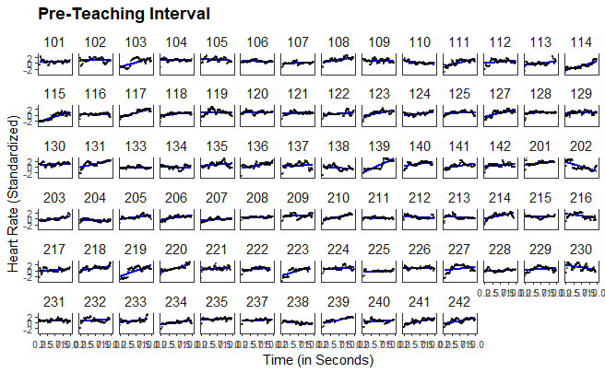

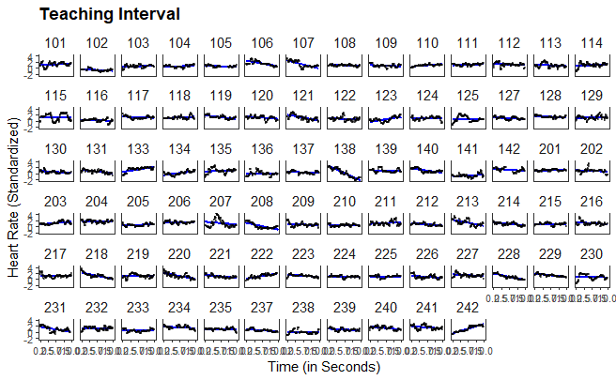

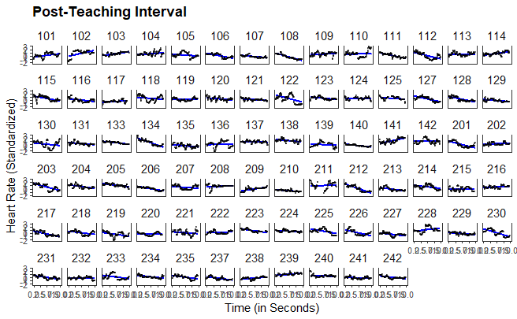

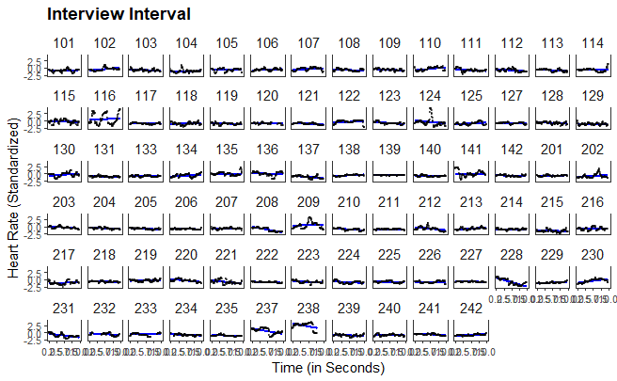

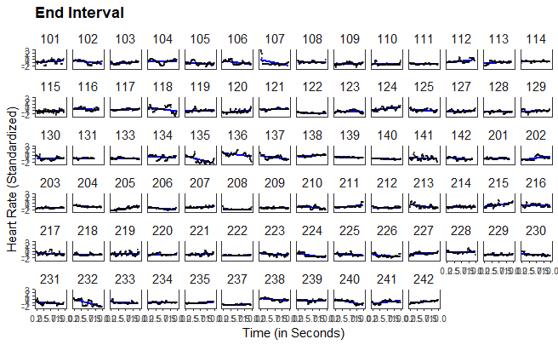

1. The fluctuations in the number of seconds in which the HR was measured are due to the participants' movements, meaning that the device could not measure the HR every second.
2. Although this procedure does not account for nonmonotonic progressions in individual HR, a graphical evaluation revealed that the linear estimates corresponded well to the majority of the cases (see XX in the supplementary material).
3. In order to avoid a post-diction, the HR levels and HR changes were only predicted in the (2) teaching interval, the (3) post-teaching interval, the (4) interview interval and the (5) end interval with the disruption and confidence appraisal, i.e., not in the (1) pre-teaching interval.