Through the Eyes of the Teacher - Multimodal Exploration of Expertise Differences in the Perception of Classroom Disruptions in a Laboratory Study

Table of Contents

## 1 Participants

Demographic information & teaching experience

| Group | N | Women in percent | M Age in years | SD Age in years | Min Age in years | Max Age in years | M Exp. | SD Exp. | Min Exp. | Max Exp. |
| --- | --- | --- | --- | --- | --- | --- | --- | --- | --- | --- |
| Expert | 40 | 60.00 | 39.10 | 10.55 | 26 | 60 | 11.55 | 11.32 | 1 | 38 |
| Novice | 42 | 69.05 | 22.83 | 1.85 | 19 | 27 | 0.00 | 0.00 | 0 | 0 |

## 2 Measures

### 2.1 Eye-Tracking Data

#### 2.1.1 Letter search

N, M, SD, min & max letter search in seconds

| Group | N | M | SD | Min | Max |
| --- | --- | --- | --- | --- | --- |
| Expert | 39 | 12.97 | 6.75 | 2.72 | 29.24 |
| Novice | 40 | 12.22 | 8.79 | 2.28 | 48.26 |

#### 2.1.2 t-test & effect size “Letter search”

Two Sample t-test

data: df_letter $Duration_{o}f_{i}nterval_{s}ec[df_{l}etter$ Group == “Expert”] and df_letter $Duration_{o}f_{i}nterval_{s}ec[df_{l}etter$ Group == “Novice”] t = 0.42858, df = 77, p-value = 0.6694 alternative hypothesis: true difference in means is not equal to 0 95 percent confidence interval: -2.760420 4.274574 sample estimates: mean of x mean of y 12.97308 12.21600

[1] 0.1 attr(,“magnitude”) [1] “negligible”

### 2.2 Fixations per minute across all AOIs

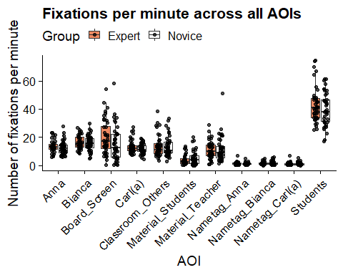

#### 2.2.1 Number of fixations per minute (micro-teaching unit)

N, M, SD, min & max number of fixation per minute (micro-teaching unit)

| Group | N | M | SD | Min | Max |
| --- | --- | --- | --- | --- | --- |
| Novice | 42 | 91.26 | 14.43 | 69 | 123 |
| Expert | 40 | 98.58 | 19.04 | 49 | 136 |

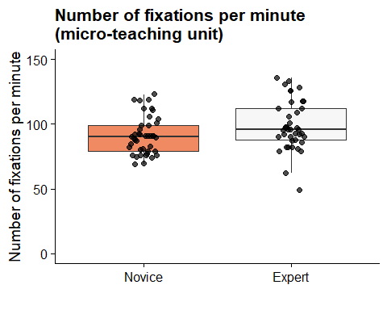

#### 2.2.2 t-test & effect size “Number of fixation (micro-teaching unit)”

Two Sample t-test

data: df_aoi_sum $Number_{f}ixation_{m}in_{m}tu[df_{a}oi_{s}um$ Group == “Expert”] and df_aoi_sum $Number_{f}ixation_{m}in_{m}tu[df_{a}oi_{s}um$ Group == “Novice”] t = 1.966, df = 80, p-value = 0.05276 alternative hypothesis: true difference in means is not equal to 0 95 percent confidence interval: -0.08935625 14.71554673 sample estimates: mean of x mean of y 98.5750 91.2619

[1] 0.43 attr(,“magnitude”) [1] “small”

#### 2.2.3 Number of fixations per minute (AOI students)

N, M, SD, min & max number of fixations per minute (AOI students)

| Group | N | M | SD | Min | Max |
| --- | --- | --- | --- | --- | --- |
| Novice | 42 | 40.08 | 11.58 | 16.91 | 61.53 |
| Expert | 40 | 43.26 | 12.55 | 25.06 | 74.31 |

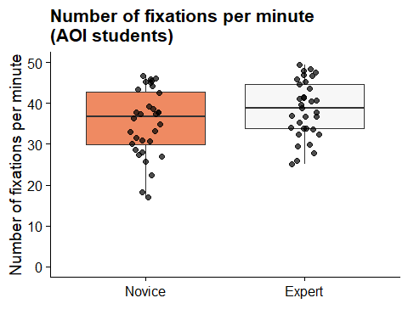

#### 2.2.4 t-test & effect size “Number of fixation” (AOI students)

Two Sample t-test

data: df_aoi_stud $Stud_{n}umber_{f}ixation_{m}in[df_{a}oi_{s}tud$ Group == “Expert”] and df_aoi_stud $Stud_{n}umber_{f}ixation_{m}in[df_{a}oi_{s}tud$ Group == “Novice”] t = 1.1925, df = 80, p-value = 0.2366 alternative hypothesis: true difference in means is not equal to 0 95 percent confidence interval: -2.125346 8.480489 sample estimates: mean of x mean of y 43.25900 40.08143

[1] 0.26 attr(,“magnitude”) [1] “small”

#### 2.2.5 Number of fixations per minute (AOI others)

N, M, SD, min & max number of fixations per minute (AOI others)

| Group | N | M | SD | Min | Max |
| --- | --- | --- | --- | --- | --- |
| Novice | 42 | 48.51 | 13.08 | 29.70 | 80.89 |
| Expert | 40 | 52.79 | 15.14 | 18.85 | 99.66 |

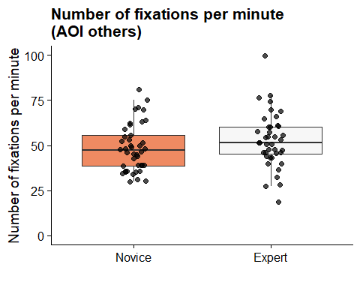

#### 2.2.6 t-test & effect size “Number of fixation” (AOI others)

Two Sample t-test

data: df_aoi_others $Others_{n}umber_{f}ixation_{m}in[df_{a}oi_{o}thers$ Group == “Expert”] and df_aoi_others $Others_{n}umber_{f}ixation_{m}in[df_{a}oi_{o}thers$ Group == “Novice”] t = 1.3722, df = 80, p-value = 0.1738 alternative hypothesis: true difference in means is not equal to 0 95 percent confidence interval: -1.927317 10.487650 sample estimates: mean of x mean of y 52.79350 48.51333

[1] 0.3 attr(,“magnitude”) [1] “small”

#### 2.2.7 Number of fixations (AOI disruptive person)

N, M, SD, min & max number of fixation (AOI disruptive person)

| Group | N | M | SD | Min | Max |
| --- | --- | --- | --- | --- | --- |
| Novice | 42 | 48.14 | 21.87 | 25 | 133 |
| Expert | 40 | 44.12 | 13.31 | 15 | 88 |

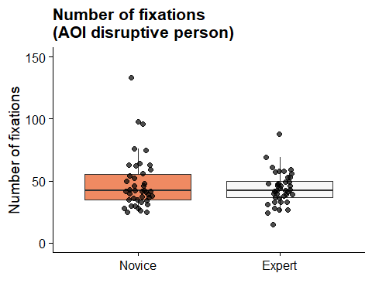

#### 2.2.8 t-test & effect size “Number of fixations” (AOI disruptive person)

Two Sample t-test

data: df_aoi_disrup $Number_{o}f_{f}ixations.Disruptive_{P}erson[df_{a}oi_{d}isrup$ Group == “Expert”] and df_aoi_disrup $Number_{o}f_{f}ixations.Disruptive_{P}erson[df_{a}oi_{d}isrup$ Group == “Novice”] t = -0.99886, df = 80, p-value = 0.3209 alternative hypothesis: true difference in means is not equal to 0 95 percent confidence interval: -12.022778 3.987063 sample estimates: mean of x mean of y 44.12500 48.14286

[1] -0.22 attr(,“magnitude”) [1] “small”

#### 2.2.9 Average duration of fixations in milliseconds (micro-teaching unit)

N, M, SD, min & max duration of fixations in milliseconds (micro-teaching unit)

| Group | N | M in ms | SD in ms | Min in ms | Max in ms |
| --- | --- | --- | --- | --- | --- |
| Novice | 42 | 513.81 | 117.71 | 247 | 749 |
| Expert | 40 | 472.92 | 106.18 | 295 | 712 |

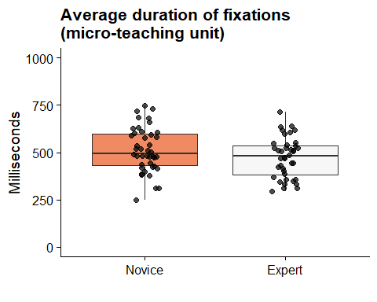

#### 2.2.10 t-test & effect size “Average duration of fixations” (micro-teaching unit)

Two Sample t-test

data: df_aoi_sum $Average_{d}uration_{m}tu[df_{a}oi_{s}um$ Group == “Expert”] and df_aoi_sum $Average_{d}uration_{m}tu[df_{a}oi_{s}um$ Group == “Novice”] t = -1.6488, df = 80, p-value = 0.1031 alternative hypothesis: true difference in means is not equal to 0 95 percent confidence interval: -90.231822 8.462774 sample estimates: mean of x mean of y 472.9250 513.8095

[1] -0.36 attr(,“magnitude”) [1] “small”

#### 2.2.11 Average duration of fixations (AOI students)

N, M, SD, min & max average duration of fixations in milliseconds (AOI students)

| Group | N | M in ms | SD in ms | Min in ms | Max in ms |
| --- | --- | --- | --- | --- | --- |
| Novice | 42 | 613.67 | 191.19 | 254 | 1115 |
| Expert | 40 | 552.55 | 146.32 | 309 | 925 |

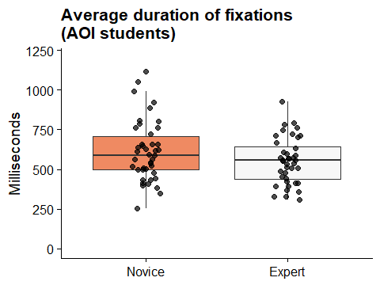

#### 2.2.12 t-test & effect size “Average duration of fixations” (AOI students)

Two Sample t-test

data: df_aoi_stud $Average_{d}uration_{s}tud[df_{a}oi_{s}tud$ Group == “Expert”] and df_aoi_stud $Average_{d}uration_{s}tud[df_{a}oi_{s}tud$ Group == “Novice”] t = -1.6197, df = 80, p-value = 0.1092 alternative hypothesis: true difference in means is not equal to 0 95 percent confidence interval: -136.20902 13.97569 sample estimates: mean of x mean of y 552.5500 613.6667

[1] -0.36 attr(,“magnitude”) [1] “small”

#### 2.2.13 Average duration of fixations (AOI disruptive person)

N, M, SD, min & max average duration of fixations in milliseconds (AOI disruptive person)

| Group | N | M in ms | SD in ms | Min in ms | Max in ms |
| --- | --- | --- | --- | --- | --- |
| Novice | 42 | 584.57 | 216.40 | 266 | 1150 |
| Expert | 40 | 503.05 | 153.92 | 303 | 1081 |

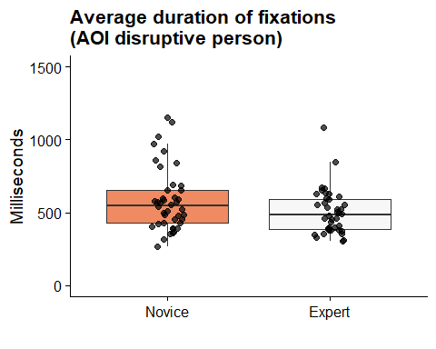

#### 2.2.14 t-test & effect size “Average duration of fixations” (AOI disruptive person)

Two Sample t-test

data: df_aoi_disrup $Average_{d}uration_{d}isrup[df_{a}oi_{d}isrup$ Group == “Expert”] and df_aoi_disrup $Average_{d}uration_{d}isrup[df_{a}oi_{d}isrup$ Group == “Novice”] t = -1.957, df = 80, p-value = 0.05383 alternative hypothesis: true difference in means is not equal to 0 95 percent confidence interval: -164.418963 1.376106 sample estimates: mean of x mean of y 503.0500 584.5714

[1] -0.43 attr(,“magnitude”) [1] “small”

#### 2.2.15 Gaze Relational Index (GRI; micro-teaching unit)

N, M, SD, min & max GRI (micro-teaching unit)

| Group | N | M | SD | Min | Max |
| --- | --- | --- | --- | --- | --- |
| Novice | 42 | 5.93 | 2.11 | 2.08 | 10.70 |
| Expert | 40 | 5.18 | 2.13 | 2.17 | 11.48 |

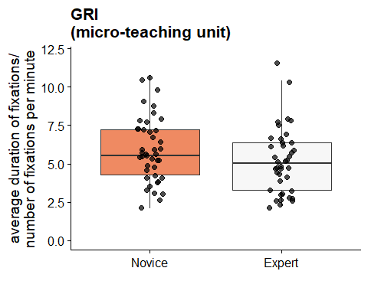

#### 2.2.16 t-test & effect size “GRI” (micro-teaching unit)

Two Sample t-test

data: df_gri $GRI[df_{g}ri$ Group == “Expert”] and df_gri $GRI[df_{g}ri$ Group == “Novice”] t = -1.5975, df = 80, p-value = 0.1141 alternative hypothesis: true difference in means is not equal to 0 95 percent confidence interval: -1.682021 0.184045 sample estimates: mean of x mean of y 5.176250 5.925238

[1] -0.35 attr(,“magnitude”) [1] “small”

#### 2.2.17 Time to first fixation in seconds (AOI disruptive person)

N, M, SD, min & max time to first fixation in seconds (AOI disruptive person)

| Group | N | M in sec | SD in sec | Min in sec | Max in sec |
| --- | --- | --- | --- | --- | --- |
| Expert | 39 | 3.57 | 2.18 | 0.25 | 8.78 |
| Novice | 40 | 3.79 | 1.80 | 0.72 | 8.89 |

N, M, SD, min & max of the perceived ´disruptive person´

| Group | Mean | SD | Min | Max |
| --- | --- | --- | --- | --- |
| Expert | 6.82 | 1.60 | 4 | 9 |
| Novice | 6.90 | 1.43 | 3 | 9 |

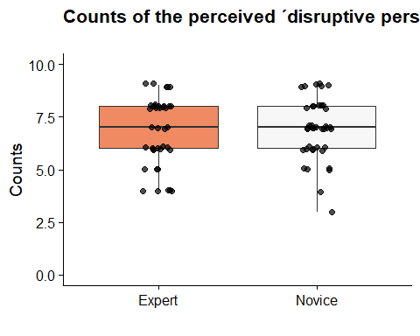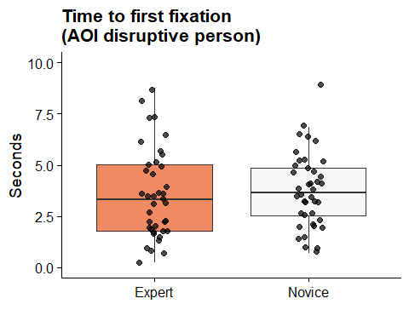

#### 2.2.18 t-test & effect size “Time to first fixation” (AOI disruptive person)

Two Sample t-test

data: df_ttff_disrup $Disrup_{t}ime_{f}ixation_{s}ec[df_{t}tff_{d}isrup$ Group == “Expert”] and df_ttff_disrup $Disrup_{t}ime_{f}ixation_{s}ec[df_{t}tff_{d}isrup$ Group == “Novice”] t = -0.67144, df = 80, p-value = 0.5039 alternative hypothesis: true difference in means is not equal to 0 95 percent confidence interval: -1.4276630 0.7073296 sample estimates: mean of x mean of y 3.766500 4.126667

[1] -0.15 attr(,“magnitude”) [1] “negligible”

### 2.3 Rating Scales (Disruption Appraisal, Confidence Appraisal, Prevalence Rating)

Disruption Appraisal

| ID | N | M | SD | Min | Max |
| --- | --- | --- | --- | --- | --- |
| Expert | 352 | 4.84 | 2.90 | 0 | 10 |
| Novice | 357 | 5.55 | 2.81 | 0 | 10 |

Disruption appraisal with event

| ID | event | N | M | SD | Min | Max |
| --- | --- | --- | --- | --- | --- | --- |
| Expert | chatting | 41 | 6.78 | 2.53 | 1 | 10 |
| Expert | clicking pen | 38 | 5.34 | 2.60 | 0 | 10 |
| Expert | drawing | 35 | 1.80 | 1.89 | 0 | 7 |
| Expert | drumming | 39 | 4.95 | 2.45 | 1 | 10 |
| Expert | head on table | 40 | 4.12 | 2.56 | 0 | 10 |
| Expert | heckling | 41 | 6.29 | 2.69 | 2 | 10 |
| Expert | looking at phone | 36 | 4.94 | 2.89 | 0 | 10 |
| Expert | snipping | 41 | 3.85 | 3.08 | 0 | 10 |
| Expert | whispering | 41 | 5.07 | 2.46 | 0 | 9 |
| Novice | chatting | 42 | 8.12 | 2.04 | 0 | 10 |
| Novice | clicking pen | 40 | 6.28 | 2.51 | 0 | 10 |
| Novice | drawing | 35 | 2.14 | 1.48 | 0 | 5 |
| Novice | drumming | 40 | 6.47 | 2.08 | 0 | 10 |
| Novice | head on table | 40 | 4.15 | 1.81 | 1 | 8 |
| Novice | heckling | 41 | 6.98 | 2.62 | 2 | 10 |
| Novice | looking at phone | 35 | 4.14 | 2.00 | 0 | 8 |
| Novice | snipping | 42 | 4.38 | 2.92 | 0 | 9 |
| Novice | whispering | 42 | 6.55 | 2.19 | 1 | 10 |

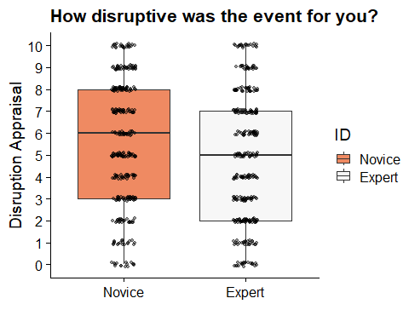

#### 2.3.1 t-Test & effect size “Disruption appraisal”

Two Sample t-test

data: sri $disruption_{a}ppraisal[sri$ ID == “Expert”] and sri $disruption_{a}ppraisal[sri$ ID == “Novice”] t = -3.3143, df = 707, p-value = 0.0009655 alternative hypothesis: true difference in means is not equal to 0 95 percent confidence interval: -1.1320397 -0.2897835 sample estimates: mean of x mean of y 4.840909 5.551821

[1] -0.25 attr(,“magnitude”) [1] “small”

Confidence appraisal

| ID | M | SD | Min | Max |
| --- | --- | --- | --- | --- |
| Expert | 8.42 | 1.70 | 2 | 10 |
| Novice | 7.18 | 2.04 | 0 | 10 |

Confidence appraisal with event

| ID | event | N | M | SD | Min | Max |
| --- | --- | --- | --- | --- | --- | --- |
| Expert | chatting | 41 | 8.10 | 1.76 | 2 | 10 |
| Expert | clicking pen | 38 | 8.50 | 1.25 | 5 | 10 |
| Expert | drawing | 35 | 9.23 | 1.00 | 5 | 10 |
| Expert | drumming | 39 | 8.74 | 1.21 | 6 | 10 |
| Expert | head on table | 40 | 8.72 | 1.22 | 5 | 10 |
| Expert | heckling | 41 | 6.78 | 2.41 | 2 | 10 |
| Expert | looking at phone | 36 | 8.75 | 1.44 | 4 | 10 |
| Expert | snipping | 41 | 8.83 | 1.60 | 4 | 10 |
| Expert | whispering | 41 | 8.32 | 1.71 | 3 | 10 |
| Novice | chatting | 42 | 6.69 | 1.97 | 0 | 10 |
| Novice | clicking pen | 40 | 7.40 | 1.72 | 3 | 10 |
| Novice | drawing | 35 | 8.63 | 1.29 | 5 | 10 |
| Novice | drumming | 40 | 7.32 | 2.12 | 1 | 10 |
| Novice | head on table | 40 | 7.03 | 1.78 | 3 | 10 |
| Novice | heckling | 41 | 5.41 | 2.55 | 1 | 10 |
| Novice | looking at phone | 35 | 7.34 | 1.59 | 3 | 10 |
| Novice | snipping | 42 | 8.02 | 1.63 | 3 | 10 |
| Novice | whispering | 42 | 7.05 | 1.91 | 2 | 10 |

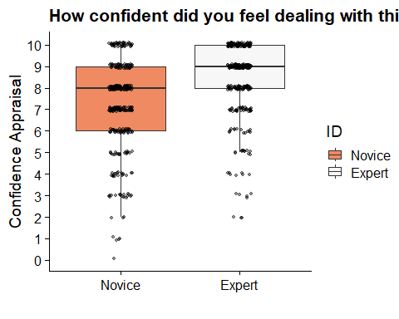

#### 2.3.2 t-Test & effect size “Confidence appraisal”

Two Sample t-test

data: sri $confidence_{a}ppraisal[sri$ ID == “Expert”] and sri $confidence_{a}ppraisal[sri$ ID == “Novice”] t = 8.766, df = 707, p-value < 2.2e-16 alternative hypothesis: true difference in means is not equal to 0 95 percent confidence interval: 0.9588466 1.5123145 sample estimates: mean of x mean of y 8.420455 7.184874

[1] 0.66 attr(,“magnitude”) [1] “medium”

### 2.4 Prevalence Rating as manipulation check

Prevalence rating

| ID | N | M | SD | Min | Max |
| --- | --- | --- | --- | --- | --- |
| Expert | 352 | 6.53 | 2.72 | 1 | 10 |
| Novice | 357 | 7.02 | 2.20 | 1 | 10 |

Prevalence rating with events

| ID | event | N | M | SD | Min | Max |
| --- | --- | --- | --- | --- | --- | --- |
| Expert | chatting | 41 | 6.41 | 2.61 | 2 | 10 |
| Expert | clicking pen | 38 | 5.76 | 2.54 | 1 | 10 |
| Expert | drawing | 35 | 8.43 | 1.77 | 3 | 10 |
| Expert | drumming | 39 | 6.00 | 2.56 | 1 | 10 |
| Expert | head on table | 40 | 6.05 | 2.59 | 1 | 10 |
| Expert | heckling | 41 | 5.15 | 2.70 | 1 | 10 |
| Expert | looking at phone | 36 | 7.03 | 2.52 | 1 | 10 |
| Expert | snipping | 41 | 5.27 | 2.77 | 1 | 10 |
| Expert | whispering | 41 | 8.95 | 1.40 | 5 | 10 |
| Novice | chatting | 42 | 6.86 | 2.18 | 1 | 10 |
| Novice | clicking pen | 40 | 6.85 | 2.02 | 3 | 10 |
| Novice | drawing | 35 | 8.40 | 1.48 | 4 | 10 |
| Novice | drumming | 40 | 5.47 | 2.14 | 1 | 10 |
| Novice | head on table | 40 | 6.62 | 1.85 | 3 | 10 |
| Novice | heckling | 41 | 5.76 | 2.32 | 2 | 10 |
| Novice | looking at phone | 35 | 7.26 | 2.05 | 3 | 10 |
| Novice | snipping | 42 | 7.05 | 1.96 | 3 | 10 |
| Novice | whispering | 42 | 9.05 | 1.23 | 4 | 10 |

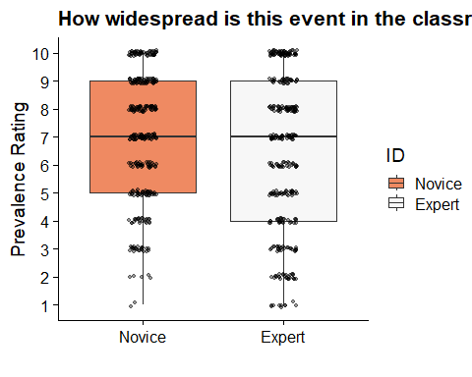 Two Sample t-test

data: sri $prevalence_{r}ating[sri$ ID == “Expert”] and sri $prevalence_{r}ating[sri$ ID == “Novice”] t = -2.6154, df = 707, p-value = 0.009103 alternative hypothesis: true difference in means is not equal to 0 95 percent confidence interval: -0.8499891 -0.1210448 sample estimates: mean of x mean of y 6.534091 7.019608

[1] -0.2 attr(,“magnitude”) [1] “negligible”

### 2.5 Internal consistency (Omega) for disruption and confidence appraisal

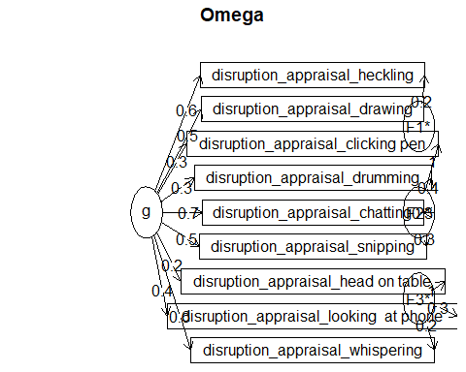Omega Call: omegah(m = m, nfactors = nfactors, fm = fm, key = key, flip = flip, digits = digits, title = title, sl = sl, labels = labels, plot = plot, n.obs = n.obs, rotate = rotate, Phi = Phi, option = option, covar = covar) Alpha: 0.76 G.6: 0.81 Omega Hierarchical: 0.62 Omega H asymptotic: 0.73 Omega Total 0.84

Schmid Leiman Factor loadings greater than 0.2 g F1* F2* F3* h2 h2 u2 disruption_appraisal_whispering 0.60 0.22 0.45 0.45 0.55 disruption_appraisal_heckling 0.63 0.24 0.47 0.47 0.53 disruption_appraisal_drawing 0.47 0.27 0.27 0.73 disruption_appraisal_snipping 0.50 0.26 0.35 0.35 0.65 disruption_appraisal_looking at phone 0.38 0.32 0.26 0.26 0.74 disruption_appraisal_head on table 0.22 0.98 1.00 1.00 0.00 disruption_appraisal_clicking pen 0.34 0.95 1.02 1.02 -0.02 disruption_appraisal_drumming 0.34 0.37 0.28 0.28 0.72 disruption_appraisal_chatting 0.67 0.28 0.57 0.57 0.43 p2 com disruption_appraisal_whispering 0.80 1.52 disruption_appraisal_heckling 0.84 1.39 disruption_appraisal_drawing 0.82 1.45 disruption_appraisal_snipping 0.71 1.85 disruption_appraisal_looking at phone 0.57 2.12 disruption_appraisal_head on table 0.05 1.10 disruption_appraisal_clicking pen 0.11 1.25 disruption_appraisal_drumming 0.42 2.35 disruption_appraisal_chatting 0.80 1.52

With Sums of squares of: g F1* F2* F3* h2 2.10 0.19 1.22 1.16 3.13

general/max 0.67 max/min = 16.24 mean percent general = 0.57 with sd = 0.31 and cv of 0.54 Explained Common Variance of the general factor = 0.45

The degrees of freedom are 12 and the fit is 0.35 The number of observations was 53 with Chi Square = 16.18 with prob < 0.18 The root mean square of the residuals is 0.05 The df corrected root mean square of the residuals is 0.09 RMSEA index = 0.079 and the 10 % confidence intervals are 0 0.174 BIC = -31.47

Compare this with the adequacy of just a general factor and no group factors The degrees of freedom for just the general factor are 27 and the fit is 1.18 The number of observations was 53 with Chi Square = 56 with prob < 0.00086 The root mean square of the residuals is 0.13 The df corrected root mean square of the residuals is 0.16

RMSEA index = 0.141 and the 10 % confidence intervals are 0.09 0.197 BIC = -51.2

Measures of factor score adequacy  
g F1* F2* F3* Correlation of scores with factors 0.84 0.30 1.01 1.00 Multiple R square of scores with factors 0.70 0.09 1.02 0.99 Minimum correlation of factor score estimates 0.41 -0.82 1.03 0.99

Total, General and Subset omega for each subset g F1* F2* F3* Omega total for total scores and subscales 0.84 0.54 0.79 0.72 Omega general for total scores and subscales 0.62 0.47 0.39 0.28 Omega group for total scores and subscales 0.21 0.06 0.39 0.44 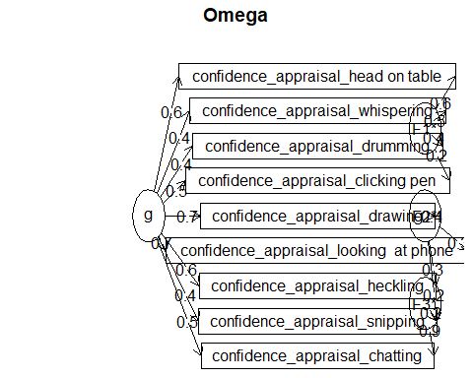Omega Call: omegah(m = m, nfactors = nfactors, fm = fm, key = key, flip = flip, digits = digits, title = title, sl = sl, labels = labels, plot = plot, n.obs = n.obs, rotate = rotate, Phi = Phi, option = option, covar = covar) Alpha: 0.82 G.6: 0.84 Omega Hierarchical: 0.66 Omega H asymptotic: 0.76 Omega Total 0.87

Schmid Leiman Factor loadings greater than 0.2 g F1* F2* F3* h2 h2 u2 confidence_appraisal_whispering 0.39 0.48 0.40 0.40 0.60 confidence_appraisal_heckling 0.59 0.28 0.45 0.45 0.55 confidence_appraisal_drawing 0.70 0.36 0.62 0.62 0.38 confidence_appraisal_snipping 0.41 0.23 0.23 0.31 0.31 0.69 confidence_appraisal_looking at phone 0.66 0.32 0.57 0.57 0.43 confidence_appraisal_head on table 0.56 0.56 0.63 0.63 0.37 confidence_appraisal_clicking pen 0.48 0.20 0.31 0.31 0.69 confidence_appraisal_drumming 0.42 0.42 0.37 0.37 0.63 confidence_appraisal_chatting 0.50 0.87 1.00 1.00 0.00 p2 com confidence_appraisal_whispering 0.38 2.11 confidence_appraisal_heckling 0.76 1.62 confidence_appraisal_drawing 0.79 1.50 confidence_appraisal_snipping 0.55 2.69 confidence_appraisal_looking at phone 0.75 1.67 confidence_appraisal_head on table 0.50 2.03 confidence_appraisal_clicking pen 0.74 1.74 confidence_appraisal_drumming 0.49 2.10 confidence_appraisal_chatting 0.25 1.60

With Sums of squares of: g F1* F2* F3* h2 2.55 0.82 0.39 0.90 2.80

general/max 0.91 max/min = 7.18 mean percent general = 0.58 with sd = 0.19 and cv of 0.33 Explained Common Variance of the general factor = 0.55

The degrees of freedom are 12 and the fit is 0.33 The number of observations was 53 with Chi Square = 15.22 with prob < 0.23 The root mean square of the residuals is 0.05 The df corrected root mean square of the residuals is 0.09 RMSEA index = 0.069 and the 10 % confidence intervals are 0 0.167 BIC = -32.43

Compare this with the adequacy of just a general factor and no group factors The degrees of freedom for just the general factor are 27 and the fit is 0.87 The number of observations was 53 with Chi Square = 41.5 with prob < 0.037 The root mean square of the residuals is 0.12 The df corrected root mean square of the residuals is 0.14

RMSEA index = 0.099 and the 10 % confidence intervals are 0.026 0.16 BIC = -65.7

Measures of factor score adequacy  
g F1* F2* F3* Correlation of scores with factors 0.84 0.72 0.48 0.96 Multiple R square of scores with factors 0.70 0.52 0.23 0.92 Minimum correlation of factor score estimates 0.41 0.04 -0.55 0.83

Total, General and Subset omega for each subset g F1* F2* F3* Omega total for total scores and subscales 0.87 0.71 0.77 1.00 Omega general for total scores and subscales 0.66 0.40 0.61 0.25 Omega group for total scores and subscales 0.15 0.32 0.16 0.75

### 2.6 Situational Jugdement Test

N, M and SD for overall value

| Group | N | M | SD | Min | Max |
| --- | --- | --- | --- | --- | --- |
| Expert | 41 | 0.75 | 0.08 | 0.54 | 0.88 |
| Novice | 42 | 0.72 | 0.13 | 0.10 | 0.91 |

N, M and SD for managing momentum

| Group | N | M | SD | Min | Max |
| --- | --- | --- | --- | --- | --- |
| Expert | 41 | 0.81 | 0.10 | 0.60 | 1 |
| Novice | 42 | 0.80 | 0.17 | 0.08 | 1 |

N, M and SD for monitoring

| Group | N | M | SD | Min | Max |
| --- | --- | --- | --- | --- | --- |
| Expert | 41 | 0.69 | 0.13 | 0.41 | 0.91 |
| Novice | 42 | 0.64 | 0.16 | 0.15 | 0.99 |

N, M and SD for rules and routines

| Group | N | M | SD | Min | Max |
| --- | --- | --- | --- | --- | --- |
| Expert | 41 | 0.74 | 0.10 | 0.49 | 0.91 |
| Novice | 42 | 0.72 | 0.13 | 0.07 | 0.92 |

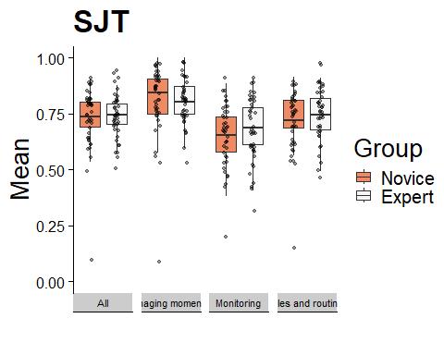

#### 2.6.1 t-test & effect size “STJ - All”

Two Sample t-test

data: df_sjt $All[df_{s}jt$ Group == “Expert”] and df_sjt $All[df_{s}jt$ Group == “Novice”] t = 0.94245, df = 81, p-value = 0.3488 alternative hypothesis: true difference in means is not equal to 0 95 percent confidence interval: -0.02434447 0.06816136 sample estimates: mean of x mean of y 0.7456548 0.7237464

[1] 0.21 attr(,“magnitude”) [1] “small”

#### 2.6.2 t-test & effect size “SJT - Managing momentum”

Two Sample t-test

data: df_sjt$`Managing momentum`[df_sjt$Group == “Expert”] and df_sjt$`Managing momentum`[df_sjt$Group == “Novice”] t = 0.15193, df = 81, p-value = 0.8796 alternative hypothesis: true difference in means is not equal to 0 95 percent confidence interval: -0.05469659 0.06374016 sample estimates: mean of x mean of y 0.8092270 0.8047052

[1] 0.03 attr(,“magnitude”) [1] “negligible”

#### 2.6.3 t-test & effect size “SJT - Monitoring”

Two Sample t-test

data: df_sjt $Monitoring[df_{s}jt$ Group == “Expert”] and df_sjt $Monitoring[df_{s}jt$ Group == “Novice”] t = 1.4415, df = 81, p-value = 0.1533 alternative hypothesis: true difference in means is not equal to 0 95 percent confidence interval: -0.01732034 0.10841421 sample estimates: mean of x mean of y 0.6877186 0.6421717

[1] 0.32 attr(,“magnitude”) [1] “small”

#### 2.6.4 t-test & effect size “SJT - Rules & routines”

Two Sample t-test

data: df_sjt$`Rules and routines`[df_sjt$Group == “Expert”] and df_sjt$`Rules and routines`[df_sjt$Group == “Novice”] t = 0.59927, df = 81, p-value = 0.5507 alternative hypothesis: true difference in means is not equal to 0 95 percent confidence interval: -0.03632644 0.06763970 sample estimates: mean of x mean of y 0.7400189 0.7243622

[1] 0.13 attr(,“magnitude”) [1] “negligible”

### 2.7 Internal consistency (Omega) for SJT

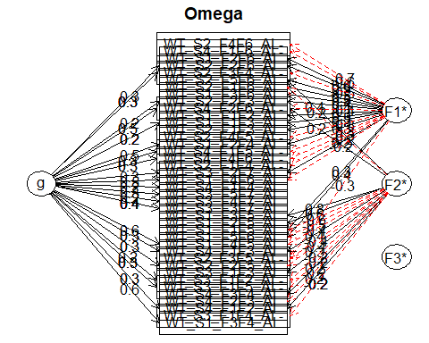Omega Call: omegah(m = m, nfactors = nfactors, fm = fm, key = key, flip = flip, digits = digits, title = title, sl = sl, labels = labels, plot = plot, n.obs = n.obs, rotate = rotate, Phi = Phi, option = option, covar = covar) Alpha: 0.68 G.6: 0.9 Omega Hierarchical: 0.66 Omega H asymptotic: 0.88 Omega Total 0.75

Schmid Leiman Factor loadings greater than 0.2 g F1* F2* F3* h2 h2 u2 p2 com WT_S1_F1F2_AL 0.35 0.15 0.85 0.13 1.47 WT_S1_F1F3_AL 0.25 0.33 0.19 0.81 0.32 2.20 WT_S1_F1F5_AL 0.26 -0.55 0.38 0.38 0.62 0.04 1.54 WT_S1_F2F4_AL 0.49 0.31 0.35 0.35 0.65 0.69 1.81 WT_S1_F2F5_AL 0.63 0.42 0.42 0.58 0.00 1.13 WT_S1_F2F6_AL 0.57 0.35 0.35 0.65 0.01 1.16 WT_S1_F3F4_AL 0.57 0.36 0.36 0.64 0.90 1.21 WT_S1_F3F5_AL 0.78 0.61 0.61 0.39 0.00 1.02 WT_S1_F3F6_AL 0.44 0.23 0.23 0.77 0.05 1.33 WT_S1_F4F5_AL 0.60 -0.39 0.52 0.52 0.48 0.69 1.75 WT_S1_F4F6_AL 0.47 -0.20 0.27 0.27 0.73 0.84 1.38 WT_S1_F5F6_AL 0.42 -0.50 0.45 0.45 0.55 0.07 2.20 WT_S2_F1F3_AL 0.33 0.14 0.86 0.02 1.52 WT_S2_F1F4_AL- -0.24 0.10 0.90 0.07 2.13 WT_S2_F1F6_AL 0.49 -0.24 0.32 0.32 0.68 0.11 1.78 WT_S2_F2F3_AL 0.22 0.44 0.24 0.24 0.76 0.20 1.48 WT_S2_F2F5_AL 0.32 -0.35 0.23 0.23 0.77 0.45 2.06 WT_S2_F2F6_AL 0.26 0.54 0.37 0.37 0.63 0.19 1.48 WT_S2_F3F4_AL- 0.31 -0.52 0.38 0.38 0.62 0.26 1.66 WT_S2_F3F5_AL- -0.33 -0.35 0.26 0.26 0.74 0.09 2.37 WT_S2_F4F5_AL- -0.31 0.15 0.85 0.14 2.13 WT_S2_F4F6_AL- -0.69 0.48 0.48 0.52 0.01 1.01 WT_S2_F5F6_AL 0.51 0.38 0.42 0.42 0.58 0.01 1.89 WT_S3_F1F2_AL- 0.25 -0.24 0.13 0.87 0.50 2.14 WT_S3_F1F3_AL 0.32 0.12 0.88 0.11 1.31 WT_S3_F1F4_AL- -0.20 0.05 0.95 0.04 1.27 WT_S3_F1F5_AL- 0.26 -0.24 0.13 0.87 0.54 2.02 WT_S3_F2F7_AL 0.31 0.21 0.16 0.84 0.57 2.37 WT_S3_F3F7_AL 0.38 0.15 0.85 0.94 1.13 WT_S3_F4F7_AL 0.24 0.06 0.94 0.86 1.33 WT_S3_F5F7_AL 0.34 0.13 0.87 0.89 1.24 WT_S4_F1F2_AL 0.29 0.21 0.16 0.84 0.53 2.49 WT_S4_F1F3_AL 0.30 0.36 0.23 0.23 0.77 0.38 2.21 WT_S4_F1F4_AL 0.20 0.06 0.94 0.64 1.86 WT_S4_F1F5_AL- 0.27 -0.29 0.16 0.84 0.46 2.10 WT_S4_F1F6_AL- -0.63 0.43 0.43 0.57 0.08 1.18 WT_S4_F2F3_AL -0.22 0.06 0.94 0.07 1.50 WT_S4_F2F6_AL- 0.47 -0.35 0.24 0.40 0.40 0.60 0.56 2.40 WT_S4_F3F4_AL 0.23 0.06 0.94 0.00 1.08 WT_S4_F4F6_AL- 0.26 -0.26 0.14 0.86 0.49 2.10

With Sums of squares of: g F1* F2* F3* h2 2.88 4.10 3.00 0.01 3.35

general/max 0.7 max/min = 293.69 mean percent general = 0.32 with sd = 0.31 and cv of 0.95 Explained Common Variance of the general factor = 0.29

The degrees of freedom are 663 and the fit is 18.76 The number of observations was 84 with Chi Square = 1253.73 with prob < 6.8e-39 The root mean square of the residuals is 0.11 The df corrected root mean square of the residuals is 0.12 RMSEA index = 0.102 and the 10 % confidence intervals are 0.095 0.112 BIC = -1683.9

Compare this with the adequacy of just a general factor and no group factors The degrees of freedom for just the general factor are 740 and the fit is 24.06 The number of observations was 84 with Chi Square = 1639.81 with prob < 5e-70 The root mean square of the residuals is 0.17 The df corrected root mean square of the residuals is 0.17

RMSEA index = 0.12 and the 10 % confidence intervals are 0.113 0.129 BIC = -1639

Measures of factor score adequacy  
g F1* F2* F3* Correlation of scores with factors 0.90 0.93 0.92 0.06 Multiple R square of scores with factors 0.81 0.87 0.84 0.00 Minimum correlation of factor score estimates 0.62 0.73 0.69 -0.99

Total, General and Subset omega for each subset g F1* F2* F3* Omega total for total scores and subscales 0.75 0.56 0.39 NA Omega general for total scores and subscales 0.66 0.53 0.38 NA Omega group for total scores and subscales 0.01 0.03 0.00 NA 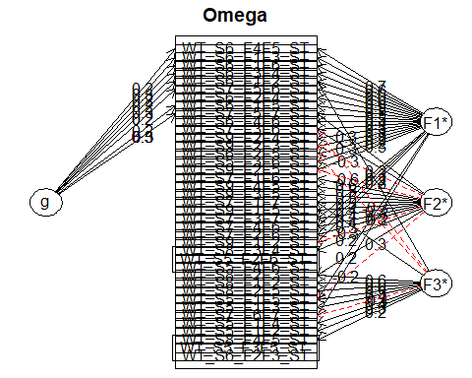Omega Call: omegah(m = m, nfactors = nfactors, fm = fm, key = key, flip = flip, digits = digits, title = title, sl = sl, labels = labels, plot = plot, n.obs = n.obs, rotate = rotate, Phi = Phi, option = option, covar = covar) Alpha: 0.81 G.6: 0.95 Omega Hierarchical: 0.13 Omega H asymptotic: 0.16 Omega Total 0.84

Schmid Leiman Factor loadings greater than 0.2 g F1* F2* F3* h2 h2 u2 p2 com WT_S5_F1F2_ST 0.28 0.11 0.89 0.09 1.90 WT_S5_F1F3_ST 0.41 0.20 0.20 0.80 0.07 1.46 WT_S5_F1F4_ST 0.37 0.19 0.81 0.06 1.74 WT_S5_F1F5_ST 0.27 -0.22 0.53 0.42 0.42 0.58 0.05 2.08 WT_S5_F2F6_ST- 0.04 0.96 0.00 1.68 WT_S5_F3F5_ST- 0.20 0.08 0.92 0.02 2.57 WT_S5_F3F6_ST 0.20 0.05 0.95 0.10 1.30 WT_S5_F4F6_ST 0.05 0.95 0.14 2.61 WT_S6_F1F2_ST 0.26 0.55 0.34 0.49 0.49 0.51 0.13 2.15 WT_S6_F1F3_ST 0.25 0.64 0.50 0.50 0.50 0.13 1.44 WT_S6_F1F5_ST 0.23 0.51 0.34 0.34 0.66 0.15 1.61 WT_S6_F1F6_ST 0.25 0.64 0.48 0.48 0.52 0.13 1.35 WT_S6_F2F3_ST 0.07 0.93 0.02 2.50 WT_S6_F2F4_ST 0.55 0.35 0.35 0.65 0.09 1.34 WT_S6_F2F5_ST 0.24 -0.21 0.13 0.87 0.05 2.87 WT_S6_F3F4_ST 0.22 0.62 0.45 0.45 0.55 0.11 1.39 WT_S6_F4F5_ST 0.25 0.71 0.58 0.58 0.42 0.10 1.32 WT_S6_F4F6_ST 0.43 0.21 0.21 0.79 0.11 1.33 WT_S7_F1F6_ST 0.64 0.48 0.48 0.52 0.07 1.37 WT_S7_F1F7_ST 0.47 0.30 0.35 0.35 0.65 0.08 2.09 WT_S7_F2F6_ST 0.24 0.29 0.17 0.83 0.09 2.78 WT_S7_F3F6_ST 0.32 0.30 -0.30 0.30 0.30 0.70 0.06 3.30 WT_S7_F3F7_ST 0.23 0.37 0.24 0.24 0.76 0.07 2.42 WT_S7_F4F6_ST 0.30 0.37 0.28 0.28 0.72 0.08 2.78 WT_S7_F5F6_ST 0.21 0.55 0.37 0.37 0.63 0.12 1.49 WT_S7_F5F7_ST 0.25 0.46 0.31 0.39 0.39 0.61 0.16 2.64 WT_S7_F6F7_ST 0.27 -0.37 0.23 0.23 0.77 0.02 2.02 WT_S8_F1F2_ST 0.59 0.37 0.37 0.63 0.00 1.13 WT_S8_F2F3_ST 0.24 0.63 0.47 0.47 0.53 0.03 1.37 WT_S8_F2F5_ST 0.58 0.35 0.35 0.65 0.03 1.09 WT_S8_F3F4_ST 0.22 0.05 0.95 0.04 1.21 WT_S8_F4F5_ST 0.23 0.08 0.92 0.10 2.24 WT_S9_F1F2_ST 0.24 -0.25 0.12 0.88 0.02 2.07 WT_S9_F1F5_ST 0.41 0.19 0.81 0.06 1.36 WT_S9_F2F3_ST 0.28 -0.27 0.16 0.84 0.03 2.14 WT_S9_F2F4_ST 0.32 0.15 0.85 0.10 1.97 WT_S9_F2F5_ST 0.35 -0.64 0.53 0.53 0.47 0.00 1.55 WT_S9_F3F5_ST 0.48 0.27 0.27 0.73 0.01 1.33 WT_S9_F4F5_ST 0.54 0.35 0.35 0.65 0.06 1.42

With Sums of squares of: g F1* F2* F3* h2 0.82 4.38 2.79 2.65 3.86

general/max 0.19 max/min = 1.65 mean percent general = 0.07 with sd = 0.04 and cv of 0.63 Explained Common Variance of the general factor = 0.08

The degrees of freedom are 627 and the fit is 18.95 The number of observations was 84 with Chi Square = 1273.13 with prob < 2.9e-46 The root mean square of the residuals is 0.11 The df corrected root mean square of the residuals is 0.12 RMSEA index = 0.11 and the 10 % confidence intervals are 0.103 0.12 BIC = -1504.99

Compare this with the adequacy of just a general factor and no group factors The degrees of freedom for just the general factor are 702 and the fit is 24.66 The number of observations was 84 with Chi Square = 1689.12 with prob < 4.7e-83 The root mean square of the residuals is 0.18 The df corrected root mean square of the residuals is 0.19

RMSEA index = 0.129 and the 10 % confidence intervals are 0.122 0.138 BIC = -1421.31

Measures of factor score adequacy  
g F1* F2* F3* Correlation of scores with factors 0.39 0.89 0.90 0.89 Multiple R square of scores with factors 0.15 0.80 0.81 0.80 Minimum correlation of factor score estimates -0.70 0.60 0.61 0.59

Total, General and Subset omega for each subset g F1* F2* F3* Omega total for total scores and subscales 0.84 0.84 0.39 0.49 Omega general for total scores and subscales 0.13 0.11 0.06 0.04 Omega group for total scores and subscales 0.37 0.73 0.33 0.45 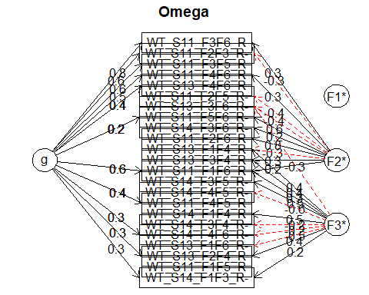Omega Call: omegah(m = m, nfactors = nfactors, fm = fm, key = key, flip = flip, digits = digits, title = title, sl = sl, labels = labels, plot = plot, n.obs = n.obs, rotate = rotate, Phi = Phi, option = option, covar = covar) Alpha: 0.65 G.6: 0.84 Omega Hierarchical: 0.69 Omega H asymptotic: 0.94 Omega Total 0.74

Schmid Leiman Factor loadings greater than 0.2 g F1* F2* F3* h2 h2 u2 p2 com WT_S11_F1F5_R 0.06 0.94 0.51 2.02 WT_S11_F1F6_R 0.58 0.24 0.26 0.46 0.46 0.54 0.73 1.76 WT_S11_F2F3_R- 0.62 -0.29 0.49 0.49 0.51 0.78 1.57 WT_S11_F2F5_R- -0.38 0.16 0.84 0.11 1.26 WT_S11_F2F6_R 0.80 0.68 0.68 0.32 0.04 1.12 WT_S11_F3F5_R 0.60 0.37 0.37 0.63 0.96 1.09 WT_S11_F3F6_R 0.79 0.33 0.73 0.73 0.27 0.84 1.36 WT_S11_F4F5_R 0.41 0.22 0.22 0.78 0.76 1.64 WT_S11_F4F6_R 0.51 0.27 0.36 0.36 0.64 0.72 1.80 WT_S11_F5F6_R- 0.21 0.59 0.40 0.40 0.60 0.11 1.26 WT_S13_F1F4_R -0.33 0.41 0.29 0.29 0.71 0.02 1.99 WT_S13_F1F6_R- -0.50 0.29 0.29 0.71 0.11 1.28 WT_S13_F2F4_R 0.26 0.38 0.21 0.21 0.79 0.33 1.81 WT_S13_F3F4_R 0.25 0.37 0.21 0.21 0.79 0.07 2.01 WT_S13_F3F6_R- -0.38 -0.33 0.26 0.26 0.74 0.05 2.17 WT_S13_F4F6_R 0.40 0.19 0.81 0.85 1.35 WT_S14_F1F3_R- 0.34 0.24 0.18 0.82 0.67 1.81 WT_S14_F1F4_R 0.55 0.32 0.32 0.68 0.01 1.12 WT_S14_F3F4_R- -0.22 0.07 0.93 0.22 2.00 WT_S14_F3F5_R- 0.49 0.30 0.30 0.70 0.10 1.49 WT_S14_F3F6_R- 0.24 0.07 0.93 0.19 1.48 WT_S14_F4F5_R- -0.64 0.43 0.43 0.57 0.01 1.14 WT_S14_F4F6_R- 0.26 -0.23 0.12 0.88 0.54 2.13

With Sums of squares of: g F1* F2* F3* h2 2.80 0.01 1.97 2.11 2.75

general/max 1.02 max/min = 211.46 mean percent general = 0.38 with sd = 0.34 and cv of 0.89 Explained Common Variance of the general factor = 0.41

The degrees of freedom are 187 and the fit is 6.03 The number of observations was 72 with Chi Square = 365.08 with prob < 1.3e-13 The root mean square of the residuals is 0.1 The df corrected root mean square of the residuals is 0.12 RMSEA index = 0.114 and the 10 % confidence intervals are 0.098 0.133 BIC = -434.66

Compare this with the adequacy of just a general factor and no group factors The degrees of freedom for just the general factor are 230 and the fit is 8.49 The number of observations was 72 with Chi Square = 525.16 with prob < 4e-25 The root mean square of the residuals is 0.15 The df corrected root mean square of the residuals is 0.16

RMSEA index = 0.133 and the 10 % confidence intervals are 0.119 0.15 BIC = -458.47

Measures of factor score adequacy  
g F1* F2* F3* Correlation of scores with factors 0.93 0.06 0.9 0.87 Multiple R square of scores with factors 0.86 0.00 0.8 0.76 Minimum correlation of factor score estimates 0.72 -0.99 0.6 0.52

Total, General and Subset omega for each subset g F1* F2* F3* Omega total for total scores and subscales 0.74 NA 0.67 0.44 Omega general for total scores and subscales 0.69 NA 0.63 0.35 Omega group for total scores and subscales 0.05 NA 0.04 0.09

### 2.8 Classroom Questionnaire

Mean, SD, min, max for classroom managament (cm) and non-/paraverbal communication (n&pv com)

| Group | N | M cm | SD cm | Min cm | Max cm | M n&pv com | SD n&pv com | Min n&pv com | Max n&pv com |
| --- | --- | --- | --- | --- | --- | --- | --- | --- | --- |
| Expert | 41 | 3.2 | 0.72 | 1 | 4 | 3.30 | 0.65 | 1 | 4 |
| Novice | 42 | 3.0 | 0.77 | 1 | 4 | 3.13 | 0.73 | 1 | 4 |

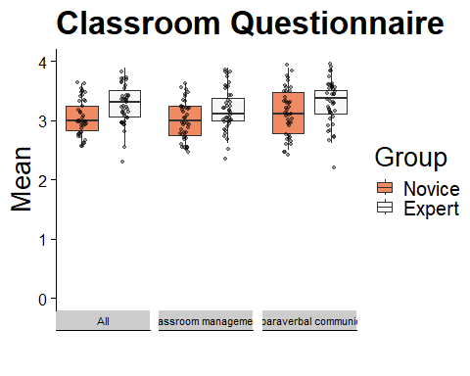

#### 2.8.1 t-test & effect size “Classroom Questionnaire - All”

Two Sample t-test

data: df_quest_plot $All[df_{q}uest_{p}lot$ Group == “Expert”] and df_quest_plot $All[df_{q}uest_{p}lot$ Group == “Novice”] t = 2.7419, df = 81, p-value = 0.007516 alternative hypothesis: true difference in means is not equal to 0 95 percent confidence interval: 0.05014992 0.31545984 sample estimates: mean of x mean of y 3.247805 3.065000

[1] 0.6 attr(,“magnitude”) [1] “medium”

#### 2.8.2 t-test & effect size “Classroom Questionnaire - Classroom Management”

Two Sample t-test

data: df_quest_plot$`Classroom management`[df_quest_plot$Group == “Expert”] and df_quest_plot$`Classroom management`[df_quest_plot$Group == “Novice”] t = 2.6421, df = 81, p-value = 0.009887 alternative hypothesis: true difference in means is not equal to 0 95 percent confidence interval: 0.04912362 0.34875094 sample estimates: mean of x mean of y 3.195366 2.996429

[1] 0.58 attr(,“magnitude”) [1] “medium”

#### 2.8.3 t-test & effect size “Classroom Questionnaire - Non-/paraverbal communication”

Two Sample t-test

data: df_quest_plot$`Non-/paraverbal communication`[df_quest_plot$Group == “Expert”] and df_quest_plot$`Non-/paraverbal communication`[df_quest_plot$Group == “Novice”] t = 1.997, df = 81, p-value = 0.04919 alternative hypothesis: true difference in means is not equal to 0 95 percent confidence interval: 0.0006129687 0.3361233844 sample estimates: mean of x mean of y 3.301463 3.133095

[1] 0.44 attr(,“magnitude”) [1] “small”

## 3 Correlations

##   
## Pearson's product-moment correlation  
##   
## data: df_merge$GRI_mtu and df_merge$SJT_All  
## t = -2.1712, df = 80, p-value = 0.03288  
## alternative hypothesis: true correlation is not equal to 0  
## 95 percent confidence interval:  
## -0.43084846 -0.01990909  
## sample estimates:  
## cor   
## -0.235897

##   
## Pearson's product-moment correlation  
##   
## data: df_merge$GRI_mtu and df_merge$Quest_All  
## t = 0.64655, df = 80, p-value = 0.5198  
## alternative hypothesis: true correlation is not equal to 0  
## 95 percent confidence interval:  
## -0.1472121 0.2846518  
## sample estimates:  
## cor   
## 0.07209825

##   
## Pearson's product-moment correlation  
##   
## data: df_merge$GRI_mtu and df_merge$Mean_disruption_appraisal  
## t = 0.60918, df = 80, p-value = 0.5441  
## alternative hypothesis: true correlation is not equal to 0  
## 95 percent confidence interval:  
## -0.1512868 0.2808174  
## sample estimates:  
## cor   
## 0.06795118

##   
## Pearson's product-moment correlation  
##   
## data: df_merge$GRI_mtu and df_merge$Mean_confidence_appraisal  
## t = -0.11168, df = 80, p-value = 0.9114  
## alternative hypothesis: true correlation is not equal to 0  
## 95 percent confidence interval:  
## -0.2288719 0.2050778  
## sample estimates:  
## cor   
## -0.0124849

##   
## Pearson's product-moment correlation  
##   
## data: df_merge_experts$GRI_mtu and df_merge_experts$`Teaching Experience`  
## t = -1.4152, df = 38, p-value = 0.1652  
## alternative hypothesis: true correlation is not equal to 0  
## 95 percent confidence interval:  
## -0.50038371 0.09433299  
## sample estimates:  
## cor   
## -0.2237514