# Vorschlag 1:

Eyes on the Classroom - How Expertise Shapes Gaze Behavior and Classroom Management Measures

# Vorschlag 2:

Who Masters Classroom Disruptions - Expertise Differences in Gaze Behavior and Classroom Management Measures in a Laboratory Setting

# Abstract

*Keywords:* classroom management, professional vision, eye-tracking, expertise differences, managing classroom disruptions

# Introduction

Classroom disruptions are a significant challenge in education, consuming a considerable amount of instructional time and affecting students’ learning experiences (Keller, 2014).

Teaching and classroom management are multidimensional settings in which teachers have to respond immediately to events as they develop (Barnes, 2004). The different interests and abilities of students must be managed to maximize the active learning time of students and minimize disruptions whilst teaching. Learning to develop such classroom management skills and to teach effectively is a complicated and complex process (Wolff, Jarodzka, & Boshuizen, 2017). Nevertheless, several studies have confirmed the positive correlation between effective classroom management and student learning success (Hattie, 2012; Stronge, Ward, & Grant, 2011).

Different principles of effective classroom management have been defined by previous research (Evertson & Harris, 1992), among them: withitness, overlapping, smoothness and momentum, and group alerting. In our study, we aim to focus on teacher´s “withitness”. This means that effective teachers are aware of what is happening in the classroom: They notice and appropriately interpret significant events in the classroom, such as disruptions or hand signals from students. Teachers give students the impression of having everything in view and of being able to deal with several things simultaneously (Nolting, 2012).

Teachers’ visual attention is a crucial component of their ability to notice and structure important events in the process of teaching (Marcum, 2017). Eye tracking technology has become a reliable means to study teachers’ visual focus of attention (“professional vision”; Dessus, Cosnefroy, & Luengo, 2016; Marcum, 2017; van den Bogert, 2016).

## Expertise in Classroom Management

Classroom management is a fundamental skill for teachers, playing a crucial role in shaping students’ learning outcomes (Hattie, 2008; Wang, 1993) and fostering a positive classroom climate (Djigic & Stojiljkovic, 2011; Mitchell & Bradshaw, 2013). When implemented effectively, it minimizes disruptions, maximizes instructional time, and nurtures constructive teacher-student relationships (Scherzinger & Wettstein, 2019). Given the dynamic and multifaceted nature of classroom interactions (Doyle, 1980), teachers must develop key skills such as *withitness* and *overlapping* (Kounin, 2006). *Withitness* refers to a teacher’s heightened awareness of classroom dynamics, allowing for proactive interventions to prevent disruptions from escalating. *Overlapping*, on the other hand, involves the ability to manage multiple demands simultaneously, ensuring a smooth instructional flow without compromising student focus.

However, the effectiveness of these skills largely depends on a teacher’s level of expertise. Research has shown that expert teachers possess more refined classroom management scripts, allowing them to anticipate potential disruptions and respond proactively (Wolff et al., 2021). They are also better at recognizing subtle cues that signal disengagement and can adapt their strategies accordingly (Wolff et al., 2015). In contrast, novice teachers often focus on surface-level behavioral cues, which can lead to reactive and less effective classroom management (König & Kramer, 2016). Moreover, experts integrate their observations with a focus on student learning outcomes, whereas novices tend to prioritize maintaining discipline (Wolff et al., 2017).

## Classroom Disruptions

This ability to anticipate and respond effectively is particularly vital when addressing one of the most persistent challenges in educational settings: classroom disruptions, as such disruptions can impair instructional time, weaken student engagement, and hinder academic achievement (Chow et al., 2024; Kraft & Monti-Nussbaum, 2021; Marder et al., 2023).

Disruptions, as described by Lohmann & Meyer (2003), are events that interfere with the essential conditions necessary for effective instruction and student participation. These behaviors can generally be categorized into four primary types, based on their nature and impact on classroom dynamics (Lohmann & Meyer, 2003). *Verbal disruptions* include spoken interruptions such as chatting, whispering, or heckling, which can disturb lesson flow and diminish focus. *Physical disruptions* refer to motor restlessness or unnecessary physical activity, like drumming on desks, snapping fingers, or clicking pens, which distract both teachers and students. *Lack of eagerness to learn* manifests through disengagement behaviors, such as drawing, resting one’s head on the desk, or using a phone – actions that reduce participation and hinder comprehension. Finally, *aggressive behavior* encompasses hostile actions or emotional outbursts, including yelling, defiance, or physical confrontations, all of which threaten the classroom’s safety.

To effectively minimize classroom disruptions, teachers must remain vigilant, consistently monitoring their environment for behaviors that could hinder the learning process. A crucial concept in understanding these disruptions is salience, which refers to how noticeable a behavior is within the classroom context (Kilbury et al., 2024). Highly salient behaviors, such as loud outbursts, naturally draw immediate attention, whereas subtle, non-salient behaviors can be equally detrimental over time if left unaddressed.

The complexity of managing disruptive behavior is further intensified by its subjective interpretation, influenced by both the behavior itself and the perceptions of teachers and students (Eckstein et al., 2016). This dual perspective requires educators to develop an acute awareness of both conspicuous and subtle indicators of disruption.

## Development of Competencies

To address the complexity of classroom management effectively, teachers require professional competencies, which are viewed as a multidimensional construct that develops along a continuum (see Figure 1; Blömeke et al., 2015). This development is dynamic and can be taught and learned through teacher training and professional development programs (Kunter et al., 2011).

**Figure 1**

*Modeling Competence as a Continuum (Blömeke et al., 2015)*

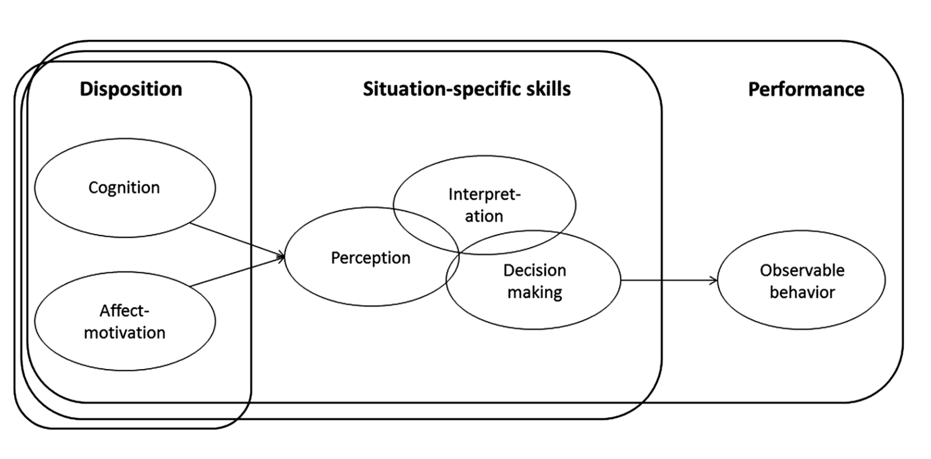

To illustrate the model with an example, consider a classroom situation where two students begin talking to each other, causing a disruption. Teachers possess cognitive dispositions, such as knowledge of various classroom management strategies, as well as motivational-affective dispositions, meaning they understand the importance of engaging as many students as possible in the lesson. When the talking occurs, the situation is first processed: teachers must *notice* it and subsequently interpret it as a classroom disruption. Following this, they reflect on whether and how to respond to the situation. This decision then manifests in performance, typically observable behavior.

The cognitive aspect highlights the importance of applying knowledge, such as classroom management strategies, as it directly influences professional vision and subsequent actions (Barth, 2017; Kunter et al., 2011; Mulder & Gruber, 2011).

## Expertise Differences in Teachers’ Professional Vision

## Eye-Tracking to Assess Teachers’ Professional Vision

Fixation Number: This metric reflected the frequency of visual attention shifts, with higher fixation numbers indicating a more dynamic scanning behavior across the classroom environment (Grub et al., 2020).

Average Duration Fixation: This metric provided a measure of cognitive processing, with longer durations suggesting more time spent processing visual information (Negi & Mitra, 2020).

The GRI provided a standardized measure of visual scanning efficiency, with smaller GRI values indicating a combination of shorter fixation durations and higher fixation frequencies, which is typically associated with more dynamic and efficient scanning behavior (Gegenfurtner et al., 2020).

## Present Study

The present study investigated differences in gaze behavior, self-reported classroom management, and strategic knowledge between experienced and inexperienced teachers during a micro-teaching unit that involved classroom disruptions. To examine these differences, multimodal data were analyzed from both in-service (experienced) and pre-service (inexperienced) teachers who participated in the laboratory-based study *Professional Vision of Novice and Expert Teachers (ProVisioNET).*

Participants individually attended a laboratory session, where they conducted a brief micro-teaching unit lasting approximately 15 minutes. The “class” consisted of three trained actors who portrayed students and simulated typical classroom disruptions. During the micro-teaching unit, teachers’ gaze patterns were recorded using eye-tracking technology. Additionally, self-reports on classroom management and strategic knowledge were assessed through a questionnaire, an interview, and a test.

The study addressed five primary aims:

One aim was to examine how teachers distribute their visual attention during classroom interactions in a lab-based micro-teaching unit. We expected students to be the primary focus of teachers’ attention. This exploration was descriptive.

Another aim was to investigate differences in gaze behavior related to noticing abilities between experienced and inexperienced teachers. We hypothesized that, compared to inexperienced teachers, experienced teachers would demonstrate more efficient gaze patterns throughout the micro-teaching unit (**Hypothesis 1a**), focus their attention more frequently on students (**Hypothesis 1b**), and notice disruptions more quickly (**Hypothesis 1c**).

Additionally, we examined whether the type of disruption (i.e., verbal disruptions, physical disruptions, and indicators of lack of eagerness to learn) influenced the speed at which teachers noticed disruptions. We hypothesized that verbal and physical disruptions would be more salient and, therefore, noticed more quickly than indicators of a lack of eagerness to learn (**Hypothesis 2a**). Furthermore, we explored whether teaching expertise had an impact on the disruption noticing speed.

Another aim was to determine whether differences in teaching expertise were reflected in classroom management measures, including self-reports on classroom management (e.g., self-evaluated classroom management, disruptiveness, and confidence ratings) as well as strategic knowledge of classroom management. We expected experienced teachers to outperform inexperienced teachers (**Hypothesis 3a**).

Finally, we examined the relationship between gaze behavior and classroom management measures, expecting these variables to be correlated.

# Method

## Participants

We recruited a total of 84 teachers from Germany (42 pre-service teachers and 42 in-service teachers) through personal contacts, email lists, and flyers. Pre-service teachers were required to be actively enrolled in a teacher education program and to have completed their first internship, while in-service teachers needed to have completed both the teacher training program (2. Staatsexamen) and to be currently working in the teaching profession. Data from two in-service teachers were excluded due to low-quality eye-tracking data, resulting in a final sample of 82 teachers, comprising 42 pre-service teachers and 40 in-service teachers.

The pre-service teachers (*n*= 29 women, *n*= 13 men) had a mean age of 22.80 years (*SD* = 1.90; range: 19–27). On average, they were in their 7th semester (*M* = 6.70, *SD* = 2.60; range: 3–11) and had an average of 9.60 hours (*SD* = 7.20; range: 1–36) of teaching experience through internships completed during their studies.

The in-service teachers (*n*= 24 women, *n*= 16 men) had a mean age of 39.10 years (*SD* = 10.60; range: 26–60) and an average of 11.60 years (*SD* = 11.30; range: 1–38) of teaching experience.

The study adhered to ethical guidelines and received approval from the University’s Institutional Review Board. Participants were fully informed about the study’s objectives before testing. Their participation was voluntary, without incentives, and commenced only after written consent.

## Setting and Procedure

Participants individually attended the lab for approximately two hours, following a standardized procedure for which a seminar room was transformed into a classroom. Upon arrival, they were welcomed by the experimenter, introduced to the procedure, and asked to sign the data protection agreement. Participants were then fitted with a binocular Tobii Pro Glasses 2 eye-tracker, adjusted for comfort and vision. After performing an initial calibration of the glasses (for details of the eye-tracker and the calibration, see Appendix A), the experimenter activated and synchronized the recording devices (eye-tracking glasses, four cameras, and an audio recorder) using an auditory signal. This setup phase included a brief introductory game to acclimate participants to the eye-tracking equipment and the three students, which took approximately 10-15 minutes.

After the initial setup, a second calibration was done in a separate room. As soon as the teacher re-entered the classroom, the micro-teaching unit started. Participants were asked to prepare a 15-minute micro-teaching unit on a topic and grade level of their choice. The only requirement was that the unit had to be an introductory micro-teaching unit, and had to consist of supervised individual work and/or frontal teaching. During the unit, three trained actors (playing students) performed scripted classroom disruptions. The students followed prompts that appeared every 1.5 minutes on a screen only visible to them (e.g., chatting with a neighbor, heckling, looking at the phone; see Table A1 in the supplementary material for an overview and categorization of all disruptions; and Figure B1 and B2 in the supplementary material for a depiction of the laboratory setting of the micro-teaching unit). The order of the disruptions and the performing students were fully balanced using Latin Squares. The whole micro-teaching unit was recorded using eye-tracking glasses to capture teachers’ gaze patterns. The micro-teaching unit lasted about 15-20 minutes.

After the teaching session, participants underwent a third calibration. Following this, all recording devices were stopped, and participants filled out a brief computer-based questionnaire (~10-15 minutes) assessing sociodemographic data and a self-evaluation of their classroom management during the micro-teaching unit. A ten-minute break followed, concluding the first part of data collection.

In the study’s second part, participants engaged in a Stimulated Recall Interview (SRI). They watched a video of their own teaching session, recorded through the eye-tracking glasses, while the experimenter paused the video at each classroom disruption. Participants answered five open-ended questions and three rating questions for each disruption, including self-reported *disruptiveness* and *confidence ratings* (see Measures). The SRI lasted approximately 45-60 minutes. Finally, participants completed a Situational Judgment Test (SJT) online, assessing their *strategic knowledge of classroom management*. The questionnaire took approximately 15 minutes to complete, marking the end of the study.

## Measures

***Gaze Behavior Measures***

Gaze behavior was analyzed using predefined Areas of Interest (AOI) to examine how participants distributed their visual attention during the micro-teaching unit[1]. Two types of AOIs were defined to structure the data meaningfully: global AOI and event-based AOI. Global AOI were used to assess gaze behavior over the entire video duration and included the following: the *students*, representing gaze points focused on the group of three students; *teacher material*, capturing gaze points directed toward instructional materials such as the board, screen, or other teaching aids; *student desks*, representing gaze points on elements related to students’ desks, including name tags and student materials; and *classroom/others*, which encompassed gaze points directed toward other areas of the classroom that were not associated with the students or teacher. In contrast, the event-based AOI was coded only during specific classroom events, i.e., disruptions caused by students. The AOI labeled *disruptive student* captured gaze behavior directed toward one of the three students who performed a classroom disruption.

#### Average Fixation Duration on AOI.

The average fixation duration was calculated by dividing the total fixation duration (in milliseconds) by the total number of fixations. Fixation data for these calculations were aggregated across all AOI and summarized for both experienced and inexperienced teachers.

#### Fixation Number per Minute on AOI *Students*.

The fixation number per minute was calculated by summing all fixations within the AOI *students* and dividing by the session duration in minutes. This yielded an individual fixation rate per participant, which was then summarized for experienced and inexperienced teachers.

#### Gaze Relational Index.

The Gaze Relational Index (GRI) was calculated as a composite metric to evaluate the efficiency of participants’ scanning behavior during the micro-teaching unit. The GRI was derived by dividing the average fixation duration (in milliseconds) by the fixation number per minute.

#### Time to First Fixation on AOI *Disruptive Student*.

The time to first fixation (TTFF) measured the time (in seconds) for participants to fixate on the AOI *disruptive student* after a disruption onset. Values were extracted by identifying the first fixation timestamp relative to the disruption onset, excluding invalid cases (TTFF = 0[2] or >30s[3]). Raw values were converted from milliseconds to seconds and log-transformed for normalization. To assess overall responsiveness to classroom disruptions, log-transformed TTFF values were averaged across all disruptions per participant and then summarized for experienced and inexperienced teachers.

### Self-Evaluated Classroom Management

After the micro-teaching unit, teachers answered a questionnaire using five items from a validated questionnaire (Helmke et al., 2013) and eleven self-developed items derived from the research literature (Kiel et al., 2013; Kounin, 2006; Marzano, 2007) to assess their self-evaluated classroom management. The questionnaire was a 4-point Likert scale (1 = strongly disagree; 4 = strongly agree).

### Disruptiveness and Confidence Ratings

The disruptiveness and confidence ratings were assessed during the SRI on an 11-point rating scale, ranging from 0 (not at all disrupting/confident) to 10 (extremely disrupting/confident). Ratings were averaged across the nine classroom disruptions for each participant to capture a general sense of how disruptive the classroom disruptions were during the micro-teaching unit and how confident participants felt in handling them.

### Strategic Knowledge of Classroom Management

Teachers’ strategic knowledge of classroom management was assessed using a Situational Judgment Test (SJT; Gold & Holodynski, 2015) via an online questionnaire on SoSci Survey. Participants graded five to six action alternatives for twelve teaching scenarios in which classroom disruptions were discussed on a six-point Likert scale (grade 1 = “very good” to grade 6 = “unsatisfactory”). As the SJT was originally designed for primary schools, adjustments were made to enable the use of the SJT for all types of schools in the *ProVisioNET* study. Due to their general applicability, all twelve scenarios and answer options were adopted and only the names of the class levels were removed from the questions - except for scenario 6, where this information was essential.

## Data analysis

The data were analyzed using R (RStudio Team, 2020, Version 2024.12.0) and IBM SPSS Statistics (Version 29). Graphics were created using ggplot2 (Wickham, 2016).

To examine teachers’ visual attention distribution (Aim 1), fixation durations[4] for different AOI (e.g., students, disruptive student, teacher material) were analyzed descriptively. Mean proportions were compared between experienced and inexperienced teachers using independent-sample *t*-tests, with effect sizes reported as Cohen’s *d* (Cohen, 1988).

To assess differences in gaze behavior related to noticing abilities (Aim 2), we calculated the GRI during the micro-teaching unit, fixation number per minuteon AOI *students*, and TTFF on AOI *disruptive student*. Group differences were tested with t-tests, and effect sizes were reported.

To investigate how disruption type affects noticing speed (Aim 3), a 2 × 3 repeated-measures ANOVA was conducted, with expertise (experienced vs. inexperienced teachers) as a between-subject factor and disruption type (verbal, physical, lack of eagerness) as a within-subject factor. Bonferroni-adjusted post-hoc comparisons were performed for significant effects.

To examine classroom management differences (Aim 4), independent-sample *t*-tests compared self-evaluated classroom management, disruptiveness and confidence ratings, and strategic knowledge.

Finally, to explore the relationship between gaze behavior and classroom management (Aim 5), Pearson correlations were computed between gaze efficiency metrics (GRI, fixation number per minuteon AOI *students*, TTFF on AOI *disruptive student*) and classroom management measures. Statistical significance was assessed using *p*-values, with effect sizes reported.

# Results

## Gaze Distribution for Areas of Interest

The descriptive results for experienced and inexperienced teachers to investigate teachers’ gaze distribution are displayed in Figure 1.

**Figure 1**

*Average Fixation Duration Percentages by Area of Interest (AOI) and Teacher Experience Group for the Entire Micro-Teaching Unit*

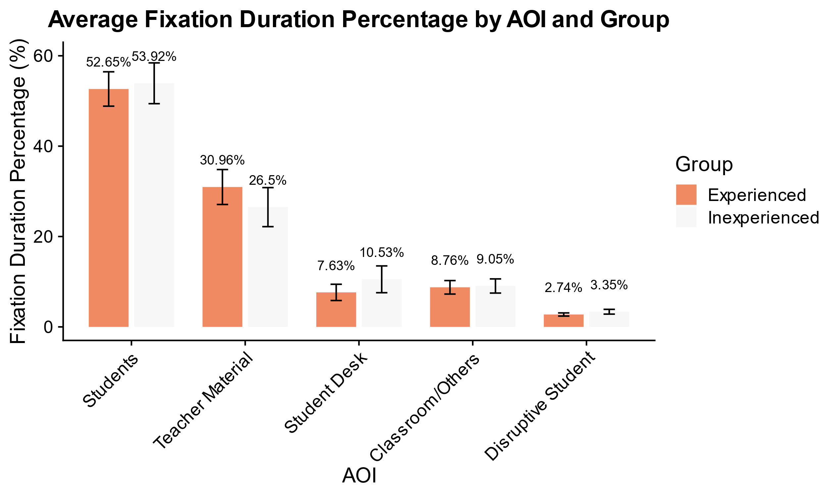

*Note.* The bar chart displays the percentage of fixation durations for five AOI (students, teacher material, student desk, classroom/others, and disruptive student) during the micro-teaching unit. Data are presented separately for experienced and inexperienced teachers, with error bars indicating 95% confidence intervals.

As suggested, both groups exhibited the highest percentages of fixation durations in the AOI *students*, while no statistically significant differences were observed between experienced and inexperienced teachers for any AOI (see Appendix C, Table C2 for *t*-test results and effect sizes).

## Gaze Behavior

Means, standard deviations, and range of experienced and inexperienced teachers’ gaze behavior measures are shown in Table 1.

**Table 1**

*Means, Standard Deviations, And Range of Experienced and Inexperienced Teachers’ Gaze Behavior Measures*

|  |  |  |  |  |  |  |  |  |
| --- | --- | --- | --- | --- | --- | --- | --- | --- |
| Gaze Behavior Measures | Experienced | | | | Inexperienced | | | |
| *M* | *SD* | Min | Max | *M* | *SD* | Min | Max |
| GRI for micro-teaching unit | 5.32 | 2.21 | 2.22 | 11.72 | 6.08 | 2.15 | 2.14 | 10.80 |
| Fixation Numbers in AOI *Students* | 98.53 | 19.21 | 49.07 | 135.81 | 91.21 | 14.52 | 68.99 | 123.37 |
| TTFF (log) in AOI *Disruptive Student* | 0.28 | 0.69 | –1.81 | 1.51 | 0.30 | 0.65 | –1.06 | 2.21 |
| *Note*. GRI = Gaze Relational Index, AOI = Area of Interest, TTFF = Time to First Fixation (log-transformed). Values represent the mean (*M*), standard deviation (*SD*), and range (minimum and maximum values) for each measure. Fixation numbers in AOI *Students* refer to the total number of fixations directed at students per minute. TTFF values represent the log-transformed time (in seconds) until teachers first fixated on a disruptive student. | | | | | | | | |

First, experienced teachers exhibited more frequent but shorter fixations, leading descriptively to a lower GRI than inexperienced teachers across the entire micro-teaching session (**Hypothesis 1a**). However, this difference was not statistically significant, *t*(80) = –1.57, *p* = .12.

Second, experienced teachers directed their gaze toward AOI *students* more often than inexperienced teachers (**Hypothesis 1b**), and this difference was statistically significant, *t*(80) = 1.96, *p* = .05, *d* = 0.43 (small effect).

Third, experienced teachers detected disruptions descriptively slightly faster, as reflected in their shorter noticing speed for the AOI *disruptive student*[5] (**Hypothesis 1c**), but with no statistically significant difference, *t*(80) = –0.14, *p* = .89.

## Effect of Disruption Type and Expertise on Disruption Noticing Speed

For **Hypothesis 2a**, a significant main effect of disruption type was found, *F*(1.94, 141.49) = 68.05, *p* < .05, *η²* = .34, indicating that the type of disruption influenced how quickly teachers noticed it. Consistent with our hypothesis, post-hoc comparisons revealed that verbal disruptions were detected significantly faster than both physical disruptions, *t*(73) = 6.33, *p* < .05, *d* = 0.62 (medium effect), and lack of eagerness disruptions, *t*(73) = 11.09, *p* < .05, *d* = 1.23 (large effect). Furthermore, physical disruptions were noticed faster than lack of eagerness disruptions, *t*(73) = -5.72, *p* < .05, *d* = 0.62 (medium effect). The main effect of expertise, *F*(1, 73) = 0.03, *p* = .86, and the interaction between expertise and disruption type, *F*(1.94, 141.49) = 1.28, *p* = .28, were not significant, suggesting that expertise did not influence noticing speed, nor did it interact with disruption type.

## Expertise Differences in Classroom Management Measures

Table 2 presents descriptive statistics and internal consistency reliabilities for all classroom management measures.

**Table 2**

*Means, Standard Deviations, Range and Internal Consistency Reliability (McDonalds’ Omega, ω) of Experienced and Inexperienced Teachers’ Classroom Management Measures*

|  |  |  |  |  |  |  |  |  |  |
| --- | --- | --- | --- | --- | --- | --- | --- | --- | --- |
| Classroom Management Measures | Experienced | | | | Inexperienced | | | | ω |
| *M* | *SD* | Min | Max | *M* | *SD* | Min | Max |
| Self-evaluated Classroom Management | 3.25 | 0.31 | 2.38 | 3.88 | 3.06 | 0.30 | 2.56 | 3.62 | .82 |
| Disruptiveness Rating | 4.81 | 2.90 | 0 | 10 | 5.55 | 2.81 | 0 | 10 | .84 |
| Confidence Rating | 8.44 | 1.68 | 2 | 10 | 7.18 | 2.04 | 0 | 10 | .88 |
| Strategic Knowledge | 0.75 | 0.08 | 0.54 | 0.88 | 0.72 | 0.13 | 0.10 | 0.91 | .89 |
| *Note*. Values represent the mean (*M*), standard deviation (*SD*), and range (minimum and maximum values), along with McDonald’s Omega (ω) coefficient, which indicates the internal consistency reliability for each measure. *Self-evaluated classroom management* refers to participants’ assessment of their classroom management competencies. The *disruptiveness rating* indicates the extent to which participants judged the disruptions as disruptive, while the c*onfidence rating* measures their confidence in managing them. S*trategic knowledge* measures teachers’ knowledge of classroom management strategies. | | | | | | | | | |

Independent-sample *t*-tests examined whether teaching expertise influenced classroom management measures (**Hypothesis 3a**). As expected, experienced teachers evaluated their classroom management competencies significantly higher than inexperienced teachers, *t*(80) = 2.78, *p* < .05, *d* = 0.62 (medium effect). They also reported disruptions as less disruptive, *t*(80) = –2.57, *p* < .05, *d* = –0.57 (medium effect), and greater confidence in managing them, *t*(80) = 5.63, *p* < .05, *d* = 1.24 (large effect). However, strategic knowledge of classroom management did not differ significantly between groups, *t*(80) = 1.00, *p* = .32, suggesting expertise was not associated with higher scores on the situational judgment test (SJT).

## Correlation Between Gaze Behavior Measures and Classroom Management Measures

Table 3 presents Pearson correlation coefficients between gaze behavior measures and classroom management measures, separately for experienced (below the diagonal) and inexperienced teachers (above the diagonal).[6]

**Table 3**

*Correlations Between the Gaze Efficiency Measure and Classroom Management Measures for Experienced (Below Diagonal) and Inexperienced (Above Diagonal) Teachers*

|  |  |  |  |  |  |  |  |
| --- | --- | --- | --- | --- | --- | --- | --- |
| Variable | (1) | (2) | (3) | (4) | (5) | (6) | (7) |
| (1) GRI | – | –.44* | .11 | –.01 | .16 | .15 | –.14 |
| (2) Fixation Number Per Minute on AOI *Students* | –.53* | – | –.39* | .39* | –.49* | –.22 | .14 |
| (3) TTFF (log) on AOI *Disruptive Student* | .05 | –.29 | – | –.20 | .32* | –.01 | .01 |
| (4) Disruptiveness Rating | .03 | –.20 | .02 | – | –.02 | .01 | –.15 |
| (5) Confidence Rating | 0 | .06 | –.06 | –.51* | – | .48* | –.19 |
| (6) Self-evaluated Classroom Management | .11 | 0 | –.18 | –.11 | .33* | – | –.21 |
| (7) Strategic Knowledge | –.36* | .16 | –.34* | –.19 | –.03 | .12 | – |
| *Note.* The table presents Pearson correlation coefficients between gaze behavior measures (GRI = Gaze Relational Index, fixation number per minute on AOI s*tudents,* and TTFF (= log-transformed time to first fixation on AOI d*isruptive student*), and classroom management measures (self-evaluated classroom management, disruptiveness and confidence ratings, and strategic knowledge) for inexperienced teachers (above diagonal) and experienced teachers (below diagonal).  Statistically significant correlations (*p* < .05) are marked with an asterisk (*).  GRI = Gaze-Relational Index; TTFF = Time to First Fixation on AOI d*isruptive student* (log-transformed). | | | | | | | |

For experienced teachers, lower GRI values (indicating more efficient gaze behavior) were significantly associated with higher fixation frequency on students and greater strategic knowledge. Additionally, more frequent fixations on students correlated with higher confidence in handling disruptions. Longer TTFF on disruptive students was linked to lower strategic knowledge.

For inexperienced teachers, greater fixation numbers on students were negatively correlated with self-evaluated classroom management and confidence ratings. Additionally, higher confidence in handling disruptions was positively associated with self-evaluated classroom management.

# Discussion

## Key Findings

Our study investigated …

Overall, our findings indicate that …

Our findings are consistent with prior research that illustrates the …

## Limitations and future directions

While the laboratory setting of the study allowed for a controlled implementation of stressors and high internal validity, it was not an authentic classroom environment, raising questions about its external validity. Most importantly, the teacher and their students did not have a shared history, and only a very thin basis for establishing a positive teacher-student relationship, which is a core characteristic of effective classroom management (Beaty-O’Ferrall et al., 2010; Rüedi, 2014).

In addition, the micro-teaching unit was only about 15 minutes long, and thus much shorter than a regular school lesson, providing less opportunities for experienced teachers to build up an engaging lesson.

Finally, the onset of disruptive student behavior was scripted, following an experimental time schedule, which was not affected by the behavior of the teacher. Thus, the setting may have masked effects of teaching experience by providing too little opportunities of experienced teachers to demonstrate their true classroom management skills.

In subsequent studies, it would therefore be insightful to …

## Conclusion

This study investigated …

In summary, our study contributes to the understanding …

# References

Barth, V. L. (2017). *Professionelle Wahrnehmung von Störungen im Unterricht*. Springer VS. https://doi.org/10.1007/978-3-658-16371-6

Beaty-O’Ferrall, M. E., Green, A., & Hanna, F. (2010). Classroom Management Strategies for Difficult Students: Promoting Change through Relationships. *Middle School Journal (J1)*, *41*(4), 4–11.

Blömeke, S., Gustafsson, J.-E., & Shavelson, R. J. (2015). Beyond dichotomies: Competence viewed as a continuum. *Zeitschrift Für Psychologie*, *223*(1), 3–13. https://doi.org/10.1027/2151-2604/a000194

Chow, J. C., Sayers, R., Fu, Y., Granger, K. L., McCullough, S., Kingsbery, C., & Morse, A. (2024). A Systematic Meta-Review of Measures of Classroom Management in School Settings. *Assessment for Effective Intervention*, *49*(2), 60–74. https://doi.org/10.1177/15345084231208671

Cohen, J. (1988). Statistical power for the behavioural sciences. Hilsdale. *NY: Lawrence Erlbaum*, *58*(1), 7–19.

Djigic, G., & Stojiljkovic, S. (2011). Classroom management styles, classroom climate and school achievement. *Procedia - Social and Behavioral Sciences*, *29*, 819–828. https://doi.org/10.1016/j.sbspro.2011.11.310

Doyle, W. (1980). *Classroom Management*. Kappa Delta Pi, P. https://eric.ed.gov/?id=ED206567

Eckstein, B., Grob, U., & Reusser, K. (2016). Unterrichtliche Devianz und subjektives Störungsempfinden. Entwicklung eines Instrumentariums zur Erfassung von Unterrichtsstörungen. *Empirische Pädagogik (EP)*, *30*(1), Article 1.

Gegenfurtner, A., Boucheix, J.-M., Gruber, H., Lehtinen, E., & Lowe, R. K. (2020). *The Gaze Relational Index as a Measure of Visual Expertise*. *3*.

Gold, B., & Holodynski, M. (2015). Development and Construct Validation of a Situational Judgment Test of Strategic Knowledge of Classroom Management in Elementary Schools. *Educational Assessment*, *20*(3), 226–248. https://doi.org/10.1080/10627197.2015.1062087

Grub, A.-S., Biermann, A., & Brünken, R. (2020). *Process-based measurement of professional vision of (prospective) teachers in the field of classroom management. A systematic review*. https://doi.org/10.25656/01:21187

Hattie, J. (2008). *Visible Learning: A Synthesis of Over 800 Meta-Analyses Relating to Achievement*. Routledge. https://doi.org/10.4324/9780203887332

Helmke, A., Schrader, F.-W., Helmke, T., Lenske, G., Pham, G., Praetorius, A.-K., & Ade-Thurow, M. (2013). *Basisfragebogen EMU - Evidenzbasierte Methoden der Unterrichtsentwicklung*. Unterrichtsdiagnostik. http://www.unterrichtsdiagnostik.info/downloads/fragebogen/

Keller, G. (2014). *Disziplinmanagement in der Schulklasse: Wie Sie Unterrichtsstörungen vorbeugen und bewältigen*. Hogrefe AG.

Kiel, E., Frey, A., & Weiß, S. (2013). *Trainingsbuch Klassenführung*. Verlag Julius Klinkhardt.

Kilbury, M., Böhnke, A., Haase, S., & Thiel, F. (2024). The development and validation of a video tool for capturing teachers’ noticing in salient and non-salient classroom disruptions. *Computers in Human Behavior Reports*, *16*, 100481. https://doi.org/10.1016/j.chbr.2024.100481

König, J., & Kramer, C. (2016). Teacher professional knowledge and classroom management: On the relation of general pedagogical knowledge (GPK) and classroom management expertise (CME). *ZDM*, *48*(1), 139–151. https://doi.org/10.1007/s11858-015-0705-4

Kounin, J. S. (2006). *Techniken der Klassenführung*. Waxmann Verlag.

Kraft, M. A., & Monti-Nussbaum, M. (2021). The Big Problem With Little Interruptions to Classroom Learning. *AERA Open*, *7*, 23328584211028856. https://doi.org/10.1177/23328584211028856

Kunter, M., Baumert, J., & Blum, W. (2011). *Professionelle Kompetenz von Lehrkräften: Ergebnisse des Forschungsprogramms COACTIV*. Waxmann Verlag.

Lohmann, G., & Meyer, H. (2003). *Mit Schülern klarkommen: Professioneller Umgang mit Unterrichtsstörungen und Disziplinkonflikten*. Cornelsen-Scriptor.

Marder, J., Thiel, F., & Göllner, R. (2023). Classroom management and students’ mathematics achievement: The role of students’ disruptive behavior and teacher classroom management. *Learning and Instruction*, *86*, 101746. https://doi.org/10.1016/j.learninstruc.2023.101746

Marzano, R. J. (2007). *The Art and Science of Teaching: A Comprehensive Framework for Effective Instruction*. ASCD.

Mitchell, M. M., & Bradshaw, C. P. (2013). Examining classroom influences on student perceptions of school climate: The role of classroom management and exclusionary discipline strategies. *Journal of School Psychology*, *51*(5), 599–610. https://doi.org/10.1016/j.jsp.2013.05.005

Mulder, R. H., & Gruber, H. (2011). Die Lehrperson im Lichte von Professions-, Kompetenz- und Expertiseforschung – die drei Seiten einer Medaille. In O. Zlatkin-Troitschanskaia (Ed.), *Stationen Empirischer Bildungsforschung: Traditionslinien und Perspektiven* (pp. 427–438). VS Verlag für Sozialwissenschaften. https://doi.org/10.1007/978-3-531-94025-0_30

Onkhar, V., Dodou, D., & de Winter, J. C. F. (2024). Evaluating the Tobii Pro Glasses 2 and 3 in static and dynamic conditions. *Behavior Research Methods*, *56*(5), 4221–4238. https://doi.org/10.3758/s13428-023-02173-7

RStudio Team. (2020). *RStudio: Integrated Development Environment for R*. RStudio, PBC.

Rüedi, J. (2014). Zur Bedeutung positive Beziehungen für die Klassenführung und den Umgang mit Unterrichtsstörungen. *Beziehungen in Schule Und Unterricht. Teil*, *3*, 105–126.

Scherzinger, M., & Wettstein, A. (2019). Classroom disruptions, the teacher–student relationship and classroom management from the perspective of teachers, students and external observers: A multimethod approach. *Learning Environments Research*, *22*(1), 101–116. https://doi.org/10.1007/s10984-018-9269-x

Tobii AB. (2024). *Tobii Pro Lab User Manual v 24.21*. https://go.tobii.com/tobii_pro_lab_user_manual

Wang, M. C. (1993). *Toward a Knowledge Base for School Learning. Publication Series #93-5a*. https://eric.ed.gov/?id=ED399311

Weinert, F. E. (Ed.). (2002). *Leistungsmessungen in Schulen* (2. unveränd. Aufl). Beltz.

Wickham, H. (2016). *ggplot2: Elegant Graphics for Data Analysis*. Springer-Verlag New York. https://doi.org/10.1007/978-0-387-98141-3

Wolff, C. E., Jarodzka, H., & Boshuizen, H. P. A. (2017). See and tell: Differences between expert and novice teachers’ interpretations of problematic classroom management events. *Teaching and Teacher Education*, *66*, 295–308. https://doi.org/10.1016/j.tate.2017.04.015

Wolff, C. E., Jarodzka, H., & Boshuizen, H. P. A. (2021). Classroom management scripts: A theoretical model contrasting expert and novice teachers’ knowledge and awareness of classroom events. *Educational Psychology Review*, *33*(1), 131–148. https://doi.org/10.1007/s10648-020-09542-0

Wolff, C. E., van den Bogert, N., Jarodzka, H., & Boshuizen, H. P. A. (2015). Keeping an Eye on Learning: Differences Between Expert and Novice Teachers’ Representations of Classroom Management Events. *Journal of Teacher Education*, *66*(1), 68–85. https://doi.org/10.1177/0022487114549810

# Appendix

# Appendix A

**Eye-tracking apparatus and calibration**

Teachers wore a binocular Tobii Pro Glasses 2 eye-tracker during the micro-teaching unit to record eye-tracking data. The system consisted of a wearable head unit and a recording unit. The head unit was a measuring device with different sensors. A high-definition scene camera captured a full HD video of the teacher’s field of vision. An integrated microphone recorded surrounding sounds. Infrared light illuminators supported the eye-tracking sensors which recorded the eye orientation to capture the teacher’s gaze point. The videos were recorded with a sampling rate of 50 Hz in a video resolution of 1920 x 1080 at 25 frames per second. The scene camera had a field of view of 90 degrees in 16:9 format (82 degrees horizontal and 52 degrees vertical) and a frame dimension of 179 x 159 x 57 mm (width x depth x height). The recording unit is a compact computer that manages the head unit. It captures and saves eye-tracking data, audio, and scene camera footage on a removable SD memory card.

The evaluation of the calibration process followed the guidelines outlined in the Manual of Tobii AB (2024) and Onkhar et al. (2024) for assessing calibration quality. Participants’ gaze was calibrated using a bullseye card that the participant held at arm’s length. A successful calibration was achieved when the participant’s gaze marker sufficiently overlapped with the bullseye for a specified time, based on criteria internally determined by the manufacturer’s software (Tobii AB, 2024). All participants achieved successful calibration, and no participants were excluded due to calibration failure. The robustness of the calibration was further verified through a secondary nine-point calibration. During this step, participants were asked to read numbers from one to nine aloud and direct their gaze at specific fields corresponding to each number. The initial calibration was performed before and the verification calibration before and after each micro-teaching unit.

**Table A1**

*Classification of Nine Typical Classroom Disruptions According to Lohmann & Meyer (2003) Performed in The Micro-Teaching Unit by Actors*

|  |  |  |
| --- | --- | --- |
| Verbal disruptions | Physical disruptions | Lack of eagerness to learn |
| Heckling | Clicking pen | Looking at phone |
| Chatting | Snipping hands | Drawing |
| Whispering | Drumming hands | Head on table |

*Note.* Disruptions were classified based on the typology provided by Lohmann & Meyer (2003)*.* Categories include verbal, physical, and disengagement-related behaviors performed during the micro-teaching unit. The order of the performing actors and the disruptions was fully balanced using Latin squares.

# Appendix B

# Laboratory Setting of The Study

**Figure B1**

*Laboratory Setting of The Micro-Teaching Unit. Ein Bild, das Mobiliar, Stuhl, Kleidung, Schuhwerk enthält.
*

*Note*. The setting included three actors as the class (left) and a teacher (participant, right).

**Figure B2**

*Laboratory Setting of The Interview.*

Ein Bild, das Mobiliar, Zeichnung, Entwurf, Tisch enthält.

*Note*. The experimenter and participant watched the previously taught micro-teaching unit on video.

# Appendix C

**Additional Results for Gaze Behavior Across AOI**

**Figure C1**

*Average Fixation Number Percentages by Area of Interest (AOI) and Teacher Experience Group for the Entire Micro-Teaching Unit with 95% Confidence Intervals*

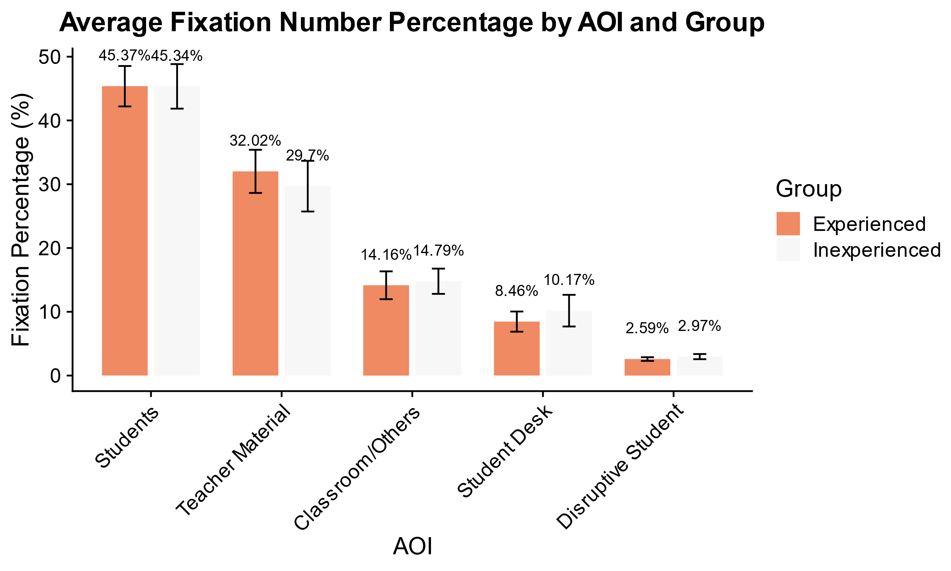

*Note.* The bar chart illustrates the average fixation number percentage directed at five AOIs (Students, Teacher Material, Classroom/Others, Student Desk, and Disruptive Student) during the micro-teaching unit. Results are presented separately for experienced and inexperienced teachers, with error bars indicating 95% confidence intervals.

**Table C2**

t*-Test Results and Effect Sizes for Fixation Number Percentages (FNP) and Fixation Duration Percentages (FDP) Across AOIs Between Experienced and Inexperienced Teachers*

|  |  |  |  |  |  |  |  |
| --- | --- | --- | --- | --- | --- | --- | --- |
| Measures | AOI | *t-*value | df | *p*-value | *M* Difference | Cohen's *d* | 95% CI |
| FNP a | Students | 0.01 | 80 | 0.99 | 0.03 | 0.00 | [–4.63, 4.69] |
| FNP | Disruptive Student | –1.32 | 80 | 0.19 | –0.27 | –0.29 | [–0.67, 0.14] |
| FNP | Teacher Material | 0.89 | 80 | 0.37 | 2.32 | 0.20 | [–2.84, 7.48] |
| FNP | Student Desk | –1.17 | 80 | 0.25 | –1.72 | –0.26 | [–4.65, 1.21] |
| FNP | Classroom/Others | –0.43 | 80 | 0.67 | –0.63 | –0.10 | [–3.53, 2.27] |
| FDP b | Students | –0.43 | 80 | 0.67 | –1.26 | –0.10 | [–7.1, 4.58] |
| FDP | Disruptive Student | –1.90 | 80 | 0.06 | –0.48 | –0.42 | [–0.98, 0.02] |
| FDP | Teacher Material | 1.55 | 80 | 0.13 | 4.45 | 0.34 | [–1.28, 10.18] |
| FDP | Student Desk | –1.67 | 80 | 0.1 | –2.89 | –0.37 | [–6.35, 0.56] |
| FDP | Classroom/Others | –0.28 | 80 | 0.78 | –0.30 | –0.06 | [–2.43, 1.84] |
| *Note*. This figure displays the results of *t*-tests and effect sizes (Cohen’s *d*) for fixation number percentages (FNP) and fixation duration percentages (FDP) across Areas of Interest (AOIs) between experienced and inexperienced teachers. AOIs included Students, Disruptive Student, Teacher Material, Student Desk, and Classroom/Others. Positive mean differences (*M* Difference) indicate higher percentages for experienced teachers. Confidence intervals (95%) for the mean differences are presented in brackets.  *p*-value < .05 is considered statistically significant.  a FNP = Fixation Number Percentages  b FDP = Fixation Duration Percentages | | | | | | | |

**Appendix D**

**Correlation Between Gaze Behavior Measures and Classroom Management Measures**

**Table D1**

*Correlations Between the Gaze Behavior Measures and Classroom Management Measures Across All Participants*

|  |  |  |  |  |  |  |
| --- | --- | --- | --- | --- | --- | --- |
| Variable | (2) | (3) | (4) | (5) | (6) | (7) |
| (1) GRI | –.50* | .08 | .06 | –.02 | .07 | –.23* |
| (2) Fixation Number Per Minute on AOI *Students* | – | –.34* | 0 | –.13 | –.06 | .16 |
| (3) TTFF (log) on AOI *Disruptive Student* | –.34* | – | –.07 | .12 | –.01 | –.12 |
| (4) Disruptiveness Rating | 0 | –.07 | – | –.36* | –.13 | –.03 |
| (5) Confidence Rating | –.13 | .12 | –.36* | – | .49* | –.06 |
| (6) Self-Evaluated Classroom Management | –.06 | –.10 | –.13 | .49* | – | –.05 |
| (7) Strategic Knowledge | .16 | –.12 | –.03 | –.06 | –.05 | – |
| *Note.* The table presents Pearson correlation coefficients between gaze behavior measures (GRI = Gaze Relational Index, fixation number per minute on AOI *students*, and TTFF = log-transformed time to first fixation on AOI *disruptive student*) and classroom management measures (self-evaluated classroom management, disruptiveness and confidence ratings, and strategic knowledge) across all participants. Lower GRI values indicate more efficient gaze behavior. Statistically significant correlations (*p* < .05) are marked with an asterisk (*). | | | | | | |

1. To code and analyze the gaze behavior, we used the software Tobii Pro Lab Analyzer (Version 1.241.54542). A fixation filter was applied, with a threshold set at 30°/sec to identify fixations, as this default fixation filter is recommended for mobile eye-tracking data in the Tobii Lab Analyzer Software (Tobii AB, 2024).
2. As our focus was on gaze behavior directed toward the disruptive student, instances where the gaze was already fixated on the disruptive student, when the event started, were excluded from the analysis.
3. Fixation times beyond 30 seconds were excluded, as they exceeded the duration of the scripted disruptions.
4. The percentage of fixation duration was used as the primary measure, as it offered a more intuitive visualization of attention distribution over time (see Appendix C, Figure C1 for the percentage for fixation numbers).
5. Before conducting the analysis, 21.33% of data points were excluded because the participant either did not fixate on the disruption or had fixation times of zero or longer than 30 seconds, exceeding the defined threshold (see Data Analysis). Removing them ensured a focus on meaningful and interpretable gaze detection times.
6. See Appendix D (Table D1) for a correlation table including all gaze behavior measures and classroom management measures for all participants.