Through the eyes of the teacher - Multimodal exploration of expertise differences in the perception of classroom disruptions

# 1 Introduction

Managing classroom disruptions is a crucial aspect of effective classroom management (Evertson, Weinstein, et al. (2006); Kounin (2006)).

Accordingly, teachers must be able to quickly notice and appropriately react to significant events in the classroom. This ability is referred to as classroom professional vision (Goodwin (2015); Sherin (2007)).

The process of professional vision can be divided into two main aspects: focusing on relevant situations for learning and teaching (“noticing”) and applying knowledge to draw appropriate conclusions in these situations (“knowledge-based reasoning”; Seidel and Stürmer (2014)).

Therefore, the early visual perception of classroom disruptions is a key component to effectively maximize students’ learning time and minimize classroom interruptions. According to Kounin (2006), these important classroom management strategies are called “withitness” and “overlapping” and can be summarized under the concept of monitoring (Gold and Holodynski (2017)).

Learning to develop such classroom management skills is a demanding and complex task for student teachers (Wolff et al. (2016)). Research on teacher expertise showed that expert and novice teachers differ in their ability to perceive classroom events, “[…] whereas only a few studies have focused on the basal process of noticing, i.e. the recognition of possible disturbing situations” (Grub, Biermann, and Brünken (2020), p.75). Mobile eye-tracking data can fill this research gap by providing new insights in how expertise differences in teacher´s professional vision manifest in teacher-student interactions (Lachner, Jarodzka, and Nückles (2016); @Wolff et al. (2016)).

# 2 Theoretical background

## 2.1 Professional competence

## 2.2 Classroom Management

* Disruptions defintiion

## 2.3 Professional Vision

## 2.4 Expertise

## 2.5 Parameter/Indicators of professional vision

# 3 Research Questions

This study examined how the degree of teaching experience influences (a) the number of fixations on relevant areas (e.g., the student performing the disruption), (b) the fixation duration in relevant areas and (c) the time to first fixation on relevant areas, using mobile eye-tracking data in a controlled, micro-teaching setting. Based on the existing literature, we expect expert teachers to outperform novices by (H1) showing more fixations on relevant areas with (H2) shorter fixation durations and (H3) perceiving classroom disruptions faster (cf. Van den Bogert et al. (2014)).

# 4 Methods

We report how we determined our sample size, all data exclusions (if any), all manipulations, and all measures in the study.

## 4.1 Participants

The sample consists of *N* = 28 participants with *n* = 7 expert teachers and *n* = 21 novice teachers.

The inclusion criterion for experts was that they have successfully completed teacher training and are actively employed in the teaching profession. According to Palmer et al. (2005), we selected teachers as experts who had at least three years of professional experience and ideally had worked in another teaching position, such as subject advisor or trainer for trainee teachers, in addition to their teaching profession in school. Novices were student teachers who had successfully completed their first internship in a school and gained one to four hours of teaching experience.

The expert teachers (5 women; 71.4%) had a mean age of 45.1 years (*SD* = 12; range: 27-59) and an average teaching experience of 18.1 years (*SD* = 14.1; range: 3-37). 71% of the experienced teachers were also engaged in an secondary teaching activity, such as lecturers at the university, main training supervisors for trainee teachers and subject advisers.

The novice teachers (13 women; 61.9%) had a mean age of 23.3 years (*SD* = 1.7; range: 20-27) with an average teaching experience of 0 years. On average, the student teachers were in their 7.4 semester (*SD* = 2.5; range: 3-11). Furthermore, they had an average teaching experience of 12 teaching units à 45min (*SD* = 8.6; range: 0-36) through the internships during their studies. 90.5% of the student teachers were also engaged in an extracurricular teaching activity, such as tutoring or homework supervision.

The subjects were primarily recruited through personal contacts, social media (Facebook), e-mail distribution lists and advertising in lectures at the University Leipzig. All study procedures were carried out in accordance with the ethical standards of the University’s Institutional Review Board. The authors received a positive vote on the study procedures from the Ethics Committee Board of Leipzig University. All participants were informed in detail about the aim and intention of the study prior to testing. Participation in the study was voluntary and only took place after written consent has been given.

## 4.2 Material

### 4.2.1 Eye-Tracking equipment

During the unit, teachers wore a binocular Tobii Pro Glasses 2 eye-tracker (<https://www.tobiipro.com/product-listing/tobii-pro-glasses-2/>). The system consisted of a wearable head unit and a recording unit. As shown in Figure 4.1, the head unit was a measuring device with different sensors. A high-definition scene camera captured a full HD video of the teacher’s field of vision. An integrated microphone recorded the surrounding sounds. Infrared light illuminators supported the eye tracking sensors which recorded the eye orientation to capure the tacher’s gaze point as shown in Figure 4.2. The videos were recorded with a sampling rate of 50 Hz in a video resolution with 1920 x 1080 at 25 frames per second. The scene camera had a field of view of 90 deg. in 16:9 format (82 deg. horizontal and 52 deg. vertical) and a frame dimension of 179 x 159 x 57 mm (width x depth x height).

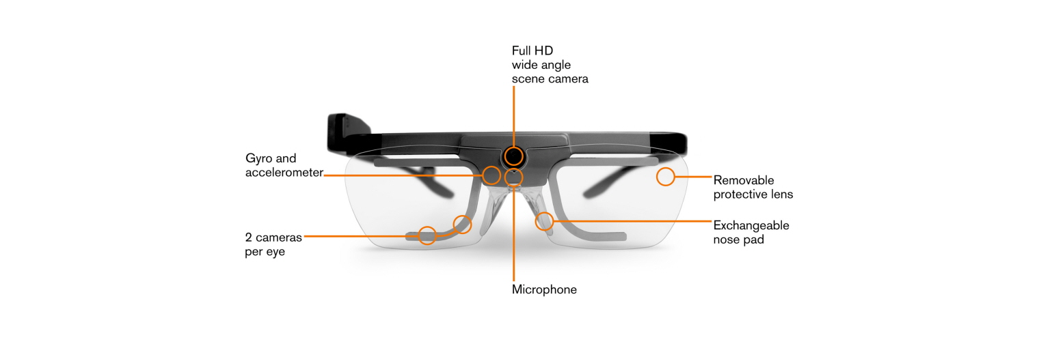

Figure 4.1: Tobii Pro Glasses 2; Source: <https://www.tobiipro.com/product-listing/tobii-pro-glasses-2/>

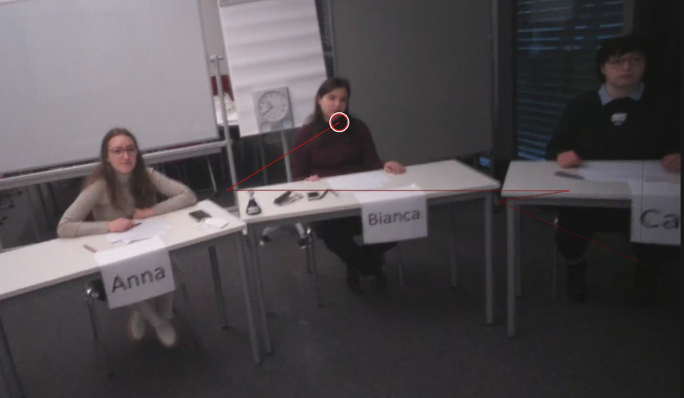

Figure 4.2: Teacher’s Gaze Point

### 4.2.2 Video and Audio recording equipment

The speech, sounds and voices of the participants were recorded with Zoom H3-VR Ambient Recorder (<https://zoomcorp.com/en/gb/handheld-recorders/handheld-recorders/h3-vr-360-audio-recorder/>) installed in the middle of the lab setting. The Zoom H3-VR recorded with four built-in mics arranged in an Ambisonic array with a bitrate of 4608 kBits/s.

Movements, facial expressions and gestures of the subjects were recorded by four Go Pro Hero 7 black cameras (<https://gopro.com/content/dam/help/hero7-black/manuals/HERO7Black_UM_ENG_REVC.pdf>) from different angles. The videos were recorded with a sampling rate of 50 Hz in a video resolution with 1920 x 1080 at 50 frames per second in 16:9 format with a linear field of view.

### 4.2.3 Questionnaire

After each micro-teaching-unit, the students answered items on teaching quality using a validated questionnaire (Helmke et al. 2014) and scales on the teacher’s presence behavior. In addition, participants were asked to give a self-assessment on classroom management by completing the questionnaire after each micro-teaching-unit. The questionnaire was a 4-point Likert scale (1 = Strongly Disagree; 2 = Disagree; 3 = Agree; 4 = Strongly Agree).

## 4.3 Procedure

In June 2021, the study was piloted with student teachers volunteers to refine the study procedure. Data collection was conducted between July 2021, and July 2022.

## 4.4 Data analysis

We investigated whether experts and novice teachers differed

All reported data analyses were conducted with the R (Version 4.1.3; R Core Team 2021) and the R-packages *ARTofR* (Version 0.3.3; Zhang 2021), *cowplot* (Version 1.1.1; Wilke 2020), *dplyr* (Version 1.0.8; Wickham et al. 2022), *forcats* (Version 0.5.1; Wickham 2021), *ggplot2* (Version 3.3.5; Wickham 2016), *gridExtra* (Version 2.3; Auguie 2017), *ltm* (Version 1.2.0; Rizopoulos 2006), *lubridate* (Version 1.8.0; Grolemund and Wickham 2011), *MASS* (Version 7.3.55; Venables and Ripley 2002), *moments* (Version 0.14; Komsta and Novomestky 2015), *msm* (Version 1.6.9; Jackson 2011), *needs* (Version 0.0.3; Katz 2016), *papaja* (Version 0.1.0.9997; Aust and Barth 2020), *polycor* (Version 0.8.1; Fox 2022), *purrr* (Version 0.3.4; Henry and Wickham 2020), *readr* (Version 2.1.1; Wickham, Hester, and Bryan 2021), *readxl* (Version 1.3.1; Wickham and Bryan 2019), *sjPlot* (Version 2.8.10; Lüdecke 2021), *stringr* (Version 1.4.0; Wickham 2019), *tibble* (Version 3.1.6; Müller and Wickham 2021), *tidyr* (Version 1.2.0; Wickham and Girlich 2022), *tidyverse* (Version 1.3.1; Wickham et al. 2019), *tinylabels* (Version 0.2.3; Barth 2022), *viridis* (Version 0.6.2; Garnier et al. 2021a, 2021b), and *viridisLite* (Version 0.4.0; Garnier et al. 2021b) and IBM SPSS 28.

# 5 Results

# 6 Discussion

# 7 References

Auguie, Baptiste. 2017. *gridExtra: Miscellaneous Functions for "Grid" Graphics*. <https://CRAN.R-project.org/package=gridExtra>.

Aust, Frederik, and Marius Barth. 2020. *papaja: Prepare Reproducible APA Journal Articles with R Markdown*. <https://github.com/crsh/papaja>.

Barth, Marius. 2022. *tinylabels: Lightweight Variable Labels*. <https://cran.r-project.org/package=tinylabels>.

Evertson, Carolyn M, Carol S Weinstein, et al. 2006. “Classroom Management as a Field of Inquiry.” *Handbook of Classroom Management: Research, Practice, and Contemporary Issues* 3 (1): 16.

Fox, John. 2022. *Polycor: Polychoric and Polyserial Correlations*. <https://CRAN.R-project.org/package=polycor>.

Garnier, Simon, Ross, Noam, Rudis, Robert, Camargo, et al. 2021a. *viridis - Colorblind-Friendly Color Maps for r*. <https://doi.org/10.5281/zenodo.4679424>.

———, et al. 2021b. *viridis - Colorblind-Friendly Color Maps for r*. <https://doi.org/10.5281/zenodo.4679424>.

Gold, Bernadette, and Manfred Holodynski. 2017. “Using Digital Video to Measure the Professional Vision of Elementary Classroom Management: Test Validation and Methodological Challenges.” *Computers & Education* 107: 13–30.

Goodwin, Charles. 2015. “Professional Vision.” In *Aufmerksamkeit*, 387–425. Springer.

Grolemund, Garrett, and Hadley Wickham. 2011. “Dates and Times Made Easy with lubridate.” *Journal of Statistical Software* 40 (3): 1–25. <https://www.jstatsoft.org/v40/i03/>.

Grub, Ann-Sophie, Antje Biermann, and Roland Brünken. 2020. “Process-Based Measurement of Professional Vision of (Prospective) Teachers in the Field of Classroom Management. A Systematic Review.” *Journal for Educational Research Online* 12 (3): 75–102.

Helmke, Andreas, Tuyet Helmke, Gerlinde Lenske, G Pham, Anna-Katharina Praetorius, Friedrich-Wilhelm Schrader, and Manuel AdeThurow. 2014. “Unterrichtsdiagnostik Mit EMU.” *Aus-Und Fortbildung Der Lehrkräfte in Hinblick Auf Verbesserung Der Diagnosefähigkeit, Umgang Mit Heterogenität Und Individuelle Förderung*, 149–63.

Henry, Lionel, and Hadley Wickham. 2020. *Purrr: Functional Programming Tools*. <https://CRAN.R-project.org/package=purrr>.

Jackson, Christopher H. 2011. “Multi-State Models for Panel Data: The msm Package for R.” *Journal of Statistical Software* 38 (8): 1–29. <https://www.jstatsoft.org/v38/i08/>.

Katz, Josh. 2016. *Needs: Attaches and Installs Packages*. <https://CRAN.R-project.org/package=needs>.

Komsta, Lukasz, and Frederick Novomestky. 2015. *Moments: Moments, Cumulants, Skewness, Kurtosis and Related Tests*. <https://CRAN.R-project.org/package=moments>.

Kounin, Jacob S. 2006. *Techniken Der Klassenführung*. Waxmann Verlag.

Lachner, Andreas, Halszka Jarodzka, and Matthias Nückles. 2016. “What Makes an Expert Teacher? Investigating Teachers’ Professional Vision and Discourse Abilities.” *Instructional Science* 44 (3): 197–203.

Lüdecke, Daniel. 2021. *sjPlot: Data Visualization for Statistics in Social Science*. <https://CRAN.R-project.org/package=sjPlot>.

Müller, Kirill, and Hadley Wickham. 2021. *Tibble: Simple Data Frames*. <https://CRAN.R-project.org/package=tibble>.

Palmer, Douglas J, Laura M Stough, Thomas K Burdenski Jr, and Maricela Gonzales. 2005. “Identifying Teacher Expertise: An Examination of Researchers’ Decision Making.” *Educational Psychologist* 40 (1): 13–25.

R Core Team. 2021. *R: A Language and Environment for Statistical Computing*. Vienna, Austria: R Foundation for Statistical Computing. <https://www.R-project.org/>.

Rizopoulos, Dimitris. 2006. “Ltm: An r Package for Latent Variable Modelling and Item Response Theory Analyses.” *Journal of Statistical Software* 17 (5): 1–25. <https://doi.org/10.18637/jss.v017.i05>.

Seidel, Tina, and Kathleen Stürmer. 2014. “Modeling and Measuring the Structure of Professional Vision in Preservice Teachers.” *American Educational Research Journal* 51 (4): 739–71.

Sherin, MG. 2007. “The Development of Teachers’ Professional Vision in Video Clubs. Video Research in the Learning Sciences. R. Goldman, r. Pea, b. Barron and SJ Derry.” Mahwah, NJ, Lawrence Erlbaum.

Van den Bogert, Niek, Jan van Bruggen, Danny Kostons, and Wim Jochems. 2014. “First Steps into Understanding Teachers’ Visual Perception of Classroom Events.” *Teaching and Teacher Education* 37: 208–16.

Venables, W. N., and B. D. Ripley. 2002. *Modern Applied Statistics with s*. Fourth. New York: Springer. <https://www.stats.ox.ac.uk/pub/MASS4/>.

Wickham, Hadley. 2016. *Ggplot2: Elegant Graphics for Data Analysis*. Springer-Verlag New York. <https://ggplot2.tidyverse.org>.

———. 2019. *Stringr: Simple, Consistent Wrappers for Common String Operations*. <https://CRAN.R-project.org/package=stringr>.

———. 2021. *Forcats: Tools for Working with Categorical Variables (Factors)*. <https://CRAN.R-project.org/package=forcats>.

Wickham, Hadley, Mara Averick, Jennifer Bryan, Winston Chang, Lucy D’Agostino McGowan, Romain François, Garrett Grolemund, et al. 2019. “Welcome to the tidyverse.” *Journal of Open Source Software* 4 (43): 1686. <https://doi.org/10.21105/joss.01686>.

Wickham, Hadley, and Jennifer Bryan. 2019. *Readxl: Read Excel Files*. <https://CRAN.R-project.org/package=readxl>.

Wickham, Hadley, Romain François, Lionel Henry, and Kirill Müller. 2022. *Dplyr: A Grammar of Data Manipulation*. <https://CRAN.R-project.org/package=dplyr>.

Wickham, Hadley, and Maximilian Girlich. 2022. *Tidyr: Tidy Messy Data*. <https://CRAN.R-project.org/package=tidyr>.

Wickham, Hadley, Jim Hester, and Jennifer Bryan. 2021. *Readr: Read Rectangular Text Data*. <https://CRAN.R-project.org/package=readr>.

Wilke, Claus O. 2020. *Cowplot: Streamlined Plot Theme and Plot Annotations for ’Ggplot2’*. <https://CRAN.R-project.org/package=cowplot>.

Wolff, Charlotte E, Halszka Jarodzka, Niek van den Bogert, and Henny Boshuizen. 2016. “Teacher Vision: Expert and Novice Teachers’ Perception of Problematic Classroom Management Scenes.” *Instructional Science* 44 (3): 243–65.

Zhang, Huanyuan. 2021. *ARTofR: Who Ever Care about the [Art of r] Scripts?* <https://CRAN.R-project.org/package=ARTofR>.