# **Scale analysis**

### **Self-Assessment**

Activation & support

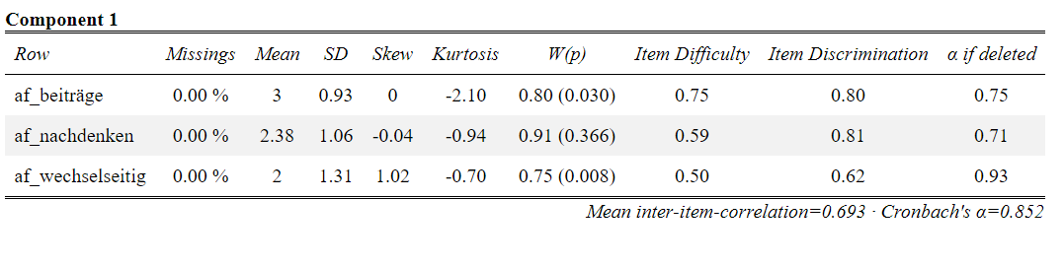

## Classroom management

## Clarity & structuredness

## Natural behaviour

## Postive clima and motivation

## Presence without subscales

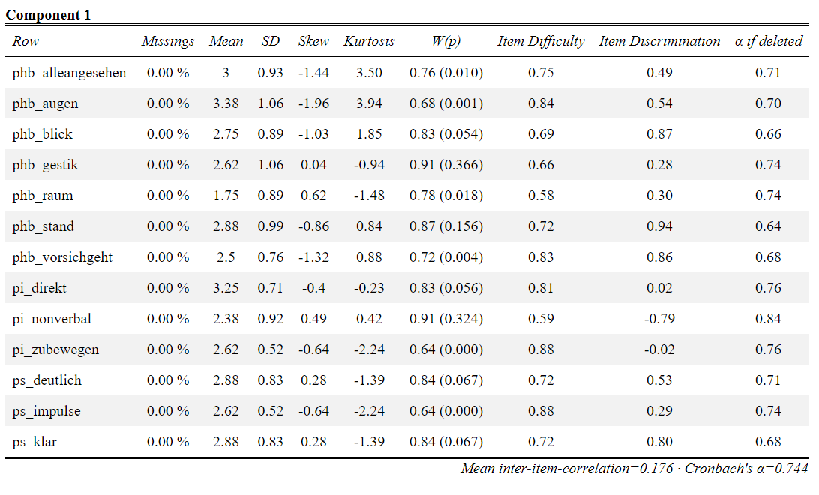

## Presence: posture & gaze

## Presence: voice

## Presence: verbal/non-verbal intervention

## **Visualization**

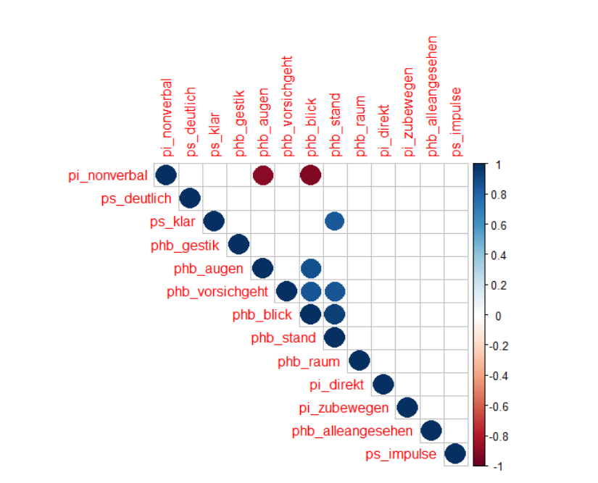**Positive correlations** are displayed in blue and **negative correlations** in red color.

Color intensity and the size of the circle are proportional to the **correlation coefficients**.

In the right side of the **correlogram**, the legend color shows the **correlation coefficients** and the corresponding colors.

### **Students‘ perception**

## Activation & support

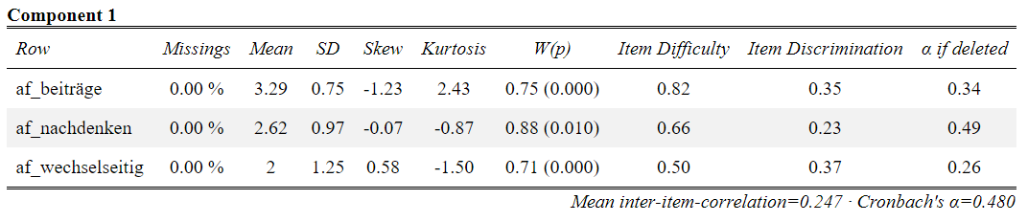

## Classroom management

## Clarity & structuredness

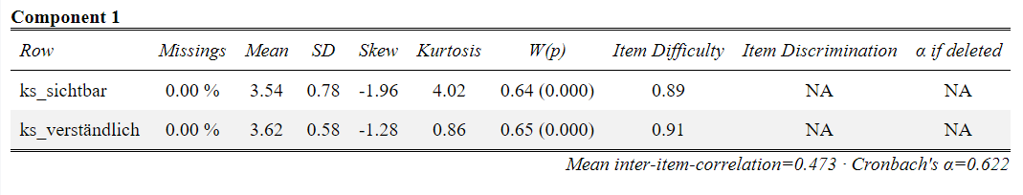

## Natural behavior

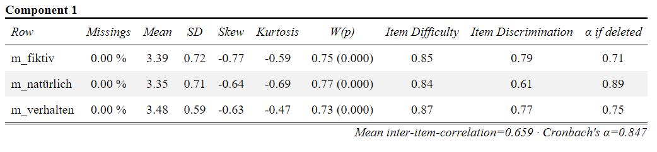

## Postive clima and motivation

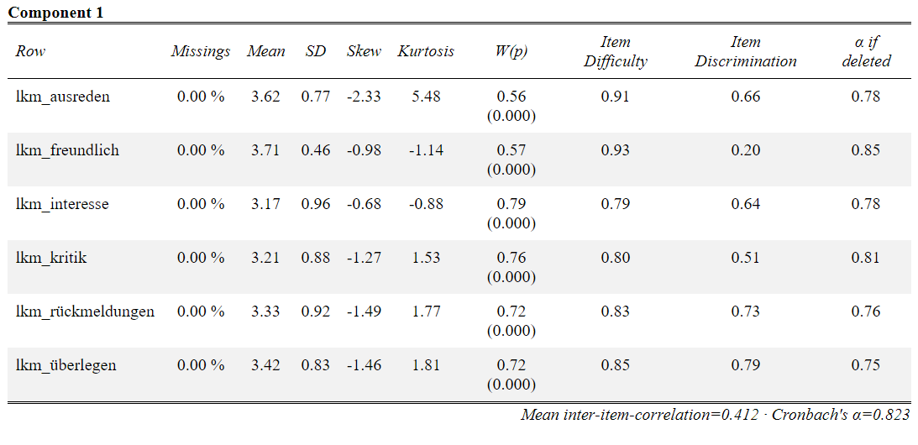

## Presence without subscales

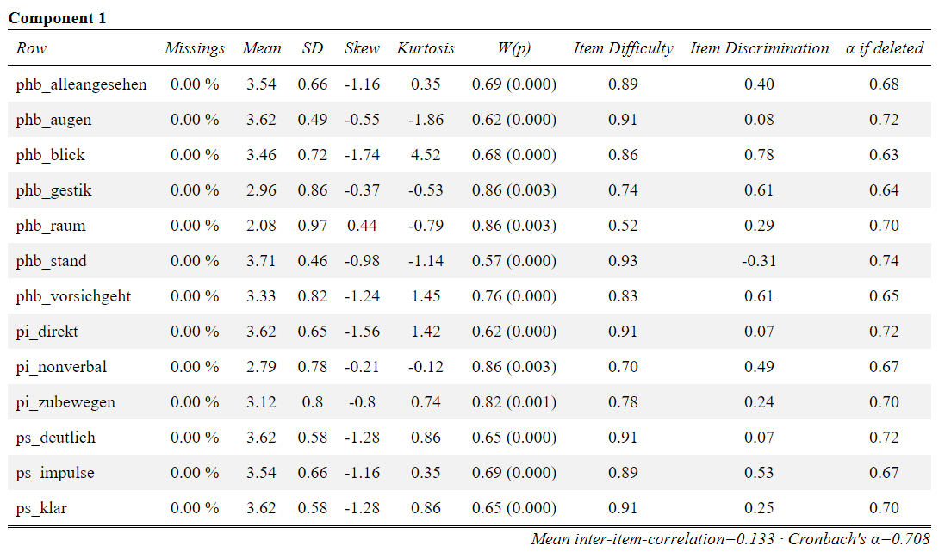

## Presence: posture & gaze

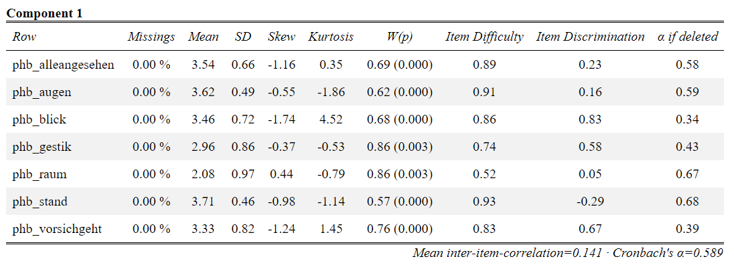

## Presence: voice

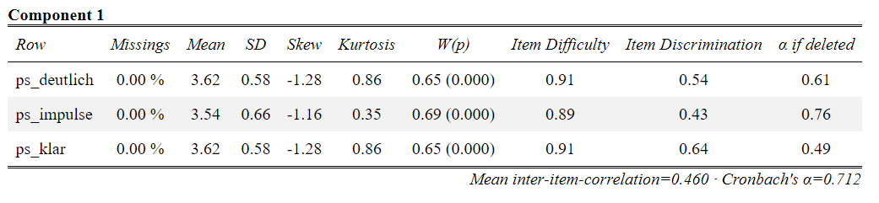

## Presence: verbal/non-verbal intervention

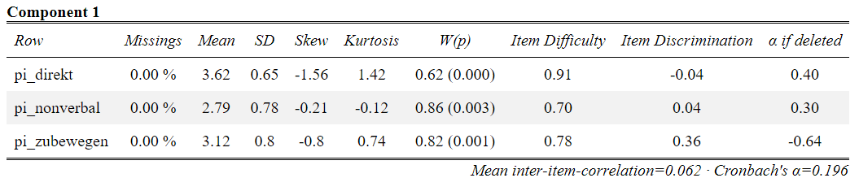

## **Visualization**

**Positive correlations** are displayed in blue and **negative correlations** in red color.

Color intensity and the size of the circle are proportional to the **correlation coefficients**.

In the right side of the **correlogram**, the legend color shows the **correlation coefficients** and the corresponding colors.

