Through the eyes of the teacher

This document is a supplement to the paper and shows first graphs findings from the pilot study.

# 1 State of research

Teaching and classroom management are multidimensional settings in which teachers have to respond immediately to events as they develop (Barnes 2004). The different interests and abilities of students must be managed in a way that maximizes the active learning time of students and minimizes disruptions whilst teaching. Learning to develop such classroom management skills and to teach effectively is a complicated and complex process (Wolff, Jarodzka, and Boshuizen 2017).

During teaching, teachers must be able to select from a variety of visual and acoustic impressions to focus their attention on the essential and to distinguish between relevant and irrelevant events. This ability is called professional vision and is a key component of teacher expertise and successful teaching (Barth 2017). Eye tracking technology has become a reliable means to study teachers’ visual focus of attention (Pouta, Lehtinen, and Palonen 2020; Bogert 2016; Wolff, Jarodzka, and Boshuizen 2017)

Educational research has repeatedly shown that there are differences between experienced and novice teachers in terms of perception and behavioral competencies (Barth 2017; Bogert 2016; Wolff, Jarodzka, and Boshuizen 2017). For example, experts direct their attention more often and more evenly to all students, whereas novices only direct their attention to some students. The frequency and duration of fixations as eye movement are decisive (Stuermer et al. 2017). Mobile eye-tracking technology has also shown that experienced teachers distribute their focus more efficiently to solve tasks (Jarodzka et al. 2010). Furthermore, in contrast to novices, experts are able to focus their attention on the entire class and guide the class while giving feedback to individual students and answering questions (Cortina et al. 2015).

## 1.1 Research questions

The aim of the pilot study was to investigate whether there are differences in how expert and novice teachers manage scripted classroom disruptions. The disruptions were experimentally varied using a previously written script. Thus, our aim was to find out whether differences in the allocation of attention between expertise groups can be detected in this controlled context.

In order to answer this question, the hypothesis was formulated that teachers with more professional experience not only notice more disruptions but also notice them faster. In the hypothesis, therefore, it is necessary to check what has already been shown in the research literature: In complex teaching situations, experts have a more structured and elaborate professional knowledge than novices in order to perceive and interpret relevant events and to act appropriately (Berliner 2001; Lachner, Jarodzka, and Nückles 2016).

# 2 Methods

We report how we determined our sample size, all data exclusions (if any), all manipulations, and all measures in the study.

## 2.1 Participants

For the sample recruitment of the subjects (N = 8, experts n = 2, novices n = 6), schools in the city of Leipzig in Saxony were contacted. The institutions as well as the subjects were informed in detail about the aim and intention of the study in advance. Participation in the study was voluntary and only took place after written consent has been given.

Table 2.1:

*Demographic Informationand and Teaching Experience*

|  |  |  |  |  |  |  |  |  |  |  |
| --- | --- | --- | --- | --- | --- | --- | --- | --- | --- | --- |
| group | N | Male | M age | Min age | Max age | SD age | M exp. | Min exp. | Max exp. | SD exp. |
| expert | 2 | 1 | 47.50 | 44 | 51 | 4.95 | 20.00 | 15.00 | 25.00 | 7.07 |
| novice | 6 | 2 | 25.67 | 20 | 33 | 4.89 | 0.68 | 0.00 | 1.50 | 0.68 |

The selection of the subjects was based on extreme groups, whereby professional experience is the crucial criterion for the selection of experts or novices. Novices were recruited as teachers who have been working in the teaching profession for no more than 3 years, whereas experts were considered to have professional experience of 10 years or more (Messner and Reusser 2000).

## 2.2 Procedure/ Data collection

### 2.2.1 Set up

For this study, scripted mini-lessons with n = 2 experts and n = 6 novices were recorded in the mobile Lab of the Empirical School and Classroom Research at the University of Leipzig. The subjects were divided into groups of four, so the study was conducted on two different sessions. All participants were asked to hold a 10-minute lesson. The duration of each appointment was approximately 2h: per group 10min briefing, 4 x 10min mini-lessons, 10min technical preparation and follow-up and 4x 10min transition points between the lessons and answering questionnaires.

One person from the group of 4 acted as a teacher, the other three subjects acted as the class. The subjects, who represented the class, were given behavioral instructions in a pre-written script to simulate typical events and disruptions in the classroom (e.g. putting their heads on the table, chatting, looking at their mobile phones, etc.).

The lesson disruptions were displayed as instructions during the lesson for all “students” but not the teacher. In order to avoid learning effects, the disruptions in each lesson were distributed pseudo-randomly over the short teaching phase. In addition, the order of the data collection was taken into account in the analyses and variance caused by order was controlled.

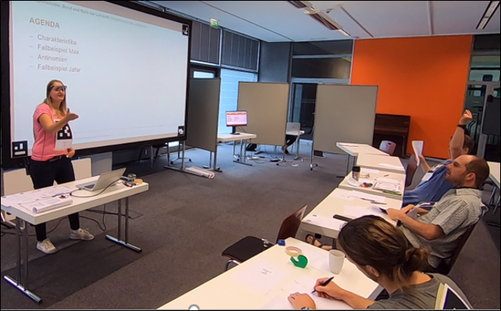

Figure 2.1: Example for set up during a mini-lesson

### 2.2.2 Questionnaire data

After each mini-lesson, the students answered items on the teaching quality using a validated questionnaire (Helmke et al. 2014) and scales on the teacher’s presence behavior (students n = 24). In addition, the teacher was asked to give a self-assessment on his/her classroom management by completing the questionnaire after each mini-lesson (teachers n = 8).

### 2.2.3 Behavioral data

The speech, sounds and voices were recorded with an audio recorder installed in the middle of the Lab. Movements, facial expressions and gestures of the subjects were recorded by four cameras from different angles. One camera was installed to film the class from the side. Two more cameras were installed on the blackboard and at the end of the Lab to film the teacher and class from the front and back. Furthermore, the fourth camera was installed in such a way that only facial expressions and gestures of the teacher were recorded, which enables a semi-automated analysis of the movement sequences.

### 2.2.4 Eyetracking data

A binocular Tobii Pro Glasses 2 eye-tracker consisting of a wearable head unit and a recording unit was used to record the eye movements of all 8 participants. The head unit is a measuring device with different sensitive sensors. A high-definition scene camera captures a full HD video and an integrated microphone records the surrounding sounds. Infrared light illuminators support the eye tracking sensors which record the eye orientation. The videos were recorded with a sampling rate of 50 Hz and a video resolution with 1920 x 1080 at 25 frames per second. The scene camera has a field of view of 90 deg. in 16:9 format (82 deg. horizontal and 52 deg. vertical) and has a frame dimension of 179 x 159 x 57mm (width x depth x height). The Tobii Pro Glasses Controller software was used to record and calibrate the eye movements.

## 2.3 Coding/ Data preparation/ Reliability

### 2.3.1 Questionnaire Data

The evaluation after each mini-lesson was conducted using paper questionnaires. Time needed to complete the questionnaire was about 5 minutes. The scales on the quality of teaching are a validated questionnaire (Helmke et al. 2014). Whereas the scales on the teacher’s presence behavior were derived from the research literature (Brophy 1986; Kiel et al. 2013; Kounin 2006; Marzano 2007; Nolting 2012) and were used in the pilot for the first time. The questionnaire is 4-point Likert scale (1 = Strongly Disagree; 2 = Disagree; 3 = Agree; 4 = Strongly Agree). Data was obtained from N = 32 subjects (students n = 24, teachers n = 8).

The following scales were assessed:

1. Classroom management
2. Positive climate and motivation
3. Clarity and structuredness
4. Activation and support
5. Presence: posture/gaze
6. Presence: voice
7. Presence: verbal and non-verbal intervention
8. Natural behaviour

Table 2.2 provides an overview over the mean, the standard deviation, the range, Cronbach’s Alpha and the Skewness & Kurtosis of all scales for the teachers’ self-assessment.

##   
## Reliability analysis   
## Call: alpha(x = self.as.wide[, -1])  
##   
## raw_alpha std.alpha G6(smc) average_r S/N ase mean sd median_r  
## 0.85 0.87 0.85 0.69 6.8 0.095 2.5 0.97 0.62  
##   
## lower alpha upper 95% confidence boundaries  
## 0.67 0.85 1.04   
##   
## Reliability if an item is dropped:  
## raw_alpha std.alpha G6(smc) average_r S/N alpha se var.r  
## af_beiträge 0.75 0.76 0.62 0.62 3.2 0.169 NA  
## af_nachdenken 0.71 0.74 0.59 0.59 2.9 0.185 NA  
## af_wechselseitig 0.93 0.93 0.87 0.87 13.7 0.049 NA  
## med.r  
## af_beiträge 0.62  
## af_nachdenken 0.59  
## af_wechselseitig 0.87  
##   
## Item statistics   
## n raw.r std.r r.cor r.drop mean sd  
## af_beiträge 8 0.90 0.92 0.90 0.80 3.0 0.93  
## af_nachdenken 8 0.92 0.93 0.92 0.81 2.4 1.06  
## af_wechselseitig 8 0.86 0.82 0.65 0.62 2.0 1.31  
##   
## Non missing response frequency for each item  
## 1 2 3 4 miss  
## af_beiträge 0.00 0.38 0.25 0.38 0  
## af_nachdenken 0.25 0.25 0.38 0.12 0  
## af_wechselseitig 0.50 0.25 0.00 0.25 0

## Warning in alpha(self.cs.wide[, -1]): Some items were negatively correlated with the total scale and probably   
## should be reversed.   
## To do this, run the function again with the 'check.keys=TRUE' option

## Some items ( ks_sichtbar ) were negatively correlated with the total scale and   
## probably should be reversed.   
## To do this, run the function again with the 'check.keys=TRUE' option

## Warning in sqrt(Vtc): NaNs wurden erzeugt

##   
## Reliability analysis   
## Call: alpha(x = self.cs.wide[, -1])  
##   
## raw_alpha std.alpha G6(smc) average_r S/N ase mean sd median_r  
## -0.76 -1.1 -0.36 -0.36 -0.53 0.94 2.8 0.53 -0.36  
##   
## lower alpha upper 95% confidence boundaries  
## -2.6 -0.76 1.08   
##   
## Reliability if an item is dropped:  
## raw_alpha std.alpha G6(smc) average_r S/N alpha se var.r  
## ks_sichtbar -0.75 -0.36 0.13 -0.36 -0.26 NA 0  
## ks_verständlich -0.17 -0.36 0.13 -0.36 -0.26 NA 0  
## med.r  
## ks_sichtbar -0.36  
## ks_verständlich -0.36  
##   
## Item statistics   
## n raw.r std.r r.cor r.drop mean sd  
## ks_sichtbar 8 0.88 0.57 NaN -0.36 3.1 1.13  
## ks_verständlich 8 0.13 0.57 NaN -0.36 2.5 0.53  
##   
## Non missing response frequency for each item  
## 1 2 3 4 miss  
## ks_sichtbar 0.12 0.12 0.25 0.5 0  
## ks_verständlich 0.00 0.50 0.50 0.0 0

##   
## Reliability analysis   
## Call: alpha(x = self.cm.wide[, -1])  
##   
## raw_alpha std.alpha G6(smc) average_r S/N ase mean sd median_r  
## 0.83 0.82 0.93 0.54 4.6 0.084 2.4 0.72 0.55  
##   
## lower alpha upper 95% confidence boundaries  
## 0.67 0.83 1   
##   
## Reliability if an item is dropped:  
## raw_alpha std.alpha G6(smc) average_r S/N alpha se var.r med.r  
## km_aktiv 0.84 0.83 0.83 0.62 5.0 0.091 0.049 0.57  
## km_klar 0.71 0.68 0.86 0.42 2.2 0.172 0.167 0.44  
## km_mitbekommen 0.89 0.89 0.94 0.74 8.4 0.070 0.033 0.82  
## km_ungestört 0.65 0.63 0.70 0.37 1.7 0.182 0.101 0.53  
##   
## Item statistics   
## n raw.r std.r r.cor r.drop mean sd  
## km_aktiv 8 0.73 0.73 0.71 0.56 2.0 0.76  
## km_klar 8 0.93 0.92 0.90 0.84 2.5 1.07  
## km_mitbekommen 8 0.60 0.62 0.51 0.40 2.8 0.71  
## km_ungestört 8 0.97 0.97 0.99 0.93 2.5 0.93  
##   
## Non missing response frequency for each item  
## 1 2 3 4 miss  
## km_aktiv 0.25 0.50 0.25 0.00 0  
## km_klar 0.12 0.50 0.12 0.25 0  
## km_mitbekommen 0.00 0.38 0.50 0.12 0  
## km_ungestört 0.12 0.38 0.38 0.12 0

##   
## Reliability analysis   
## Call: alpha(x = self.nb.wide[, -1])  
##   
## raw_alpha std.alpha G6(smc) average_r S/N ase mean sd median_r  
## 0.9 0.9 0.87 0.76 9.4 0.061 2.8 0.71 0.76  
##   
## lower alpha upper 95% confidence boundaries  
## 0.78 0.9 1.02   
##   
## Reliability if an item is dropped:  
## raw_alpha std.alpha G6(smc) average_r S/N alpha se var.r med.r  
## m_fiktiv 0.91 0.91 0.83 0.83 10.1 0.065 NA 0.83  
## m_natürlich 0.81 0.81 0.68 0.68 4.2 0.135 NA 0.68  
## m_verhalten 0.86 0.86 0.76 0.76 6.4 0.096 NA 0.76  
##   
## Item statistics   
## n raw.r std.r r.cor r.drop mean sd  
## m_fiktiv 8 0.88 0.89 0.79 0.75 3.0 0.76  
## m_natürlich 8 0.94 0.94 0.92 0.87 2.6 0.74  
## m_verhalten 8 0.92 0.91 0.86 0.81 2.9 0.83  
##   
## Non missing response frequency for each item  
## 2 3 4 miss  
## m_fiktiv 0.25 0.50 0.25 0  
## m_natürlich 0.50 0.38 0.12 0  
## m_verhalten 0.38 0.38 0.25 0

##   
## Reliability analysis   
## Call: alpha(x = self.pcm.wide[, -1])  
##   
## raw_alpha std.alpha G6(smc) average_r S/N ase mean sd median_r  
## 0.78 0.78 0.97 0.37 3.5 0.11 2.9 0.61 0.41  
##   
## lower alpha upper 95% confidence boundaries  
## 0.57 0.78 1   
##   
## Reliability if an item is dropped:  
## raw_alpha std.alpha G6(smc) average_r S/N alpha se var.r  
## lkm_ausreden 0.81 0.81 0.88 0.47 4.4 0.10 0.083  
## lkm_freundlich 0.80 0.78 0.91 0.41 3.5 0.09 0.120  
## lkm_interesse 0.73 0.74 0.98 0.36 2.8 0.15 0.114  
## lkm_kritik 0.69 0.66 0.84 0.28 2.0 0.16 0.122  
## lkm_rückmeldungen 0.67 0.68 0.79 0.30 2.1 0.18 0.088  
## lkm_überlegen 0.77 0.78 0.88 0.41 3.5 0.12 0.091  
## med.r  
## lkm_ausreden 0.48  
## lkm_freundlich 0.46  
## lkm_interesse 0.41  
## lkm_kritik 0.24  
## lkm_rückmeldungen 0.41  
## lkm_überlegen 0.43  
##   
## Item statistics   
## n raw.r std.r r.cor r.drop mean sd  
## lkm_ausreden 8 0.32 0.46 0.46 0.20 3.2 0.46  
## lkm_freundlich 8 0.51 0.59 0.59 0.31 3.1 0.83  
## lkm_interesse 8 0.80 0.72 0.66 0.63 2.6 1.19  
## lkm_kritik 8 0.88 0.90 0.91 0.82 3.0 0.76  
## lkm_rückmeldungen 8 0.91 0.86 0.87 0.85 2.5 0.93  
## lkm_überlegen 8 0.66 0.60 0.60 0.48 2.6 0.92  
##   
## Non missing response frequency for each item  
## 1 2 3 4 miss  
## lkm_ausreden 0.00 0.00 0.75 0.25 0  
## lkm_freundlich 0.00 0.25 0.38 0.38 0  
## lkm_interesse 0.25 0.12 0.38 0.25 0  
## lkm_kritik 0.00 0.25 0.50 0.25 0  
## lkm_rückmeldungen 0.12 0.38 0.38 0.12 0  
## lkm_überlegen 0.12 0.25 0.50 0.12 0

## Warning in cor.smooth(r): Matrix was not positive definite, smoothing was done

## In factor.stats, I could not find the RMSEA upper bound . Sorry about that

## Warning in cor.smooth(R): Matrix was not positive definite, smoothing was done

## Warning in cor.smooth(R): Matrix was not positive definite, smoothing was done  
  
## Warning in cor.smooth(R): Matrix was not positive definite, smoothing was done

##   
## Reliability analysis   
## Call: alpha(x = self.ppg.wide[, -1])  
##   
## raw_alpha std.alpha G6(smc) average_r S/N ase mean sd median_r  
## 0.85 0.86 0.94 0.47 6.3 0.077 2.7 0.69 0.45  
##   
## lower alpha upper 95% confidence boundaries  
## 0.7 0.85 1.01   
##   
## Reliability if an item is dropped:  
## raw_alpha std.alpha G6(smc) average_r S/N alpha se var.r  
## phb_alleangesehen 0.87 0.88 0.97 0.55 7.3 0.072 0.099  
## phb_augen 0.81 0.82 0.98 0.44 4.7 0.104 0.113  
## phb_blick 0.79 0.80 0.99 0.40 3.9 0.114 0.102  
## phb_gestik 0.88 0.88 0.96 0.56 7.5 0.066 0.081  
## phb_raum 0.88 0.89 0.97 0.57 8.1 0.068 0.078  
## phb_stand 0.78 0.80 0.86 0.40 4.0 0.118 0.107  
## phb_vorsichgeht 0.80 0.80 0.94 0.40 3.9 0.108 0.110  
## med.r  
## phb_alleangesehen 0.49  
## phb_augen 0.45  
## phb_blick 0.42  
## phb_gestik 0.52  
## phb_raum 0.62  
## phb_stand 0.42  
## phb_vorsichgeht 0.42  
##   
## Item statistics   
## n raw.r std.r r.cor r.drop mean sd  
## phb_alleangesehen 8 0.51 0.52 0.46 0.35 3.0 0.93  
## phb_augen 8 0.85 0.84 0.83 0.76 3.4 1.06  
## phb_blick 8 0.96 0.96 0.98 0.94 2.8 0.89  
## phb_gestik 8 0.52 0.50 0.48 0.33 2.6 1.06  
## phb_raum 8 0.43 0.45 0.36 0.26 1.8 0.89  
## phb_stand 8 0.95 0.95 0.97 0.93 2.9 0.99  
## phb_vorsichgeht 8 0.96 0.96 0.96 0.94 2.5 0.76  
##   
## Non missing response frequency for each item  
## 1 2 3 4 miss  
## phb_alleangesehen 0.12 0.00 0.62 0.25 0  
## phb_augen 0.12 0.00 0.25 0.62 0  
## phb_blick 0.12 0.12 0.62 0.12 0  
## phb_gestik 0.12 0.38 0.25 0.25 0  
## phb_raum 0.50 0.25 0.25 0.00 0  
## phb_stand 0.12 0.12 0.50 0.25 0  
## phb_vorsichgeht 0.12 0.25 0.62 0.00 0

##   
## Reliability analysis   
## Call: alpha(x = self.pv.wide[, -1])  
##   
## raw_alpha std.alpha G6(smc) average_r S/N ase mean sd median_r  
## 0.77 0.76 0.82 0.51 3.2 0.12 2.8 0.62 0.54  
##   
## lower alpha upper 95% confidence boundaries  
## 0.53 0.77 1.01   
##   
## Reliability if an item is dropped:  
## raw_alpha std.alpha G6(smc) average_r S/N alpha se var.r med.r  
## ps_deutlich 0.65 0.70 0.54 0.54 2.32 0.213 NA 0.54  
## ps_impulse 0.89 0.89 0.79 0.79 7.75 0.081 NA 0.79  
## ps_klar 0.31 0.34 0.21 0.21 0.52 0.434 NA 0.21  
##   
## Item statistics   
## n raw.r std.r r.cor r.drop mean sd  
## ps_deutlich 8 0.87 0.81 0.76 0.64 2.9 0.83  
## ps_impulse 8 0.62 0.71 0.52 0.39 2.6 0.52  
## ps_klar 8 0.96 0.95 0.95 0.88 2.9 0.83  
##   
## Non missing response frequency for each item  
## 2 3 4 miss  
## ps_deutlich 0.38 0.38 0.25 0  
## ps_impulse 0.38 0.62 0.00 0  
## ps_klar 0.38 0.38 0.25 0

## Warning in alpha(self.pvni.wide[, -1]): Some items were negatively correlated with the total scale and probably   
## should be reversed.   
## To do this, run the function again with the 'check.keys=TRUE' option

## Some items ( pi_nonverbal ) were negatively correlated with the total scale and   
## probably should be reversed.   
## To do this, run the function again with the 'check.keys=TRUE' option

## Warning in sqrt(Vtc): NaNs wurden erzeugt

##   
## Reliability analysis   
## Call: alpha(x = self.pvni.wide[, -1])  
##   
## raw_alpha std.alpha G6(smc) average_r S/N ase mean sd median_r  
## -0.75 -0.81 -0.42 -0.18 -0.45 1 2.8 0.35 -0.17  
##   
## lower alpha upper 95% confidence boundaries  
## -2.76 -0.75 1.26   
##   
## Reliability if an item is dropped:  
## raw_alpha std.alpha G6(smc) average_r S/N alpha se var.r med.r  
## pi_direkt -0.58 -0.72 -0.264 -0.264 -0.42 0.95 NA -0.264  
## pi_nonverbal -0.21 -0.22 -0.098 -0.098 -0.18 0.81 NA -0.098  
## pi_zubewegen -0.38 -0.40 -0.165 -0.165 -0.28 0.94 NA -0.165  
##   
## Item statistics   
## n raw.r std.r r.cor r.drop mean sd  
## pi_direkt 8 0.49 0.53 NaN -0.22 3.2 0.71  
## pi_nonverbal 8 0.64 0.41 NaN -0.30 2.4 0.92  
## pi_zubewegen 8 0.20 0.46 NaN -0.29 2.6 0.52  
##   
## Non missing response frequency for each item  
## 1 2 3 4 miss  
## pi_direkt 0.00 0.12 0.50 0.38 0  
## pi_nonverbal 0.12 0.50 0.25 0.12 0  
## pi_zubewegen 0.00 0.38 0.62 0.00 0

## Warning in cor.smooth(r): Matrix was not positive definite, smoothing was done

## Warning in alpha(self.p.wide[, -1]): Some items were negatively correlated with the total scale and probably   
## should be reversed.   
## To do this, run the function again with the 'check.keys=TRUE' option

## Some items ( pi_nonverbal ) were negatively correlated with the total scale and   
## probably should be reversed.   
## To do this, run the function again with the 'check.keys=TRUE' option

## Warning in cor.smooth(R): Matrix was not positive definite, smoothing was done

## In smc, smcs < 0 were set to .0

## Warning in cor.smooth(R): Matrix was not positive definite, smoothing was done

## In smc, smcs < 0 were set to .0

## Warning in cor.smooth(R): Matrix was not positive definite, smoothing was done

## In smc, smcs < 0 were set to .0

## Warning in cor.smooth(R): Matrix was not positive definite, smoothing was done

## In smc, smcs < 0 were set to .0

## Warning in cor.smooth(R): Matrix was not positive definite, smoothing was done

## In smc, smcs < 0 were set to .0

## Warning in cor.smooth(R): Matrix was not positive definite, smoothing was done

## In smc, smcs < 0 were set to .0

## Warning in cor.smooth(R): Matrix was not positive definite, smoothing was done

## In smc, smcs < 0 were set to .0

## Warning in cor.smooth(R): Matrix was not positive definite, smoothing was done

## In smc, smcs < 0 were set to .0

## Warning in cor.smooth(R): Matrix was not positive definite, smoothing was done

## In smc, smcs < 0 were set to .0

## Warning in cor.smooth(R): Matrix was not positive definite, smoothing was done

## In smc, smcs < 0 were set to .0

## Warning in cor.smooth(R): Matrix was not positive definite, smoothing was done

## In smc, smcs < 0 were set to .0

## Warning in cor.smooth(R): Matrix was not positive definite, smoothing was done

## In smc, smcs < 0 were set to .0

## Warning in cor.smooth(R): Matrix was not positive definite, smoothing was done

## In smc, smcs < 0 were set to .0

## Warning in cor.smooth(R): Matrix was not positive definite, smoothing was done

## In smc, smcs < 0 were set to .0

## Warning in cor.smooth(R): Matrix was not positive definite, smoothing was done

## In smc, smcs < 0 were set to .0

##   
## Reliability analysis   
## Call: alpha(x = self.p.wide[, -1])  
##   
## raw_alpha std.alpha G6(smc) average_r S/N ase mean sd median_r  
## 0.74 0.74 0.73 0.18 2.8 0.1 2.7 0.42 0.18  
##   
## lower alpha upper 95% confidence boundaries  
## 0.54 0.74 0.95   
##   
## Reliability if an item is dropped:  
## raw_alpha std.alpha G6(smc) average_r S/N var.r med.r  
## phb_alleangesehen 0.71 0.70 0.74 0.16 2.3 0.20 0.159  
## phb_augen 0.70 0.70 0.72 0.16 2.4 0.18 0.159  
## phb_blick 0.66 0.66 0.67 0.14 1.9 0.17 0.145  
## phb_gestik 0.74 0.73 0.75 0.19 2.8 0.20 0.178  
## phb_raum 0.74 0.72 0.72 0.18 2.6 0.20 0.178  
## phb_stand 0.65 0.65 0.67 0.14 1.9 0.17 0.129  
## phb_vorsichgeht 0.68 0.66 0.68 0.14 1.9 0.18 0.096  
## pi_direkt 0.76 0.76 0.75 0.21 3.1 0.21 0.273  
## pi_nonverbal 0.84 0.83 0.81 0.29 4.9 0.12 0.291  
## pi_zubewegen 0.76 0.76 0.78 0.21 3.1 0.21 0.214  
## ps_deutlich 0.71 0.70 0.77 0.17 2.4 0.20 0.145  
## ps_impulse 0.74 0.72 0.74 0.18 2.6 0.21 0.202  
## ps_klar 0.68 0.66 0.69 0.14 2.0 0.19 0.130  
##   
## Item statistics   
## n raw.r std.r r.cor r.drop mean sd  
## phb_alleangesehen 8 0.617 0.65 0.644 0.495 3.0 0.93  
## phb_augen 8 0.673 0.62 0.587 0.545 3.4 1.06  
## phb_blick 8 0.908 0.88 0.845 0.872 2.8 0.89  
## phb_gestik 8 0.453 0.38 0.257 0.280 2.6 1.06  
## phb_raum 8 0.439 0.49 0.389 0.296 1.8 0.89  
## phb_stand 8 0.956 0.92 0.891 0.935 2.9 0.99  
## phb_vorsichgeht 8 0.893 0.87 0.834 0.859 2.5 0.76  
## pi_direkt 8 0.147 0.18 0.023 0.019 3.2 0.71  
## pi_nonverbal 8 -0.723 -0.71 -1.014 -0.789 2.4 0.92  
## pi_zubewegen 8 0.075 0.17 0.072 -0.019 2.6 0.52  
## ps_deutlich 8 0.638 0.60 0.622 0.534 2.9 0.83  
## ps_impulse 8 0.376 0.47 0.452 0.291 2.6 0.52  
## ps_klar 8 0.855 0.86 0.819 0.805 2.9 0.83  
##   
## Non missing response frequency for each item  
## 1 2 3 4 miss  
## phb_alleangesehen 0.12 0.00 0.62 0.25 0  
## phb_augen 0.12 0.00 0.25 0.62 0  
## phb_blick 0.12 0.12 0.62 0.12 0  
## phb_gestik 0.12 0.38 0.25 0.25 0  
## phb_raum 0.50 0.25 0.25 0.00 0  
## phb_stand 0.12 0.12 0.50 0.25 0  
## phb_vorsichgeht 0.12 0.25 0.62 0.00 0  
## pi_direkt 0.00 0.12 0.50 0.38 0  
## pi_nonverbal 0.12 0.50 0.25 0.12 0  
## pi_zubewegen 0.00 0.38 0.62 0.00 0  
## ps_deutlich 0.00 0.38 0.38 0.25 0  
## ps_impulse 0.00 0.38 0.62 0.00 0  
## ps_klar 0.00 0.38 0.38 0.25 0

Component 1

Row

Missings

Mean

SD

Skew

Kurtosis

W(p)

Item Difficulty

Item Discrimination

α if deleted

af_beitrÃ¤ge

0.00 %

3

0.93

0

-2.10

0.80 (0.030)

0.75

0.80

0.75

af_nachdenken

0.00 %

2.38

1.06

-0.04

-0.94

0.91 (0.366)

0.59

0.81

0.71

af_wechselseitig

0.00 %

2

1.31

1.02

-0.70

0.75 (0.008)

0.50

0.62

0.93

Mean inter-item-correlation=0.693 · Cronbach’s α=0.852

Component 1

Row

Missings

Mean

SD

Skew

Kurtosis

W(p)

Item Difficulty

Item Discrimination

α if deleted

km_aktiv

0.00 %

2

0.76

0

-0.70

0.85 (0.093)

0.67

0.56

0.83

km_klar

0.00 %

2.5

1.07

0.47

-0.83

0.86 (0.120)

0.62

0.84

0.71

km_mitbekommen

0.00 %

2.75

0.71

0.4

-0.23

0.83 (0.056)

0.69

0.40

0.89

km_ungestÃ¶rt

0.00 %

2.5

0.93

0

0.00

0.93 (0.522)

0.62

0.93

0.66

Mean inter-item-correlation=0.536 · Cronbach’s α=0.835

## Warning: Data frame needs at least three columns for reliability-test.

Component 1

Row

Missings

Mean

SD

Skew

Kurtosis

W(p)

Item Difficulty

Item Discrimination

α if deleted

ks_sichtbar

0.00 %

3.12

1.13

-1.11

0.29

0.81 (0.036)

0.78

NA

NA

ks_verstÃ¤ndlich

0.00 %

2.5

0.53

0

-2.80

0.66 (0.001)

0.83

NA

NA

Mean inter-item-correlation=-0.356 · Cronbach’s α=-0.762

Component 1

Row

Missings

Mean

SD

Skew

Kurtosis

W(p)

Item Difficulty

Item Discrimination

α if deleted

m_fiktiv

0.00 %

3

0.76

0

-0.70

0.85 (0.093)

0.75

0.75

0.91

m_natÃ¼rlich

0.00 %

2.62

0.74

0.82

-0.15

0.80 (0.027)

0.66

0.87

0.81

m_verhalten

0.00 %

2.88

0.83

0.28

-1.39

0.84 (0.067)

0.72

0.81

0.86

Mean inter-item-correlation=0.758 · Cronbach’s α=0.902

Component 1

Row

Missings

Mean

SD

Skew

Kurtosis

W(p)

Item Difficulty

Item Discrimination

α if deleted

lkm_ausreden

0.00 %

3.25

0.46

1.44

0.00

0.57 (0.000)

0.81

0.20

0.81

lkm_freundlich

0.00 %

3.12

0.83

-0.28

-1.39

0.84 (0.067)

0.78

0.31

0.80

lkm_interesse

0.00 %

2.62

1.19

-0.39

-1.23

0.87 (0.168)

0.66

0.63

0.73

lkm_kritik

0.00 %

3

0.76

0

-0.70

0.85 (0.093)

0.75

0.82

0.69

lkm_rÃ¼ckmeldungen

0.00 %

2.5

0.93

0

0.00

0.93 (0.522)

0.62

0.85

0.67

lkm_Ã¼berlegen

0.00 %

2.62

0.92

-0.49

0.42

0.91 (0.324)

0.66

0.47

0.77

Mean inter-item-correlation=0.371 · Cronbach’s α=0.785

Component 1

Row

Missings

Mean

SD

Skew

Kurtosis

W(p)

Item Difficulty

Item Discrimination

α if deleted

phb_alleangesehen

0.00 %

3

0.93

-1.44

3.50

0.76 (0.010)

0.75

0.49

0.71

phb_augen

0.00 %

3.38

1.06

-1.96

3.94

0.68 (0.001)

0.84

0.54

0.70

phb_blick

0.00 %

2.75

0.89

-1.03

1.85

0.83 (0.054)

0.69

0.87

0.66

phb_gestik

0.00 %

2.62

1.06

0.04

-0.94

0.91 (0.366)

0.66

0.28

0.74

phb_raum

0.00 %

1.75

0.89

0.62

-1.48

0.78 (0.018)

0.58

0.30

0.74

phb_stand

0.00 %

2.88

0.99

-0.86

0.84

0.87 (0.156)

0.72

0.94

0.64

phb_vorsichgeht

0.00 %

2.5

0.76

-1.32

0.88

0.72 (0.004)

0.83

0.86

0.68

pi_direkt

0.00 %

3.25

0.71

-0.4

-0.23

0.83 (0.056)

0.81

0.02

0.76

pi_nonverbal

0.00 %

2.38

0.92

0.49

0.42

0.91 (0.324)

0.59

-0.79

0.84

pi_zubewegen

0.00 %

2.62

0.52

-0.64

-2.24

0.64 (0.000)

0.88

-0.02

0.76

ps_deutlich

0.00 %

2.88

0.83

0.28

-1.39

0.84 (0.067)

0.72

0.53

0.71

ps_impulse

0.00 %

2.62

0.52

-0.64

-2.24

0.64 (0.000)

0.88

0.29

0.74

ps_klar

0.00 %

2.88

0.83

0.28

-1.39

0.84 (0.067)

0.72

0.80

0.68

Mean inter-item-correlation=0.176 · Cronbach’s α=0.744

Component 1

Row

Missings

Mean

SD

Skew

Kurtosis

W(p)

Item Difficulty

Item Discrimination

α if deleted

phb_alleangesehen

0.00 %

3

0.93

-1.44

3.50

0.76 (0.010)

0.75

0.35

0.87

phb_augen

0.00 %

3.38

1.06

-1.96

3.94

0.68 (0.001)

0.84

0.76

0.81

phb_blick

0.00 %

2.75

0.89

-1.03

1.85

0.83 (0.054)

0.69

0.94

0.79

phb_gestik

0.00 %

2.62

1.06

0.04

-0.94

0.91 (0.366)

0.66

0.33

0.88

phb_raum

0.00 %

1.75

0.89

0.62

-1.48

0.78 (0.018)

0.58

0.26

0.88

phb_stand

0.00 %

2.88

0.99

-0.86

0.84

0.87 (0.156)

0.72

0.93

0.78

phb_vorsichgeht

0.00 %

2.5

0.76

-1.32

0.88

0.72 (0.004)

0.83

0.94

0.80

Mean inter-item-correlation=0.473 · Cronbach’s α=0.854

Component 1

Row

Missings

Mean

SD

Skew

Kurtosis

W(p)

Item Difficulty

Item Discrimination

α if deleted

ps_deutlich

0.00 %

2.88

0.83

0.28

-1.39

0.84 (0.067)

0.72

0.64

0.65

ps_impulse

0.00 %

2.62

0.52

-0.64

-2.24

0.64 (0.000)

0.88

0.39

0.89

ps_klar

0.00 %

2.88

0.83

0.28

-1.39

0.84 (0.067)

0.72

0.88

0.31

Mean inter-item-correlation=0.513 · Cronbach’s α=0.770

Component 1

Row

Missings

Mean

SD

Skew

Kurtosis

W(p)

Item Difficulty

Item Discrimination

α if deleted

pi_direkt

0.00 %

3.25

0.71

-0.4

-0.23

0.83 (0.056)

0.81

-0.22

-0.58

pi_nonverbal

0.00 %

2.38

0.92

0.49

0.42

0.91 (0.324)

0.59

-0.30

-0.20

pi_zubewegen

0.00 %

2.62

0.52

-0.64

-2.24

0.64 (0.000)

0.88

-0.29

-0.38

Mean inter-item-correlation=-0.176 · Cronbach’s α=-0.750

Table 2.2:

*Scale analysis for teachers’ self-assessment*

|  |  |  |  |  |  |  |  |
| --- | --- | --- | --- | --- | --- | --- | --- |
| scale | M | SD | Min | Max | Skewness | Kurtosis | Cronbach’s Aplha |
| Activation and support | 2.46 | 1.14 | 1 | 4 | 0.10 | 1.65 | 0.85 |
| Clarity and structuredness | 2.81 | 0.91 | 1 | 4 | -0.17 | 2.17 | -0.76 |
| Classroom management | 2.44 | 0.88 | 1 | 4 | 0.19 | 2.38 | 0.83 |
| Natural behaviour | 2.83 | 0.76 | 2 | 4 | 0.28 | 1.84 | 0.90 |
| Positive climate and motivation | 2.85 | 0.87 | 1 | 4 | -0.49 | 2.65 | 0.78 |
| Presence: posture/gaze | 2.70 | 1.01 | 1 | 4 | -0.44 | 2.15 | 0.85 |
| Presence: verbal and non-verbal intervention | 2.75 | 0.79 | 1 | 4 | -0.07 | 2.48 | -0.75 |
| Presence: voice | 2.79 | 0.72 | 2 | 4 | 0.32 | 2.03 | 0.77 |

Table 2.3 provides an overview over the mean, the standard deviation, the range, Cronbach’s Alpha and the Skewness & Kurtosis of all scales for the students’ perception of the teacher’s behaviour in class.

##   
## Reliability analysis   
## Call: alpha(x = stud.as.wide[, -1])  
##   
## raw_alpha std.alpha G6(smc) average_r S/N ase mean sd median_r  
## 0.48 0.5 0.41 0.25 0.99 0.17 2.6 0.71 0.22  
##   
## lower alpha upper 95% confidence boundaries  
## 0.14 0.48 0.82   
##   
## Reliability if an item is dropped:  
## raw_alpha std.alpha G6(smc) average_r S/N alpha se var.r  
## af_beiträge 0.34 0.35 0.22 0.22 0.55 0.26 NA  
## af_nachdenken 0.49 0.54 0.37 0.37 1.18 0.18 NA  
## af_wechselseitig 0.26 0.27 0.16 0.16 0.37 0.29 NA  
## med.r  
## af_beiträge 0.22  
## af_nachdenken 0.37  
## af_wechselseitig 0.16  
##   
## Item statistics   
## n raw.r std.r r.cor r.drop mean sd  
## af_beiträge 24 0.64 0.72 0.49 0.35 3.3 0.75  
## af_nachdenken 24 0.64 0.65 0.31 0.23 2.6 0.97  
## af_wechselseitig 24 0.82 0.75 0.55 0.37 2.0 1.25  
##   
## Non missing response frequency for each item  
## 1 2 3 4 miss  
## af_beiträge 0.04 0.04 0.50 0.42 0  
## af_nachdenken 0.12 0.33 0.33 0.21 0  
## af_wechselseitig 0.58 0.00 0.25 0.17 0

##   
## Reliability analysis   
## Call: alpha(x = stud.cs.wide[, -1])  
##   
## raw_alpha std.alpha G6(smc) average_r S/N ase mean sd median_r  
## 0.62 0.64 0.47 0.47 1.8 0.15 3.6 0.58 0.47  
##   
## lower alpha upper 95% confidence boundaries  
## 0.34 0.62 0.91   
##   
## Reliability if an item is dropped:  
## raw_alpha std.alpha G6(smc) average_r S/N alpha se var.r med.r  
## ks_sichtbar 0.64 0.47 0.22 0.47 0.9 NA 0 0.47  
## ks_verständlich 0.35 0.47 0.22 0.47 0.9 NA 0 0.47  
##   
## Item statistics   
## n raw.r std.r r.cor r.drop mean sd  
## ks_sichtbar 24 0.90 0.86 0.59 0.47 3.5 0.78  
## ks_verständlich 24 0.81 0.86 0.59 0.47 3.6 0.58  
##   
## Non missing response frequency for each item  
## 1 2 3 4 miss  
## ks_sichtbar 0.04 0.04 0.25 0.67 0  
## ks_verständlich 0.00 0.04 0.29 0.67 0

##   
## Reliability analysis   
## Call: alpha(x = stud.cm.wide[, -1])  
##   
## raw_alpha std.alpha G6(smc) average_r S/N ase mean sd median_r  
## 0.75 0.75 0.73 0.42 2.9 0.085 3.2 0.69 0.37  
##   
## lower alpha upper 95% confidence boundaries  
## 0.58 0.75 0.91   
##   
## Reliability if an item is dropped:  
## raw_alpha std.alpha G6(smc) average_r S/N alpha se var.r med.r  
## km_aktiv 0.59 0.59 0.50 0.33 1.5 0.143 0.0038 0.35  
## km_klar 0.68 0.68 0.59 0.41 2.1 0.114 0.0063 0.37  
## km_mitbekommen 0.76 0.76 0.73 0.52 3.2 0.085 0.0319 0.50  
## km_ungestört 0.70 0.70 0.67 0.44 2.4 0.109 0.0555 0.36  
##   
## Item statistics   
## n raw.r std.r r.cor r.drop mean sd  
## km_aktiv 24 0.85 0.85 0.83 0.70 3.0 0.93  
## km_klar 24 0.76 0.77 0.70 0.56 3.3 0.86  
## km_mitbekommen 24 0.66 0.66 0.45 0.40 3.3 0.92  
## km_ungestört 24 0.74 0.74 0.59 0.52 3.1 0.93  
##   
## Non missing response frequency for each item  
## 1 2 3 4 miss  
## km_aktiv 0.04 0.29 0.29 0.38 0  
## km_klar 0.04 0.12 0.33 0.50 0  
## km_mitbekommen 0.08 0.04 0.33 0.54 0  
## km_ungestört 0.08 0.12 0.42 0.38 0

##   
## Reliability analysis   
## Call: alpha(x = stud.nb.wide[, -1])  
##   
## raw_alpha std.alpha G6(smc) average_r S/N ase mean sd median_r  
## 0.85 0.85 0.82 0.66 5.8 0.056 3.4 0.59 0.61  
##   
## lower alpha upper 95% confidence boundaries  
## 0.74 0.85 0.96   
##   
## Reliability if an item is dropped:  
## raw_alpha std.alpha G6(smc) average_r S/N alpha se var.r med.r  
## m_fiktiv 0.71 0.71 0.56 0.56 2.5 0.120 NA 0.56  
## m_natürlich 0.89 0.90 0.82 0.82 8.9 0.044 NA 0.82  
## m_verhalten 0.75 0.75 0.61 0.61 3.1 0.103 NA 0.61  
##   
## Item statistics   
## n raw.r std.r r.cor r.drop mean sd  
## m_fiktiv 23 0.92 0.92 0.89 0.79 3.4 0.72  
## m_natürlich 23 0.83 0.82 0.64 0.61 3.3 0.71  
## m_verhalten 23 0.89 0.90 0.86 0.77 3.5 0.59  
##   
## Non missing response frequency for each item  
## 2 3 4 miss  
## m_fiktiv 0.13 0.35 0.52 0  
## m_natürlich 0.13 0.39 0.48 0  
## m_verhalten 0.04 0.43 0.52 0

##   
## Reliability analysis   
## Call: alpha(x = stud.pcm.wide[, -1])  
##   
## raw_alpha std.alpha G6(smc) average_r S/N ase mean sd median_r  
## 0.82 0.81 0.86 0.41 4.2 0.05 3.4 0.6 0.44  
##   
## lower alpha upper 95% confidence boundaries  
## 0.72 0.82 0.92   
##   
## Reliability if an item is dropped:  
## raw_alpha std.alpha G6(smc) average_r S/N alpha se var.r  
## lkm_ausreden 0.78 0.77 0.78 0.40 3.3 0.063 0.043  
## lkm_freundlich 0.85 0.86 0.86 0.54 5.9 0.048 0.014  
## lkm_interesse 0.79 0.76 0.85 0.39 3.2 0.060 0.079  
## lkm_kritik 0.81 0.80 0.85 0.44 3.9 0.052 0.062  
## lkm_rückmeldungen 0.76 0.74 0.81 0.36 2.8 0.067 0.075  
## lkm_überlegen 0.75 0.72 0.76 0.34 2.6 0.070 0.057  
## med.r  
## lkm_ausreden 0.41  
## lkm_freundlich 0.54  
## lkm_interesse 0.42  
## lkm_kritik 0.51  
## lkm_rückmeldungen 0.41  
## lkm_überlegen 0.43  
##   
## Item statistics   
## n raw.r std.r r.cor r.drop mean sd  
## lkm_ausreden 24 0.77 0.75 0.75 0.66 3.6 0.77  
## lkm_freundlich 24 0.32 0.41 0.31 0.20 3.7 0.46  
## lkm_interesse 24 0.78 0.76 0.68 0.64 3.2 0.96  
## lkm_kritik 24 0.68 0.65 0.54 0.51 3.2 0.88  
## lkm_rückmeldungen 24 0.84 0.84 0.80 0.73 3.3 0.92  
## lkm_überlegen 24 0.87 0.88 0.90 0.79 3.4 0.83  
##   
## Non missing response frequency for each item  
## 1 2 3 4 miss  
## lkm_ausreden 0.04 0.04 0.17 0.75 0  
## lkm_freundlich 0.00 0.00 0.29 0.71 0  
## lkm_interesse 0.04 0.25 0.21 0.50 0  
## lkm_kritik 0.08 0.04 0.46 0.42 0  
## lkm_rückmeldungen 0.08 0.04 0.33 0.54 0  
## lkm_überlegen 0.04 0.08 0.29 0.58 0

## Warning in alpha(stud.ppg.wide[, -1]): Some items were negatively correlated with the total scale and probably   
## should be reversed.   
## To do this, run the function again with the 'check.keys=TRUE' option

## Some items ( phb_stand ) were negatively correlated with the total scale and   
## probably should be reversed.   
## To do this, run the function again with the 'check.keys=TRUE' option

##   
## Reliability analysis   
## Call: alpha(x = stud.ppg.wide[, -1])  
##   
## raw_alpha std.alpha G6(smc) average_r S/N ase mean sd median_r  
## 0.59 0.54 0.74 0.14 1.2 0.11 3.2 0.39 0.17  
##   
## lower alpha upper 95% confidence boundaries  
## 0.37 0.59 0.81   
##   
## Reliability if an item is dropped:  
## raw_alpha std.alpha G6(smc) average_r S/N alpha se var.r  
## phb_alleangesehen 0.58 0.54 0.74 0.163 1.17 0.119 0.120  
## phb_augen 0.59 0.52 0.74 0.156 1.10 0.113 0.138  
## phb_blick 0.34 0.26 0.47 0.055 0.35 0.187 0.074  
## phb_gestik 0.43 0.36 0.66 0.085 0.56 0.160 0.106  
## phb_raum 0.67 0.61 0.76 0.203 1.53 0.086 0.109  
## phb_stand 0.68 0.68 0.76 0.259 2.09 0.096 0.073  
## phb_vorsichgeht 0.39 0.31 0.54 0.070 0.45 0.171 0.100  
## med.r  
## phb_alleangesehen 0.182  
## phb_augen 0.135  
## phb_blick 0.062  
## phb_gestik 0.135  
## phb_raum 0.215  
## phb_stand 0.215  
## phb_vorsichgeht 0.062  
##   
## Item statistics   
## n raw.r std.r r.cor r.drop mean sd  
## phb_alleangesehen 24 0.45 0.425 0.287 0.231 3.5 0.66  
## phb_augen 24 0.33 0.455 0.291 0.158 3.6 0.49  
## phb_blick 24 0.90 0.876 0.972 0.827 3.5 0.72  
## phb_gestik 24 0.77 0.748 0.706 0.577 3.0 0.86  
## phb_raum 24 0.40 0.256 0.085 0.048 2.1 0.97  
## phb_stand 24 -0.14 0.025 -0.130 -0.295 3.7 0.46  
## phb_vorsichgeht 24 0.82 0.813 0.880 0.671 3.3 0.82  
##   
## Non missing response frequency for each item  
## 1 2 3 4 miss  
## phb_alleangesehen 0.00 0.08 0.29 0.62 0  
## phb_augen 0.00 0.00 0.38 0.62 0  
## phb_blick 0.04 0.00 0.42 0.54 0  
## phb_gestik 0.04 0.25 0.42 0.29 0  
## phb_raum 0.33 0.33 0.25 0.08 0  
## phb_stand 0.00 0.00 0.29 0.71 0  
## phb_vorsichgeht 0.04 0.08 0.38 0.50 0

## Warning in alpha(stud.pvni.wide[, -1]): Some items were negatively correlated with the total scale and probably   
## should be reversed.   
## To do this, run the function again with the 'check.keys=TRUE' option

## Some items ( pi_direkt ) were negatively correlated with the total scale and   
## probably should be reversed.   
## To do this, run the function again with the 'check.keys=TRUE' option

##   
## Reliability analysis   
## Call: alpha(x = stud.pvni.wide[, -1])  
##   
## raw_alpha std.alpha G6(smc) average_r S/N ase mean sd median_r  
## 0.2 0.16 0.23 0.062 0.2 0.27 3.2 0.46 0.18  
##   
## lower alpha upper 95% confidence boundaries  
## -0.34 0.2 0.73   
##   
## Reliability if an item is dropped:  
## raw_alpha std.alpha G6(smc) average_r S/N alpha se var.r med.r  
## pi_direkt 0.40 0.40 0.25 0.25 0.68 0.24 NA 0.25  
## pi_nonverbal 0.30 0.30 0.18 0.18 0.44 0.28 NA 0.18  
## pi_zubewegen -0.64 -0.66 -0.25 -0.25 -0.40 0.66 NA -0.25  
##   
## Item statistics   
## n raw.r std.r r.cor r.drop mean sd  
## pi_direkt 24 0.43 0.51 0.063 -0.040 3.6 0.65  
## pi_nonverbal 24 0.59 0.55 0.181 0.038 2.8 0.78  
## pi_zubewegen 24 0.80 0.78 0.636 0.356 3.1 0.80  
##   
## Non missing response frequency for each item  
## 1 2 3 4 miss  
## pi_direkt 0.00 0.08 0.21 0.71 0  
## pi_nonverbal 0.04 0.29 0.50 0.17 0  
## pi_zubewegen 0.04 0.12 0.50 0.33 0

##   
## Reliability analysis   
## Call: alpha(x = stud.pv.wide[, -1])  
##   
## raw_alpha std.alpha G6(smc) average_r S/N ase mean sd median_r  
## 0.71 0.72 0.65 0.46 2.6 0.1 3.6 0.48 0.44  
##   
## lower alpha upper 95% confidence boundaries  
## 0.51 0.71 0.92   
##   
## Reliability if an item is dropped:  
## raw_alpha std.alpha G6(smc) average_r S/N alpha se var.r med.r  
## ps_deutlich 0.61 0.62 0.44 0.44 1.60 0.16 NA 0.44  
## ps_impulse 0.76 0.76 0.61 0.61 3.08 0.10 NA 0.61  
## ps_klar 0.49 0.50 0.33 0.33 0.98 0.20 NA 0.33  
##   
## Item statistics   
## n raw.r std.r r.cor r.drop mean sd  
## ps_deutlich 24 0.79 0.81 0.67 0.54 3.6 0.58  
## ps_impulse 24 0.76 0.74 0.50 0.43 3.5 0.66  
## ps_klar 24 0.84 0.85 0.77 0.64 3.6 0.58  
##   
## Non missing response frequency for each item  
## 2 3 4 miss  
## ps_deutlich 0.04 0.29 0.67 0  
## ps_impulse 0.08 0.29 0.62 0  
## ps_klar 0.04 0.29 0.67 0

## Warning in alpha(stud.p.wide[, -1]): Some items were negatively correlated with the total scale and probably   
## should be reversed.   
## To do this, run the function again with the 'check.keys=TRUE' option

## Some items ( phb_stand ) were negatively correlated with the total scale and   
## probably should be reversed.   
## To do this, run the function again with the 'check.keys=TRUE' option

##   
## Reliability analysis   
## Call: alpha(x = stud.p.wide[, -1])  
##   
## raw_alpha std.alpha G6(smc) average_r S/N ase mean sd median_r  
## 0.71 0.67 0.89 0.13 2 0.081 3.3 0.33 0.11  
##   
## lower alpha upper 95% confidence boundaries  
## 0.55 0.71 0.87   
##   
## Reliability if an item is dropped:  
## raw_alpha std.alpha G6(smc) average_r S/N alpha se var.r  
## phb_alleangesehen 0.68 0.63 0.86 0.125 1.7 0.088 0.079  
## phb_augen 0.72 0.68 0.90 0.150 2.1 0.080 0.083  
## phb_blick 0.63 0.57 0.83 0.099 1.3 0.106 0.068  
## phb_gestik 0.65 0.60 0.86 0.110 1.5 0.100 0.072  
## phb_raum 0.70 0.65 0.87 0.135 1.9 0.081 0.078  
## phb_stand 0.74 0.73 0.90 0.182 2.7 0.073 0.066  
## phb_vorsichgeht 0.65 0.60 0.85 0.110 1.5 0.099 0.072  
## pi_direkt 0.72 0.69 0.90 0.155 2.2 0.078 0.078  
## pi_nonverbal 0.67 0.62 0.86 0.122 1.7 0.093 0.070  
## pi_zubewegen 0.70 0.66 0.87 0.141 2.0 0.082 0.079  
## ps_deutlich 0.72 0.67 0.89 0.147 2.1 0.077 0.078  
## ps_impulse 0.67 0.61 0.87 0.115 1.6 0.092 0.079  
## ps_klar 0.70 0.65 0.85 0.133 1.8 0.081 0.076  
## med.r  
## phb_alleangesehen 0.097  
## phb_augen 0.137  
## phb_blick 0.062  
## phb_gestik 0.101  
## phb_raum 0.101  
## phb_stand 0.181  
## phb_vorsichgeht 0.093  
## pi_direkt 0.152  
## pi_nonverbal 0.101  
## pi_zubewegen 0.093  
## ps_deutlich 0.152  
## ps_impulse 0.084  
## ps_klar 0.114  
##   
## Item statistics   
## n raw.r std.r r.cor r.drop mean sd  
## phb_alleangesehen 24 0.52 0.53 0.53 0.401 3.5 0.66  
## phb_augen 24 0.19 0.25 0.16 0.077 3.6 0.49  
## phb_blick 24 0.84 0.83 0.85 0.781 3.5 0.72  
## phb_gestik 24 0.72 0.70 0.69 0.606 3.0 0.86  
## phb_raum 24 0.49 0.42 0.40 0.295 2.1 0.97  
## phb_stand 24 -0.21 -0.11 -0.18 -0.308 3.7 0.46  
## phb_vorsichgeht 24 0.72 0.70 0.72 0.608 3.3 0.82  
## pi_direkt 24 0.22 0.19 0.12 0.075 3.6 0.65  
## pi_nonverbal 24 0.62 0.57 0.57 0.490 2.8 0.78  
## pi_zubewegen 24 0.41 0.35 0.33 0.244 3.1 0.80  
## ps_deutlich 24 0.20 0.28 0.23 0.066 3.6 0.58  
## ps_impulse 24 0.63 0.65 0.62 0.526 3.5 0.66  
## ps_klar 24 0.37 0.44 0.44 0.250 3.6 0.58  
##   
## Non missing response frequency for each item  
## 1 2 3 4 miss  
## phb_alleangesehen 0.00 0.08 0.29 0.62 0  
## phb_augen 0.00 0.00 0.38 0.62 0  
## phb_blick 0.04 0.00 0.42 0.54 0  
## phb_gestik 0.04 0.25 0.42 0.29 0  
## phb_raum 0.33 0.33 0.25 0.08 0  
## phb_stand 0.00 0.00 0.29 0.71 0  
## phb_vorsichgeht 0.04 0.08 0.38 0.50 0  
## pi_direkt 0.00 0.08 0.21 0.71 0  
## pi_nonverbal 0.04 0.29 0.50 0.17 0  
## pi_zubewegen 0.04 0.12 0.50 0.33 0  
## ps_deutlich 0.00 0.04 0.29 0.67 0  
## ps_impulse 0.00 0.08 0.29 0.62 0  
## ps_klar 0.00 0.04 0.29 0.67 0

Component 1

Row

Missings

Mean

SD

Skew

Kurtosis

W(p)

Item Difficulty

Item Discrimination

α if deleted

af_beitrÃ¤ge

0.00 %

3.29

0.75

-1.23

2.43

0.75 (0.000)

0.82

0.35

0.34

af_nachdenken

0.00 %

2.62

0.97

-0.07

-0.87

0.88 (0.010)

0.66

0.23

0.49

af_wechselseitig

0.00 %

2

1.25

0.58

-1.50

0.71 (0.000)

0.50

0.37

0.26

Mean inter-item-correlation=0.247 · Cronbach’s α=0.480

Component 1

Row

Missings

Mean

SD

Skew

Kurtosis

W(p)

Item Difficulty

Item Discrimination

α if deleted

km_aktiv

0.00 %

3

0.93

-0.35

-1.05

0.84 (0.001)

0.75

0.70

0.59

km_klar

0.00 %

3.29

0.86

-1.08

0.62

0.78 (0.000)

0.82

0.56

0.68

km_mitbekommen

0.00 %

3.33

0.92

-1.49

1.77

0.72 (0.000)

0.83

0.40

0.76

km_ungestÃ¶rt

0.00 %

3.08

0.93

-0.89

0.22

0.82 (0.001)

0.77

0.52

0.70

Mean inter-item-correlation=0.424 · Cronbach’s α=0.746

## Warning: Data frame needs at least three columns for reliability-test.

Component 1

Row

Missings

Mean

SD

Skew

Kurtosis

W(p)

Item Difficulty

Item Discrimination

α if deleted

ks_sichtbar

0.00 %

3.54

0.78

-1.96

4.02

0.64 (0.000)

0.89

NA

NA

ks_verstÃ¤ndlich

0.00 %

3.62

0.58

-1.28

0.86

0.65 (0.000)

0.91

NA

NA

Mean inter-item-correlation=0.473 · Cronbach’s α=0.622

Component 1

Row

Missings

Mean

SD

Skew

Kurtosis

W(p)

Item Difficulty

Item Discrimination

α if deleted

m_fiktiv

0.00 %

3.39

0.72

-0.77

-0.59

0.75 (0.000)

0.85

0.79

0.71

m_natÃ¼rlich

0.00 %

3.35

0.71

-0.64

-0.69

0.77 (0.000)

0.84

0.61

0.89

m_verhalten

0.00 %

3.48

0.59

-0.63

-0.47

0.73 (0.000)

0.87

0.77

0.75

Mean inter-item-correlation=0.659 · Cronbach’s α=0.847

Component 1

Row

Missings

Mean

SD

Skew

Kurtosis

W(p)

Item Difficulty

Item Discrimination

α if deleted

lkm_ausreden

0.00 %

3.62

0.77

-2.33

5.48

0.56 (0.000)

0.91

0.66

0.78

lkm_freundlich

0.00 %

3.71

0.46

-0.98

-1.14

0.57 (0.000)

0.93

0.20

0.85

lkm_interesse

0.00 %

3.17

0.96

-0.68

-0.88

0.79 (0.000)

0.79

0.64

0.78

lkm_kritik

0.00 %

3.21

0.88

-1.27

1.53

0.76 (0.000)

0.80

0.51

0.81

lkm_rÃ¼ckmeldungen

0.00 %

3.33

0.92

-1.49

1.77

0.72 (0.000)

0.83

0.73

0.76

lkm_Ã¼berlegen

0.00 %

3.42

0.83

-1.46

1.81

0.72 (0.000)

0.85

0.79

0.75

Mean inter-item-correlation=0.412 · Cronbach’s α=0.823

Component 1

Row

Missings

Mean

SD

Skew

Kurtosis

W(p)

Item Difficulty

Item Discrimination

α if deleted

phb_alleangesehen

0.00 %

3.54

0.66

-1.16

0.35

0.69 (0.000)

0.89

0.40

0.68

phb_augen

0.00 %

3.62

0.49

-0.55

-1.86

0.62 (0.000)

0.91

0.08

0.72

phb_blick

0.00 %

3.46

0.72

-1.74

4.52

0.68 (0.000)

0.86

0.78

0.63

phb_gestik

0.00 %

2.96

0.86

-0.37

-0.53

0.86 (0.003)

0.74

0.61

0.64

phb_raum

0.00 %

2.08

0.97

0.44

-0.79

0.86 (0.003)

0.52

0.29

0.70

phb_stand

0.00 %

3.71

0.46

-0.98

-1.14

0.57 (0.000)

0.93

-0.31

0.74

phb_vorsichgeht

0.00 %

3.33

0.82

-1.24

1.45

0.76 (0.000)

0.83

0.61

0.65

pi_direkt

0.00 %

3.62

0.65

-1.56

1.42

0.62 (0.000)

0.91

0.07

0.72

pi_nonverbal

0.00 %

2.79

0.78

-0.21

-0.12

0.86 (0.003)

0.70

0.49

0.67

pi_zubewegen

0.00 %

3.12

0.8

-0.8

0.74

0.82 (0.001)

0.78

0.24

0.70

ps_deutlich

0.00 %

3.62

0.58

-1.28

0.86

0.65 (0.000)

0.91

0.07

0.72

ps_impulse

0.00 %

3.54

0.66

-1.16

0.35

0.69 (0.000)

0.89

0.53

0.67

ps_klar

0.00 %

3.62

0.58

-1.28

0.86

0.65 (0.000)

0.91

0.25

0.70

Mean inter-item-correlation=0.133 · Cronbach’s α=0.708

Component 1

Row

Missings

Mean

SD

Skew

Kurtosis

W(p)

Item Difficulty

Item Discrimination

α if deleted

phb_alleangesehen

0.00 %

3.54

0.66

-1.16

0.35

0.69 (0.000)

0.89

0.23

0.58

phb_augen

0.00 %

3.62

0.49

-0.55

-1.86

0.62 (0.000)

0.91

0.16

0.59

phb_blick

0.00 %

3.46

0.72

-1.74

4.52

0.68 (0.000)

0.86

0.83

0.34

phb_gestik

0.00 %

2.96

0.86

-0.37

-0.53

0.86 (0.003)

0.74

0.58

0.43

phb_raum

0.00 %

2.08

0.97

0.44

-0.79

0.86 (0.003)

0.52

0.05

0.67

phb_stand

0.00 %

3.71

0.46

-0.98

-1.14

0.57 (0.000)

0.93

-0.29

0.68

phb_vorsichgeht

0.00 %

3.33

0.82

-1.24

1.45

0.76 (0.000)

0.83

0.67

0.39

Mean inter-item-correlation=0.141 · Cronbach’s α=0.589

Component 1

Row

Missings

Mean

SD

Skew

Kurtosis

W(p)

Item Difficulty

Item Discrimination

α if deleted

ps_deutlich

0.00 %

3.62

0.58

-1.28

0.86

0.65 (0.000)

0.91

0.54

0.61

ps_impulse

0.00 %

3.54

0.66

-1.16

0.35

0.69 (0.000)

0.89

0.43

0.76

ps_klar

0.00 %

3.62

0.58

-1.28

0.86

0.65 (0.000)

0.91

0.64

0.49

Mean inter-item-correlation=0.460 · Cronbach’s α=0.712

Component 1

Row

Missings

Mean

SD

Skew

Kurtosis

W(p)

Item Difficulty

Item Discrimination

α if deleted

pi_direkt

0.00 %

3.62

0.65

-1.56

1.42

0.62 (0.000)

0.91

-0.04

0.40

pi_nonverbal

0.00 %

2.79

0.78

-0.21

-0.12

0.86 (0.003)

0.70

0.04

0.30

pi_zubewegen

0.00 %

3.12

0.8

-0.8

0.74

0.82 (0.001)

0.78

0.36

-0.64

Mean inter-item-correlation=0.062 · Cronbach’s α=0.196

## Loading required package: lattice

## Loading required package: survival

## Loading required package: Formula

##   
## Attaching package: 'Hmisc'

## The following object is masked from 'package:psych':  
##   
## describe

## The following objects are masked from 'package:dplyr':  
##   
## src, summarize

## The following objects are masked from 'package:base':  
##   
## format.pval, units

## corrplot 0.84 loaded

Table 2.3:

*Scale analysis for students’ perspective*

|  |  |  |  |  |  |  |  |
| --- | --- | --- | --- | --- | --- | --- | --- |
| scale | M | SD | Min | Max | Skewness | Kurtosis | Cronbach’s Alpha |
| Activation and support | 2.64 | 1.13 | 1 | 4 | -0.32 | 1.73 | 0.48 |
| Clarity and structuredness | 3.58 | 0.68 | 1 | 4 | -1.75 | 6.09 | 0.62 |
| Classroom management | 3.18 | 0.91 | 1 | 4 | -0.87 | 2.86 | 0.75 |
| Natural behaviour | 3.43 | 0.67 | 2 | 4 | -0.74 | 2.46 | 0.85 |
| Positive climate and motivation | 3.41 | 0.83 | 1 | 4 | -1.40 | 4.29 | 0.82 |
| Presence: posture/gaze | 3.24 | 0.89 | 1 | 4 | -1.05 | 3.31 | 0.59 |
| Presence: verbal and non-verbal intervention | 3.18 | 0.81 | 1 | 4 | -0.66 | 2.70 | 0.20 |
| Presence: voice | 3.60 | 0.60 | 2 | 4 | -1.18 | 3.36 | 0.71 |

The individual items of a scale are further represented in graphs.

1. Classroom management 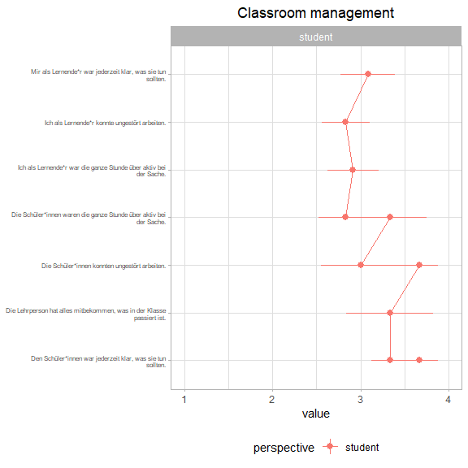
2. Positive climate and motivation 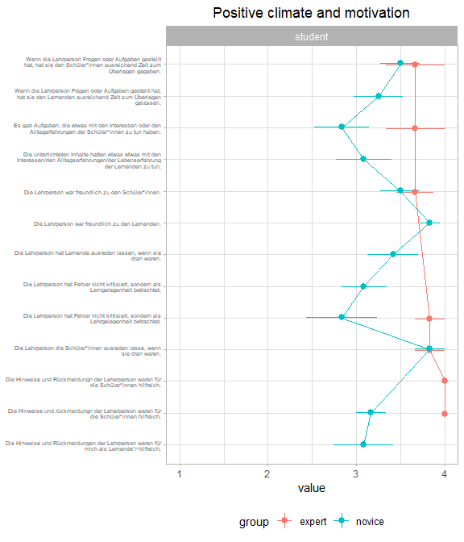
3. Clarity and structuredness 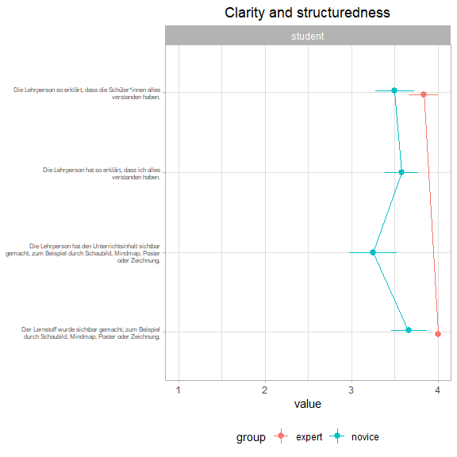
4. Activation and support 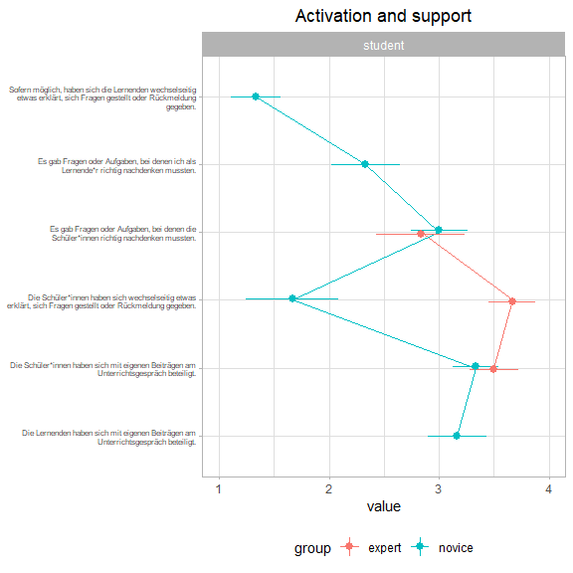

(ref:presenceposturegaze-caption) (5) Presence: posture/gaze

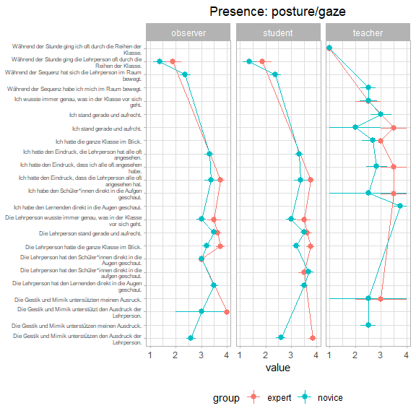

Figure 2.2: (ref:presenceposturegaze-caption)

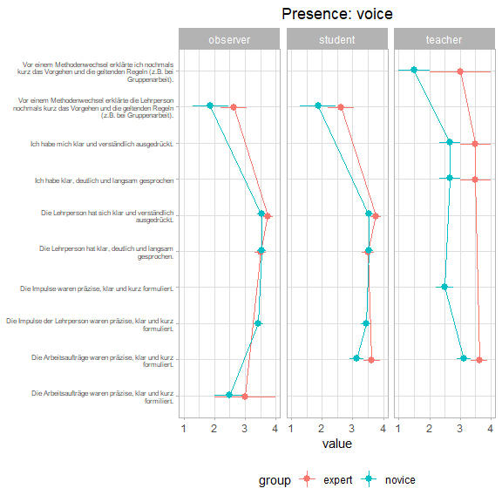

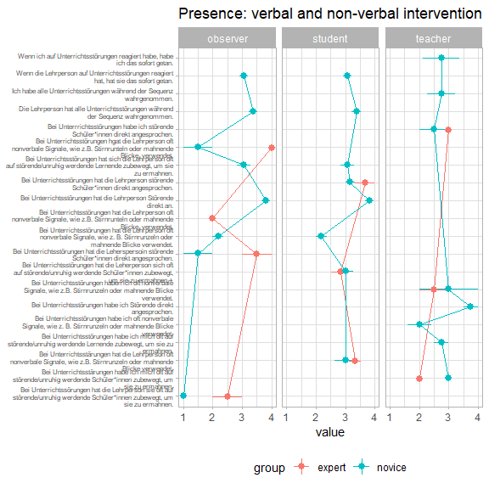 (8) Natural behaviour 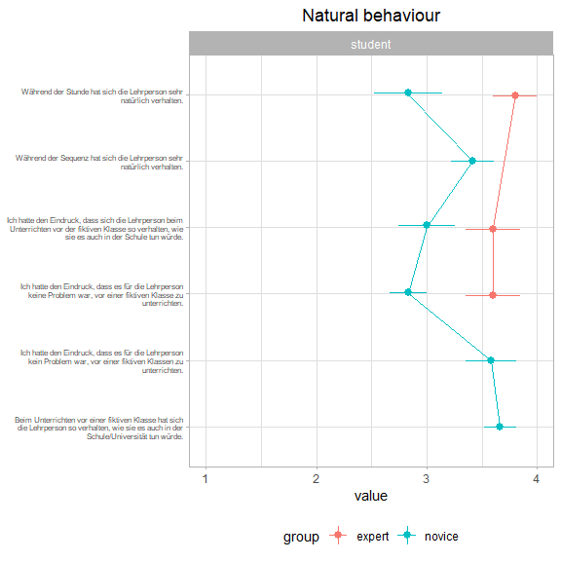 In addition, we plotted all scales. Graph provides boxplots and individual data for experts and novices.

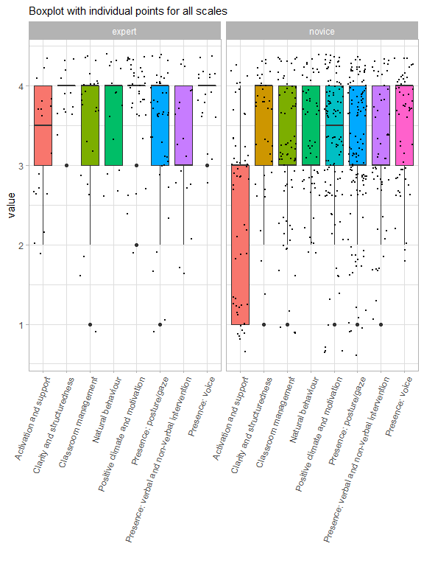

(#fig:boxplot scales)Boxplots and individual data for experts and novices

### 2.3.2 Behavioral Data

The recorded lessons were coded in a post-hoc procedure with the coding software MAXQDA by previously trained raters (Kuckartz and Rädiker 2019). The following coding scheme was developed:

* phase - lesson begin, state event: teacher starts the lesson with a noise, talk, taking a position in class
* phase - lesson end, state event: teacher finishes the lesson with a noise, talk, taking a position in class
* phase - organization/transition points, state event: any situation that does not imply effective learning time (fetching chalk, working material, organizing desks, opening windows, printing work results etc.)
* phase - single, state event: any individual student activity on a given task (reading, writing, drawing etc.)
* phase - group, state event: any student activity on a given task together in a group of at least 3 students (reading, writing, drawing etc.)
* phase - class discussion, state event: discussion in class, teacher talks to class/individual/group
* phase - pair: state event: any student activity on a given task together in a team of 2 students (reading, writing, drawing etc.)
* phase - teachers lecture, state event: any teacher’s presentation on a certain topic which maybe supported by a PPP, PREZI, notes on board, OHP etc.
* phase - other, state event: not categorizable
* phase - break, state event: e.g. drinking, relaxation exercises
* phase - external interruption, state event: external interruptions (e.g. fire alarm, technical problems, other teachers coming into the room)
* speaking time - teacher, state event
* speaking time - students, state event
* disruption - chatting with neighbor, state event (perceived/ not perceived, reacted: verbal, non-verbal/ not reacted)
* disruption - asking a question, state event (perceived/ not perceived, reacted: verbal, non-verbal/ not reacted)
* disruption - yelling, state event (perceived/ not perceived, reacted: verbal, non-verbal/ not reacted)
* disruption - looking at phone, state event (perceived/ not perceived, reacted: verbal, non-verbal/ not reacted)
* disruption - staring out of window, state event (perceived/ not perceived, reacted: verbal, non-verbal/ not reacted)
* disruption - drawing, state event (perceived/ not perceived, reacted: verbal, non-verbal/ not reacted)
* disruption - head on table, state event (perceived/ not perceived, reacted: verbal, non-verbal/ not reacted)
* disruption - clicking pen, state event (perceived/ not perceived, reacted: verbal, non-verbal/ not reacted)
* disruption - drumming hands, state event (perceived/ not perceived, reacted: verbal, non-verbal/ not reacted)
* disruption - walking around, state event (perceived/ not perceived, reacted: verbal, non-verbal/ not reacted)

First, we coded the speaking time of the teacher and the students to compare all perspectives: coder, observer, students, teacher. The graph below shows the result of the coded speaking duration compared to the estimated speaking duration assessed with the questionnaire.

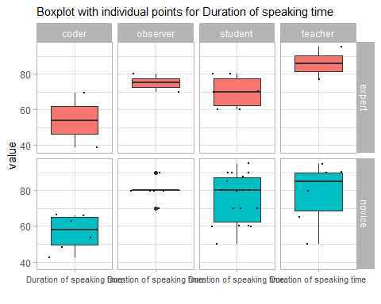

### 2.3.3 Eyetracking Data

The Tobii Pro Lab 2 software was used to analyze the teachers’ visual attetion during each mini-lesson. The software allows for non-screen based recordings of a participants’ attention while moving in real-world settings. The recordings of the glasses contain both HD-video from the subjects’ perspective as well as the respective gaze data mapped onto the video. In order to map multiple recordings to AOIs, we first imported the eye-tracking recordings into the Tobii Pro Analyzer software. Second, we created dynamic Areas of Interest (AOI) manually to plot the gaze data. Once the AOIs are created, the gaze recordings of multiple recordings can be mapped and analyzed in aggregated form. Tobii Pro does not allow to do AOI based analyses within Pro Lab. So we exported a tsv. file to do further analyses in the software R.

#### 2.3.3.1 Gaze relational index (GRI)

The GRI is a measure of visual expertise in information processing. This metric is calculated as the ratio of mean fixation duration to fixation count. The GRI is higher for novices than for experts. (Gegenfurtner et al. 2020)

Table 2.4:

*Number and Duration (in msec) of Fixations*

|  |  |  |  |  |  |  |
| --- | --- | --- | --- | --- | --- | --- |
| Participant | Variable | Fixation Number | Fixation Duration | M Duration Fixation | TOI | GRI |
| 01_01_D | Expert | 803.00 | 316,571.00 | 394.00 | 781,978.00 | 0.49 |
| 01_02_A | Expert | 1,070.00 | 385,812.00 | 361.00 | 838,026.00 | 0.34 |
| 01_03_B | Novice | 617.00 | 374,315.00 | 607.00 | 744,444.00 | 0.98 |
| 01_04_C | Novice | 769.00 | 384,537.00 | 500.00 | 723,922.00 | 0.65 |
| 02_01_A | Novice | 569.00 | 101,541.00 | 178.00 | 729,762.00 | 0.31 |
| 02_02_B | Novice | 1,140.00 | 520,431.00 | 457.00 | 730,565.00 | 0.40 |
| 02_03_C | Novice | 1,048.00 | 469,018.00 | 448.00 | 737,604.00 | 0.43 |
| 02_04_D | Novice | 613.00 | 438,655.00 | 716.00 | 747,729.00 | 1.17 |

(#tab:calibration phase TOI)

*Number and Duration (in msec) of Fixations during calibration*

|  |  |  |  |  |  |  |
| --- | --- | --- | --- | --- | --- | --- |
| Participant | Variable1 | Fixation Number | Fixation Duration | M Duration Fixation | TOI | GRI |
| 01_01_D | Expert | 9.00 | 14,372.00 | 1,597.00 | 16,470.00 | 177.44 |
| 01_02_A | Expert | 10.00 | 10,194.00 | 1,019.00 | 13,335.00 | 101.90 |
| 01_03_B | Novice | 17.00 | 9,234.00 | 543.00 | 10,615.00 | 31.94 |
| 01_04_C | Novice | 14.00 | 15,311.00 | 1,094.00 | 17,224.00 | 78.14 |
| 02_01_A | Novice | 13.00 | 5,157.00 | 397.00 | 17,902.00 | 30.54 |
| 02_02_B | Novice | 12.00 | 10,654.00 | 888.00 | 12,325.00 | 74.00 |
| 02_03_C | Novice | 18.00 | 14,151.00 | 786.00 | 16,494.00 | 43.67 |
| 02_04_D | Novice | 14.00 | 19,128.00 | 1,366.00 | 20,964.00 | 97.57 |

2.3.3.1.0.0.0.0.0.0.0.0.0.0.0.0.0.0.0.0.0.0.0.0.0.0.0.0.0.0.0.0.0.0.0.0.0.0.0.0.1

## 2.4 Data analysis

We used R [Version 4.0.3; R Core Team (2019)] and the R-packages *}dplyr* [@}R-dplyr], *forcats* [Version 0.5.0; Wickham (2020a)], *ggplot2* [Version 3.3.2; Wickham (2016)], *moments* [Version 0.14; Komsta and Novomestky (2015)], *papaja* [Version 0.1.0.9997; Aust and Barth (2020)], *papayar* (Muschelli 2016), *psych* [Version 2.0.12; Revelle (2020)], *purrr* [Version 0.3.4; Henry and Wickham (2020)], *readr* [Version 1.4.0; Wickham, Hester, and Francois (2018)], *sjPlot* [Version 2.8.7; Lüdecke (2021)], *stringr* [Version 1.4.0; Wickham (2019)], *tibble* [Version 3.0.4; Müller and Wickham (2021)], *tidyr* [Version 1.1.2; Wickham (2020b)], and *tidyverse* [Version 1.3.0; Wickham et al. (2019)] for all our analyses.

Lorem ipsum dolor sit amet, consetetur sadipscing elitr, sed diam nonumy eirmod tempor invidunt ut labore et dolore magna aliquyam erat, sed diam voluptua. At vero eos et accusam et justo duo dolores et ea rebum. Stet clita kasd gubergren, no sea takimata sanctus est Lorem ipsum dolor sit amet. Lorem ipsum dolor sit amet, consetetur sadipscing elitr, sed diam nonumy eirmod tempor invidunt ut labore et dolore magna aliquyam erat, sed diam voluptua. At vero eos et accusam et justo duo dolores et ea rebum. Stet clita kasd gubergren, no sea takimata sanctus est Lorem ipsum dolor sit amet.

### 2.4.1 Questionnaire Data

### 2.4.2 Behavioral Data

### 2.4.3 Eyetracking Data

# 3 Results

Lorem ipsum dolor sit amet, consetetur sadipscing elitr, sed diam nonumy eirmod tempor invidunt ut labore et dolore magna aliquyam erat, sed diam voluptua. At vero eos et accusam et justo duo dolores et ea rebum. Stet clita kasd gubergren, no sea takimata sanctus est Lorem ipsum dolor sit amet. Lorem ipsum dolor sit amet, consetetur sadipscing elitr, sed diam nonumy eirmod tempor invidunt ut labore et dolore magna aliquyam erat, sed diam voluptua. At vero eos et accusam et justo duo dolores et ea rebum. Stet clita kasd gubergren, no sea takimata sanctus est Lorem ipsum dolor sit amet.

### 3.0.1 Questionnaire Data

### 3.0.2 Behavioral Data

### 3.0.3 Eyetracking Data

# 4 Discussion

Lorem ipsum dolor sit amet, consetetur sadipscing elitr, sed diam nonumy eirmod tempor invidunt ut labore et dolore magna aliquyam erat, sed diam voluptua. At vero eos et accusam et justo duo dolores et ea rebum. Stet clita kasd gubergren, no sea takimata sanctus est Lorem ipsum dolor sit amet. Lorem ipsum dolor sit amet, consetetur sadipscing elitr, sed diam nonumy eirmod tempor invidunt ut labore et dolore magna aliquyam erat, sed diam voluptua. At vero eos et accusam et justo duo dolores et ea rebum. Stet clita kasd gubergren, no sea takimata sanctus est Lorem ipsum dolor sit amet.

# 5 References

Aust, Frederik, and Marius Barth. 2020. *papaja: Create APA Manuscripts with R Markdown*. <https://github.com/crsh/papaja>.

Barnes, Douglas. 2004. “The Significance of Teachers’ Frames for Teaching.” In *Teachers and Teaching*, 16–38. Routledge.

Barth, Victoria L. 2017. *Professionelle Wahrnehmung von Störungen Im Unterricht*. Springer.

Berliner, David C. 2001. “Learning about and Learning from Expert Teachers.” *International Journal of Educational Research* 35 (5): 463–82.

Bogert, Niek J van den. 2016. *On Teachers’ Visual Perception and Interpretation of Classroom Events Using Eye Tracking and Collaborative Tagging Methodologies*. Technische Universiteit Eindhoven.

Brophy, Jere. 1986. “Classroom Management Techniques.” *Education and Urban Society* 18 (2): 182–94.

Cortina, Kai S, Kevin F Miller, Ryan McKenzie, and Alanna Epstein. 2015. “Where Low and High Inference Data Converge: Validation of CLASS Assessment of Mathematics Instruction Using Mobile Eye Tracking with Expert and Novice Teachers.” *International Journal of Science and Mathematics Education* 13 (2): 389–403.

Gegenfurtner, Andreas, Jean-Michel Boucheix, Hans Gruber, Florian Hauser, Erno Lehtinen, and Richard K Lowe. 2020. “The Gaze Relational Index as a Measure of Visual Expertise.” *Journal of Expertise. East Lansing, Michigan: Michigan State University, 2020, Vol. 3, Iss. 1*.

Helmke, Andreas, Tuyet Helmke, Gerlinde Lenske, G Pham, Anna-Katharina Praetorius, Friedrich-Wilhelm Schrader, and Manuel AdeThurow. 2014. “Unterrichtsdiagnostik Mit EMU.” *Aus-Und Fortbildung Der Lehrkräfte in Hinblick Auf Verbesserung Der Diagnosefähigkeit, Umgang Mit Heterogenität Und Individuelle Förderung*, 149–63.

Henry, Lionel, and Hadley Wickham. 2020. *Purrr: Functional Programming Tools*. <https://CRAN.R-project.org/package=purrr>.

Jarodzka, Halszka, Katharina Scheiter, Peter Gerjets, and Tamara Van Gog. 2010. “In the Eyes of the Beholder: How Experts and Novices Interpret Dynamic Stimuli.” *Learning and Instruction* 20 (2): 146–54.

Kiel, Ewald, Anne Frey, Sabine Weiß, and Sabine Weiss. 2013. *Trainingsbuch Klassenführung*. Vol. 3992. UTB.

Komsta, Lukasz, and Frederick Novomestky. 2015. *Moments: Moments, Cumulants, Skewness, Kurtosis and Related Tests*. <https://CRAN.R-project.org/package=moments>.

Kounin, Jacob S. 2006. *Techniken Der Klassenführung*. Waxmann Verlag.

Kuckartz, Udo, and Stefan Rädiker. 2019. *Analyzing Qualitative Data with MAXQDA*. Springer.

Lachner, Andreas, Halszka Jarodzka, and Matthias Nückles. 2016. “What Makes an Expert Teacher? Investigating Teachers’ Professional Vision and Discourse Abilities.” *Instructional Science* 44 (3): 197–203.

Lüdecke, Daniel. 2021. *sjPlot: Data Visualization for Statistics in Social Science*. <https://CRAN.R-project.org/package=sjPlot>.

Marzano, Robert J. 2007. *The Art and Science of Teaching: A Comprehensive Framework for Effective Instruction*. Ascd.

Messner, Helmut, and Kurt Reusser. 2000. “Die Berufliche Entwicklung von Lehrpersonen Als Lebenslanger Prozess.” *Beiträge Zur Lehrerinnen-Und Lehrerbildung* 18 (2): 157–71.

Muschelli, John. 2016. *Papayar: View Medical Research Images Using the Papaya JavaScript Library*. <https://CRAN.R-project.org/package=papayar>.

Müller, Kirill, and Hadley Wickham. 2021. *Tibble: Simple Data Frames*. <https://CRAN.R-project.org/package=tibble>.

Nolting, Hans-Peter. 2012. *Störungen in Der Schulklasse*. Beltz.

Pouta, Maikki, Erno Lehtinen, and Tuire Palonen. 2020. “Student Teachers’ and Experienced Teachers’ Professional Vision of Students’ Understanding of the Rational Number Concept.”

R Core Team. 2019. *R: A Language and Environment for Statistical Computing*. Vienna, Austria: R Foundation for Statistical Computing. <https://www.R-project.org/>.

Revelle, William. 2020. *Psych: Procedures for Psychological, Psychometric, and Personality Research*. Evanston, Illinois: Northwestern University. <https://CRAN.R-project.org/package=psych>.

Stuermer, Kathleen, Tina Seidel, Katharina Mueller, Janina Häusler, and Kai S Cortina. 2017. “What Is in the Eye of Preservice Teachers While Instructing? An Eye-Tracking Study about Attention Processes in Different Teaching Situations.” *Zeitschrift für Erziehungswissenschaft* 20 (1): 75–92.

Wickham, Hadley. 2016. *Ggplot2: Elegant Graphics for Data Analysis*. Springer-Verlag New York. <https://ggplot2.tidyverse.org>.

———. 2019. *Stringr: Simple, Consistent Wrappers for Common String Operations*. <https://CRAN.R-project.org/package=stringr>.

———. 2020a. *Forcats: Tools for Working with Categorical Variables (Factors)*. <https://CRAN.R-project.org/package=forcats>.

———. 2020b. *Tidyr: Tidy Messy Data*. <https://CRAN.R-project.org/package=tidyr>.

Wickham, Hadley, Mara Averick, Jennifer Bryan, Winston Chang, Lucy D’Agostino McGowan, Romain François, Garrett Grolemund, et al. 2019. “Welcome to the tidyverse.” *Journal of Open Source Software* 4 (43): 1686. <https://doi.org/10.21105/joss.01686>.

Wickham, Hadley, Jim Hester, and Romain Francois. 2018. *Readr: Read Rectangular Text Data*. <https://CRAN.R-project.org/package=readr>.

Wolff, Charlotte E, Halszka Jarodzka, and Henny PA Boshuizen. 2017. “See and Tell: Differences Between Expert and Novice Teachers’ Interpretations of Problematic Classroom Management Events.” *Teaching and Teacher Education* 66: 295–308.